10alytics
Threat Intelligence Capstone Project
Harmony Health Threat Investigation
Prepared by
Faith Ejele
SOC Analyst
10alytics | 2026
SOC Investigation Report: Email 4, DHL Delivery and Redelivery-Fee Phishing

Document details
Title | Threat Intelligence Capstone Project: Harmony Health Threat Investigation
Report subject | Email 4: suspected DHL failed-delivery phishing with a $2.99 redelivery-fee link and a ZIP attachment
Prepared by | Faith Ejele, SOC Analyst
Organisation / year | 10alytics, 2026
Report date | 26 October 2026
Email received | Friday 17 April 2026, 20:05:36–20:05:44 UTC (the header calls it Thursday)
Method | Static, desk-based analysis of original .eml screenshots and lab screenshots. No live execution.
Disposition | High-priority suspected delivery phishing. Payment, information theft and malware execution are NOT confirmed.
Handling | Internal – Confidential. Contains defanged indicators.
Evidence base | Email 4 SOC report (Email4_Shipping_Analysis) with 19 original lab screenshots; Part A desk-based report

Contents
1. Executive summary
2. Scope, evidence and method
3. Header inspection
4. Received chain and timestamps
5. SPF, DKIM and DMARC
6. Message content and lure analysis
7. Indicators and enrichment
8. Attachment analysis
9. Timeline and link to other cases
10. Risk assessment
11. Evidence gaps and limitations
12. Recommendations
13. Final conclusion
Appendix A: Suggested static lab commands
Appendix B: Original lab screenshots

1. Executive summary
Verdict: High-risk delivery-themed phishing with a payment pretext. No payment, information theft or malware execution is confirmed.
The email impersonates "DHL Express - Delivery Notification" and tells the recipient (recipient@targetcorp.com) that a parcel could not be delivered. To "reschedule", the recipient must confirm a delivery address and pay a $2.99 redelivery fee on a website outside DHL's domain. A ZIP file is presented as "shipment documentation and customs clearance forms". The likely aim is to collect personal and card details, and the ZIP is an extra, unconfirmed risk.

Key findings
- Identity mismatch. The From address is noreply@dhl.com, but the Return-Path, Reply-To, Message-ID, every link and the mail servers use dhl-delivery-info[.]xyz. The impersonated domain appears only in the From line and in the authentication claims.
- Sending path. The four-hop chain starts at a private relay (172.16.88.9, HELO MAIL-RELAY-03), passes smtp. and mail.dhl-delivery-info[.]xyz (176.111.174.33, then 176.111.174.55) and reaches Google 6 seconds later. Both public IPs belong to NUBES LLC (AS212136, Moscow). Two header-analyser flags mark both public hops as blacklisted.
- Authentication failed, and the signature was never real. SPF, DKIM and DMARC are all reported as failed. The DKIM signature is a placeholder (a run of "G" characters followed by "H" characters). DMARC shows p=QUARANTINE but dis=NONE, so no quarantine action is recorded.
- The ZIP is small and inconsistent. The ZIP is only about 160 bytes and holds one text file, ShippingDocs_PKG8821.txt. Its internal size fields do not match its actual bytes, so it looks hand-built. No executable member is visible. This is better evidence than the source report had, but it is still a reading of screenshots.
- Content has the marks of a template. The "Sender: Amazon.com" claim, the tracking number (1928374650, digits that run in a pattern), the 11:34 AM attempt time that appears only in the HTML part, and the header weekday error all show weak fabrication.
- Reputation evidence is thin. Both IPs show 0% abuse confidence on old reports (2021 to 2024). That does not clear them. No reputation result was supplied for the domain itself.

Overall confidence
Confidence that this is a phishing attempt: high. Confidence in the technical routing and authentication details: low to medium, because they rest on screenshots of an .eml and not on a gateway record. Several features of the sample (placeholder DKIM value, a pattern string reused between the Message-ID and the DKIM header, a one-year timestamp shift, an invented-looking tracking number and a file named email4_shipping_zip.eml) suggest it may be a training sample. It is analysed as if it were live, as the process requires.

2. Scope, evidence and method

2.1 Evidence reviewed
Source | Content used
Email 4 SOC report (Email4_Shipping_Analysis.docx) | Header comparison, authentication results, indicator enrichment and attachment findings, plus 19 original lab screenshots.
Original .eml screenshots (email4_shipping_zip.eml) | Full headers with four Received hops, DKIM-Signature, plain-text and HTML bodies, and the ZIP MIME part with its base64 content.
Lab tool screenshots | AbuseIPDB pages for 176.111.174.55 and 176.111.174.33, an email header analyser, a header-parsing page and an HxD hex view of the decoded ZIP.
PART A: Desk-based Analysis | Earlier consolidated extract for the same email (selected headers only).

2.2 Method and evidence standards
- Header inspection, Received-chain timing, authentication review, content analysis, indicator enrichment and static attachment review. Nothing was executed.
- Headers can be forged, so values in an untrusted message are recorded as reported. In a genuine chain only the hops added by the receiving organisation's servers are trustworthy; lower hops are supplied by the sender.
- A DMARC policy does not show what a gateway did. A published or claimed DKIM domain is not proof of a valid signature. Private addresses are not external senders.
- Reputation screenshots show a past lookup, not a fresh one, and a clean result does not prove safety.

3. Header inspection

3.1 Message metadata
Subject | DHL: Your Parcel Could Not Be Delivered - Tracking #1928374650
From | "DHL Express - Delivery Notification" <noreply@dhl[.]com>
Reply-To | support@dhl-delivery-info[.]xyz
Return-Path / envelope | tracking@dhl-delivery-info[.]xyz
To / Delivered-To | recipient@targetcorp.com
Date | Thu, 17 Apr 2026 20:05:36 +0000
Message-ID | <20260417200536.Vn3Qp@dhl-delivery-info[.]xyz>
Priority | X-Priority: 2
DHL-style headers | X-DHL-Notification: DELIVERY_EXCEPTION; X-Tracking-Number: 1928374650; X-Delivery-Attempt: 1 of 3
Mailer signs | X-Mailer: MailMate (1.14.1r5936); X-PHP-Originating-Script: 77:tracking_notify.php; Exim 4.94.2; HELO MAIL-RELAY-03
X-Originating-IP | 176.111.174.55
Structure | multipart/mixed containing multipart/alternative (text/plain and text/html, quoted-printable) and an application/zip attachment (base64)

3.2 Identity comparison
Field | Domain / value | Assessment
From | dhl[.]com | Claimed identity; does not align with the envelope sender
Return-Path | tracking@dhl-delivery-info[.]xyz | Unrelated .xyz domain, also used for the Message-ID
Reply-To | support@dhl-delivery-info[.]xyz | Replies go to the attacker, although the body says not to reply
Link domain | dhl-delivery-info[.]xyz | Reschedule, support and unsubscribe links all use it
Mail servers | smtp. and mail.dhl-delivery-info[.]xyz | Sending hosts use the lookalike domain

Two header features give mixed signals about how the message was produced. The X-Mailer names MailMate (a desktop mail client), but X-PHP-Originating-Script names a server-side script (tracking_notify.php, user ID 77). Both cannot describe one submission path, so at least one of these headers is false or was added by a relay. The DHL-style X-headers (X-DHL-Notification, X-Tracking-Number) are not standard DHL mail headers as far as I know, but this was not checked. They add a veneer of authenticity and are controlled by the sender.

4. Received chain and timestamps
Four hops are shown, from earliest to delivery:
Hop | From → by | Timestamp as shown | UTC | Trust
1 | from [172.16.88.9] (helo=MAIL-RELAY-03) → smtp.dhl-delivery-info[.]xyz, ESMTP, id 1jYgRZ-00006P-2Q | Thu, 17 Apr 2026 20:05:38 +0000 | 20:05:38 | Sender-supplied; private IP, not an external sender
2 | from smtp.dhl-delivery-info[.]xyz ([176.111.174.33]) → mail.dhl-delivery-info[.]xyz, ESMTPA (Exim 4.94.2), envelope-from tracking@dhl-delivery-info[.]xyz, id 1jYgRc-0001pW-Kv | Thu, 17 Apr 2026 20:05:41 +0000 | 20:05:41 | Sender-supplied
3 | from mail.dhl-delivery-info[.]xyz (dhl-delivery-info.xyz. [176.111.174.55]) → mx.google.com, ESMTP, TLS 1.2 (ECDHE-RSA-AES256-GCM-SHA256) | Thu, 17 Apr 2026 13:05:43 -0700 (PDT) | 20:05:43 | Receiving side (if genuine)
4 | → 10.114.72.201, SMTP, id z2csp4837211qkd | Thu, 17 Apr 2026 13:05:44 -0700 (PDT) | 20:05:44 | Receiving side (internal private relay)

- The Date header (20:05:36 UTC), the Message-ID stamp (20260417200536) and the four Received times (20:05:38 to 20:05:44 UTC) agree with each other. The message took 8 seconds from the Date header to delivery, and 6 seconds from the first hop. The "-0700 (PDT)" offset is correct for April.
- Hop 3 is the key hop. If the receiving side is genuine, 176.111.174.55 is the real SMTP peer that connected to Google; otherwise it is a claim. Check this against original gateway logs.
- The header analyser (B-05) marks hops 2 and 3 (176.111.174.33 and .55) with a red blacklist flag and the private first hop green. The tool does not say which list matched, and this is not independent evidence.
- Hop 1 uses a private 172.16.x.x address with the HELO name MAIL-RELAY-03. This is not routable and is not an external sender.

Timestamp anomalies
- The header gives the date as Thursday, but 17 April 2026 was a Friday.
- The DKIM timestamp (t=1744909541) and the MIME boundary suffix (…1744909535) decode to 17 April 2025, 17:05:41 and 17:05:35 UTC. That is one year earlier, and 17 April 2025 was a Thursday. This matches the weekday error and the one-year shift seen in Emails 1 and 2. It suggests the message was built with 2025 timestamps and the year later changed.
- The HTML part says the delivery attempt was "today at 11:34 AM" with no time zone. The email was sent at 20:05 UTC (13:05 PDT), so 11:34 AM is plausible only for a US Pacific-like zone and cannot be tested. The plain-text part omits the time.

5. SPF, DKIM and DMARC
Control | Reported result (Authentication-Results: mx.google.com) | Validation status
SPF | fail: "domain of dhl.com does not designate 176.111.174.55 as permitted sender"; smtp.mailfrom=tracking@dhl-delivery-info[.]xyz. Received-SPF also fail; client-ip=176.111.174.55. | Not reproduced. The wording evaluates dhl.com although the envelope sender is dhl-delivery-info[.]xyz, so the extract is internally loose.
DKIM | fail (no key for signature: key record not found in DNS); header.i=@dhl.com; header.s=dkim; header.b=Vn3QpX7s. Signature d=dhl.com, s=dkim, rsa-sha256, relaxed/relaxed. | Not reproducible. The b= value is "GGGG…" followed by "HHHH…=", a placeholder, and does not match header.b=Vn3QpX7s. The prefix "Vn3Qp" also appears in the Message-ID.
DMARC | fail (p=QUARANTINE sp=QUARANTINE dis=NONE); header.from=dhl.com; reason: "SPF and DKIM both fail; From header domain dhl.com does not align with envelope sender dhl-delivery-info.xyz" | Gateway action unverified. The policy asks for quarantine, but the disposition is NONE, so a local override is possible. Where the message landed is unknown.

A genuine DHL message would be signed with a key published by DHL. A signature claiming d=dhl.com whose key cannot be found, with a placeholder value, is consistent with spoofing. All of this is untrusted text, so it supports the conclusion but cannot establish it. Because the reported policy is p=QUARANTINE, a correctly configured gateway would have been expected to quarantine this message. The record shows dis=NONE, which should be checked against the gateway log.

6. Message content and lure analysis

6.1 What the email says
Item | Content
Greeting | "Dear DHL Customer" (generic)
Claim | "We attempted to deliver your parcel today but were unable to complete the delivery." Reason: no one available at the registered address.
Shipment details | Tracking 1928374650; status DELIVERY FAILED - ADDRESS EXCEPTION; sender "Amazon.com"; estimated weight 2.3 kg; delivery attempt 1 of 3
Deadline | Parcel held at the depot for 5 business days and then returned; HTML part gives a hold deadline of April 24, 2026
Instruction | "TO RESCHEDULE DELIVERY: You must pay a small redelivery administration fee of $2.99 and confirm your delivery address."
Link | hxxps://dhl-delivery-info[.]xyz/reschedule?track=1928374650&ref=TCORP04&fee=2.99 (quoted-printable escapes decoded and line breaks joined)
Other links | hxxps://dhl-delivery-info[.]xyz/support and /unsubscribe; phone 1-800-DHL-SHIP (1-800-345-7447)
Attachment claim | "Please see the attached ZIP file for your full shipment documentation and customs clearance forms."
HTML styling | DHL yellow header (#FFCC00) with a red (#D40511) "DHL" logo, an alert bar "DELIVERY FAILED — ACTION REQUIRED WITHIN 5 DAYS", a tracking table, a fee box and a "Reschedule My Delivery »" button
Footer | "© 2026 DHL International GmbH. All rights reserved."

6.2 Phishing indicators
- Fee pretext. The recipient must pay a small fee and confirm an address on a lookalike site. The low amount is meant to lower suspicion while collecting card and personal details.
- Pressure. A five-business-day deadline, a "1 of 3" attempt count and the threat that the parcel will be returned.
- Generic greeting. "Dear DHL Customer" with no name, and no real recipient address or order details.
- Reply conflict. The body says "Do not reply to this email" while the Reply-To points to the attacker domain.
- Unexpected attachment. A ZIP of "customs clearance forms" for a parcel that has not yet been delivered is unexpected, and customs paperwork is not normally sent after a failed delivery attempt (general knowledge, not verified for this carrier).

6.3 Features that look fabricated
Detail | Observation | Assessment
Tracking number 1928374650 | The digits pair up as 1-9, 2-8, 3-7, 4-6, 5-0 | A pattern, not a random waybill number. Cannot be tested without a DHL lookup, which was not done.
Sender "Amazon.com" | Named as the shipper in both parts | A well-known brand added for credibility. No link to the recipient is shown.
Hold deadline April 24, 2026 | Five business days after Friday 17 April is Friday 24 April | Consistent with the real date (Friday), and not with the header's "Thursday".
Phone 1-800-DHL-SHIP (1-800-345-7447) | The letters map correctly to the digits | Not verified against DHL's published numbers.
ref=TCORP04 | A campaign or recipient tag in the URL | May relate to the targetcorp.com recipient domain. Not confirmed.
Plain-text and HTML parts | Only the HTML gives "11:34 AM" and the hold deadline | The parts differ, a mild anomaly.

7. Indicators and enrichment

7.1 Indicators
Type | Indicator | Role
Domain | dhl-delivery-info[.]xyz; smtp. and mail.dhl-delivery-info[.]xyz | Return-Path, Reply-To, Message-ID, links and sending hosts
Domain | dhl[.]com | Impersonated brand. Do not block.
URL | hxxps://dhl-delivery-info[.]xyz/reschedule?track=1928374650&ref=TCORP04&fee=2.99 | Payment and address lure
URL | hxxps://dhl-delivery-info[.]xyz/support; hxxps://dhl-delivery-info[.]xyz/unsubscribe | Secondary links
IP | 176.111.174.55 | Claimed SMTP origin and X-Originating-IP (mail.dhl-delivery-info[.]xyz)
IP | 176.111.174.33 | Relay (smtp.dhl-delivery-info[.]xyz), same /24
Private IP | 172.16.88.9 (HELO MAIL-RELAY-03) | Sender-side relay; not an external sender
Private IP | 10.114.72.201 | Receiving-side relay
Email | tracking@dhl-delivery-info[.]xyz; support@dhl-delivery-info[.]xyz; noreply@dhl[.]com | Return-Path; Reply-To; display From
Phone | 1-800-DHL-SHIP (1-800-345-7447) | Contact line in body and footer (unverified)
Identifier | Tracking 1928374650; ref=TCORP04; Message-ID <20260417200536.Vn3Qp@dhl-delivery-info[.]xyz> | Mail-log and proxy-log searches
Header | X-PHP-Originating-Script: 77:tracking_notify.php; X-Mailer: MailMate (1.14.1r5936); X-DHL-Notification: DELIVERY_EXCEPTION | Hunting aids
File | ShippingDocs_1928374650.zip (member ShippingDocs_PKG8821.txt) | Attachment; SHA-256 not calculated

7.2 Reputation results shown in the screenshots
Indicator / service | Result shown
176.111.174.55 (AbuseIPDB) | 0% abuse confidence ("Low Risk", neutral activity); 4 reports from 4 reporters; latest 2 years ago; no reports in the last 60 days. ISP NUBES LLC; usage Data Center/Web Hosting/Transit; ASN AS212136; domain nubes.ru; Russian Federation (Moscow). The four reports are RDP brute force (10 July 2024), PostgreSQL login attempts (31 May 2022), MSSQL brute force on a honeypot (28 April 2021) and a PostgreSQL port scan (24 April 2021).
176.111.174.33 (AbuseIPDB) | 0% abuse confidence; 1 report from 1 reporter, latest 2 years ago; same ISP, usage type, ASN and location as .55.
dhl-delivery-info[.]xyz | No reputation result supplied. The source report relied on static analysis only.

Reading these results with care:
- No lookup date is shown. "Latest 2 years ago" fits a lookup made in or after July 2026, so the data is at least three months after the email, and probably more.
- The 0% score reflects the absence of recent reports, and AbuseIPDB says scores decay over time. The earlier reports are for scanning and brute force against database and remote-desktop ports, not for phishing.
- Both IPs are on a rented data-centre network from one provider, in the same /24. That fits an attacker's rented server but does not identify the operator.
- The IP results say nothing about the domain, which is the stronger indicator here. A domain lookup (registration date, passive DNS, reputation) is still needed.

7.3 Screenshots and tool use that need care
- B-06 is a header-analyser result for webmail.mailer-srv-dispatch[.]xyz, 127.0.0.1, mx.google.com and 10.114.72.133 with a Monday 14 April 2026 timestamp. This is the Email 1 chain and does not belong to Email 4. It is shown in Appendix B for completeness and is not used as Email 4 evidence.
- B-04 shows the ZIP MIME part pasted into a header-analyser form. That tool reads headers, so it adds no information about the attachment.

8. Attachment analysis: ShippingDocs_1928374650.zip
Property | Finding
Declared | Content-Type application/zip; name="ShippingDocs_1928374650.zip"; Content-Disposition attachment; base64
Signature | The base64 begins UEsDB, which decodes to "PK" 03 04, a ZIP local file header. The HxD view (B-12) confirms the bytes 50 4B 03 04.
Local header (from B-12) | Version 20, flags 0, method 8 (deflate), CRC-32 0x8ABD846F, compressed size 38, uncompressed size 34, name length 23, no extra field. The DOS timestamp decodes to 6 April 2009 12:32:46, unrelated to the email.
Member | ShippingDocs_PKG8821.txt (24 characters): a text file, not an executable or script. The name does not match the tracking number in the ZIP's own name (1928374650).
Total size | About 160 bytes (my decode of the base64 shown in B-11 and B-19; the first 0x77 bytes also appear in B-12 and agree).
Internal inconsistencies | The header gives a name length of 23, but the name is 24 characters. It states 38 compressed bytes, but only 15 bytes sit between the name and the central directory, which starts at offset 0x45 (69). The end-of-archive record gives a central directory offset of 91 (0x5B), which equals 30 + 23 + 38 and so follows the stated sizes, not the real bytes.
Content | Inflating the 15 visible compressed bytes gives 13 bytes that are not readable text and do not match the stored CRC-32 or the stated 34-byte size. This is my reconstruction from screenshots and could also reflect a transcription or decode error.
Active content | None visible. The only member is a .txt file. No executable, script, macro or archive-in-archive appears.
Hash | SHA-256 not calculated: the original attachment bytes were not supplied

Conclusion: the ZIP is a very small archive with one text member and size fields that do not match its contents, so it looks hand-built or corrupted. At about 160 bytes it is too small to carry a typical executable payload. Its purpose appears to be to support the "customs documents" story. A standard unzip would probably report errors (not tested). This is not proof that the file is harmless. The original attachment must be extracted, hashed and tested with unzip -t and zipinfo.

9. Timeline and link to other cases
Date / time (2026) | Event
14–15 April | Emails 1 (Microsoft) and 2 (invoice) are delivered to targetcorp.com.
17 April, 20:05:36–20:05:44 UTC | Email 4 created, relayed and delivered to recipient@targetcorp.com (8 seconds).
18 April | Email 5 (Bank of America) arrives.
24 April | Hold deadline in the HTML part (185 days before this report).
26 October | This report (192 days after the email).

Email 4 shares several features with Emails 1 and 2, which suggests a common author, template or data set:
- All were delivered to targetcorp.com through private receiving relays in 10.114.72.0/24 (10.114.72.133 for Emails 1 and 2, 10.114.72.201 for Email 4).
- Each carries a placeholder DKIM value (A/B, C/D and G/H runs) and a DKIM timestamp and MIME boundary that decode to the same date one year earlier.
- Each uses a short pattern string in the Message-ID that is reused in the DKIM header.b value (Email 4: "Vn3Qp").
- Each mixes a desktop mail-client signature with a server-side PHP script header.
- The sending infrastructure differs: Email 4 used NUBES LLC hosting in Moscow, and Email 2 used Flyservers hosting. No shared sending IP is visible between Email 4 and the other cases.

10. Risk assessment
Factor | Rating | Reasoning
Likelihood of phishing | High | Domain mismatch, fee-based lure, generic greeting, failed authentication, placeholder signature, lookalike links.
Potential impact | Medium-High | Card and personal-data theft through the fee page. The ZIP adds a small and unconfirmed malware risk.
Evidence of loss | None seen | No click, payment, reply or file-open record is in the evidence.
Evidence quality | Medium | Complete .eml text is visible in screenshots, but the original file, gateway logs and attachment bytes are missing.
Overall priority | Medium-High | Treat as urgent if the recipient visited the link, paid or opened the ZIP.

MITRE ATT&CK mapping
Technique | ID | Relevance
Phishing: spearphishing link | T1566.002 | Reschedule and fee link
Phishing: spearphishing attachment | T1566.001 | ShippingDocs ZIP (content unconfirmed)
Phishing for information | T1598 | Address confirmation and card data
Impersonation | T1656 | DHL brand and notification headers
Acquire infrastructure: domains | T1583.001 | dhl-delivery-info[.]xyz
User execution: malicious link / file | T1204.001 / T1204.002 | If the link was clicked or the ZIP opened

11. Evidence gaps and limitations
Check | Status | Note
Original .eml | Screenshots only | Headers readable; not independently authenticated
SPF / DKIM / DMARC reproduction | Not done | Reported values only; DKIM value is a placeholder
Gateway disposition and mailbox location | Not verified | Policy p=QUARANTINE but dis=NONE
Domain reputation and registration data | Not done | No result supplied for dhl-delivery-info[.]xyz
IP reputation | Partly done | AbuseIPDB for two IPs, lookup date unknown
ZIP hash, integrity test and member extraction | Not done | Original bytes unavailable; reading is from screenshots
Tracking number and phone number check against DHL | Not done | Cannot confirm they are invalid
User interaction (click, payment, file open) | No evidence | Needs proxy, DNS, endpoint and card-issuer records
Authenticity of the sample | Uncertain | Placeholder DKIM, patterned strings, 2025 timestamps and lab-style file name suggest a training sample

12. Recommendations

12.1 Immediate (first working day)
- Establish exposure. Ask the recipient whether they clicked the reschedule link, entered an address or card details, paid $2.99 or opened the ZIP. Search proxy and DNS logs for dhl-delivery-info[.]xyz and the tracking number.
- Protect the user. If card details were entered, tell the card issuer, replace the card and watch for later charges. If credentials were reused anywhere, reset them.
- Check the endpoint. If the ZIP was opened, isolate the endpoint and run a full scan, then check for new files, processes and outbound connections around 17 April.
- Contain. Block dhl-delivery-info[.]xyz (including smtp. and mail.) and the two IPs at the mail and web gateways, and search for other messages from them or with the same script header, tracking number or ref=TCORP04. Do not block dhl[.]com.

12.2 Short term (this week)
- Get the originals. Retrieve the original .eml and ZIP from the mail system with a record of who collected them, then repeat the SPF, DKIM and DMARC checks and check the gateway log for the quarantine decision.
- Static attachment analysis. Hash the ZIP, run unzip -t and zipinfo -v, and list and extract members in an isolated machine (see Appendix A).
- Enrich indicators. Run dated lookups for the domain (registration, passive DNS, reputation) and both IPs, and record tool, date and result. Check the tracking number on dhl.com.
- Report abuse. Report the domain to the registrar and hosting provider, and to DHL's abuse team if the sample is live.

12.3 Longer term
- Add gateway rules for delivery-notification wording from senders whose domain does not match the brand, and for links with a fee or payment parameter.
- Alert on external messages with a ZIP attachment from a first-time sender, and quarantine messages whose own DMARC result is fail on a quarantine or reject policy.
- Brief staff that carriers do not ask for small fees through email links, and show them how to check a parcel on the carrier's own website.
- Enforce DMARC on your own domains and alert on lookalike-domain registrations.

13. Final conclusion
The evidence shows a deliberate delivery-themed phishing email: a DHL impersonation from unrelated infrastructure, failed authentication with a placeholder signature, a $2.99 fee lure on a lookalike domain and a tiny ZIP with one text member. The evidence does not show that anyone clicked, paid, opened the attachment or lost data.
Final disposition: High-priority suspected DHL redelivery phishing; no confirmed compromise. Confirm user exposure first, then obtain the original message and ZIP for hashing and full static analysis.

Appendix A: Suggested static lab commands
For use on the original attachment extracted from the .eml, in an isolated environment. Nothing is executed.
base64 -d shippingdocs.b64 > ShippingDocs_1928374650.zip
file ShippingDocs_1928374650.zip
sha256sum ShippingDocs_1928374650.zip
xxd -l 160 ShippingDocs_1928374650.zip
unzip -t ShippingDocs_1928374650.zip
unzip -l ShippingDocs_1928374650.zip
zipinfo -v ShippingDocs_1928374650.zip
strings -a ShippingDocs_1928374650.zip

If any member looks executable, inspect its full PE headers and imports, because an MZ prefix alone proves nothing. Do not extract or open members on a production machine. Use a command-line decode of the original MIME part, not a web tool.

Appendix B: Original lab screenshots
The 19 images below are reproduced from the Email 4 lab analysis in their original order. They are documentary screenshots, not independently validated mail, network or malware-analysis records. The "What it shows" line is the analyst reading of each image for this report.
Figure B-01. AbuseIPDB: 176.111.174.55 summary
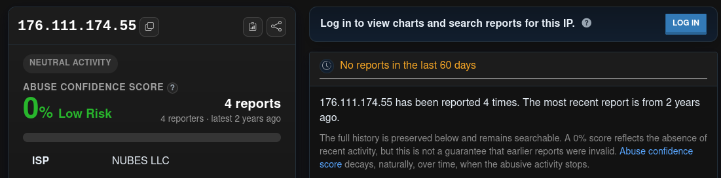
What it shows: 0% abuse confidence (Low Risk), 4 reports from 4 reporters, latest 2 years ago, "No reports in the last 60 days", ISP NUBES LLC, with AbuseIPDB's note that a 0% score reflects the absence of recent activity.
Figure B-02. AbuseIPDB: 176.111.174.55 card
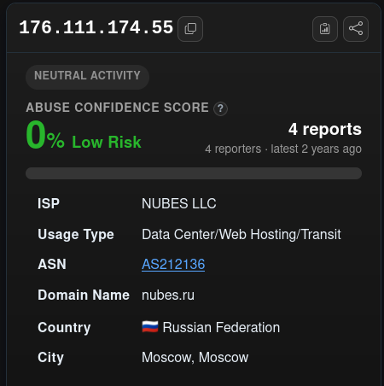
What it shows: NUBES LLC, Data Center/Web Hosting/Transit, AS212136, nubes.ru, Russian Federation (Moscow).
Figure B-03. AbuseIPDB: report history for 176.111.174.55
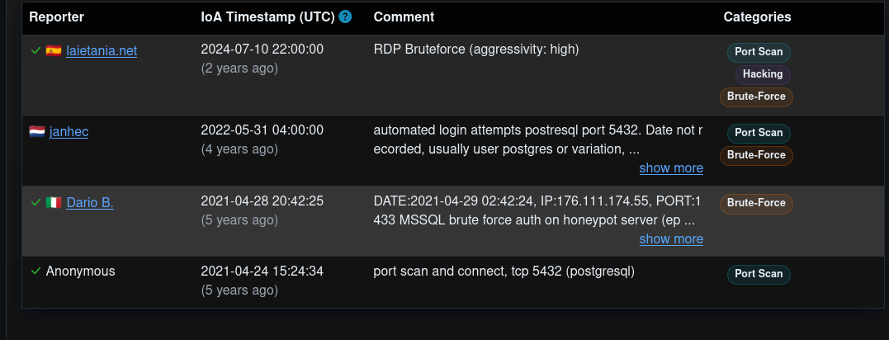
What it shows: RDP brute force (10 July 2024), PostgreSQL login attempts (31 May 2022), MSSQL brute force on a honeypot (28 April 2021) and a PostgreSQL port scan (24 April 2021).
Figure B-04. Header analyser with the ZIP MIME part pasted
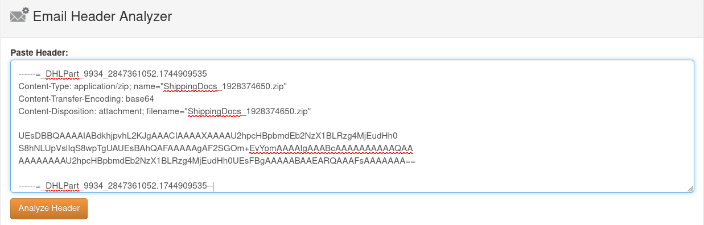
What it shows: The attachment part (Content-Type application/zip, name ShippingDocs_1928374650.zip, base64 starting UEsDBBQ…) pasted into a header-analysis form. A header tool gives no information about the file itself.
Figure B-05. Header analyser: Email 4 hop table
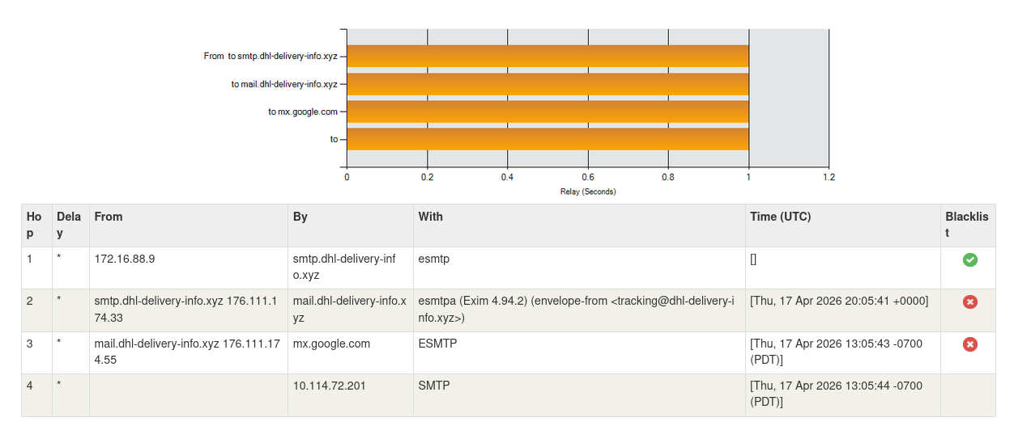
What it shows: Four hops: 172.16.88.9 to smtp.dhl-delivery-info.xyz; 176.111.174.33 to mail.dhl-delivery-info.xyz (Exim 4.94.2, 20:05:41 UTC); 176.111.174.55 to mx.google.com (13:05:43 PDT); then 10.114.72.201 (13:05:44 PDT). Red blacklist markers on hops 2 and 3.
Figure B-06. Header analyser: Email 1 hop table (not Email 4)
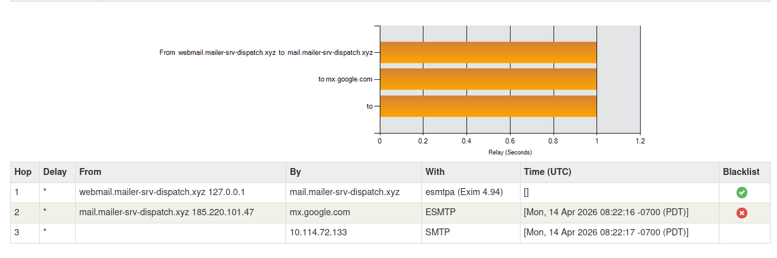
What it shows: Three hops for webmail.mailer-srv-dispatch.xyz (127.0.0.1), mail.mailer-srv-dispatch.xyz (185.220.101.47, 14 April 2026 08:22:16 PDT) and 10.114.72.133. This belongs to Email 1.
Figure B-07. SPF and DKIM header-parsing page
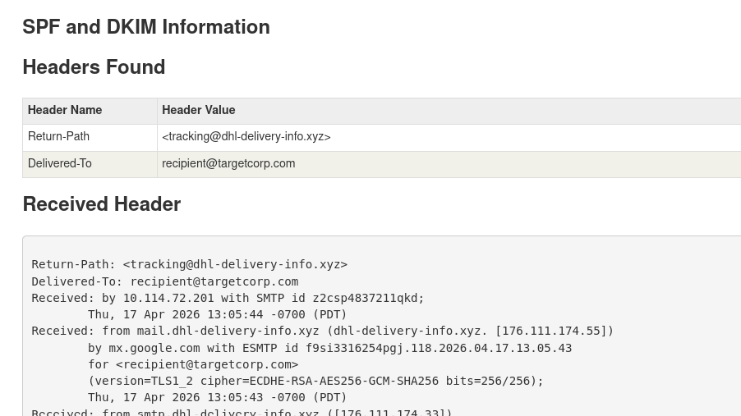
What it shows: A web header tool showing Return-Path tracking@dhl-delivery-info.xyz, Delivered-To recipient@targetcorp.com and the first Received lines with the Google hop.
Figure B-08. Header text: Received chain through DKIM-Signature
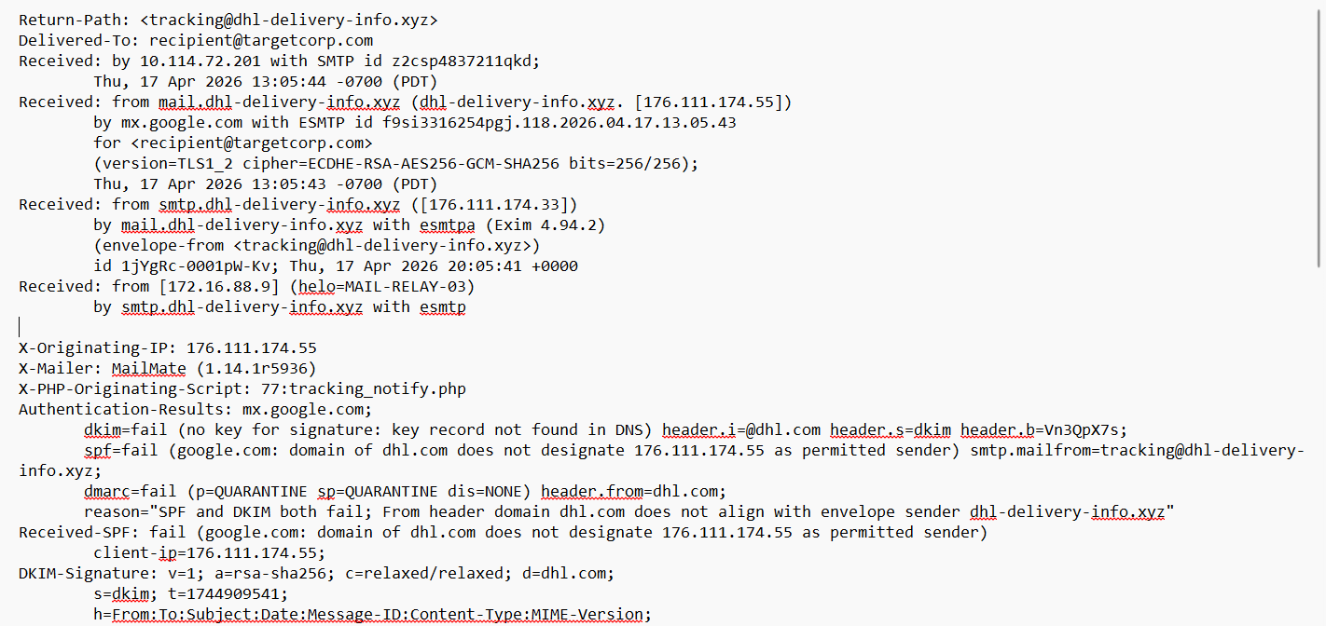
What it shows: Return-Path, Delivered-To, the four Received hops, X-Originating-IP, X-Mailer MailMate, X-PHP-Originating-Script tracking_notify.php, Authentication-Results (DKIM, SPF, DMARC fail) and the start of the DKIM-Signature.
Figure B-09. AbuseIPDB: 176.111.174.33 card
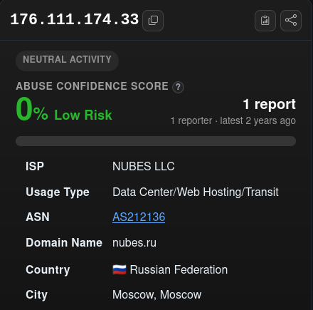
What it shows: 0% abuse confidence, 1 report from 1 reporter, latest 2 years ago; NUBES LLC, AS212136, nubes.ru, Russian Federation (Moscow).
Figure B-10. Plain-text body excerpt
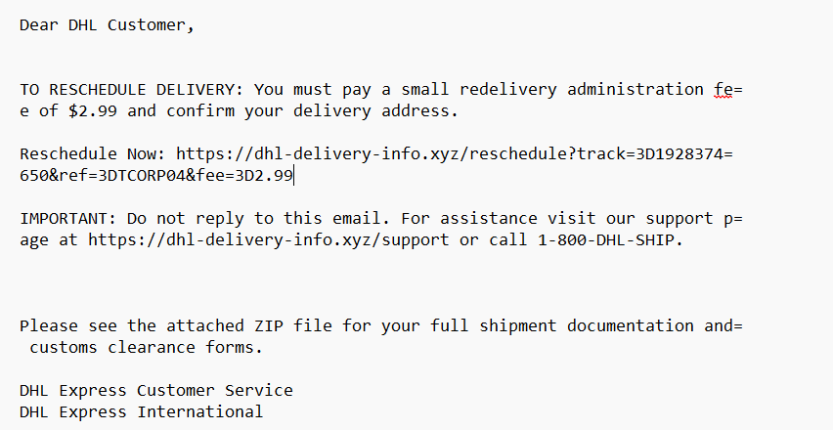
What it shows: The "TO RESCHEDULE DELIVERY" fee instruction, the reschedule URL with quoted-printable escapes (=3D) and line breaks, the support link and 1-800-DHL-SHIP, and the attached-ZIP sentence.
Figure B-11. ZIP MIME part with base64
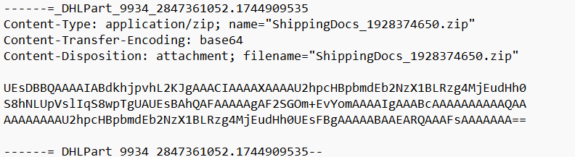
What it shows: The application/zip part ShippingDocs_1928374650.zip with a short base64 body beginning UEsDBBQAAAAIABdk…, ending in the DHLPart boundary.
Figure B-12. HxD hex view of the decoded ZIP
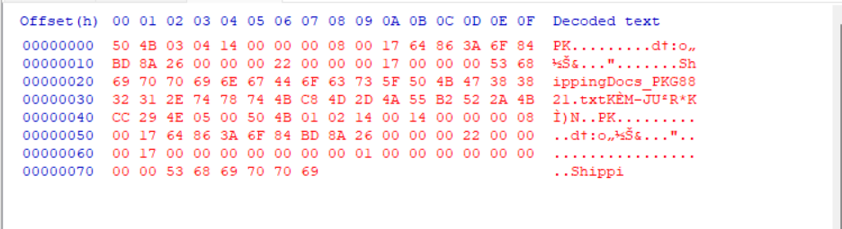
What it shows: Offsets 0x00 to 0x77: "PK" local header, method 8, the name ShippingDocs_PKG8821.txt, 15 compressed bytes and the start of the central directory (PK 01 02).
Figure B-13. Original .eml: top headers
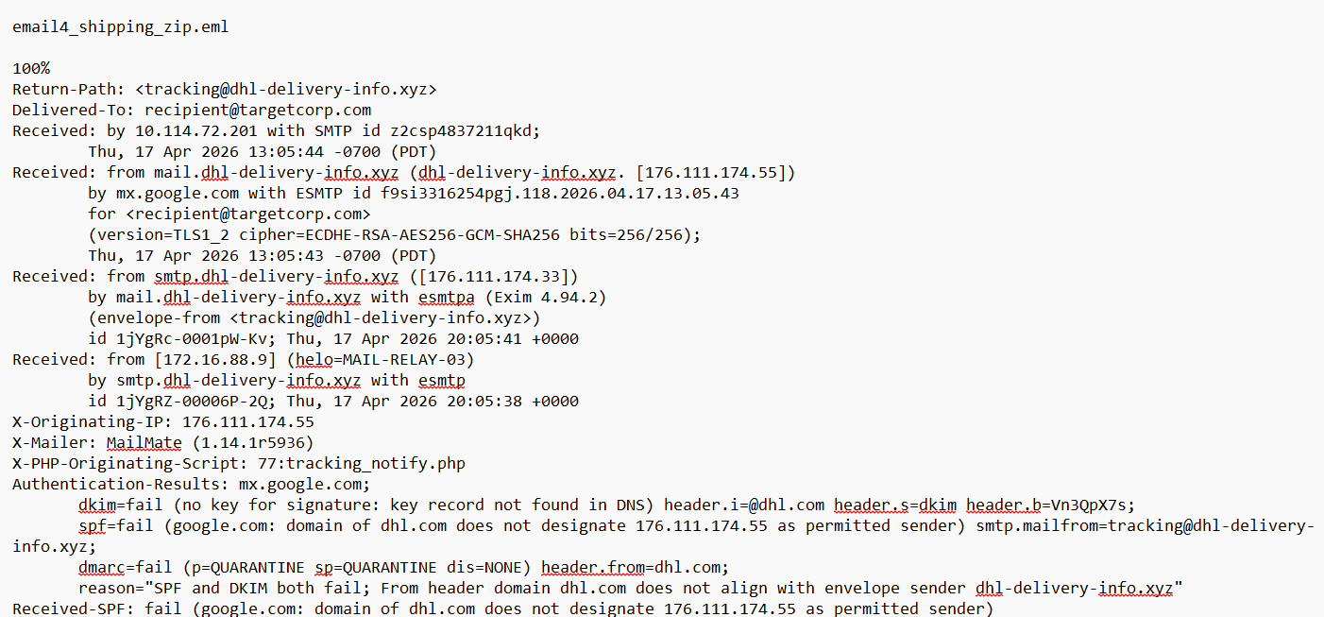
What it shows: email4_shipping_zip.eml: Return-Path, Delivered-To, four Received hops with timestamps and IDs, X-Originating-IP, X-Mailer, X-PHP-Originating-Script and Authentication-Results.
Figure B-14. Original .eml: DKIM signature and message headers
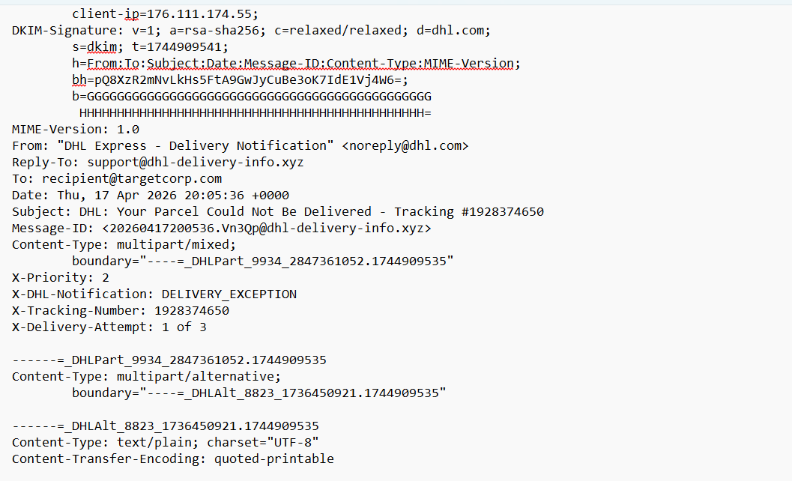
What it shows: DKIM-Signature (d=dhl.com, s=dkim, t=1744909541, placeholder b= value), From, Reply-To, To, Date, Subject, Message-ID, boundary, X-Priority and the X-DHL-Notification, X-Tracking-Number and X-Delivery-Attempt headers.
Figure B-15. Original .eml: plain-text body
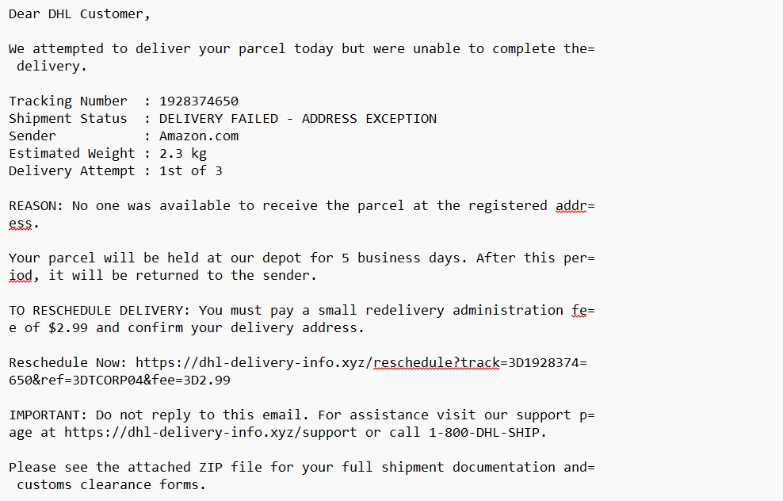
What it shows: Greeting, tracking table (sender Amazon.com, 2.3 kg, attempt 1 of 3), 5-business-day hold, the $2.99 fee instruction, the reschedule URL and the support line.
Figure B-16. Original .eml: end of plain text and start of HTML
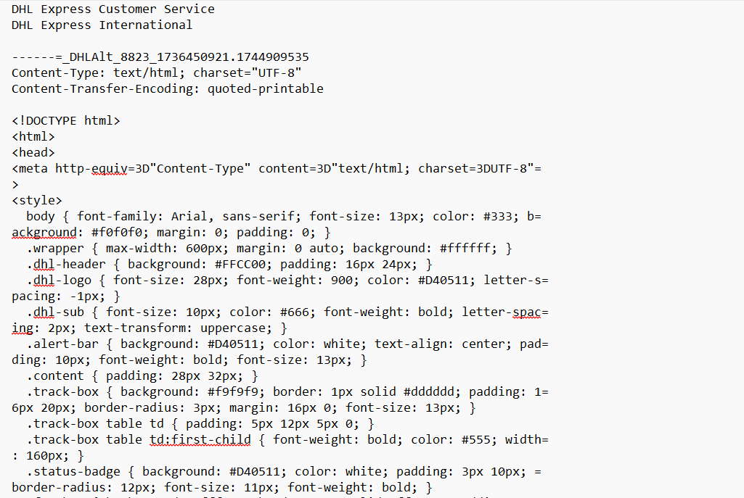
What it shows: Signature lines, then the HTML part with DHL-style CSS (yellow #FFCC00 header and red #D40511 logo).
Figure B-17. Original .eml: HTML source (styles and opening)
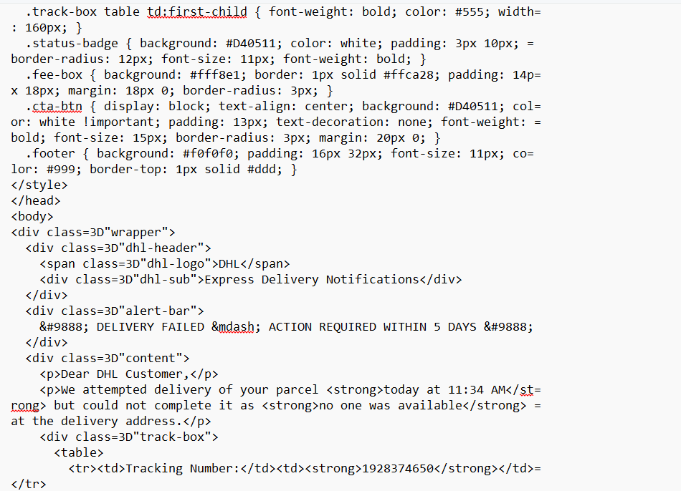
What it shows: Remaining style rules, the "Express Delivery Notifications" header, the alert bar "DELIVERY FAILED — ACTION REQUIRED WITHIN 5 DAYS" and the start of the tracking table, including "today at 11:34 AM".
Figure B-18. Original .eml: HTML body and footer
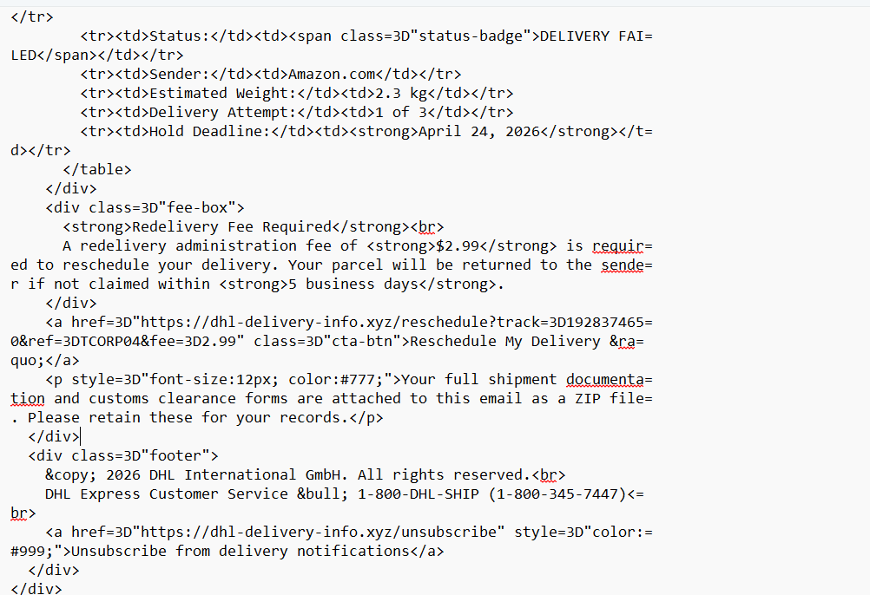
What it shows: Status, sender, weight, attempt and "Hold Deadline: April 24, 2026", the fee box, the "Reschedule My Delivery »" link, the ZIP sentence and the footer with 1-800-DHL-SHIP and an unsubscribe link on the phishing domain.
Figure B-19. Original .eml: end of HTML and ZIP part
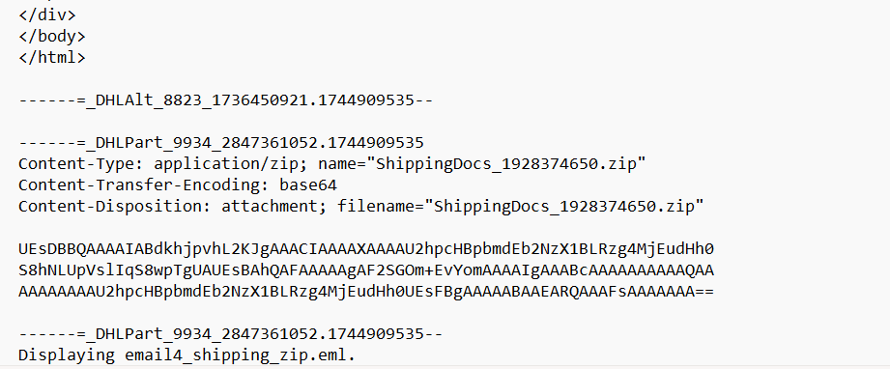
What it shows: End of the HTML, then the application/zip part with its base64 content ending in …EARQAAAFsAAAAAAA== and the closing boundary.

End of SOC Investigation Report.

