10alytics
Threat Intelligence Capstone Project
Harmony Health Threat Investigation
Prepared by
Faith Ejele
SOC Analyst
10alytics | 2026
SOC Investigation Report: Email 5, Bank of America Password Reset Phishing

Document details
Title | Threat Intelligence Capstone Project: Harmony Health Threat Investigation
Report subject | Email 5: suspected banking credential phishing impersonating the Bank of America Security Center
Prepared by | Faith Ejele, SOC Analyst
Organisation / year | 10alytics, 2026
Report date | 26 October 2026
Email received | Saturday 18 April 2026, 14:31:10–14:31:19 UTC (the header calls it Friday)
Method | Static, desk-based analysis of original .eml screenshots and lab screenshots. No live execution.
Disposition | High-priority suspected banking credential phishing. Credential theft, account compromise and malware execution are NOT confirmed.
Handling | Internal – Confidential. Contains defanged indicators.
Evidence base | Email 5 SOC report (Email5_Bank_Pwd_Analysis) with 10 original lab screenshots; Part A desk-based report

Contents
1. Executive summary
2. Scope, evidence and method
3. Header inspection
4. Received chain and timestamps
5. SPF, DKIM and DMARC
6. Message content analysis
7. Indicators and enrichment
8. Attachment analysis
9. Timeline and links to Emails 1 and 2
10. Risk assessment
11. Evidence gaps and limitations
12. Recommendations
13. Final conclusion
Appendix A: Suggested static lab commands
Appendix B: Original lab screenshots

1. Executive summary
Verdict: High-risk banking credential phishing. Credential theft and account compromise are not confirmed.
The email impersonates the "Bank of America Security Center" and tells the recipient (user@targetcorp.com) that unauthorised access to their online banking account was detected from a Tor exit node in Bucharest, Romania. It says the account is "temporarily restricted" and demands a password reset within 12 hours through a link on secure-boa-alerts[.]cc, threatening continued restriction and an automatic fraud investigation.
The pattern is a standard banking credential lure: a trusted brand, a fabricated security incident, a short deadline and a reset page on an unrelated domain. The evidence shows an attempt, not an outcome.

Key findings
- Identity mismatch. The From address is security.alert@bankofamerica.com, but the Return-Path, Reply-To, Message-ID, sending hosts and the reset link all use secure-boa-alerts[.]cc.
- Authentication failures, with a placeholder signature. The screenshots now show explicit failures at mx.google.com: SPF fail, DKIM fail ("RSA key size 512 bits is too weak") and DMARC fail (p=REJECT, "message would have been rejected"), yet the message was delivered. The DKIM signature value is a visible placeholder (a run of "I" characters followed by "J" characters). Part A listed no DMARC result for this email.
- Timestamps are consistent, but the year is off. The Date header, the four Received hops and the Message-ID stamp all agree (14:31:10 to 14:31:19 UTC, 9 seconds). This resolves the question in Part A about the 14:31 and 07:31 values: 07:31 PDT is 14:31 UTC. The only timing error is the weekday: 18 April 2026 was a Saturday, but the header says Friday. The DKIM time and MIME boundary decode to 18 April 2025, which was a Friday.
- IP role-swap with Email 1. Email 5 names 185.220.101.47 (a Tor exit) as the "attacker login" IP and sends from 91.108.56.122. Email 1 does the reverse. This should be recorded as a link between the two cases.
- Claimed locations do not match lookups. The body places the Tor IP in Bucharest, Romania, but AbuseIPDB (in the Email 1 screenshots) shows it in Berlin, Germany. The sending IP is listed by AbuseIPDB under "Telegram Messenger Network" in Singapore, while Email 1 describes the same address as a sign-in from Kyiv, Ukraine. The location claims in the lures do not match the lookups.
- Attachment looks like a placeholder. The PNG attachment decodes at the start to a 640 x 120 pixel image, and most of its base64 body is a long run of "A" characters (zero bytes). It looks like a stub, not a rendered security notice.

Overall confidence
Confidence that this is a phishing attempt: high. Confidence in the technical routing and authentication details: low to medium, because they come from screenshots of an .eml rather than a gateway record. Several features suggest a training sample: placeholder DKIM value, a short pattern string ("Lk5Rx") reused in the Message-ID and the DKIM header.b value, 2025 timestamps, the custom X-BofA headers and a file named email5_bank_password_reset.eml. It is analysed as if live, as the process requires.

2. Scope, evidence and method

2.1 Evidence reviewed
Source | Content used
Email 5 SOC report (Email5_Bank_Pwd_Analysis.docx) | Header comparison, authentication, indicator enrichment and attachment findings, plus 10 original lab screenshots.
Original .eml screenshots (email5_bank_password_reset.eml) | Full headers with four Received hops, DKIM-Signature, plain-text body and the PNG MIME part.
Reputation and analyser screenshots | AbuseIPDB pages for 91.108.56.122, 185.220.101.47 (report list), 10.114.72.205 and 10.20.30.45, and a header-analyser route view.
PART A: Desk-based Analysis | Earlier consolidated extract for the same email (selected headers only).

2.2 Method and evidence standards
- Header inspection, Received-chain timing, authentication review, content analysis, indicator enrichment and static attachment review. Nothing was executed.
- Headers can be forged, so values in an untrusted message are recorded as reported. In a genuine chain only the hops added by the receiving organisation's servers are trustworthy; lower hops are supplied by the sender.
- A DMARC policy does not show what a gateway did. An IP named in the email body is a claim by the sender, not evidence of the SMTP source. Private addresses are not external senders.
- Reputation screenshots show a past lookup, not a fresh one. A low or empty result does not prove safety.

3. Header inspection

3.1 Message metadata
Subject | SECURITY ALERT: Unusual Activity Detected - Immediate Password Reset Required
From | "Bank of America Security Center" <security.alert@bankofamerica[.]com>
Reply-To | security-noreply@secure-boa-alerts[.]cc
Return-Path / envelope | noreply@secure-boa-alerts[.]cc
To / Delivered-To | user@targetcorp.com
Date | Fri, 18 Apr 2026 14:31:10 +0000
Message-ID | <20260418143110.Lk5Rx@secure-boa-alerts[.]cc>
Priority | X-Priority: 1 (Highest); X-MSMail-Priority: High; Importance: High
Mailer signs | X-Mailer: SwiftMailer v6.3.0; X-PHP-Originating-Script: 12:send_alert.php; Exim 4.94; HELO SMTP-OUT-02.localnet
Custom headers | X-BofA-Alert-Type: SECURITY_COMPROMISE; X-BofA-Case-ID: BOA-SEC-2026-119847
X-Originating-IP | 91.108.56.122
Structure | multipart/mixed containing multipart/alternative and an image/png attachment (base64)

3.2 Identity comparison
Field | Domain / value | Assessment
From | bankofamerica[.]com | Claimed identity; does not align with the envelope sender. Do not treat the real bank domain as attacker-controlled.
Return-Path | secure-boa-alerts[.]cc | Unrelated .cc domain; also the Message-ID domain
Reply-To | security-noreply@secure-boa-alerts[.]cc | Replies would go to the attacker
Sending hosts | smtp. and mailer.secure-boa-alerts[.]cc | Same lookalike domain as the reset link
Reset link | secure-boa-alerts[.]cc/online-banking/verify | Credential page outside the bank's domain

The X-BofA-Alert-Type and X-BofA-Case-ID headers are custom, sender-supplied lines that claim a bank origin. They prove nothing: any sender can add them. The same case ID (BOA-SEC-2026-119847) is reused in the body, the reset URL and the attachment file name, which ties the lure together but does not make it genuine. The mailer signs are mixed: SwiftMailer and a PHP script (send_alert.php, user ID 12) point to a bulk-mail script, and the first-hop HELO name (SMTP-OUT-02.localnet) is a generic internal-style name. This fits scripted sending but does not prove abuse on its own.

4. Received chain and timestamps
Four hops are shown, from earliest to delivery:
Hop | From → by | Timestamp as shown | UTC | Trust
1 | from [10.20.30.45] (helo=SMTP-OUT-02.localnet) → smtp.secure-boa-alerts[.]cc, ESMTP, id 1jZhPX-00031Q-8K | Fri, 18 Apr 2026 14:31:13 +0000 | 14:31:13 | Sender-supplied; private IP, not an external sender
2 | from smtp.secure-boa-alerts[.]cc ([91.108.56.99]) → mailer.secure-boa-alerts[.]cc, ESMTPA (Exim 4.94), envelope-from noreply@secure-boa-alerts[.]cc, id 1jZhPa-0002nL-Bm | Fri, 18 Apr 2026 14:31:16 +0000 | 14:31:16 | Sender-supplied
3 | from mailer.secure-boa-alerts[.]cc (secure-boa-alerts.cc. [91.108.56.122]) → mx.google.com, ESMTP, TLS 1.2 (ECDHE-RSA-AES256-GCM-SHA384) | Fri, 18 Apr 2026 07:31:18 -0700 (PDT) | 14:31:18 | Receiving side (if genuine)
4 | → 10.114.72.205, SMTP, id m4csp5920133qle | Fri, 18 Apr 2026 07:31:19 -0700 (PDT) | 14:31:19 | Receiving side (internal private relay)

- The Date header (14:31:10 UTC), the Message-ID stamp (20260418143110) and the four Received times (14:31:13 to 14:31:19 UTC) agree. The message went from the Date header to delivery in 9 seconds. The "-0700 (PDT)" offset is correct for April. Part A noted a 7-hour difference between 14:31 and 07:31; that is simply UTC versus PDT.
- Hop 3 is the key hop. If the receiving side is genuine, 91.108.56.122 is the real SMTP peer that connected to Google; otherwise it is a claim. This must be checked against original gateway logs.
- A header-analyser view of the chain (B-08) shows the same four hops. Its blacklist check is clear for 10.20.30.45 and for 91.108.56.122, and the second hop shows no IP in that view.

Timestamp anomalies
- The header gives the date as Friday, but 18 April 2026 was a Saturday.
- The DKIM timestamp (t=1744986676) and the MIME boundary suffix (…1744986670) decode to 18 April 2025, 14:31:16 and 14:31:10 UTC. That is one year earlier, and 18 April 2025 was a Friday. This matches the weekday error and the same one-year shift seen in Emails 1 and 2. It suggests the message was built with 2025 timestamps and the year later changed, or that the generator mixes years.
- The body says unauthorised access was detected at 13:47 UTC on 18 April, about 44 minutes before the Date header. This cannot be verified.

5. SPF, DKIM and DMARC
Control | Reported result (Authentication-Results: mx.google.com) | Validation status
SPF | fail: "domain of bankofamerica.com does not designate 91.108.56.122 as permitted sender"; smtp.mailfrom=noreply@secure-boa-alerts[.]cc. Received-SPF also fail; client-ip=91.108.56.122. | Not reproduced. The wording evaluates bankofamerica.com although the envelope sender is secure-boa-alerts[.]cc, so the extract is internally loose.
DKIM | fail (signature verification failed: RSA key size 512 bits is too weak); header.i=@bankofamerica.com; header.s=s2048; header.b=Lk5RxN2p. Signature d=bankofamerica.com, s=s2048, rsa-sha256, relaxed/relaxed. | Not reproducible. The b= value is "IIII…" followed by "JJJJ…=", a placeholder. A selector named "s2048" with a "512 bits" key is inconsistent. The prefix "Lk5Rx" also appears in the Message-ID. The bh= value as shown looks shorter than the 44 characters of a base64 SHA-256 hash (low confidence; transcribed from a screenshot).
DMARC | fail (p=REJECT sp=REJECT dis=NONE); header.from=bankofamerica.com; reason: "From domain bankofamerica.com (p=REJECT) does not align with envelope sender secure-boa-alerts.cc; message would have been rejected" | Gateway action unverified. A REJECT policy with disposition NONE and a "would have been rejected" note, yet delivery, suggests an override or an edited header.

A signature claiming d=bankofamerica.com cannot be validly produced by this sender, so it is either failed or forged, and the placeholder value indicates it was never real. All of this is untrusted text. The bank's own DMARC policy being p=REJECT is a published policy statement; whether the receiving gateway rejected, quarantined or delivered this message is not established, and the Delivered-To and hop 4 lines show only that a copy reached an internal relay.

6. Message content analysis

6.1 What the email says
Item | Content
Banner and greeting | "BANK OF AMERICA - SECURITY ALERT"; "Dear Valued Customer" (generic)
Claim | "We have detected unauthorized access to your Bank of America Online Banking account from an unrecognized device."
Incident details | Case ID BOA-SEC-2026-119847; detection time April 18, 2026 at 13:47 UTC; source IP 185.220.101.47 (Tor Exit Node); location Bucharest, Romania; "2 failed login attempts; 1 successful authentication"; status ACCOUNT TEMPORARILY RESTRICTED
Call to action | "RESET YOUR PASSWORD NOW": hxxps://secure-boa-alerts[.]cc/online-banking/verify?cid=BOA-SEC-2026-119847&restore=1 (quoted-printable escapes decoded)
Pressure | Reset within 12 hours or access "will remain restricted and a fraud investigation will be opened automatically"; the 12 hours from the Date header end at 02:31 UTC on 19 April 2026
Reassurance | Fraud Prevention Hotline 1-800-432-1000 (appears to be a published Bank of America number; not verified here)

6.2 Phishing indicators
- Off-brand credential page. The reset link is on secure-boa-alerts[.]cc, not on the bank's own domain, and carries the case ID in the query string.
- Fabricated incident. A "successful authentication" from a Tor exit combined with "account temporarily restricted" is designed to frighten. No evidence supports the incident.
- Urgency. Twelve hours and a threatened "fraud investigation" push the recipient to act before checking.
- Generic greeting. "Dear Valued Customer", no name and no partial account number.
- Mixed real and fake contact details. A real bank number is given as the contact, which adds credibility, while the link and the reply address lead elsewhere.

6.3 Checking the claims against the lookups
Claim in the email | What the evidence shows | Assessment
Source IP 185.220.101.47 in Bucharest, Romania | AbuseIPDB (Email 1 screenshots, B-02 there) shows it as a Tor exit relay in Berlin, Germany, hostname tor-exit-47.for-privacy.net | Location does not match the lookup; Tor exits are shared, so no single user is identified
Detection at 13:47 UTC with a successful login | Nothing supplied (no bank log, no sign-in record) | Unsupported claim
Case BOA-SEC-2026-119847 | Reused in the URL and the attachment file name | A reused string, not a verifiable bank record
Sending IP 91.108.56.122 | AbuseIPDB lists it under Telegram Messenger Network, Singapore; Email 1 claims the same IP as a sign-in from Kyiv, Ukraine | The two cases describe the same address in different places

7. Indicators and enrichment

7.1 Indicators
Type | Indicator | Role
Domain | secure-boa-alerts[.]cc; smtp.secure-boa-alerts[.]cc; mailer.secure-boa-alerts[.]cc | Return-Path, Reply-To, Message-ID, sending hosts, reset link
Domain | bankofamerica[.]com | Claimed identity; not attacker-controlled
URL | hxxps://secure-boa-alerts[.]cc/online-banking/verify?cid=BOA-SEC-2026-119847&restore=1 | Credential-reset page
Email | noreply@secure-boa-alerts[.]cc; security-noreply@secure-boa-alerts[.]cc; security.alert@bankofamerica[.]com | Return-Path; Reply-To; From (display)
IP | 91.108.56.122 | Claimed SMTP peer and X-Originating-IP (mailer.secure-boa-alerts[.]cc)
IP | 91.108.56.99 | Earlier relay (smtp.secure-boa-alerts[.]cc), same /24
IP | 185.220.101.47 | Alleged login source in the body; Tor exit; not the sending IP in this email
Private IP | 10.20.30.45 (HELO SMTP-OUT-02.localnet); 10.114.72.205 | Sender-side relay; receiving-side relay
Identifier | BOA-SEC-2026-119847; Message-ID <20260418143110.Lk5Rx@secure-boa-alerts[.]cc> | Mail-log and proxy-log searches
Header | X-Mailer: SwiftMailer v6.3.0; X-PHP-Originating-Script: 12:send_alert.php; X-BofA-Alert-Type: SECURITY_COMPROMISE | Hunting aids
Phone | 1-800-432-1000 | Contact in body (appears to be a real bank number)
File | Security_Notice_BOA-SEC-2026-119847.png (image/png) | Attachment; SHA-256 not calculated

7.2 Reputation results shown in the screenshots
Indicator / service | Result shown
91.108.56.122 (AbuseIPDB) | 9% abuse confidence ("Caution"), "activity trending down"; 2 reports from 2 reporters, latest 2 weeks ago. ISP Telegram Messenger Network; usage Data Center/Web Hosting/Transit; ASN AS62014; domain telegram.org; Singapore. The lookup date is not shown.
185.220.101.47 (AbuseIPDB report list) | Reports dated 14–16 October 2026: web-app attacks, brute force, a VPN login attempt, a Cloudflare WAF block, an SSH honeypot and a fail2ban Tor ban. The age labels ("18 hours ago" for a 16 October 07:31 UTC report) put the lookup at about 01:30 UTC on 17 October 2026. The summary card is in the Email 1 evidence: 100%, 6,846 reports, Tor exit, Berlin, Germany.
10.114.72.205 and 10.20.30.45 (AbuseIPDB) | Shown as private, non-public, reserved addresses with a note that any reports on such pages are for testing only. Not meaningful evidence about this email.
Header analyser | No blacklist hit for 10.20.30.45 or 91.108.56.122 (green ticks, B-08).

Reading these results with care:
- The 9% score for 91.108.56.122 is low, but the address belongs to a messaging network's hosting range, which is an unusual place for a bank's mail relay. That is a reason to look further, not a finding in itself, and a low score does not clear it. Part A did not have this ISP detail.
- The 185.220.101.47 reports concern web attacks and scanning on a shared Tor exit and do not relate to email or banking. The report list was captured about 182 days after the email.
- No reputation result was supplied for secure-boa-alerts[.]cc. The domain assessment is static, based on the name, the .cc top-level domain and the off-brand reset path.

8. Attachment analysis: Security_Notice_BOA-SEC-2026-119847.png
Property | Finding
Declared | Content-Type image/png; name="Security_Notice_BOA-SEC-2026-119847.png"; Content-Disposition attachment; base64
Signature | The base64 begins iVBORw0KGgo, which decodes to the PNG signature (89 50 4E 47 0D 0A 1A 0A). It is a PNG by signature.
Header fields (my decode of the visible start) | IHDR 640 x 120 pixels, 8-bit RGBA; an sBIT chunk; and a tEXt chunk "Software: gnome-screenshot".
Body | About nine lines of the base64 are a long run of "A" characters (zero bytes), ending in "…ErkJggg==", the end of a PNG IEND chunk. A genuine rendered notice would not compress to mostly zero bytes, so the image looks like a placeholder.
Visible content, QR code, beacon | Not established. Nothing in the screenshots shows the image content, and there is no basis to say it holds a QR code or a tracking beacon.
Source report note | The source text mentions a "Bank.pdf viewer error", but no such screenshot is among the 10 images supplied, so it could not be reviewed. In any case a PNG that will not open as a PDF would not show that the file is malicious.
Hash | SHA-256 not calculated: the original attachment bytes were not supplied

Conclusion: the attachment is a small PNG that looks like a stub rather than a real security notice. The visible bytes show no sign of an exploit, but the original .eml is needed for a reliable decode, hash, metadata check and QR check. The credential lure is in the email body and link, so the attachment adds credibility rather than the main risk. Open it only on an isolated analysis machine.

9. Timeline and links to Emails 1 and 2
Date / time | Event
18 April 2026, 13:47 UTC | Time the body gives for the alleged unauthorised access (unverified).
18 April, 14:31:10–14:31:19 UTC | Email 5 created, relayed and delivered to user@targetcorp.com (9 seconds).
19 April, 02:31 UTC | End of the 12-hour deadline measured from the Date header.
About 17 October, 01:30 UTC | AbuseIPDB report list for 185.220.101.47 captured (inferred from the age labels; 182 days after the email).
26 October | This report (191 days after the email).

9.1 IP role-swap with Email 1
IP address | Role in Email 1 | Role in Email 5
185.220.101.47 | Claimed SMTP sending IP and X-Originating-IP | Alleged "unauthorised access" source (Tor exit, Bucharest claimed)
91.108.56.122 | Alleged sign-in IP in the body (Kyiv, Ukraine claimed) | Claimed SMTP sending IP and X-Originating-IP

Unrelated campaigns rarely share two addresses in mirrored roles. The likely explanations are one operator or phishing kit reusing an address pool for the "sender" and "attacker login" stories; a training data set where addresses were reused when the cases were written; or forged headers built from a list. The overlap should be recorded as a link whichever applies.

9.2 Other shared features
- All three cases (Emails 1, 2 and 5) were delivered to targetcorp.com through private receiving relays in 10.114.72.0/24 (.133 for Emails 1 and 2, .205 for Email 5).
- Each carries a placeholder DKIM value (A/B in Email 1, C/D in Email 2, I/J in Email 5) and a DKIM timestamp and MIME boundary that decode to the same date one year earlier.
- Each uses a short pattern string in the Message-ID that is reused in the DKIM header.b value (Email 5: "Lk5Rx").
- The PNG attachments in Emails 2 and 5 both start with a PNG header and a "gnome-screenshot" text chunk (300 x 300 and 640 x 120 pixels) and are followed by a long run of "A" characters. This points to a common generator.
- The sending infrastructure differs: Email 5 uses secure-boa-alerts[.]cc with relays in 91.108.56.0/24.

10. Risk assessment
Factor | Rating | Reasoning
Likelihood of phishing | High | Domain mismatch, off-brand reset link, urgency, generic greeting, failed authentication and a placeholder signature.
Potential impact | High | Banking credentials give access to funds and personal data, if the recipient holds an account at the bank.
Evidence of exposure | None seen | No click, credential submission or attachment-open record is in the evidence.
Evidence quality | Medium | Complete .eml text is visible in screenshots, but the original file, gateway logs and attachment bytes are missing.
Overall priority | High | Treat as urgent until the recipient's interaction is established.

MITRE ATT&CK mapping
Technique | ID | Relevance
Phishing: spearphishing link | T1566.002 | Password-reset link on secure-boa-alerts[.]cc
Phishing: spearphishing attachment | T1566.001 | PNG attachment (content unconfirmed)
Phishing for information | T1598 | Banking credentials requested
Impersonation | T1656 | Bank of America Security Center
Acquire infrastructure: domains | T1583.001 | secure-boa-alerts[.]cc
User execution: malicious link | T1204.001 | If the link was clicked

11. Evidence gaps and limitations
Check | Status | Note
Original .eml | Screenshots only | Headers readable; not independently authenticated
SPF / DKIM / DMARC reproduction | Not done | Reported values only; DKIM value is a placeholder
Gateway disposition and mailbox location | Not verified | DMARC disposition NONE conflicts with the policy and the note
Live reputation for secure-boa-alerts[.]cc and 91.108.56.99 | Not done | No result supplied
Lookup dates | Partly inferred | 185.220.101.47 list about 17 October 2026 (from age labels); 91.108.56.122 date not shown
Attachment hash, metadata, content and QR check | Not done | Original bytes unavailable; the "Bank.pdf" screenshot cited in the source was not supplied
Recipient interaction (click, credentials) | No evidence | Needs proxy, DNS, endpoint and bank-side records
Whether the recipient has a Bank of America account | Unknown | Determines the real exposure
Authenticity of the sample | Uncertain | Placeholder DKIM, reused pattern strings, 2025 timestamps and lab-style file name suggest a training sample

12. Recommendations

12.1 Immediate (first working day)
- Establish exposure. Ask the recipient (user@targetcorp.com) whether they opened the email or attachment, clicked the link or entered any details. Search proxy and DNS logs for secure-boa-alerts[.]cc and for the case ID BOA-SEC-2026-119847.
- Protect the account. If the recipient holds a Bank of America account and clicked or entered credentials, advise them to contact the bank using the number on their card or the official app, and to change the password from a clean device. Do not use anything in the email.
- Contain. Block secure-boa-alerts[.]cc, its sub-domains and the reset URL at the mail and web gateways, and search for other messages with the same script header or Message-ID pattern. Do not block bankofamerica[.]com.
- Find other recipients. Search mail logs for other recipients of messages from 91.108.56.99 and 91.108.56.122, and for the same Return-Path.

12.2 Short term (this week)
- Get the originals. Retrieve the original .eml and attachment from the mail system with a record of who collected them, then repeat the SPF, DKIM and DMARC checks.
- Static attachment analysis. Decode the PNG with a command-line tool, hash it, check its metadata and look for a QR code on an isolated machine (see Appendix A).
- Enrich indicators. Run dated lookups for secure-boa-alerts[.]cc and both /24 ranges, including registration data and passive DNS, and record tool, date and result. Examine the shared IPs with Email 1.
- Report abuse. Report the lookalike domain to its registrar and host, and the lure to the bank through its published phishing-report channel.

12.3 Longer term
- Add gateway rules for external mail that names a bank or other well-known brand while the Return-Path and Reply-To domains differ.
- Alert on newly registered lookalike domains for brands your users rely on.
- Remind staff that banks do not ask for passwords through email links, and that urgent security alerts should be checked through the official app or website.

13. Final conclusion
The evidence shows a deliberate banking credential lure. The sender impersonates the Bank of America Security Center from unrelated infrastructure, the authentication failed, the reset link is off-brand, and the location and incident claims do not match the lookups. The evidence does not show that the recipient clicked, entered credentials or was compromised, or that the attachment is harmful.
Final disposition: High-priority suspected banking credential phishing; no confirmed compromise. Establish the recipient's interaction and block the domain first.

Appendix A: Suggested static lab commands
For use on the original attachment extracted from the .eml, in an isolated environment. Nothing is executed.
base64 -d notice_png.b64 > Security_Notice_BOA-SEC-2026-119847.png
file Security_Notice_BOA-SEC-2026-119847.png
sha256sum Security_Notice_BOA-SEC-2026-119847.png
xxd -l 64 Security_Notice_BOA-SEC-2026-119847.png
exiftool Security_Notice_BOA-SEC-2026-119847.png
pngcheck -v Security_Notice_BOA-SEC-2026-119847.png
zbarimg Security_Notice_BOA-SEC-2026-119847.png (checks for a QR code)
strings -a Security_Notice_BOA-SEC-2026-119847.png | grep -Ei "https?://"

Use a command-line decode of the original MIME part, not a web decoder, and do not save the decoded file under a different extension or open it in a document viewer on a production machine.

Appendix B: Original lab screenshots
The 10 images below are reproduced from the Email 5 lab analysis in their original order. They are documentary screenshots, not independently validated mail or threat-intelligence records. The "What it shows" line is the analyst reading of each image for this report.
Figure B-01. AbuseIPDB: 10.114.72.205
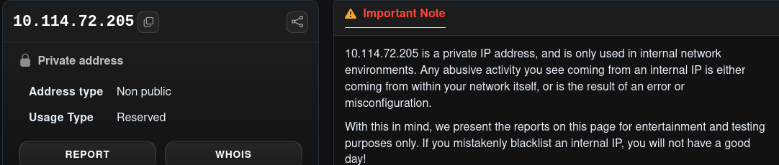
What it shows: Private, non-public, reserved address with the note that reports on such addresses are for testing only. This is the receiving-side relay in hop 4.
Figure B-02. AbuseIPDB: 91.108.56.122
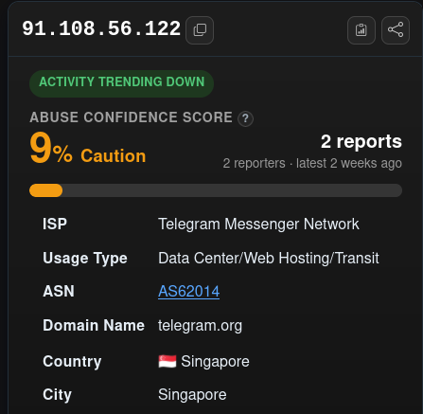
What it shows: 9% abuse confidence ("Caution"), activity trending down, 2 reports from 2 reporters, latest 2 weeks ago; Telegram Messenger Network, Data Center/Web Hosting/Transit, AS62014, telegram.org, Singapore.
Figure B-03. AbuseIPDB: 10.20.30.45
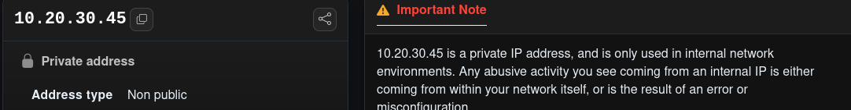
What it shows: Private, non-public address with the same testing note. This is the sender-side first-hop address.
Figure B-04. Original .eml: top headers
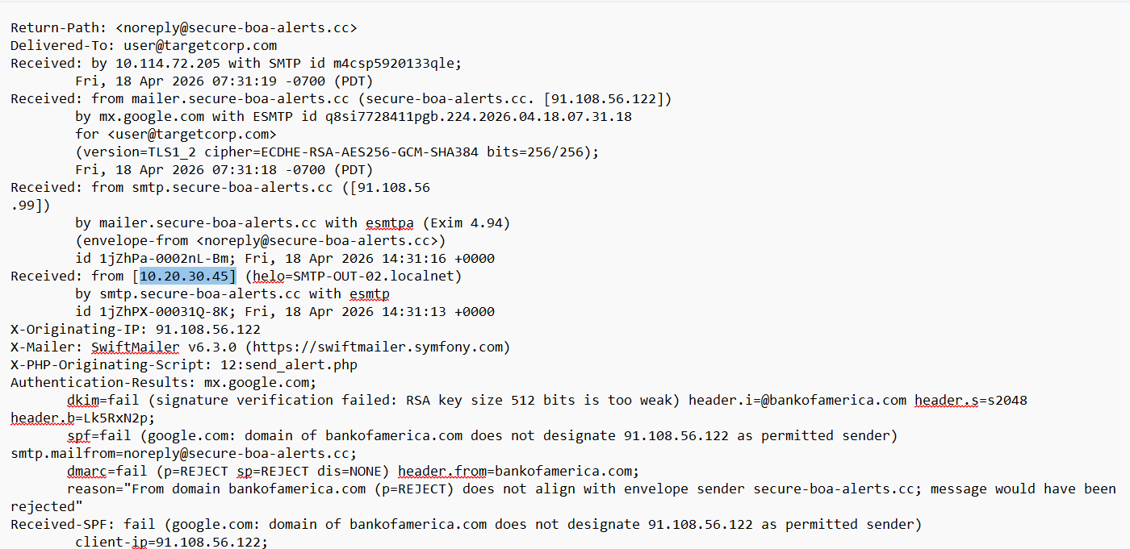
What it shows: email5 headers: Return-Path, Delivered-To user@targetcorp.com, four Received hops (14:31:13 to 14:31:19 UTC), X-Originating-IP, SwiftMailer, X-PHP-Originating-Script send_alert.php, and Authentication-Results with DKIM (512-bit key too weak), SPF and DMARC failures.
Figure B-05. Original .eml: message headers
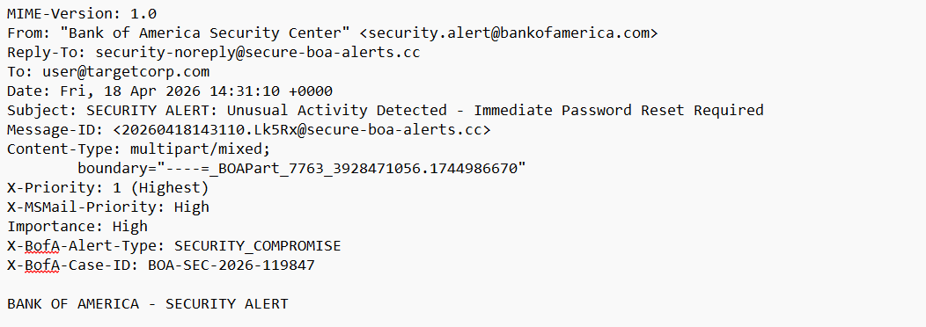
What it shows: From security.alert@bankofamerica.com, Reply-To security-noreply@secure-boa-alerts.cc, Date Fri 18 Apr 2026 14:31:10 +0000, Subject, Message-ID, boundary, priority headers and the X-BofA custom headers.
Figure B-06. AbuseIPDB: report list for 185.220.101.47
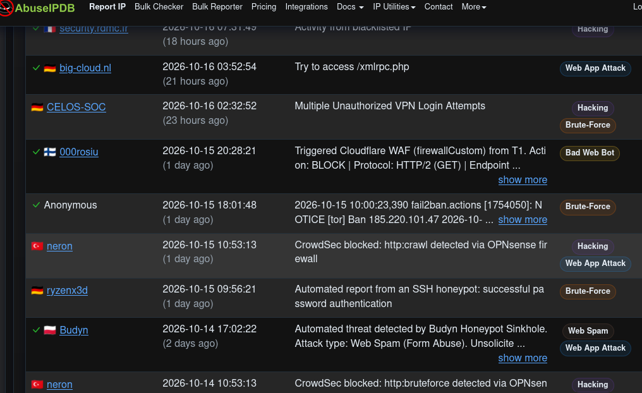
What it shows: Reports dated 14–16 October 2026 with age labels such as "18 hours ago": a blacklisted-IP note, an /xmlrpc.php probe, unauthorised VPN logins, a Cloudflare WAF block, a fail2ban Tor ban naming 185.220.101.47, and a honeypot report.
Figure B-07. Original .eml: plain-text body
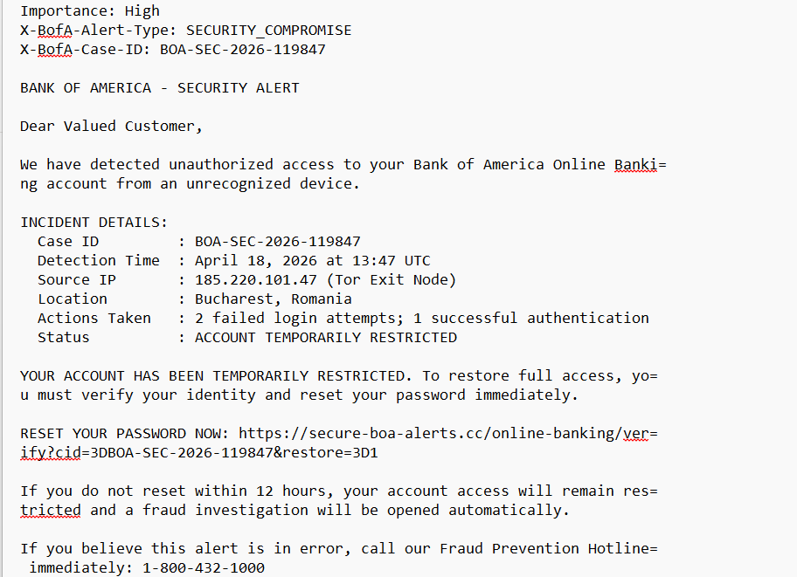
What it shows: "Dear Valued Customer", the unauthorised-access claim, incident details (case ID, 13:47 UTC, Tor exit source IP, Bucharest, 2 failed and 1 successful login), the restricted status, the reset link, the 12-hour deadline and the hotline number.
Figure B-08. Header analyser: route view
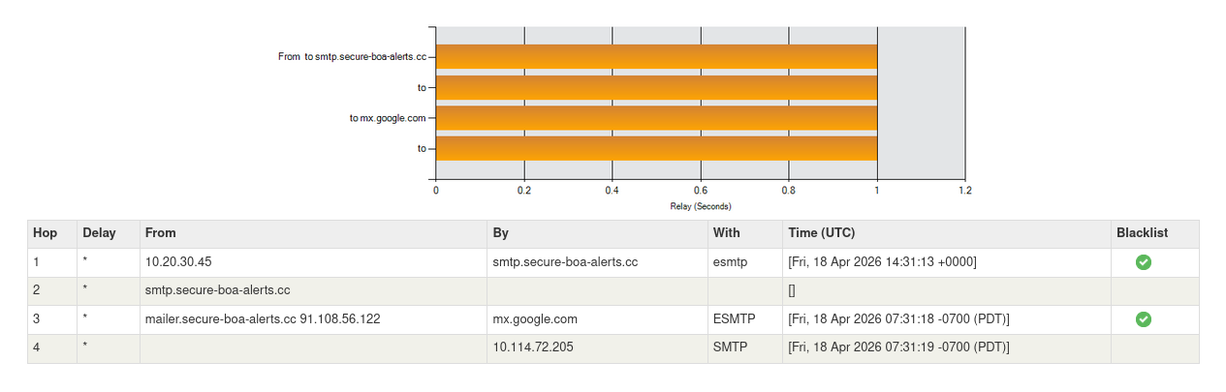
What it shows: Four hops with timestamps (14:31:13 +0000, then 07:31:18 and 07:31:19 -0700) and green blacklist ticks for 10.20.30.45 and 91.108.56.122; hop 2 shows no IP.
Figure B-09. Original .eml: authentication and DKIM signature
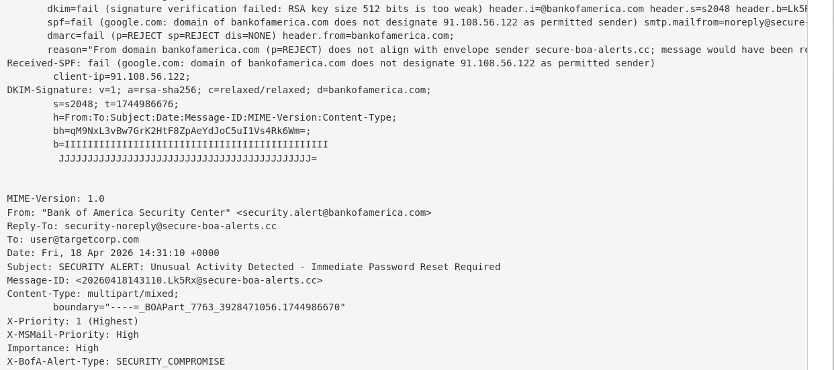
What it shows: DKIM, SPF and DMARC results ("message would have been rejected"), Received-SPF, the DKIM-Signature (d=bankofamerica.com, s=s2048, t=1744986676, placeholder b= value of I and J characters) and the start of the message headers.
Figure B-10. Original .eml: PNG MIME part
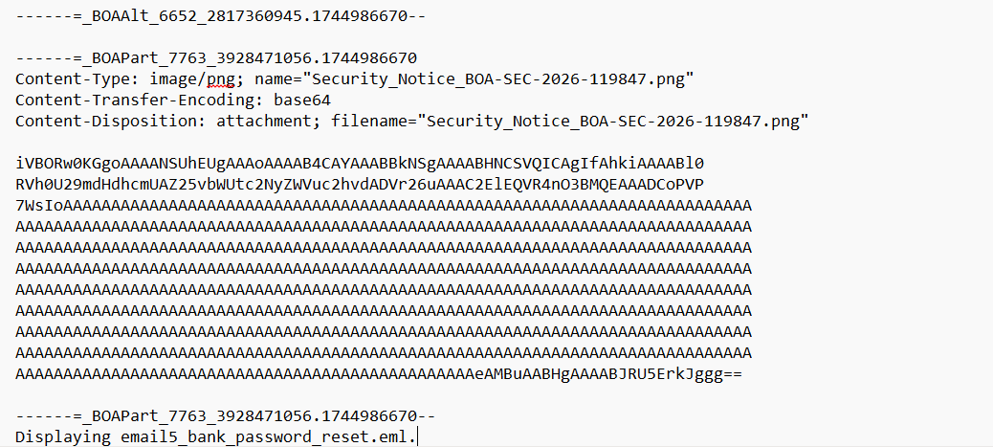
What it shows: The image/png part Security_Notice_BOA-SEC-2026-119847.png with base64 content (PNG header, about nine lines of "A" characters and an IEND ending) and the closing boundaries; the viewer title reads email5_bank_password_reset.eml.

End of SOC Investigation Report.

