10alytics
Threat Intelligence Capstone Project
Harmony Health Threat Investigation
PART B
Threat Detection and Monitoring Lab
YARA Malware Detection | Suspicious Binaries | Shellshock Attack Pattern
Prepared by
Faith Ejele
SOC Analyst
10alytics | 2026
Wazuh monitoring preparation and verification report

Document details
Title | Threat Intelligence Capstone Project: Harmony Health Threat Investigation, Part B
Report subject | Monitoring set-up and verification for YARA malware detection, suspicious (trojaned) binary detection and Shellshock attack-pattern detection
Prepared by | Faith Ejele, SOC Analyst
Organisation / year | 10alytics, 2026
Report date | 27 October 2026
Lab date | Saturday 24 October 2026 (dashboard times are WAT, UTC+1)
Platform | Wazuh server 192.168.1.100; agent 001 "dev-ubuntu" 192.168.1.105 (Ubuntu 24.04.3 LTS, Wazuh v4.14.x); attacker VM (Kali) 192.168.1.103
Method | Review of 86 lab screenshots (PART B document). Text was read from the images and the key alert screens were checked by eye. Nothing was re-run.
Handling | Internal – Confidential. Lab environment; malware samples were deliberately downloaded for testing.

Contents
1. Executive summary
2. Scope, evidence and method
3. Lab environment
4. Monitoring preparation
5. Monitoring verification matrix
6. Investigation 1: malware and YARA integration
7. Investigation 2: suspicious binaries
8. Investigation 3: Shellshock attack pattern
9. Consolidated timeline
10. MITRE ATT&CK mapping
11. Gaps and limitations
12. Recommendations
13. Conclusion
Appendix A: Commands and configuration reference
Appendix B: Lab screenshots (Figures 1–86)

1. Executive summary
Verdict: Two of the three detections are proven end to end in the screenshots. The third, YARA scanning, is fully configured but its scan result is not shown.
The lab prepared Wazuh to watch for three kinds of threat on one Ubuntu endpoint, then simulated each one. Monitoring was set up before each simulation, and the resulting alerts were checked in the Wazuh dashboard.
Detection goal | Status | What the evidence shows
Malware via YARA integration | Partly verified | YARA 4.5.5 built and passed 16/16 tests; active response, decoder and rules configured; sample files dropped into the monitored folder triggered rules 100300 and 100301 (Figures 31–40, 51–56). No "wazuh-yara" scan-result alert appears.
Suspicious binaries | Verified | /usr/bin/w was replaced with a script; rootcheck rule 510 reported "Trojaned version of file '/bin/w' detected" repeatedly from 03:20:34 WAT (Figures 59, 62, 64, 82).
Shellshock attack pattern | Verified (attempt) | The Kali request with a "() { :; };" User-Agent produced rule 31168 "Shellshock attack detected", level 15, at 04:03:38 WAT (Figures 76, 78, 80, 84). The server answered HTTP 200 with the default page, so exploitation is not shown.

Key findings
- FIM trigger works. Real-time file integrity monitoring on /tmp/yara/malware worked. The xbash sample changed size three times (7,737,344 → 7,868,416 → 7,983,104 → 9,568,976 bytes) and each change raised rule 100300 with before/after hashes.
- YARA result missing. The chain from file event to YARA scan is configured (active response on rules 100300 and 100301 calling yara.sh), but no screenshot shows the scan output, the yara_decoder match or a rule-108000 alert. YARA detection should not be called proven until that alert is shown.
- Trojan detection is signature-based. The rootcheck signature is generic ("uname -a|proc\.h|bash"). It matched because the replacement script contains "bash", so the detection is real but heuristic.
- Shellshock was an attempt. The Shellshock string was caught from the Apache access log. The response was the stock Apache page (10,926 bytes) and the request targeted "/", not a CGI script, so this was a detected attempt, not a successful exploit.

Overall confidence
High that the FIM, rootcheck and Shellshock rules fired as shown, because the alert documents are on screen. Medium on exact timings and some digits, which were read from screenshots. The lab is a controlled simulation using public sample files, so none of this represents a real intrusion.

2. Scope, evidence and method

2.1 Evidence reviewed
Source | Content used
PARTB_Threat_Intelligence_Yara_Shellock_SuspiciousBinaries.docx | 86 screenshots with a few text headings: "Enable SSHD from Wazuh…", "ATTACK SIMULATIONS", "Suspicious Binaries" and "Shellshock".

2.2 Method
- Every screenshot was extracted and read, and the alert detail screens (rule configuration, FIM alerts, rootcheck alerts and the Shellshock alert) were inspected directly.
- FIM hash fields were compared across events: each "before" hash equals the previous event's "after" hash, so the three xbash changes form a consistent chain.
- Dashboard times are WAT (UTC+1). Epoch values in alert IDs were converted and compared with the displayed timestamps.
- Where the screenshots do not show something, the report says so instead of assuming it.

2.3 Confidence terms
"Verified" means the alert or output is visible in a screenshot. "Configured" means the settings are visible but no result is. "Not shown" means no screenshot covers it.

3. Lab environment
Component | Detail | Role
Wazuh server | 192.168.1.100 (wazuh-server) | Manager, indexer and dashboard; holds custom rules, decoders and the active-response definition.
Monitored endpoint | agent 001 dev-ubuntu, 192.168.1.105, Ubuntu 24.04.3 LTS | Runs YARA, syscheck, rootcheck, Apache2 and the Wazuh agent.
Attacker VM | Kali Linux, 192.168.1.103 | Sends the Shellshock request.
YARA | v4.5.5 built from source | Scanner invoked by active response.
YARA rules | Valhalla demo rule set | Rule file for scanning (download shown; folder name see section 11).
Time zone | WAT (UTC+1) | All dashboard times.

4. Monitoring preparation

4.1 YARA installation (agent)
YARA 4.5.5 was built from the VirusTotal source tarball after installing make, gcc, autoconf, libtool, libssl-dev, pkg-config and jq (Figures 1–2). The test suite reported TOTAL 16, PASS 16, FAIL 0 (Figure 3). A rules directory was created and the Valhalla demo rules were requested with curl (Figures 4, 9). A bare "yara" call printed its usage text (Figure 6).

4.2 Active-response script (agent)
/var/ossec/active-response/bin/yara.sh reads the JSON passed by Wazuh, takes the YARA path and rule file from the command's extra_args, and takes the file to scan from alert.syscheck.path (Figure 5). Its output goes to the active-responses log.

4.3 File integrity monitoring (agent)
In the agent's ossec.conf, syscheck runs every 60 seconds with scan_on_start. /etc, /usr/bin, /usr/sbin, /bin, /sbin and /boot are checked on schedule, and /tmp/yara/malware is checked in real time (realtime="yes") (Figure 7). The agent was restarted to apply this (Figure 8). The first attempt to create the folder failed because /tmp/yara did not yet exist (Figures 17–18).

4.4 Custom rules, decoder and active response (manager)
Item | Configuration seen
Rule 100300 | Child of 550 (integrity checksum changed), matches file path /tmp/yara/malware/, level 7: "File modified in /tmp/yara/malware/ directory."
Rule 100301 | Child of 554 (file added), same path, level 7: "File added to /tmp/yara/malware/ directory."
Rule 108000 | Group "yara", level 0, decoded_as yara_decoder: "Yara grouping rule". The remaining child rules are not visible in the capture.
Decoders | yara_decoder (prematch "wazuh-yara:") and a child that extracts log type, yara_rule and yara_scanned_file from "wazuh-yara: … - Scan result: <rule> <file>".
Command | yara_Linux runs yara.sh with -yara_path /usr/local/bin and -yara_rules (path partly cut off), timeout_allowed no.
Active response | Command yara_Linux, location local, triggered by rule IDs 100300,100301.
Log collection | localfile reading /var/ossec/logs/active-responses.log so YARA output reaches the manager.
The manager was restarted after editing local_rules.xml, local_decoder.xml and ossec.conf (Figures 10–13).

4.5 Sample drop for the YARA test
malware_downloader.sh was placed in /tmp/yara/malware and run after a caution prompt (Figures 19–22). It reported "Error while downloading" for Mirai and "Done!" for Xbash, VPNFilter and a PHP web shell. These are public sample files used deliberately in an isolated lab. They should not be opened outside a lab.

4.6 Rootcheck (agent)
Rootcheck was enabled with check_files, check_trojans, check_dev, check_sys, check_pids, check_ports and check_if all set to yes, frequency 60, using etc/shared/rootkit_trojans.txt (Figure 57).

4.7 Web server for the Shellshock test
Apache2 was installed on the agent (Figures 67–68). ufw was told to allow Apache although its status was inactive (Figure 69), and the default page loaded locally (Figure 70). Wazuh decodes Apache access-log lines with its web-accesslog decoder; the alert location /var/log/apache2/access.log (Figure 78) confirms the log was being read.

4.8 Dashboard readiness
The Wazuh dashboard showed one active agent (dev-ubuntu, 001) and no disconnected, pending or never-connected agents (Figures 23–24). The Threat Hunting and Events views were then used for all searches (Figures 27–29).

5. Monitoring verification matrix
Control | Result | Evidence
Agent connected and reporting | Verified | Agent 001 active; events arriving (Figures 23–24, 27–29).
YARA installed | Verified | 16/16 tests passed (Figure 3).
YARA rules downloaded | Configured | Download command shown (Figures 4, 9); the downloaded rule file is not listed.
Real-time FIM on /tmp/yara/malware | Verified | Rules 100300 and 100301 fired (Figures 31–40, 51–56).
Active response on 100300/100301 | Configured | Block in ossec.conf (Figure 12); execution not shown.
YARA decoder and rule 108000 | Configured | Figures 10–11; no matching alert shown.
YARA scan result in Wazuh | Not shown | No "wazuh-yara: … Scan result" event in any screenshot.
Rootcheck trojan detection | Verified | Rule 510 alerts for /bin/w (Figures 62, 64, 82).
Apache access-log monitoring | Verified | Alert location /var/log/apache2/access.log (Figure 78).
Shellshock rule 31168 | Verified | Level 15 alert (Figures 76–80, 84–86).

6. Investigation 1: malware and YARA integration

6.1 What was done
With real-time monitoring on, the downloader script placed or updated xbash, webshell and other sample files in /tmp/yara/malware. Wazuh syscheck saw these changes immediately.

6.2 What Wazuh detected
Alert | Detail
File added | Rule 100301, level 7: "File '/tmp/yara/malware/webshell' added", mode realtime (Figure 31).
xbash change 1 | Rule 100300. Size 7,737,344 → 7,868,416. Old MD5 d2e16464…fa61; new MD5 5bb6e4ae…5175. Old SHA-1 ab63853f…; new SHA-1 e144bf59…. Time 24 Oct 02:04:49 WAT (Figures 51–56).
xbash change 2 | Size 7,868,416 → 7,983,104; rule fired 66 times (Figure 32).
xbash change 3 | Size 7,983,104 → 9,568,976; rule fired 67 times (Figure 38).
The file was owned by root, permissions rw-r--r--, and kept the same inode (393785), so it was growing in place while the download wrote to it. A steadily growing file is what a download in progress looks like, so the three alerts reflect one transfer, not three separate modifications by an attacker.

6.3 Integrity of the evidence chain
The "before" hash of each event equals the "after" hash of the one before it (for example SHA-1 e144bf59… is the "after" value in change 1 and the "before" value in change 2). This supports that the alerts are consecutive and unedited.

6.4 YARA scanning
Rules 100300 and 100301 are listed as the triggers for the yara_Linux active response. If it ran, yara.sh would scan the file named in alert.syscheck.path with the Valhalla rules and write a "wazuh-yara:" line that the custom decoder parses. None of that output is visible in the screenshots. The exercise therefore proves the trigger side of the pipeline, and the YARA side is configured but unconfirmed.
Assessment: malware-file activity in the monitored folder was detected by Wazuh. Detection of the files as malware by YARA was not demonstrated.

6.5 Related background alerts
Other alerts in the same window were routine system activity: netstat listening-ports changes (rule 533, Figures 44–48), a scheduled integrity change on /etc/ld.so.cache (Figure 83) and /etc/cups/subscriptions.conf (Figures 49, 74). They are not linked to the malware samples.

7. Investigation 2: suspicious binaries

7.1 Simulation
The analyst backed up the original with "sudo cp -p /usr/bin/w /usr/bin/w.copy", then used "sudo tee /usr/bin/w" to overwrite the binary with a bash script. The script writes the date and the words "this is evil" to /tmp/trojan_created_file, appends "test for /usr/bin/w trojaned file", and then runs the saved original so that "w" still appears to work (Figures 58–59). The shell output carries the time Sat Oct 24 03:19:06 AM WAT 2026.

7.2 Detection
Field | Value
Decoder / location | rootcheck
Message | Trojaned version of file '/bin/w' detected. Signature used: 'uname -a|proc\.h|bash' (Generic).
Rule | 510, level 7, "Host-based anomaly detection event (rootcheck)", groups ossec, rootcheck
First seen in the screenshot list | 24 Oct 03:20:34 WAT; pairs of alerts at 03:22:52, 03:25:07, 03:27:18, 03:29:23, 03:31:38
Later alert | 04:05:04 WAT (Figure 76), still firing about 45 minutes after the change
The alert names /bin/w while the file edited was /usr/bin/w. On Ubuntu 24.04 /bin is normally a link to /usr/bin, which would explain it, but the screenshots do not prove the link. The alerts arrived roughly every two minutes, matching the 60-second rootcheck interval plus scan time (Figure 57).

7.3 Assessment
- Detection worked: a replaced system binary was flagged by rootcheck within about 90 seconds of being changed.
- The signature matched the string "bash" inside the replacement script. Real trojaned binaries are often compiled and may not contain this string, so rootcheck alone would miss them. Syscheck hashing of /usr/bin is the stronger control, but no FIM alert for /usr/bin/w appears in the screenshots.
- The trojaned file was still present when the later alerts fired, so the alert repeats until the file is restored. The restore step is not shown.

8. Investigation 3: Shellshock attack pattern

8.1 Simulation
From Kali (192.168.1.103) the analyst ran: curl -H "User-Agent: () { :; }; /bin/cat /etc/passwd" 192.168.1.105. The reply was the Apache2 Ubuntu default page (Figure 73). The header value is the classic Shellshock (CVE-2014-6271) test string: a bash function definition followed by an injected command.

8.2 Detection
Field | Value
Rule | 31168 "Shellshock attack detected", level 15, mail true
Groups | web, accesslog, attack
Reference | CVE-2014-6271
MITRE | T1068 Exploitation for Privilege Escalation; T1190 Exploit Public-Facing Application (tactics: Privilege Escalation, Initial Access)
Source | data.srcip 192.168.1.103; GET /; decoder web-accesslog; log /var/log/apache2/access.log
Log line | 192.168.1.103 - - [24/Oct/2026:04:03:38 +0100] "GET / HTTP/1.1" 200 10926 "-" "() { :; }; /bin/cat /etc/passwd"
Alert time | 24 Oct 2026 04:03:38.103 WAT (Figure 76)
Compliance tags | SI.4 (NIST), 11.4 (PCI DSS), CC6.1, CC6.8, CC7.2, CC7.3 (TSC)

8.3 Assessment
Wazuh matched the attack pattern in the User-Agent field and raised its highest-severity alert. The HTTP status was 200 and the size 10,926 bytes, the size of the stock Apache page, and the target was "/" rather than a CGI script. Shellshock only works against a CGI or similar handler that passes headers to bash, so there is no sign that /etc/passwd was read. Verdict: attack pattern detected, exploitation not indicated.
In the screenshots the epoch-style prefix of the alert ID (1792811818) converts to about 03:16:58 UTC, which does not match the 04:03:38 +0100 (03:03:38 UTC) log time. This may be an OCR digit error in the ID, so it is noted but not relied on; the dashboard timestamp and the log line agree with each other.

9. Consolidated timeline
All times are 24 October 2026, WAT, from dashboard timestamps unless stated.
Time (WAT) | Event
01:45:44 | Rule 533 netstat listening-ports change (background; Figure 48).
02:04:49 | First xbash FIM alert, rule 100300, size 7,737,344 → 7,868,416 (Figures 29, 56).
After 02:04 | Further xbash size changes to 7,983,104 and 9,568,976 bytes; webshell added (rule 100301). Exact times are not legible.
03:19:06 | /usr/bin/w replaced with a script (shell output, Figure 59).
03:20:34 | First rootcheck rule 510 alert for /bin/w in the screenshot list (Figure 82).
03:22:52 – 03:31:38 | Rule 510 repeats about every two minutes.
04:03:38 | Shellshock request logged by Apache; rule 31168, level 15 (Figures 76, 84).
04:05:04 | Rule 510 alert for /bin/w still firing (Figure 76).

10. MITRE ATT&CK mapping
ID | Technique | Basis
T1105 | Ingress Tool Transfer | Malware samples downloaded by the script (inferred from the lab steps, not from an alert tag).
T1554 | Compromise Host Software Binary | Closest mapping for the replaced /usr/bin/w. Wazuh rule 510 carries no MITRE tag in the screenshots.
T1068 | Exploitation for Privilege Escalation | Tag on rule 31168 (Figure 80).
T1190 | Exploit Public-Facing Application | Tag on rule 31168 (Figure 80).

11. Gaps and limitations
- YARA result. No "wazuh-yara" scan result, yara_decoder match or rule-108000-group alert is shown, so the central claim of "malware detected by YARA" is not proven.
- Possible path mismatch. The rules folder was created as /tmp/yara/rule (Figures 4, 6, 9), but the active-response extra_args point at a path beginning /tmp/yara/rules/ (Figure 12, partly cut off). If the names differ, yara.sh would not find the rules. This is a possibility to check, not a confirmed fault.
- Rule coverage. The Valhalla demo rule set is small, and the download output is not shown. It may not contain signatures for Xbash, VPNFilter or the web shell.
- Missing outputs. The active-response log, a manual yara run on a sample and the Mirai download error are not explained.
- Legibility. Alert times for the second and third xbash changes and some hash digits were read from small text and may contain errors. The first change is cross-checked against the dashboard timestamp.
- Binary follow-up. No before/after FIM alert for /usr/bin/w and no clean-up of the trojaned file or the sample folder is shown.
- Lab scale. Single endpoint, single attacker, public sample files, no real traffic. Results show that rules work, not how often they would fire or miss in production.

12. Recommendations
- Close the YARA evidence gap. Run yara manually against /tmp/yara/malware/xbash with the rules file, capture the match, and screenshot the "wazuh-yara:" event in the Events tab. Check /var/ossec/logs/active-responses.log on the agent.
- Check the rules path. Confirm the rules path used in extra_args and the folder that holds the rule file are the same, and that yara.sh is executable by the agent.
- Make matches visible. Add a child rule under 108000 that alerts (for example level 12) when a YARA match is reported, so that matches are not silent at level 0.
- Strengthen binary monitoring. Put /usr/bin and /usr/sbin under realtime or frequent syscheck with report_changes so a binary swap raises a hash alert as well as the rootcheck alert, and add a rootkit_trojans.txt entry specific to critical binaries.
- Clean up the lab. Restore /usr/bin/w from /usr/bin/w.copy, delete /tmp/trojan_created_file, w.copy and the sample files, and confirm that rule 510 stops firing.
- Extend the Shellshock test. Add a test with a real CGI script and check whether the Shellshock string is reflected in the response, so detection and exploitation can be told apart. Keep Apache and bash patched.
- Automate containment. Add an active response that blocks 192.168.1.103 (firewall-drop) for rule 31168 and test it.

13. Conclusion
Part B built a working monitoring set-up on one Ubuntu endpoint and tested it against three simulated threats. Real-time FIM caught the malware-sample files being written, rootcheck caught a trojaned system binary, and the Apache log rule caught a Shellshock attack string at level 15. The YARA scan itself is configured end to end but its result is not shown, so the report treats YARA detection as pending one more screenshot rather than as confirmed. The Shellshock alert records an attempt only; the response shows no sign of exploitation.

Appendix A: Commands and configuration reference
Reconstructed from the screenshots; text cut off in the images is not filled in.

YARA build (agent)
sudo apt update
sudo apt install -y make gcc autoconf libtool libssl-dev pkg-config jq
sudo curl -LO https://github.com/VirusTotal/yara/archive/v4.5.5.tar.gz
sudo tar -xvzf v4.5.5.tar.gz -C /usr/local/bin/
(bootstrap, configure, make, make install, make check) # make check: 16/16 pass

Agent syscheck (ossec.conf)
<directories>/etc,/usr/bin,/usr/sbin</directories>
<directories>/bin,/sbin,/boot</directories>
<directories realtime="yes">/tmp/yara/malware</directories>

Manager local_rules.xml
<rule id="100300" level="7"><if_sid>550</if_sid><field name="file">/tmp/yara/malware/</field> …</rule>
<rule id="100301" level="7"><if_sid>554</if_sid><field name="file">/tmp/yara/malware/</field> …</rule>
<rule id="108000" level="0"><decoded_as>yara_decoder</decoded_as> …</rule>

Manager local_decoder.xml
<decoder name="yara_decoder"><prematch>wazuh-yara:</prematch></decoder>
<decoder name="yara_decoder1"><parent>yara_decoder</parent>
<regex>wazuh-yara: (\S+) - Scan result: (\S+) (\S+)</regex>
<order>log_type, yara_rule, yara_scanned_file</order></decoder>

Manager active response (ossec.conf)
<command><name>yara_Linux</name><executable>yara.sh</executable>
<extra_args>-yara_path /usr/local/bin -yara_rules … </extra_args>
<timeout_allowed>no</timeout_allowed></command>
<active-response><disabled>no</disabled><command>yara_Linux</command>
<location>local</location><rules_id>100300,100301</rules_id></active-response>

Trojaned binary test
sudo cp -p /usr/bin/w /usr/bin/w.copy
sudo tee /usr/bin/w # bash script writing /tmp/trojan_created_file, then runs w.copy

Shellshock test (Kali)
sudo curl -H "User-Agent: () { :; }; /bin/cat /etc/passwd" 192.168.1.105

Dashboard query used
location:rootcheck AND rule.id:510 AND data.title:Trojaned version of file detected.

Appendix B: Lab screenshots
All 86 screenshots from the supplied Part B document, in original order, with a caption and a note on what each shows. Descriptions are the analyst's reading of each image.

B.1 YARA installation and monitoring configuration
Figure 1. YARA build prerequisites and download (agent)
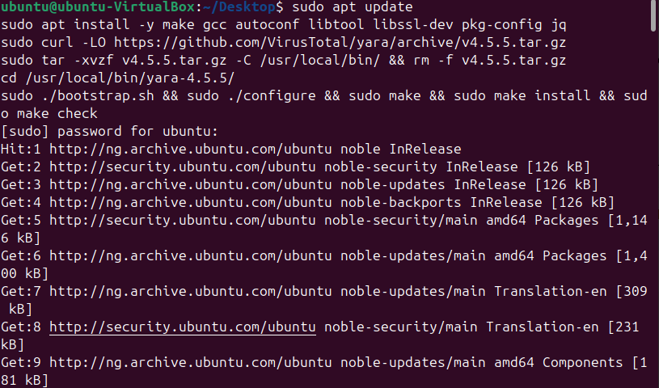
What it shows: Terminal on the Ubuntu agent running apt update/install (make, gcc, autoconf, libtool, libssl-dev, pkg-config, jq) and downloading the YARA v4.5.5 tarball.
Figure 2. YARA source extracted and configured
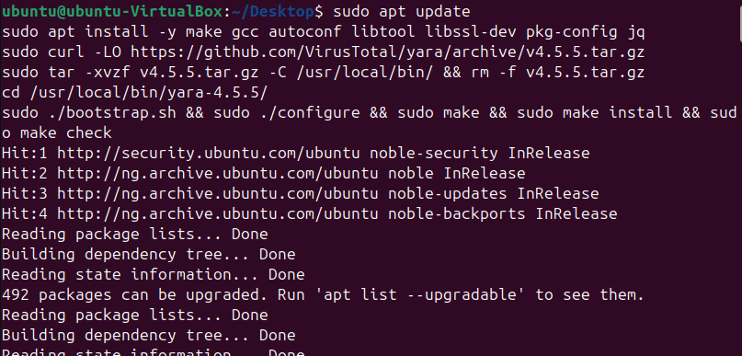
What it shows: Continuation of the same session: tarball extracted under /usr/local/bin and the build started.
Figure 3. YARA 4.5.5 test suite passes
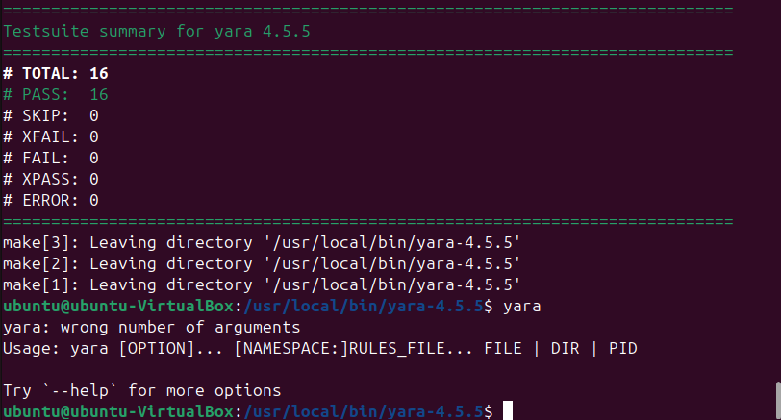
What it shows: "Testsuite summary for yara 4.5.5": TOTAL 16, PASS 16, FAIL 0, ERROR 0.
Figure 4. Rules directory created and Valhalla download requested
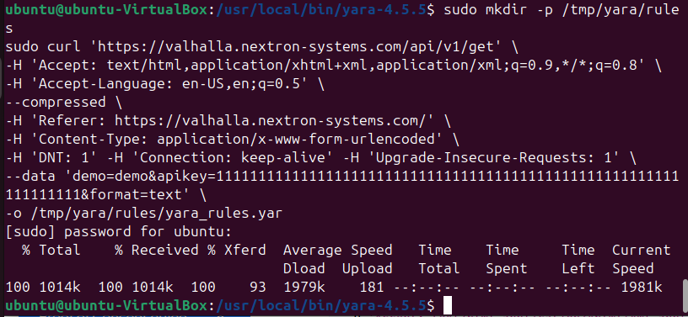
What it shows: mkdir -p /tmp/yara/rule followed by a curl request to the Valhalla API to fetch the demo rule set.
Figure 5. yara.sh active-response script (agent)
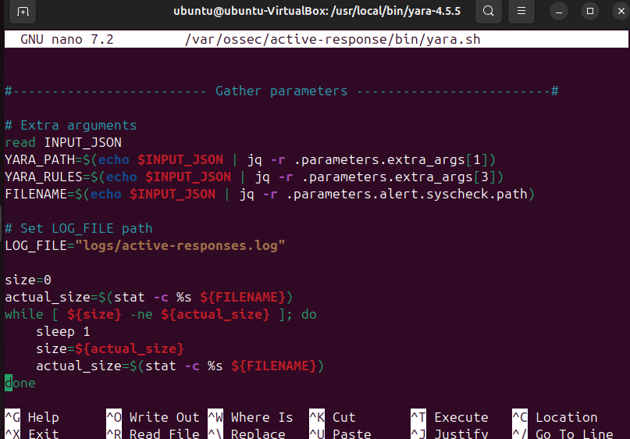
What it shows: nano view of /var/ossec/active-response/bin/yara.sh: reads the JSON input, takes the YARA path and rules from extra_args and the scanned file from alert.syscheck.path.
Figure 6. yara command usage output
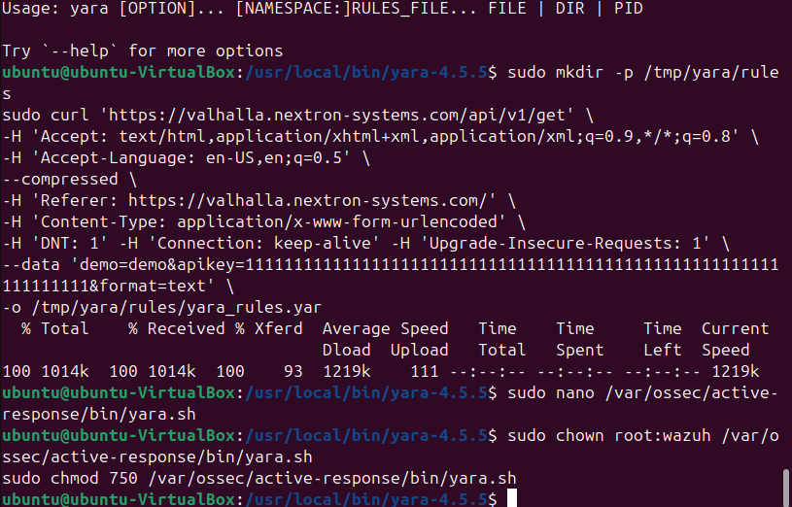
What it shows: Running yara without arguments prints its usage text, with the rules download command visible below it.
Figure 7. Agent syscheck configuration
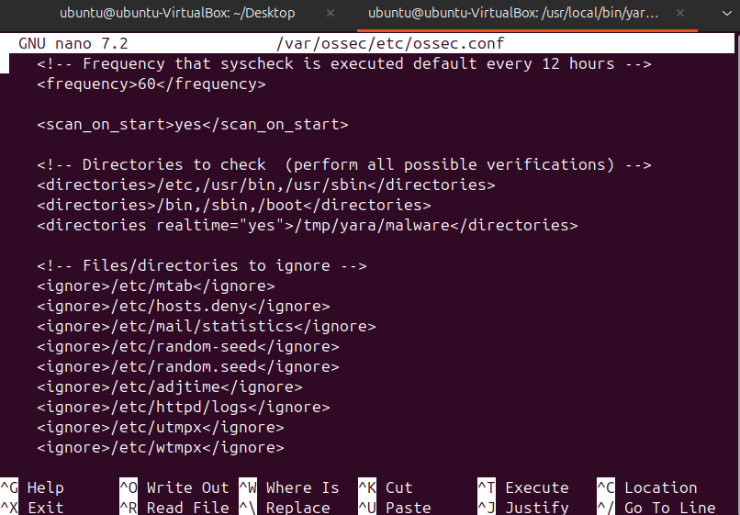
What it shows: ossec.conf with syscheck frequency 60, scan_on_start yes, /etc,/usr/bin,/usr/sbin,/bin,/sbin,/boot monitored and /tmp/yara/malware monitored with realtime="yes".
Figure 8. Wazuh agent restarted
What it shows: systemctl restart wazuh-agent to apply the syscheck change.
Figure 9. Valhalla rules download command
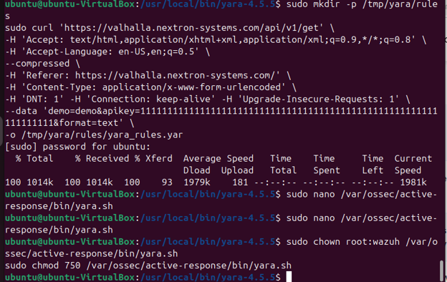
What it shows: Full curl command (headers and form data) used to fetch the rule file.
Figure 10. Custom FIM rules 100300 and 100301 and YARA group 108000 (manager)
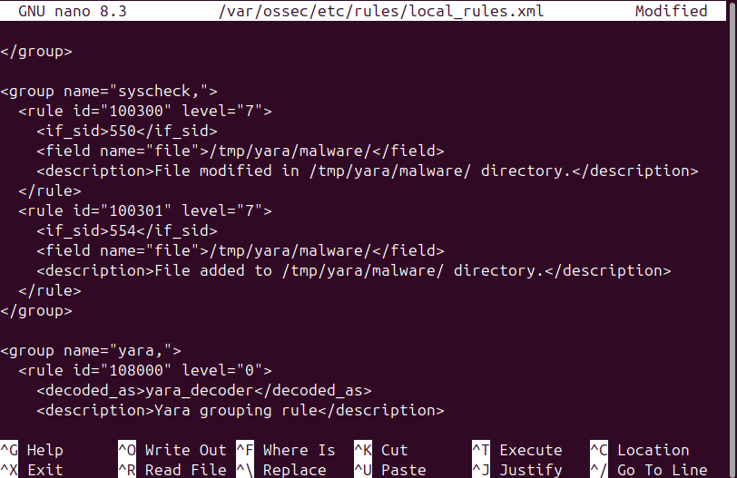
What it shows: local_rules.xml: 100300 (child of 550, "File modified in /tmp/yara/malware/ directory", level 7); 100301 (child of 554, "File added…", level 7); group "yara" with rule 108000, level 0, decoded_as yara_decoder.
Figure 11. Custom YARA decoders (manager)
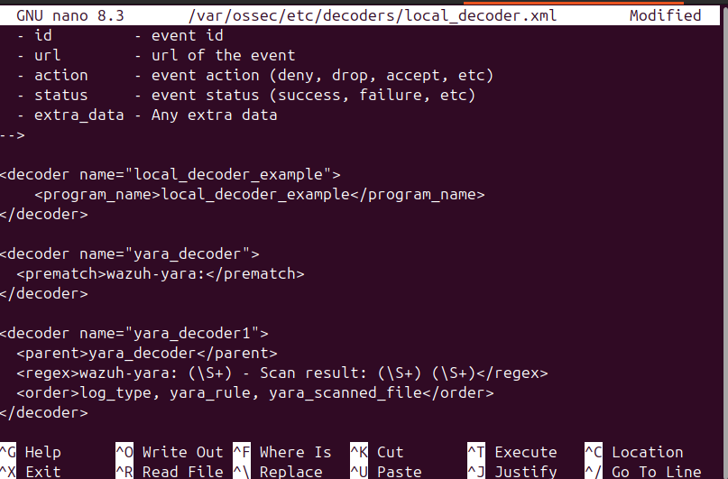
What it shows: local_decoder.xml: yara_decoder (prematch "wazuh-yara:") and yara_decoder1 extracting log type, yara_rule and yara_scanned_file.
Figure 12. Manager command and active-response blocks
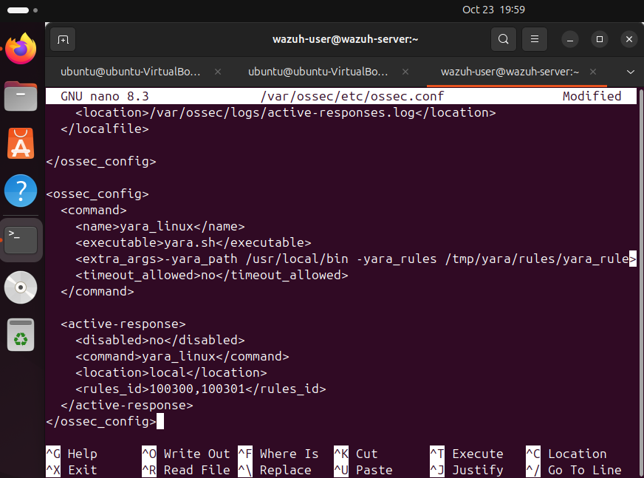
What it shows: ossec.conf: command yara_Linux (executable yara.sh, extra_args with yara_path and yara_rules), active-response on location local for rule IDs 100300,100301, and a localfile reading /var/ossec/logs/active-responses.log.
Figure 13. Manager rules, decoder and configuration edited, manager restarted
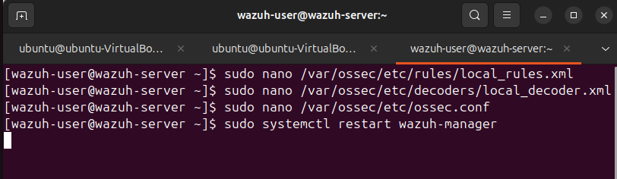
What it shows: Shell history: nano on local_rules.xml, local_decoder.xml and ossec.conf, then systemctl restart wazuh-manager.
Figure 14. sshd started on the Wazuh server
What it shows: systemctl start sshd so the Ubuntu agent VM can connect.
Figure 15. SSH from the Ubuntu agent to the Wazuh server
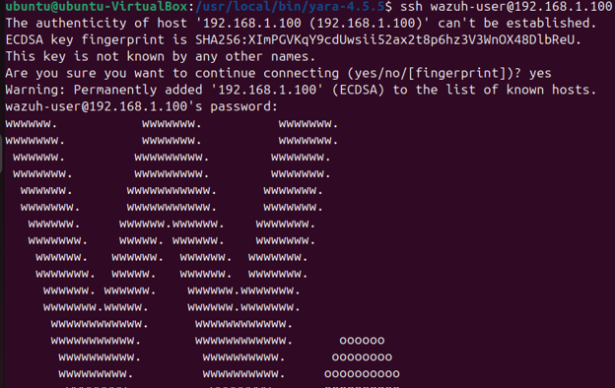
What it shows: ssh wazuh-user@192.168.1.100, host fingerprint prompt.
Figure 16. Wazuh server login banner
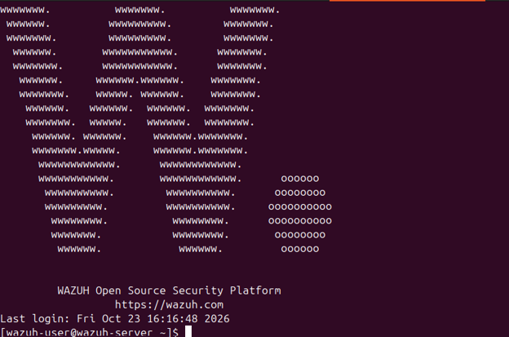
What it shows: Wazuh Open Source Security Platform banner after a successful SSH login.
Figure 17. mkdir /tmp/yara/malware fails
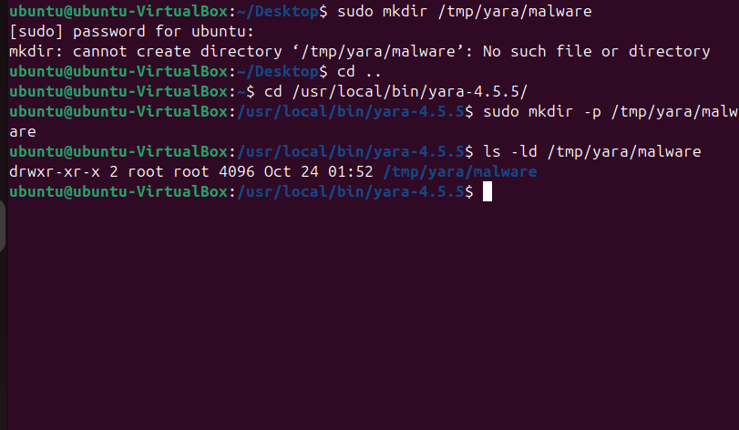
What it shows: "mkdir: cannot create directory /tmp/yara/malware: No such file or directory" (parent directory missing).
Figure 18. mkdir failure, repeated view
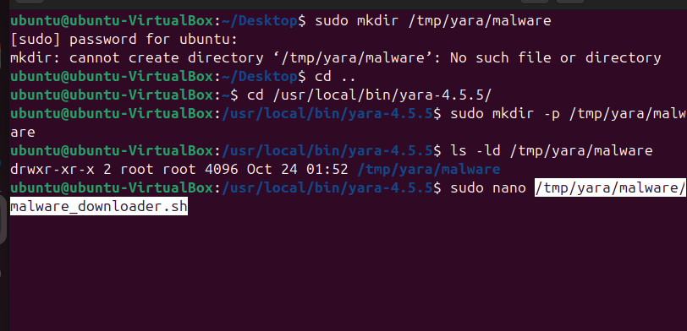
What it shows: Same error, shown in a second capture.
Figure 19. malware_downloader.sh opened in nano
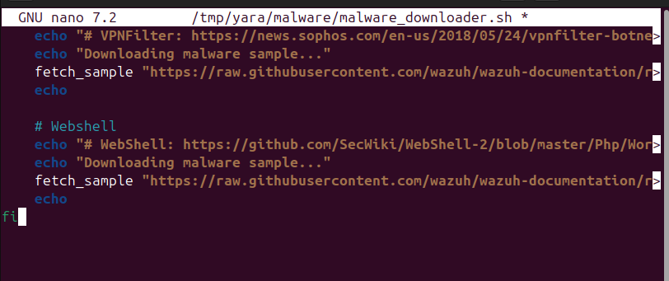
What it shows: Script in /tmp/yara/malware that fetches sample files from public URLs (fetch_sample calls).
Figure 20. malware_downloader.sh, warning and sample list
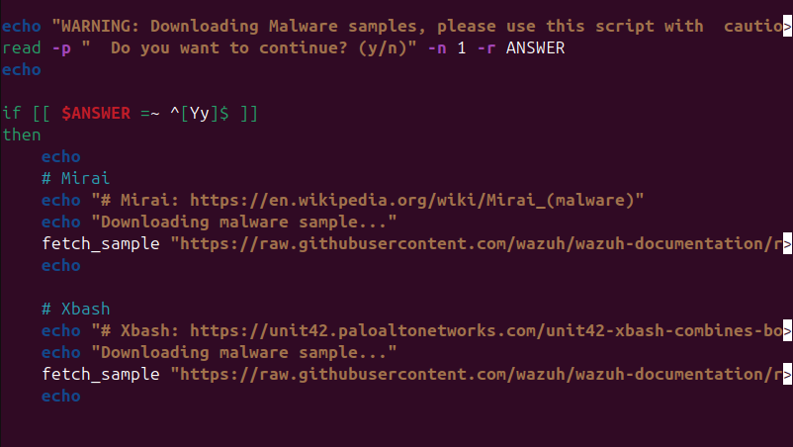
What it shows: Script warning prompt and the list of sources (Mirai, Xbash, VPNFilter, WebShell).
Figure 21. Downloader script reopened
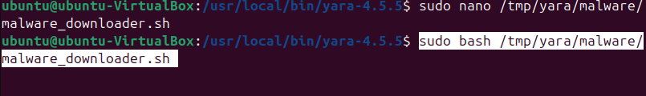
What it shows: sudo nano /tmp/yara/malware/malware_downloader.sh.
Figure 22. Downloader executed
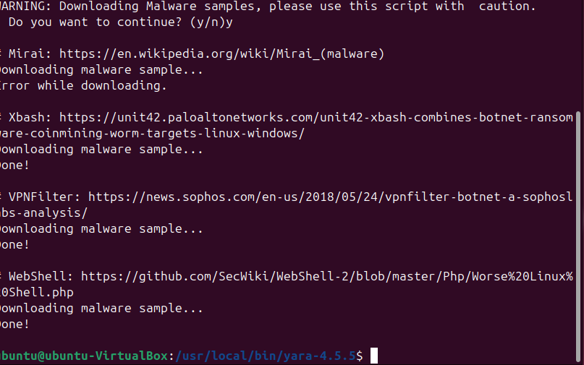
What it shows: Warning accepted with "y". Mirai: "Error while downloading". Xbash, VPNFilter and WebShell: "Done!".

B.2 Wazuh dashboard and malware-sample (FIM) alerts
Figure 23. Wazuh dashboard, endpoints summary
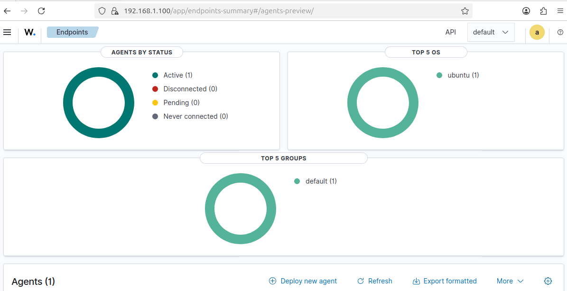
What it shows: Agents by status: 1 active, 0 disconnected, 0 pending, 0 never connected.
Figure 24. Agent list
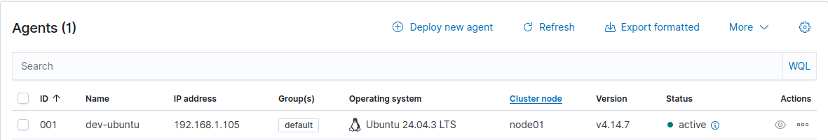
What it shows: Agent 001, dev-ubuntu, 192.168.1.105, group default, Ubuntu 24.04.3 LTS, node01, v4.14.x, active.
Figure 25. Agent inventory and vulnerability/SCA panels
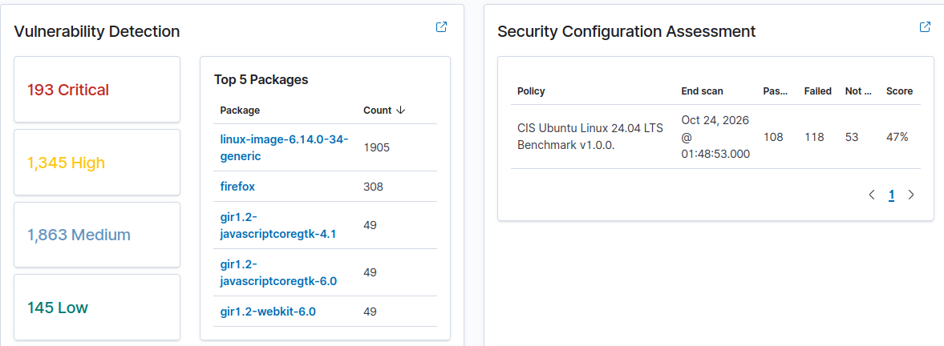
What it shows: Vulnerability detection and Security Configuration Assessment widgets for dev-ubuntu.
Figure 26. System inventory and event-count evolution
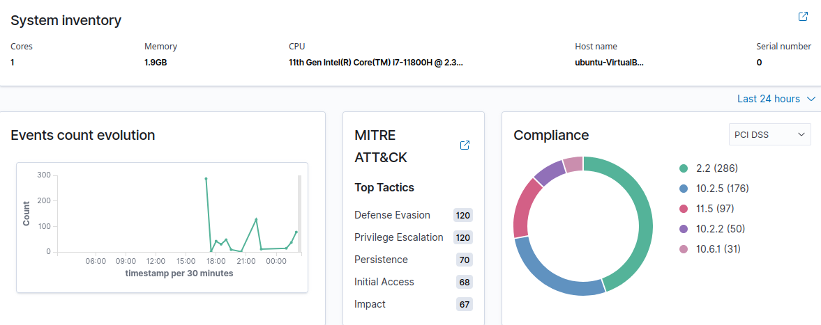
What it shows: Host details and the 24-hour events-count chart with MITRE panel.
Figure 27. Threat Hunting dashboard, dev-ubuntu
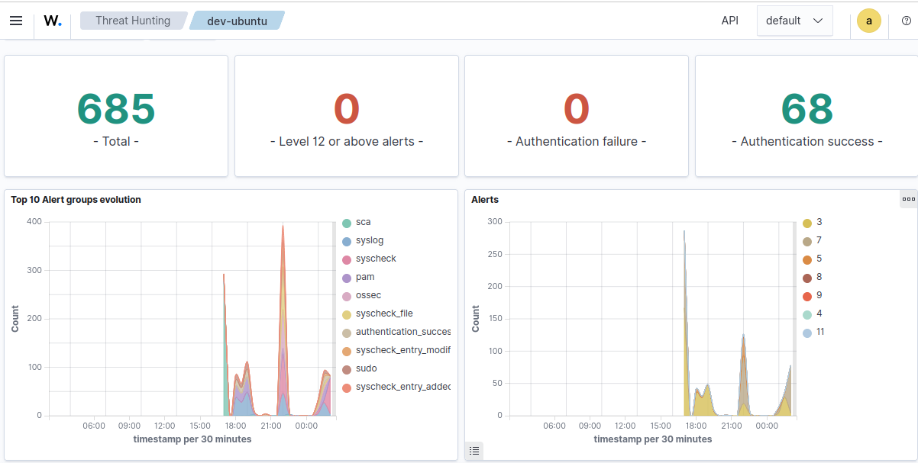
What it shows: Alert group evolution (syslog, syscheck and others) for the last 24 hours.
Figure 28. Threat Hunting, Events tab
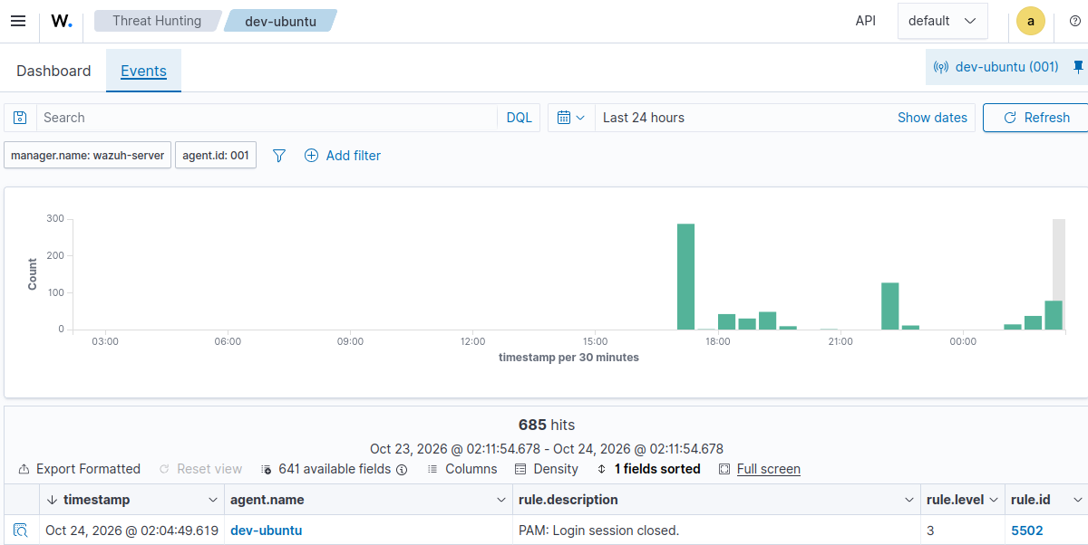
What it shows: Events view for agent 001 with the 24-hour histogram.
Figure 29. Events table with syscheck alerts
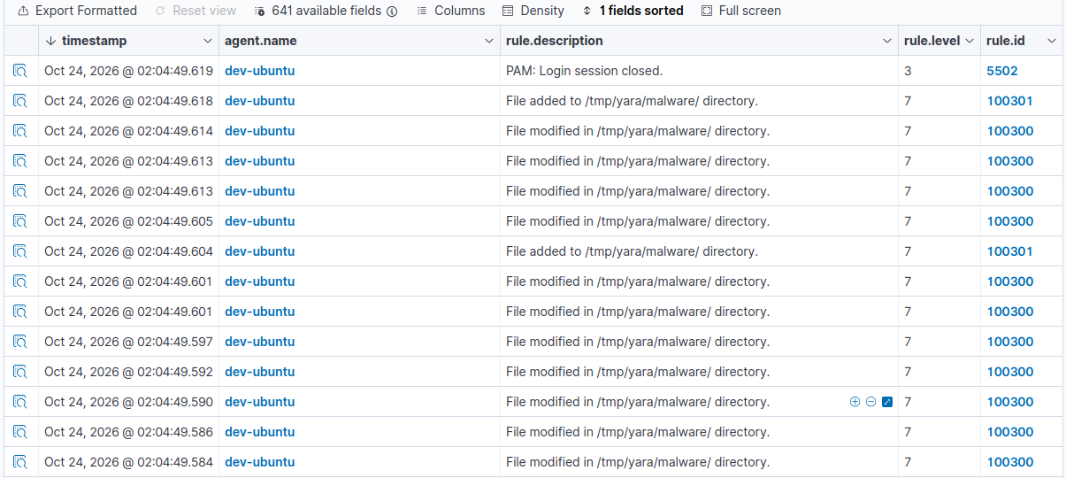
What it shows: Event rows, including the 02:04:49 entry on 24 Oct 2026 (WAT).
Figure 30. FIM alert document (syscheck_integrity_changed)
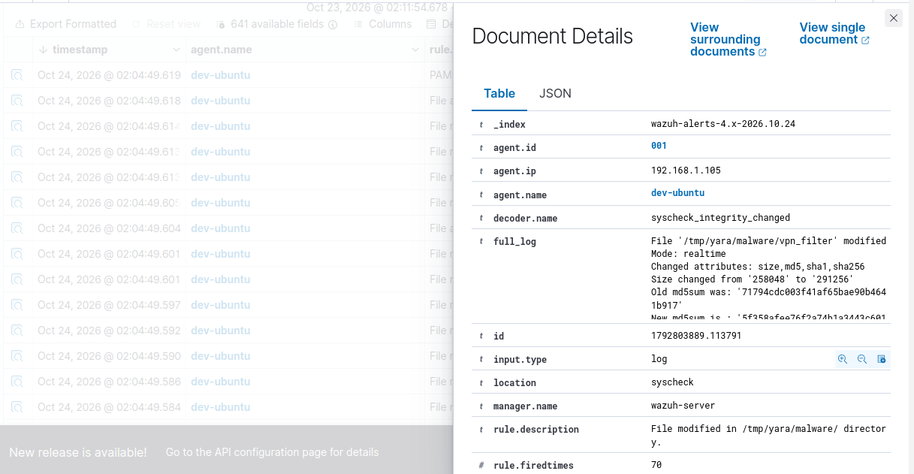
What it shows: Document details for a modified-file alert on agent 001.
Figure 31. FIM alert: file added, webshell
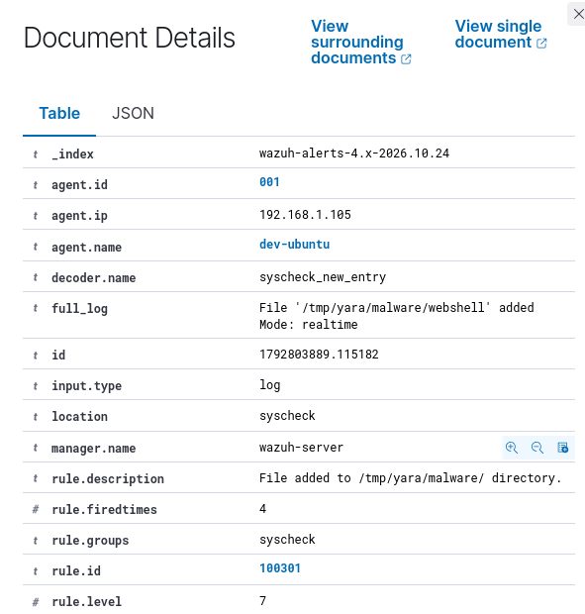
What it shows: syscheck_new_entry: "File '/tmp/yara/malware/webshell' added", mode realtime, rule 100301, level 7, rule fired 4 times.
Figure 32. FIM alert: xbash modified (size 7,868,416 to 7,983,104)
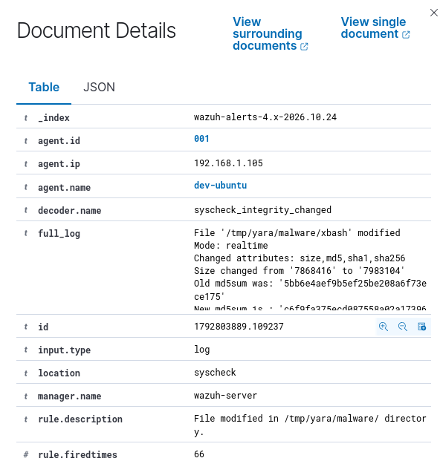
What it shows: Changed attributes size, md5, sha1, sha256, rule 100300; fired 66 times.
Figure 33. FIM alert fields (rule 100300)
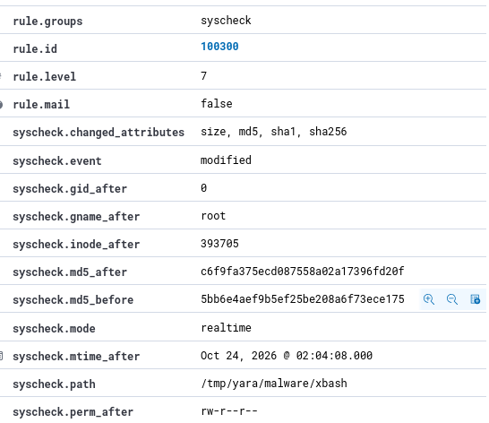
What it shows: rule.groups syscheck, rule.id 100300, rule.level 7, changed attributes size/md5/sha1/sha256, event modified.
Figure 34. FIM alert hashes (before/after)
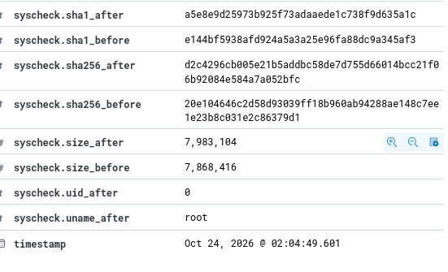
What it shows: sha1_after, sha1_before and sha256_after values for the modified file.
Figure 35. FIM alert: sha256 old/new values
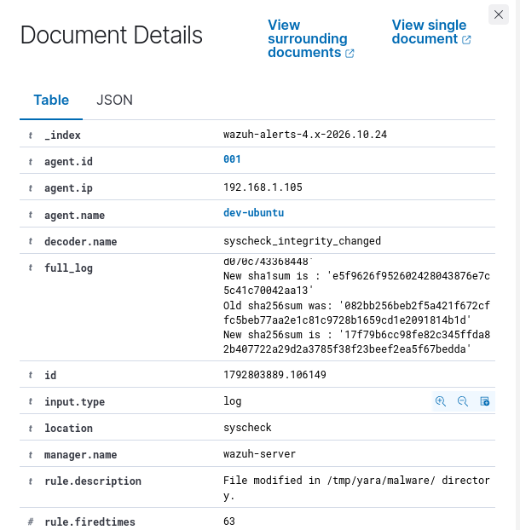
What it shows: Old and new checksum values and rule fired count 63.
Figure 36. FIM alert fields (rule 100300), second event
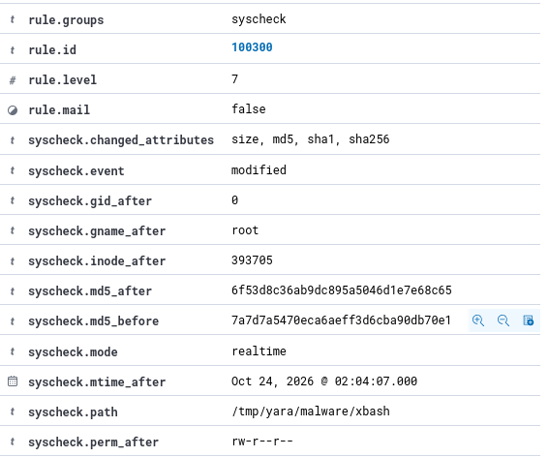
What it shows: Same rule fields for the next modification event.
Figure 37. FIM alert hashes, second event
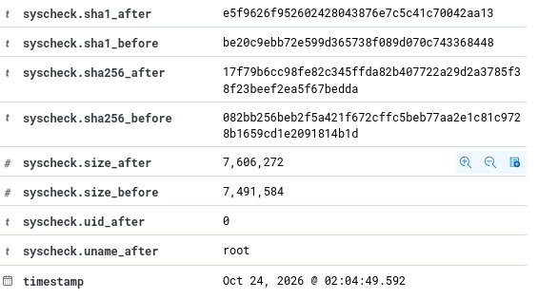
What it shows: sha1_after and sha1_before values; the "before" value matches the "after" value of the previous event.
Figure 38. FIM alert: xbash modified (size 7,983,104 to 9,568,976)
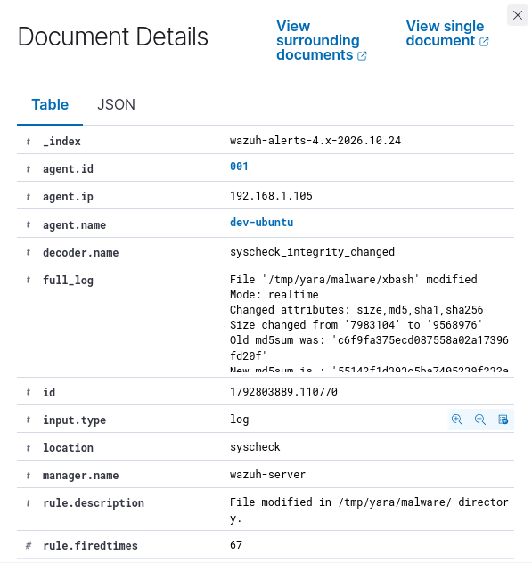
What it shows: Rule fired 67 times; old and new MD5 shown.
Figure 39. FIM alert fields (rule 100300), third event
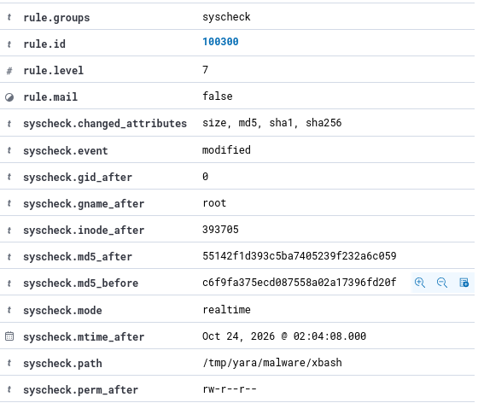
What it shows: Rule fields for the third modification event.
Figure 40. FIM alert hashes, third event
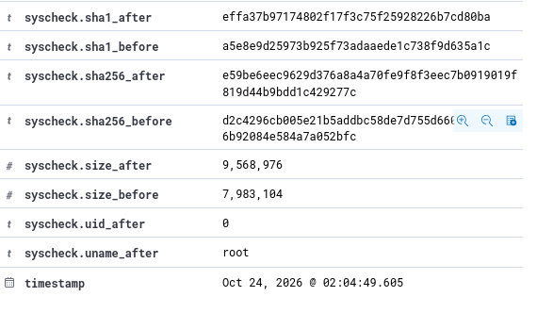
What it shows: sha1 and sha256 values for the final observed modification.
Figure 41. Discover view, wazuh-alerts-*, 769 hits
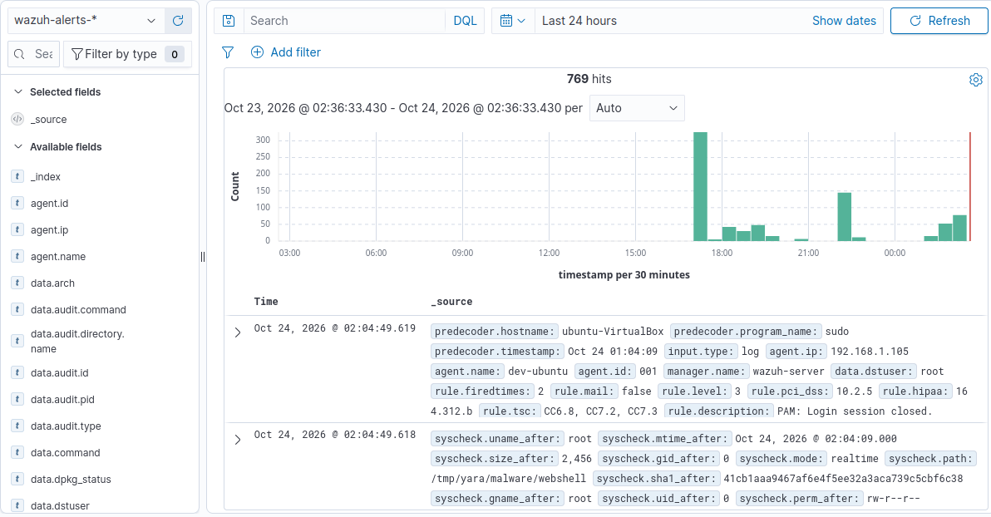
What it shows: 24-hour alert search with the field list and histogram.
Figure 42. Alert with previous_log/previous_output
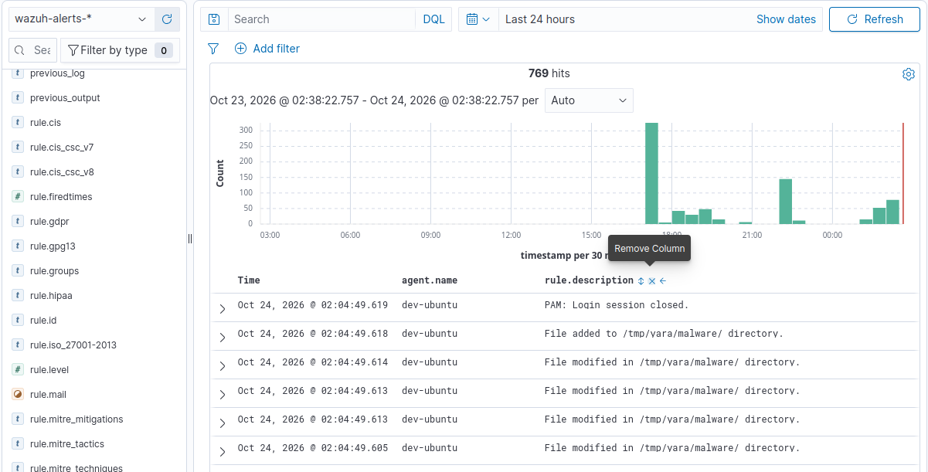
What it shows: Alert showing previous output captured by a command monitor.
Figure 43. Integrity checksum alerts list
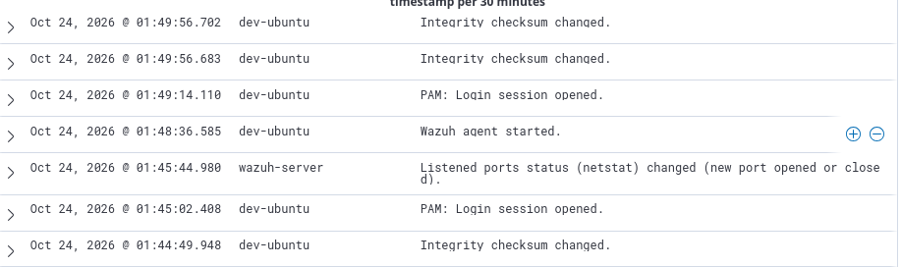
What it shows: Entries at 01:49 and "PAM: Login session opened" on 24 Oct 2026.
Figure 44. Alert document: netstat listening ports
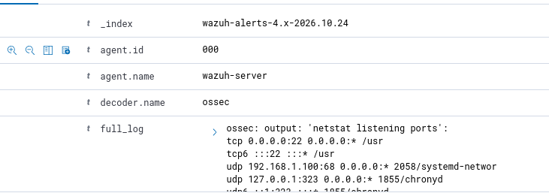
What it shows: Command monitor output listing listening TCP/UDP ports (agent name wazuh-server).
Figure 45. Alert document: netstat, previous_log
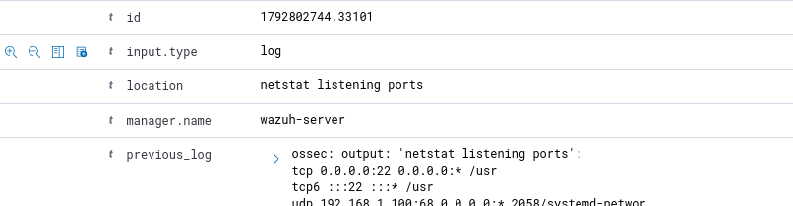
What it shows: Current and previous netstat output.
Figure 46. Alert document: netstat, previous_output
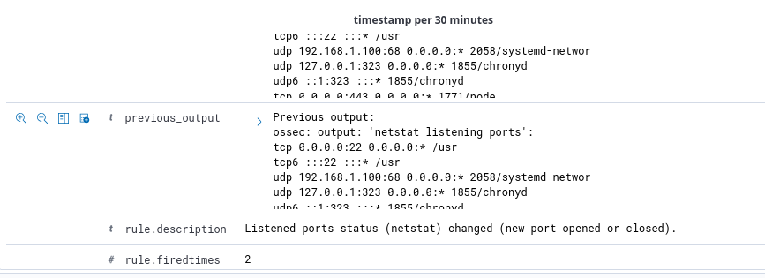
What it shows: Port listing continued, including chronyd and systemd-networkd entries.
Figure 47. Alert rule fields: rule 533
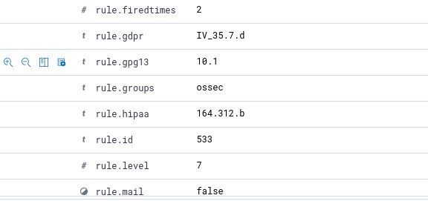
What it shows: rule.id 533, level 7, groups ossec; rule fired 2 times.
Figure 48. Alert compliance fields and timestamp
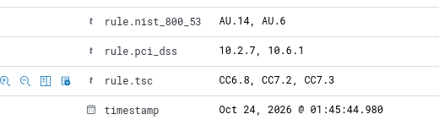
What it shows: NIST, PCI DSS and TSC fields; timestamp 24 Oct 2026 01:45:44.
Figure 49. Discover view, 771 hits
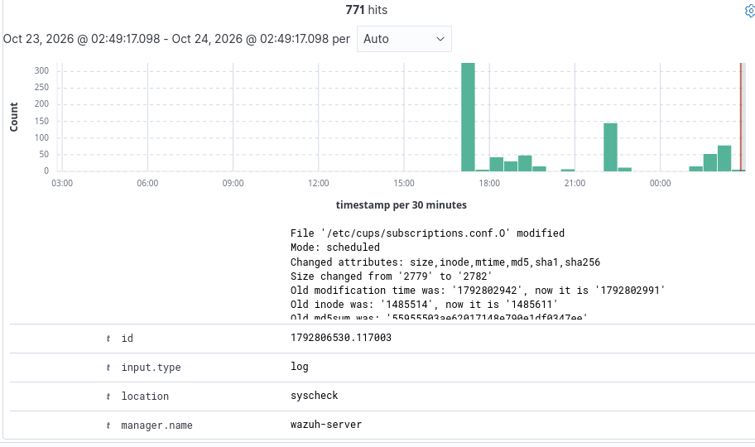
What it shows: 24-hour search, with a /etc/cups/subscriptions.conf integrity entry.
Figure 50. FIM alert document
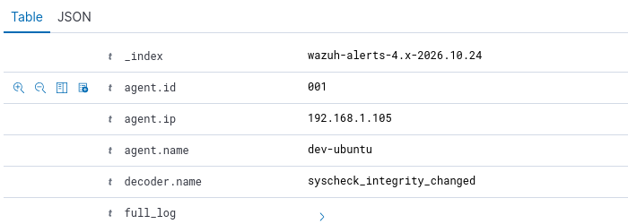
What it shows: Document details of a syscheck_integrity_changed alert.
Figure 51. FIM alert: xbash 7,737,344 to 7,868,416
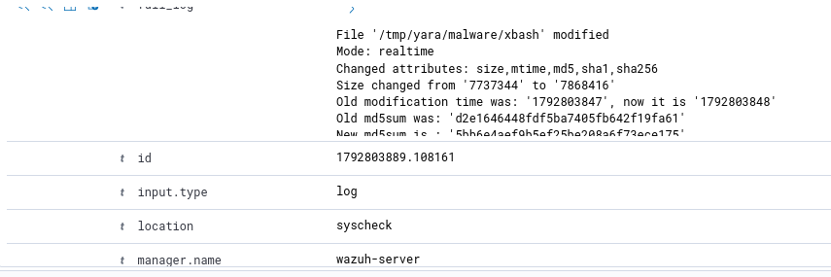
What it shows: Mode realtime; old modification time 1792803847, new 1792803848; old MD5 d2e1646448fdf5ba7405fb642f19fa61.
Figure 52. FIM alert 100300 summary
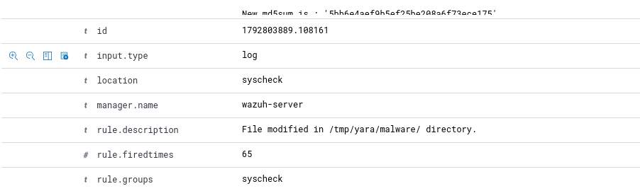
What it shows: Rule description "File modified in /tmp/yara/malware/ directory."
Figure 53. FIM alert fields (rule 100300)
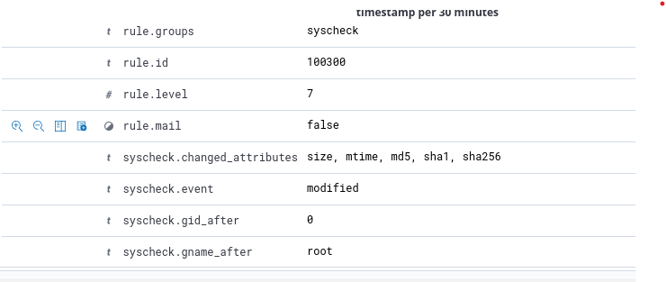
What it shows: Rule group syscheck, level 7, changed attributes size/mtime/md5/sha1/sha256.
Figure 54. FIM alert MD5 values
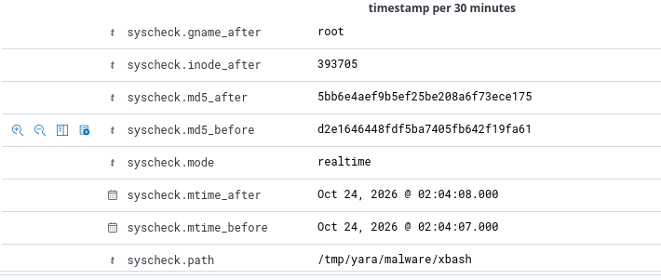
What it shows: md5_after 5bb6e4aef9b5ef25be208a6f73ece175; md5_before d2e1646448fdf5ba7405fb642f19fa61; mode realtime.
Figure 55. FIM alert path and SHA1 values
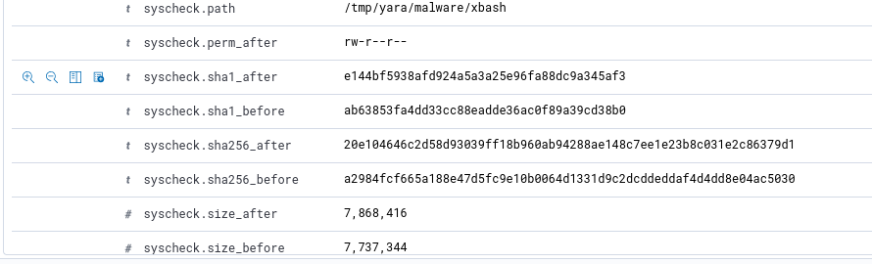
What it shows: Path /tmp/yara/malware/xbash, permissions rw-r--r--, sha1_after e144bf59… and sha1_before ab63853f….
Figure 56. FIM alert size and timestamp
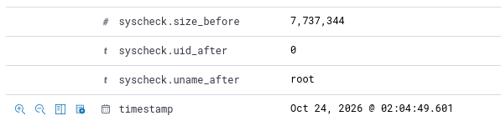
What it shows: size_before 7,737,344; user root; timestamp 24 Oct 2026 02:04:49.601.

B.3 Attack simulation: suspicious binaries
Figure 57. Agent rootcheck configuration
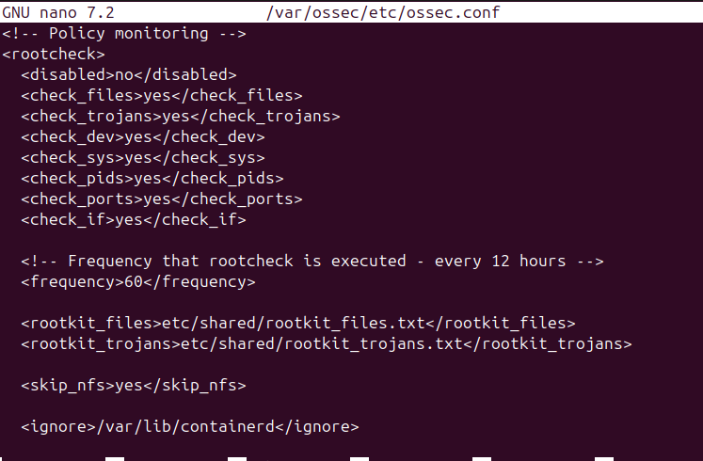
What it shows: rootcheck enabled with check_files, check_trojans, check_dev, check_sys, check_pids, check_ports, check_if all "yes", frequency 60 and the rootkit_trojans.txt file.
Figure 58. Downloader finished; /usr/bin/w copied
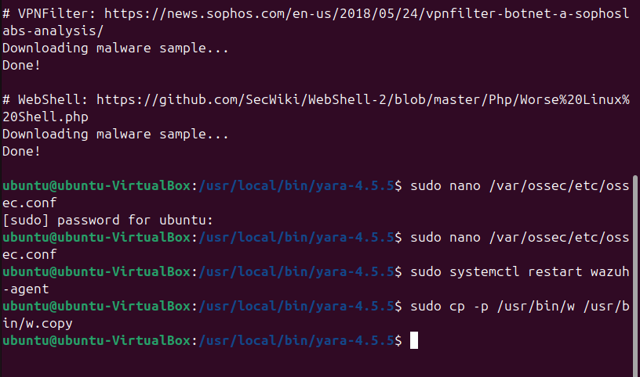
What it shows: VPNFilter and WebShell downloads "Done!"; ossec.conf edited; agent restarted; sudo cp -p /usr/bin/w /usr/bin/w.copy.
Figure 59. /usr/bin/w overwritten with a script (trojan simulation)
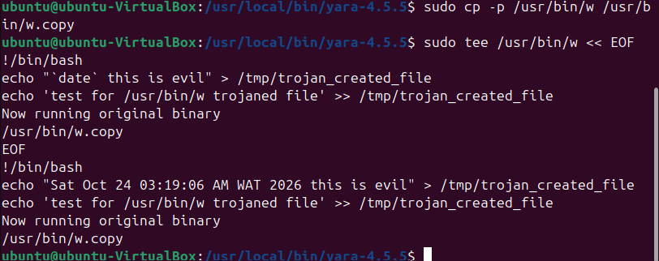
What it shows: sudo tee /usr/bin/w writes a bash script that writes "…this is evil" to /tmp/trojan_created_file, then runs /usr/bin/w.copy. Timestamp in the output: Sat Oct 24 03:19:06 AM WAT 2026.
Figure 60. Dashboard events view after the trojan was created
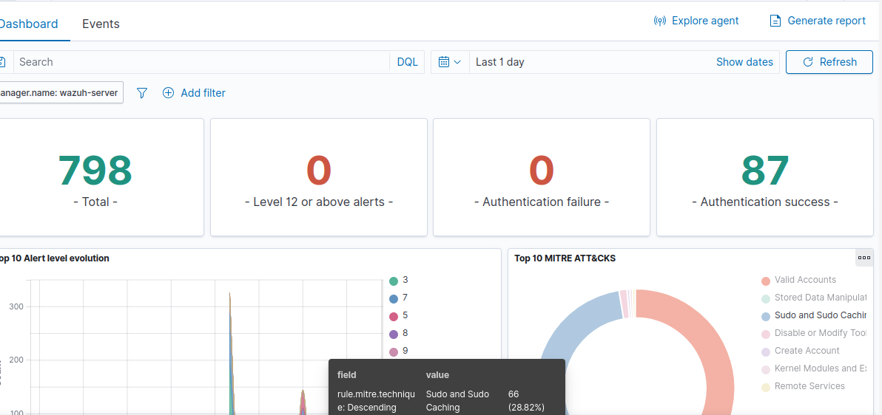
What it shows: Threat Hunting Events tab, last 1 day.
Figure 61. Events list, 800 hits
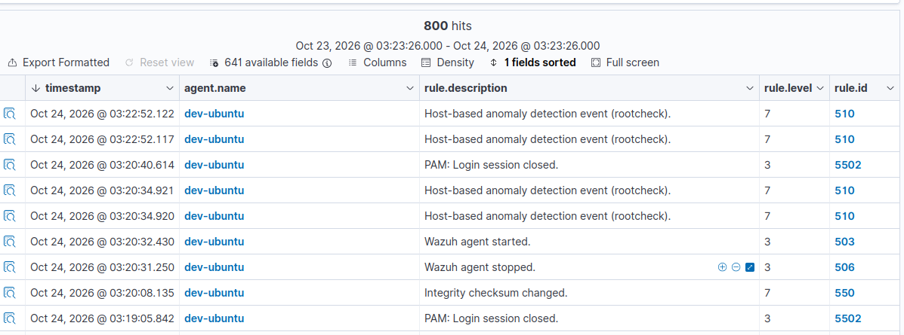
What it shows: Rootcheck and other alerts for the period.
Figure 62. Rootcheck alert document: /bin/w
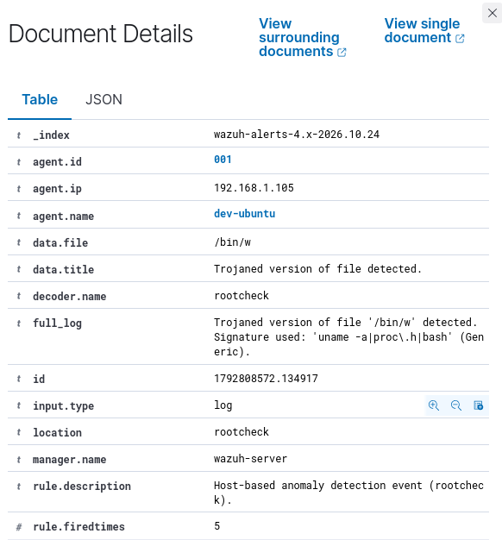
What it shows: "Trojaned version of file '/bin/w' detected. Signature used: 'uname -a|proc\.h|bash' (Generic)." Location rootcheck, rule fired 5 times.
Figure 63. Rootcheck alert fields
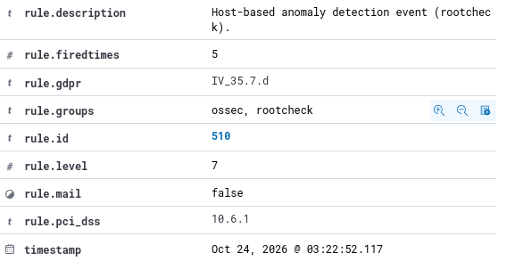
What it shows: rule.description "Host-based anomaly detection event (rootcheck)", groups ossec, rootcheck, level 7.
Figure 64. Rootcheck alert document: /bin/w, earlier event
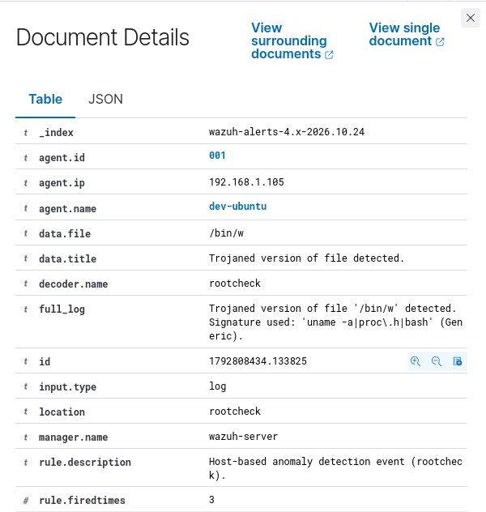
What it shows: Same finding, rule fired 3 times.
Figure 65. Events list, 804 hits
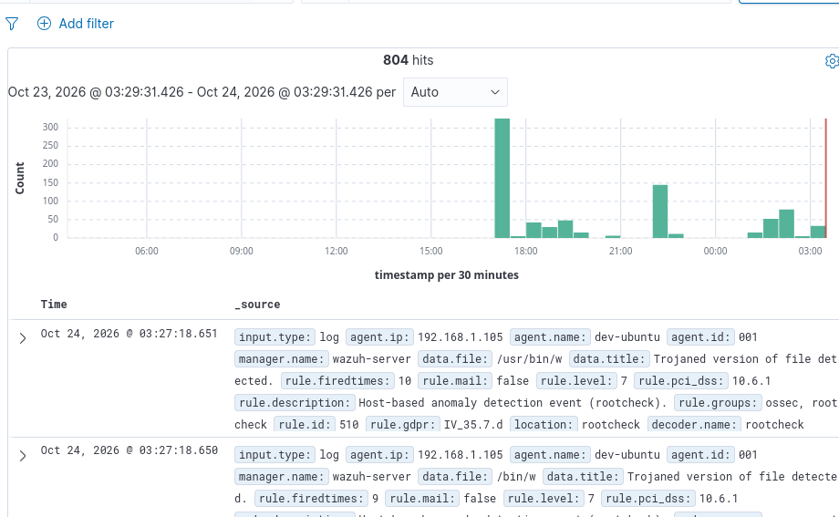
What it shows: Alert histogram and rows around the rootcheck events.
Figure 66. Rootcheck query filter
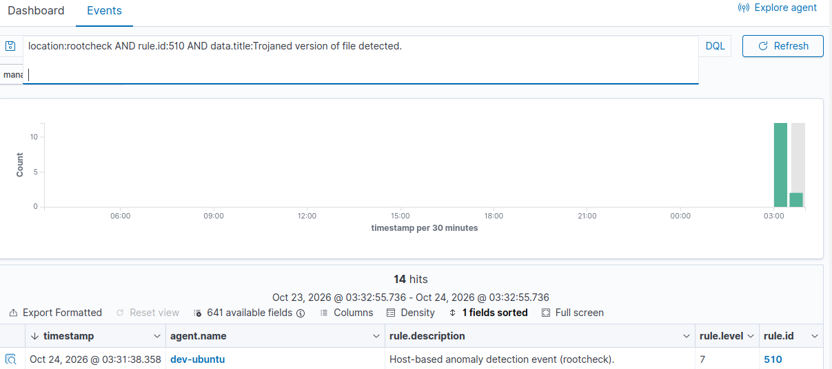
What it shows: Query: location:rootcheck AND rule.id:510 AND data.title:Trojaned version of file detected.

B.4 Attack simulation: Shellshock
Figure 67. Apache2 installation started
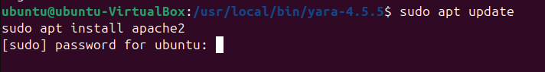
What it shows: sudo apt update; sudo apt install apache2 on the agent.
Figure 68. Apache2 installation output
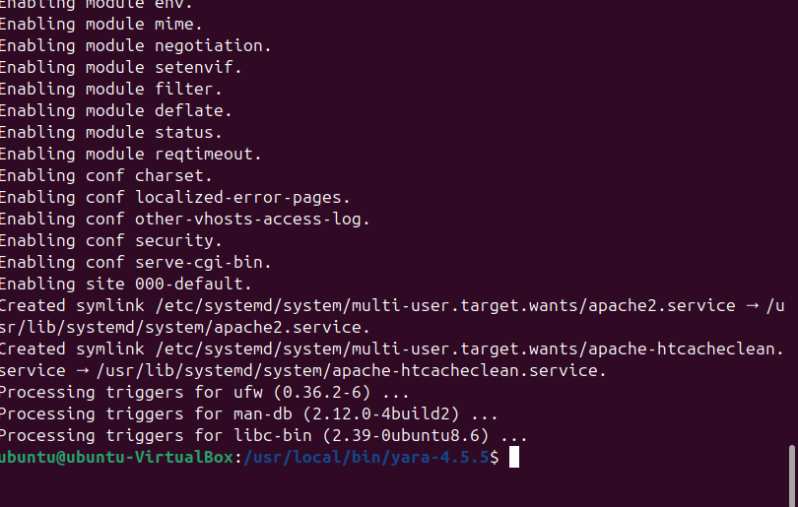
What it shows: Modules enabled (mime, negotiation, setenvif, filter, deflate, status, reqtimeout).
Figure 69. Firewall rules for Apache
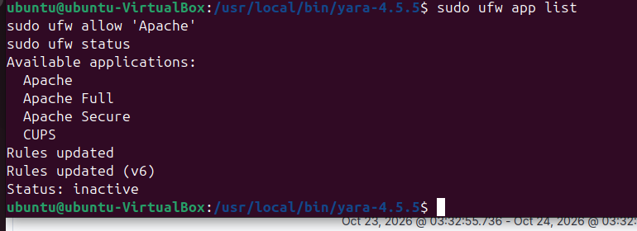
What it shows: ufw app list; ufw allow Apache; ufw status shows "inactive".
Figure 70. Apache2 default page in a browser
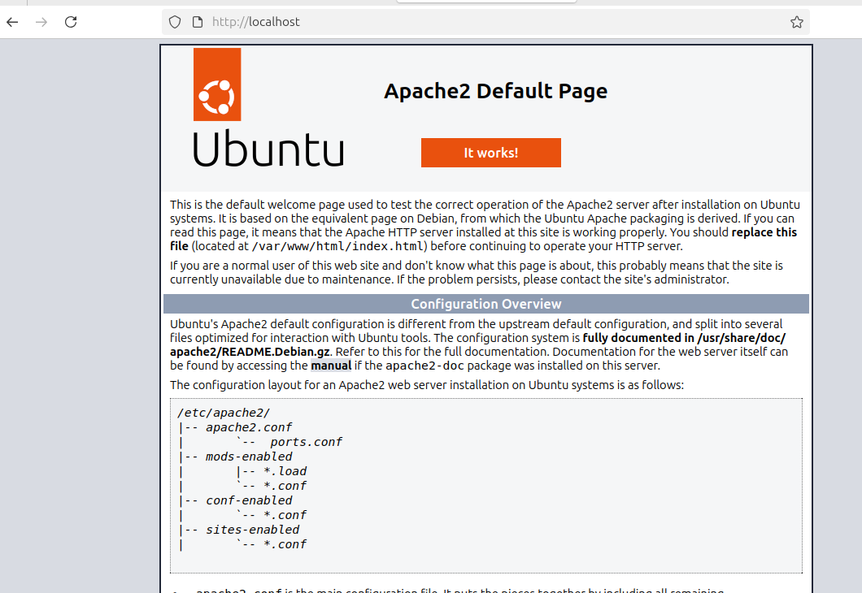
What it shows: "Apache2 Ubuntu Default Page: It works" at http://localhost.
Figure 71. Agent ossec.conf, localfile blocks
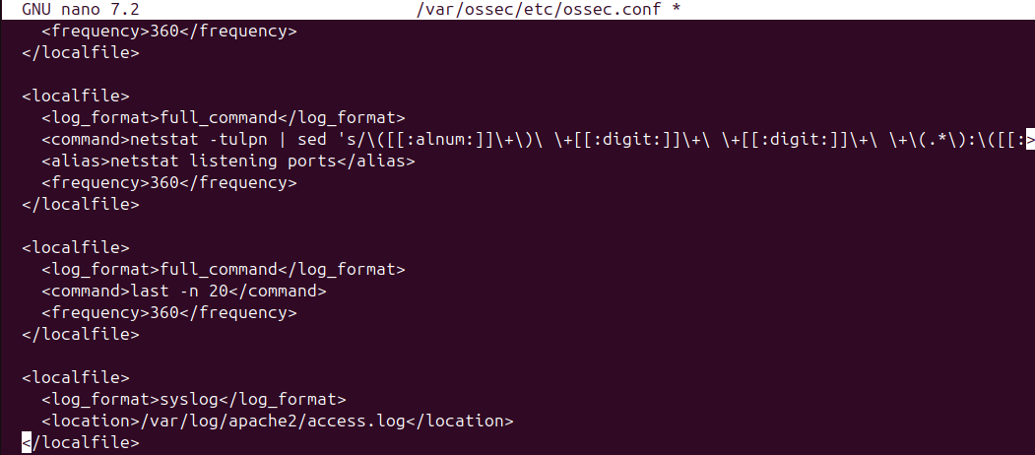
What it shows: Command monitor for netstat and a localfile block; the Apache log monitoring entry is not clearly visible in this capture.
Figure 72. Agent restarted; IP address check
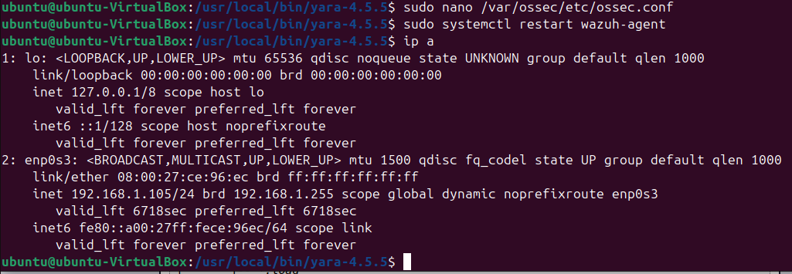
What it shows: Agent IP 192.168.1.105/24 on enp0s3.
Figure 73. Shellshock request from Kali
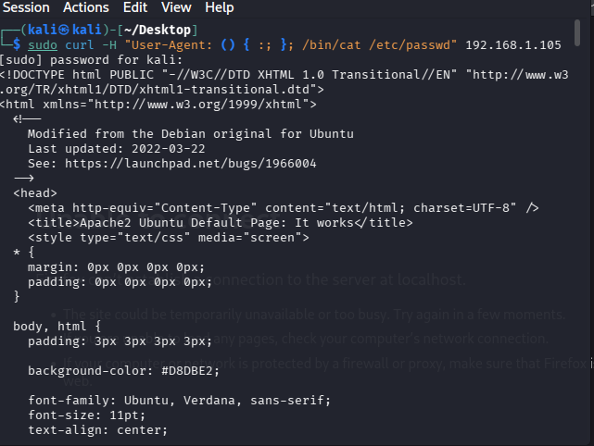
What it shows: sudo curl -H "User-Agent: () { :; }; /bin/cat /etc/passwd" 192.168.1.105. The response is the Apache2 Ubuntu default page HTML.
Figure 74. FIM recent events widget
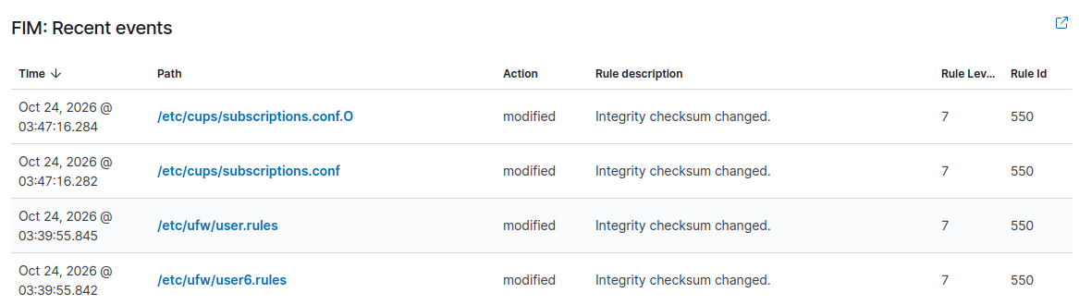
What it shows: Recent FIM events including /etc/cups/subscriptions.conf (rule 550, level 7).
Figure 75. Threat Hunting dashboard after the Shellshock request
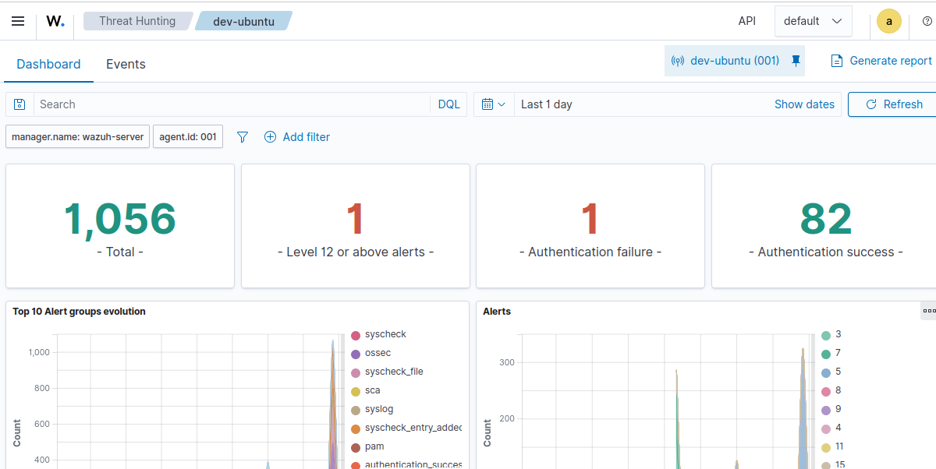
What it shows: Dashboard for dev-ubuntu with the Events tab.
Figure 76. Event rows: Shellshock and rootcheck
What it shows: 24 Oct 2026 04:03:38.103 "Shellshock attack detected" level 15, rule 31168; 04:05:04.469 rootcheck, rule 510, level 7.
Figure 77. Events list around the Shellshock alert
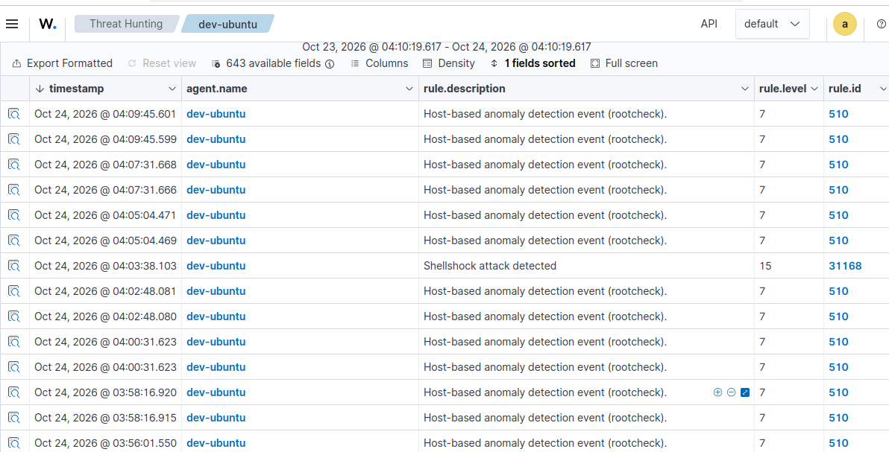
What it shows: Event table, 643 available fields.
Figure 78. Shellshock alert document: log source
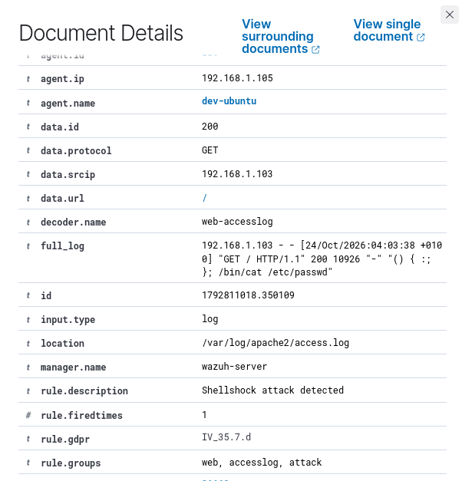
What it shows: data.srcip 192.168.1.103, GET /, decoder web-accesslog, location /var/log/apache2/access.log; full_log shows the "() { :; }; /bin/cat /etc/passwd" User-Agent.
Figure 79. Shellshock alert document, continued
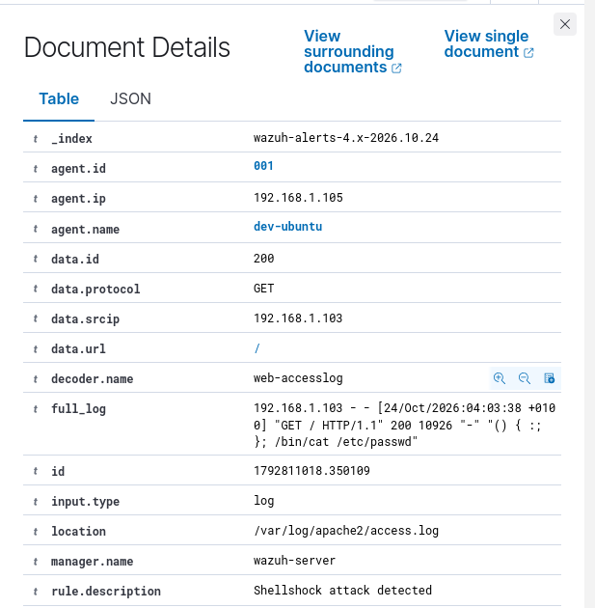
What it shows: Same alert document with agent and data fields.
Figure 80. Shellshock alert rule fields
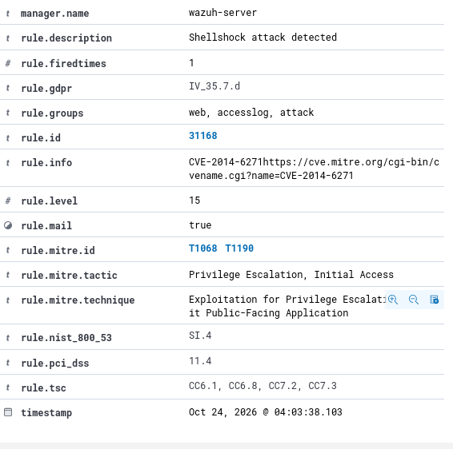
What it shows: Rule 31168, level 15, groups web, accesslog, attack; CVE-2014-6271; MITRE T1068 and T1190 (tactics Privilege Escalation, Initial Access).
Figure 81. Other events in the same period
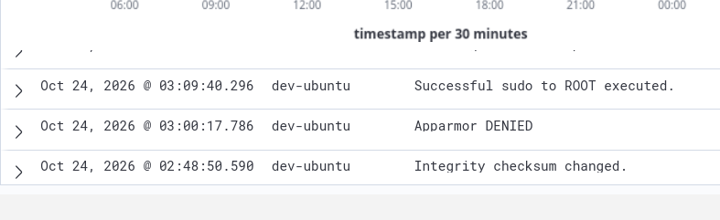
What it shows: Successful sudo to ROOT (03:09:48), AppArmor DENIED (03:00:17), Integrity checksum changed (02:48:58).
Figure 82. Rootcheck rule 510 events, 03:20 to 03:31
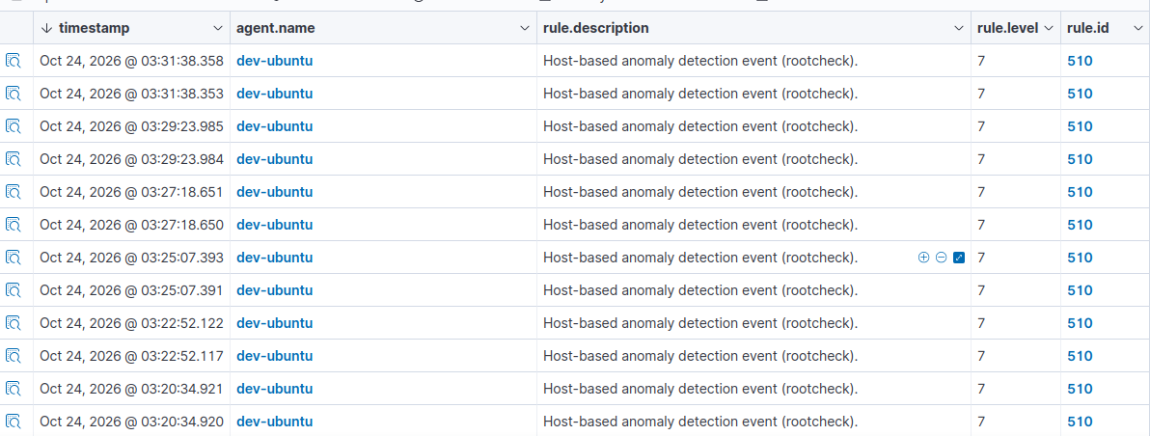
What it shows: Pairs of rule 510 alerts at 03:20:34, 03:22:52, 03:25:07, 03:27:18, 03:29:23 and 03:31:38.
Figure 83. FIM alert: /etc/ld.so.cache modified
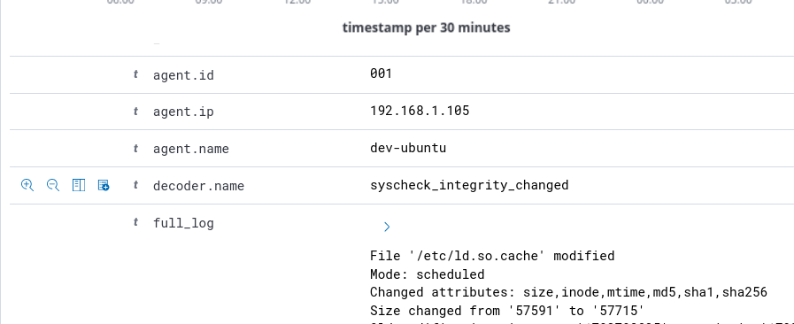
What it shows: Mode scheduled; size changed from 57591 to 57715.
Figure 84. Shellshock alert full_log
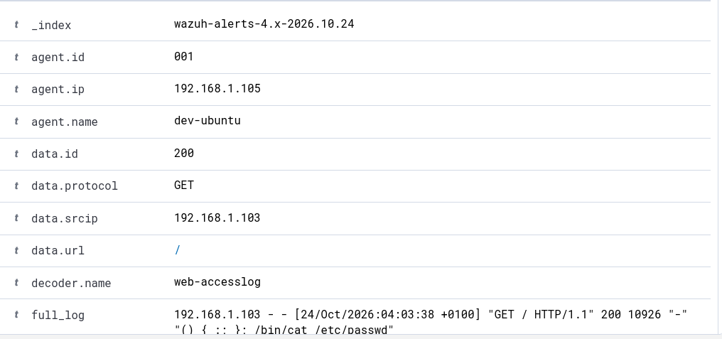
What it shows: 192.168.1.103 – – [24/Oct/2026:04:03:38 +0100] "GET / HTTP/1.1" 200 10926 "-" "() { :; }; /bin/cat /etc/passwd".
Figure 85. Shellshock alert rule metadata
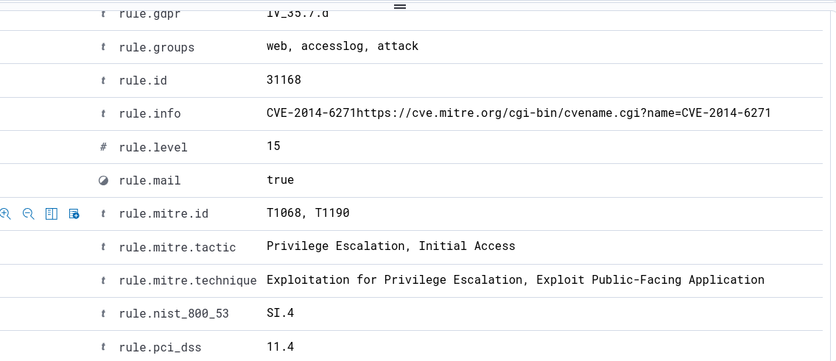
What it shows: Rule 31168, level 15, mail true, groups web, accesslog, attack, CVE-2014-6271 reference.
Figure 86. Shellshock alert compliance tags
What it shows: tsc CC6.1, CC6.8, CC7.2, CC7.3.

End of Part B report.

