**Web Dev 3 – Developing REST Api for RaceCard**

**Configuring the Server side**:

You will use a database called “racing”. The database will contain one table called “card” which contains a number of “race card entries”. A “race card entry” contains details about a particular horse that has been entered in a race (e.g. owner, jockey, betting, trainer).

1. Create a database called “racing” in MySQL. Then use the file called racing.SQL to add the table (card) and its 12 rows of data.

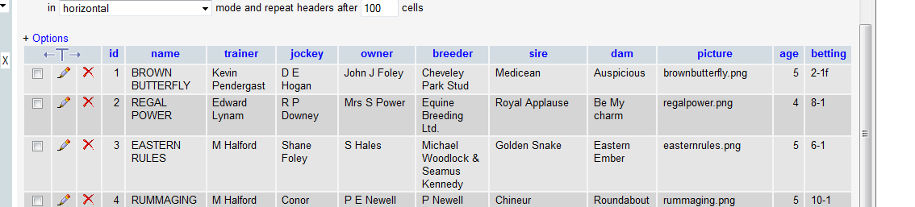

2. Implement the following REST API and test using Postman REST client or with browser.

|  |  |
| --- | --- |
| URI |  |
| http://localhost/racecard/api/runners | Get all runners in the race |
| http://localhost/racecard/api/runners/8 | Get by id |
| http://localhost/racecars/api/runners?sort=column | Add an **optional** parameter so that the data is returned sorted based on the parameter. If the parameter is not specified returned the list sorted by name.  e.g. http://localhost/racecard/api/runners?sort=age |
|  |  |

Notes:- The parameters appended in the url will be available in the $_GET array. As the sort parameter is optional, it may or may not be present. You can use the ISSET function if php to check if the parameter is set. If not default to sorting by name.