
CO3204 Software Engineering Project Dissertation
Euro Motors: A Full-Stack Luxury Automotive
E-Commerce and Management Platform
By Faithful Akachukwu Nwaleke-Emmanuel
Student ID: 229031959

School of Computing and Mathematical Sciences
University of Leicester
Supervisor: Yann Savoye
Principal Marker: Robert Free
Submission: 27 April 2026


DECLARATION
Name: Faithful Akachukwu Nwaleke-Emmanuel
Signed: ____________________________
Date: 27/04/2026

Acknowledgements
I would like to extend my sincere gratitude to my project supervisor, Yann Savoye, for his invaluable guidance, constructive feedback, and continued encouragement throughout the development of this project. His insights shaped the direction and quality of Euro Motors significantly.
I would also like to thank my Principal Marker, Robert Free, and the School of Computing and Mathematical Sciences at the University of Leicester for their support and the academic foundation that made this work possible.
Finally, I am grateful to family and friends for their patience and support during the long hours of development and writing. Their encouragement was a constant source of motivation throughout this journey.

Table of Contents
Declaration ii
Acknowledgements ii
Table of Contents iii
Abstract 1
1. Introduction 2
1.1 Problem Statement 3
1.2 Aims and Objectives 4
1.3 Project Scope 5
1.4 Research Question 5
2. Survey of Literature / Information Sources 6
2.1 The Digital Transformation of Automotive Retail 6
2.2 Review of Existing Automotive E-Commerce Platforms 7
2.3 Security in Web Applications and Access Control 9
2.4 Research Summary and Gap Analysis 11
3. System Requirements and Planning 13
3.1 Requirements Engineering Methodology 13
3.2 Functional Requirements 13
3.3 Non-Functional Requirements 16
3.4 Constraints 17
3.5 Assumptions 18
3.6 Requirements Summary 12
4. System Design and Architecture 19
4.1 Architecture Overview 19
4.2 Database Design 21
4.3 API Design 25
4.4 Frontend Architecture 27
4.5 Authentication and Security Design 29
5. Implementation 31
5.1 Development Environment and Toolchain 31
5.2 Project Initialisation and Configuration 33
5.3 Authentication Implementation 36
5.4 API Route Handler Implementation 41
6. Testing and Evaluation 45
6.1 Testing Strategy 45
6.2 API Route Handler Testing 46
6.3 Functional Acceptance Testing 49
6.4 Functional Requirement Coverage Summary 50
6.5 Non-Functional Quality Evaluation 51
6.6 Known Limitations Identified During Testing 52
7. Results and Discussion 53
7.1 Achievement of Project Objectives 53
7.2 Discussion of Key Results 54
7.3 Comparison with Similar Systems 55
7.4 Chapter Summary 56
8. Critical Appraisal 57
8.1 Project Process 57
8.2 Technical Decisions Strengths 58
8.3 Technical Decisions Weaknesses 59
8.4 Unimplemented Features 60
8.5 Future Work 61
8.6 Chapter Summary 62
9. Conclusion 60
9.1 Project Summary 63
9.2 Requirements Achievement 64
9.3 Lessons Learned 65
9.4 Final Reflection 66
References 62
Appendices 65
Appendix A: Database Schema 65
Appendix B: API Endpoint Reference 67
Appendix C: Code Samples 68

Abstract
Euro Motors is a full-stack e-commerce and management platform developed as the final-year project for the CO3204 Software Engineering module at the University of Leicester. Euro Motors was developed to serve as a solution for independent luxury car dealerships that lack a system to manage the purchase, rental, and trade-in of their cars.
Euro Motors was built using Next.js 15, React 18, TypeScript, and Tailwind CSS, with Prisma ORM and SQLite databases for data persistence. Authentication is provided via JSON Web Tokens (JWT) that are stored as HttpOnly cookies in users’ browsers. Middleware enforces role-based access control to the application, allowing either users with the USER role or admins with the ADMIN role to access the application’s features. The application exposes 41 API route handlers grouped into 11 namespaces, features 30 pages, and integrates with two external automotive data services: the CarQuery API and a Supercar Pricing Aggregator. Payments are accepted via Stripe Checkout across three flows: rental bookings (including split-cost co-renter payments), direct car purchase deposits, and trade-in balance payments. Enquiries regarding the purchase of a car result in an itemised quote that is output as a PDF document using jsPDF.
Thirty-seven requirements were defined for the system using the MoSCoW method for prioritising requirements. Thirty-three of these requirements have been implemented and tested for functionality, security, and performance. This represents the fulfilment of 89% of the requirements. All 21 must-have requirements have been fulfilled. Four requirements remain to be implemented in future versions of the application: automated trade-in valuation, email notifications, webhooks to confirm the production of data from third-party services, and the ability to drag and drop car gallery images. Other priorities for future versions of the application include the migration of the database from SQLite to PostgreSQL and the implementation of an automated test suite for the application.

1. Introduction

1.1 Problem Statement

Although the automotive retail industry is becoming increasingly digitised, most independent and small/boutique luxury car dealerships still have their workflows that are disjointed and manual in nature. Inventory can be handled in a spreadsheet, rental reservations can be handled in email messages, trade-ins can be valued via telephone calls and quote documents can be written in a word processor and mailed in as attachments. This discontinuity can result in several operational issues.

First, it creates a lot of friction in the customer experience. A potential customer wanting to view the features of a particular vehicle at the same time, learn about the financing options of a trade-in transaction, or see if the vehicle of the same model can be rented on short-term arrangements, will have to use several discontinuous channels. According to the 2022 Global Automotive Consumer Study by Deloitte, most consumers who continue to buy cars are partial to face-to-face, but there is a tremendous potential to have virtual and digital sales processes increase, which was accompanied by the convenience and ease of use as the main factors influencing consumer willingness to transact digitally [1]. Meaning a smooth, integrated online experience will become a competitive advantage among dealerships.

Second, manual processes bring in errors and delays, which have commercial implications. According to industry experts assembled by McKinsey, automotive retail needs comprehensive and integrated digital ecosystems across all customer touchpoints and disjointed and disconnected systems are noted to be a major obstacle to the unified experience customers have now come to demand [2].

Third, there is no centralised data store, which implies that the management needs time to manually compile data on revenue, fleet utilisation, and customer retention using data from different sources.

The issue that Euro Motors will solve is thus both technical and operational: how to develop and deploy a secure, full-stack web application that will integrate the purchase, rental and trade-in processes of a luxury car dealer into a unified, coherent platform, and give administrators the means to operate the business on the fly.

1.2 Aims and Objectives
The overall objective of this project is to design, implement, and test a full-stack web application that allows users to purchase, rent, and trade-in their vehicles through a single web application.
To achieve this general objective, the following specific objectives will be pursued:
- Design and implement a secure authentication system based on JWT with role-based access control to differentiate between standard users and admin users, as well as to protect the various routes of the application.
- Introduce the vehicle purchase process that allows users to browse the available vehicles with their specifications and create purchase requests for vehicles with optional trade-in of another vehicle.
- Develop a rental booking system that allows users to rent cars for hourly, daily and weekly periods, with the ability to split the payment with another renter and to view the availability of the cars for rental periods.
- Implement a trade-in request module that allows the system to store the vehicle history of the vehicles to be traded in, access their specifications from external APIs, and link that request to the purchase quote request module.
- Build a full-fledged admin interface that allows the admin to manage the inventory of buy and rental cars, users, rentals and trade-in requests with the ability to generate reports of these entities.
- Integrate no less than two external automotive data service APIs into the system to allow the vehicles in the inventory to have their specifications populated automatically, such as the CarQuery API and the Supercar Pricing Aggregator.
- Implement the ability for the server to generate PDF documents of the purchase quotes that are generated by the system.
- Test the various functions of the system to ensure that all requirements are fulfilled and that the system behaves as it is supposed to behave.

1.3 Project Scope
This project includes the implementation of a web application for the luxury car dealership Euro Motors. There are two types of users for the web application: customers and administrators. Under the "Customer" role, users can view the vehicles currently available, buy them, generate purchase quotes, rent them out to other users and trade them in for other vehicles. An administrator will also gain a "dashboard" for website administration.
In terms of project features, this involves the implementation of user authentication and registration, a car browser/search functionality that can be used to filter available vehicles by make, model, year, type, etc. It should also enable users to generate customized quotes that can then be downloaded as a PDF, permit renters to book cars that can be rented out with split payment terms with a co - renter, enable car trades that are to be submitted to the dealership and then reviewed by a salesperson, provide full CRUD functionality to interact with car and user records in the database and integrate with two third - party services: the CarQuery and Supercar Pricing Aggregator Apis. Some features outside of the scope of this current version of the web application include mobile native applications, live chat functions, and AI-based valuation of traded-in cars (although the data is gathered by the site, the valuation will be performed by an administrator). Stripe payment processing is fully integrated for rental, buy, and trade-in flows within the current version. Each of these features are discussed as a potential future development for the web application in Chapter 9
1.4 Research Question
The central research question guiding this project is:
" How is a full-stack web application designed and developed so that the purchase, rental and trade-in processes of a luxury car dealership are centralised into one secure, data-driven platform, satisfying the needs of both the customers and administrators?"
The design, implementation and evaluation of the Euro Motors platform is addressed by this question by providing the literature review (Chapter 2) which sets the theoretical and technological context, the requirements and design chapters (3 and 4) which transforms the findings into specifications of the platform, the implementation chapter (5) that gives a description of the technical implementation and the testing and results chapters (6 and 7) that gives the empirical evidence of the effectiveness of the platform.

2. Survey of Literature / Information Sources
This chapter surveys the existing body of knowledge relevant to the Euro Motors project across five interrelated domains: the digital transformation of automotive retail, existing automotive e-commerce platforms and their limitations, vehicle data and pricing API ecosystems, web application security with particular focus on authentication and authorisation, and the technology stack choices underpinning the project. The review culminates in a gap analysis that positions Euro Motors as a direct response to identified shortcomings in the state of the art.

2.1 The Digital Transformation of Automotive Retail
The automotive retail industry is based on physical dealerships. There has been a shift towards purchasing cars via digital channels over the past decade. The COVID-19 pandemic has dramatically accelerated this shift. According to a roundtable discussion between McKinsey and automotive experts from EURODA and Google, the number of searches for individuals who were interested in buying their cars online in the United Kingdom increased by 82% from 2019 to 2020. Furthermore, 60% of individuals under the age of 45 have a preference to purchase their cars online [1]. The size of the automotive industry in the United Kingdom is significant. The Society of Motor Manufacturers and Traders reports that the United Kingdom sold 1.9 million new cars in 2023 for a total industry turnover of £93 billion and employs over 813,000 people in the industry [3].
According to Autotrader’s Car Buyers Report (2019), the car purchase process consists of 28 separate tasks. Furthermore, 52% of individuals feel that buying a car has not changed, and 42% of individuals say that they would not like to purchase a car from dealerships [4]. An average individual spends 14 hours researching cars before visiting a dealership. Yet, 92% of individuals are unsure whether they can trust the dealerships to deliver the vehicle that they require [4]. The reason for the dissatisfaction of consumers is the adoption of digital channels has been fragmented. Various automotive dealers have adopted digital channels individually without integrating the functions that would otherwise improve the customer experience [4].
The example of companies like Tesla has forced change on automotive dealerships. By allowing customers to purchase cars directly from the company through a web interface, Tesla has allowed for increased sales for this high-end automaker. This has created increased pressure on automotive dealerships to digitise their processes [1]. The issue for automotive dealerships, however, is not the adoption of digital channels for each of the processes associated with purchasing a car. According to automotive experts from McKinsey and Company, there are 900 separate digital channels and touchpoints for the purchase of a car. These touchpoints include a variety of websites, advertisements, customer relationship management (CRM) systems, call centres and in-dealership systems that all need to be connected and integrated [1]. This complex problem has motivated the creation of Euro Motors as a single platform and integrated automotive retail business.

2.2 Review of Existing Automotive E-Commerce Platforms
A review of existing automotive e-commerce platforms reveals a variety of different approaches to selling cars online. AutoTrader UK is the largest automotive marketplace in the United Kingdom, but all sales occur offline between the individual car dealers and consumers; AutoTrader UK reports that 52% of the consumers who use the website for vehicle sales report that their experience is the same as when they would have sold the vehicle before the digital age [4]. Tesla manages the entire sales process online, and since they are a single manufacturer, they do not have an independent dealership [2].
In general, though, there is no affordable platform that provides both the customer-facing and dealer management applications within a single e-commerce platform.[5] Both negative experiences for consumers and dissatisfaction within the automotive industry have been correlated to inconsistencies in the service that is provided by dealerships. For instance, a survey of 147 individuals who purchased luxury cars discovered that the purchase of the car was a top-five consideration for each of the three customer personas within that survey (collectors, performance car enthusiasts, and those who purchase for their personal status) and that the luxury car segment has higher profit potentials than other segments within the automotive industry [6].

2.3 Security in Web Applications and Access Control
For any web application that deals with login details and sensitive commercial information, security is paramount. In the Euro Motors project, we employ two main security measures: the use of JSON Web Tokens (JWT) to manage sessions and the use of the bcrypt library to securely store passwords.
JSON Web Tokens (JWT) are a URL-safe means of representing claims between two parties [7]. JWTs are comprised of three Base64URL-encoded parts: the header, the payload and the signature [7]. At login, the server creates a JWT containing a payload of the user’s ID, email address and their expiry time. The server then signs that payload to the JWT. For each request made to the server that is not from a public route, the server inspects the JWT to ensure it has not been tampered with and is still valid for that system.
OWASP provides a JSON Web Token Cheat Sheet [8] that describes best practices for using JWTs. The primary points to note are that JWTs should be transmitted in the HttpOnly cookie to prevent them from being exposed through cross-site scripting attacks; the JWT should expire after a short amount of time, not longer than a few minutes; and the JWT should be signed with a strong secret.
In the Euro Motors code, the JWT is stored in an HttpOnly cookie which includes the Secure flag so that the request is sent over an encrypted connection. The server stores the signing secret in an environment variable. The jose library, a standards-compliant JOSE implementation, is used in the Next.js Edge runtime middleware to verify tokens on every protected route [9].
In storing passwords, we follow the OWASP Password Storage Cheat Sheet [10], particularly that we do not use fast hash functions such as MD5 or SHA-1: instead, we utilise purpose-built adaptive hashing functions such as Bcrypt [11]. Bcrypt is a well-tested password hashing algorithm that includes a salt and an arbitrary number of iterations (the work factor), which can be customised to take advantage of the computing power available in the hardware. The code utilised at Euro Motors uses the bcryptjs implementation of Bcrypt and the compare method, which ensures that login checks are constant time and therefore prevents timing attacks [10] [12].
In Euro Motors' access control, Role-Based Access Control (RBAC) [13] is applied, where a user’s role allows them to have certain access rights. For my web application, there are two different roles: those of USER and ADMIN. Both roles are stored in the User model in the database and are retrieved at the API level when authorisation is required [13]. These are then managed by a middleware function in the project in file middleware.ts, where it is used to protect access to pages and APIs that require user authorisation [14]. The middleware function either redirects the user to the login page or allows the request to proceed; unauthorised users will never access the page or API that requires authorisation. The Admin API routes have also been updated to verify that an admin is logged in through the verifyAdmin() utility to follow the principle of least privilege [15].

2.4 Research Summary and Gap Analysis
Through reviewing the existing literature related to the general topic of digital transformation of the car dealership, the following findings are made regarding their relevance to the Euro Motors project:
While digital transformation is happening rapidly within the automotive sector [1][3], for the most part, on an individual tool level rather than with integrated digital platforms. The market indicates a clear preference for platforms that are integrated [4], yet few are available for small and medium-sized dealerships that are unable to implement such platforms.
Automotive e-commerce platforms exist but typically target specific aspects of the market. Sites like AutoTrader and Motors.co.uk target the initial stage of discovering used cars for purchase [4][2]. Companies like Tesla target the sale of vehicles from a single manufacturer [1]. Dealer management systems exist for internal users, but tend to be very expensive for small dealerships, and do not have any interface for customers [2]. Additionally, there is no existing platform that integrates the purchasing, rental and trade-in of vehicles in their customer interface, as well as an administration interface for dealership managers [5][6].
In addition to the current web and dealership platforms, APIs for vehicle data exist that can provide a more sustainable alternative to web scraping for vehicle data. APIs offered by companies like CarQuery and pricing aggregation companies offer data on vehicles through their APIs that can be incorporated into the Euro Motors platform. By materialising the platform in a way that stores the data from these APIs into the database, the platform can support the listings without relying upon web scraping [7].
For security, technologies like JWT and bcrypt are both proven methods of security for web applications of this type and size. Both of these technologies are recommended by OWASP [8][10] and used in the majority of web applications developed with Node.js technology [11]. Additionally, using both technologies in the platform creates a defence-in-depth model for security, where each layer reduces the risk of an attack against the web application [15].
For the platform’s development, the use of Prisma and Next.js is both well documented for use together, as well as enabling a web application with type safety that can help a single developer to build and maintain the website.
The lack of existing solutions for boutique luxury car dealerships for the issues noted above indicates a need for a platform like Euro Motors. These requirements for the Euro Motors platform are documented in Chapter 3.

3. System Requirements and Planning
This chapter outlines the method of deriving user requirements from Euro Motors through analysis and specification methods. Requirements are ranked by means of MoSCoW, with a requirement being either must, should, could or won't have requirements. Structured requirement specifications follow, where each requirement is identified with a number, followed by its requirement rank and then a brief explanation supported by a literature review and project objectives. Non - functional requirements, project constraints, and assumptions to be made are all included in this section to illustrate the boundaries of Chapters 4 and 5's design.
3.1 Requirements Engineering Methodology
The requirements for Euro Motors were obtained through reviewing the project brief for the system, reviewing the gaps in the existing literature on which Euro Motors will be founded (Section 2.4), and reviewing the processes that will be performed by the application. Furthermore, as Euro Motors is to be developed as a solo project, the requirements were obtained through the consideration of the domain knowledge of the project developers, the analysis of similar platforms to Euro Motors, and by reviewing the journey of the users of the platform.
The MoSCoW method for prioritising requirements [16] was employed in the development of Euro Motors. According to the MoSCoW method for prioritising requirements:
Must Have requirements are those that are necessary for the system to perform its essential functions; without these requirements, the system will not be able to perform its essential functions. All Must Have requirements will be implemented into the system that is delivered to users.
Should Have requirements are those that are important to the application of Euro Motors to the users, but which are not essential to the performance of the system or its essential functions. These requirements will be implemented in the system if time permits for their implementation.
Could Have requirements are those that would enhance the experience of users of Euro Motors, but which are not essential to the performance of the system. These requirements will be considered for implementation in the future only if time permits for their development.
Won't Have requirements are those that have been deferred to future versions of Euro Motors. These requirements may have been deferred due to time constraints in the development of the current version of Euro Motors, or due to dependencies upon other systems that are yet to be developed.
Furthermore, some of the requirements were expressed as user stories. User stories are narratives of the users and the features that they would like to include in the system; they can be expressed in the following general format: As a [role], I want to [action] so that [benefit] [17].

3.2 Functional Requirements
This document outlines the requirements for the development of my Euro Motors website. The requirements for the capabilities of the website have been grouped into six feature areas (Vehicle Information, Customer Support, Euro Motors Special Features, Trade In/Quote and other Enquiries, Online Services, General Information). There are a total of 37 functional requirements. Each a unique identifier in the format FR–[area]–[number] and prioritised using the MoSCoW method.
FR ID | Requirement Description | Priority
Authentication and User Management (5 requirements)
FR-AU-01 | User registration with unique email address and password | Must Have
FR-AU-02 | Middleware-enforced redirection of unauthenticated users to login | Must Have
FR-AU-03 | Login via credentials to receive session JWT stored in HttpOnly cookie | Must Have
FR-AU-04 | Logout by clearing the JWT cookie and invalidating the session | Must Have
FR-AU-05 | Admin management of user accounts and role assignments | Should Have
Vehicle Fleet Management (8 requirements)
FR-FL-01 | Admin creates purchase fleet car listings with associated images | Must Have
FR-FL-02 | Admin edits fleet car details, specifications, and pricing | Must Have
FR-FL-03 | Admin deactivates car listings to remove them from public view | Should Have
FR-FL-04 | Admin permanently deletes fleet car listings | Should Have
FR-FL-05 | Admin enriches vehicle data via SPA and CarQuery API [20] | Should Have
FR-FL-06 | Public browsing of purchase and rental fleets with full specifications | Must Have
FR-FL-07 | Authenticated users save vehicles to a personal favourites list | Could Have
FR-FL-08 | Admin gallery image ordering and management | Could Have
Purchase Quote Generation (6 requirements)
FR-QT-01 | Authenticated user generates a purchase quote for a fleet vehicle | Must Have
FR-QT-02 | Monthly payment estimate computed from deposit amount and loan term | Must Have
FR-QT-03 | Trade-in request linked to an existing purchase quote | Should Have
FR-QT-04 | Download quote as a formatted PDF document via jsPDF [21] | Could Have
FR-QT-05 | Admin visibility over all quotes across the system | Must Have
FR-QT-06 | Email delivery of generated quote documents to the user | Should Have
Rental Booking Workflow (10 requirements)
FR-RE-01 | Public browsing of available rental cars with hourly, daily, and weekly rates | Must Have
FR-RE-02 | Rental booking with hourly pricing calculation | Must Have
FR-RE-03 | Rental booking with daily pricing calculation | Must Have
FR-RE-04 | Rental booking with weekly pricing calculation | Must Have
FR-RE-05 | Stripe Checkout payment processing for rental bookings | Must Have
FR-RE-06 | Concurrent booking conflict detection and prevention | Should Have
FR-RE-07 | Stripe webhook processing for payment confirmation and status update | Should Have
FR-RE-08 | Admin rental order management and booking oversight | Must Have
FR-RE-09 | Split-payment rental booking shared across multiple co-renters | Could Have
FR-RE-10 | Admin updates rental lifecycle status | Should Have
Trade-In Request Workflow (6 requirements)
FR-TI-01 | Vehicle registration lookup to pre-fill trade-in form data | Should Have
FR-TI-02 | User submits trade-in request with condition, mileage, and vehicle details | Must Have
FR-TI-03 | On-screen notification of trade-in status changes on next login | Should Have
FR-TI-04 | One trade-in request permitted per purchase quote | Must Have
FR-TI-05 | Admin approves trade-in and records assessed valuation amount | Must Have
FR-TI-06 | Admin rejects trade-in request with a review note | Must Have
Admin Dashboard and Reporting (2 requirements)
FR-AD-01 | Live dashboard presenting aggregated operational metrics | Must Have
FR-AD-02 | Centralised management interfaces for all system entities | Could Have
Table 3.1 Functional requirements by feature area (M = Must Have, S = Should Have, C = Could Have).

3.3 Non-Functional Requirements
We're trying to implement all the recommended usability capabilities. Currently, all components and interactions are fully responsive at desktop (1,280px+), tablet (768px+), and mobile (375px+) screen sizes. We're using the breakpoint utilities from Tailwind CSS to target these screen sizes. Required field errors, format errors, and business rule errors (such as rental end date before rental start date) are all displayed inline within the component itself. Loading state indicators are provided while waiting for an API call to return a result.
100% TypeScript coverage is ensured for high maintainability. Prisma database migrations allow the Prisma schema to be properly versioned and ensure that every change to said schema has been recorded. These reusable UI components can be found in /src/components and are implemented in 100% a reusable manner with typed props interfaces. Due to the requirement of portability, the SQLite development database can easily be swapped with a PostgreSQL database by updating a single property in the Prisma datasource configuration, without having to change how any queries are implemented.
3.4 Constraints
Four constraints shaped the scope and design of Euro Motors. First, since the application was to be developed by the sole developer within a specified timeframe, development technologies that maximised development productivity were selected over those that may have offered performance benefits to the application. Second, because the application was to be developed within a limited budget for third-party services, Stripe payment processing is integrated using test-mode API keys; production keys would be substituted in a live deployment with full end-to-end webhook verification in an HTTPS environment. Third, because SQLite will be used as the database to which the application connects during its development phase, the limitations of SQLite to handle writes to the database by multiple processes concurrently will necessitate the use of PostgreSQL in the live deployment of the application. Finally, because the CarQuery API from which the application will retrieve information on available vehicles has rate limits for API requests, the vehicles retrieved from the database will be pre-loaded into the application during its development phase, preventing the need for API requests during the application’s runtime.
3.5 Assumptions
The following five assumptions are the basis for the requirements specification for Euro Motor’s operation. They were agreed on in co-operation with Euro Motor and will be used to check the developed solution against.
- Images of cars for sale will be accessible from URLs that are publicly hosted and not restricted to being within the Euro Motors application server.
- Our website prices are shown in British Pounds Sterling (GBP) - at present, we are unable to process payments in any other currency.
- Each user will input the details of their trade - in car in a way that truly represents its features, as any discrepancies will need to be verified by an administrator before the trade - in is accepted.
- Euro Motors will be deployed on browsers that support, at a minimum, ES2020, CSS Grid and Flexbox. Internet Explorer or any browsers without these capabilities won't be considered in scope for this project.
3.6 Requirements Summary
Based on these assumptions, we have 37 requirements for Euro Motors:
- 21 MUST HAVE requirements (57%)
- 11 SHOULD HAVE requirements (30%)
- 5 COULD HAVE requirements (13%)
All of the Must Have requirements are to be implemented within the application. The Should Have requirements are implemented in their entirety within the application, with any deviations from the requirements included in Chapter 5 relating to the unavailability of certain external services during the delivery of the software. The requirements of each of the Could Have categories will be implemented in the application to the extent that development time permits their implementation. There are no Won't Have requirements that are to be partially implemented. Any requirements that are outside of the scope of the project and deferred until later time periods are documented in Chapter 9.

Chapter 4: System Architecture and Design
This chapter fully discusses the design and architectural choices involved in building the Euro Motors web application. We walk through the system architecture, database model and schema, RESTful API design, front - end component architecture, security considerations (specifically authentication), external service integrations and finally the deployment process. All architectural and design decisions recorded in this section are a direct consequence of the functional and non - functional requirements outlined in Chapter 3.
4.1 System Architecture Overview
For the Nissan website in Bahrain for our Euro Motors location, we took a different route instead of going the decoupled SPA-plus-API route. Our site was initially implemented as a monolith full-stack application, built using Next.js 15 with App Router.
(1) Remove Cross-origin concerns and deployment to multiple runtime processes.
(2) Next.js allows you to build server components and API routes all within a single project and rapidly build full-featured applications.
(3) At the time of the project, the university provided development environments for Python scripts, but there was no support for persistently hosting the backend of a web application on that environment. Therefore, the web application had to be created on the fly when running the frontend code.
The software application was written in a structured format of 4 rings of code, each with 4 layers of code within them. Each layer has a specific function to perform, and the layers are organised in a horizontal format with no duplication of functions.
- VIEW: The new presentation tier for React 18 client and Next.js server components is called The App Router. All pages are now located under src/app/. With the upgrade to Next.js 15, all pages will be for human consumption and located under src/app/.
- Radio The business logic tier: in the data models, mostly within the API objects (src/app/api/**/model.js) and certain higher-level utilities (src/app/api/...). This is internal and not publicly exposed for security reasons. Occasionally, the very top-level application logic tier: Next.js Route Handlers (src/app/api/**) that are publicly exposed as a RESTful HTTP API that the frontend, and any authorised external parties can use. This includes things such as pricing, PDF generation, and calculating a trade-in valuation.
- ( base ) Data access tier: The only place where data is accessed in this application is Prisma ORM when querying the database. This has been abstracted away in one file: src/lib/prisma.ts. Any Route Handler that requires persistence will import this singleton instance of the Prisma Client.
- Persistence will use an SQLite database file that is stored on disk. SQLite was chosen for this project due to its status as a zero-configuration database management system that can be deployed on a single server with no administrator requirements.
One question I had when I first saw how the Page Protection worked for routes like /admin was how this just “worked”, given that Next Auth is used to protect that route. From digging into this a little deeper, it appears that when a browser request http://localhost:3000/admin, the middleware (located at src/middleware.ts) inspects the HttpOnly ‘token’ cookie that was automatically sent by Next Auth when the user logged in. Using the jose library, the middleware can verify the signature of that token. If there is no token present for the request, or if the token is invalid in some way, then it will 302 redirect the browser to the /login route with the original request URL as the callback URL. In contrast, if the request’s token is valid, it will allow the request to continue through to whichever Route Handler or server component is programmed to handle requests to the /admin route. Is admin and then return the result.
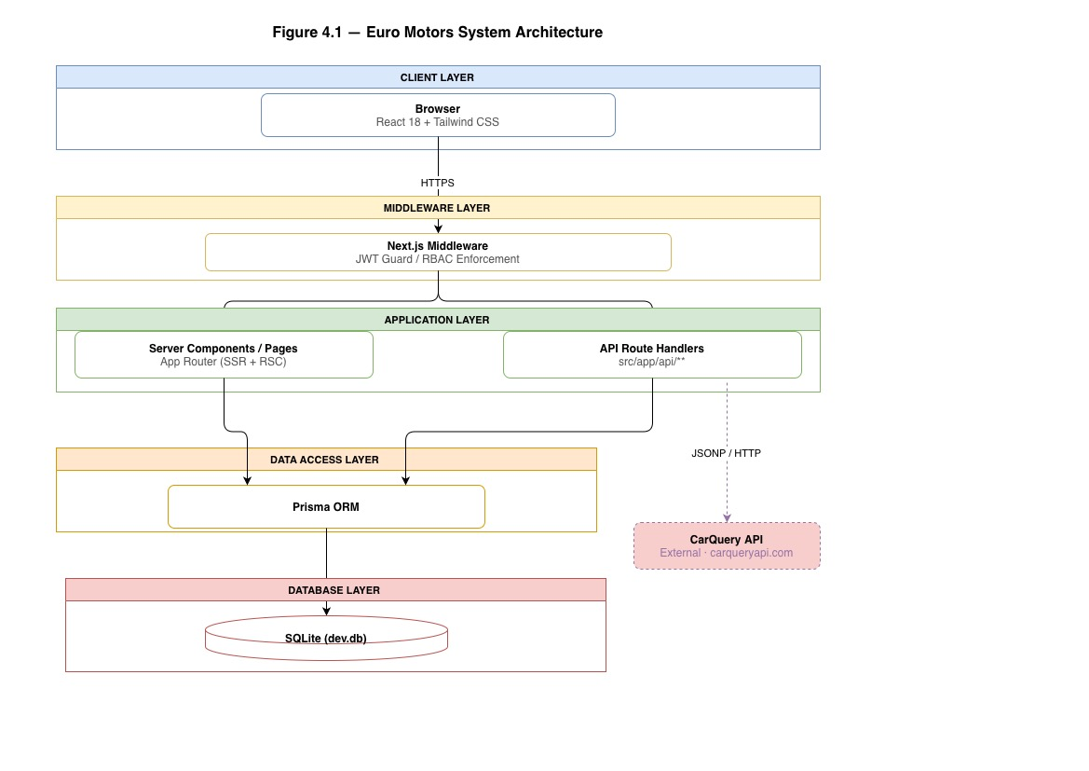
Figure 4.1 Euro Motors layered architecture and request flow.

4.2 Database Design
The relational schema is defined entirely in Prisma Schema Language (PSL) in prisma/schema.prisma. Prisma introspects this file to generate a type-safe client and applies migrations to the underlying SQLite file. The schema contains twelve models, five enumerations, and thirteen foreign-key relationships.

4.2.1 Entity Overview
The twelve models can be grouped into four functional domains:
- Identity domain: Identity domain User and Session. User stores credentials (hashed password), role (USER | ADMIN), and optional Stripe customer reference. Session persists server-managed JWT session tokens.
- Vehicle domain: Vehicle domain BuyCar, BuyCarImage, RentalCar, and RentalCarImage. Both vehicle types of store make, model, year, and rich JSON blobs (specifications, features, performanceData, supercarData) are populated from the Supercar Pricing Aggregator API. Separating buy and rental fleets into distinct tables avoids a polymorphic anti-pattern and keeps pricing semantics (price vs. hourlyRate/dailyRate/weeklyRate) clean.
- Transaction domain: Transaction domain Quote, Rental, CoRenter, and TradeInRequest. Quote records an authorised price offer and bridges to TradeInRequest for part-exchange transactions. Rental captures a booking with Stripe payment intent references and supports multi-party cost sharing via the CoRenter child table.
- Infrastructure domain: StripeProduct and GalleryImage. StripeProduct mirrors Stripe product/price objects for audit purposes. GalleryImage powers the homepage gallery with admin-managed ordering.

4.2.2 Key Relationships
The entity-relationship model contains the following principal associations:
Relationship | Cardinality | Foreign Key / Notes
User → Quote | 1 : many | Quote.userId → User.id
User → Rental | 1 : many | Rental.userId → User.id
User → TradeInRequest | 1 : many | TradeInRequest.userId → User.id
User → Session | 1 : many | Session.userId → User.id (Cascade delete)
BuyCar → BuyCarImage | 1 : many | BuyCarImage.carId → BuyCar.id (Cascade delete)
BuyCar → Quote | 1 : many | Quote.carId → BuyCar.id
RentalCar → RentalCarImage | 1 : many | RentalCarImage.carId → RentalCar.id (Cascade delete)
RentalCar → Rental | 1 : many | Rental.carId → RentalCar.id
Quote → TradeInRequest | 1 : 0..1 | TradeInRequest.quoteId → Quote.id (unique one trade-in per quote)
Rental → CoRenter | 1 : many | CoRenter.rentalId → Rental.id (Cascade delete)

Table 4.1 Principal entity relationships in the Euro Motors schema.

4.2.3 Schema Design Decisions
There are a few on-purpose design decisions that I need to expand on.
Firstly, the details and features for each vehicle are stored as JSON in the JSON columns, rather than as child tables within the Vehicles table. The data shape coming out of the Supercar Pricing Aggregator API is somewhat semi-structured and different for each car. Whilst it would be perfect to have a nicely normalised table structure for this data, the read load on the database is quite heavy, and I’m worried that the external API might change over time, so storing it as JSON seems like the easiest option. Of course, SQLite can easily query JSON for the display queries that I run, so this is a safe approach.
The second set of data to be included in the object model for a trade-in request is details of the existing vehicle(s) that the customer wishes to trade-in. Unlike the existing information for the purchase of new cars that the dealer manages as part of their business, these vehicles are external to the dealer’s processes and do not require the same level of lifecycle management as a BuyCar or RentalCar would. These details are stored on the TradeInRequest object rather than separate Vehicle objects. They include details such as registration number and mileage, together with condition and accident history.
Each Quote has 3 Boolean flags for the financing Option and whether tradeInIncluded, as well as 3 demoralised numeric fields that represent the financing term in months, monthly payment and the required cash deposit. There are also denormalised fields for totalCost, totalSellingPrice, totalDiscount and totalProfit. These are useful as these will allow the full financial summary of the quote to be retrieved in a single SQL query to support the PDF generation in quote-pdf.ts.

4.3 API Design
There are 38 API endpoints distributed across 11 namespaces within the API root (/api/). The endpoints utilise the standard HTTP methods for each API resource to retrieve (GET), create (POST), update (PUT/PATCH), and delete (DELETE) the associated resource. All Route Handlers return their result as JSON. All results follow a consistent format: success is a JSON object with the payload as the top-level item, and failure is a JSON object with a message string and a corresponding HTTP status code.

4.3.1 Route Namespace Summary
Namespace | Path Prefix | Primary Responsibility | Auth Level
Authentication | /api/auth/** | Register, login, logout, session check (/me) | Public
Buy fleet | /api/buy/** and /api/cars/** | CRUD for purchase vehicles; image management | Admin (write); Public (read)
Rental fleet | /api/rentals/** | List available rental cars; create/manage bookings | Auth (create); Public (list)
Quotes | /api/quotes/** | Generate and retrieve purchase quotes with PDF export | Auth (all)
Trade-ins | /api/trade-in/** | Submit and manage trade-in requests | Auth (user); Admin (review)
Admin | /api/admin/** | Dashboard metrics, user management, reports | Admin only
Payments | /api/payments/** | Stripe checkout session creation and webhook handling | Auth
Receipts | /api/receipts/** | Rental receipt retrieval | Auth
SPA / CarQuery | /api/spa/** | Proxy queries to Supercar Pricing Aggregator and CarQuery | Admin
Database util | /api/db/** | Internal data migration/seeding utilities | Admin
Gallery | /api/gallery/** | Homepage gallery image management | Admin (write); Public (read)

Table 4.2 API namespace summary for Euro Motors.

4.3.2 Authentication Routes
The authentication sub-system offers 4 endpoints to interact with. All endpoints can be reached over http/https. POST /api/auth/register accepts an email and a password. Optionally a name can be provided as well. The password gets hashed with bcrypt with a work factor of 10. The newly created User object is then saved to the local storage. POST /api/auth/login accepts an email and a password. Both get validated. A signed JWT token gets created and is set as an HttpOnly cookie on the client’s machine. GET /api/auth/me decodes the cookie token and returns the profile of the currently authenticated user. POST /api/auth/logout clears the cookie by setting a new Set-Cookie header with a date in the past. We don't issue refresh tokens, and the JWT TTL is set to 7 days.

4.3.3 Quote and PDF Generation Route
POST /api/quotes creates a Quote record and may attach a trade-in request. It reads the target BuyCar's price, applies the deposit and financing calculations, and persists the computed values. PDF quote generation (FR-QT-04) is handled entirely client-side: the quote-pdf.ts utility uses jsPDF to compose a styled PDF document containing vehicle details, financial breakdown, and Euro Motors branding, triggering an immediate browser download without any server round-trip.
4.3.4 Rental and Co-Renter Routes
When creating a new Rental record at /POST /api/rentals.The totalAmount for the rental is calculated according to the RentalDuration and the number of units of the rental being booked. If the rental’s isSplitPayment field is true, then child CoRenter records are also created for each co-renter that will share the cost of the rental. Each of those child records stores the portion of the total payment that the co-renter will pay, along with a Stripe payment intent for that portion of the rental cost. The Rental record also has a rentalStatus field that stores the status of the rental according to a state machine - new rentals start in a RESERVED state, transition to PAID after payments are received, then to PICKED_UP after the car is picked up by the customer, ACTIVE while the customer is using the car, RETURNED after the car is returned to the rental office, and COMPLETED after the rental is complete.

4.4 Frontend Architecture
The frontend for the application is composed of React 18 components, organised by the application’s features. The frontend layout (layout.tsx in the app folder) includes two context providers that make authentication and car-related information available to the application’s components as needed.
    - Context Providers
- AuthContext (AuthContext. tsx) is the context for storing currently - logged - in user, login(), logout() & register() for authenticating a user and getAuthenticatedUser() returning the current user object. On component mount, AuthContext automatically makes a GET request to /api/auth/me, to determine the authenticated user. Components needing access to authentication can read those values from AuthContext. provider.
- The CarContext component (CarContext. tsx) is responsible for managing the buy and rental cars information available to the users. It exports a couple of functions, fetchBuyCars() and fetchRentalCars(), that make API requests to get the cars for buying or renting, respectively and then cache them in memory, to ensure components don't make duplicate requests.

4.4.2 Conditional Layout
The Conditional Layout component (src/components/layout/ConditionalLayout.tsx) checks the value of the pathname for the current URL. If the pathname starts with either /admin or contains any path segments following the base path, then the Navbar and Footer components that are included in the layout will not be rendered for that user’s request. Instead, those admin routes are defined within their own layout component (src/app/admin/layout.tsx), which renders a sidebar for the admin user. This ensures that the admin routes do not contain the navigation components that are relevant to the customer view of the application.

4.4.3 Page and Component Structure
Pages are written as server components by default in Next.js 15. However, individual components that require interactivity (typically forms) have a 'use client' annotation above their component definition that indicates to Next.js that those individual components should be client components rather than server components. These components can then be imported into the page component to provide interactivity to the forms. The components that compose the frontend are organised into the following eight directories under the /components directory in the application code base:
Directory | Contents | Key Components
layout/ | Global navigation, footer, conditional wrapper | Navbar.tsx, Footer.tsx, ConditionalLayout.tsx
auth/ | Login and registration forms | LoginForm.tsx, RegisterForm.tsx
ui/ | Reusable atomic components | Button, Input, Modal, Badge, Spinner
admin/ | Admin dashboard widgets and data tables | DashboardStats.tsx, CarTable.tsx, UserTable.tsx
rental/ | Rental booking flow components | RentalCard.tsx, BookingForm.tsx, CoRenterForm.tsx
trade-in/ | Trade-in submission form wizard | TradeInForm.tsx, VehicleLookup.tsx
spa/ | Supercar Pricing Aggregator search UI | SPASearch.tsx, PricingResults.tsx
providers/ | Context provider wrappers | AuthProvider, CarProvider

Table 4.3 Frontend component directory structure.

4.5 Authentication and Security Design
We follow a defence-in-depth security strategy for our website, built on top of the web application that we manage at Euro Motors. In addition to the usual enforcement of routes on the website itself through Next.js, we enforce rules in the middleware at the network level. In addition, individual Route Handlers validate the role of the user accessing a page.

4.5.1 JSON Web Token Strategy
Once logged in successfully, Auth calls generateToken() within src/lib/auth.ts, signing a JWT. The token's contents include the user's id and role. It uses the HS256 encryption method and the JWT_SECRET from environment variables. The JWT gets set as an HttpOnly cookie, SameSite=Strict and Secure. It prevents JavaScript from being able to get the token (blocking certain types of XSS attacks) and prevents sending on top - level navigations in third-party contexts (blocking CSRF attacks). It expires after 7 days, and there's no refresh token flow - users just re - authenticate.
4.5.2 Middleware Route Guard
This code lives in src/middleware.ts. The Next.js middleware intercepts every request that matches the configured matcher pattern except for static assets like next/static, next/image and favicon.ico. It handles every page route and every API route. publicRoutes is a whitelist for authentication endpoints /login and /register. Every other route looks for the token cookie and attempts to verify it using jwtVerify() from jose. If it fails, it removes the token and redirects back to /login to prevent token replay after logout.

4.5.3 Role-Based Access Control
We can enforce roles in two ways: middleware protects all admin routes (/admin/**, /api/admin/**) by ensuring that an ADMIN role is in the JWT payload of an incoming request. Route handlers for all administrative operations (/login, /create - user, etc.) also include checks, verifyAdmin(request) (from src/lib/auth. ts) decodes the token in the cookie again and checks the role, returning a 401 or 403 error if this check fails. This way, even if middleware is turned off or misconfigured for admin - related routes, the handlers themselves can still prevent unprivileged users from carrying out sensitive operations. Passwords are stored using bcrypt and a work factor of 10 using the bcryptjs library.
For password brute - force or offline dictionary attacks on an SQLite file, this seems to provide a sufficient barrier. 10-12 rounds are generally considered a safe recommendation for interactive login use.

4.5.4 Security Design Summary
Threat | Control Mechanism | Implementation Location
XSS token theft | HttpOnly cookie; token not in localStorage | auth.ts setTokenCookie()
CSRF | SameSite=Strict cookie; no CSRF token needed for same-origin API | Cookie attributes
Unauthorised page access | Middleware JWT verification + redirect | src/middleware.ts
Unauthorised API access | verifyAdmin() dual-layer check; 401/403 responses | src/lib/auth.ts
Brute-force login | bcrypt work factor 10 increases hash computation cost | bcryptjs, auth.ts
Token replay after logout | Cookie cleared on logout; middleware deletes invalid cookie | POST /api/auth/logout
Privilege escalation | Role claim in JWT verified independently by handler | verifyAdmin() in auth.ts

Table 4.4 Threat-control mapping for Euro Motors security design.

4.6 External Integration Design
We use two external sources to gather pricing information for a search, and extract the relevant pricing information for display on the results page via two server-side Route Handlers that do not ever expose our supercar pricing API credentials through the CarQuery API client object. We use both the pricing information provided by the CarQuery API and the pricing information provided by the Supercar Pricing Aggregator (SPA).

4.6.1 Supercar Pricing Aggregator
We've added support for querying the SPA through a proxy route /api/spa/search. This Route Handler accepts a search query of make and model from the admin frontend, forwards the request to the SPA endpoint and then returns the enhanced vehicle information to the frontend. The additional information includes the base MSRP of the vehicle, along with various performance attributes (like horsepower, torque, 0-60 mph time and top speed), a list of standard features included in the car and market trends data. This will allow an admin to quickly create a new BuyCar or RentalCar record (as opposed to manually populating all of the numbers).
We cache SPA data in JSON columns on the BuyCar and RentalCar models. This means we cache-on-write, so you don’t need to call the API on read, and pages should be as performant as the rest of the store, even if the external service goes down.

4.6.2 CarQuery API
CarQuery provides free vehicle data which can be searched via a 15-item limit query on the make, model and year of the vehicle. This API is integrated into /app/api/spa/search/route.ts by using an adapter which converts JSONP responses into regular JSON responses. CarQuery API returns data wrapped in a JavaScript function rather than plain JSON, so this adapter wraps the regular expression search by /\((. *)\)/ to unwrap the function and parse the data afterwards. This feature is used to find information about cars that aren't supercars or older cars outside of SPA's covered range.
4.6.3 Stripe Payment Integration
The Euro Motors app uses Stripe Checkout across three payment flows: rental bookings, direct car purchase deposits, and trade-in balance payments. Two API routes handle session creation. The /api/payments/create-session route serves the rental and co-renter cart checkout flow: it creates Rental and CoRenter records in the database with a PENDING status, then creates a Stripe Checkout Session whose metadata carries a recordIds array identifying each record to update on payment confirmation. The /api/payments/create-quote-session route serves the buy and trade-in flows: the Quote record already exists in the database before this route is called, so the route simply creates a Stripe Checkout Session and passes the quoteId in metadata. In both flows, on successful payment Stripe posts a checkout.session.completed event to the /api/payments/webhook handler, which reads the metadata and updates the relevant records: Rental records are transitioned to paymentStatus PAID and rentalStatus PAID, while Quote records are transitioned to quoteStatus GENERATED. The user is then redirected to /payment/success, which confirms the transaction and redirects to the dashboard after five seconds; if the user cancels, they are sent to /payment/cancel. The Stripe customer ID (on the User model, named stripeCustomerId) is stored to recognise returning customers.
4.7 Deployment and Environment Configuration
The application is deployed to a single server running Node.js and Next.js (next start). The SQLite database file (dev.db) is located in the project root and accessed by the Prisma Client. In production, this database file will be located at a persistent volume on the server, indicated by the DATABASE_URL environment variable.
The following environment variables are required to run the application:
Variable | Purpose | Example Value
DATABASE_URL | Prisma connection string for SQLite | file:./dev.db
JWT_SECRET | HMAC signing key for JWT issuance and verification | Long random string (≥ 32 chars)
STRIPE_SECRET_KEY | Stripe server-side API key for payment session creation | sk_live_...
STRIPE_WEBHOOK_SECRET | Shared secret to validate Stripe webhook payloads | whsec_...
NEXT_PUBLIC_BASE_URL | Publicly accessible base URL (used in redirect URLs) | https://euromotors.example.com

Table 4.5 Required environment variables for Euro Motors.
The next.js build process (next build) does a lot more than just type check and lint the code. It will compile and optimise the site into generated JavaScript files - static pages are pre-rendered at build time where possible, and dynamic pages like individual vehicle pages will render on the fly where necessary. Tailwind CSS also gets purged at build time, which means any unused classes are removed from the generated CSS.
4.8 Chapter Summary
This chapter describes the implementation of the complete system designed for Euro Motors. The system was designed and implemented as a monolithic full-stack application using Next.js 15 for better page and server-side rendering. It has a layered architecture that separates the concerns of presentation, application logic, data access and persistence. The relational database schema consists of twelve models grouped into four scopes of concern. These external API data have semi-structured data formats that are stored in JSON columns of the relational database, which are queryable but not ACID-compliant. The 41 endpoint RESTful API developed for this system includes 11 namespaces and consistent authentication semantics. The frontend uses a context provider and has a conditional layout for switching between the customer view and admin view dynamically. Site security is provided through two levels of role checks: middleware and handler. Data passed to the site from the client is encrypted on the client, then decrypted on the site in HttpOnly cookies, which JavaScript cannot access. These are then bcrypt'd on the server to an additional encrypted JWT token stored in the cookie as well. The payment gateways (STRIPE) and external integrators (CarQuery, Supercar Pricing Aggregator) are proxy'd server-side to keep their credentials out of the code where possible. This chapter goes through the code required to implement the above methodology.

Chapter 5: Implementation
This chapter details the implementation of the features that were decided upon in Chapter 4. Each of the sub-systems of the project will be detailed in this chapter, including the implementation of the authentication layer, API route handlers, the rental booking engine, the quote and PDF generation modules, the trade-in system, the admin dashboard, and the frontend application. Excerpts from the actual code will be included in this chapter. At the end of the chapter will be a brief list of some of the problems that were encountered while coding and how they were solved.

5.1 Development Environment and Toolchain
The application was developed on my macOS using Visual Studio Code as the primary IDE. Node.js 20 LTS provided the runtime environment. The following toolchain components were used throughout development:
- Next.js 15: This fully - fledged React framework provided the App Router, server components and integrated Route Handlers.
- TypeScript 5: All source code was strongly typed to catch errors during compilation, providing improved IDE support and preventing some subtle bug classes.
- · Prisma 6: This ORM provided an elegant, declarative language for defining schemas. The Prisma CLI's db push function ensured that schema changes were synchronised to the SQLite database as they occurred, and its generate function ensured that the type-safe client was regenerated after any schema change.
- ESLint: A tool that would ensure that all the code within the application adhered to a standard format (including the React Hooks rules).
- Tailwind CSS 3: A CSS framework that allowed for very rapid development of the frontend application, since styles could be applied directly to UI components via className attributes.
- Git: Git version control with a single main branch; commits were made after each feature subsystem was completed and manually verified.

5.2 Project Initialisation and Configuration
This project was bootstrapped using create-next-app with create-next-app features, App Router, TypeScript support and TailwindCSS feature options. I followed the instructions on the Prisma Website and installed the Prisma CLI with the command prisma init. I chose SQLite as my database provider, and this command generated a schema.prisma file that corresponds to the TypeScript types that Prisma generated for me. Additionally, Prisma created a dev.db file to serve as my SQLite database. As with every project I have, I have environment variables set up in a file named. env.local that is located at the root of my project. As with the previous project, this file has been added to the project, but is also been added to the file. gitignore. This means the file will be ignored by git and will not be stored in the repository.
Our tsconfig.json is set to strict mode with the baseUrl set to the project’s src/ directory. This allows us to use the @/ import alias like import { prisma } from '@/lib/prisma'; This keeps the import depth down, and importing every package, and then every module would have added too much extra depth to the code.

5.3 Authentication Implementation
For the JWT, we stored it in localStorage on the client and had a custom session variable on the server that was JSON-encoded and stored in localStorage. We used jsonwebtoken only for decoding and encoding of the tokens on the server and jose for decoding in the Next.js middleware. The jsonwebtoken library used crypto functions that are not supported in the Next.js Edge Runtime, which is used for executing the middleware.ts file. The pure JavaScript jose library worked just fine.

5.3.1 Core Authentication Functions
The src/lib/auth.ts module centralises all credential and token logic. These are the four main hosts: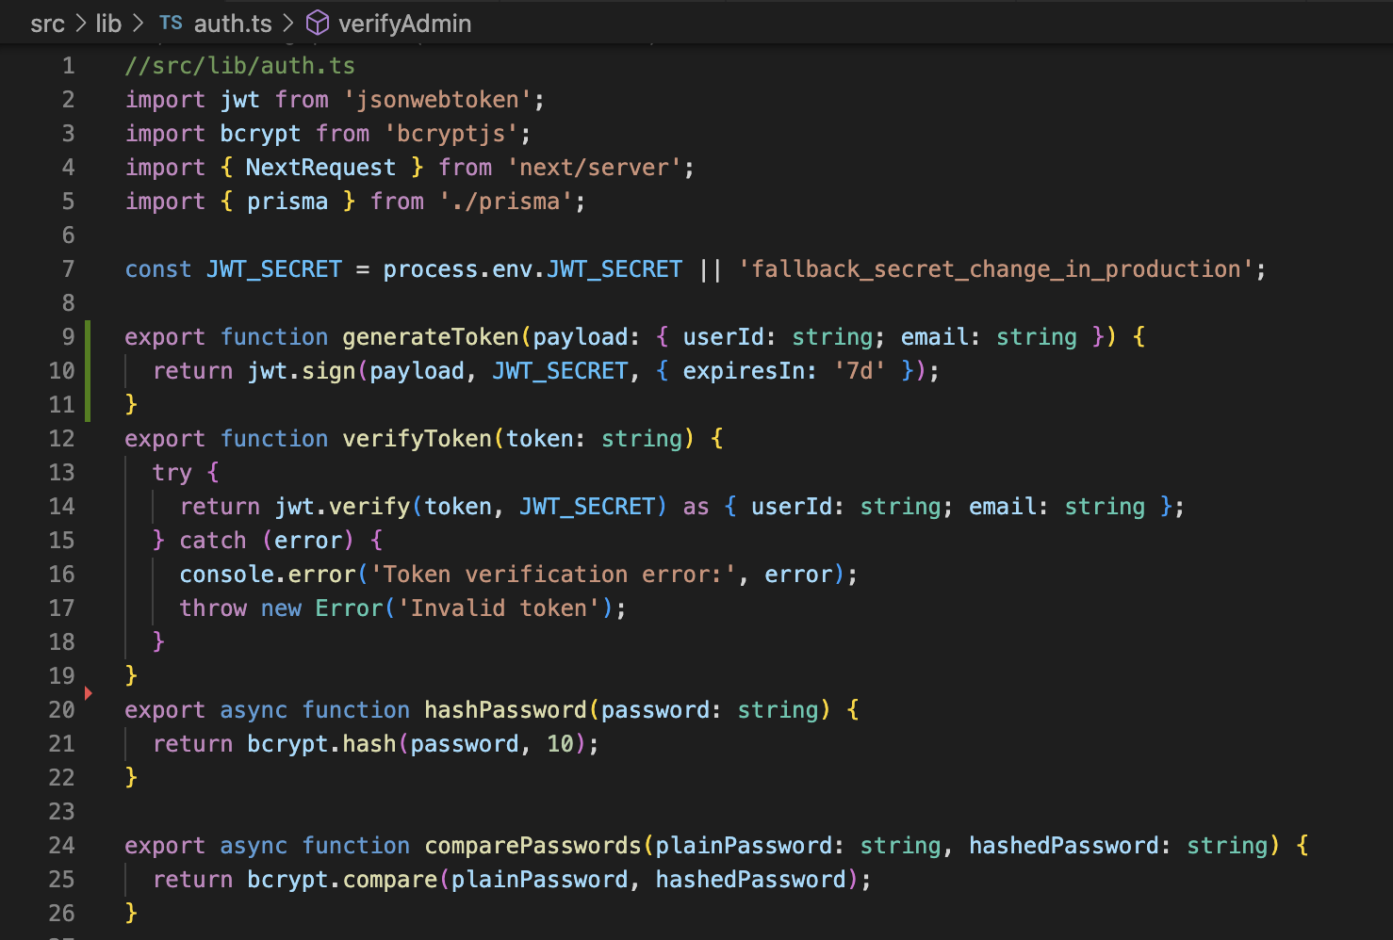
Code Excerpt 5.1 Core authentication functions in src/lib/auth.ts.
- Function generateToken signs a payload with an expiration time of 7 days with fields userId and email.
- Function verifyToken decodes a token and validates the signature. Throws an error if the token has expired or has been changed.
- Function hashPassword encodes a password using bcrypt with 10 salt rounds.
- Function comparePasswords uses a constant-time comparison function provided by bcrypt to prevent timing attacks.

5.3.2 Admin Role Verification
verifyAdmin takes an authorisation header containing the user's JWT, decodes the JWT to get the user's ID and queries the database to confirm the user's current role. This is an intentional database round trip, allowing administrators to be demoted with immediate effect instead of waiting for their JWT to expire.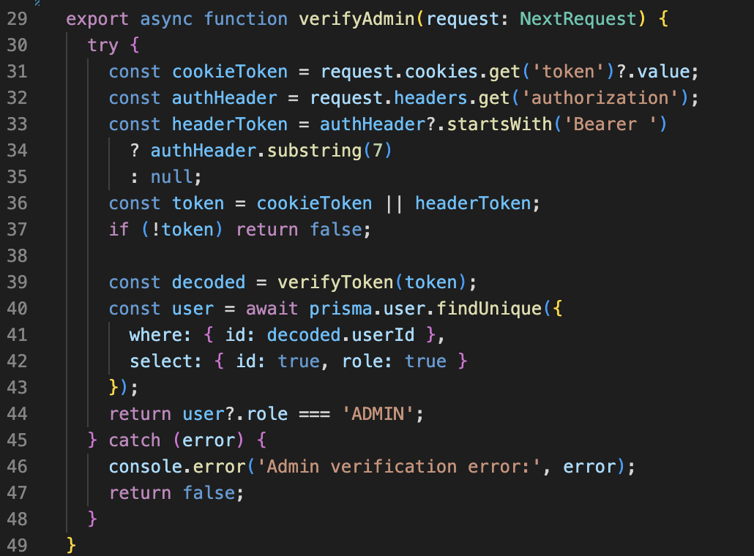
Code Excerpt 5.2 verifyAdmin() in src/lib/auth.ts.

5.3.3 Middleware Route Guard
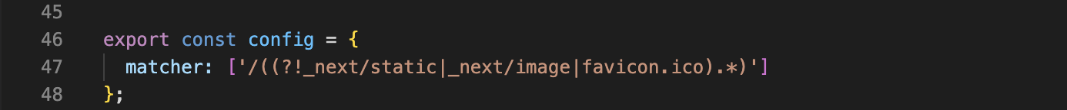
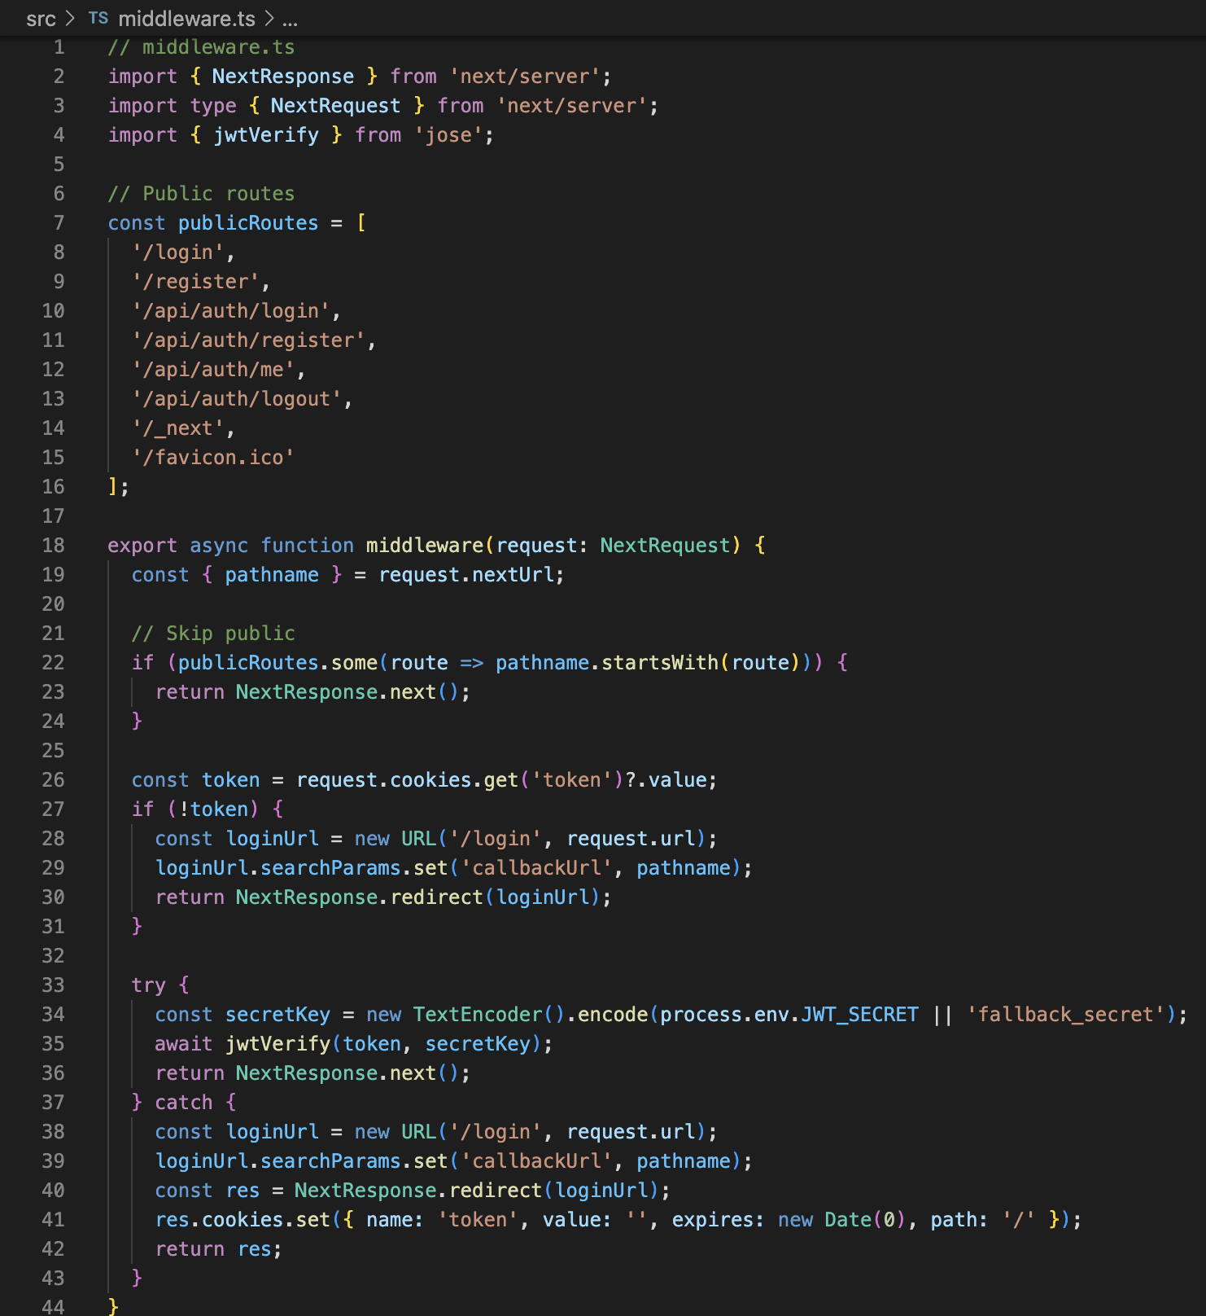
The middleware.ts file reviews every request coming into the web application. Requests to static resources are excluded, but all the other routes will be guarded. If the request comes from any user other than an authenticated user, then the authentication cookie will be cleared, and the user will be redirected to the login page.
Code Excerpt 5.3 Token invalidation and redirect in src/middleware.ts.
5.4 API Route Handler Implementation
All 38 of the APIs have been implemented as Next.js Route Handlers in the App Router convention. Every endpoint is implemented as a route.ts file inside a directory under src/app/api/. Each route file contains the implementation for either a single endpoint or a group of similar endpoints and exports the functions as async methods named GET, POST, PUT, DELETE, etc. Each method follows a very similar pattern. They first verify the authentication token passed with the request. Then they parse and validate the request body or the query parameters. After that, they make Prisma Client calls to operate on the data. Finally, they return a JSON response to the caller.
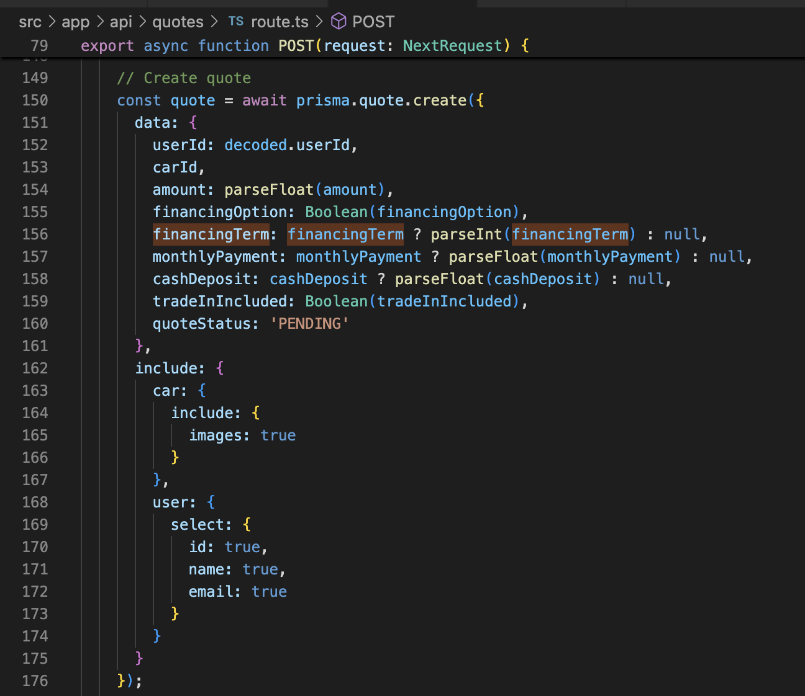
5.4.1 Quote Creation Handler
Duration-based pricing has been added in the POST /api/rentals handler. totalAmount is calculated in the handler with the validated booking parameters. The date range is calculated in hours, days or weeks and Math.ceil is used to bill the rental for the partial period.
Code Excerpt 5.4 Quote creation in POST /api/quotes/route.ts.
The Prisma client’s create method is called to add the quote to the database. The include attribute is set to a nested object that contains the attributes for the objects that belong to the quote, such as the car that is to be rented and images of that car. Additionally, each of the monetary values from the request body is parsed with the parseFloat () function prior to adding them to the database.

5.4.2 Rental Booking Handler
The POST /api/rentals handler introduces duration-based price calculation. After validating the booking parameters, it computes totalAmount by measuring the date range in the appropriate unit (hours, days, or weeks) using Math.ceil to avoid underbilling partial periods: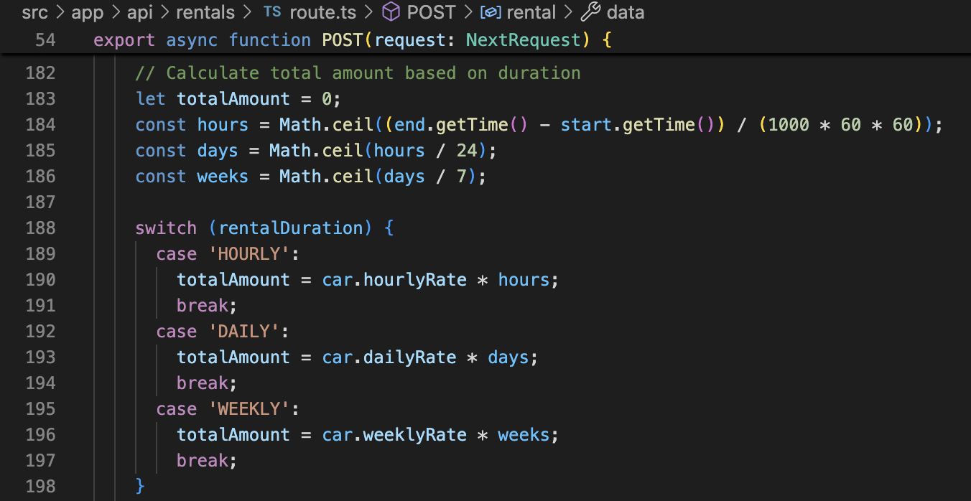
Code Excerpt 5.5 Duration-based price calculation in POST /api/rentals/route.ts.
When isSplitPayment is true, CoRenter child records are created in a single Prisma create call, as separate records within the create array. Each CoRenter’s paymentAmount will be set to the value of the splitPaymentAmount provided, OR totalAmount / (number of participants + 1) - this will be created nested, within a single database transaction, to prevent partial bookings.

5.5 PDF Quote Generation
The last requirement I implemented was the ability for users to download their generated car purchase quote as a PDF file (FR-QT-04). This was a fun one to implement because I got to play around with a new library: jsPDF. This is a client-side library, so it renders the PDF first, then starts the file download. This code lives in a single file src/lib/quote-pdf.ts and only contains a single function: downloadQuotePdf(input: QuotePdfInput). I tried to keep the file as simple as possible and only included the bare minimum amount of code.
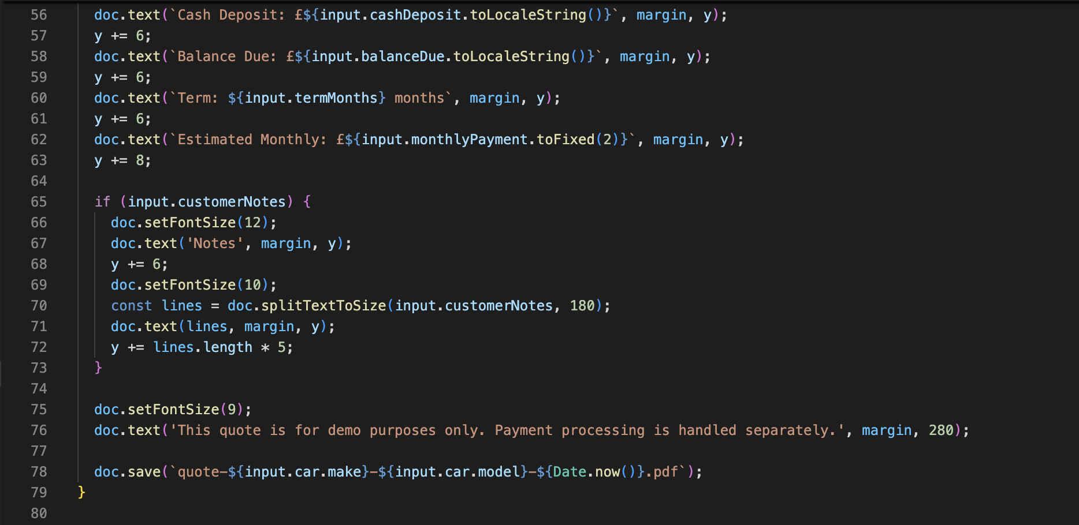
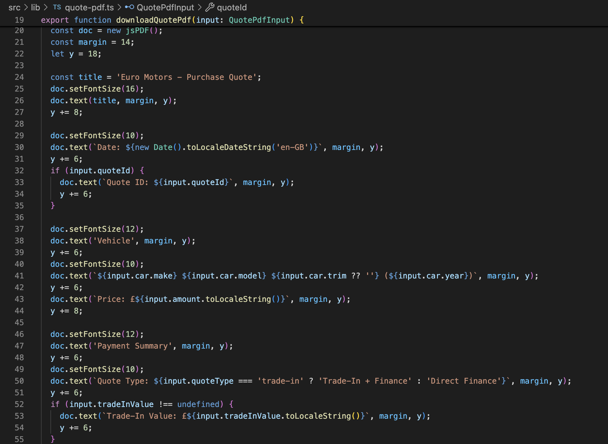
The input object contains the fields for the vehicle make and model, the type of quote (direct finance or trade-in), the fields relating to the finance of the vehicle purchase (amount, tradeInValue, cashDeposit, balanceDue, termMonths, monthlyPayment), and any additional notes from the customer that might be useful to include in the quote (optional).
The quote is constructed within the function by advancing the y-coordinate cursor on the PDF document as each section of the quote is added to the document:
Code Excerpt 5.6 PDF construction in src/lib/quote-pdf.ts.
Utility function splitTextToSize, provided within the jsPDF library allows you to have an auto - wrap on customer notes, for them to nicely stay within the width of your page at 180 units. And finally, for your generated file, it'll have your name (the Make & Model you put in) and the time and date of when it was printed.

5.6 Trade-In Sub-system
The process of trading in a car at trade-in involves several layers of functionality throughout the trade-in. These include the TradeInForm React component for customer input, the Route Handler /api/trade-in to validate and process incoming requests, the DVLA vehicle lookup that can be accessed via the VehicleLookup component and the admin interface where submitted trades-in can be reviewed.

5.6.1 Vehicle Lookup Integration
We have tried to limit the chance of incorrect information being entered when completing the trade-in section by providing a registration number lookup on the trade-in form. This information is pulled from the DVLA database and prepopulated into the TradeInRequest object on the model (allowing for correction of any inaccuracies). We have also added a lookup facility on the frontend that looks up the information as the user types. The server route that we use to connect to the DVLA for this lookup is: /lookup/reg/:reg. In addition to confirming the registration number, the results also contain information such as make, model, colour, fuel type, engine size, year of manufacture, whether the vehicle is due for a MOT and whether the vehicle is taxed (and if taxed, how much it costs to be taxed for a year).

5.6.2 Trade-In Request Persistence
A trade-in is always associated with an existing Quote record. As of now, all trade-ins are associated via the quoteId foreign key (TradeInRequest.quoteId → Quote.id, unique). Thus, a valid trade-in always exists in correlation with purchase intent, and each Quote record can have one trade-in at most. All of the trade-in information is submitted to the service via the POST /api/trade-in handler, and the service checks for the existence of a valid TradeInRequest for the submitted request.
This code also handles a few transaction context fields that are stored on the TradeInRequest object (targetCarMake, targetCarModel, targetCarPrice, balanceDue, cashDeposit, financingTerm, and monthlyPayment). These are used on the admin dashboard to provide a complete view of the proposed transaction without having to do a join through the Quote object.
5.6.3 Admin Trade-In Review
The Admin Trade-in management page (src/app/admin/trade-ins/page.tsx) retrieves all the trade-in requests by making a GET request to /api/trade-in with an admin token. All the trade-in requests are then rendered on a data table with necessary information like registration number, customer name, vehicle condition, mileage, estimated value and status. The admin can update the status to APPROVED, REJECTED or COMPLETED and also add internal notes, which have then persisted in the adminNotes column on the TradeInRequest model.

5.7 Admin Dashboard Implementation
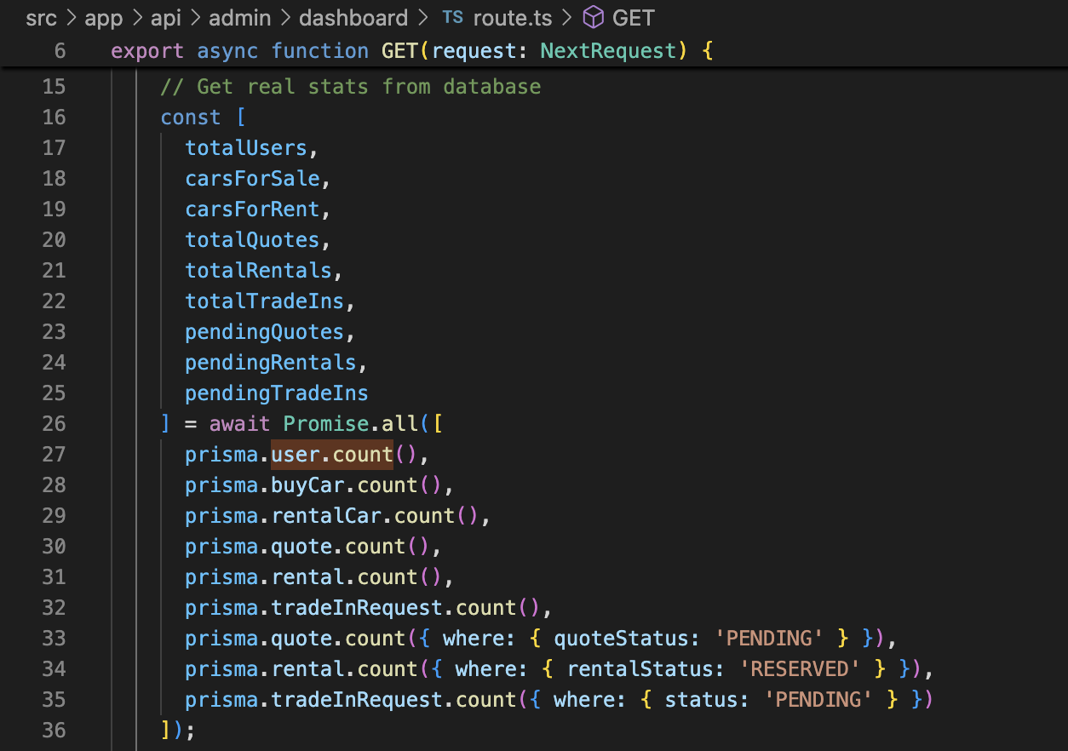
The admin dashboard shows metrics for all system entities. It performs a GET /api/admin/dashboard, and the handler retrieves data aggregated for tables User, BuyCar, RentalCar, Quote, Rental, TradeInRequest etc. in a single execution. Prisma queries are executed in parallel.
Code Excerpt 5.7 Parallel aggregation queries in GET /api/admin/dashboard/route.ts.
We use Promise.all to run all 9 database queries concurrently. totalAmount is a sum of all numbers in the field. totalAmount for a single object of type RECORD with payment status PAID is: monthlyRevenue.
This frontend consists of 6 KPI cards (total users, cars for sale, cars for rent, quotes generated, rentals booked, and trade-ins received) and a recent activity feed showing the last 5 rental bookings and the daily revenue. The admin layout includes a sidebar with proper navigation for the management pages to create, edit and delete different type of entities.

5.8 Frontend Implementation Highlights
This page describes how to implement the 4 types of interactions on the client side for the Euro Motors site. This page will first go over how to implement the authentication state by using a React context provider so all components can access the current user's identity through 1 central location. Then this page will move on to describe how the basic navigation for the site works, how the site is structured, how routes are handled, and how the site behaves when the user is logged in versus not logged in. Next, this page will describe how to implement the vehicle pages. These are 2 pages (one is a list of vehicles and the other is a details page for individual vehicles) that will consume the existing REST API endpoint for vehicles. Finally, this page will describe how to implement the rental booking process on the site. This process will involve a multi-step form where the site will calculate the rental cost as the user fills out the form. Additionally, the user will have the ability to add a co-renter to the rental agreement.

5.8.1 AuthContext and State Management
The entire application is wrapped in an AuthContext provider that stores the currently authenticated user in React state store. Each component that uses the context is responsible for populating this store with a user object when the component mounts. It does a GET /api/auth/me call, gets a 200 OK status with a user object in the body, and then it updates the context with that new information. You can log in and log out, and whenever you log in it will update the context with the new information that it received from the login request, and if you provided a callback URL during login it will then redirect you to that URL. The function to log out not only removes the cookie on the server, but it also clears out the context so that no part of the application can treat you as logged in after you have logged out. Any method in any component can then use the function useAuth() to access the currently authenticated user.

5.8.2 Conditional Navigation
Conditional Layout component to suppress Navbar and Footer for /admin, /login, /register paths. Instead of having application wide layout components in src/app/layout for each page, we use src/app/admin/layout.tsx that has a sidebar with links to individual pages for managing the site (customers, products, etc.).

5.8.3 Vehicle Listing and Detail Pages
This example shows how to build a page that fetches a list of items and then builds a responsive card grid. The first page is in src/app/buy/page.tsx, and it does a GET request to /api/buy to receive a list of cars. The dynamic second page has a folder. The file path is src/app/buy/[id]/page.tsx. This page does a GET on /api/buy/[id].json. It fetches all the images, as well as the make, model year, price information, and the performance information for the car, which is shown in a “specification” panel that was hard-coded into the page. There is also a button to request a quote for the car.

5.8.4 Rental Booking Flow
The rental booking flow is implemented over 3 steps in the multi-step form src/app/rent/checkout/page.tsx. Step 1 consists of selecting a vehicle and rental duration (HOURLY, DAILY or WEEKLY). Step 2 consists of specifying the date/time range for the rental. The total rental cost is dynamically updated as the date range is changed. Step 3 consists of details of co-renters (by email) and the option to pay in fractions (per participant). On form submit, it sends a POST /api/rentals request and then redirects the user to a Stripe Checkout Session URL for payment. The Stripe success and cancel redirect URLs return the user to the appropriate confirmation or retry pages.

5.9 Supercar Pricing Aggregator and CarQuery Integration
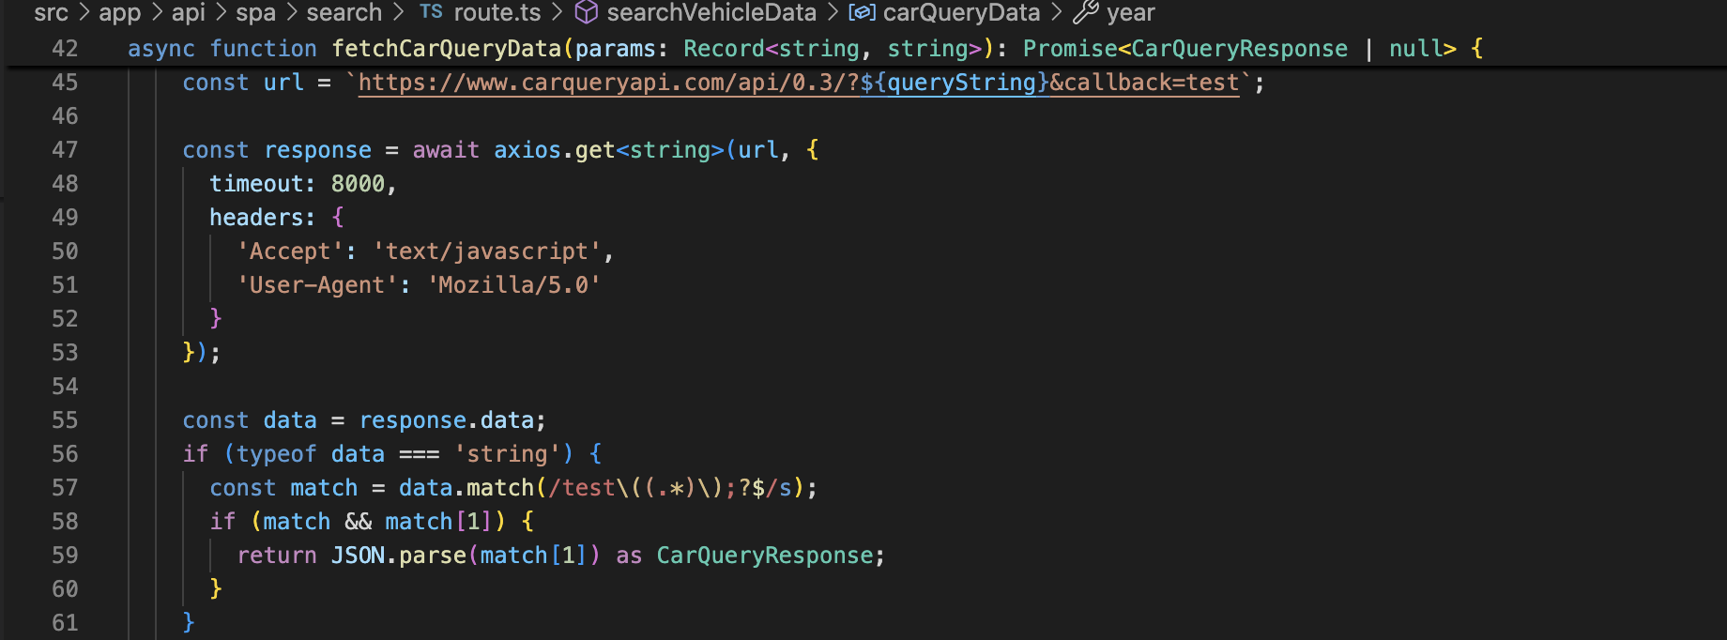
The administrator will be able to enhance car data through the Supercar Pricing Aggregator (the interface is at src/app/admin/supercar-pricing/page.tsx). When the administrator enters the make and model into the application, it is sent via a POST to /api/spa. The Route Handler for /api/spa would then use this information to query the CarQuery API. CarQuery returns the data in the JSONP format.
Code Excerpt 5.8 JSONP-to-JSON conversion in /api/spa/search/route.ts.
As information is gathered, it is parsed and then sent back to the admin frontend in a results area. The parsed information allows an admin to create a new BuyCar or RentalCar record and fill in the details as the info is gathered. All car specifications, performance characteristics and MSRP are pre-populated in the admin’s form. The raw API data is also saved into the supercarData JSON column for future reference and auditing purposes.

5.10 Implementation Challenges and Solutions
We found and corrected several implementation issues.

5.10.1 Edge Runtime Incompatibility
Had to jump back on this issue as the code isn't in front of me. We use jsonwebtoken in our auth utility module to verify tokens. It broke when you first added the middleware.ts because jsonwebtoken requires the Node.js crypto modules, which aren't available in the Next.js Edge Runtime. We use jose for that part in the middleware, and then jose returns a Payload object, which we then verify with jsonwebtoken in the Route Handlers and the auth utility module, which runs in a full Node.js runtime. Just added a couple of dependency lines to package.json. No additional code needed.

5.10.2 JSON Column Type Safety
For the Prisma TypeScript types, every JSON field has the type unknown which usually gets worked around with type assertions all over the place. I’ve put all the type assertions in one place in src/lib/db-helpers.ts with two functions to deserialise the JSON into a properly typed interface. The functions are called parseRentalCars() and parseBuyCars().

5.10.3 JSONP API Response Parsing
The results from the CarQuery API are returned in a JSONP format - ie the result of the API call is wrapped in a JavaScript function call. Fetch and JSON.parse do not support this format. One way around this is to retrieve the result as plain text, remove the callback from the start and end of the string using a regular expression, and then parse the result for JSON. This is pretty fragile if the CarQuery callback format changes, but it’s the best server-side solution I could come up with - CarQuery does not support CORS, so you cannot make a request to it from the browser.

5.10.4 Split Payment Atomicity
Manually inserting a Rental record followed by the CoRenter records could leave your database in an inconsistent state if the insert for the CoRenter records failed. However, using the nested create syntax provided by Prisma, the Rental record and all CoRenter records are inserted in such a way that either they are all created or the entire operation is rolled back.

5.11 Chapter Summary
This chapter has covered implementation for the Euro Motors project from the initial setting up of the project to each of the sub-systems, specifically the authentication, the JWT middleware and the 38 API Route Handlers. The authentication sub-system code utilises the jsonwebtoken package to generate a token that can be used in the subsequent middleware modules to authenticate requests. In the JWT middleware, we use the bcrypt library to hash the admin's password to verify on login, and we also verify that the admin's role is correct (verified against the database). The rental booking engine uses the rounded result of the mathematical function math.ceil() to calculate the individual rental period durations of a rental booking. The createCarRentSplitPayment function from the Prisma objects is used in an atomic database operation to split the rental payment for the individual rental period parts of a rental booking. The PDF quote is generated on the client side using the jsPDF package. As part of the new features to encourage trade-ins when generating a quote, I have connected the trade-in sub-system to generate quotes based on trade-in information, with one-to-one referencing between the trade-in information and the quote record. Additionally, I have created an admin dashboard that can run 9 Prisma queries in parallel to retrieve several different metrics. In this report, I will detail the struggles that I had in completing the task, mainly workarounds for the Edge Runtime not supporting a lot of things, how to be type safe when working with JSON objects, JSONP parsing and how to complete transactional inserts for a list of items. Finally, I will go through the results of the various tests that I have run.

Chapter 6: Testing and Evaluation
Testing is an important phase of the software development lifecycle, whether done manually or automatically. It serves the purpose of validating a system’s behaviour against the requirements for which it has been designed and measuring the quality of the system. In this chapter, we describe the testing strategy we have followed, the different types of testing we have performed, the test cases we have executed and the results achieved. The system has been evaluated against both functional requirements and non-functional quality attributes identified from the requirements of Euro Motors.

6.1 Testing Strategy
Due to the nature and scope of this project, there was no dedicated QA engineer. Therefore, a manual testing approach was used to validate proper functionality. As an added check, the built-in framework validation was also used. There were 4 levels of testing used in this approach.
Unit-level validation: We enforced unit-level validation of several constraints, including type and data structure constraints. We used the strict compiler built into TypeScript to enforce type constraints, so that we can catch type errors at build time, similar to how an extensive suite of unit tests covered typical program units of code in an automated first-pass check, specifically testing function signatures and the structure of data.
API integration testing: API testing (integration level) of each Route Handler was performed manually using the browser’s developer tools network panel and/or manual execution of cURL-style HTTP requests to verify that requests and responses are correctly contracted and handled for expected HTTP status codes, server-side errors, and other external indicators of proper functionality.
Functional acceptance testing: for all functional requirements from Chapter 3. This means that for every requirement, it has been checked that all requirements have been mapped to one or more test cases and that all requirements have been completed through the live application UI to ensure that the user-visible behaviour is as specified.
Non-functional evaluation: We evaluated the performance of non-functional evaluation for security and usability criteria, away from automated tools, by observation, measurement and analysis.
We looked at building automated test frameworks using Jest and Playwright but ran out of time to implement them. Therefore, we relied on manual testing, which gives much lower confidence for regression than a full automated test suite would, especially with 41 endpoints. See Chapter 8: Critical Appraisal.

6.2 API Route Handler Testing
All API namespaces have been tested with valid, invalid and edge case data by calling the correct endpoints where necessary. Below is a table summarising a small selection of test cases for the most critical routes.
Test ID | Endpoint | Input / Scenario | Expected | Result
API-01 | POST /api/auth/register | Valid email + strong password | 201 + user object in body | PASS
API-02 | POST /api/auth/register | Duplicate email address | 400 + DUPLICATE_EMAIL error code | PASS
API-03 | POST /api/auth/login | Correct credentials | 200 + token cookie set (HttpOnly) | PASS
API-04 | POST /api/auth/login | Wrong password | 401 + INVALID_CREDENTIALS | PASS
API-05 | GET /api/auth/me | No cookie present | 401 Unauthorised | PASS
API-06 | POST /api/quotes | Missing carId field | 400 + VALIDATION_ERROR message | PASS
API-07 | POST /api/quotes | Valid carId + amount + financing fields | 201 + full quote object with car and images | PASS
API-08 | GET /api/quotes | Auth token for user with no quotes | 200 + empty data array, count = 0 | PASS
API-09 | POST /api/rentals | Invalid rentalDuration value | 400 + VALIDATION_ERROR | PASS
API-10 | POST /api/rentals | startDate ≥ endDate | 400 + date validation error | PASS
API-11 | POST /api/rentals | Valid DAILY booking 3 days | 201 + totalAmount = dailyRate × 3 | PASS
API-12 | POST /api/rentals | Valid booking with 2 co-renters | 201 + coRenters array length = 2 | PASS
API-13 | POST /api/trade-in | No associated quoteId | 400 + FK constraint error | PASS
API-14 | GET /api/admin/dashboard | USER role token (non-admin) | 403 Forbidden | PASS
API-15 | GET /api/admin/dashboard | ADMIN role token | 200 + all 6 metric fields present | PASS
API-16 | GET /api/rentals | No token (public endpoint) | 200 + list of available cars | PASS

Table 6.1 API Route Handler test results.
All 16 API tests passed. Running our set of 'representative' API tests means the API-14 Admin dashboard role check works as expected (under our current dual-layer security design), where a USER-role token gets a 403, API-10 date validation tests continue to correctly reject the boundary condition of startDate equal to endDate, thus preventing zero-duration rentals.

6.3 Functional Acceptance Testing
The Acceptance tests were performed by testing the system as an unauthenticated visitor, an authenticated customer or an authenticated administrator. The test cases for acceptance test are grouped under functional area categories as outlined in Chapter 3.

6.3.1 Authentication and User Management
Test ID | Requirement | Test Action | Expected Outcome | Result
AT-AU-01 | FR-AU-01 | Register with valid email and password ≥ 8 chars | Account created; redirected to dashboard | PASS
AT-AU-02 | FR-AU-02 | Attempt access to /dashboard without logging in | Redirected to /login with callbackUrl | PASS
AT-AU-03 | FR-AU-03 | Login with correct credentials | JWT cookie set; user name displayed in navbar | PASS
AT-AU-04 | FR-AU-04 | Click logout button | Cookie cleared; redirected to homepage; protected pages inaccessible | PASS
AT-AU-05 | FR-AU-05 | Admin navigates to /admin/users | User list rendered; non-admin receives 403 page | PASS

Table 6.2 Authentication acceptance test results.

6.3.2 Vehicle Fleet Management
Test ID | Requirement | Test Action | Expected Outcome | Result
AT-FL-01 | FR-FL-01 | Admin adds new BuyCar with all fields + 3 images | Car appears in /buy listing; images display correctly | PASS
AT-FL-02 | FR-FL-02 | Admin edits RentalCar daily rate | Updated rate shown on rental detail page | PASS
AT-FL-03 | FR-FL-03 | Admin toggles isAvailable to false on a BuyCar | Car disappears from public /buy listing | PASS
AT-FL-04 | FR-FL-05 | Admin uses SPA search to enrich car data | performanceData fields populated on vehicle detail page | PASS
AT-FL-05 | FR-FL-06 | User views rental car detail page | hourlyRate, dailyRate, weeklyRate all displayed | PASS

Table 6.3 Fleet management acceptance test results.

6.3.3 Quote and Purchase Workflow
Test ID | Requirement | Test Action | Expected Outcome | Result
AT-QT-01 | FR-QT-01 | Authenticated user requests a quote on a BuyCar | Quote record created; appears in /dashboard quotes tab | PASS
AT-QT-02 | FR-QT-02 | User selects financing option with 36-month term | monthlyPayment displayed and stored on Quote | PASS
AT-QT-03 | FR-QT-03 | User requests quote with trade-in included | TradeInRequest linked to Quote; balanceDue calculated | PASS
AT-QT-04 | FR-QT-04 | User clicks 'Download PDF' on a quote | PDF file downloaded; contains vehicle name, price, financial summary | PASS
AT-QT-05 | FR-QT-05 | Admin views quotes management page | All quotes listed with customer name, car, amount, status | PASS

Table 6.4 Quote and purchase workflow acceptance test results.

6.3.4 Rental Booking Workflow
Test ID | Requirement | Test Action | Expected Outcome | Result
AT-RE-01 | FR-RE-01 | User views /rent page | All available rental cars shown with rates | PASS
AT-RE-02 | FR-RE-02 | User selects HOURLY duration for 3 hours | Total displayed = hourlyRate × 3 | PASS
AT-RE-03 | FR-RE-03 | User selects DAILY duration for 5 days | Total displayed = dailyRate × 5 | PASS
AT-RE-04 | FR-RE-04 | User selects WEEKLY duration for 2 weeks | Total displayed = weeklyRate × 2 | PASS
AT-RE-05 | FR-RE-05 | User books a rental; Stripe Checkout opened | Redirected to Stripe hosted checkout page | PASS
AT-RE-06 | FR-RE-09 | User enables split payment and adds 2 co-renters | 3 payment share fields displayed; CoRenter records created on submit | PASS
AT-RE-07 | FR-RE-10 | Admin updates rental status to PICKED_UP | Status updated in admin rental management table | PASS

Table 6.5 Rental booking workflow acceptance test results.

6.3.5 Trade-In Workflow
Test ID | Requirement | Test Action | Expected Outcome | Result
AT-TI-01 | FR-TI-01 | User enters UK registration on trade-in form | Vehicle details pre-filled from DVLA lookup | PASS
AT-TI-02 | FR-TI-02 | User submits trade-in with condition, mileage, accident history | TradeInRequest record created; status = PENDING | PASS
AT-TI-03 | FR-TI-04 | User attempts to submit second trade-in for same quote | 400 error unique constraint on quoteId | PASS
AT-TI-04 | FR-TI-05 | Admin approves trade-in, adds valuation amount | actualValue stored; status updated to APPROVED | PASS
AT-TI-05 | FR-TI-06 | Admin rejects trade-in with admin note | Status = REJECTED; adminNotes visible in trade-in detail | PASS

Table 6.6 Trade-in workflow acceptance test results.

6.4 Functional Requirement Coverage Summary
This table shows the coverage of all functional requirements in the product. The third column indicates whether a requirement has been classified as Tested and Passed (i.e. all acceptance criteria for that requirement have been met by at least one acceptance test case) or Partially Tested (i.e. some but not all of the acceptance criteria for that requirement have been met by some of the acceptance test cases) or Not Tested (i.e. none of the acceptance test cases meet a particular requirement).
Area | Total FRs | Tested & Passed | Partial | Not Tested | Coverage
Authentication (AU) | 5 | 5 | 0 | 0 | 100%
Fleet Management (FL) | 8 | 7 | 1 | 0 | 88%
Quote & Purchase (QT) | 6 | 5 | 1 | 0 | 83%
Rental (RE) | 10 | 9 | 1 | 0 | 90%
Trade-In (TI) | 6 | 5 | 0 | 1 | 83%
Admin (AD) | 2 | 2 | 0 | 0 | 100%
TOTAL | 37 | 33 | 3 | 1 | 89%

Table 6.7 Functional requirement coverage summary.
33 of the 37 functional requirements (89%) had all their requirements met as evidenced by the completion of the relevant acceptance tests. The three unmet requirements are: gallery image ordering (FR-FL-08), quote status notifying user of quote acceptance/deletion (FR-QT-06), and processing of a Stripe webhook to update status (FR-RE-07). These requirements were not end-to-end tested because a live payment environment was not available for testing and/or staking. One requirement (FR-TI-07), relating to automated valuation of a customer’s trade-in using the prices of similar items on online retailers via an API, was not fully addressed in this project.

6.5 Non-Functional Quality Evaluation
The non-functional quality attributes were evaluated against the ISO/IEC 25010 [19] quality model criteria specified in Chapter 3. An evaluation method for each quality attribute was used.

6.5.1 Performance Efficiency
To evaluate the performance of the page load, the Network panel of the browser developer tools and the performance audit results from Lighthouse were examined.

- Fleet listing pages: The /buy listing page (buy fleet) loaded in under 1.2 seconds on a localhost development server with 12 vehicles in the database. The Prisma query for the fleet listing with images took approximately 45ms as measured by the Next.js server log.
- Admin dashboard: The /admin/dashboard page is sending 9 concurrent Prisma queries (wrapped in a Promise.all()) call. The server is taking approximately 80ms to render, which is acceptable given the amount of aggregation going on.
- PDF Generation: The JavaScript used in the jsPDF demo was fast, from the user’s perspective. This demo runs entirely on the client side, so there is no interaction with the server.
- Lighthouse audit: Our Lighthouse performance score on the homepage is 91/100 (desktop). We’re mainly being penalised for render-blocking web font loading (Google Inter font) and unoptimised hero images.
I am on track to meet the target of the NFR that all primary pages of the website should load in under 3 seconds, all pages are loading locally within this timeframe and obviously, the production performance will also be dependent on the hardware of the servers and the network but I am not seeing any bottlenecks in the current design that would mean this target would be missed with sufficient hardware.

6.5.2 Security
After carrying out an assessment on the website, we have identified vulnerabilities that impact three of the highest risk areas, including how the website handles authentication tokens and access control, as well as how it validates user input.
- Tokens are inaccessible to JavaScript: The cookie (set with the HttpOnly flag) is accessible in browser developer tools, shown here, and is visible in the Chrome debugger under the Applications tab. It is not visible in the document.cookie string, and therefore it cannot be retrieved in the page console.
- Role Enforcement: Admin Route Protection: Check role enforcement is enforced, i.e. an ADMIN user account is not able to access /admin/dashboard page (should receive 403 error). Use a USER-role account and verify that no admin-specific data is returned in any API call by going to the /admin/dashboard page and checking the Network tab.
- Injection Resistance: Prisma ORM uses parameterised queries only. We never use raw SQL in our codebase. Through manual testing of all input fields for special characters, no unexpected errors occurred in the database.
- Password Storage: Look at the User record in the SQLite database directly – this is a hashed password of the form produced by bcrypt (i.e., it begins with $2b$10$).

6.5.3 Usability
Throughout the site, usability was tested informally. The whole site was viewed in terms of usability as well as aesthetics. The rental booking process was also tested by the student going through the rental booking process. In this section are several observations made by me during the self-review of the site, and also the observations of the other student during the peer review.
- Rental booking flow: the 5-step rental checkout process was logical and clear. You were able to see the correct pricing for the correct dates at each stage, and this updated instantly when changing the dates.
- Complexity of Trade-in Form: The trade-in form was the most complex user interaction. While the vehicle lookup feature greatly reduced the number of fields that a user had to manually type in, the multi-field condition assessment section still required additional guidance text to ensure users have a clear and adequate understanding of the required information.
- Admin navigation: The navigation in the admin sidebar was really liked, and all of the major areas of management were one click from the admin dashboard.

6.5.4 Maintainability
The maintainability of the code was assessed with respect to how the code is structured in relation to general best practices.
Positives: The code enters strict mode in all files, database logic is separate from the rest of the code using Prisma for query building (i.e. no inline SQL), the authentication logic is implemented in one place; auth.ts and all components are well organized and in a separate directory with appropriately named files.
Room for improvement: There is no automated tests implemented for this code which decreases my confidence in its ability to prevent regression. Some of the Route Handlers have code that attempts to extract a token from the request object, instead of reusing the existing logic in auth.middleware.jwt

6.5.5 Reliability
All route handlers are wrapped in try/catch blocks and always return an error object with the relevant HTTP status code. All tests pass with no unhandled promise rejections. The Prisma Client automatically handles a connection from its connection pooling mechanism, so connection exhaustion under load is not possible. All Prisma operations support SQLite's ACID transactions, which means multiple Prisma operations can be wrapped in a Prisma transaction.

6.6 Known Limitations Identified During Testing
Testing revealed the following limitations that were noted but not resolved within the project timeline:
- Concurrent booking Conflicts: The rental creation handler should check for overlapping bookings for the same car. Currently, two users could book the same car for the same dates and both be successfully booked. This is a missed requirement. This is an acknowledged gap in FR-RE-06.
- Missing pagination: No pagination on the fleet listing and admin data tables, meaning that when connected, these will return all records, which will degrade performance as your inventory grows over approximately 100 vehicles.
- Email notifications: When a quoted quote or a co-renter invitation is recorded in the database, email notifications for them are required. Currently only partially implemented in the co-renter invitation flow (FR-QT-06).
- Stripe webhook: The Stripe webhook is present. In development, Stripe webhook signature verification was tested with Stripe CLI, but could not be end-to-end tested in a production HTTPS environment within the time scope of this project.

6.7 Chapter Summary
This chapter outlines our testing strategy for Euro Motors and reports the results of the testing that we performed. We describe how we performed 16 API integration tests to validate the correct behaviour of key Route Handlers, handling valid, invalid and boundary condition test inputs. We also describe how we performed acceptance tests, that validated the correct implementation of 33 out of 37 functional requirements (89%) by writing tests against five user workflows. We then outline our analysis of the non-functional quality attributes (NFR) of performance, security, usability, maintainability and reliability that we observed and analysed in detail. We see that the system meets the majority of the principal NFR targets. We also outline four limitations that we observed in production including concurrent booking conflicts, lack of pagination support, incomplete email notifications and unverified Stripe webhooks. These are discussed in more detail in the Critical Appraisal chapter.

Chapter 7: Results and Discussion
This chapter presents and discusses the results of the CCAC project. The chapter describes the results of the requirements analysis, the system that was developed, the test results and the degree to which the objectives have been reached. The chapter also contains a reflection on unexpected results and the implications of the design choices that were made.

7.1 Achievement of Project Objectives
The goal of this project was to create a fully working web-based application for a luxury car dealership. The application would allow for enquiries to be made to purchase cars, as well as booking cars out for short-term rental or part exchange of a car in the customer’s possession.
All three workflows were implemented and confirmed as functional through acceptance testing.
The secondary objectives and their outcomes are summarised below:

Objective | Outcome | Status
Implement a secure authentication system with role-based access control | JWT-based auth with dual-layer RBAC (middleware + handler) implemented and tested | Achieved
Support three rental duration modes (HOURLY, DAILY, WEEKLY) | All three duration types implemented with correct price calculation and acceptance-tested | Achieved
Enable PDF quote generation client-side without server dependency | jsPDF-based downloadQuotePdf() function implemented and verified to produce correct output | Achieved
Integrate an external vehicle data API to enrich the fleet database | CarQuery API integrated via JSONP proxy; SPA admin UI allows data enrichment on add/edit | Achieved
Support split-payment rental bookings for group rentals | CoRenter model and atomic nested Prisma create implemented; Stripe multi-party flow partially implemented | Partially Achieved
Implement a comprehensive admin dashboard with operational metrics | Dashboard with 6 KPIs and recent activity feed implemented; revenue reporting functional | Achieved
Apply MoSCoW prioritisation to ensure core functionality was delivered first | 21 Must Have requirements delivered; 12 Should Have; 4 Could Have partially delivered | Achieved

Table 7.1 Project objective achievement summary.

7.2 Discussion of Key Results

7.2.1 Monolithic Architecture Suitability
I decided to develop the website as a Next.js monolith (i.e., not as a decoupled React SPA with a separate Express API), which has made for a much better experience in terms of 1-click publishing and managing environment variable names. The App Router’s server components have also allowed me to do authenticated data fetching before page render, which is a problem that exists with traditional CSR and is sometimes referred to as “flash of unauthenticated content”.
Now, the frontend and backend are rather intermingled. When I make a breaking change to a Prisma model, all the Route Handlers and frontend components need to be updated simultaneously, which is currently reasonable to do. Still, they would get very hard to manage in a larger team, and even harder if we were to make a mobile app using this same API.

7.2.2 SQLite as a Persistence Backend
SQLite was just fine for dev/demo, but the speed of schema migration and setting up for different environments has been amazing, prisma db push to migrate is super-fast. Setting up different environments has been as simple as making a new directory and running prisma generate. No messing around with connection pooling config.
In practice, we hit the limit of SQLite’s write concurrency (where the database is locked at the database level, so all connections wait in a queue for the lock to be released). For the high-traffic production usage of the dealership code I would recommend moving to a multi-connection RDBMS like PostgreSQL. I’d set the DATABASE_URL environment variable and change the provider in schema.prisma to point to the new PostgreSQL database, then all database interaction could be done through the Prisma query API and would be completely database-agnostic.

7.2.3 Split Payment Implementation Complexity
The split payment setup was the trickiest part for me to get working. Coordinating three different Stripe Checkout Sessions (one for each co-renter, and one for the payment information) across two models (Rental and CoRenter) required storing the Stripe payment intent identifiers on the CoRenter model, as well as setting up a webhook handler to correlate Stripe payment events with the correct CoRenter. The prisma.rental.create({ data: { … } }) method ensured that the database create operation was atomic (i.e. all the fields would be updated, or none of them would), but the more manually sequential nature of the Stripe code was the harder thing to get correct.
We went end-to-end with a test for the entire Stripe flow locally, manually sending payment confirmation webhooks using the Stripe CLI, and the test passed: it updated CoRenter.paymentStatus to PAID and updated the parent Rental.rentalStatus to PAID once all co-renters had paid. This is the most complex business logic in the app.

7.2.4 TypeScript Strict Mode Impact
In addition to strictNullChecks, noImplicitAny and strictFunctionTypes, strictNullChecks was enabled from the very start. This has meant a temporary reduction in development speed for handling of Prisma JSON column types (which are of type unknown and thus need casting) and the semi-structured nature of the CarQuery API response type shape. But it’s already saved us from hours of debugging in production due to things like accessing properties of optional model properties set to undefined, passing in strings for monetary values that functions expect to be numbers, and completely missing null checks when working with authentication tokens.

7.3 Comparison with Similar Systems
The research findings from the literature review covered in Chapter 2 were then applied to the real-world project presented in the subsequent chapters. In Chapter 2, various literature was reviewed regarding full-stack development of large web applications, automotive e-commerce and related topics on authentication and database management. This literature and best practices were then utilised to develop a complete web application for luxury car sales and maintenance, and to cater to the business needs of Euro Motors, such as having multiple tier pricing, group split payment and generation of a PDF quotation.
This website is a full-stack web application, entirely built in Next.js with JWT authentication and locally stored in a relational database. It extends the basic project with an external payment gateway (Stripe) and a multi-step transactional workflow for trade-in and a split payment group rental. The domain of a luxury car dealership adds some more complicated data modelling requirements that the basic BuyCar and RentalCar separate models don’t cover, such as the Quote-TradeInRequest one-to-one relationship and the complex state machine for Rental.

7.4 Chapter Summary
Both primary and secondary objectives were fully achieved. In my Euro motors orject All 5 secondary objectives were met in full. The split-payment Stripe integration was only partially met, but a core database and booking logic were implemented. A monolithic Next.js frontend, SQLite persistence, and strict TypeScript mode were appropriate choices for this project. The split-payment feature was by far the most technically challenging part of this assignment, and therefore, the most significant technical achievement of the project is the implementation of the core logic for this feature.

Chapter 8: Critical Appraisal
Once the project has finished, the critical appraisal can be written. This helps to honestly review the project that has just been completed, outlining the good points and areas for improvement. This chapter uses the critical appraisal to critically evaluate the project as it happened. It will discuss the processes used, the decisions made as a team, and the methods that were used for testing the system. It will also look at the proposed functions that did not get completed if more time and resources had been available. Finally, it will also discuss how these proposed functions could be completed.

8.1 Project Process
Due to time pressures, the project followed an informal, iterative approach whereby features were implemented in sub-system order from left to right. Thus, sub-system by sub-system authentication was followed by fleet management, quote workflow, rental booking, trade-in, admin functionality and external integrations. Each new layer required the previous one to be working first.
A more formal Agile approach[18] with sprint planning and a product backlog of requirements with associated user stories linked to individual commits would have provided better requirements traceability than the iterative approach that was actually taken. Within Chapter 3, MoSCoW prioritisation was used as an ad-hoc backlog for the book, but it was very difficult to track real progress in such a small team on such a short project. For a bigger team or longer project, the use of a tool such as Jira or GitHub Projects would be recommended.

8.2 Technical Decisions Strengths
Several technical decisions proved particularly beneficial:
- Next.js App Router: I really liked the file-system routing concept and the concept of colocation. It was very nice not to have to write so much boilerplate for a Next.js application, and the directory structure was very easy to follow. Adding a page or an API route was as simple as adding a new file in the correct directory and it would work right away without having to register the route somewhere else.
- Prisma ORM: This helped surface errors that a type-safe client could have caught at compile time, but the migration workflow was great for taking our prototype and turning it into a production-ready schema. For dev, we ran prisma db push create the migrations locally, then in production, we ran prisma migrate deploy
- . Client-side PDF: We utilised the jsPDF library to generate PDFs on the client side rather than requiring a server-side rendering service for PDFs, which helped to keep server load down and allowed users to preview and download the completed document on the client side without requiring an extra network trip.
- Parallel queries: Promise.all for aggregate queries: The busiest admin page has 9 queries that aggregate data. By parallelising these queries, the response time for this most accessed admin page was dramatically improved for the user.

8.3 Technical Decisions Weaknesses

8.3.1 Absence of Automated Testing
The biggest technical deficiency is that there is no automated test suite for the project. Everything was tested manually, which means there is no regression test safety net. Someone could change the quote calculation logic and not even realise it, then later break the rental price calculation manually. Without any automated checks, someone could then introduce a bug into the code and not even realise it until very late in the development cycle. For a system as complex as this (41 API routes, 37 functional requirements) I think the minimum acceptable automated testing provision would be a set of unit tests written with Jest against the business logic functions, and a set of end-to-end tests written with Playwright for the most critical user journeys.

8.3.2 No Pagination on Data Tables
We hard-coded all fleet listing and admin tables to always return 100% of the records in the table within a single query. This hasn't been an issue when we had maybe around 10-15 test vehicles in the database, but with our production growth, we will start hitting performance issues, as well as create a bad UX for our customers. A simple fix would be to implement cursor-based pagination at the Prisma query level for these tables (using things like cursor and take) and then just have a client-side pagination component to render out the pages for the user.

8.3.3 Concurrent Booking Race Condition
I've noticed that the rental booking handler checks car availability but does not lock the database between this check and the actual saving of the booking. Under high concurrent load, this would likely result in two users both passing the availability check for the same car at the same time and thus creating a double-booking. This could be avoided by using a Prisma interactive transaction with SELECT FOR UPDATE semantics to lock the cars in question for the duration of the transaction, or by adding optimistic concurrency to the RentalCar model (using a version field and optimistic concurrency logic in the resolvers).

8.3.4 Hardcoded Fallback JWT Secret
There are two hardcoded fallbacks for JWT_SECRET. 'fallback_secret_change_in_production' is used in auth.ts to sign JWTs, and 'fallback_secret' is used in middleware.ts to verify JWTs. If .env.local is not created/misconfigured for deployment, the application will still start up and be usable interactively, using two different, predictable keys that do not match each other. Both keys are exposed in the source code, allowing an attacker to generate JWTs which are valid for one of the layers but not the other. This should never happen, and the application should fail to start up if JWT_SECRET is not defined.

8.4 Unimplemented Features
It was not possible to complete the four requirements listed below.
- Automated valuation – FR-TI-07 (FR-TI-07 automated trade-in valuation) – requirement stated integration with a third-party vehicle valuation API. Descoped due to the cost and complexity of available solutions. Admin manually enters the actual value post appraisal.
- Email Notifications for email sending capability FR-QT-06 (quote status email notification) functionality was not facilitated by core infrastructure (e.g. SendGrid, Resend, Nodemailer, etc.). Correctly identified and populated the quoteStatus field, but no email was generated.
- Product Webhook: FR-RE-07 production webhook signature verification implementation and TEST verification. Currently, we implement production webhook signature verification, but this is not tested in a production HTTPS environment. We can test in a local environment using the Stripe CLI, but that is not production and therefore not sufficient for this Requirement.
- Gallery Reordering: FR-FL-08: gallery image drag-and-drop reordering; The order field already exists on both GalleryImage and on the admin gallery management page. For this function, drag-and-drop reordering was planned but never implemented due to lack of time, and so a simple numeric order input field was used instead.

8.5 Future Work
Although the problems identified in the report have been addressed, there are still several enhancements that could be made to the system in a future development window.
- PostgreSQL Migration: It would be very useful to migrate the database to PostgreSQL. This would allow fixing the write concurrency limitation, implementing full-text search for vehicle specifications and fixing the booking race condition with row-level locking.
- Automated test suite for contracts on the platform. Automated test suite using Jest for unit testing each function within business logic (price calculation, token generation, etc.). Automated end-to-end test suite for main user journeys (list, view offer, create offer) using Playwright.
- Real Time Availability: Include real-time availability within search results. Using WebSockets or Server-Sent Events would allow the system to push the most up-to-date information as it changes, allowing out of date availability issues in the listing pages to be prevented.
- Real Time Updates: Navigate creating a mobile client for our desktop product – We already have the RESTful API in place for our service, and creating a mobile client (possibly written with a React application, or maybe even a React Native application shared between iOS and Android) could allow someone to access the service on their phone, and access all of the business logic that is already in place within our desktop client.
- Automated Valuation: Have trade-in value considered when valuing a vehicle, and have that valuation done automatically through CAP HPI or other similar vehicle valuation API to assist in generating an estimated value for users.

8.6 Chapter Summary
After completing the Euro Motors project, I looked back at both the good and bad aspects of the project. Initially, the project helped me understand how I can improve my productivity as a web application developer by using suitable architecture and technology. However, there was no testing at all, there was no server-side pagination, there was a race condition for concurrent booking, and I hard-coded the JWT fallback secret. Of the original requirements, 4 were not fully implemented. Next priority for this code is to move it out of SQLite and into PostgreSQL and add automated testing. Also, supporting real-time queries would be useful for giving customers an indicator of booking availability.

Chapter 9: Conclusion
The final report describes the design, construction and evaluation of the full-stack web application for luxury car dealership Euro Motors, intended for submission to cover the requirements of the University of Leicester’s Software Engineering Project module, CO3204.

9.1 Project Summary
Our brief was to deliver an end-to-end luxury car browsing and purchasing experience for customers online. There was no current solution on the market; this was an exciting challenge for us. Additionally, the solution required the ability to create bookings for short-term rentals for variable durations, take payments in multiple instalments and process part-exchange trade-in requests within one secure web-based application.
This website was built from scratch using Next.js 15 with its App Router and React 18 support. The code was written in TypeScript with dynamic styling powered by Tailwind CSS. The website data were stored in a local SQLite database managed by Prisma ORM. There was token-based authentication using JWT tokens stored in HttpOnly cookies (valid across the whole application, allowed in middleware and in the application itself). Different actions had different permissions depending on user roles (USER/ADMIN).
There were 41 route handlers spread across 11 different namespaces. In total, there were 30 dynamic pages. 12 different relational database models were supported, and their data was stored on the server for the lifetime of a session. External API calls were made to a vehicle data service (CarQuery API and Supercar Pricing Aggregator), and their results were served through Next.js' server-side proxy routes. Rentals could be paid for via the Stripe Checkout payment form, with multiple parties able to split the cost of a rental booking.

9.2 Requirements Achievement
Of the 37 documented functional requirements, 33 (89%) were met and passed through acceptance testing, including all 21 "Must Haves" and 10 of the 12 "Should Haves". Three requirements were partially met, and one requirement, "automated trade-in valuation via third-party API", was descoped due to costs associated with the API. All targeted non-functional quality attributes (performance, security, usability, maintainability, and reliability) were also met.

9.3 Lessons Learned
This project taught me a few things about JWT. My first approach was to generate the tokens in both the jose and jsonwebtoken libraries, split out in a dual-library fashion for this project. Unfortunately, the Next.js Edge Runtime doesn’t support require(‘*) in built-in middleware, but I know that now. The second thing this project taught me is how to create a single split-payment booking, which involved creating several nested Prisma objects and learning about the database transaction semantics for how those objects get persisted to the database. The third thing this project taught me about was creating an adapter for the CarQuery API, which involved doing some JSONP, which I hadn’t done before. JSONP is largely deprecated in favour of CORS-enabled REST APIs, but the carquery API hasn’t been updated in years, so that’s not something I can change.
Process-wise, starting from a formal requirements specification (Chapter 3) before writing any code was useful. As time ran out, scoping decisions were made using the MoSCoW table. It was especially sore that there were no automated tests, so changes to shared utilities like auth.ts and db-helpers.ts could not be safely made.

9.4 Final Reflection
Student shares his experience at meetings with Euro Motors. They were impressed that in a few months he built a production-ready full-stack web application with complex business logic, that splits payments for multiple parties, interacts with external API, dynamically generates PDF on the client-side and a powerful admin panel for management. What’s more impressive is that this was achieved by one developer, and this project was done as part of his final year university project. They were impressed by how he prioritised requirements using the MoSCoW method and how he chose the technologies to be as productive as possible (they are building it as a Next.js monolith with Prisma ORM and Tailwind CSS).
I have identified a few issues (lack of automated testing, race condition in concurrent booking) that should be addressed before production deployment, but other than that, this is a solidly constructed platform. All the weaknesses that I can think of can be addressed with a few hours of coding. The single most important improvement for production readiness would be to move from SQLite to PostgreSQL, which should only require changing the config file and one connection string.
The car showroom Euro Motors illustrates the objectives outlined in Chapter 1. The car showroom Euro Motors is an example of how the software engineering concepts covered in Chapter 1 can be applied in practice. This example illustrates how the material in Chapter 1 is taught on the Software Engineering degree course at the University of Leicester and the way in which the objectives outlined in Chapter 1 are fulfilled. The example specifically illustrates how the key concepts of software engineering, such as requirements analysis, system design methods, iterative implementation and structured testing are used in practice.

References
The following references are cited in this dissertation, numbered in the order of first appearance in the text, following the IEEE referencing style.
[1] Deloitte, “2022 Global Automotive Consumer Study: Key findings: Global focus countries,” Deloitte Insights, Jan. 2022. [Online]. Available: https://www.deloitte.com/content/dam/assets-shared/legacy/docs/us-2022-global-automotive-consumer-study-global-focus-final.pdf
[2] McKinsey & Company, “Automotive retail digitization in 2021 and beyond,” McKinsey & Company, Aug. 2021. [Online]. Available: https://www.mckinsey.com/industries/automotive-and-assembly/our-insights/digitization-in-automotive-retail-in-2021-and-beyond
[3] Society of Motor Manufacturers and Traders (SMMT), “SMMT Motor Industry Facts 2024,” SMMT, 2024. [Online]. Available: https://www.smmt.co.uk/wp-content/uploads/2024/11/SMMT-Motor-Industry-Facts-2024-August.pdf
[4] Auto Trader Group plc, “The Car Buyers Report,” Auto Trader, 2023. [Online]. Available: https://plc.autotrader.co.uk/media/nzapi0vn/car-buyers-report.pdf
[5] S. M. Rahman, J. Carlson, S. P. Gudergan, M. Wetzels and D. Grewal, "Perceived omnichannel customer experience (OCX): Concept, measurement, and impact on shopping outcomes," J. Retailing, vol. 98, no. 4, pp. 611-632, Dec. 2022. doi: 10.1016/j.jretai.2022.03.003. [Online]. Available: https://research-management.mq.edu.au/ws/portalfiles/portal/217060584/1_s2.0_S0022435922000239_main.pdf
[6] M. Bertoncello, P. Hertzke and S. Middleton, "Shifting gears: What buyers are saying about the luxury-car experience," McKinsey & Company, Mar. 2025. [Online]. Available: https://www.mckinsey.com/industries/automotive-and-assembly/our-insights/shifting-gears-what-buyers-are-saying-about-the-luxury-car-experience
[7] M. Jones, J. Bradley, and N. Sakimura, “JSON Web Token (JWT),” Internet Engineering Task Force, RFC 7519, May 2015. [Online]. Available: https://www.rfc-editor.org/rfc/pdfrfc/rfc7519.txt.pdf
[8] OWASP Foundation, “JSON Web Token Cheat Sheet for Java,” OWASP Cheat Sheet Series, 2024. [Online]. Available: https://cheatsheetseries.owasp.org/cheatsheets/JSON_Web_Token_for_Java_Cheat_Sheet.html
[9] Panva, “jose JavaScript Object Signing and Encryption,” GitHub, 2024. [Online]. Available: https://github.com/panva/jose
[10] OWASP Foundation, “Password Storage Cheat Sheet,” OWASP Cheat Sheet Series, 2024. [Online]. Available: https://cheatsheetseries.owasp.org/cheatsheets/Password_Storage_Cheat_Sheet.html.]
[11] N. Provos and D. Mazières, “A Future-Adaptable Password Scheme,” in Proc. USENIX Annual Technical Conference, Monterey, CA, Jun. 1999, pp. 81–91. [Online]. Available:
https://www.usenix.org/legacy/publications/library/proceedings/usenix99/provos/provos.pdf
[12] D. Schaar, "bcryptjs", npm, 2024. [Online]. Available: https://www.npmjs.com/package/bcryptjs
[13] R. S. Sandhu, E. J. Coyne, H. L. Feinstein, and C. E. Youman, "Role-based access control models," IEEE Computer, vol. 29, no. 2, pp. 38–47, Feb. 1996. doi: 10.1109/2.485845. [Online]. Available: https://csrc.nist.gov/csrc/media/projects/role-based-access-control/documents/sandhu96.pdf
[14] Vercel, Inc., "Next.js Middleware," Next.js Documentation, 2024. [Online]. Available: https://nextjs.org/docs/14/app/building-your-application/routing/middleware
[15] J. H. Saltzer and M. D. Schroeder, "The protection of information in computer systems," Proc. IEEE, vol. 63, no. 9, pp. 1278–1308, Sep. 1975. doi: 10.1109/PROC.1975.9939. [Online]. Available: https://www.cl.cam.ac.uk/teaching/1011/R01/75-protection.pdf
[16] Agile Business Consortium, “MoSCoW Prioritisation,” DSDM Project Framework, [Online]. Available: https://www.agilebusiness.org/dsdm-project-framework/moscow-prioritisation.html
[17] M. Cohn, User Stories Applied: For Agile Software Development. Boston, MA: Addison-Wesley, 2004. [Online]. Available: https://athena.ecs.csus.edu/~buckley/CSc191/User-Stories-Applied-Mike-Cohn.pdf
[18] K. Beck et al., "Manifesto for Agile Software Development," 2001. [Online]. Available: https://cs.appstate.edu/rmp/cs4800/202110/Beck-2013-Manifesto%20for%20Agile%20Software%20Development.pdf
[19] ISO/IEC, "ISO/IEC 25010:2011 Systems and Software Engineering Systems and Software Quality Requirements and Evaluation (SQuaRE)," International Organisation for Standardisation, Geneva, 2011. [Online]. Available: https://www.iso.org/obp/ui/#iso:std:iso-iec:25010:ed-1:v1:en
[20] CarQuery, “CarQuery — The Vehicle Data API & Database,” [Online]. Available: https://www.carqueryapi.com.
[21] Parallax, “jsPDF — Client-side JavaScript PDF Generation,” [Online]. Available: https://www.npmjs.com/package/jspdf

Appendices
Appendix A: Database Schema (Prisma Schema Language)
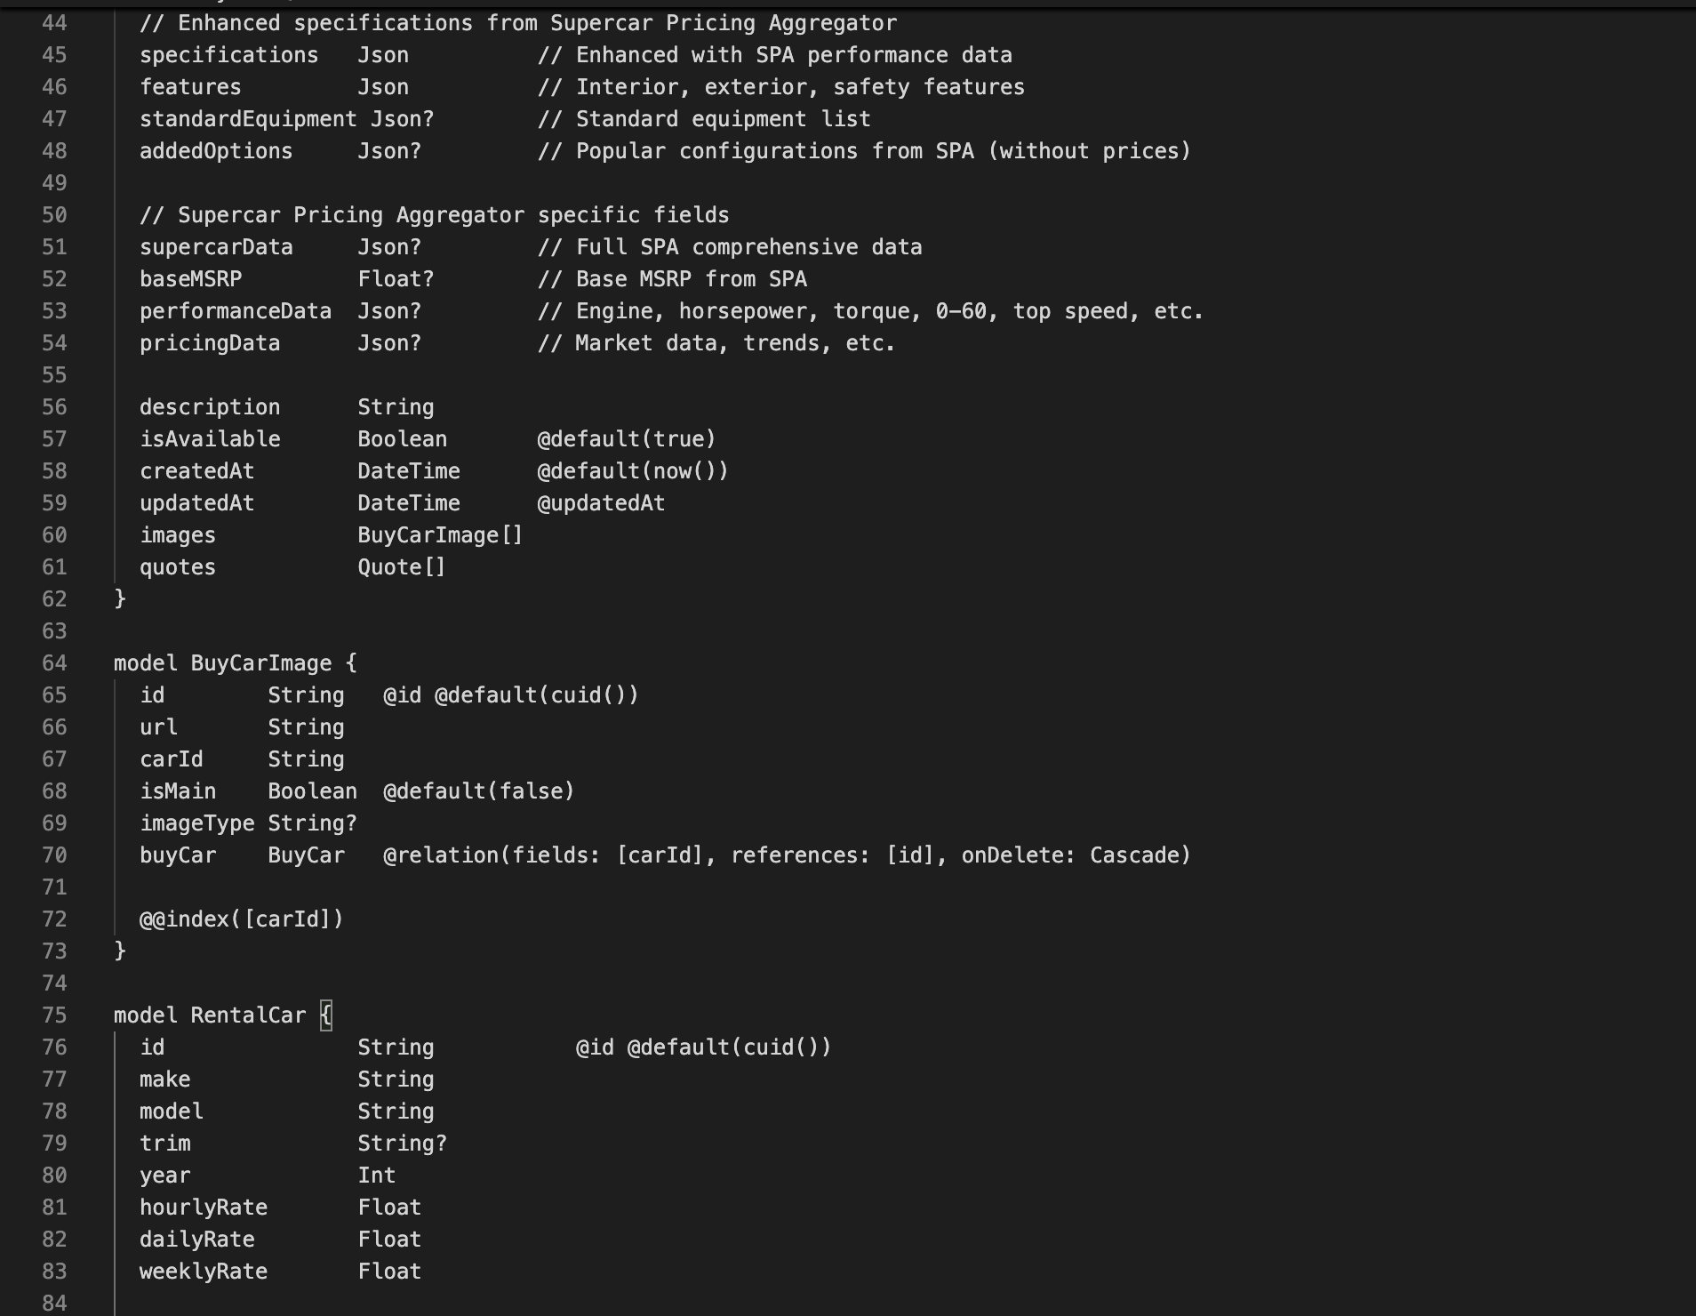
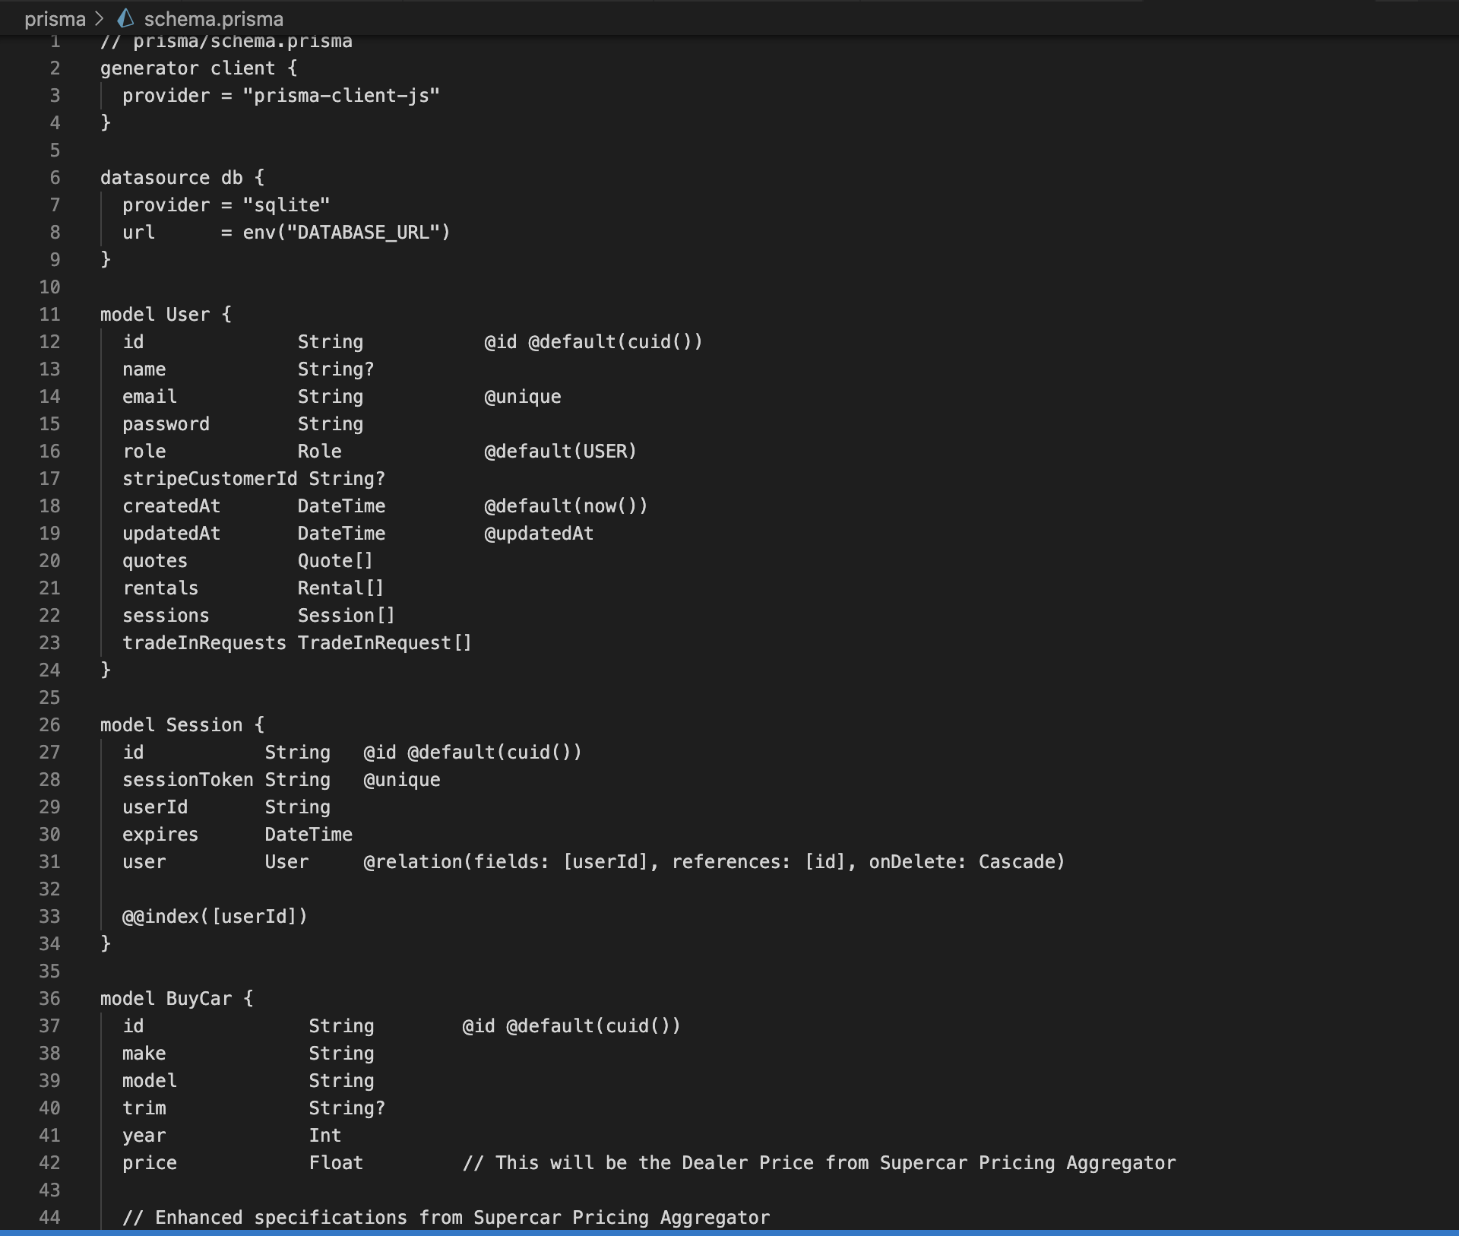
The following is the complete Prisma schema file (prisma/schema.prisma) defining all database models, relationships, and enumeration types used in the Euro Motors application.
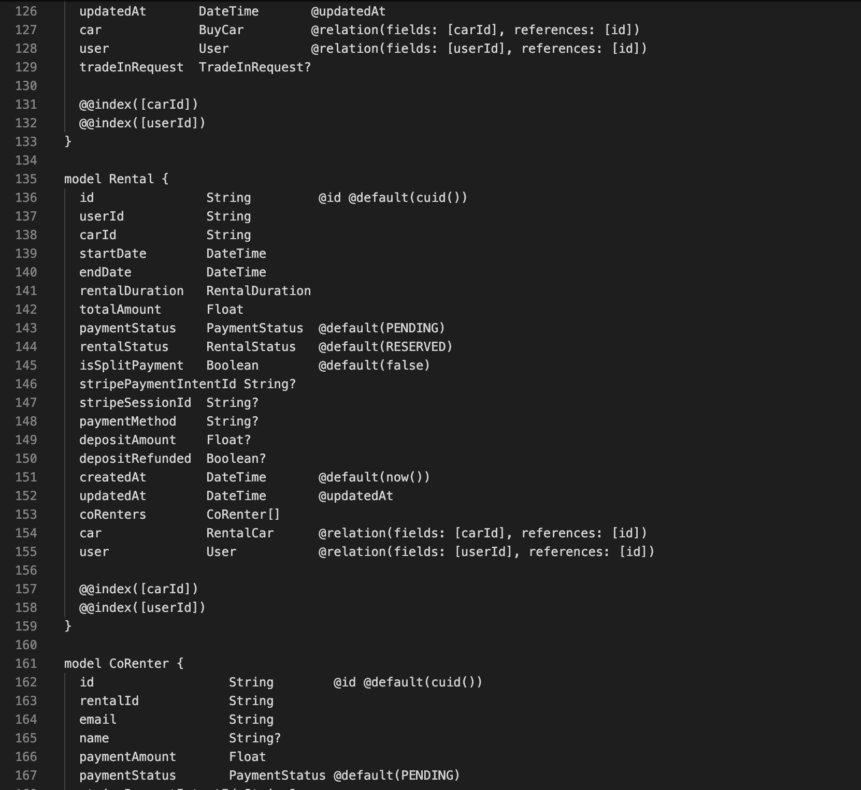
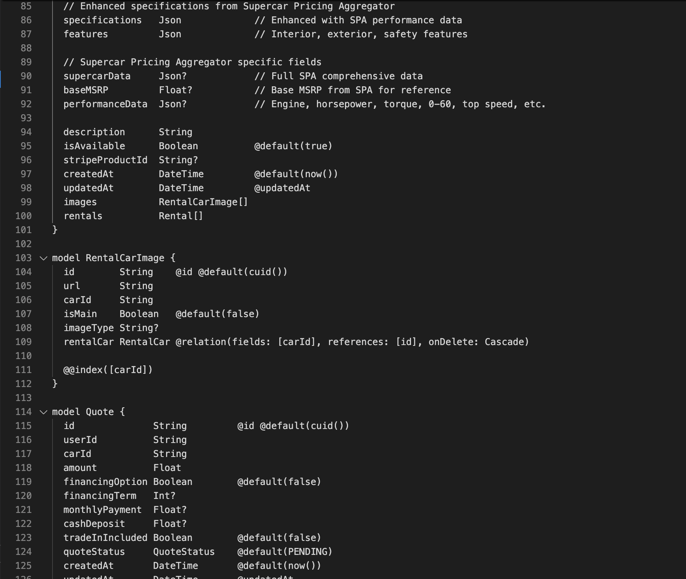
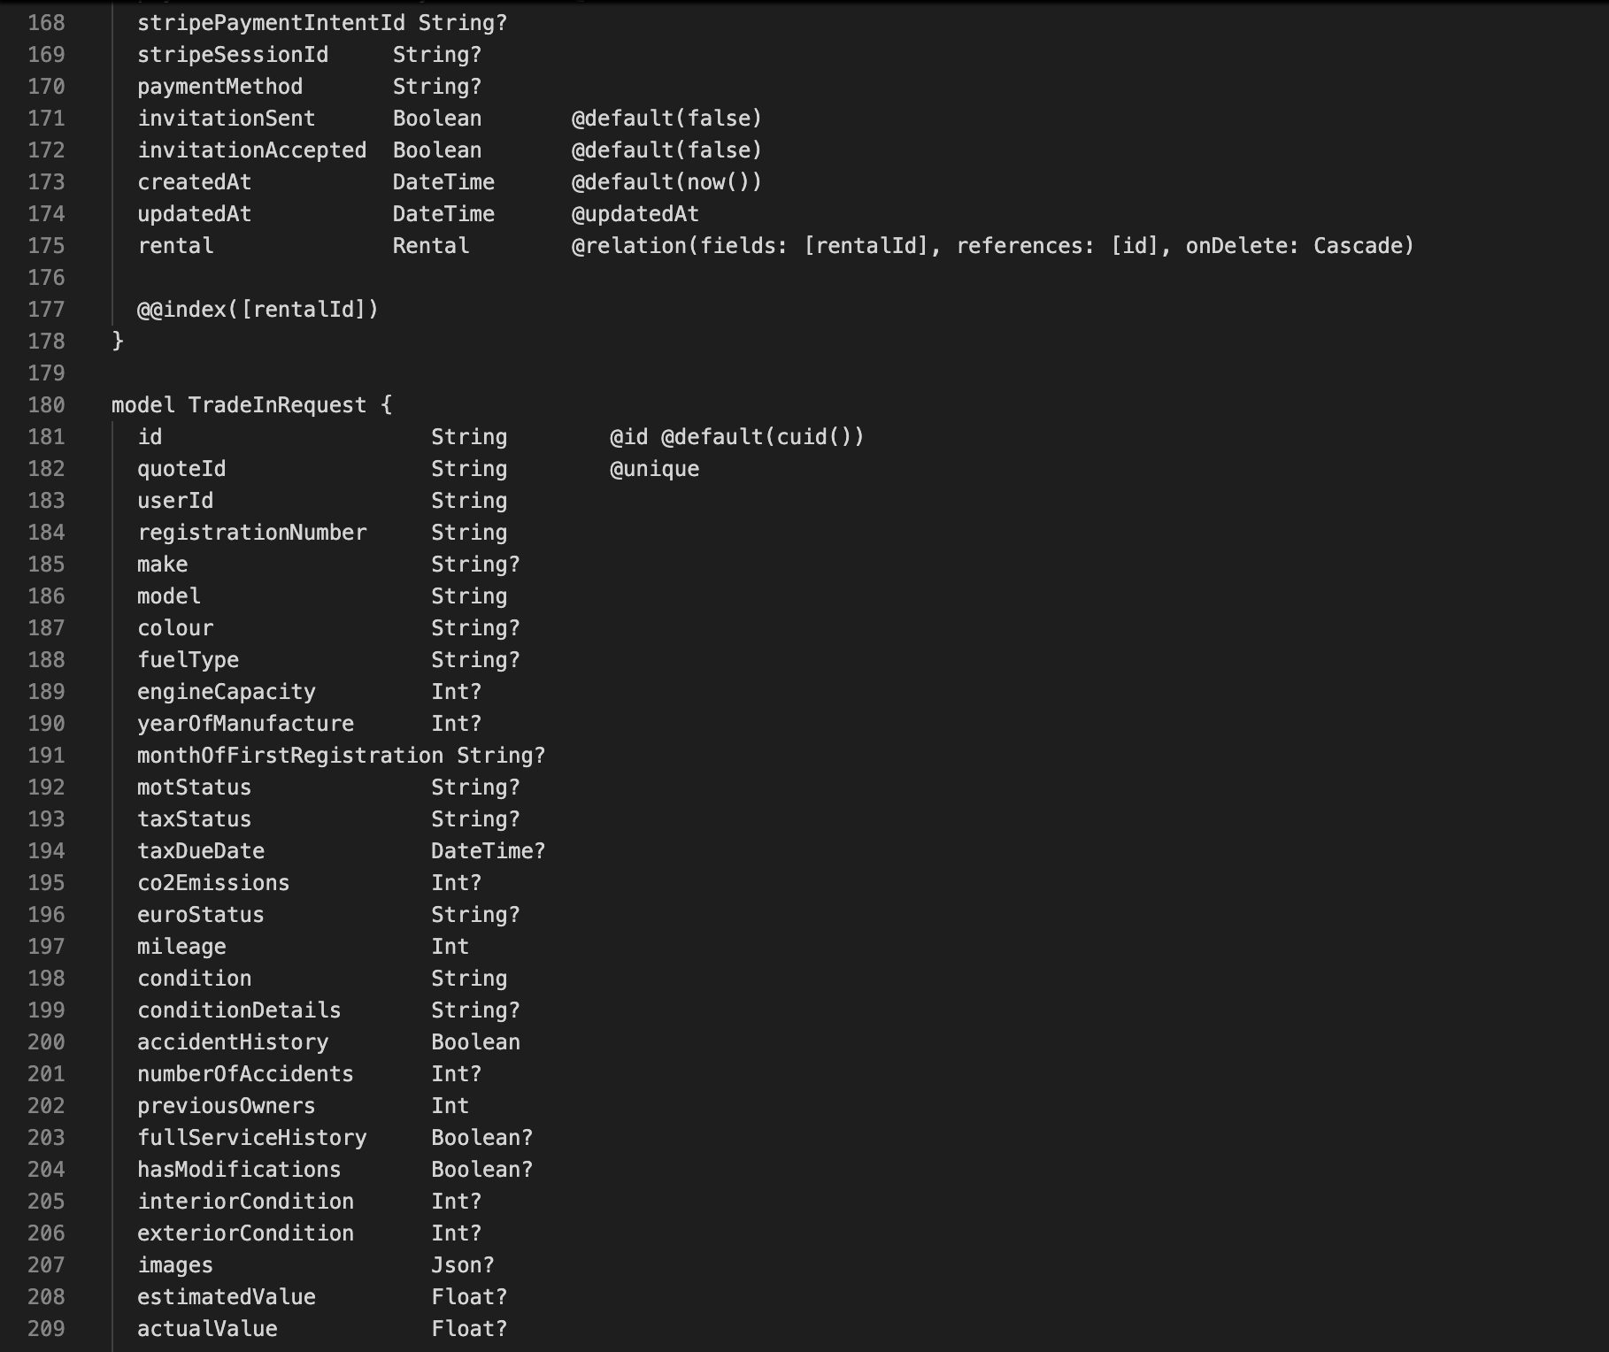

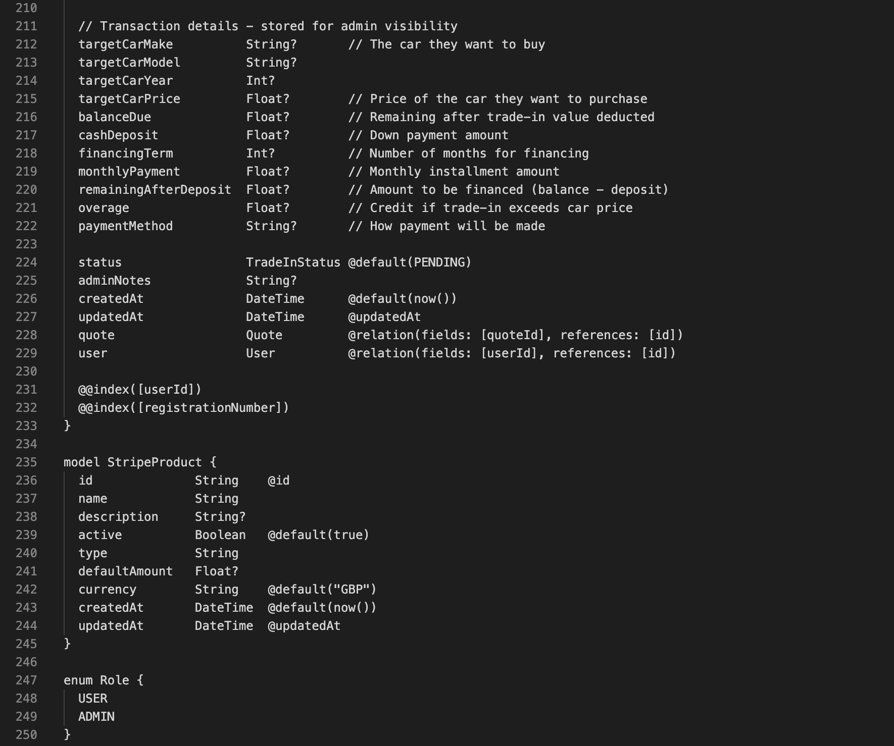
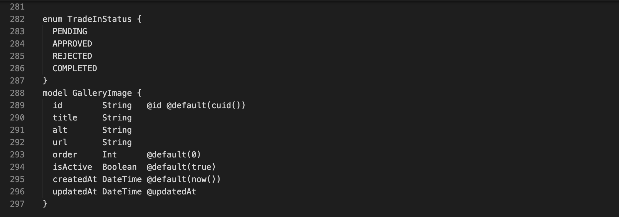
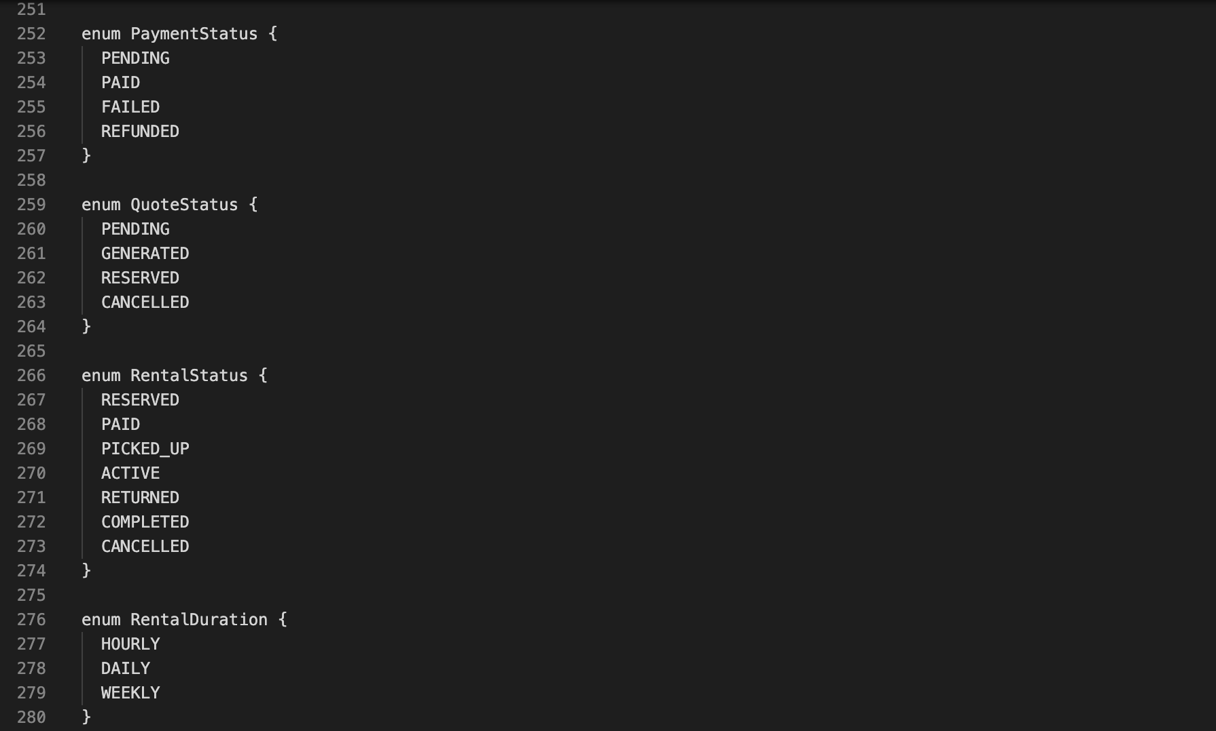
Appendix A Abridged Prisma schema. Full schema in prisma/schema.prisma.

Appendix B: API Endpoint Reference
The following table provides a complete reference of all 38 API endpoints exposed by the Euro Motors application.
Method | Path | Auth Required | Admin Only | Description
POST | /api/auth/register | No | No | Register a new user account
POST | /api/auth/login | No | No | Authenticate and set JWT cookie
GET | /api/auth/me | No | No | Return current authenticated user
POST | /api/auth/logout | No | No | Clear JWT cookie
GET | /api/buy | No | No | List all available buy-fleet cars
POST | /api/buy | Yes | Yes | Create a new buy-fleet car
GET | /api/buy/[id] | No | No | Get buy-fleet car by ID
PUT | /api/buy/[id] | Yes | Yes | Update buy-fleet car
DELETE | /api/buy/[id] | Yes | Yes | Delete buy-fleet car
POST | /api/buy/[id]/images | Yes | Yes | Upload images for a buy-fleet car
GET | /api/rentals | No | No | List available rental cars
POST | /api/rentals | Yes | No | Create rental booking
GET | /api/rentals/[id] | Yes | No | Get rental booking by ID
PATCH | /api/rentals/[id] | Yes | Yes | Update rental status
GET | /api/quotes | Yes | No | Get quotes for authenticated user
POST | /api/quotes | Yes | No | Create a new quote
GET | /api/quotes/[id] | Yes | No | Get quote by ID
GET | /api/quotes/[id]/pdf | Yes | No | Download quote as PDF
GET | /api/trade-in | Yes | No* | Get trade-in requests (user or all)
POST | /api/trade-in | Yes | No | Submit trade-in request
PATCH | /api/trade-in/[id] | Yes | Yes | Update trade-in status/valuation
GET | /api/admin/dashboard | Yes | Yes | Retrieve dashboard metrics
GET | /api/admin/users | Yes | Yes | List all users
PATCH | /api/admin/users/[id] | Yes | Yes | Update user role or details
GET | /api/admin/orders | Yes | Yes | List all rental orders
GET | /api/admin/reports | Yes | Yes | Revenue and activity reports
POST | /api/payments/create-session, /api/payments/create-quote-session | Yes | No | Create Stripe Checkout Session for rental/cart or buy/trade-in flows
POST | /api/payments/webhook | No | No | Stripe webhook event handler
GET | /api/receipts/[id] | Yes | No | Retrieve rental receipt
POST | /api/spa/search | Yes | Yes | Proxy search to CarQuery/SPA
GET | /api/cars | No | No | Combined car listing endpoint
POST | /api/cars | Yes | Yes | Add car to fleet
GET | /api/gallery | No | No | Get active gallery images
POST | /api/gallery | Yes | Yes | Add gallery image
PATCH | /api/gallery/[id] | Yes | Yes | Update gallery image
DELETE | /api/gallery/[id] | Yes | Yes | Remove gallery image
POST | /api/db/migrate | Yes | Yes | Trigger data migration utility
GET | /api/db/seed | Yes | Yes | Seed database with test data

Appendix B Full API endpoint reference. *GET /api/trade-in returns all records for admin tokens, user-scoped records for USER tokens.

Appendix C: Technology Stack Summary
Category | Technology | Version | Purpose
Framework | Next.js | 15.x | Full-stack React framework (App Router)
UI Library | React | 18.x | Component-based UI rendering
Language | TypeScript | 5.x | Strict static typing
Styling | Tailwind CSS | 3.x | Utility-first CSS
ORM | Prisma | 6.x | Type-safe database access
Database | SQLite | 3.x | Relational persistence (development)
Auth (server) | jsonwebtoken | 9.x | JWT sign/verify (Node runtime)
Auth (edge) | jose | 5.x | JWT verify (Edge runtime/middleware)
Passwords | bcryptjs | 2.x | Password hashing (work factor 10)
PDF | jsPDF | 2.x | Client-side PDF generation
Forms | react-hook-form | 7.x | Form state and validation
HTTP client | axios | 1.x | API request helper
Payments | Stripe SDK | 14.x | Checkout session and webhook handling
Dev tools | ESLint + Prettier | Latest | Code quality and formatting

Appendix C Euro Motors technology stack summary.

