 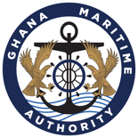

**MARITIME LABOUR CERTIFICATE FOR FISHING VESSELS**

This Certificate is issued in fulfilment of Part IV of the Ghana Shipping Act, 2003 (Act 645)

……………………………………………….………………………………………………………………

Particulars of the ship

Name of ship: .................................................................................................................................

Distinctive GMA number: ..............................................................................................................

Port of registry: ................................................................................................................................

Date of registry: ...............................................................................................................................

Gross tonnage: ................................................................................................................................

IMO number: ..................................................................................................................................

Type of ship:....................................................................................................................................

Name of the shipowner: .................................................................................................................

Address of the shipowner: .........................................................................................................................................................

**Date of Issue Expiry Date**

**Cert No. Director General**