Group name: **REVERIE**

Members: **RICO SUSAINE, REODIQUE CURT JUSTIN N. VALEZA MHELARRY, SAÑADO FAITH ANN S., BORBE RECHELLE**

Course Yr. & Block: **BSIS-2A**

| **Problem Number 1: DFD** |
| --- |
| **Problem Statement:** Our Level 2 Data Flow Diagram contains inaccurate process icons. The database was incorrectly represented as a process instead of a data store. |
|  |

| **CODE CHANGES** | **INTERFACE CHANGES** | **Describe the functionality added or Changed** |
| --- | --- | --- |
| None |  | We corrected it to accurately reflect the system’s data storage. |

| **Problem Number 2: Add stock history** |
| --- |
| **Problem Statement:**  Stocks problem statement:  Our customers currently lack visibility into product availability. The absence of stock history on our website prevents them from seeing whether items are in stock before ordering, or how many stocks are still there in the products they are viewing. |
|  |

| **CODE CHANGES** | **INTERFACE CHANGES** | **Describe the functionality added or Changed** |
| --- | --- | --- |
|  |  |  |

| **Problem Number 3: ADMIN SEARCH BAR** |
| --- |
| **Problem statement: Admin display will have a problem in the future once there are orders more than the display. Find a way to make it tabular and put a search bar that can find the specific order.** |

| **<?php**  **include 'config.php';**  **session_start();**  **$user_id = $_SESSION['user_id'];**  **if (!isset($user_id)) {**  **header('location:login.php');**  **exit;**  **}**  **?>**  **<!DOCTYPE html>**  **<html lang="en">**  **<head>**  **<meta charset="UTF-8">**  **<meta http-equiv="X-UA-Compatible" content="IE=edge">**  **<meta name="viewport" content="width=device-width, initial-scale=1.0">**  **<title>Search Orders</title>**  **<!-- font awesome cdn link -->**  **<link rel="stylesheet" href="https://cdnjs.cloudflare.com/ajax/libs/font-awesome/6.0.0/css/all.min.css">**  **<!-- custom css file link -->**  **<link rel="stylesheet" href="css/style.css">**  **</head>**  **<body>**  **<div class="heading">**  **<h3>Search Orders</h3>**  **<p><a href="admin_page.php">Dashboard</a> / search orders</p>**  **</div>**  **<section class="search-form">**  **<form action="" method="post">**  **<input type="text" name="search" placeholder="Search orders by product name or order ID..." class="box">**  **<input type="submit" name="submit" value="Search" class="btn">**  **</form>**  **</section>**  **<section class="Orders" style="padding-top: 0;">**  **<div class="box-container">**  **<?php**  **if (isset($_POST['submit'])) {**  **$search_item = $_POST['search'];**  **// Query to search orders for the logged-in user**  **$select_orders = mysqli_query($conn, "SELECT * FROM `products` WHERE name LIKE '%$search_item%'") or die('Query failed');**  **if (mysqli_num_rows($select_orders) > 0) {**  **while ($fetch_order = mysqli_fetch_assoc($select_orders)) {**  **?>**  **<div class="box-container">**  **<?php**  **// Querying for all orders based on search result**  **$select_orders_inner = mysqli_query($conn, "SELECT * FROM `orders`") or die('Query failed');**  **if (mysqli_num_rows($select_orders_inner) > 0) {**  **while ($fetch_orders = mysqli_fetch_assoc($select_orders_inner)) {**  **?>**  **<div class="box">**  **<p>user id: <span><?php echo $fetch_orders['user_id']; ?></span></p>**  **<p>placed on: <span><?php echo $fetch_orders['placed_on']; ?></span></p>**  **<p>name: <span><?php echo $fetch_orders['name']; ?></span></p>**  **<p>number: <span><?php echo $fetch_orders['number']; ?></span></p>**  **<p>email: <span><?php echo $fetch_orders['email']; ?></span></p>**  **<p>address: <span><?php echo $fetch_orders['address']; ?></span></p>**  **<p>total products: <span><?php echo $fetch_orders['total_products']; ?></span></p>**  **<p>total price: <span>Php <?php echo $fetch_orders['total_price']; ?>.oo</span></p>**  **<p>payment method: <span><?php echo $fetch_orders['method']; ?></span></p>**  **<form action="" method="post">**  **<input type="hidden" name="order_id" value="<?php echo $fetch_orders['id']; ?>">**  **<select name="update_payment">**  **<option value="" selected disabled><?php echo $fetch_orders['payment_status']; ?></option>**  **<option value="pending">pending</option>**  **<option value="completed">completed</option>**  **</select>**  **<input type="submit" value="update" name="update_order" class="option-btn">**  **<a href="admin_orders.php?delete=<?php echo $fetch_orders['id']; ?>" onclick="return confirm('delete this order?');" class="delete-btn">delete</a>**  **</form>**  **</div>**  **<?php**  **}**  **} else {**  **echo '<p class="empty">No orders placed yet!</p>';**  **}**  **?>**  **</div>**  **<?php**  **}**  **} else {**  **echo '<p class="empty">No matching orders found!</p>';**  **}**  **} else {**  **echo '<p class="empty">Search for an order!</p>';**  **}**  **?>**  **</div>**  **</section>**  **<!-- custom js file link -->**  **<script src="js/script.js"></script>**  **</body>**  **</html>** | **INTERFACE CHANGES** | **Describe the functionality added or Changed**   * - Enhanced the admin page with a user-friendly search functionality. A new “Search Products” button/icon was added to provide quick access to a search bar, aiming to allow administrators to easily locate specific products within the system. |
| --- | --- | --- |
|  |  |  |

*.*

**INTERFACE CHANGE**

**PROBLEM 1:**

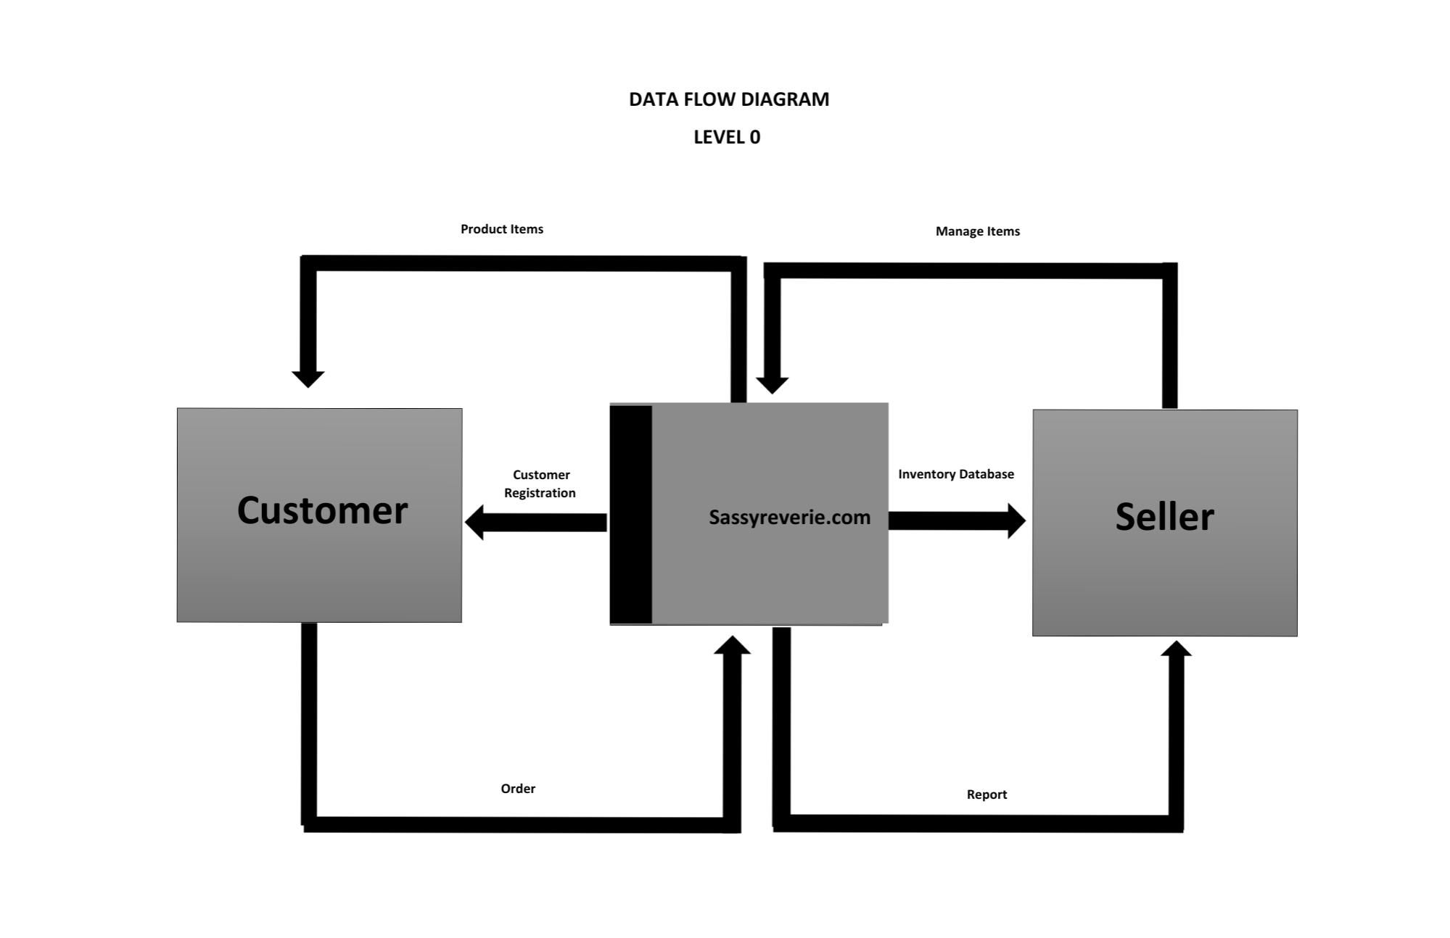

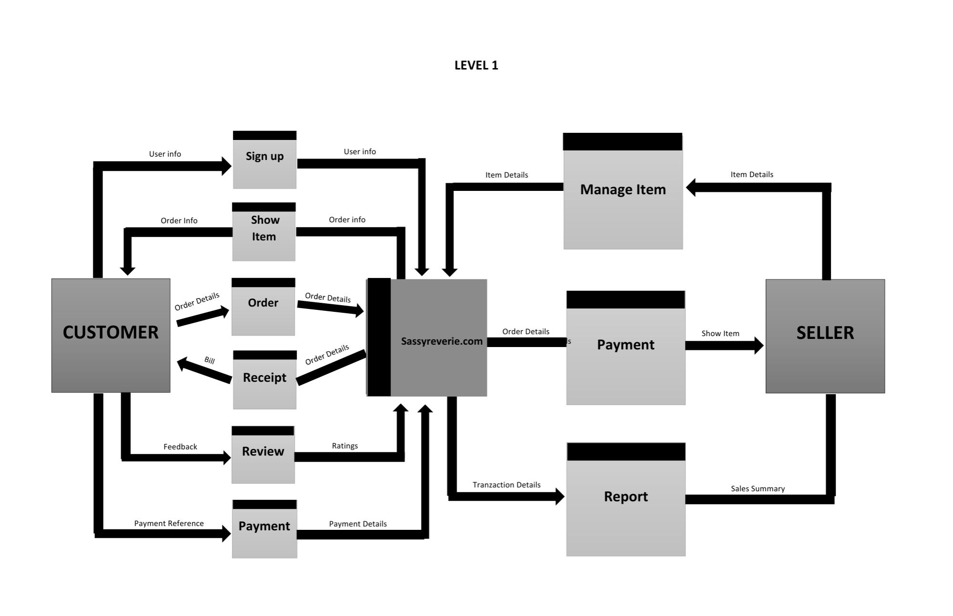

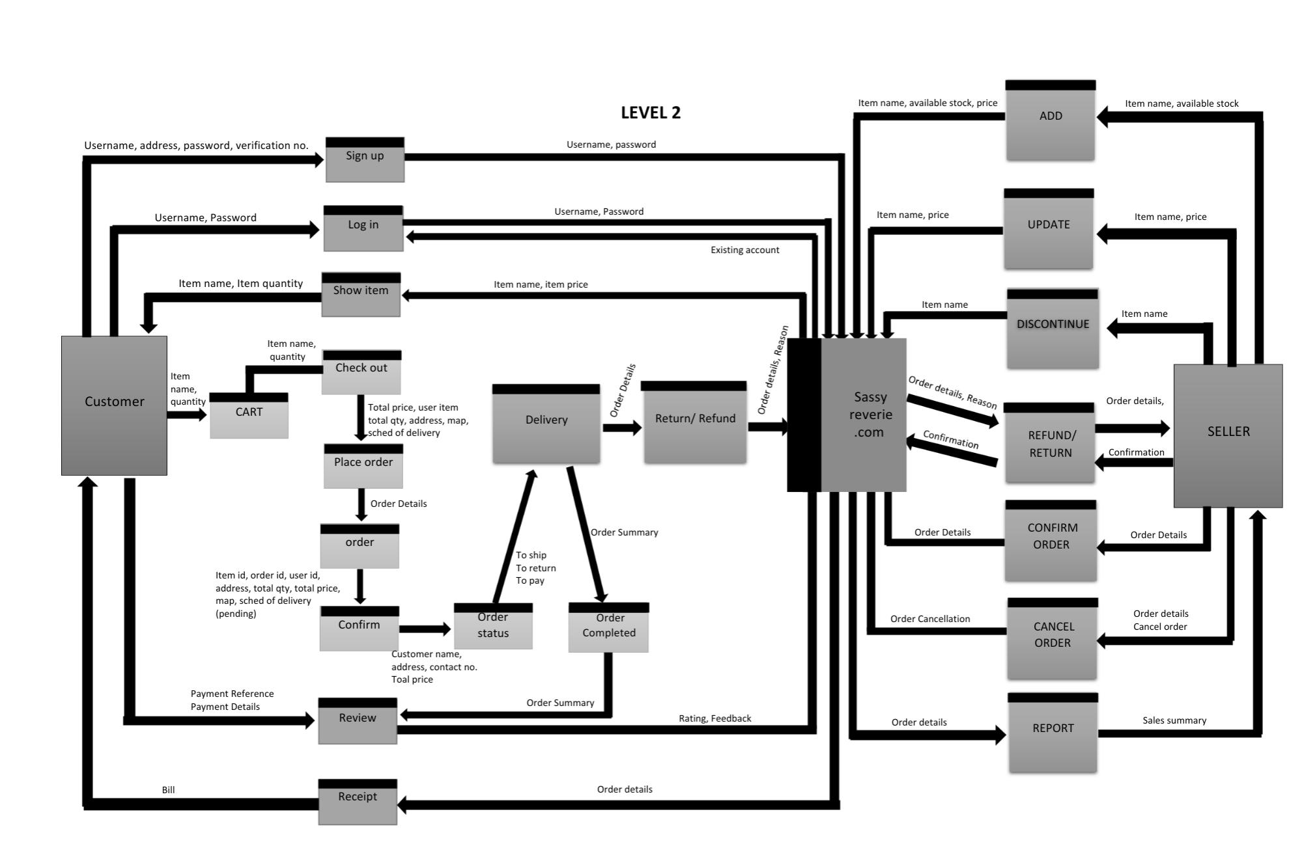

**PROBLEM 2:**

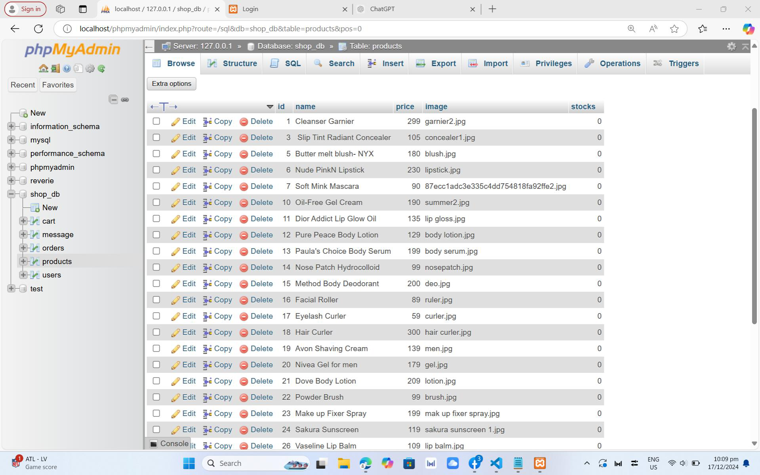

**PROBLEM 3: ADMIN SEARCH** 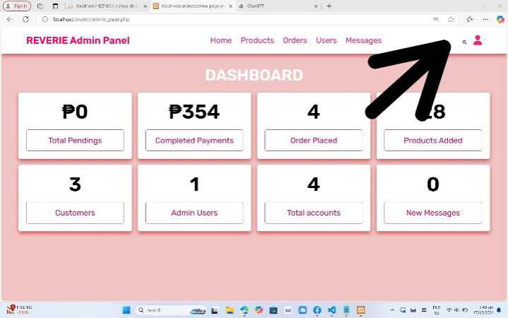

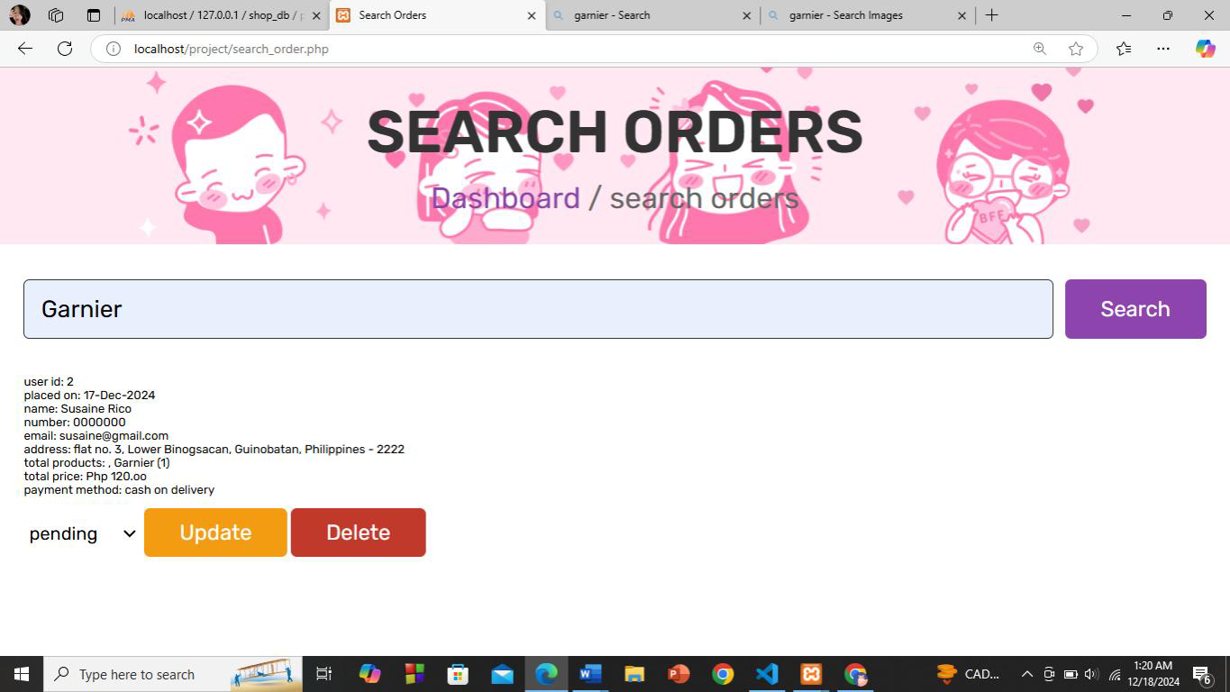

**NAME: Faith Ann Sañado**

**INDIVIDUAL ROLE: Support**

* **As a support, I was tasked to provide assistance in every website’s issues and technical errors during the website development. It is my role to assist the other team members whenever they encounter difficulties and provide them the help as needed.**