R markdow - How To Import An Excel File

Faith Kabanda

2022-07-25

## Extra Notes

* *Echo = FALSE* allows you to hide the code.
* fig.show = “hide”: Hides plots. (leave two trailing spaces/lines to start new line in text)

## R Markdown - Import Excel file

library(readxl)  
covid_data<- read_excel("C:/Users/Faith Kabanda/OneDrive/Desktop/My Research Work/Vaccines VS Data/covid who data.xlsx",   
 sheet = "Jan 2021", range = "A1:E32")  
summary(covid_data$New_cases)

## Min. 1st Qu. Median Mean 3rd Qu. Max.   
## 0.0 334.0 639.0 633.7 829.5 1365.0

## Bloxplts

### Short Notes

* factor(0)
* stat_boxplot creates whiskers

library(ggplot2)  
new_cases_boxplot<- ggplot(covid_data, aes(x = factor(0), y = New_cases, fill = "red", color = "black")) +stat_boxplot() + geom_boxplot() + xlab("Days Of The Month") + ylab("New Daily Covid 19 Cases") + ggtitle("January 2021 Covid 19 Daily New Cases")  
new_cases_boxplot

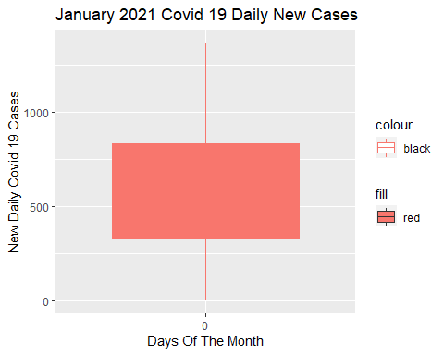

## Scatter Plot

library(ggplot2)  
new_cases_scatterplot<- ggplot(covid_data, aes(x = Date_reported, y = New_cases)) + geom_point()+ xlab("Days Of The Month") + ylab("New Daily Covid 19 Cases") + ggtitle("January 2021 Covid 19 Daily New Cases")  
new_cases_scatterplot

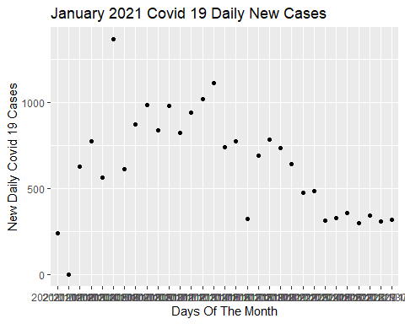 ## Pie Chart

* If it is stat = “identity” , we are asking R to use the y-value we provide for the dependent variable. If we specify stat = “count” or leave geom_bar() blank, R will count the number of observations based on the x-variable groupings.
* theme_void removes stuff from the background of the data vizualization image.
* under aes, equating*x=““*, creates a pie chart with a complete circle.

library(ggplot2) #data vizualization  
library(dplyr) #data manipulation

##   
## Attaching package: 'dplyr'

## The following objects are masked from 'package:stats':  
##   
## filter, lag

## The following objects are masked from 'package:base':  
##   
## intersect, setdiff, setequal, union

dataset<-data.frame(group = c("Section 1", "Section 2", "Section 3"), value = c(45, 30, 25))  
head(dataset)

## group value  
## 1 Section 1 45  
## 2 Section 2 30  
## 3 Section 3 25

piechart<- ggplot(dataset, aes( x = "", y = value, fill = group)) + geom_bar(width = 1, stat = "identity", color = "black") + coord_polar("y", start = 0) + geom_col() + geom_text(aes(label = value), position = position_stack(vjust = 0.5)) + theme_void()  
piechart

