

**DEDAN KIMATHI UNIVERSITY OF TECHNOLOGY**

**Project Title: RESUME SCANNING AND CANDIDATE SHORTLISTING SYSTEM.**

**OTIENO FAITH CATHERINE**

**C026-01-0306/2018**

A project submitted to the Department of Computer Science in the School of Computer science and IT in partial fulfillment of a degree in Computer Science.

October 2021.

**DECLARATION**

I Faith Catherine Otieno registration number C026-01-0306/2018 declare that everything presented in this document is my original work and has not been presented for a degree award in any other Institution.

Name: ………………………………………………………………………………………..

……………………….…. ………………………………

Signature Date

This proposal has been submitted for examination with my approval as University Supervisor

Name: ………………………………………………………………………………………..

……………………… ……………………………………

Signature Date

**ABSTRACT**

As the population increases, the number of job seekers also increases. The work of searching for and recruiting candidates is usually the duty of the HR department. Most companies do the better part of the process manually. The demanding part of the recruiting process is the reviewing of resumes and filtering candidates who are more qualified for the job. This work can be tedious if the number of applications to be reviewed is high. The department is then burdened to find candidates yet still have timelines to meet. Using natural language processing methods and semantic matching this system aims solve part of this problem by scanning the resumes and short listing candidates. The system will be built using the agile approach. The system will be trained using a resume dataset and also tested to ensure its function with limited errors. This system is highly recommended as it will ease the burden of scanning through applications and also ensure companies get their best fit candidates according to their requirements.

Table of Contents

[Chapter 1 INTRODUCTION 1-6](#_Toc86739074)

[BACKGROUND 1-6](#_Toc86739075)

[PROBLEM STATEMENT 1-7](#_Toc86739076)

[Objectives 1-7](#_Toc86739077)

[Main objective 1-7](#_Toc86739078)

[Specific objectives 1-8](#_Toc86739079)

[Justification. 1-8](#_Toc86739080)

[Scope 1-8](#_Toc86739081)

[Chapter 2 : LITERATURE REVIEW 2-9](#_Toc86739082)

[INTRODUCTION 2-9](#_Toc86739083)

[CASE STUDIES 2-10](#_Toc86739084)

[Case study 1: IDEAL’s virtual assistant 2-10](#_Toc86739085)

[Case study 2: Avrio AI Inc. 2-11](#_Toc86739086)

[Case study 3: Entelo 2-12](#_Toc86739087)

[Case study 4: Mya Systems. 2-13](#_Toc86739088)

[Summary 2-14](#_Toc86739089)

[Research Gap 2-14](#_Toc86739090)

[Proposed methodology 2-15](#_Toc86739091)

[Chapter 3 :METHODOLOGY 3-16](#_Toc86739092)

[Introduction 3-16](#_Toc86739093)

[Fact finding techniques 3-16](#_Toc86739094)

[Record Views 3-16](#_Toc86739095)

[Observation 3-16](#_Toc86739096)

[Interviews 3-17](#_Toc86739097)

[Software design - Software development procedures. 3-17](#_Toc86739098)

[Preliminary Data Processing and analysis. 3-18](#_Toc86739099)

[Chapter 4 System Analysis And Design 4-19](#_Toc86739100)

[Introduction 4-19](#_Toc86739101)

[Requirements Analysis 4-19](#_Toc86739102)

[Functional Requirements 4-19](#_Toc86739103)

[Non Functional Requirements 4-20](#_Toc86739104)

[Data Analysis 4-20](#_Toc86739105)

[Data Collection Procedures 4-20](#_Toc86739106)

[Data Analysis 4-21](#_Toc86739107)

[System Design 4-22](#_Toc86739108)

[Use case Diagram. 4-22](#_Toc86739109)

[Activity diagram 4-23](#_Toc86739110)

[Sequence Diagram 4-24](#_Toc86739111)

[Data Flow Diagram 4-25](#_Toc86739112)

[Class Diagram 4-26](#_Toc86739113)

[System Analysis 4-27](#_Toc86739114)

[Chapter 5 Testing and Implementation 5-32](#_Toc86739115)

[INTRODUCTION 5-32](#_Toc86739116)

[Chapter 6 CONCLUSION AND RECOMMENDATION 6-33](#_Toc86739117)

[Discussion 6-33](#_Toc86739118)

[Limitations 6-33](#_Toc86739119)

[Recommendations 6-34](#_Toc86739120)

[REFERENCES 6-35](#_Toc86739121)

[Ronen ShetelBoim (2017, May 4). 2017 Recruiting Funnel Benchmark Report. Jobvite 6-35](#_Toc86739122)

# INTRODUCTION

## BACKGROUND

As the population increases, so is the number of people looking for jobs. These numbers are higher now especially in the corporate sector as there are more entries to Universities, colleges and tertiary schools. According to a report by the Bureau labor of Statistics (2020) around 10.7 million people in the United States were looking for jobs in 2020. Here in Kenya Kepha Muiruri(2020) articles state that in 2020 around 2.6 million Kenyans were actively looking for jobs. A report on recruiting statistics by Glassdoor(2015) states that on average, each corporate job attracts about 250 resumes.

In the era of technology, majority of job postings and job applications are done online. Some employers find their employees in online platforms such as linked in. The JobVite(2016) national report states that 87% of recruiters used linked in to search for candidates. Many employees build portfolios and profiles online that can be evaluated by the employers. Unlike olden days, most applications are sent by email or through companies platforms and employers communicate with the applicants through these same platforms,

The process of hiring in companies is a series of different activities. Companies will first have job postings specifying the job qualifications, deadlines of applications and documents to be attached. Once the posting is done and applications are received, the human resource department of the company will go through the resumes to find the applicants with the required qualifications then filter the applications to a certain number of candidates who will be called for an interview. According to a JobVite report by Ronen Shetolboim(2017) it took roughly 39 days to hire a new employee in 2016, down from 43 days in 2015 and that the average cost per hire for companies is $4,129 this according o SHRM(2016).

The process of short listing candidates for a job involves reading through the applications to match candidate skills with the ones required in the job description, doing background checks and verification of a candidates profile and background, checking projects done and checking volunteer work. This process can be quite exhausting for the department. The JobVite report(2018)talks of some of the challenges as working with hiring managers. 50% of recruiters see problems in moving candidates through the hiring process, while 44% cite hiring managers reviewing resumes as reasons for slowing the process down. Some companies have also complained of the bulk of resumes with no skills or very little skills. Many companies face challenges of shortage of expertise even from the applications they receive therefore, a lot of work is used in scanning resumes that are not valuable for the job description, making the process more tiring and discouraging .

From the above research, it is quite clear that there is an increase in people actively seeking jobs, there is evidence that most of the job connections are formed online and that the process of shortlisting and hiring of candidates can be quite hectic as it takes to both the time and resources of the company. This has therefore brought a need for better, easier and more efficient ways to handle the process. There have arisen different models built to assist in different sectors of the hiring process. Some models suggest candidates that will meet a company’s needs, others read the resumes and match the candidates skills with those in the job description while other models take part in the interview process. There are models that incorporate more than one of the steps of the hiring process. This research inspired the building of this system that can be part of the process of shortlisting candidates by matching their skills with the company’s requirements.

## PROBLEM STATEMENT

Companies have a difficult time in reading through job applications to extract skills and match them to the skills in the job description due to very many job applications. Companies also find it difficult to filter through the applications and choose the best fit for an interview. There is a need to find better and more efficient ways to handle this process. This system aims to use natural language processing methods and semantic matching to build a model that will read the resumes sent by applicants, extract the skills and match candidates that have skills required by the company.

## Objectives

### Main objective

To develop a Natural Language Processing system that evaluates applications and shortlist candidates best fit for the job.

### Specific objectives

1. To investigate the challenges faced by recruiters when processing job applications
2. To develop a model that will optimize job applications evaluation process.
3. To test and evaluate the proposed model.

**Research Questions**

1. Are there any challenges faced by recruiters when processing job applications?
2. Can one develop a model to optimize the evaluation process of job applications?
3. Can one test and evaluate the model?

## Justification.

The main reason for creating this system is to provide companies with a more efficient way to filter through applications and shortlist. By having intelligent models review resumes and make decisions of the best fit candidates, the workload is reduced and resources that were to be used for this process are diverted to other areas. The company also gets to save on time in the hiring process as the machines will use a shorter time to review and make decisions as compared to humans. This system is also a necessary venture to avoid selecting unqualified candidates, that is candidates with zero to no skills.

## Scope

This model will be trained to handle majorly Technical and some business skills. It will therefore be viable within the boundaries of Technical companies.

The system would be able to do the following:

* Allow the company to post a job opening.
* Allow the company to post the job requirements.
* Allow the company to set an application period
* Allow candidates to post resumes
* Allow the company to view posted resumes.

# : LITERATURE REVIEW

## INTRODUCTION

This review aims to show existing systems and the approaches they have taken to help in the process of hiring. Artificial intelligence can be helpful to the hiring process in different ways, models in the market have been useful in talent sourcing, talent recruitment and candidate screening and engagement.

Talent sourcing is the process of looking for talent needed by companies. Models have been built to assist in talent sourcing. This process may involve predictions on candidates who may be looking for a new job in the near future that is depending on their posts or the state of companies they currently work for. Models will look for such candidates matching them with the company. Models also look at platforms such as Linked in and Zety and match job seekers that are more likely to qualify for positions with the company.

Talent recruitment involves assisting in the repetitive processes of the hiring process such as resume and application review. Such models go through applications sent by candidates to extract the skills and qualifications and match them to the job description of the company. The candidates more qualified for the job will be recommended to the company while those with little or no skill will be left out. This eases the burden of reading through all those applications.

Candidate screening and engagement involves having conversations with the candidates. Most of these models use natural language processing and can be helpful in inquiries by answering candidate questions or being part of the interview process. Some models are able to break down answers given by candidates and analyze them to make conclusions on social skills like communication and team work skills and also on virtues needed such as integrity and commitment. Some models can even have video calls with candidates and have abilities to analyze the candidates from their posture, intonation and other gestures.

All these are ways in which Artificial Intelligence has been used to assist humans in the process of hiring. All these models are very helpful in reduce the work load, saving time and choosing the best fit candidates.

## CASE STUDIES

### Case study 1: IDEAL’s virtual assistant

According to Sennar K(2017), the ideal’s assistant integrates with the client’s existent applicant tracking systems and is trained on the client’s data set. This ensures the model is specific to the client’s needs as it is aware of their needs and their previous hiring processes. It is a model that has already been trained on more than a million hiring decisions and is therefore very efficient in decision making as it knows how to filter and make the best choices given a certain type of circumstances. This also allows the model to quickly adapt to the new clients process of hiring.

The ideal platform delivers two types of services.

**Resume screening**

The platform provides resume screening services to the clients. The model by stating parameters that are standard to the company, gets a picture of what an ideal candidate would look like for the company and then the model uses pattern recognition to identify those elements in applications. The model can then eliminate applications that don’t fit the criteria and remain with the candidates best fit for the job.

**Candidate Sourcing**

Ideal has claims that its virtual assistant can do candidate sourcing for companies. By training using the companies datasets and learning their preferences, the model has the ability to connect to external third party websites such as career builder and then searches these platforms to match candidates matching the employers criteria.The ideals virtual assistant is a very useful model in the hiring scene. The algorithm performs two services that are very essential in the process of selecting candidates. It assists in both talent recruitment and candidate sourcing. The team from ideal has reports that the model being used in Canada’s largest bookstore chain reduced their cost per hire by over 71% and tripled their hiring of qualified candidates.

The gap present in the model is very minimal as the only service that is not present in this model is that of candidate engagement. The model does not provide any assistance in the process of inquiries or interviews, thus no assistant in choosing the final candidates that will be employed. The similarity of this model and the short listing system is that they both assist in talent recruitment through resume screening. This model is different from the short listing system as the short listing system will not provide any services on talent sourcing.

### Case study 2: Avrio AI Inc.

According to Sennar K(2017), the Avrio’s main distinctive feature is in the realm of candidate engagement. Apart from features in candidates sourcing and recruitment, this model claims to incorporate a chatbot from Facebook to chat with the candidates in a pre-screen interview format. The assistant Rio asks the candidates different questions to gauge on their knowledge concerning the position they applied for. Some of the questions may include how they will handle certain scenarios and challenges that may occur in the work place. The model is able to analyze the candidate’s answers to see their knowledge skills and abilities to work in the job therefore making decisions on the more efficient candidates. Rio can also quote salary ranges based on the candidate’s social media and the company’s salary range and therefore identifying candidates more qualified in matters of salary.

This model uses natural language processing to analyze conversations with candidates and then uses the analyzed data to inference decisions. This model is very efficient in engaging the candidates pre-interviews to find candidates most qualified for the job while eliminating those with lower skill levels and those that don’t meet the company’s requirement or job description.This model is very efficient as apart from talent sourcing and talent recruitment, it goes a step further into doing pre interviews so as to assess candidates.

The gap present in this model is that it is not involved in the actual real interview process. It is otherwise a very efficient model as it filters candidates in three processes thus allowing for the best fit candidates. This model is very different from the short listing model. While the short listing model has only the resume screening process, The Rio model goes way further into looking for candidates viable for the job and further into pre-interviewing candidates that it has found to be more qualified for the job, so as to narrow down the candidates using salary ranges and other job skills that the company may require.

### Case study 3: Entelo

According to Sennar K(2017), Entelo is a platform with a machine learning model for talent sourcing. The company uses Artificial Intelligence to help companies find candidates viable for a job. The company claims that its algorithm is capable of identifying candidates who have a 30% likelihood of changing their jobs within the next 90 days. The Entelo model has identified more than 70 variables that they use for prediction. These variables are used to analyze data from candidates or their current employers and then make decisions based on these variables. The model will then suggest to the company employees who are more likely to be looking for a new job, therefore providing the company with talent they needed.

Some of the variables that the algorithm looks into include, update in candidates profiles such as their LinkedIn profiles. For example, the candidate may include posts such as “coming to the end of my contract” or “ time to look for new projects”. Such updates on a person’s social profile may be a sign that the person will be leaving their current place of work and may be looking for a new job in a different place.The algorithm may also look into the health of the company where a candidate works. Any indications of layoffs or stock fluctuations in a company may be signs of the candidates losing their jobs and therefore higher chances of them looking for a new job. Layoffs may cause the candidate to lose their job and stock fluctuations may lead to the company the candidate is currently working in to close. Both scenarios will lead to the candidate looking for a new job.

The Entelo platform looks for passive candidates, that is candidates that are still in other employments and are not currently looking for work but are still open to new opportunities. The platform will therefore find these candidates and recommend them to companies that may be looking for talent with their qualifications. The platform claims that it provides the companies with access to more than 275 million passive candidates.In a case study by Entelo(2018) the platform reports of their client Opower an oracle company that was able to improve its percentages of hiring more qualified candidates. The company increased its hire of female candidates from 40% to 47% and their minority technical hires from 1.5% to 11%. This study therefore proving increase in efficiency of hires according to the clients criteria by using this platform.

This model is quite different from the short listing model as it doesn’t do any resume screening but only does technical outsourcing. This model is still an efficient system in the hiring process.

Case study 4: Mya Systems.

According to Sennar K(2017), The Mya Artificial Intelligence Recruiting system launched by the Mya Systems in July 2016, uses natural Language processing and deep learning frameworks to analyze dialogues with candidates. The company claims that its model incorporates two main methods in its candidate engagement process.

**Entity Extraction**

This involves extracting and organizing information from text into categories like locations, experience, education and skills.

**Sentence semantic analysis**

This is a method of text interpretation by looking for the similarities in sentences and thus finding interpretation. This method is very useful in optimizing searches and categorizing elements.

Mya integrates into the client’s applicant tracking system and immediately starts to communicate with candidates who have applied for a job. The model then asks follow up questions to gauge knowledge on the depth of skills of the applicant. The model also scores applications based on data extracted from their resumes and other attached documents. The platform has claimed that from applications ranging up to 4000 the system is able to reduce the time required to hire a candidate by more than 70% and that more than 91% of their candidates complete the screening. This platform is therefore quite efficient in helping in the process of hiring.

The major gap in this model will be in the talent sourcing but otherwise its processes are very efficient in the hiring process. This model is quite different from the short listing model as it is mainly based on candidate engagement to make decisions while the short listing system is involved in talent recruitment through reviewing applications.

### Summary

Most of the artificial Intelligence system used in the hiring process assists using one or two of the main methods used in the hiring process. These models are quite efficient as they train using the client’s datasets therefore solving issues per client and also as they have been trained in making decisions of a wide range, most of the decisions made are highly accurate. Most of these models have reports of successes with the companies they have worked with showing increase percentages in hiring more qualified clients, reduction of resources used in the hiring process and less time used in the hiring process. The models therefore make it very efficient for the companies that use them.

### Research Gap

Although the systems have used different approaches to assist in the hiring process, the major research gap identified is that these systems do not specify on one particular area. This can be limiting as the more data a model is trained on, the more accurate it becomes. The shortlisting system will specify in one area that is technology therefore allowing for more accuracy in that area.

### Proposed methodology

The short listing model aims to use Natural language processing methods and semantic matching to read through resumes and compare the company’s requirements with the candidates qualification

# :METHODOLOGY

## Introduction

This chapter comprises of the data collection methods aimed in carrying out the process of project development and also the software development life cycle, they include the software models and other documentation. Designing of the systems aimed to focus on the users’ need and ensuring the system is user friendly and interactive. The Agile model was concluded to be most suitable during the software development phase.

## Fact finding techniques

In conducting my research, there is need to collect facts and all relevant information. The facts when expressed in qualitative form are termed as data. The success of any project is depended upon the accuracy of available data. In this specific research, I will need to collect data on how companies conduct their hiring process, resume writing formats and how candidates apply for jobs. Accurate information can be collected with help of certain methods/ techniques. These specific methods for finding information of the system are termed as fact finding techniques. Record Views, Observations, Interviews and questionnaires are the different fact finding techniques used by the analyst in this study, the outlined are some of the fact finding techniques implored.

### Record Views

There was necessity to go through information related to the hiring process in companies and the system. I will look at sources like newspapers, magazines, journals, documents etc. The record review helped me to get valuable information about the already existing systems and the users and why there is a need for this system. Looking into current companies and the issues they face in hiring candidates.

### Observation

Unlike the other fact finding techniques, in this method the analyst looks into how companies manually do the hiring process and observes and understand the flow of documents, working of the existing systems if there are any and the users of the system.

### Interviews

The analyst conducts interview with different companies on their hiring processes and collects data. The interview will involve previously set questions that will be used.

## Software design - Software development procedures.

The approach set to be used in the system development methodology is the Agile Design. The Agile model was considered because it employs continual planning, learning, improvement, and evolutionary development.  It encourages flexible responses to change and allows for  both development and testing activities to be done concurrently, This is the implementation of SDLC stepwise into the system development methodology.

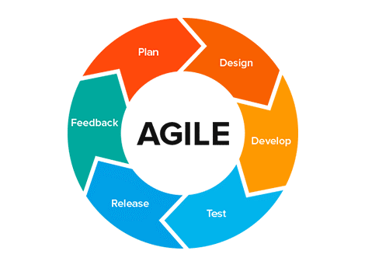

**Planning**

Here in developing of the new system the first step is to identify a need for the shortlisting system, and also plan how to develop the functional requirements of a system. This includes conducting a feasibility study to determine developing a project plan and estimating the viability of the system in question. Looking at the tools to use and the steps to take to finish the project

**Designing**

This will involve designing how the system will look, i.e the interface and the flow of the system in general.

**Developing**

This will involve the actual coding of the system.

**Testing**

Will involve testing the efficiency and accuracy of the system

**Release**

Releasing the system to the market

**Feedback**

Await feedback from the users of the system.

## Preliminary Data Processing and analysis.

From the observations and the records reviewed the conclusion arrived at was that there is a great need for a machine learning model especially in Kenya as there is no model available here. It was also clear that the model will reduce workload and save time.

# System Analysis And Design

## Introduction

This chapter expounds on the technicalities of the system, as well as answering questions such as: who will use the system, what the system will do and where it will be used. It will also discuss in detail the system design techniques used to develop the system.

## Requirements Analysis

### Functional Requirements

* The system should register a company
* The system should allow registered companies to create job openings and save them
* The system should allow registered users to view jobs they have created
* The system should allow applicants to view different job openings
* The system should allow anyone to apply for a job opening by sending their application.
* The system should scan through candidate resumes and select the best fit candidates for a job interview

### Non Functional Requirements

* The system should be operational and should work on any web browser
* The system should have a high performance
* The system should be secure
* Developed system should be easily accessible
* The system should validate users and be easy to use.

## Data Analysis

### Data Collection Procedures

The two procedures used to collect data for this system were observation and an Interview.

These process were conducted in a technical company DewCIS Solutions.

**OBSERVATION**

The company has an existing applicant Tracking System that allows candidates to register in the system, view the company’s job openings and create a resume on the portal. The company has only automated the process of submitting resumes. The remaining work that is done in the recruiting process is manually done. The HR department reads through the resumes submitted and selects best fit candidates to be called for an interview. I was able to interact with the system and see how it works.

**INTERVIEW**

The interview process was facilitated by previously prepared questions that I will attach in the appendix. From the Interview information gathered includes the number of applications received for any job opening, the time it takes to read through applications and call the applicants that will move to the next recruiting process and how satisfactory the current approach is for the company.

### Data Analysis

The company receives a range of applications. The time taken to finish the recruiting process can take up to 50 working days. Most of this time is taken to review the resumes submitted by applicants.

Depending on the number of resumes, The days taken to complete the recruiting process vary.

The company will consider almost the same number of candidates every time for a job interview. When the resumes are more it takes more time to choose these candidates, therefore even though the interview process will mostly take around the same time, more resume will increase the total time taken in the recruiting process.

## System Design

### Use case Diagram.

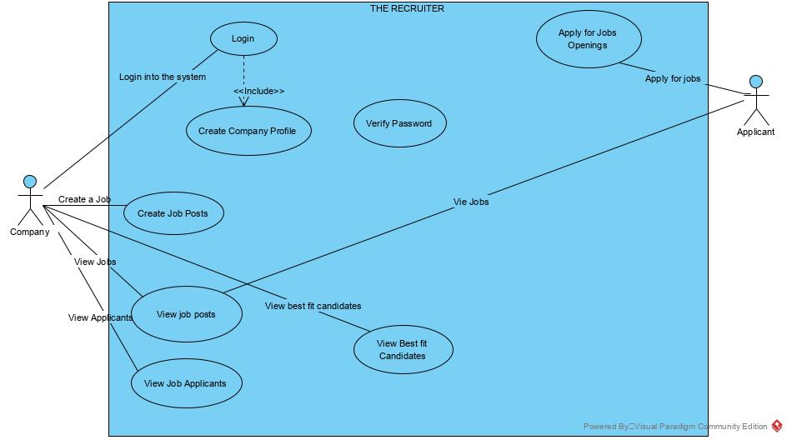

### Activity diagram

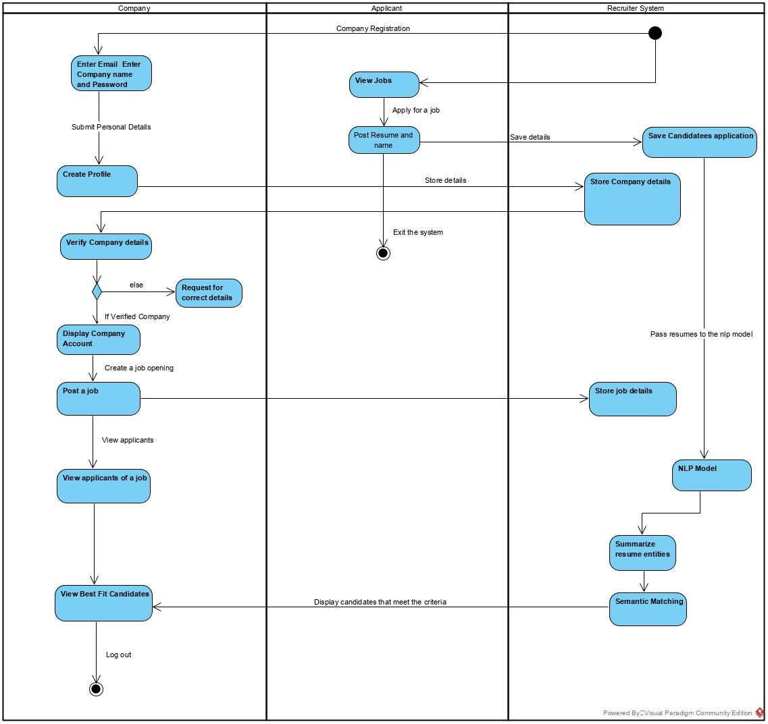

### Sequence Diagram

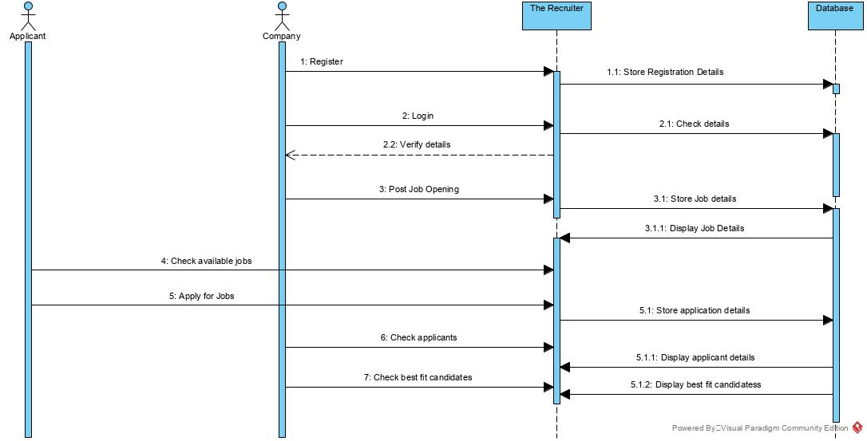

### Data Flow Diagram

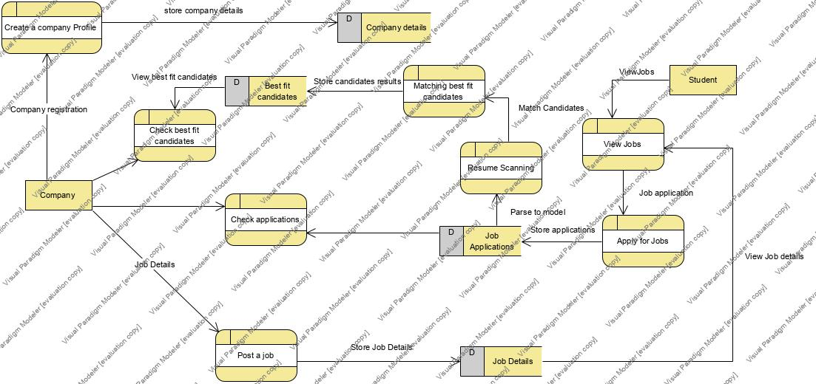

### Class Diagram

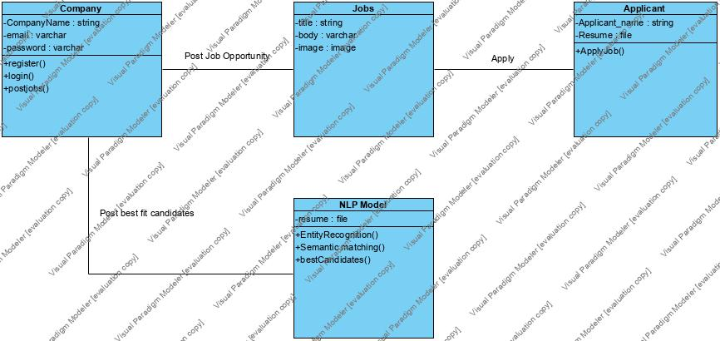

## System Analysis

**Authentication code.**

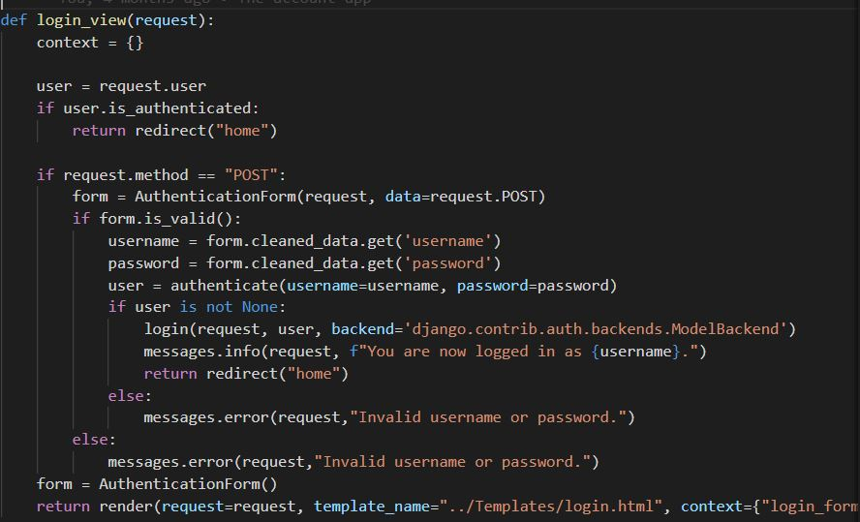

**Post jobs**

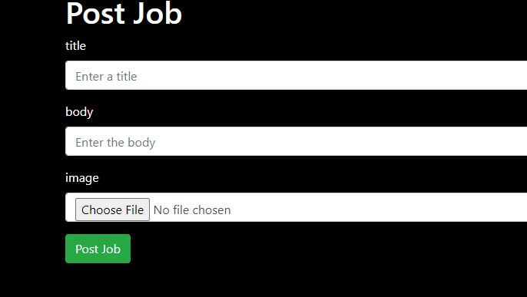

**Post resume**

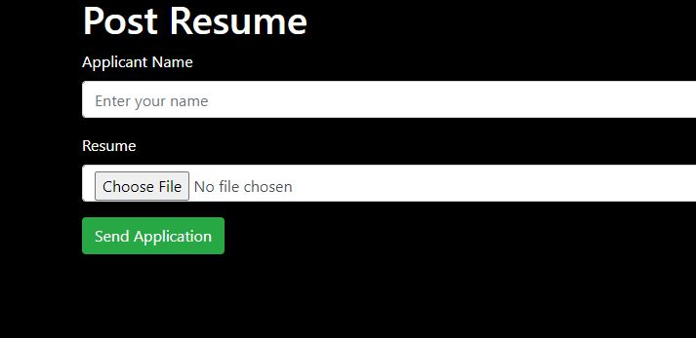

**Entity Recognition on the received file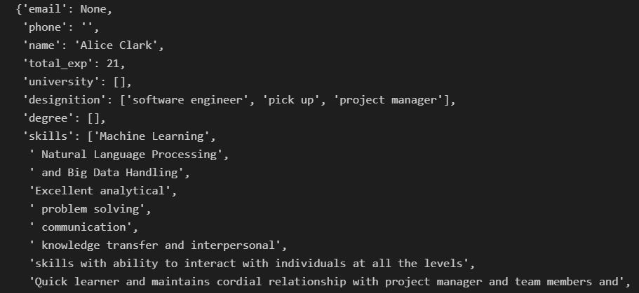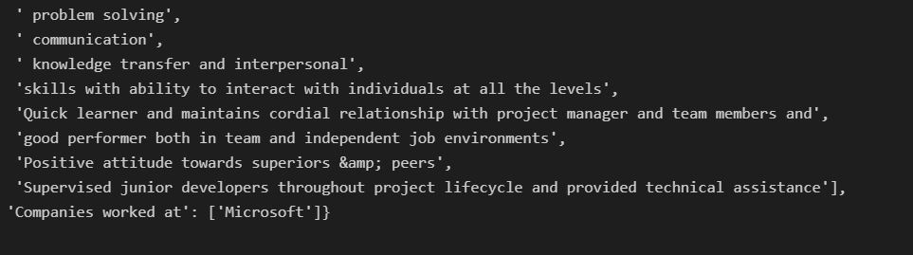**

**Calculating similarity scores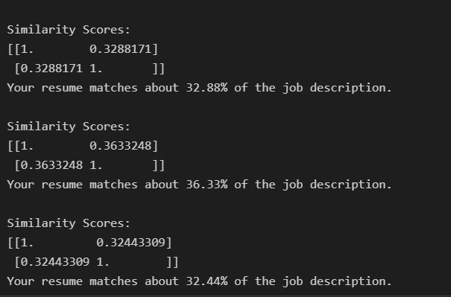**

**Ranking according to scores**

****

# Testing and Implementation

## INTRODUCTION

System testing is quality assurance to ensure that different parts of the system work and interact well together.

System implementation is the process of defining how the system should be built, that is the system design and

**TEST CASES**

**Authentication**

When the user inputs invalid values.

Authentication_error.JPG

When user inputs correct values.

authentication-successful.JPG

Testing the entity recognition model.

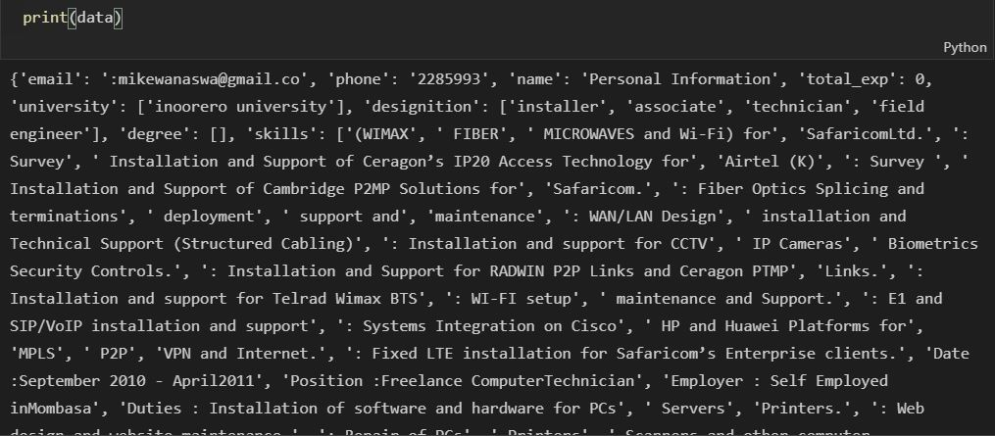

# CONCLUSION AND RECOMMENDATION

## Discussion

The research questions that I set out to answer were as follows:

1. Are there any challenges faced by recruiters when processing job applications?
2. Can one develop a model to optimize the evaluation process of job applications?
3. Can one test and evaluate the model?

Yes there are challenges faced by recruiters when processing job applications, these are many resumes to scan and some receiving some resumes that are irrelevant for the job application.

A model to optimize the evaluation process of job applications can be developed. The function of the model will however be based on the data used.

The created model can be tested and gauged so as to see its performance.

## Limitations

Some of the limitations that I faced when working on this project include:

1. Not enough reading resources and code written on semantic matching and various algorithms. Most of the research is theoretical therefore made the implementation of the system challenging.
2. Different resume structures made it difficult to create a good model for entity recognition therefore making the matching harder.

## Recommendations

1. Using a specific resume builder to help fine tune the structure of resumes which will in turn create a better model for parsing the resumes and analyzing them.

## REFERENCES

Sennaar, K. (2017, December 12). Machine Learning for Recruiting and Hiring –

6 Current Applications | Emerjâ” from Emerj website:

https://emerj.com/ai-sector-overviews/machine-learning-for-recruiting

and-hiring/

Bureau of Labor Statistics (2020, November 1). Current Employment Statistics Highlights November 2020

Glassdoor (2015, January 20). 50 HR and Recruiting Stats That Make You Think. Glassdoor

Kepha Muiruri(2020, February 24) 2.6 million Kenyans searching for jobs – Report. For Citizen Digital

Jobbatical 2020 Hiring statistics, trends and data: The ultimate list of recruitment styles, February 2020

# Ronen ShetelBoim (2017, May 4). 2017 Recruiting Funnel Benchmark Report. Jobvite

Jobvite (2016). Jobvite Recruiter national report 2016 . Jobvite

Jobvite (2020). 2020 Recruiter nation Survey report. Jobvite

SHRM (2016, November 1). 2016 Human Capital BenchMarking Report . SHRM

Opower(2018, June 25). Opower Chooses Entelo and Increases Female Hires from 40% to 47% and Minority Technical hires from 1.5% to 11%

**GANTT CHART**

|  |  |  |
| --- | --- | --- |
| **Activity** | **Start** | **Finish** |
| Preparation and presenting of proposal.(A) | January | February |
| Gathering of requirements and necessary information.(B) | March | April |
| Development of Prototype.(C) | March | May |
| Presentation of progress.(D) | May | May |
| Finish of development.(E) | June | July |
| Presentation of final work.(F) | July | July |

|  |  |  |  |  |  |  |  |
| --- | --- | --- | --- | --- | --- | --- | --- |
|  | January | February | March | April | May | June | July |
| A |  |  |  |  |  |  |  |
| B |  |  |  |  |  |  |  |
| C |  |  |  |  |  |  |  |
| D |  |  |  |  |  |  |  |
| E |  |  |  |  |  |  |  |
| F |  |  |  |  |  |  |  |

**Budget**

|  |  |
| --- | --- |
| **HARDWARE** | **COST** |
| Laptop | 30,000 |
| Ethernet Cable | 300 |
| **SOFTWARE** | **COST** |
| Operating System | Free |
| Python Interpreter | Free |
| Text Editor | Free |
| Browser | Free |
| **OTHERS** | **COST** |
| Bundles | 2000 |
| Transport | 1000 |
| Printing Questionnaires | 500 |
| Total | 33,800 |