Security Governance Simulation, Control Implementation and Executive Reporting

Security Governance Simulation Assessment Brief

Student Name: Faith Mathapelo Letsoara

Registration number: C11/26/CGRC/17582

Cohort /Batch: Cohort 11

Instructor Name: Steve Wamala Gamba

Submission Date: 11/10/2026

PART 1: SETTING UP A SIMULATED ENVIRONMENT

Introduction

This section documents the creation and validation of a Docker-based simulated security governance environment. The environment was designed to host an intentionally vulnerable Apache Struts application to support governance analysis, control implementation and security reporting activities.

1.2 Environment Setup Evidence

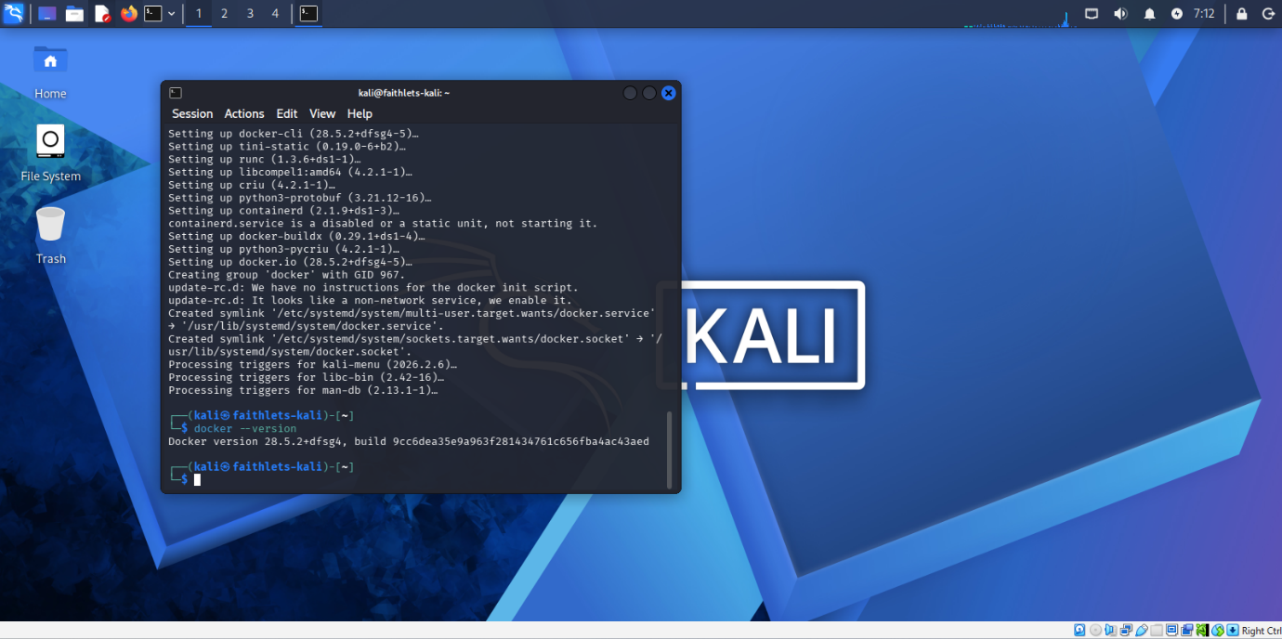Evidence 1 – Docker Version Verification

Docker version information was verified to confirm that the Docker platform was successfully installed and available within the laboratory environment.

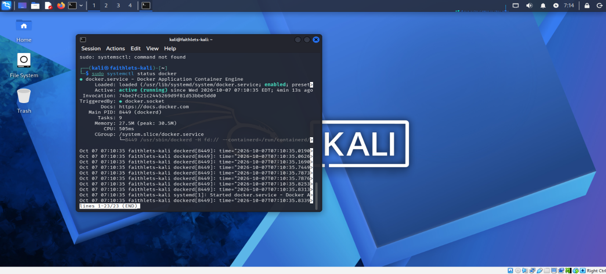Evidence 2- Docker Service Status

Docker service status was verified to ensure container services were operational before deployment activities commenced.

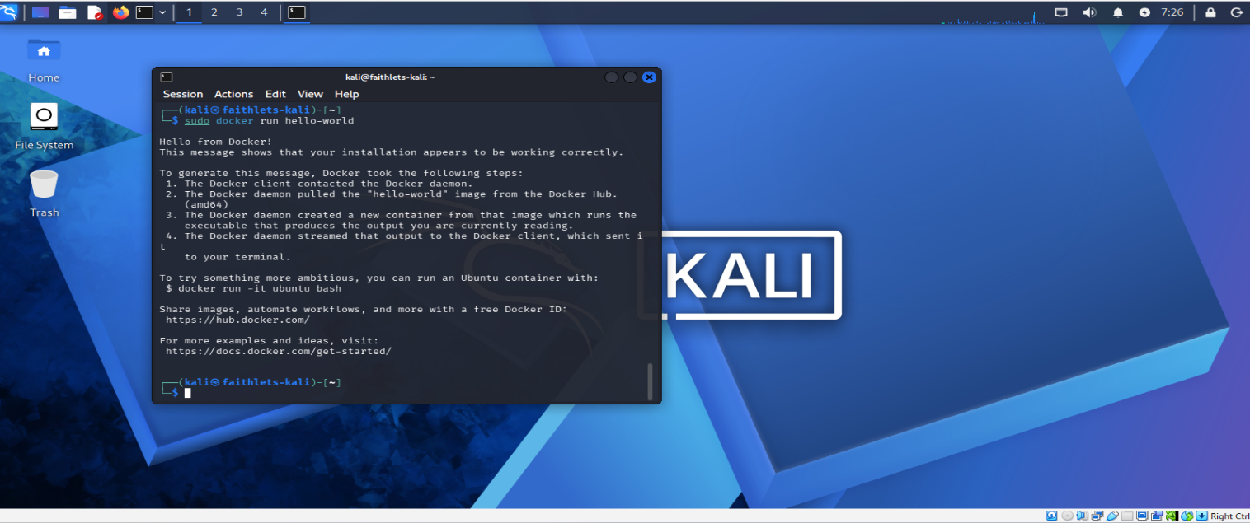Evidence 3- Docker Hello World Test

Docker hello World container was executed successfully, confirming that docker could download and run container images.

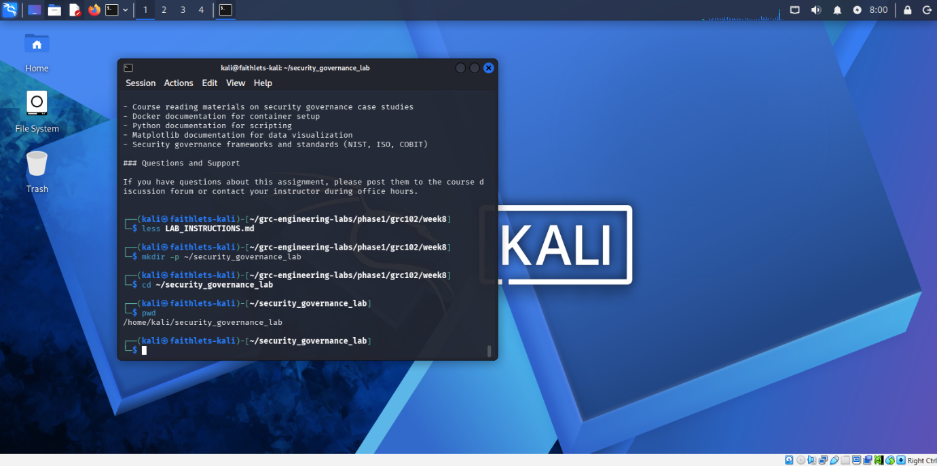Evidence 4-Security Governance Lab Directory

The security governance laboratory directory structure was created to organise project resources and supporting files.
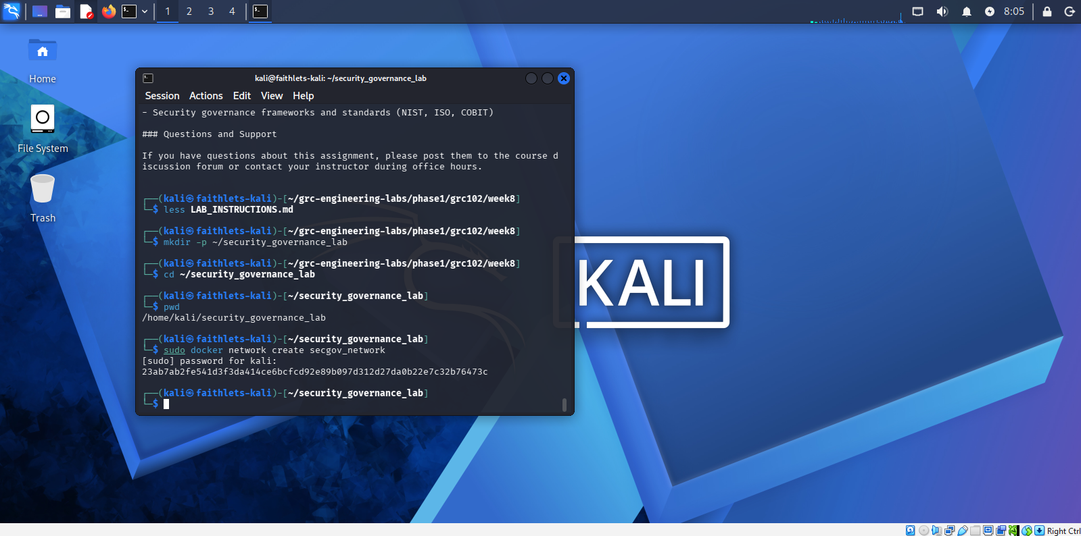Evidence 5- Docker Network Creation

A dedicated Docker network was created to support isolated deployment of laboratory resources.

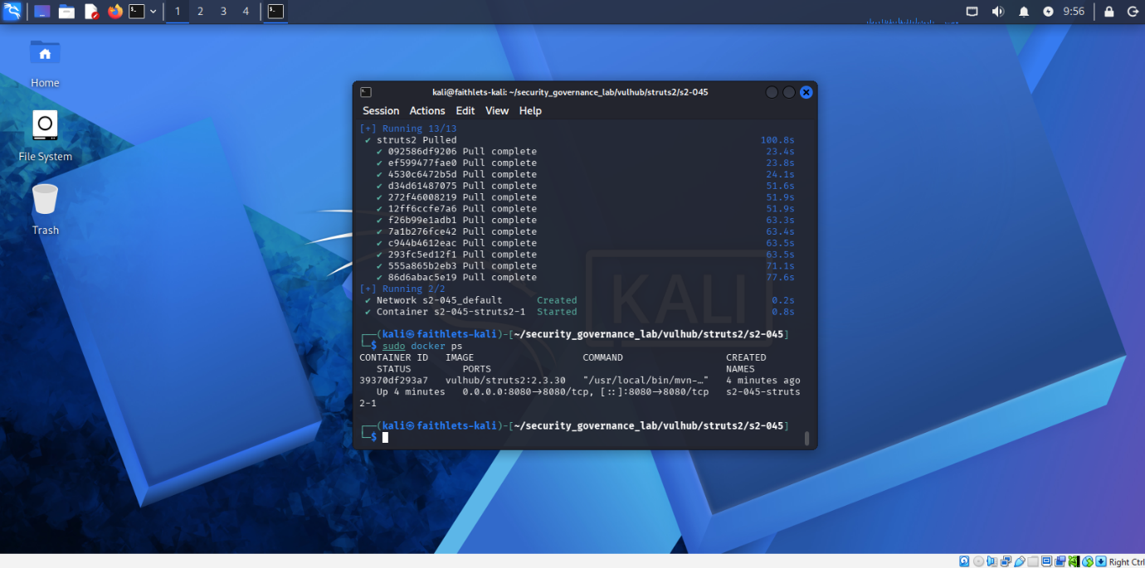Evidence 6-Struts2 Container Deployment

The Apache Struts2 vulnerable container was successfully deployed within the docker environment.

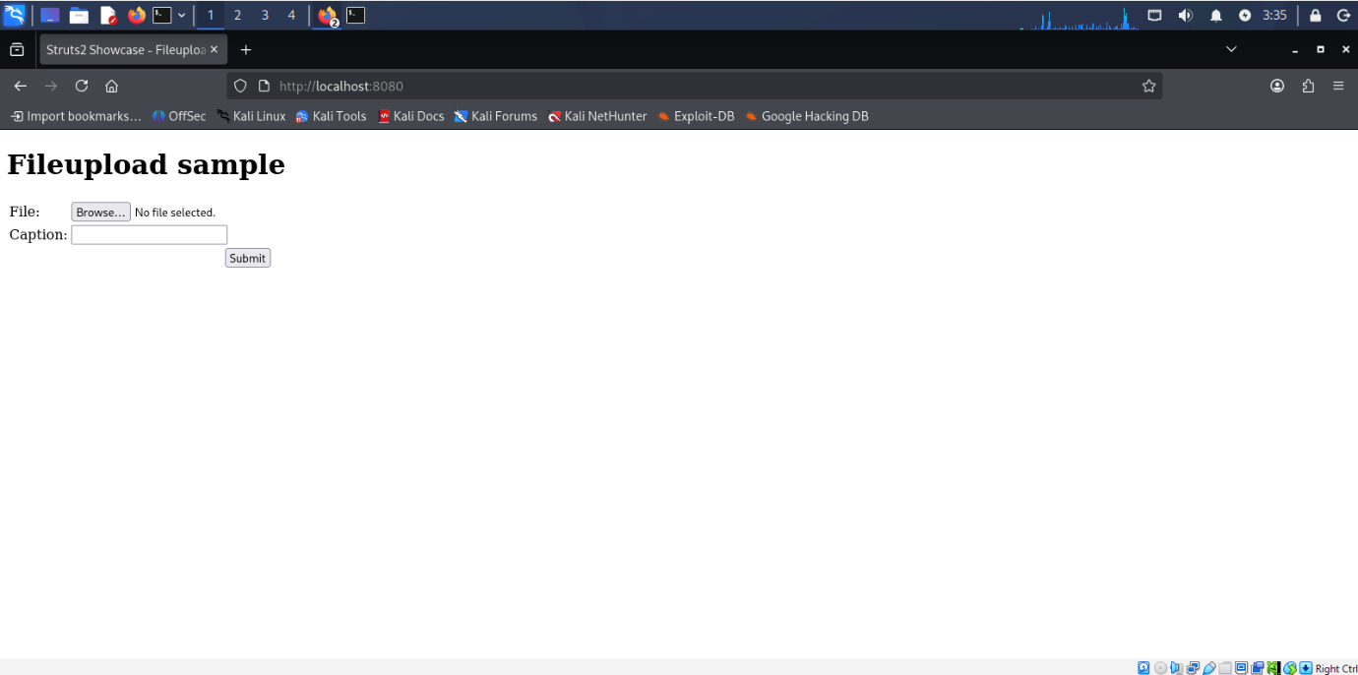Evidence 7- Vulnerable Application Deployment

Deployment verification confirmed that the vulnerable Apache Struts 2 application was successfully installed and accessible through a web browser on port 8080. The application served as the target system for governance analysis and control validation activities.

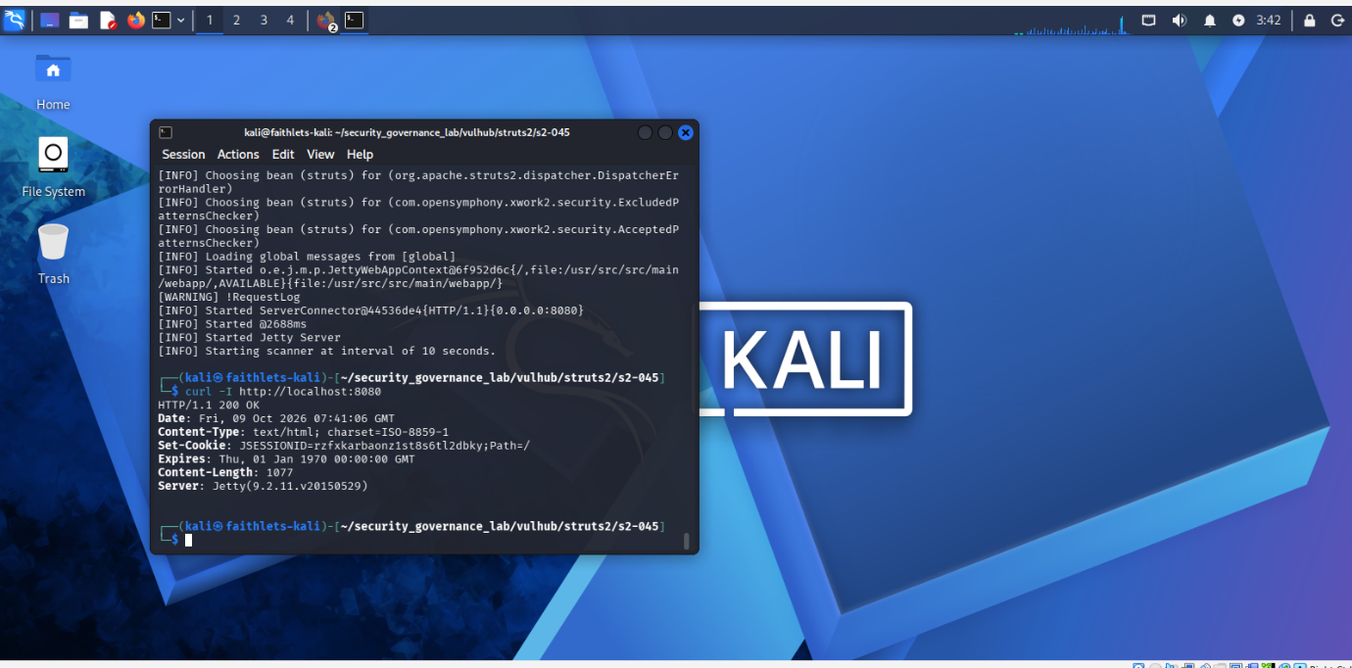Evidence 8-Application Access Verification

Access to the vulnerable web application was successfully verified through the web interface.

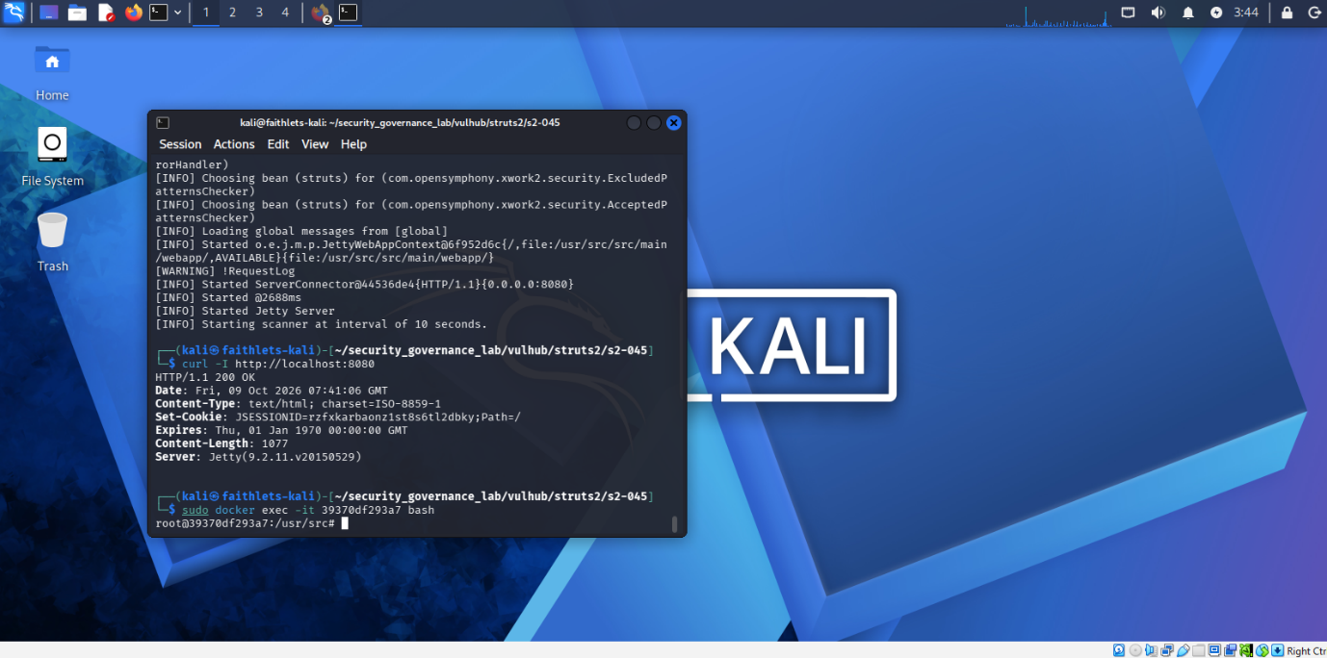Evidence 9-Container Shell Access

Shell access to the running Docker container was verified to support configuration validation activities.

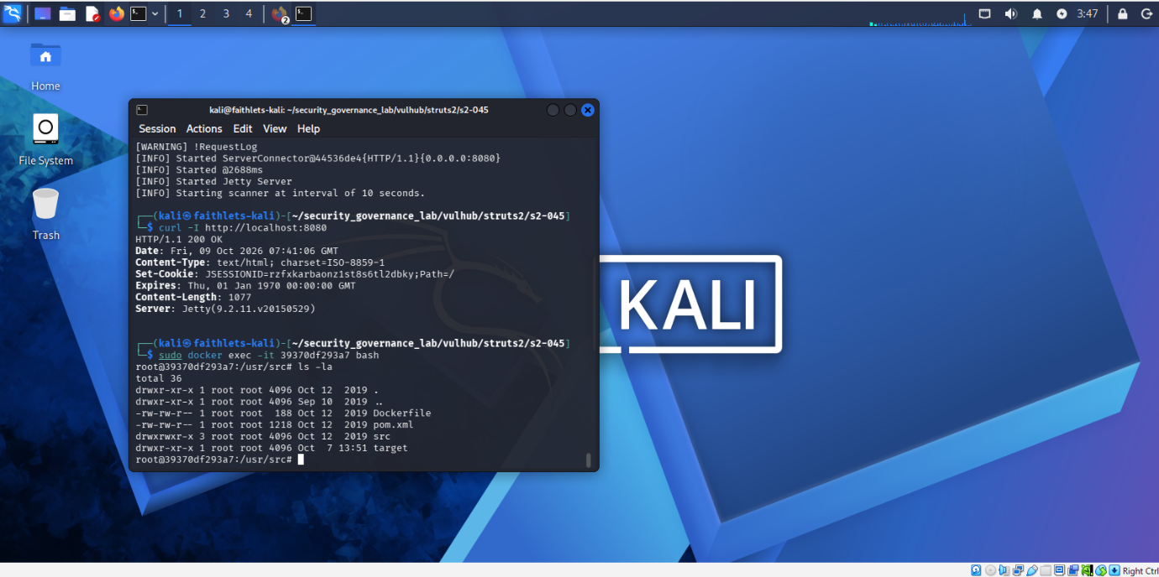Evidence 10-Application Directory Verification

Application directories inside the docker container were reviewed to confirm successful deployment.

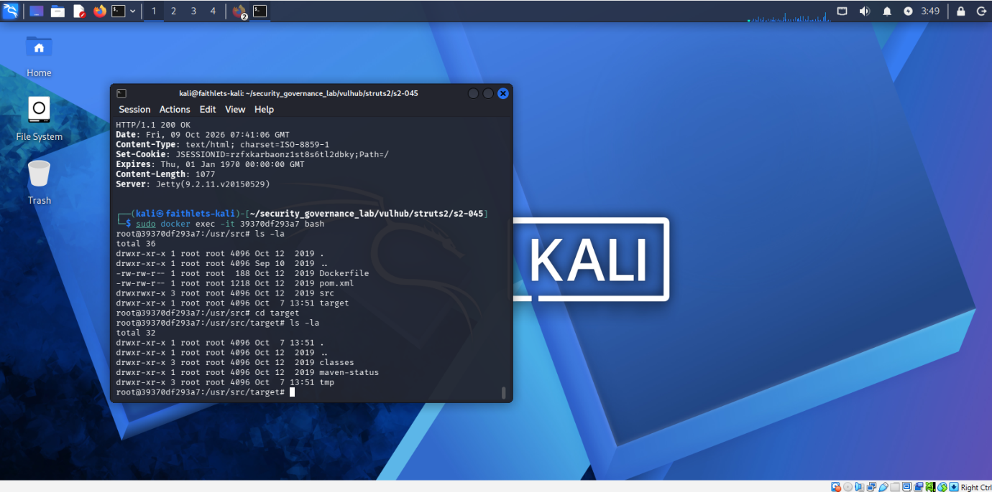Evidence 11 -Build Artifacts Verification

Application build artifacts were verified to confirm successful configuration.

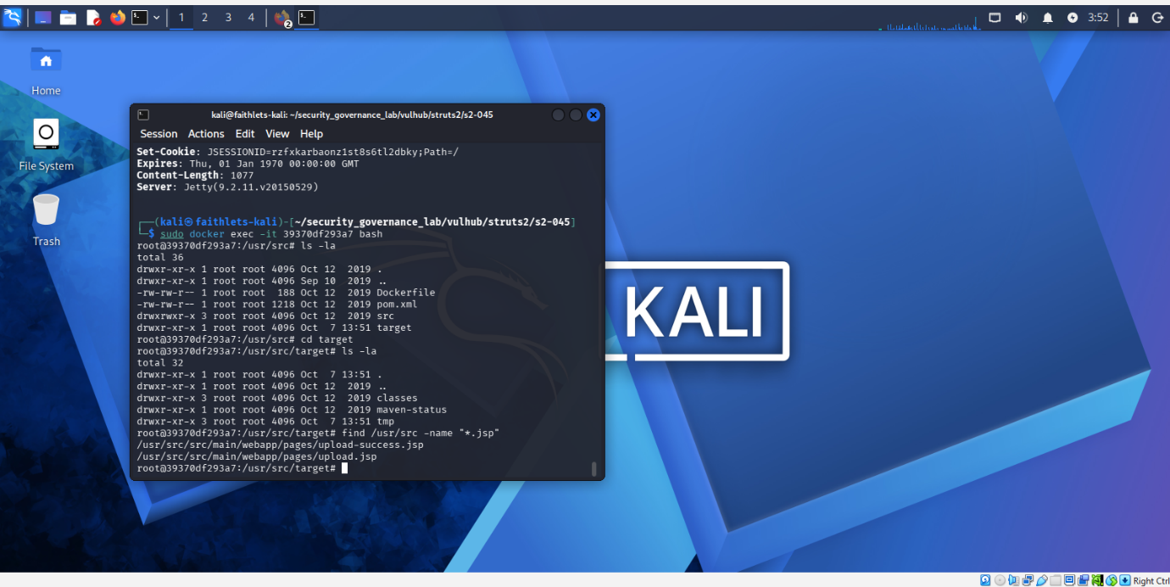Evidence 12-JSP File Verification

Java Server Pages (JSP) files were reviewed as part of application verification activities.

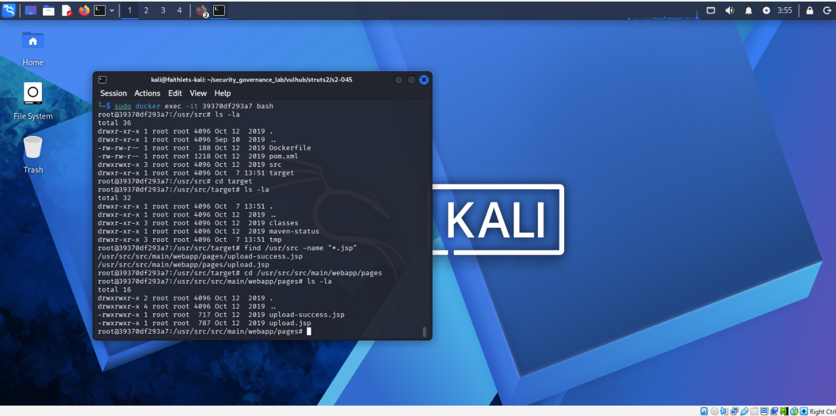Evidence 13 – Web Application Files

Web application files were confirmed within the deployed Apache Struts environment.

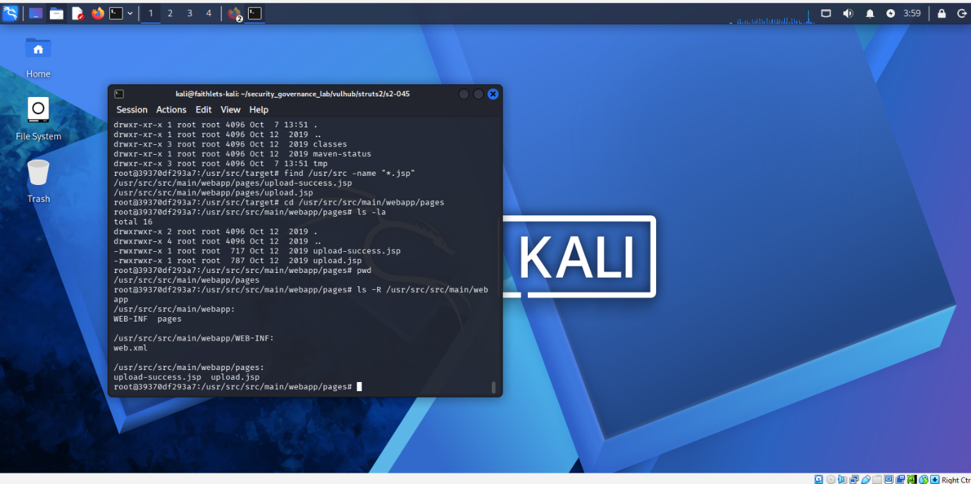Evidence 14 – Environment Structure Verification

Final verification confirmed that all required components of the simulated environment were successfully deployed.

1.3 Environment Summary

The Docker-based environment was successfully created and validated. Verification activities confirmed that the vulnerable Apache Struts application was operational within an isolated laboratory environment. The environment provided the foundation required for governance failure analysis, control implementation and governance reporting activities.

PART 2: ANALYSING SECURITY GOVERNANCE FAILURES

2.1 Vulnerable Application Verification

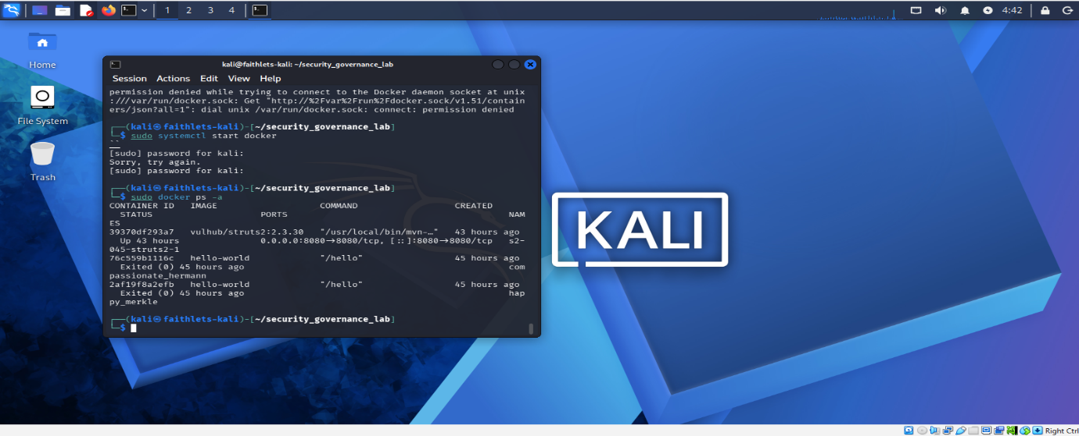Evidence 15 – Docker Container Status

Docker container status confirmed that the vulnerable Apache Struts application remained operational within the simulated environment.

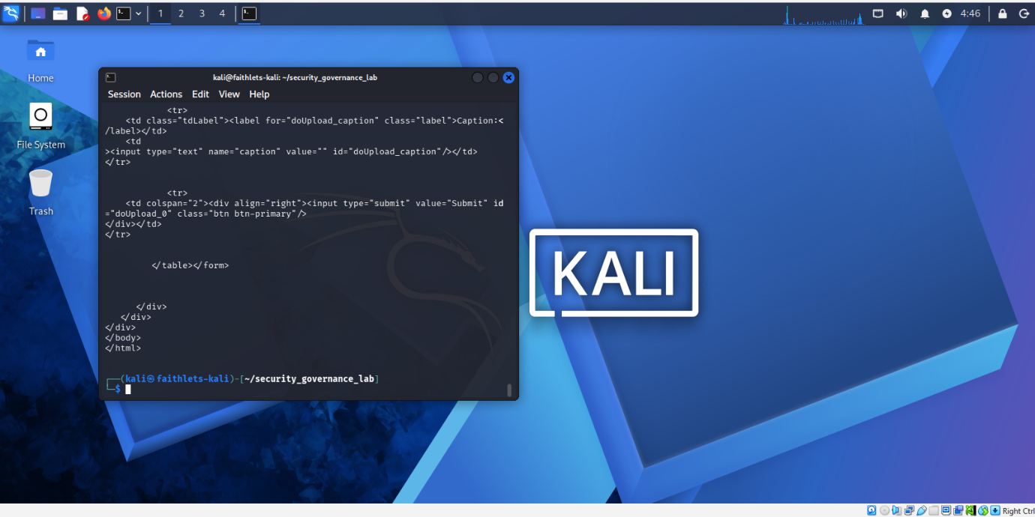Evidence 16 – Vulnerable Application Response Verification

The vulnerable Apache Struts application responded successfully to HTTP requests, confirming that the application was accessible and functioning as expected.

2.2 Governance Failure Analysis

The assessment confirmed that a vulnerable Apache Struts application was active within the simulated environment. Analysis identified multiple governance weaknesses that increased organisational risk.

The primary governance failures identified were:
- Inadequate patch management processes.
- Failure to remediate known vulnerabilities.
- Insufficient governance oversight.
- Weak monitoring and vulnerability management practices.
- Increased exposure to exploitation and unauthorised access.

These failures demonstrate how ineffective governance processes can contribute directly to security incidents and organisational risk.

2.3 Equifax Comparison

The findings closely align with the 2017 Equifax data breach. In the Equifax incident, attackers exploited a known Apache Struts vulnerability that remained unpatched despite available security updates.

Similarities between the simulation and the Equifax breach include:
- Use of a vulnerable Apache Struts application.
- Delayed patch management activities.
- Weak governance oversight.
- Poor vulnerability management controls.

The simulation demonstrates how governance failures can significantly increase organisational exposure to cyber threats and data breaches.

2.4 Findings Summary

Analysis activities confirmed that ineffective governance processes contributed to increased security risk exposure. Weak patch management, insufficient monitoring and limited governance oversight were identified as the primary contributors to the identified vulnerabilities. The findings highlight the importance of proactive governance and continuous security monitoring.

Part 3: Governance Controls

3.1 Governance Controls Implemented
The following governance controls were implemented within the simulated environment:

- Network segmentation was implemented through dedicated Docker bridge networks.
- Monitoring and logging controls were enabled through Docker container logs.
- Governance oversight was supported through documented evidence collection and verification activities.
- Security controls were validated through container status checks, network inspections, and application monitoring.

These controls improve visibility, reduce exposure to vulnerable services, and support ongoing governance and risk management activities.

3.2 Patch Management Control
The assessment identified an outdated Apache Struts application version. Patch management controls were reviewed to demonstrate the importance of applying vendor security updates in a timely manner to reduce exploitability and improve governance compliance.

The failure to patch known vulnerabilities was a key lesson from the Equifax breach and remains a critical governance responsibility.

3.3 Database Security Control
Database security was supported through deployment within an isolated Docker environment and dedicated Docker network. Network isolation reduced exposure to unauthorised access and supported governance requirements for secure application deployment.
Implementing database security controls helps protect sensitive information and reduces the likelihood of data compromise.

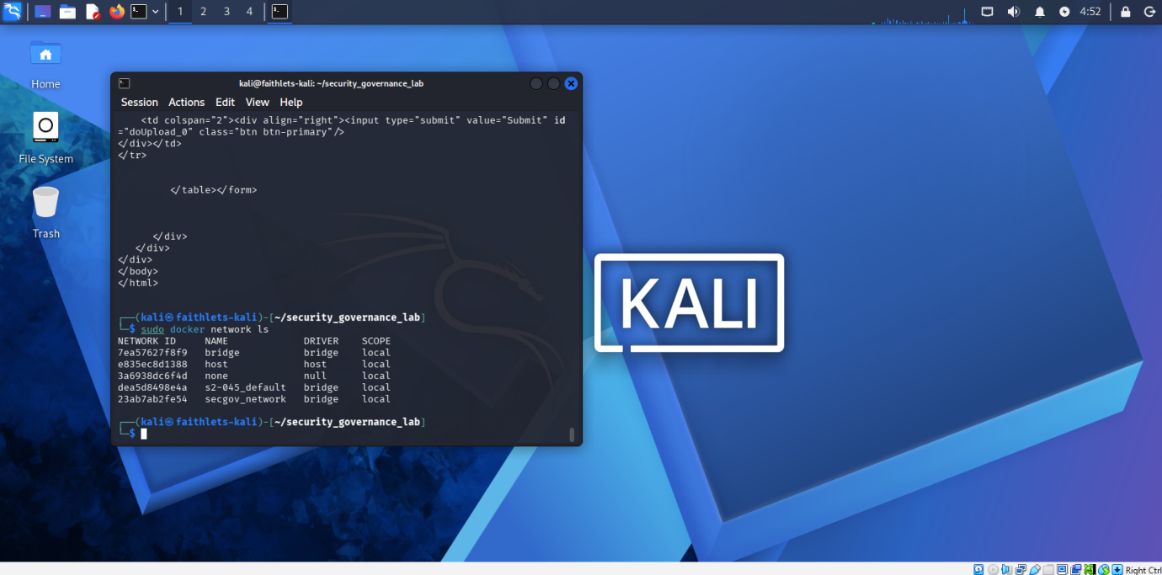Evidence 17 – Docker Network Verification
Docker network configuration was verified to confirm network segmentation within the simulated governance environment.

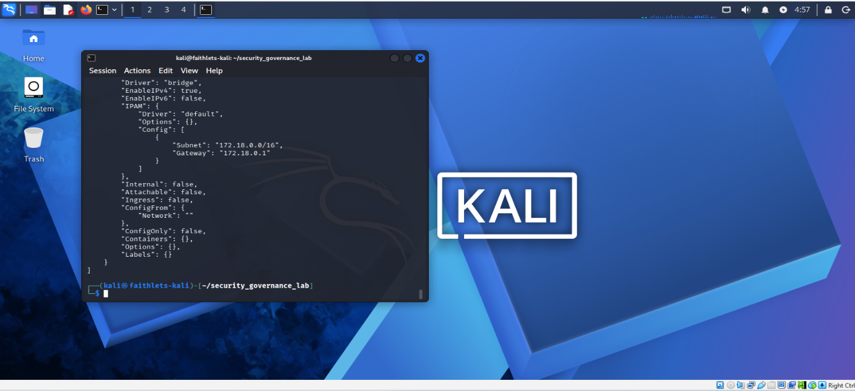Evidence 18 – Docker Network Segmentation Verification
Inspection of the secgov_network confirmed segmentation and isolation controls through subnet and gateway configuration.
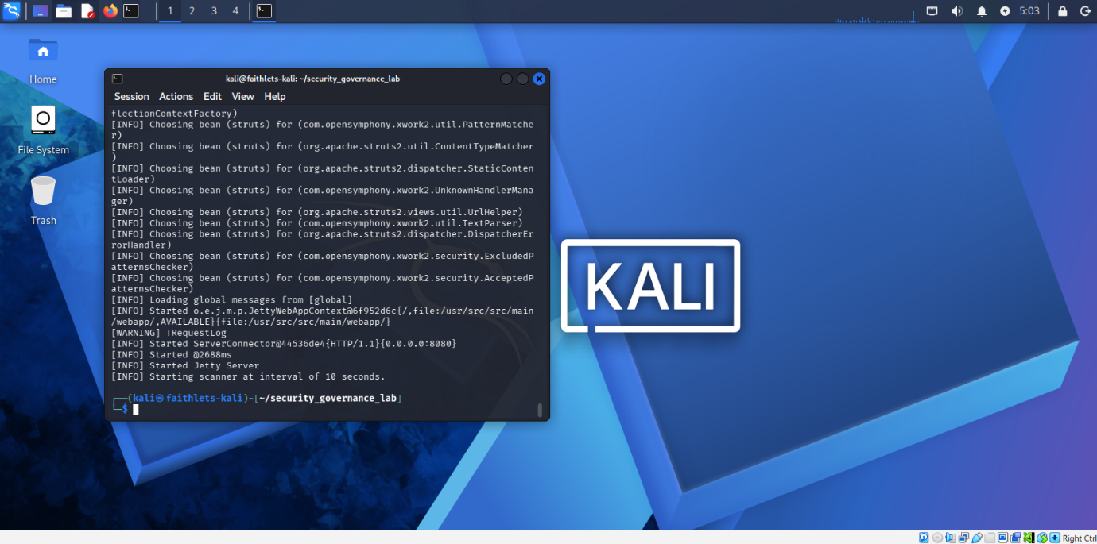Evidence 19 – Monitoring and Log Collection Verification
Docker container logs confirmed application startup, monitoring activity and governance oversight.

Part 4: Governance Metrics and Reporting
4.1 Governance Metrics
Metric | Value
Vulnerable Applications Identified | 1
Docker Containers Monitored | 1
Dedicated Security Networks Configured | 2
Governance Controls Verified | 4

4.2 Metrics Framework
Metric | Purpose
Vulnerable Applications Identified | Measure security exposure
Docker Containers Monitored | Measure monitoring coverage
Dedicated Security Networks Configured | Measure segmentation effectiveness
Governance Controls Verified | Measure governance maturity

4.3 Executive Governance Dashboard
Governance Dashboard | Value
Vulnerable Applications | 1
Containers Monitored | 1
Security Networks | 2
Controls Verified | 4

4.4 Board Report
The governance assessment identified a vulnerable Apache Struts application operating within the simulated environment. Governance weaknesses were observed in vulnerability management, monitoring, segmentation and oversight processes.

Governance controls were implemented and validated through Docker network segmentation, application monitoring, log collection and security verification activities. These controls improved visibility and reduced risk exposure.
Ongoing governance reviews, monitoring activities and vulnerability management processes are recommended to ensure continued security oversight.

4.5 Executive Summary
The assessment identified a vulnerable Apache Struts application operating within the simulated environment. Review activities confirmed governance weaknesses related to patching and oversight. Governance controls including network segmentation, monitoring, and logging were implemented and validated. The environment demonstrates how governance processes can be used to identify, monitor, and manage cybersecurity risks.

4.6 Dashboard User Guide
The governance dashboard provides a consolidated view of governance and security metrics. Users should review the dashboard regularly to monitor vulnerable assets, evaluate governance control effectiveness, and support risk-based decision-making.

Conclusion
This practical assessment successfully demonstrated the creation of a Docker-based security governance environment, identification of governance failures, implementation of governance controls, and development of governance metrics and executive reporting. The exercise highlighted the importance of patch management, monitoring, network segmentation, and governance oversight in reducing organisational security risk and improving overall security posture.

