WEEK 10 DOCUMENTATION

Topic: Application Integration, Testing and Debugging

Activities Carried Out

During Week 10, I focused on integrating all modules of the SchoolLink mobile application into one complete system. The login page, parent dashboard, student profile, academic records, fee payment section, and Firebase database were connected to ensure smooth navigation throughout the application. I also improved the user interface by arranging buttons properly, using consistent colours, and making the application easier for parents to use.

I tested every screen to ensure data entered by users was saved correctly in Firebase and displayed whenever needed. I verified that activities opened correctly using Android Intents and fixed navigation errors that prevented some pages from opening. Input validation was added to prevent users from submitting empty fields and appropriate error messages were displayed whenever invalid information was entered.

After integration, I performed debugging using Android Studio Logcat to identify and fix application errors. The application was tested several times to ensure it no longer crashed during execution. This improved the stability and usability of the SchoolLink application.

Skills Gained

Application integration

Functional testing

Debugging using Logcat

Firebase database testing

User interface improvement

Navigation testing

screenshots:

1. Android Studio showing your project structure.
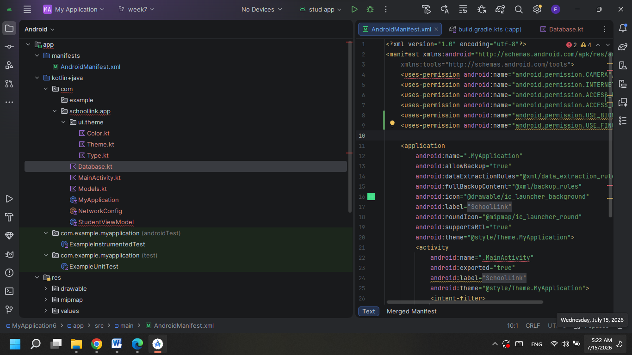

2. Logcat showing the application running without errors.

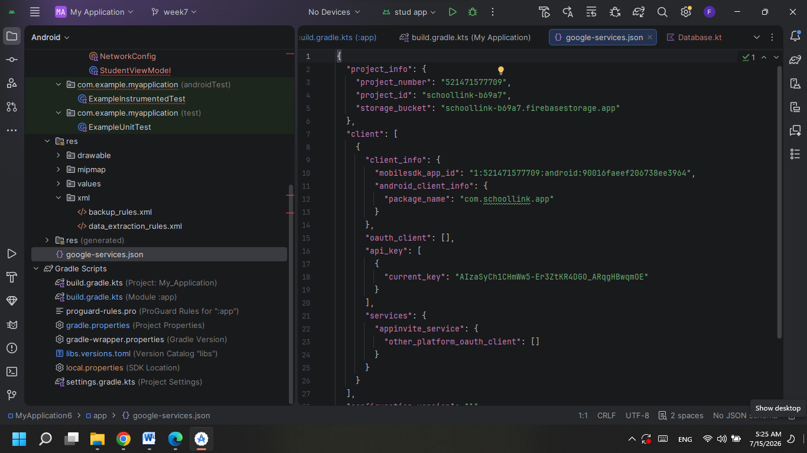

3. XML layout (activity_login.xml or activity_dashboard.xml).
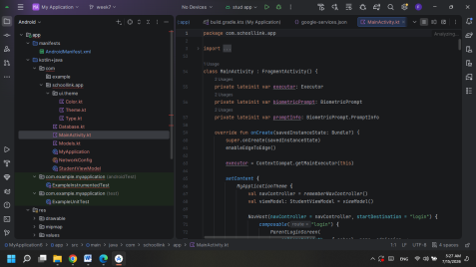

WEEK 11 DOCUMENTATION

Topic: Application Deployment and Publishing

Activities Carried Out

During Week 11, I prepared the SchoolLink application for deployment. I reviewed the project and removed unnecessary files to improve performance. The application name, icon, and version information were updated to make the application appear more professional.

I conducted final testing to ensure that all modules were functioning correctly before deployment. The login system, dashboard, student information, examination results, fee payment, and Firebase database connectivity were tested successfully. Error handling was also verified to ensure users received clear messages whenever incorrect information was entered.

I prepared the application for release by generating an APK file using Android Studio. I also created application screenshots that can be used when publishing the application. Finally, I documented the application's features, target users, and future improvements.

Skills Gained

Preparing an Android application for deployment

APK generation

Final application testing

Application documentation

Release preparation

Version management

SCREENSHOTS OF:
AndroidManifest.xml.
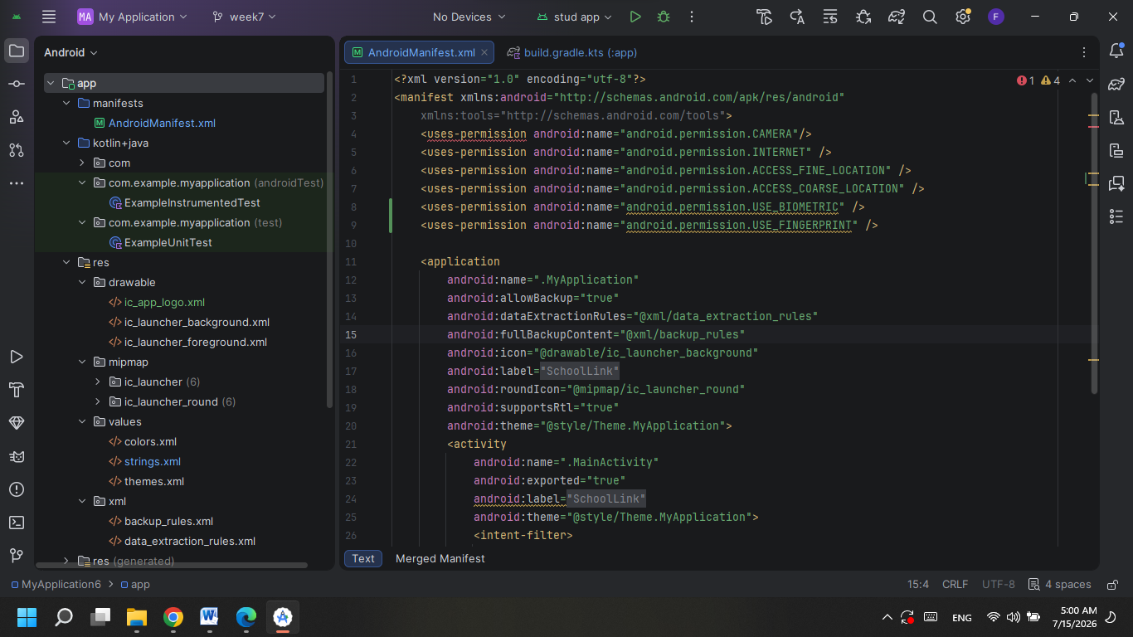

build.gradle showing version information.
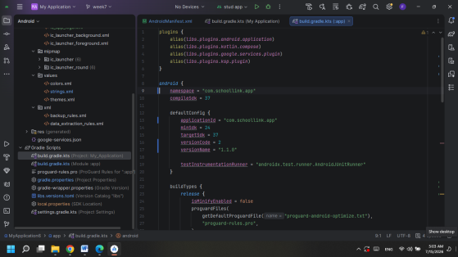

Project running successfully in Android Studio.
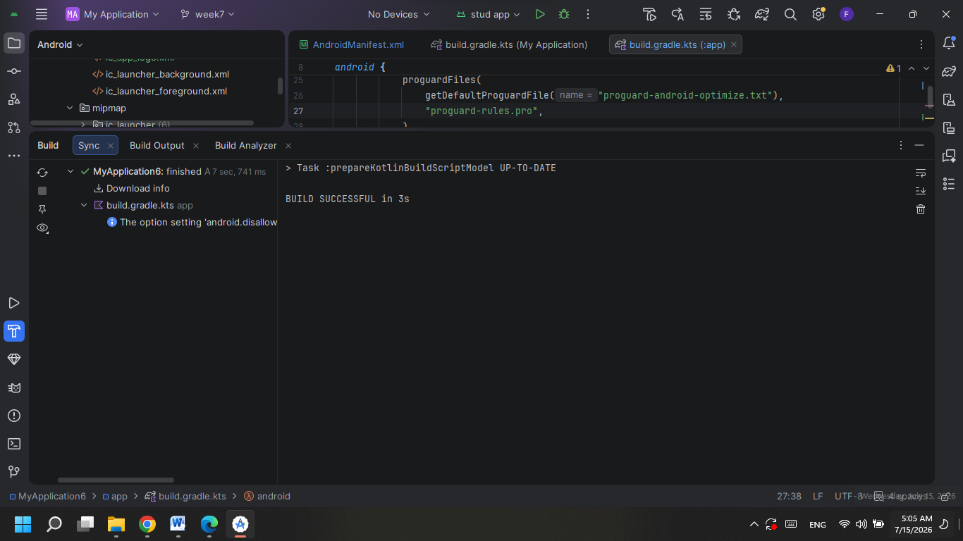
Code Screenshots to Include
Database.kt
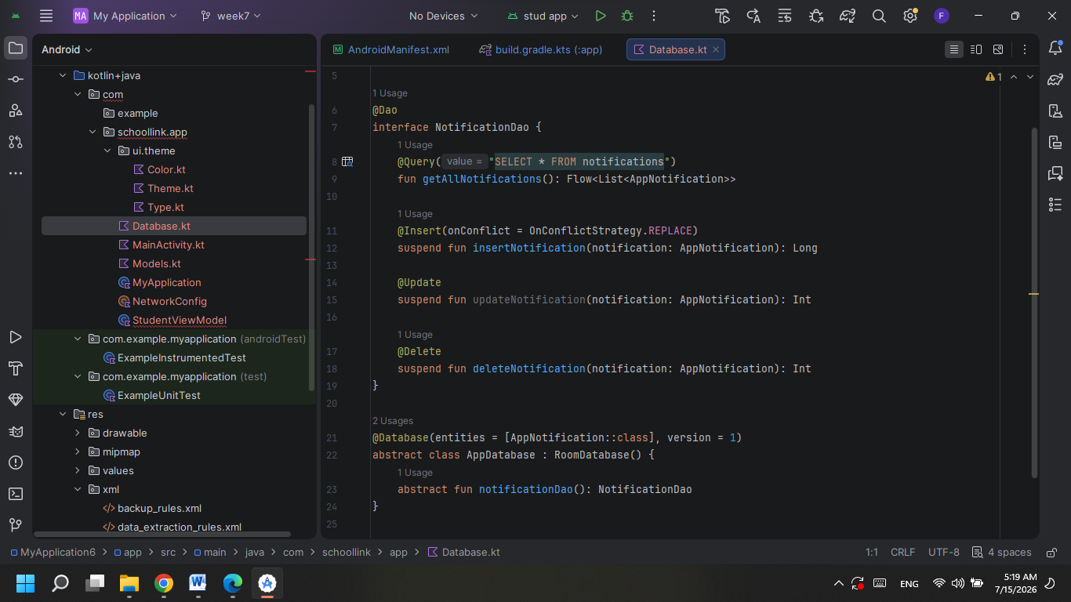
mainActivity.kt
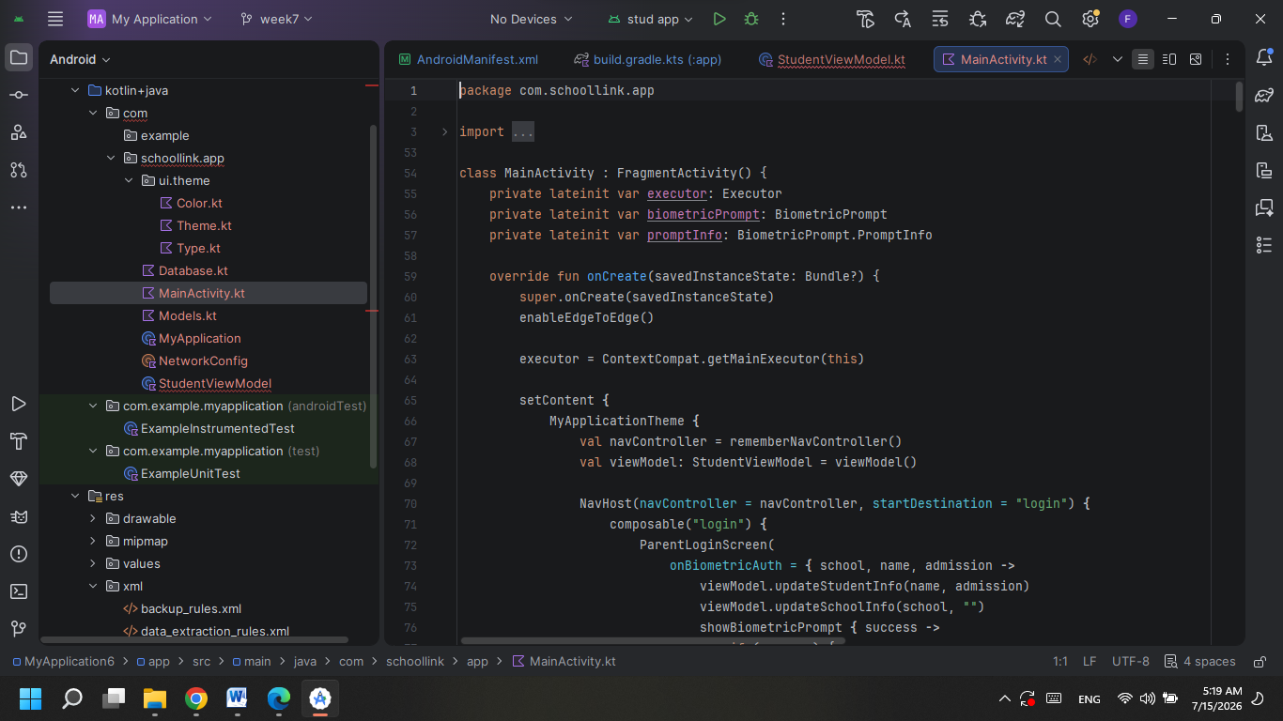
student model
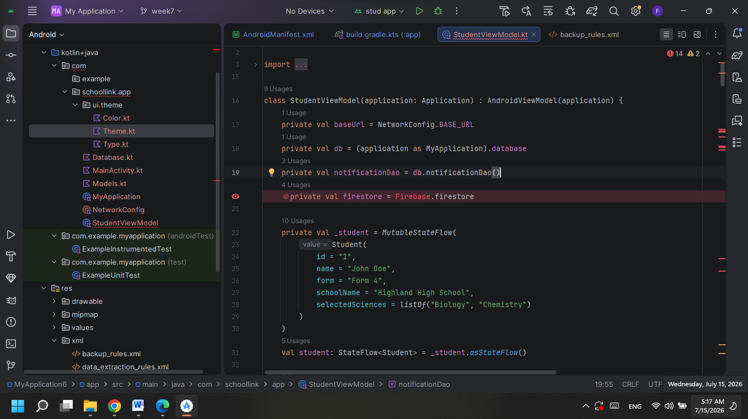
AndroidManifest.xml
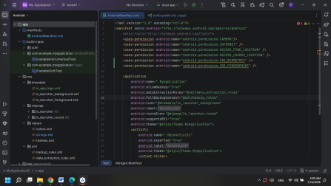
build.gradle (Module: app)
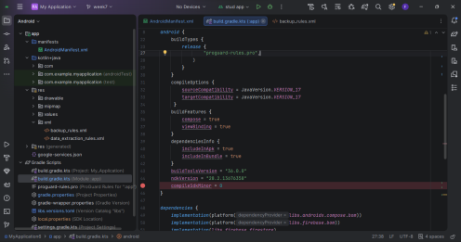

WEEK 12–14 DOCUMENTATION
1. Application Overview

SchoolLink is an Android mobile application developed to improve communication between schools and parents. The application allows parents to securely log in and access important information about their children, including academic performance, attendance records, fee balances, school announcements, and personal student information. It also provides a platform for receiving notifications from the school and enables administrators to manage student records efficiently.

The application was developed using Android Studio (Java) with Firebase Authentication for secure login and Firebase Realtime Database for storing and retrieving school data.

---

2. Testing and Debugging

Before deployment, the SchoolLink application underwent several testing activities to ensure that it functioned correctly.

The following tests were performed:

Login authentication testing.

Registration form validation.

Student record retrieval testing.

Firebase database connectivity testing.

Navigation testing between different screens.

Button functionality testing.

Logout testing.

During testing, Android Studio Logcat was used to monitor errors while breakpoints helped identify coding mistakes. Runtime errors caused by incorrect Firebase references and missing input validation were corrected before further testing.

3. Test Results

Test | Expected Result | Actual Result | Status
User Login | Parent logs in successfully | Successful | Passed
User Registration | New account created | Successful | Passed
Student Profile | Student information displayed | Successful | Passed
Attendance Records | Attendance loaded | Successful | Passed
Academic Results | Exam results displayed | Successful | Passed
Firebase Connection | Data synchronized | Successful | Passed
Logout | User redirected to login page | Successful | Passed

---

4. Performance Optimization

Several optimization techniques were implemented to improve the application's performance.

Optimized Firebase database queries.

Reduced unnecessary data loading.

Improved screen navigation speed.

Compressed application images.

Removed unused Java classes and resources.

Tested memory usage using Android Studio Profiler.

Improved application startup time.

These improvements made the application faster and more responsive.

5. Deployment Preparation

To prepare SchoolLink for deployment, the following activities were completed:

Application icon designed.

Splash screen created.

Version Name: 1.0

Version Code: 1

Release build generated in Android Studio.

Application signed using a secure keystore.

Android App Bundle (AAB) prepared for Google Play Store submission.

Play Store screenshots prepared.

Privacy Policy drafted because the application stores user information using Firebase.

6. Google Play Store Listing

App Name

SchoolLink

Short Description

A mobile application that connects schools and parents through real-time student information.

Long Description

SchoolLink is an Android application designed to improve communication between schools and parents. Parents can securely log in to monitor student academic performance, attendance records, fee balances, school announcements, and personal information. The application uses Firebase Authentication and Firebase Realtime Database to provide secure, reliable, and real-time access to student information. SchoolLink improves transparency between schools and parents while reducing paperwork and manual communication.

7. Challenges Encountered

Several challenges were experienced during development.

Difficulty connecting Firebase to Android Studio.

Authentication configuration errors.

Slow internet affecting Firebase synchronization.

XML layout design issues.

Application crashes caused by incorrect database references.

GitHub repository configuration challenges.

8. Solutions Implemented

The challenges were resolved by:

Reconfiguring Firebase services.

Correcting database references.

Testing internet connectivity.

Using Android Studio Logcat to identify errors.

Using breakpoints to debug the application.

Regularly committing source code to GitHub.

9. Lessons Learned

This project improved my understanding of:

Android application development using Java.

Firebase Authentication.

Firebase Realtime Database.

Mobile user interface design.

Application testing and debugging.

Version control using GitHub.

Mobile application deployment procedures.

Google Play Store publishing requirements.

10. Conclusion

The SchoolLink mobile application successfully demonstrates the complete mobile application development lifecycle. The application provides an effective solution for improving communication between schools and parents by offering secure access to academic records, attendance, school announcements, and fee information. Testing, debugging, performance optimization, and deployment preparation improved the quality and reliability of the application. The project also enhanced practical skills in Android development, Firebase integration, software testing, and deployment.

