UACT Event Tracker

Project Documentation

Prepared by:
Vhonn Gabriel P. Habulin — 2024-4558-A
Mark Lorenz O. Vargas — 2024-1598-A
Camille Rose G. Sagucom — 2024-8556-A

Course: Bachelor of Science in Information Technology
Section/Block: 2C

Instructor:
Mr. Kenneth Roeven C. Saylo

June 26, 2026
System Overview
UAct Event Tracker is a campus life information system designed for student organizations, event officers, students, and university administrators. Officers use it to create and manage events by entering details like title, date, time, venue, and the owning organization. Students can browse and register for events online, and their participation is recorded automatically. Attendance tracking and event histories are maintained for each organization, giving officers a clear record of past activities.
The system solves coordination and transparency problems common in campus event management. It centralizes event creation and registration, reduces manual attendance tracking, and prevents schedule conflicts by providing up-to-date event information. For administrators, UAct provides aggregated participation trends and organization-level histories that support resource planning, identify engagement gaps, and improve oversight—helping campuses run safer, better-organized student activities.

ERD (Entity-Relationship Diagram)

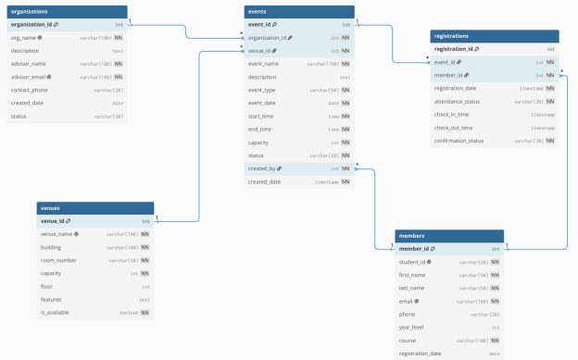

Relationships
- organizations 1 — * events: one organization can create many events; each event belongs to one organization (events.organization_id → organizations.organization_id).
- venues 1 — * events: one venue can host many events; each event uses one venue (events.venue_id → venues.venue_id).
- members 1 — * events (creator): events.created_by references members.member_id, meaning a member created the event.
- events 1 — * registrations and members 1 — * registrations: registrations is a many-to-many join between members and events (registrations.event_id → events.event_id and registrations.member_id → members.member_id), allowing many members per event and many events per member.

Data Dictionary
Table 1.
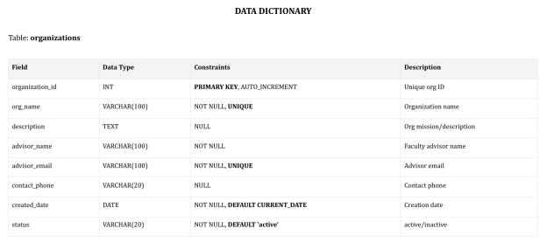
This table shows a data dictionary for a database table named organizations, which defines the structure, data types, and constraints for storing information about different organizations.
It contains eight distinct fields, including a unique identifier (organization_id) acting as an auto-incrementing primary key, alongside descriptive fields like the organization's name, description, and status. Essential contact details are captured through fields for the faculty advisor's name and email, as well as a contact phone number.
To ensure data integrity, specific constraints are applied, such as enforcing uniqueness on the organization name and advisor email, making certain fields mandatory with NOT NULL, and applying automatic default values for both the creation date (CURRENT_DATE) and the organization's initial status ('active').

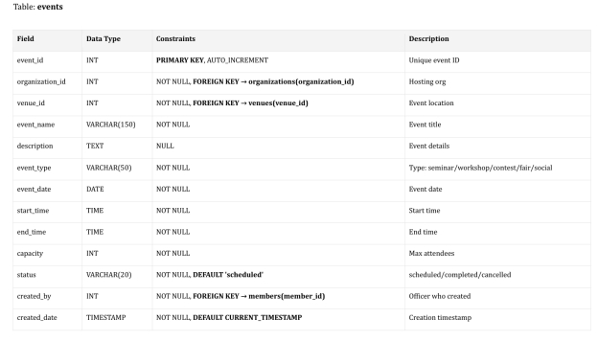
Table 2.

This table shows a data dictionary for a database table named events, which outlines the schema required to manage and track various scheduled events.

It features an event_id as an auto-incrementing primary key to uniquely identify each record, alongside structural relationships managed via three foreign keys:

- organization_id (linking to the hosting organization),
- venue_id (linking to the event location)
- created_by (linking to the member/officer who created the entry).

The table captures essential event characteristics such as the name, detailed description, categorized type (e.g., seminar, workshop, social), scheduled date, start and end times, and maximum attendee capacity. Data integrity is strictly maintained by marking almost all fields as NOT NULL, while automated tracking is handled through a default status of 'scheduled' and a created_date that automatically records the current system timestamp.
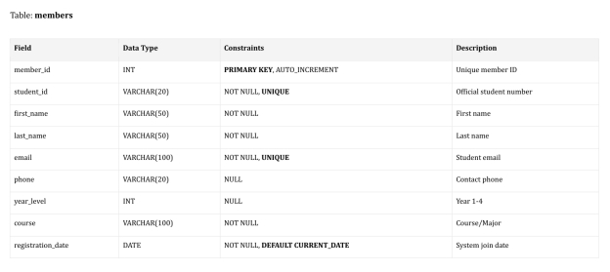
Table 3.

This table shows a data dictionary for a database table named members, which defines the structure and business rules for storing student membership information. It utilizes member_id as an auto-incrementing primary key to uniquely identify each person, complemented by mandatory unique constraints on both the student_id (the official student number) and the student's email to prevent duplicate accounts.

The table captures personal identification data through required fields for first_name, last_name, and academic course, while allowing optional entries for a contact phone number and student year_level. Finally, database tracking is streamlined by enforcing a NOT NULL constraint on the registration_date, which automatically populates with the current system date (CURRENT_DATE) upon entry creation.

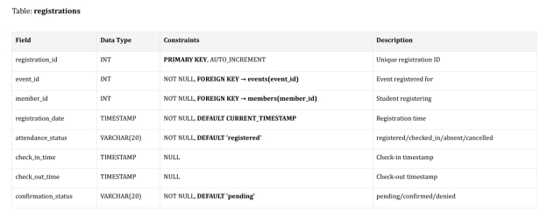
Table 4.

This table shows a data dictionary for a database table named registrations, which functions as a junction table to track event sign-ups and attendance for individual members. It uses a unique, auto-incrementing registration_id as its primary key and establishes relationships with other tables through two vital foreign keys:

- event_id (pointing to the specific event)
- member_id (pointing to the student registering).

The table logs the initial transaction time using a registration_date that defaults to the system's current timestamp, and it monitors lifecycle tracking via attendance_status (defaulting to 'registered') and confirmation_status (defaulting to 'pending'). Additionally, it provides optional nullable timestamp fields for check_in_time and check_out_time to effectively capture physical or virtual attendance during the actual event.

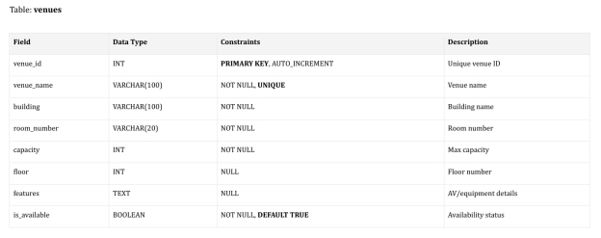
Table 5.

This table shows a data dictionary for a database table named venues, which establishes the schema for managing physical event spaces and locations. It uses an auto-incrementing venue_id as the primary key to ensure each location is unique, alongside a NOT NULL and UNIQUE constraint on the venue_name to prevent duplicate venue titles.

To accurately locate and assess a space, the schema enforces mandatory entries for the building name, room_number, and maximum attendee capacity, while leaving the floor number and specific features (like audio-visual or equipment details) as optional fields. Lastly, the table tracks real-time resource availability through a required is_available boolean field, which automatically defaults to TRUE upon creation.

QL Script Summary
index.php
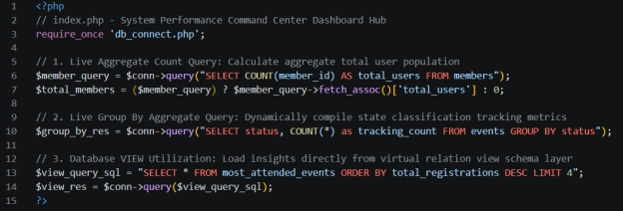
- At least one aggregate function used on the Dashboard, at least one view exists and is used by the app, All pages are styled and consistent (navigation present on all pages).

events_list.php
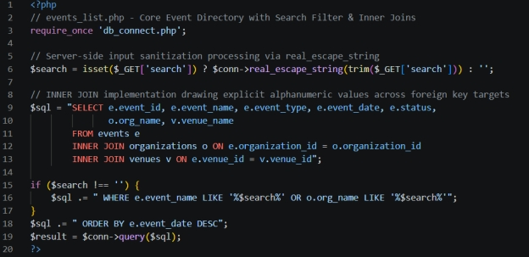
- Search or filter feature is functional, at least one JOIN query used in a frontend-facing page, All CRUD operations work through the frontend (not just phpMyAdmin).

new_event.php
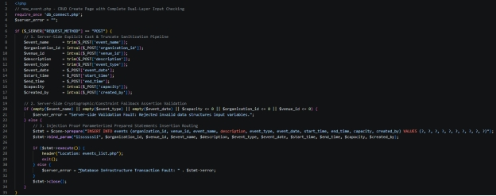
- Client-side validation (JS) on all forms, Server-side validation/sanitization (PHP) on all form handlers, All CRUD operations work through the frontend (not just phpMyAdmin).

edit_event.php
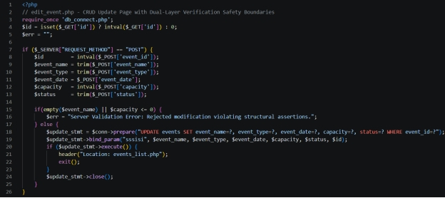

- Client-side validation (JS) on all forms, Server-side validation/sanitization (PHP) on all form handlers, All CRUD operations work through the frontend (not just phpMyAdmin).

delete_event.php
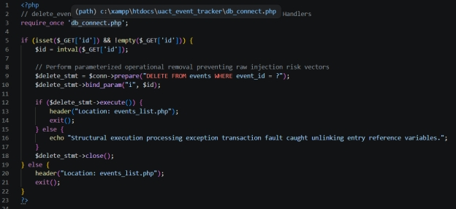
- All CRUD operations work through the frontend (not just phpMyAdmin).

Acitivity_Overview.php
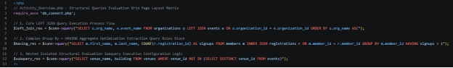
- at least one subquery used somewhere in the system.

registration.php
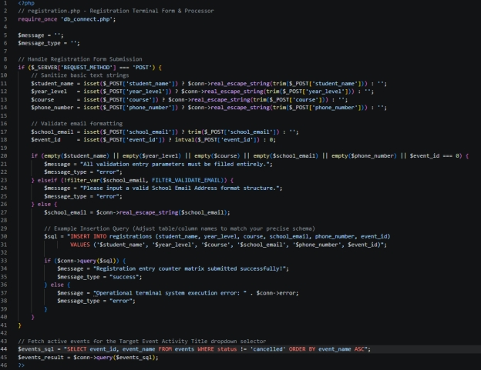
- At least one stored procedure exists and is called by the app.

manage_registrations.php
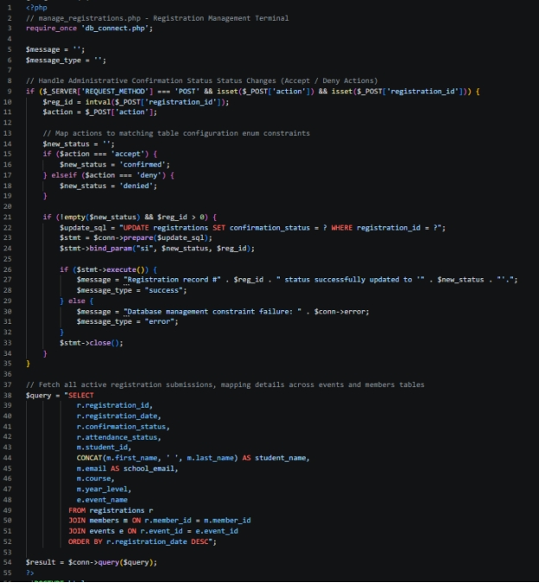
- It uses an INNER JOIN query to pull clear student details alongside their registration profiles. It also features built-in Server-Side Validation/Sanitization (PHP) to safely process status changes.

System Screenshots
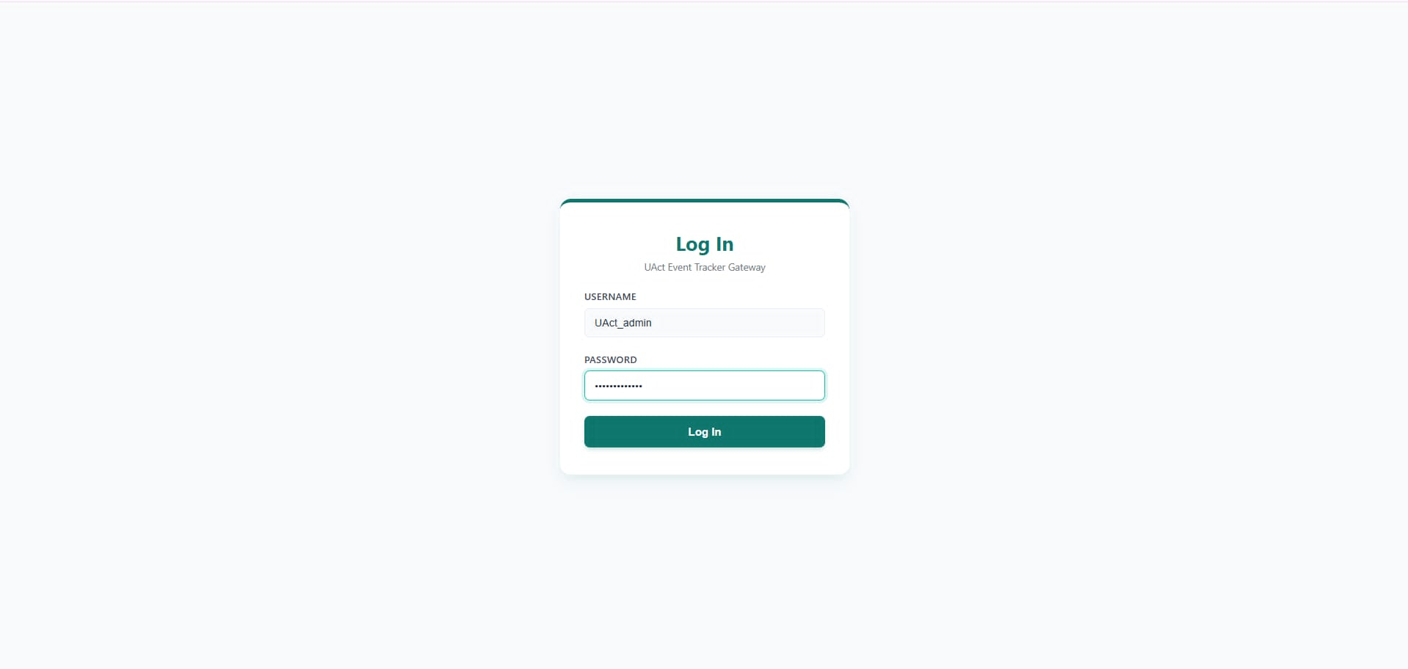
Admin’s Perspective (POV)

- Log In

Use the following to log in for Admin’s account:
Username: UAct_admin
Password: UAT_admin@123
The Log In page acts as the UAct Event Tracker Gateway, providing administrators with a secure, centralized portal to authenticate credentials before accessing the management system backend.
This interface features a clean, minimalist card design focused purely on user access security:
- USERNAME Input Field: A text input area where users input their unique administrative identity handle (e.g., currently populated with UAct_admin).
- PASSWORD Input Field: A masked security input area that hides keystrokes to ensure credentials remain private during authentication.
- Log In Button: A primary teal action block centered at the base of the interface that checks credentials against the system database to authorize access.

Function:
The Log In page serves as the security shield and authentication layer for the platform:
- All System Views: Access to everything—the Dashboard Home, Events Directory, Create New Event, Organization Activity Overview, and Review Registerees—is locked behind a successful authentication session initiated on this interface.
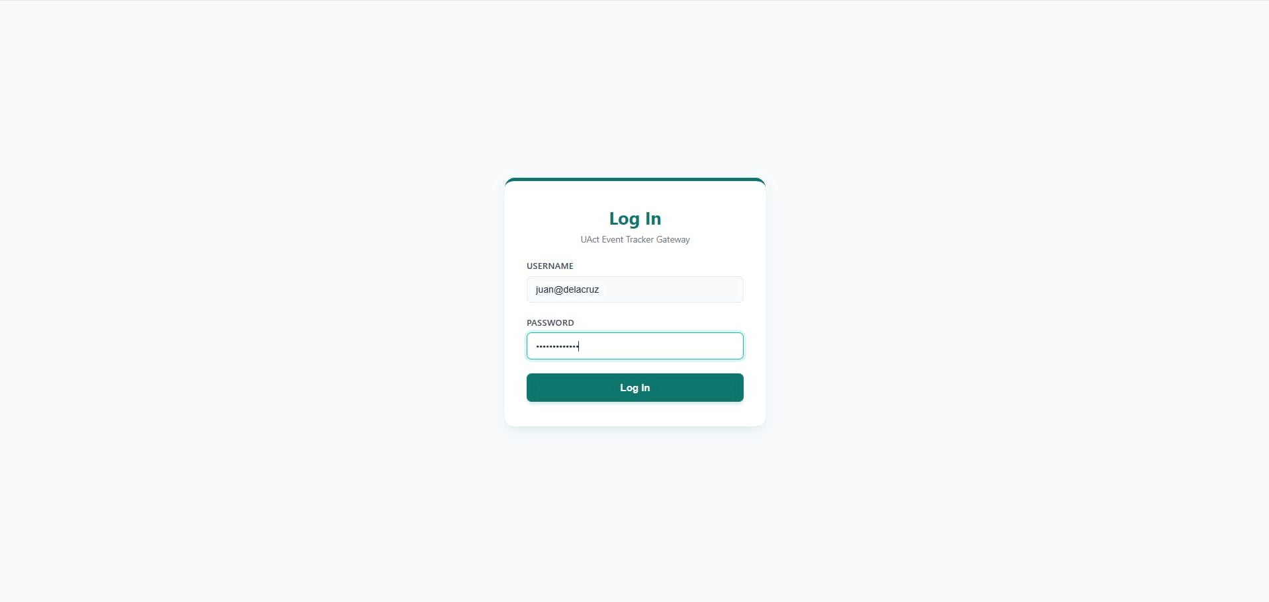
User’s Perspective(POV)
- Log In
Use the following to log in for User’s account:
Username: juan@delacruz
Password: jd.delacruz@123
From the perspective of general campus users, the Log In page serves as the common entry gate to the tracking application. Students, faculty, and staff interact with the exact same layout card to access public features.
- Interface View: The user inputs their campus email handle or standard username ID into the text box and keys their password securely into the masked hidden characters field before clicking the teal activation button.
- Function & Inter-Category Link: Entering valid public-tier credentials ensures they bypass administrative dashboards entirely. Instead, the authentication routing assigns them read-and-register privileges, seamlessly redirecting them straight to the public Home greeting portal.
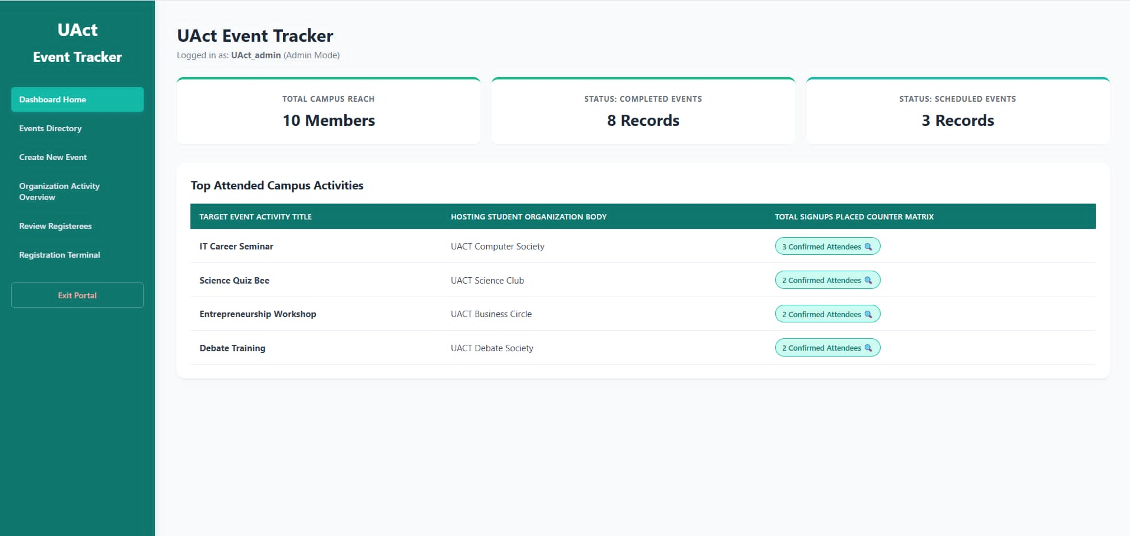
Admin’s Perspective (POV)
- Dashboard Home
The Dashboard Home acts as the System Status Command Hub Overview, providing administrators with a high-level, data-driven summary of all campus engagement and event metrics immediately upon entry.
This layout features summary cards and an event tracking matrix:
- Summary Cards: Three analytical overview containers at the top highlighting critical metric snapshots:
  - TOTAL CAMPUS REACH: Displays aggregate platform engagement, currently reading 10 Members.
  - STATUS: COMPLETED EVENTS: Shows past events volume, currently counting 8 Records.
  - STATUS: SCHEDULED EVENTS: Displays pending events volume, currently sitting at 3 Records.
- Top Attended Campus Activities Table: A concise ranking grid sorting activities by validated participant volume:
  - TARGET EVENT ACTIVITY TITLE: The official name of the specific campus activity (e.g., IT Career Seminar).
  - HOSTING STUDENT ORGANIZATION BODY: The organization assigned to manage the event (e.g., UACT Computer Society).
  - TOTAL SIGNUPS PLACED COUNTER MATRIX: Custom indicators tracking successful sign-up instances (e.g., 3 Confirmed Attendees).

Function:
The Dashboard Home serves as the system's analytical core, reading dynamic values updated throughout the application:
Events Directory: The historical and future calculations displayed inside the COMPLETED EVENTS and SCHEDULED EVENTS cards are controlled directly by records modified or initialized in the Events Directory.
- Review Registerees: The TOTAL CAMPUS REACH and attendee counters gather values directly from verified user records managed within Review Registerees.

User’s Perspective (POV)
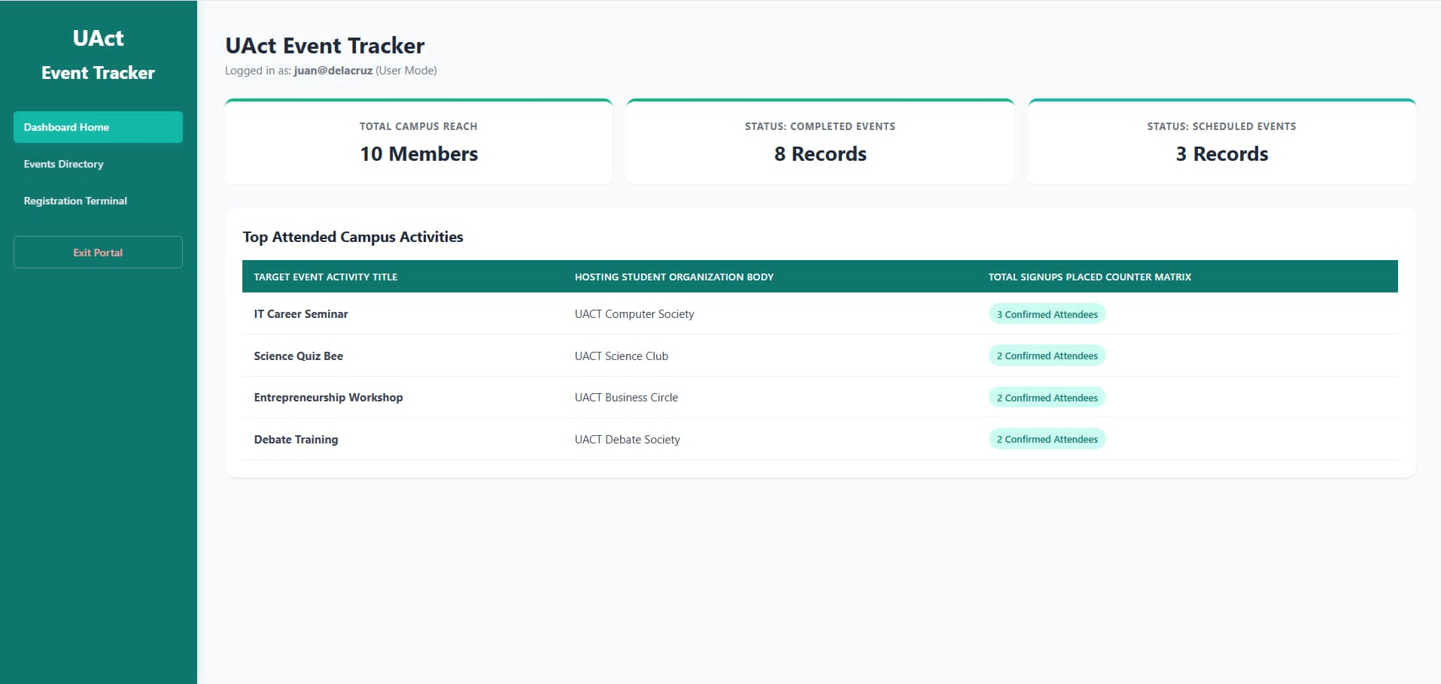
- Dashboard Home
For regular users, the backend administrative metrics dashboard is entirely hidden. Instead, logging in opens up their customized Home screen.
- Interface View: Users see a clean, informative welcome portal featuring the header "Welcome to UAct Event Tracker". Below the greeting text, they can view a public, read-only copy of the Top Attended Campus Activities matrix table.
- Function & Inter-Category Link: This view serves as an aggregate announcement block. It pulls active event lists from the database to show students which programs are trending across campus. It provides immediate shortcuts, prompting users to navigate directly to the Events Directory to see full schedules or to the Registration Terminal to secure open seats.

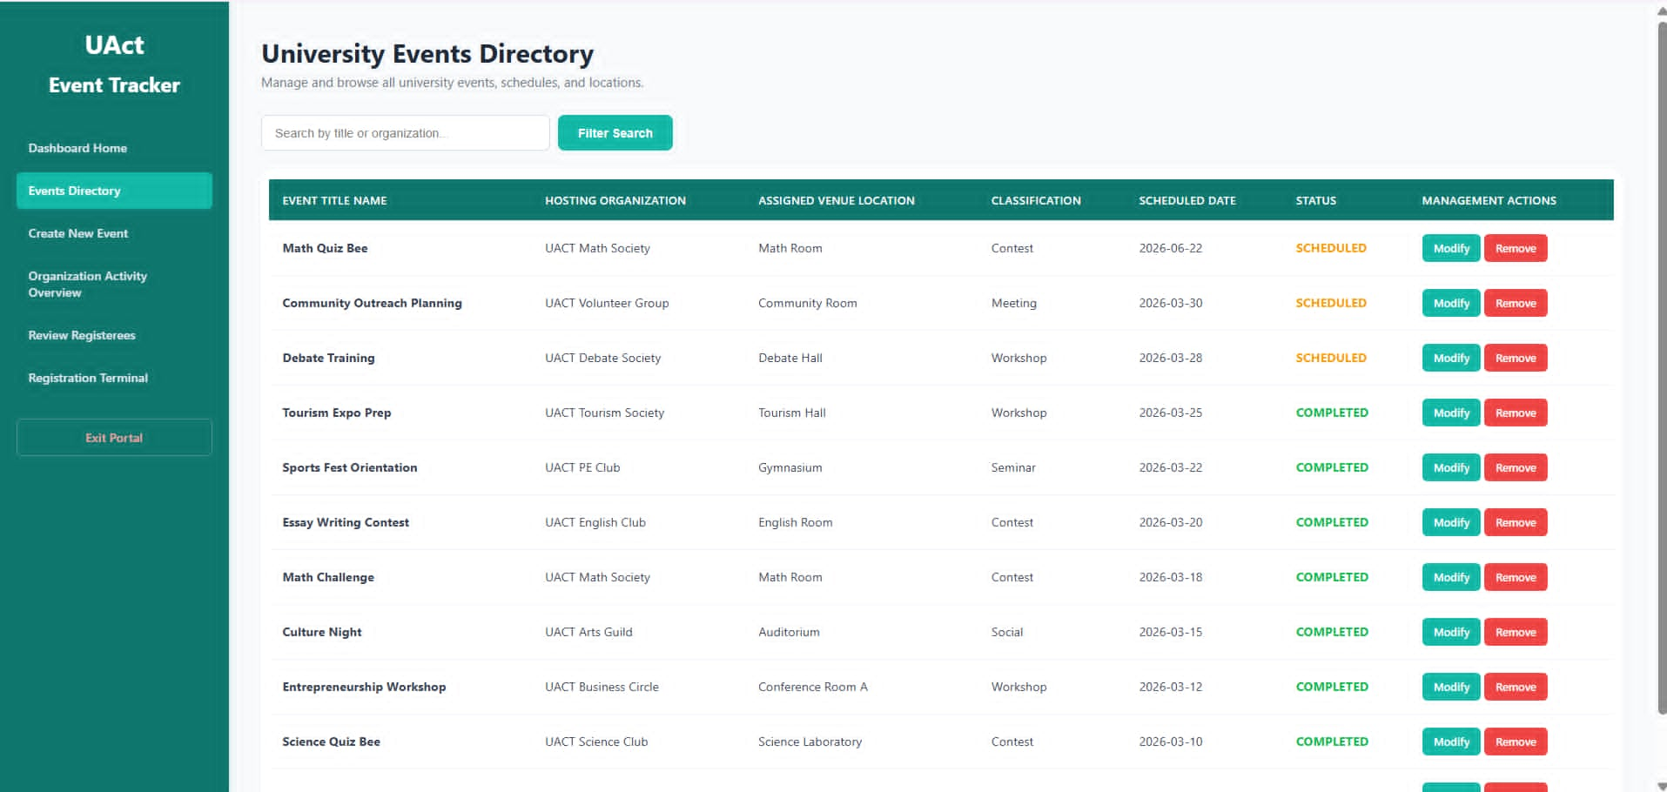
Admin’s Perspective (POV)

- Events Directory
The Events Directory is a centralized administrative hub designed to oversee, organize, and track all campus events.
This interface provides a comprehensive, structured data table displaying essential event details briefly:
- Event Title Name & Hosting Organization: Identifies the event (e.g., Math Quiz Bee, Debate Training) and the group responsible (e.g., UACT Math Society).
- Assigned Venue Location & Classification: Displays where the event is held (e.g., Math Room, Gymnasium) and its type (e.g., Contest, Workshop, Seminar).
- Scheduled Date & Status: Tracks when the event takes place and its current state, whether it is SCHEDULED or COMPLETED.
- Management Actions: Interactive controls allowing administrators to Modify details or Remove an event entirely.
- Search & Navigation: Features a search bar to filter by title or organization and a top navigation menu for seamless system-wide access.
Function:
The Manage Events Directory acts as the core operational bridge between the other functional areas of the platform:
- Dashboard Home: While the dashboard provides a high-level overview of metrics and quick insights, this directory is where administrators drill down to execute specific day-to-day modifications.
- Create New Event: Once a new event is successfully generated in the Create New Event category, it is automatically populated here into the main directory list for ongoing tracking.
- Organization Activity Overview: This directory feeds data into the activity overview, allowing the system to aggregate how many contests, workshops, or seminars each specific campus group is hosting.
- Review Registerees & Registration Terminal: The status and dates managed within this directory directly dictate whether students can check in via the Registration Terminal or if administrators need to audit attendee lists under Review Registerees.

User’s Perspective (POV)
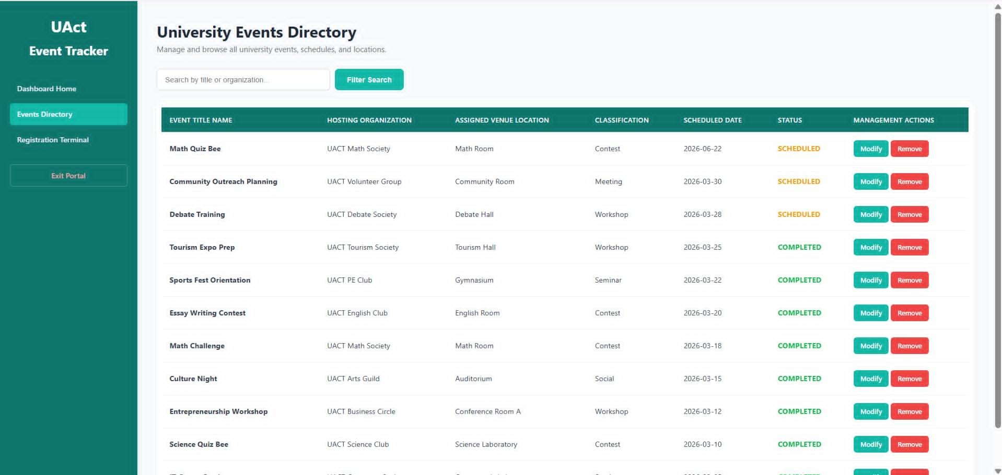
- Events Directory
For the student body, faculty, and staff, the Events page transforms into a public-facing, interactive University Events Directory.
- Interface View: Regular users see an identical ledger of activities but with a critical privilege difference: the interactive "Modify" and "Remove" action controls are completely hidden. Instead, they use a Search by title or organization... input window paired with a teal "Filter Search" button to look up active logistics. High-visibility text tags clearly display whether an entry is upcoming (SCHEDULED) or finished (COMPLETED).
- Function & Inter-Category Link: This section acts as the official itinerary guide. Users browse this list to find active event locations and scheduled dates. Once they select a desired event, they move directly to the Registration Terminal category, where that specific activity title becomes available for form submission.

Admin’s Perspective (POV)
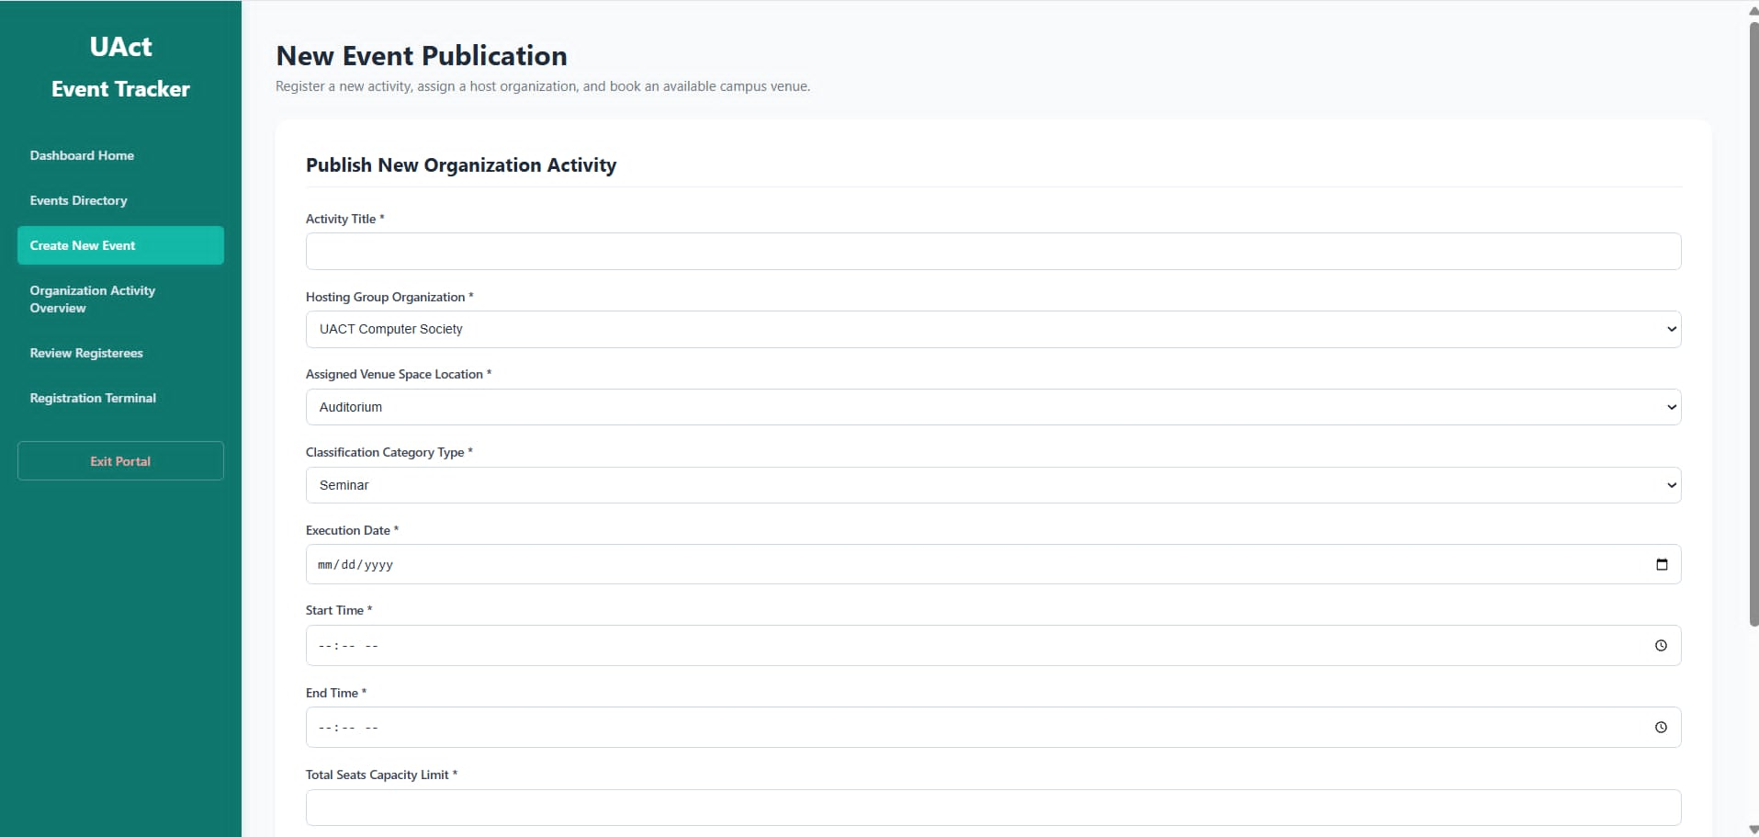

- Create Event
The Create New Event page acts as the System Creation and Scheduling Engine, providing administrators and authorized student leaders with a privileged configuration workspace to officially register and inject new campus functions into the system repository.
This interface features a structured database configuration form titled "Publish New Organization Activity" designed to enforce strict logistics parameters:
- Event Specifics: Form fields where the administrator establishes the unique Activity Title and keys in a descriptive Detailed Description.
- Logistics & Scheduling: Data management elements allowing the admin to assign the Hosting Group Organization, book the Assigned Venue Space Location, select the structural Classification Category Type (e.g., Seminar), and enforce time constraints via the Execution Date, Start Time, and End Time.
- Capacity & Approval: Administrative control inputs enabling the admin to define a strict numerical Total Seats Capacity Limit and utilize a dropdown menu to designate the official Registry Authorizing Officer.
- Submission Action: A prominent red execution button at the base of the layout labeled "Commit Secure Store Insertion" that runs the database insert query to finalize and publish the event.
Function:
The Create New Event module serves as the primary data-generation foundation for the entire website ecosystem, directly feeding parameters into all other administrative sections:
- To "Dashboard Home": Once the administrator saves an event, summary analytical data (like upcoming timelines or active record additions) automatically increments the main dashboard counting matrices for immediate review.
- To "Manage Events Directory": Saved entries are pushed immediately to this ledger, giving administrators the security privileges to edit, modify, track, or drop records from the system.
- To "Organization Activity Overview": The structural values provided here allow the analytics engine to aggregate active metrics regarding which student clubs are hosting items and which physical venues are currently booked.
- To "Review Registerees" & "Registration Terminal": Establishing the Total Seats Capacity Limit applies backend logic constraints across the portal. This maps out available quotas on the client terminal and ensures student lists inside the review deck freeze automatically once seats are full.

Admin’s Perspective (POV)
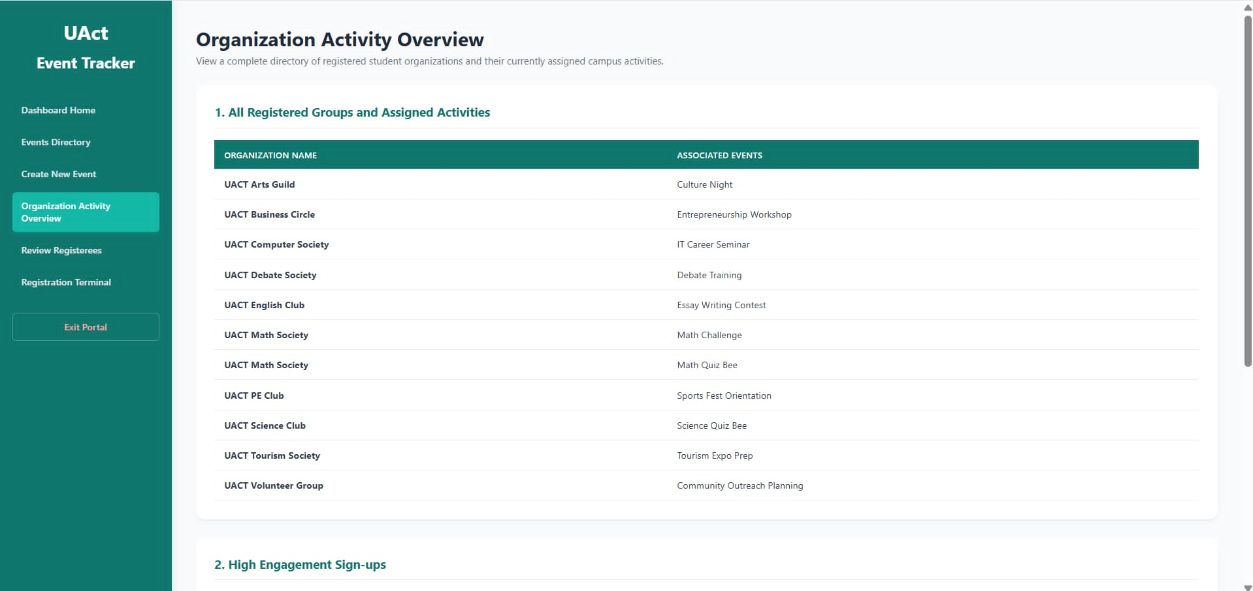

Organization Activity Overview
The Organization Activity Overview page acts as the System Intelligence and Resource Auditing Dashboard, presenting administrators with a centralized, read-only analytical report to track student group dynamics, individual engagement metrics, and physical asset allocation.
This oversight module splits its live data monitoring down into three distinct auditing tables:
- All Registered Groups and Assigned Activities: A structured directory mapping registered student clubs (Organization Name) directly alongside their planned schedules (Associated Events).
- High Engagement Sign-ups: An individual tracking ledger allowing administrators to identify top-performing users by matching a Student Identity Name against their cumulative Total Active Verified Forms Registrations (e.g., 2 Accounts Booked).
- Available Campus Venues: A real-time facility monitoring status block that tracks active real estate conflicts across campus, displaying a warning message when rooms are maxed out (e.g., "All venues are currently booked.").
Function:
The Organization Activity Overview serves as the system's business intelligence and auditing layer. It does not take direct form manipulation inputs from the administrator; instead, it compiles background states across other categories:
- To All Other Categories: This dashboard works as a cross-referencing information center. It systematically reads active listings from Create New Event (to project organizations and room schedules) and hooks into Review Registerees (to compile verified student sign-ups) to output an immediate, high-level look at club performance and facility utilization.

Admin’s Perspective (POV)
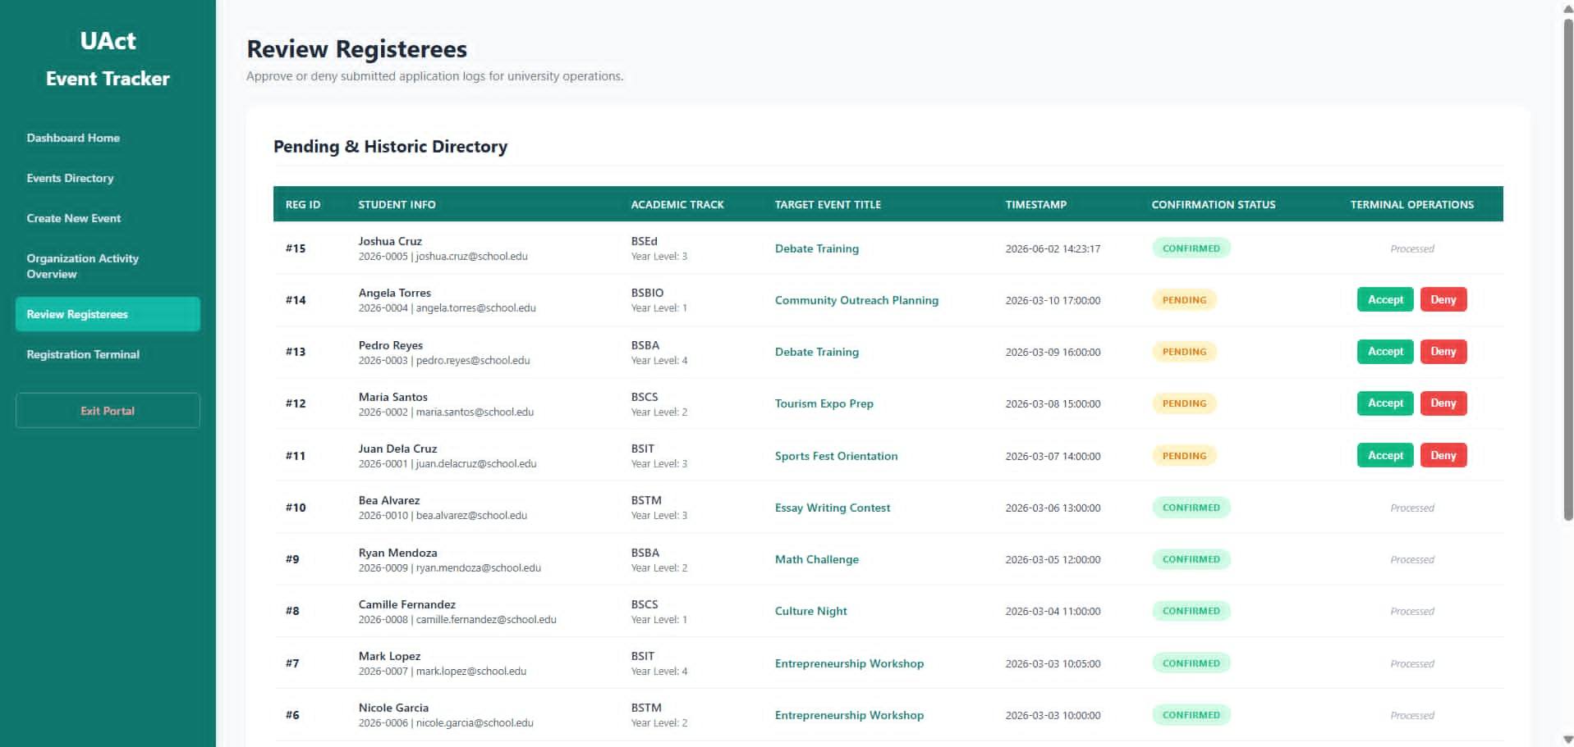

Review Registerees
The Review Registerees interface acts as the Roster Verification and Application Gatekeeper, showcasing an internal control panel titled "Pending & Historic Roster Directory" that gives administrators exclusive power to track, audit, and filter student applications.
This grid view features a dense administrative table organized into functional columns for evaluating incoming data requests:
- Roster Information Logs: Multi-tier rows tracing structural database keys chronologically, documenting the REG ID, STUDENT INFO (name and email credentials), ACADEMIC TRACK (course and year), TARGET EVENT TITLE, and an exact transactional TIMESTAMP.
- CONFIRMATION STATUS Markers: Color-coded system status indicators declaring live states—displaying a green "CONFIRMED" tag for accepted attendees or a yellow "PENDING" tag for outstanding validations.
- TERMINAL OPERATIONS Controls: An active control matrix providing the administrator with a green "Accept" button and a red "Deny" button to dynamically run data updates, or displaying an italicized "Processed" label for locked records.

Function:
The Review Registerees module works as the platform's quality control center, granting administrators full veto authority over participant lists before data changes impact the rest of the site:
- To "Registration Terminal": This screen acts as the direct review queue for processing data generated on the public form, allowing administrators to audit entries case-by-case.
- To "Organization Activity Overview": When the administrator clicks "Accept" on a pending row, the system runs an update query that recalculates the global participant volume tracked on the analytical overview boards.

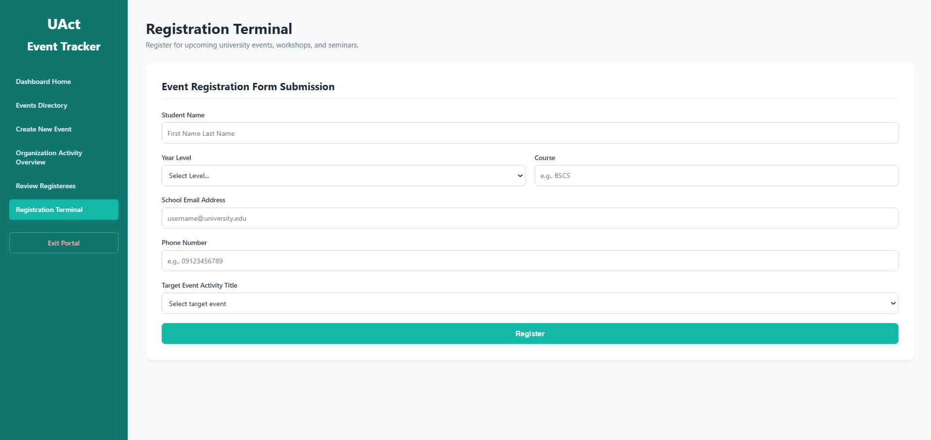
Admin’s Perspective (POV)

Registration Terminal
The Registration Terminal acts as the System Intake Portal, monitoring the student-facing "Event Registration" data collection interface where individual applicants must supply structural criteria to request an event seat.
From the administrative side, this category monitors a standardized collection form layout targeting specific personal attributes:
- Student Info: Data validation fields designed to collect an applicant's Student Name, Course, School Email Address, and Phone Number.
- Year Level Selection: A structured dropdown selection menu used to categorize the applicant's current academic year status.
- Target Event Activity Title: A dynamic system selector dropdown menu showcasing open, valid campus operations currently accepting registrations.
- Submission Action Button: A broad action button at the base of the container labeled "Process Terminal Registration" that executes the transaction to forward the form metadata.
Function:
The Registration Terminal serves as the inbound data pipeline for the web application, transforming public user intent into trackable records for the admin tools:
- To "Create New Event": The choice pool for the Target Event Activity Title menu is completely dependent on the creation engine; it dynamically reads rows originated and published by the administrator in the event creation module.
- To "Review Registerees": The moment a student triggers the processing button, the terminal pushes the payload forward, generating a new database entry with a yellow PENDING flag directly inside the administrator's review directory.

User’s Perspective (POV)
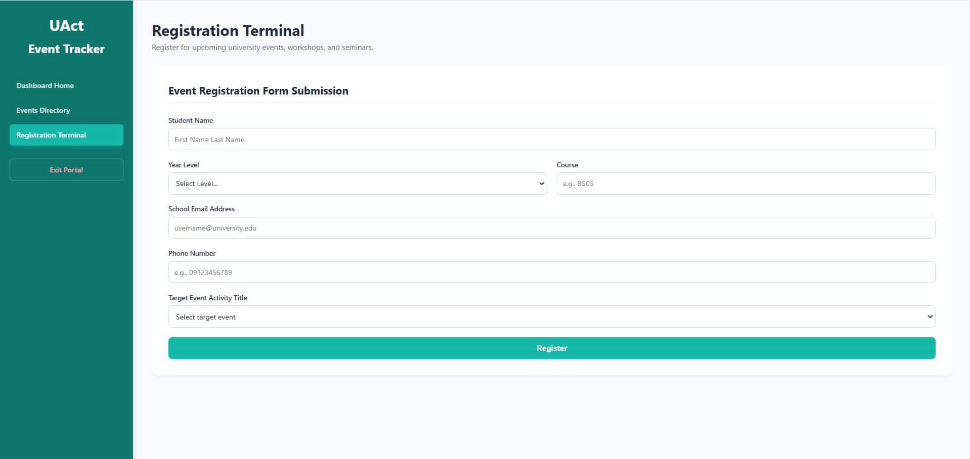

Registration Terminal
The Registration Terminal serves as the primary self-service interface for students, faculty, and staff to interact directly with the event tracking database.
- Interface View: The user interacts with the empty form inputs to provide their descriptive profile metrics. They type their full name, academic course major, official institutional email handle, and phone number. They use the Year Level Selection dropdown to choose their academic tier and click the Target Event Activity Title menu to isolate which upcoming campus activity they want to attend.
- Function & Inter-Category Link: This is the primary inbound portal for user engagement data. Clicking the large red "Process Terminal Registration" button pushes their metadata payload directly into the system processing pipeline. This logs their information under the admin's verification directory as a PENDING request, initiating the review process.

Section 7 - Individual Contribution Summary

Vhonn Gabriel P. Habulin
"I designed and built the entire relational database backend for this project. Specifically, I wrote the complete SQL script to create all five core tables (organizations, events, members, registrations, and venues), ensuring that data integrity rules like NOT NULL and UNIQUE were strictly enforced. I also mapped out and implemented the primary keys and foreign key relationships to link the tables together, such as connecting registrations to both events and members—and pre-loaded the database with sample data for testing."

Mark Lorenz O. Vargas
"I designed and built the entire system website for our project. Specifically, I created the core web pages, including the homepage, the event discovery catalog, and the user profile views. I implemented the navigation system to allow seamless movement between pages and wrote the scripts necessary to fetch data from our backend, ensuring that live information about organizations, events, and venues displays correctly on the website for users."

Camille Rose G. Sagucom
"I assisted in designing and building the application's system interface. Specifically, I focused on creating the frontend layouts and input forms for the event registration and venue viewing pages. I collaborated closely with my teammate to ensure the visual elements aligned properly with our project requirements, and I helped implement the input validation on the forms to ensure user data matches our SQL database constraints before it is submitted."

