VUKA MUSIC
Release. Sell. Earn. Own.
Technical Documentation
Requirements Specification · Use Case Model · System Architecture · Domain Model · Full Database Design & Data Dictionary
Companion to: Vuka Music Business Documentation
Source: live Prisma schema (91 tables, parsed directly — not hand-transcribed)
Date: July 2026

Table of Contents
1. Requirements Specification 4
1.1 Functional Requirements 4
1.2 Non-Functional Requirements 5
2. Use Case Model 7
2.1 Use Case Descriptions 9
3. System Architecture 11
4. Domain Model (Class Diagram) 12
5. Full Database Design 15
5.1 Identity & Access 15
5.2 Catalogue & Distribution 16
5.3 Commerce & Payments 17
5.4 Fan Engagement 18
5.5 Marketplace & Industry 19
5.6 Rights & Compliance 20
5.7 Analytics 21
5.8 CMS & Communications 22
5.9 Platform Administration 23
6. Complete Data Dictionary 24
6.1 Identity & Access 24
6.2 Catalogue & Distribution 29
6.3 Commerce & Payments 35
6.4 Fan Engagement 41
6.5 Marketplace & Industry 50
6.6 Rights & Compliance 55
6.7 Analytics 59
6.8 CMS & Communications 62
6.9 Platform Administration 65
7. Known Gaps & Proposed Fixes 66

1. Requirements Specification

1.1 Functional Requirements

Identity & Access
- FR-1: Users shall register and log in as Fan, Artist, Industry User, or Admin.
- FR-2: Artists and Admins shall be able to enable two-factor authentication (2FA).
- FR-3: Users shall be able to reset a forgotten password via a time-limited token.
- FR-4: The system shall track active device sessions per user for security review.
- FR-5: Users shall be able to log in via a passwordless magic link sent to their registered email.
- FR-6: Users shall be able to view and edit their own account profile and notification/communication settings.
- FR-7: Admins shall be able to fix or repair an individual user account (e.g. role or auth-state corrections) via a dedicated admin tool.

Catalogue Management
- FR-8: Artists shall create, edit, and publish releases containing one or more tracks.
- FR-9: Artists shall list beats with pricing tiers/licenses, videos, and samples for sale.
- FR-10: Artists shall list physical/digital merchandise with stock tracking.
- FR-11: Artists shall attach a split sheet (collaborator revenue shares) to a release or track; the sheet auto-locks on first sale.
- FR-12: The system shall track release status (draft, pending, live) and artwork approval per release; Vuka does not deliver releases to any streaming DSP.
- FR-13: The system shall generate and let fans/licensees verify a beat license (lease, exclusive, unlimited) and its terms.
- FR-14: Artists shall upload release/beat/video/sample assets directly to object storage (Cloudflare R2) with progress feedback.

Commerce & Payments
- FR-15: Fans shall purchase releases, beats, merch, samples, videos, memberships, and event tickets.
- FR-16: The system shall support Paystack (ZAR) and PayPal (international) at checkout.
- FR-17: The system shall generate an invoice for every completed purchase, retrievable by the buyer.
- FR-18: Fans shall support/tip an artist directly outside of a specific product purchase.
- FR-19: Fans shall add items to a wishlist and manage it independently of purchase history.
- FR-20: Artists shall set a flat per-item shipping fee at merch listing time; the fee is shown as a separate line item at checkout and is excluded from the platform commission calculation.
- FR-21: Purchasers of digital goods shall be able to securely re-download a previously purchased item via a signed, expiring link.
- FR-22: The system shall display an indicative ZAR/USD exchange rate to support cross-currency purchase decisions.
- FR-23: Artists shall request payouts on demand against their available balance, subject to manual admin approval, and view payout history.
- FR-24: The system shall disburse approved payouts via bank transfer (Paystack) or PayPal, per artist preference.
- FR-25: The system shall record revenue and tax-relevant records per artist per period.
- FR-26: Admins shall be able to run payout reconciliation against gateway records to catch mismatches.

Fan Engagement
- FR-27: Fans shall follow artists and receive notifications about new releases/events.
- FR-28: Users shall message other users (fan↔artist, industry↔artist) through threaded conversations.
- FR-29: Artists shall run crowdfunding campaigns with tiered backer rewards and a deadline.
- FR-30: Artists shall offer paid membership tiers with exclusive content; cancellation ends access immediately.
- FR-31: Fans shall post, like, comment on, repost, and save content in a social feed.
- FR-32: Fans shall browse, search, and discover music/beats/merch, including trending and recommended items.
- FR-33: Fans shall vote in artist awards; the system shall auto-generate a shareable award/achievement plaque image per milestone.
- FR-34: Artists shall generate referral links; the system shall track referred sign-ups and issue referral rewards automatically.

Marketplace & Industry
- FR-35: Industry users (labels/managers) shall list and manage services in the marketplace.
- FR-36: Fans/artists shall order a marketplace service, track order status, and leave a review.
- FR-37: Labels shall manage a roster of artists and team members, including invite-and-accept onboarding.
- FR-38: Industry users shall track and manage deals with artists.
- FR-39: Industry users shall maintain a public profile and browse other industry listings.

Rights & Compliance
- FR-40: Rights holders shall file a DMCA report against allegedly infringing content.
- FR-41: Admins shall review and action abuse reports, content flags, and DMCA reports on a per-case basis (no automatic strike system).
- FR-42: Admins shall verify artist identity/ownership claims as part of moderation review.

Events & Ticketing
- FR-43: Artists shall create and manage events with ticket types and capacity.
- FR-44: Fans shall purchase event tickets through the standard checkout flow.
- FR-45: Event staff shall check fans in at the door by scanning a QR code tied to their ticket.

Analytics
- FR-46: Artists shall view creator analytics covering audience, engagement, plays/streams, and revenue.
- FR-47: Admins shall view platform-wide analytics and conversion funnel reporting.

CMS & Communications
- FR-48: Admins shall manage CMS pages, content blocks, and media assets on the public site.
- FR-49: Admins shall curate featured artists shown on the public site.
- FR-50: The system shall send transactional email (via Resend) for key lifecycle events (welcome, purchase, payout, etc.).
- FR-51: Admins shall broadcast a message/notification to a segment of users.
- FR-52: Users shall receive in-app notifications for relevant account and platform events.

Platform Administration
- FR-53: Admins shall manage user, artist, and plan-tier records.
- FR-54: Admins shall approve or reject artist payout requests and view platform-wide finance.
- FR-55: Admins shall configure platform-wide security settings.
- FR-56: Admins shall run database repair/consistency tooling for data-integrity issues.
- FR-57: The system shall maintain an audit log of sensitive admin actions.
- FR-58: The system shall run scheduled jobs for campaign-deadline enforcement, plan-tier expiry, and referral-reward payout.
- FR-59: The system shall expose a health-check endpoint for uptime monitoring.

1.2 Non-Functional Requirements
Category | Requirement
Performance | Public storefront pages should render via SSR with CDN caching for static assets; audio delivery via signed, edge-cached R2 URLs.
Security | Passwords hashed; 2FA available; rate limiting on auth and payment endpoints via Upstash Redis; POPIA-aware handling of personal data.
Availability | Platform monitored via Sentry (errors), PostHog (usage), and Better Uptime (uptime alerting).
Scalability | Serverless deployment (Vercel) and pooled Postgres connections (PgBouncer) to handle bursty traffic without dedicated servers.
Portability | Core business logic lives in the web app so it can be wrapped by Tauri (desktop) without a rewrite; native mobile apps consume the same API.
Maintainability | Prisma schema is the single source of truth for data structure; every schema change is paired with a migration file.
Usability | Consistent brand system (VukaMark/VukaLogo/VukaLoader, dark theme with green/gold accents) applied across all dashboards.
Compliance | DMCA takedown workflow; artist agreement, privacy policy, refund, and terms pages published in-app.
Localization | All fan-facing pricing is denominated in ZAR by default with a live indicative USD conversion; UI copy is English-first with room for local language expansion.
Data Retention & Backup | Supabase Postgres automated daily backups with point-in-time recovery; uploaded media in Cloudflare R2 is retained until the owning artist deletes the item.
Observability | Structured application logs and an internal audit trail back admin actions and payout decisions for after-the-fact review.
Accessibility | Public storefront pages target readable contrast ratios and semantic HTML so screen readers can navigate core purchase flows.
Disaster Recovery | Infrastructure is defined so the platform can be redeployed from source and environment config alone; no server holds state that isn't also in Postgres or R2.

2. Use Case Model
Four actor types interact with Vuka Music: the Fan (buyer/supporter), the Artist (seller/creator), the Industry User (label/manager), and the Admin (platform operator).
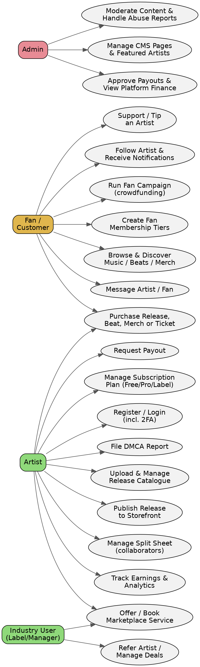
Figure 1. Use case diagram — actors and primary use cases.

2.1 Use Case Descriptions
Use Case | Primary Actor | Description | Pre-condition
Purchase Release/Beat/Merch | Fan | Fan selects an item, checks out via Paystack or PayPal, receives invoice and download/access. | Item is published; fan has a valid payment method.
Publish Release to Storefront | Artist | Artist selects a completed release and publishes it to their Vuka storefront for fans to buy; Vuka does not deliver it to any streaming DSP. | Release has all required metadata and audio files.
Request Payout | Artist | Artist requests withdrawal of available balance; requires manual admin approval before payment. | Artist has a positive available balance and a verified bank account.
Run Crowdfunding Campaign | Artist | Artist creates a crowdfunding campaign with tiers; fans back tiers; system tracks progress toward goal. | Artist account is in good standing.
Back a Crowdfunding Campaign | Fan | Fan pledges to an active campaign at a reward tier; payment is captured and the campaign total updates. | Campaign is live and accepting backers.
Book Marketplace Service | Fan / Artist | Buyer orders a listed industry service (e.g. mixing, mastering); order and dispute lifecycle tracked. | Service is published by an Industry User.
Moderate Content | Admin | Admin reviews an abuse report/content flag and takes one case-by-case action: dismiss, warn, remove, or suspend. | A report or automated spam signal exists.
File DMCA Report | Fan / Artist / Admin | A rights holder files a takedown report against an infringing item; Admin actions it individually. | Allegedly infringing content is live on the platform.
Follow Artist & Get Notified | Fan | Fan follows an artist and receives notifications when they publish a new release, event, or campaign. | Artist profile exists.
Subscribe to Fan Membership | Fan | Fan joins a paid membership tier and gains access to exclusive content; access ends immediately on cancellation. | Artist has a published tier.
Manage Wishlist | Fan | Fan saves items for later and reviews them from a dedicated wishlist page. | Fan account exists.
Refer a New Artist | Artist | Artist shares a referral link; the system tracks the resulting sign-up and issues the referral reward automatically once earned. | Artist has a referral link.
Vote in Artist Awards | Fan | Fan casts a vote for an artist in an awards category; system tallies votes and generates a shareable plaque on milestones. | Voting round is open.
Check In at Event | Admin / Artist | Event staff scan a fan's ticket QR code at the door to check them in and prevent duplicate entry. | Fan holds a valid ticket.
Manage Label Roster | Industry User | Label invites an artist to join its roster; artist accepts and appears under the label's managed roster. | Label account exists.
Accept/Reject Split Sheet | Artist | A declared collaborator reviews a proposed revenue split percentage and accepts or rejects it before it locks permanently on first sale. | Release/track has a declared split sheet awaiting confirmation.
Manage CMS Content | Admin | Admin edits public site pages, content blocks, and featured-artist placements without a code deploy. | Admin is authenticated.
Broadcast Platform Notice | Admin | Admin sends a broadcast message or notification to a targeted segment of users. | Recipient segment is defined.

3. System Architecture
The platform follows a serverless, edge-cached architecture. The Next.js application handles both server-rendered pages and API routes; Cloudflare sits in front for CDN and signed audio delivery; Supabase provides the managed Postgres database, authentication, and realtime features.
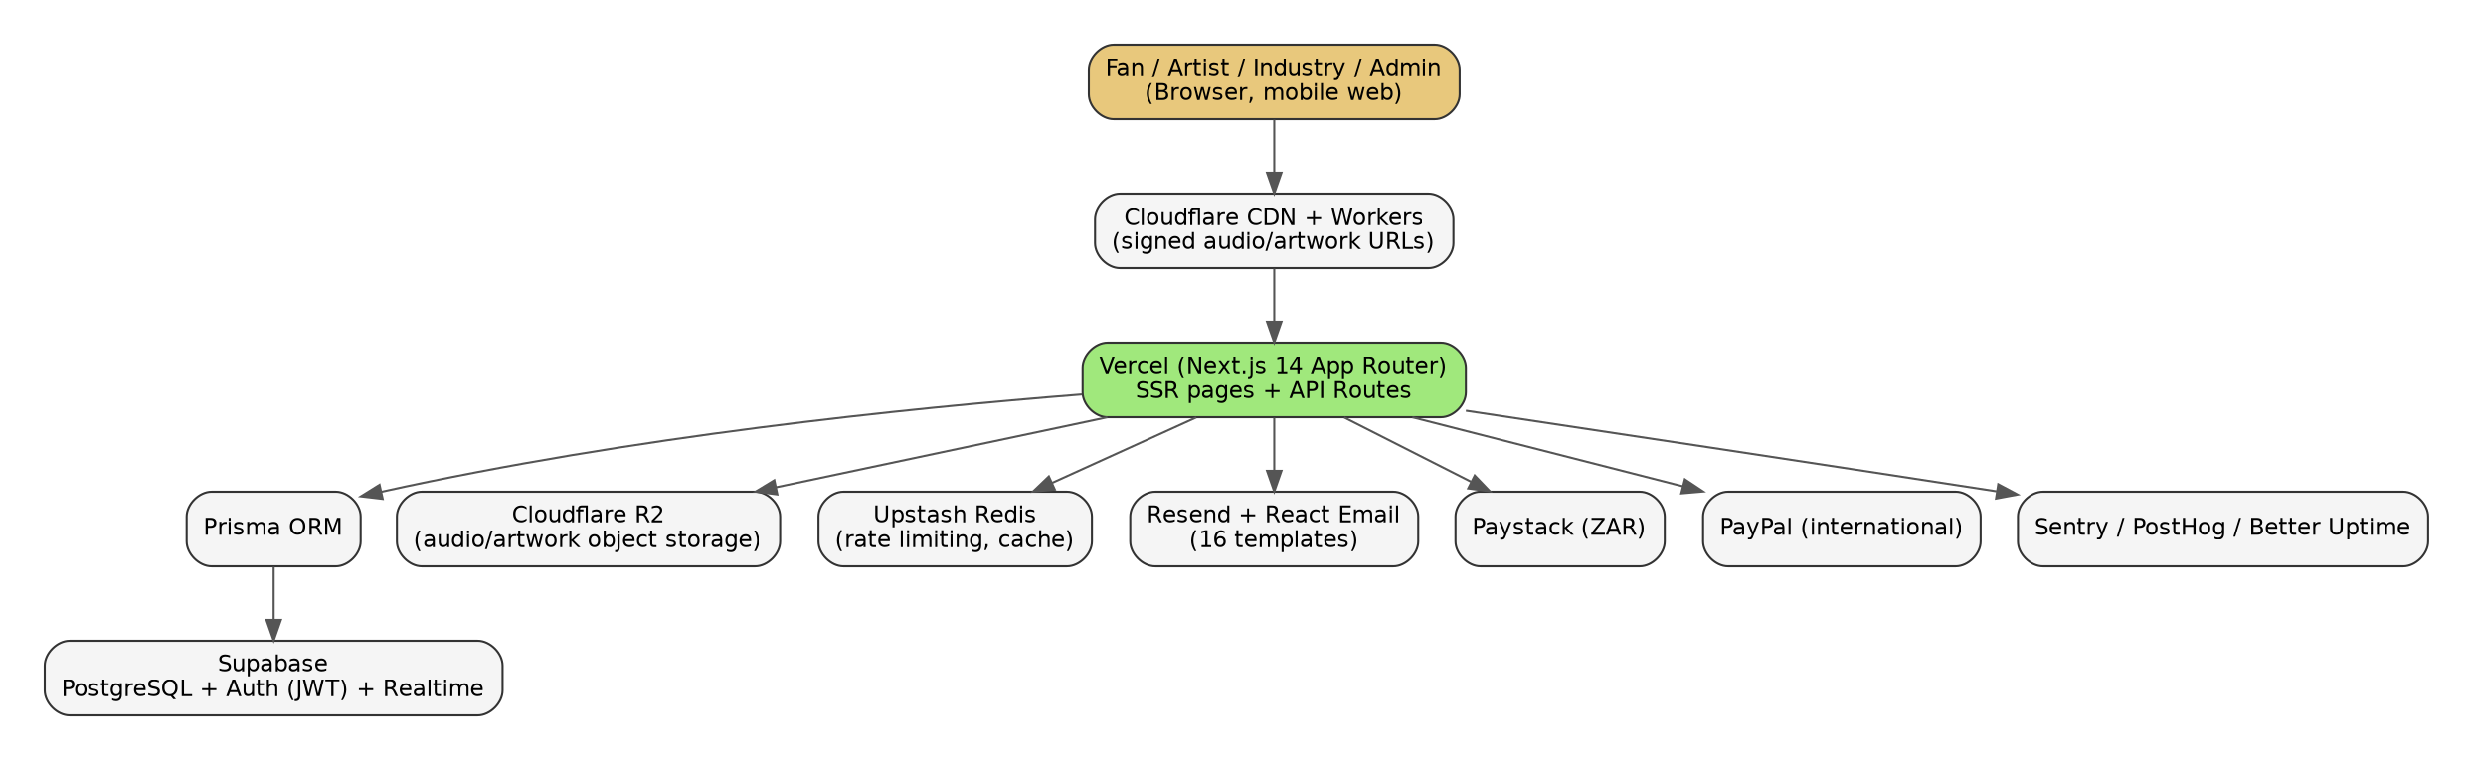
Figure 2. High-level system architecture.

4. Domain Model (Class Diagram)
The simplified class diagram below shows the core classes that drive the platform's central flow: a User becomes an Artist, an Artist publishes Releases, a User makes a Purchase against catalogue items, and completed purchases fund an ArtistPayout.
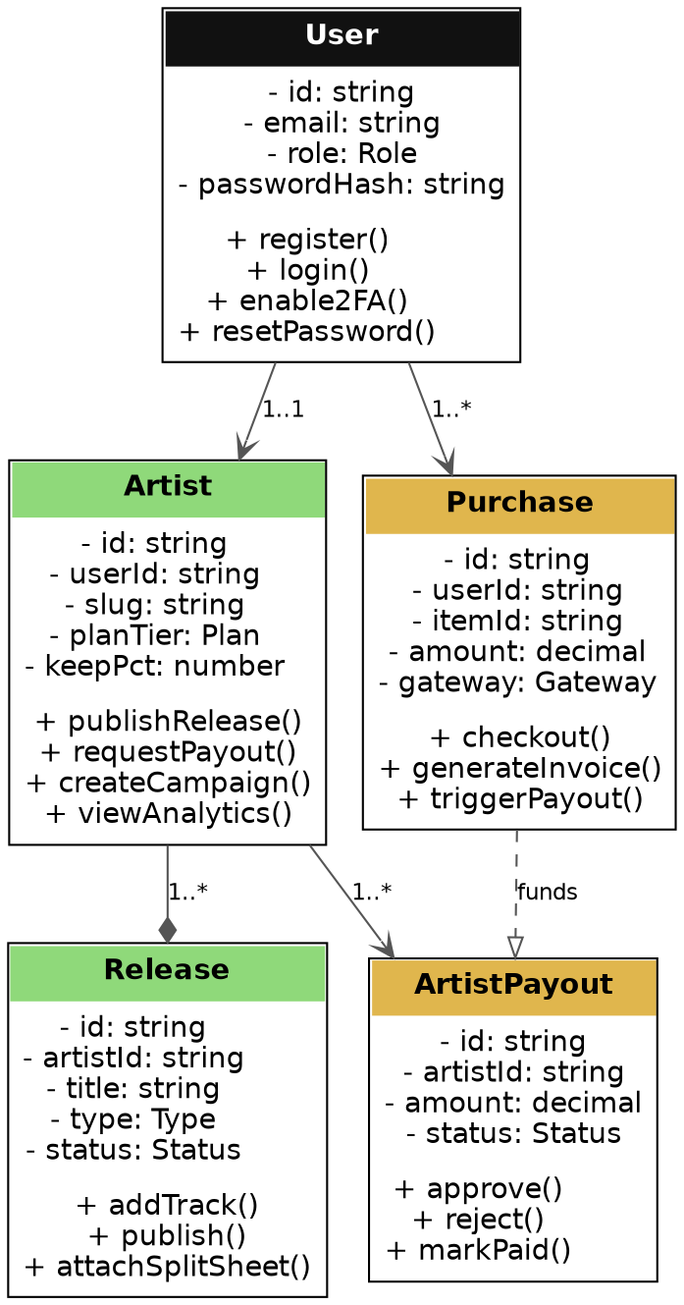
Figure 3. Core domain classes, attributes, and operations.

5. Full Database Design
The production Prisma schema contains 91 tables and 108 foreign-key relationships. Rather than one unreadable diagram, the schema is grouped into 9 subsystems below. Every diagram and every field in the data dictionary that follows was generated directly from the live prisma/schema.prisma file — not retyped by hand — so it reflects exactly what's deployed.
Subsystem | Table Count
Identity & Access | 8
Catalogue & Distribution | 10
Commerce & Payments | 12
Fan Engagement | 24
Marketplace & Industry | 11
Rights & Compliance | 9
Analytics | 6
CMS & Communications | 9
Platform Administration | 2
Diagram notation: solid boxes are tables in this subsystem (PK = primary key, FK = foreign key). Dashed grey boxes are tables that live in a different subsystem, shown only to indicate a cross-subsystem relationship — see that table's own subsystem section for its full field list.

5.1 Identity & Access
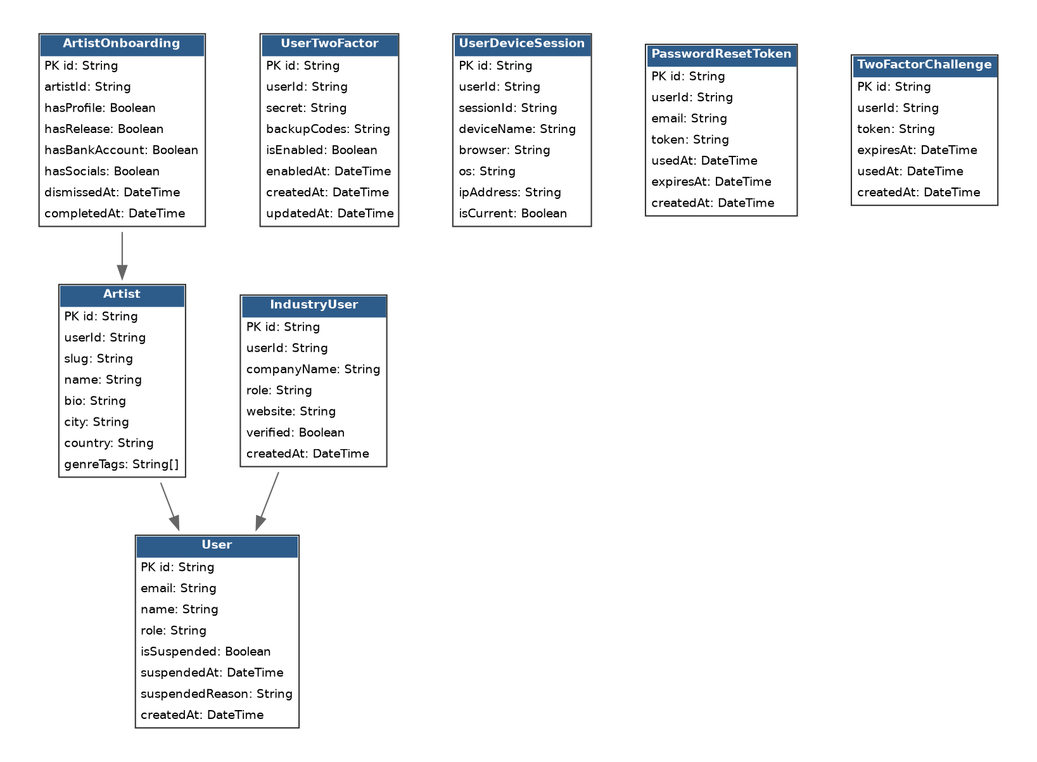
Figure 4. Identity & Access — entity relationships (8 tables).

5.2 Catalogue & Distribution
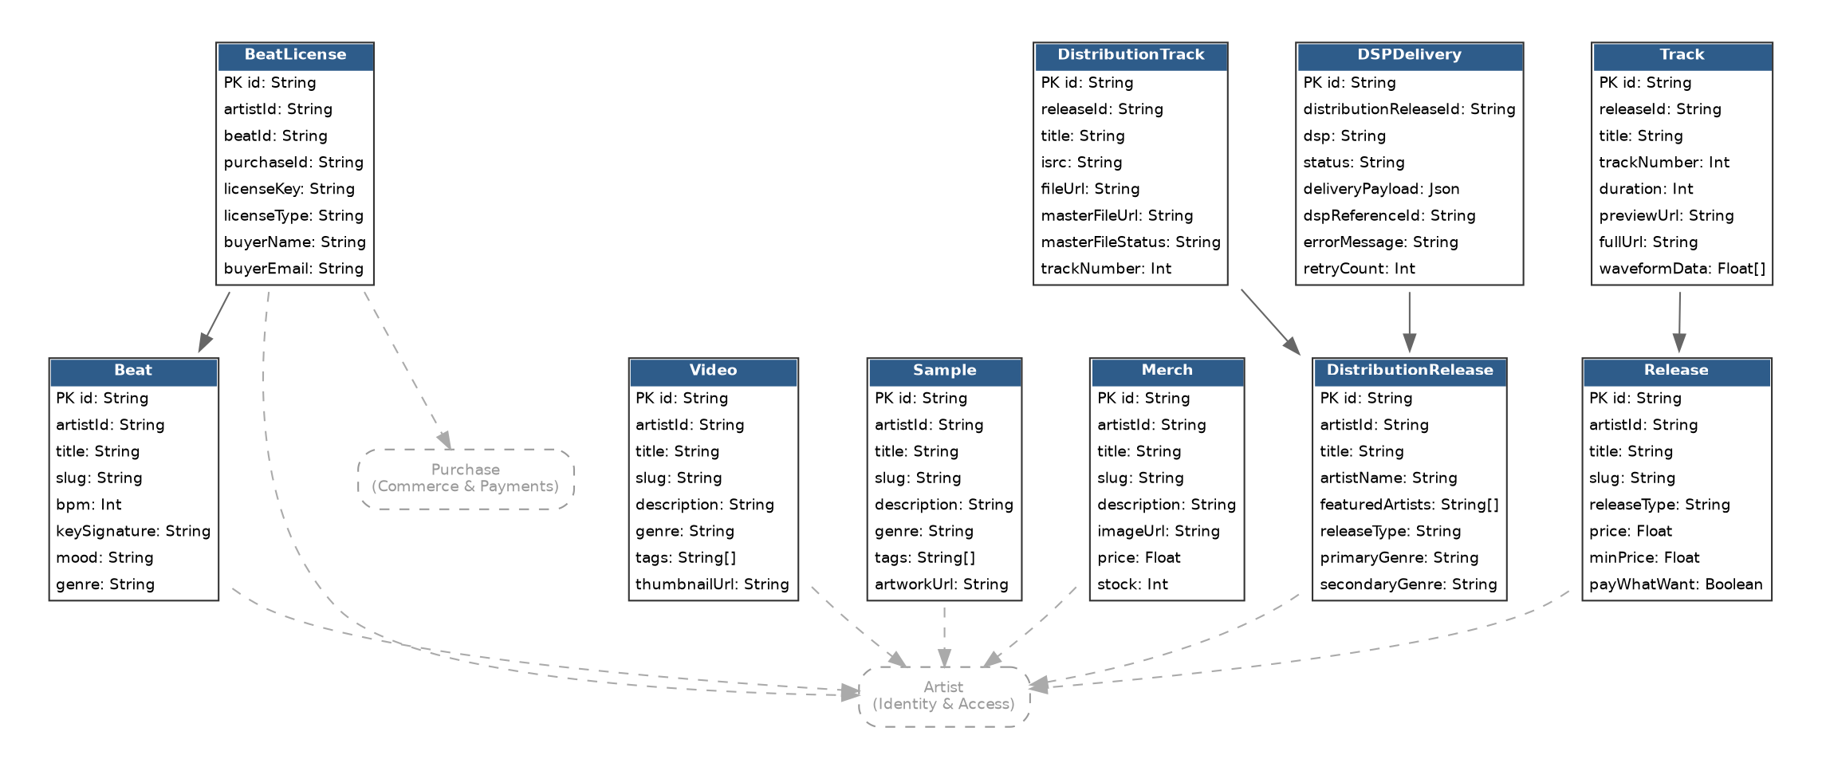
Figure 5. Catalogue & Distribution — entity relationships (10 tables).
Note: DistributionRelease, DistributionTrack, and DSPDelivery are legacy schema tables from an earlier build phase. Vuka Music is a direct-to-fan sales platform, not a distributor — these tables are not wired into any live, user-facing feature and no release is delivered to a streaming DSP.

5.3 Commerce & Payments
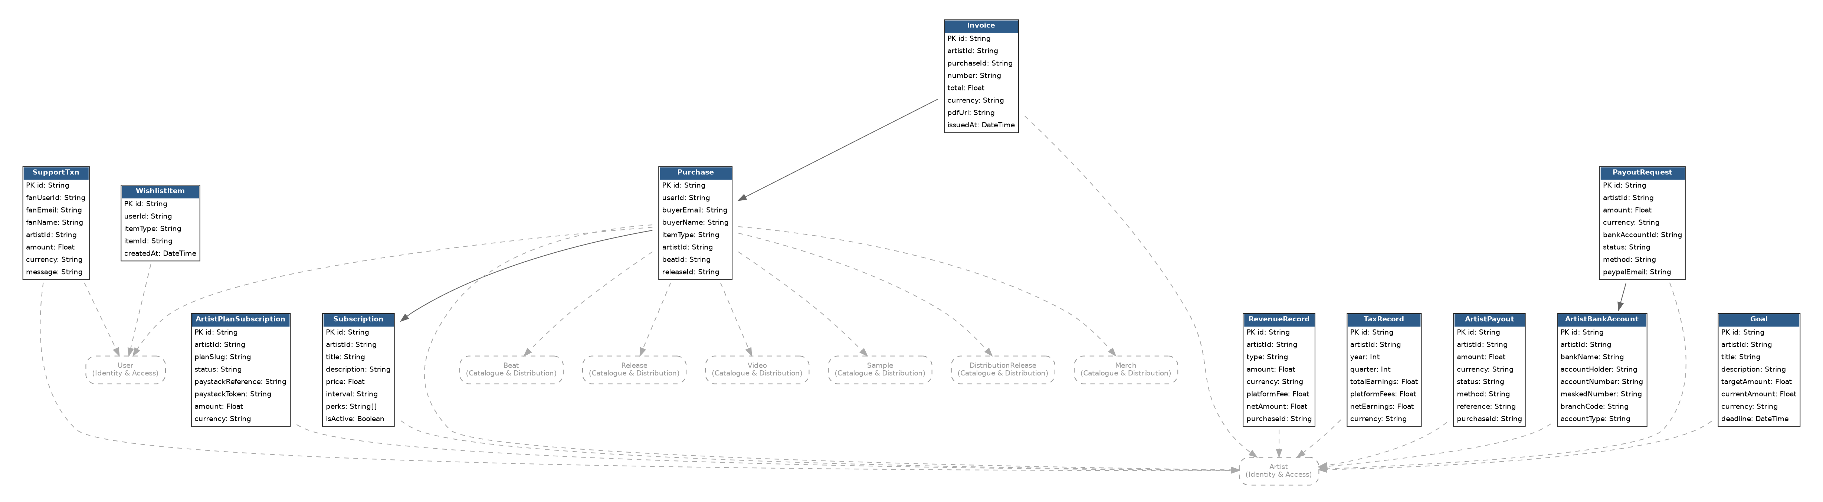
Figure 6. Commerce & Payments — entity relationships (12 tables).

5.4 Fan Engagement
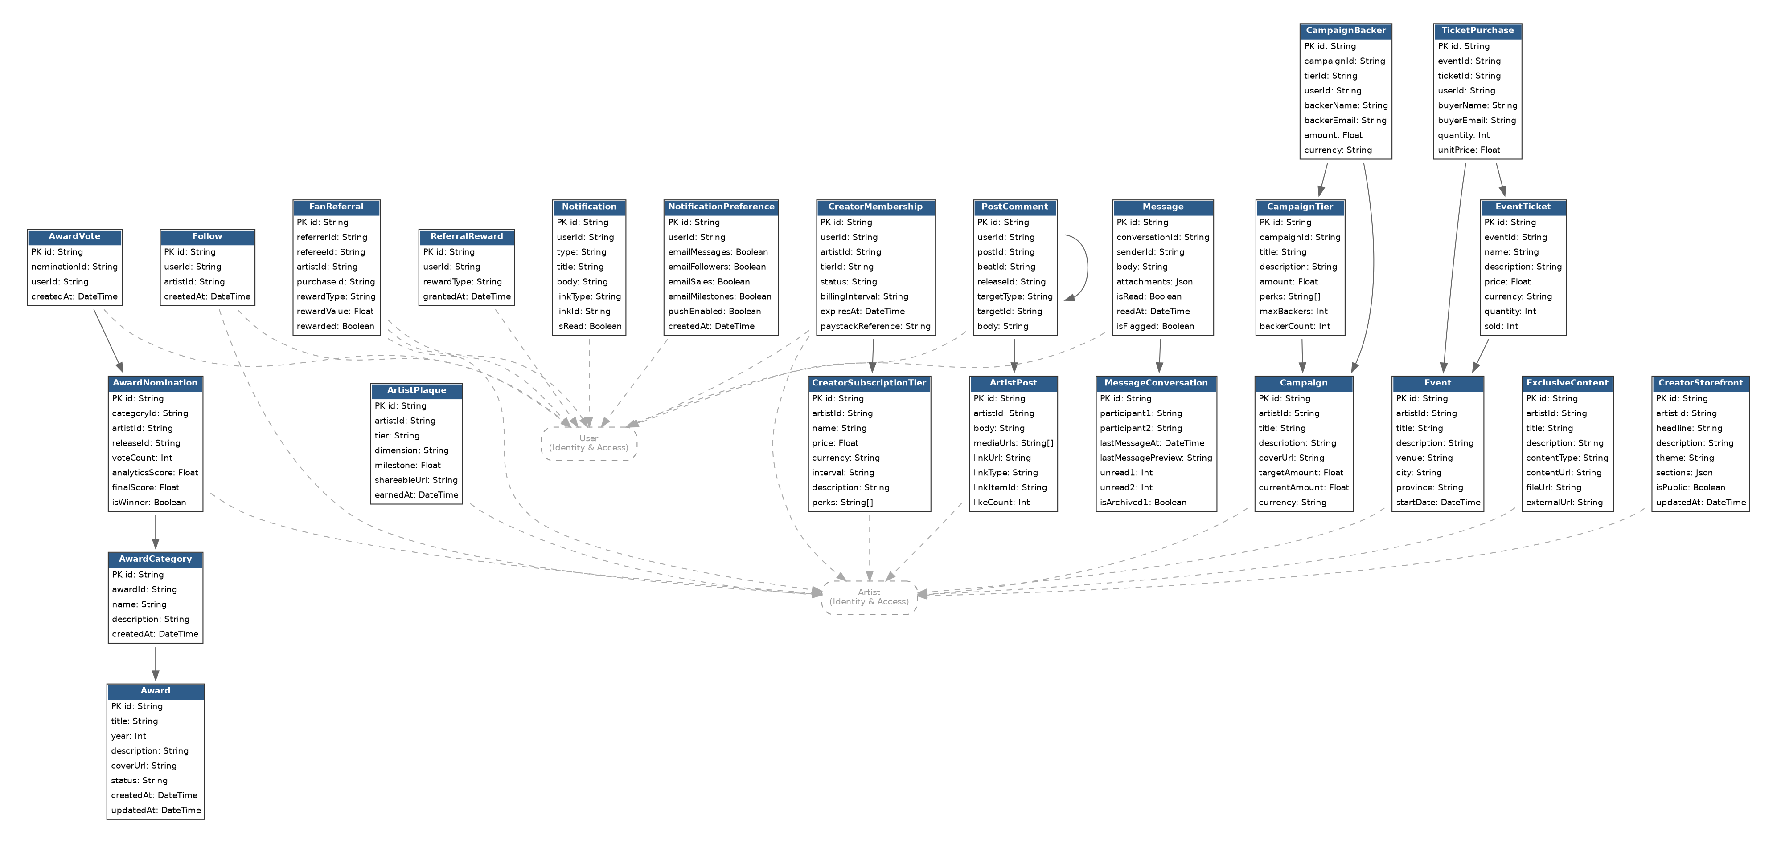
Figure 7. Fan Engagement — entity relationships (24 tables).

5.5 Marketplace & Industry
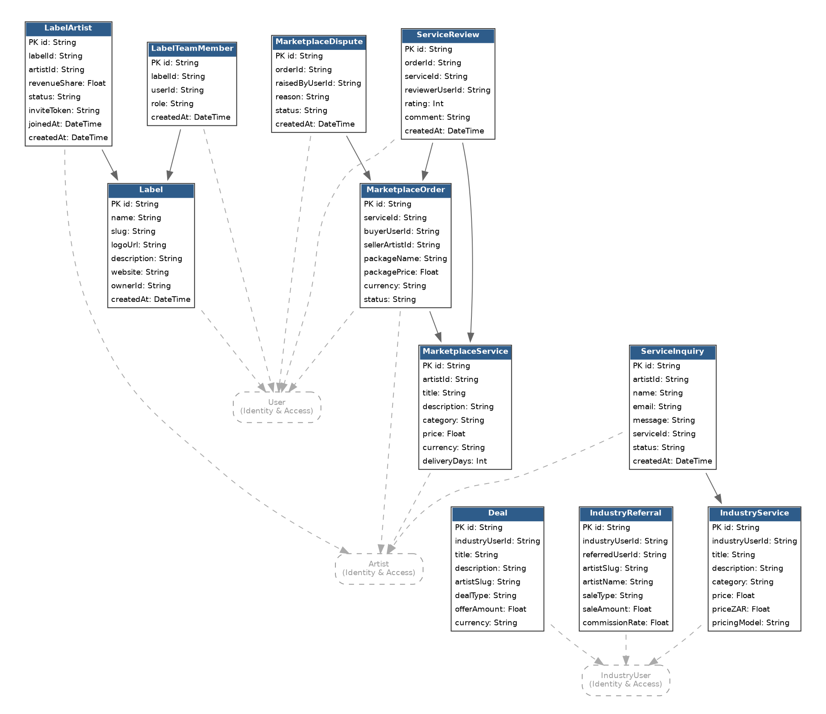
Figure 8. Marketplace & Industry — entity relationships (11 tables).

5.6 Rights & Compliance
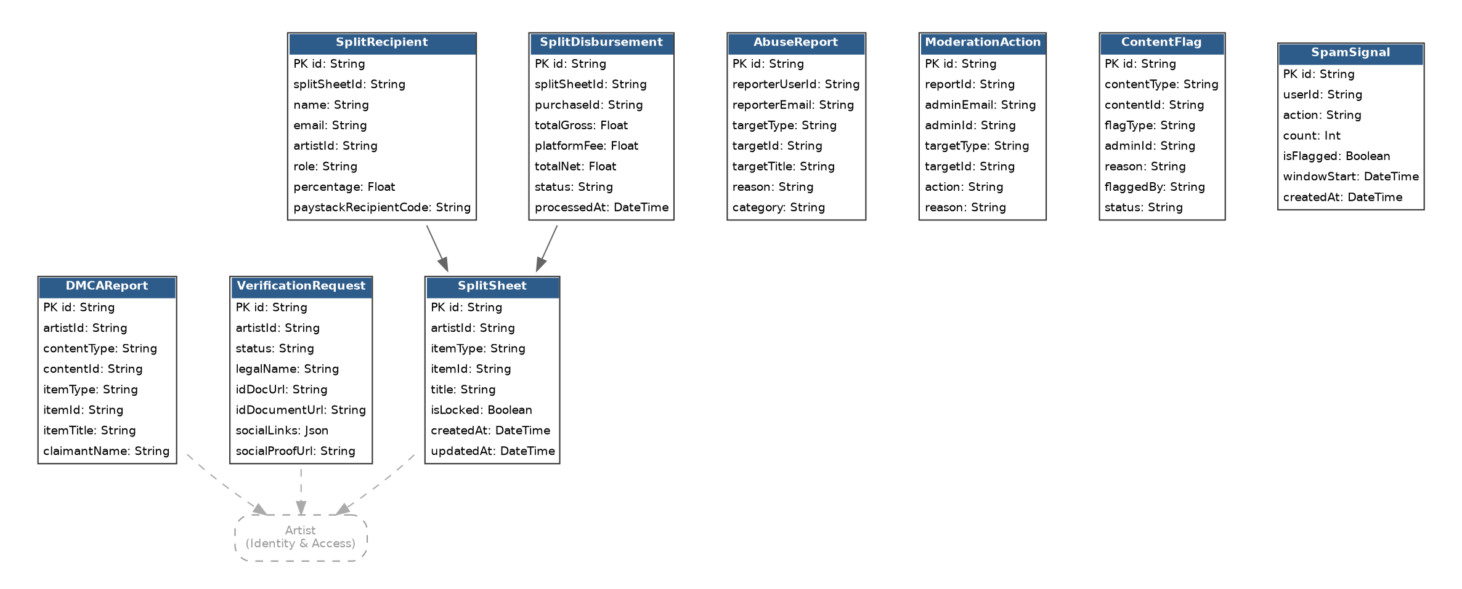
Figure 9. Rights & Compliance — entity relationships (9 tables).

5.7 Analytics
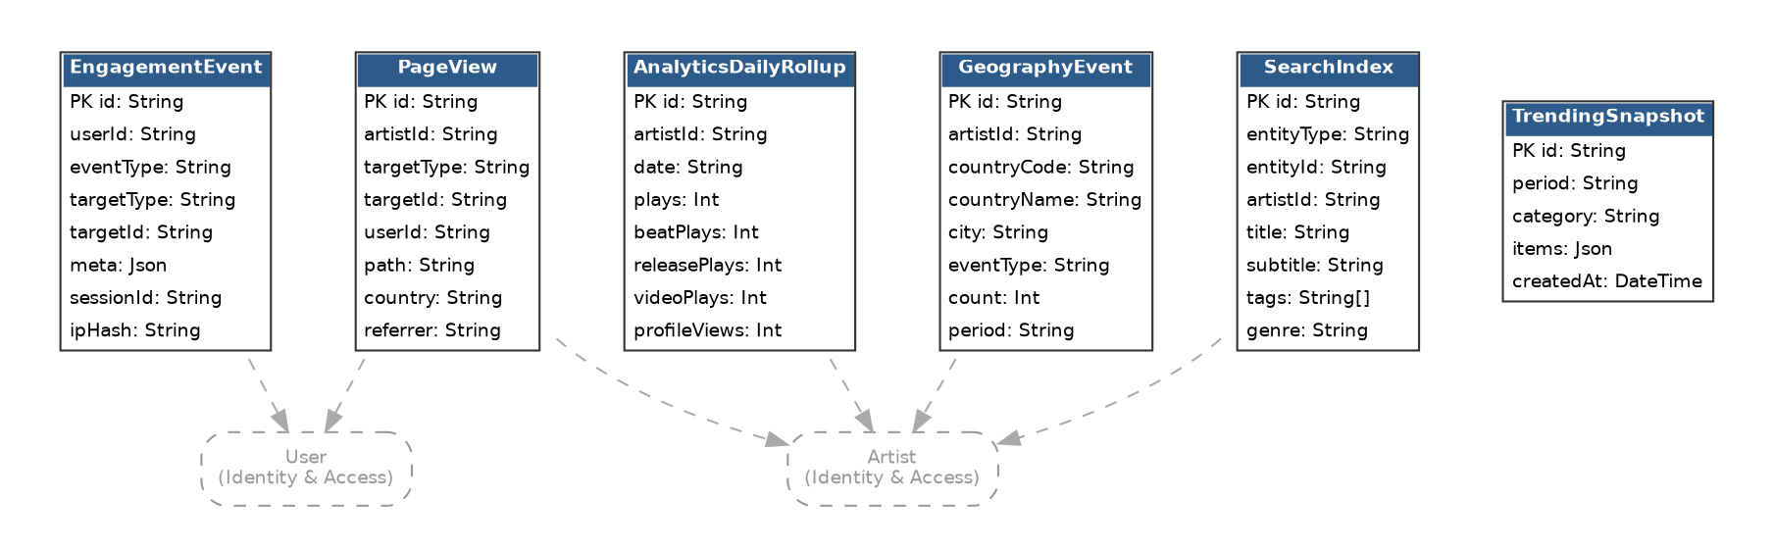
Figure 10. Analytics — entity relationships (6 tables).

5.8 CMS & Communications
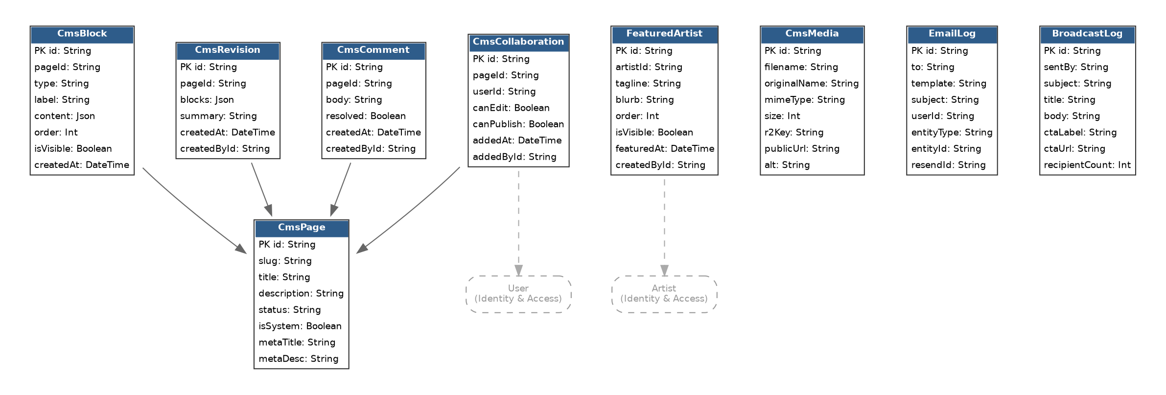
Figure 11. CMS & Communications — entity relationships (9 tables).

5.9 Platform Administration
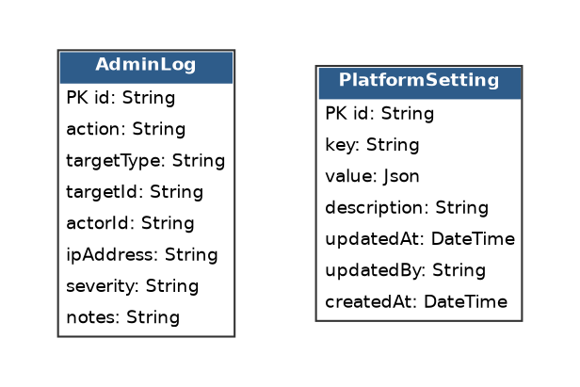
Figure 12. Platform Administration — entity relationships (2 tables).

6. Complete Data Dictionary
Every table and every field in the production schema, grouped by subsystem. PK = primary key, FK = foreign key, UNIQUE = unique constraint, (relation) = a Prisma relation field (not a physical column, but shown for completeness of the model).

6.1 Identity & Access

User
Field | Type | Key | Notes
id | String | PK
email | String | UNIQUE
name | String
role | String |  | fan, artist, industry, admin, moderator, owner, super_admin
isSuspended | Boolean
suspendedAt | DateTime?
suspendedReason | String
createdAt | DateTime
referralCode | String? | UNIQUE | this user's shareable code (auto-generated on first access)
referredBy | String? |  | the code used when this user signed up
referralRewards | ReferralReward[] (relation)
artist | Artist? (relation)
industryUser | IndustryUser? (relation)
purchases | Purchase[] (relation)
supportsSent | SupportTxn[] (relation)
wishlist | WishlistItem[] (relation)
follows | Follow[] (relation)
memberships | CreatorMembership[] (relation)
marketplaceOrders | MarketplaceOrder[] (relation)
disputesRaised | MarketplaceDispute[] (relation)
reviewsWritten | ServiceReview[] (relation)
sentMessages | Message[] (relation)
notifications | Notification[] (relation)
notificationPrefs | NotificationPreference? (relation)
engagementEvents | EngagementEvent[] (relation)
postComments | PostComment[] (relation)
pageViews | PageView[] (relation)
cmsCollaborations | CmsCollaboration[] (relation)
label | Label? (relation)
labelTeam | LabelTeamMember[] (relation)
fanReferralsMade | FanReferral[] (relation)
fanReferralsReceived | FanReferral[] (relation)
awardVotes | AwardVote[] (relation)

Artist
Field | Type | Key | Notes
id | String | PK
userId | String | UNIQUE
user | User (relation) | FK
slug | String | UNIQUE
name | String
bio | String
city | String
country | String
genreTags | String[]
photoUrl | String
coverUrl | String
socialLinks | Json
paystackRecipient | String? |  | bank account number for Paystack payout registration
paypalEmail | String? |  | preferred PayPal email for international payouts
planSlug | String
planExpiresAt | DateTime? |  | null = never expires (paid ongoing). Set for trial/promo plans.
currency | String
isPublic | Boolean
isVerified | Boolean
totalPlays | Int
isFoundingArtist | Boolean |  | permanent badge, granted manually to first 5 completing referral goal
lifetimeGrossSales | Float |  | running total of all confirmed gross sales; used by platformFeeRate()
beats | Beat[] (relation)
releases | Release[] (relation)
videos | Video[] (relation)
samples | Sample[] (relation)
subscriptions | Subscription[] (relation)
merch | Merch[] (relation)
supportReceived | SupportTxn[] (relation)
goals | Goal[] (relation)
payouts | ArtistPayout[] (relation)
followers | Follow[] (relation)
dmcaReports | DMCAReport[] (relation)
serviceInquiries | ServiceInquiry[] (relation)
distributionReleases | DistributionRelease[] (relation)
subscriptionTiers | CreatorSubscriptionTier[] (relation)
memberships | CreatorMembership[] (relation)
exclusiveContent | ExclusiveContent[] (relation)
storefront | CreatorStorefront? (relation)
marketplaceServices | MarketplaceService[] (relation)
marketplaceOrdersSold | MarketplaceOrder[] (relation)
payoutRequests | PayoutRequest[] (relation)
bankAccounts | ArtistBankAccount[] (relation)
revenueRecords | RevenueRecord[] (relation)
taxRecords | TaxRecord[] (relation)
beatLicenses | BeatLicense[] (relation)
invoices | Invoice[] (relation)
posts | ArtistPost[] (relation)
pageViews | PageView[] (relation)
dailyRollups | AnalyticsDailyRollup[] (relation)
geoEvents | GeographyEvent[] (relation)
verificationRequest | VerificationRequest? (relation)
searchIndex | SearchIndex[] (relation)
planSubscriptions | ArtistPlanSubscription[] (relation)
directPurchases | Purchase[] (relation)
featuredArtist | FeaturedArtist? (relation)
plaques | ArtistPlaque[] (relation)
campaigns | Campaign[] (relation)
splitSheets | SplitSheet[] (relation)
events | Event[] (relation)
nominations | AwardNomination[] (relation)
labelRoster | LabelArtist[] (relation)
onboarding | ArtistOnboarding? (relation)
fanReferrals | FanReferral[] (relation)
createdAt | DateTime

IndustryUser
Field | Type | Key | Notes
id | String | PK
userId | String | UNIQUE
user | User (relation) | FK
companyName | String
role | String
website | String
verified | Boolean
services | IndustryService[] (relation)
deals | Deal[] (relation)
referrals | IndustryReferral[] (relation)
createdAt | DateTime

UserTwoFactor
Field | Type | Key | Notes
id | String | PK
userId | String | UNIQUE
secret | String
backupCodes | String
isEnabled | Boolean
enabledAt | DateTime?
createdAt | DateTime
updatedAt | DateTime

UserDeviceSession
Field | Type | Key | Notes
id | String | PK
userId | String
sessionId | String | UNIQUE
deviceName | String
browser | String
os | String
ipAddress | String
isCurrent | Boolean
isRevoked | Boolean
revokedAt | DateTime?
lastSeenAt | DateTime
createdAt | DateTime

PasswordResetToken
Field | Type | Key | Notes
id | String | PK
userId | String
email | String
token | String | UNIQUE
usedAt | DateTime?
expiresAt | DateTime
createdAt | DateTime

TwoFactorChallenge
Field | Type | Key | Notes
id | String | PK
userId | String
token | String | UNIQUE
expiresAt | DateTime
usedAt | DateTime?
createdAt | DateTime

ArtistOnboarding
Field | Type | Key | Notes
id | String | PK
artistId | String | UNIQUE
artist | Artist (relation) | FK
hasProfile | Boolean
hasRelease | Boolean
hasBankAccount | Boolean
hasSocials | Boolean
dismissedAt | DateTime?
completedAt | DateTime?
createdAt | DateTime
updatedAt | DateTime

6.2 Catalogue & Distribution
Note: the DistributionRelease, DistributionTrack, and DSPDelivery tables below are legacy schema from an earlier build phase, not an active product feature. Vuka Music does not distribute releases to Spotify, Apple Music, or any other streaming DSP.

Release
Field | Type | Key | Notes
id | String | PK
artistId | String
artist | Artist (relation) | FK
title | String
slug | String | UNIQUE
releaseType | String
price | Float
minPrice | Float
payWhatWant | Boolean
artworkUrl | String
description | String
credits | String
releaseDate | DateTime?
plays | Int
sales | Int
isActive | Boolean
tracks | Track[] (relation)
purchases | Purchase[] (relation)
createdAt | DateTime

Track
Field | Type | Key | Notes
id | String | PK
releaseId | String
release | Release (relation) | FK
title | String
trackNumber | Int
duration | Int
previewUrl | String
fullUrl | String
waveformData | Float[]

Beat
Field | Type | Key | Notes
id | String | PK
artistId | String
artist | Artist (relation) | FK
title | String
slug | String | UNIQUE
bpm | Int
keySignature | String
mood | String
genre | String
tags | String[]
artworkUrl | String
previewUrl | String
fullWavUrl | String
fullMp3Url | String
waveformData | Float[]
basicPrice | Float
premiumPrice | Float
exclPrice | Float
plays | Int
sales | Int
isActive | Boolean
isExclusive | Boolean
purchases | Purchase[] (relation)
licenses | BeatLicense[] (relation)
createdAt | DateTime

Video
Field | Type | Key | Notes
id | String | PK
artistId | String
artist | Artist (relation) | FK
title | String
slug | String | UNIQUE
description | String
genre | String
tags | String[]
thumbnailUrl | String
videoUrl | String
previewUrl | String
price | Float
plays | Int
sales | Int
isActive | Boolean
purchases | Purchase[] (relation)
createdAt | DateTime

Sample
Field | Type | Key | Notes
id | String | PK
artistId | String
artist | Artist (relation) | FK
title | String
slug | String | UNIQUE
description | String
genre | String
tags | String[]
artworkUrl | String
previewUrl | String
fileUrl | String
price | Float
bpm | Int
keySignature | String
trackCount | Int
sales | Int
isActive | Boolean
purchases | Purchase[] (relation)
createdAt | DateTime

Merch
Field | Type | Key | Notes
id | String | PK
artistId | String
artist | Artist (relation) | FK
title | String
slug | String | UNIQUE
description | String
imageUrl | String
price | Float
stock | Int
sizes | String[]
isActive | Boolean
purchases | Purchase[] (relation)
createdAt | DateTime

BeatLicense
Field | Type | Key | Notes
id | String | PK
artistId | String
artist | Artist (relation) | FK
beatId | String
beat | Beat (relation) | FK
purchaseId | String | UNIQUE
purchase | Purchase (relation) | FK
licenseKey | String | UNIQUE
licenseType | String |  | basic, premium, exclusive
buyerName | String
buyerEmail | String
terms | String
isRevoked | Boolean
revokedReason | String
streams | Int?
salesCap | Int?
radioStations | Boolean
tvSync | Boolean
musicVideo | Boolean
profitSharing | Float
artistName | String
songTitle | String
issuedAt | DateTime
expiresAt | DateTime?
pdfUrl | String
createdAt | DateTime

DistributionRelease
Field | Type | Key | Notes
id | String | PK
artistId | String
artist | Artist (relation) | FK
title | String
artistName | String
featuredArtists | String[]
releaseType | String |  | single, ep, album
primaryGenre | String
secondaryGenre | String
language | String
labelName | String
distributor | String
upc | String?
artworkUrl | String
artworkStatus | String |  | pending, approved, rejected
copyrightHolder | String
copyrightYear | Int?
pLine | String
cLine | String
targetDSPs | String[]
scheduledDate | DateTime?
scheduledFor | DateTime?
originalReleaseDate | DateTime?
catalogNumber | String
adminNotes | String
rejectionReason | String
statusHistory | Json
status | String |  | draft, pending, submitted, live, rejected, rollback, takedown
submittedAt | DateTime?
liveAt | DateTime?
platforms | String[]
price | Float
minPrice | Float
payWhatYouWant | Boolean
retryCount | Int
lastRetryAt | DateTime?
liveNotifiedAt | DateTime?
tracks | DistributionTrack[] (relation)
dspDeliveries | DSPDelivery[] (relation)
purchases | Purchase[] (relation)
updatedAt | DateTime
createdAt | DateTime

DistributionTrack
Field | Type | Key | Notes
id | String | PK
releaseId | String
release | DistributionRelease (relation) | FK
title | String
isrc | String?
fileUrl | String
masterFileUrl | String
masterFileStatus | String |  | pending, approved, rejected
trackNumber | Int
duration | Int?
explicit | Boolean
composers | String[]
producers | String[]
featuredArtists | String[]
lyricists | String[]
language | String
createdAt | DateTime

DSPDelivery
Field | Type | Key | Notes
id | String | PK
distributionReleaseId | String
distributionRelease | DistributionRelease (relation) | FK
dsp | String |  | spotify, apple_music, youtube_music, tiktok, deezer, audiomack, amazon_music
status | String |  | queued, submitting, submitted, live, failed, rolled_back
deliveryPayload | Json
dspReferenceId | String?
errorMessage | String
retryCount | Int
submittedAt | DateTime?
liveAt | DateTime?
failedAt | DateTime?
lastRetryAt | DateTime?
rolledBackAt | DateTime?
createdAt | DateTime

6.3 Commerce & Payments

Purchase
Field | Type | Key | Notes
id | String | PK
userId | String?
user | User? (relation) | FK
buyerEmail | String
buyerName | String
itemType | String |  | beat, release, video, sample, distribution, subscription, membership, marketplace
artistId | String? |  | direct FK — populated for subscription, membership, marketplace
artist | Artist? (relation) | FK
beatId | String?
beat | Beat? (relation) | FK
releaseId | String?
release | Release? (relation) | FK
videoId | String?
video | Video? (relation) | FK
sampleId | String?
sample | Sample? (relation) | FK
distributionReleaseId | String?
distributionRelease | DistributionRelease? (relation) | FK
subscriptionId | String?
subscription | Subscription? (relation) | FK
merchId | String?
merch | Merch? (relation) | FK
amount | Float
currency | String
licenseType | String
licenseId | String | UNIQUE
stripePaymentId | String?
paystackReference | String?
status | String |  | pending, confirmed, refunded
licenseUrl | String?
receiptUrl | String?
downloadToken | String | UNIQUE
downloadCount | Int
platformFee | Float
netAmount | Float
beatLicense | BeatLicense? (relation)
invoices | Invoice[] (relation)
createdAt | DateTime

SupportTxn
Field | Type | Key | Notes
id | String | PK
fanUserId | String?
fan | User? (relation) | FK
fanEmail | String
fanName | String
artistId | String
artist | Artist (relation) | FK
amount | Float
currency | String
message | String
tier | String
isPublic | Boolean
stripePaymentId | String?
paystackReference | String?
status | String
createdAt | DateTime

Subscription
Field | Type | Key | Notes
id | String | PK
artistId | String
artist | Artist (relation) | FK
title | String
description | String
price | Float
interval | String
perks | String[]
isActive | Boolean
purchases | Purchase[] (relation)
createdAt | DateTime

ArtistPlanSubscription
Field | Type | Key | Notes
id | String | PK
artistId | String
artist | Artist (relation) | FK
planSlug | String |  | pro | label
status | String |  | active | cancelled | expired | failed
paystackReference | String? |  | Paystack payment reference
paystackToken | String? |  | reserved for future recurring billing
amount | Float
currency | String
billingInterval | String
currentPeriodStart | DateTime
currentPeriodEnd | DateTime
cancelledAt | DateTime?
failedAt | DateTime?
failReason | String?
createdAt | DateTime
updatedAt | DateTime

Invoice
Field | Type | Key | Notes
id | String | PK
artistId | String
artist | Artist (relation) | FK
purchaseId | String?
purchase | Purchase? (relation) | FK
number | String | UNIQUE
total | Float
currency | String
pdfUrl | String?
issuedAt | DateTime
createdAt | DateTime

RevenueRecord
Field | Type | Key | Notes
id | String | PK
artistId | String
artist | Artist (relation) | FK
type | String |  | beat_sale, release_sale, support, subscription, marketplace
amount | Float
currency | String
platformFee | Float
netAmount | Float
purchaseId | String?
period | String |  | YYYY-MM
updatedAt | DateTime
createdAt | DateTime

TaxRecord
Field | Type | Key | Notes
id | String | PK
artistId | String
artist | Artist (relation) | FK
year | Int
quarter | Int
totalEarnings | Float
platformFees | Float
netEarnings | Float
currency | String
createdAt | DateTime

ArtistPayout
Field | Type | Key | Notes
id | String | PK
artistId | String
artist | Artist (relation) | FK
amount | Float
currency | String
status | String |  | pending, processing, paid, failed
method | String |  | bank, paystack, paypal, flutterwave
reference | String
purchaseId | String?
notes | String
processedAt | DateTime?
createdAt | DateTime

PayoutRequest
Field | Type | Key | Notes
id | String | PK
artistId | String
artist | Artist (relation) | FK
amount | Float
currency | String
bankAccountId | String?
bankAccount | ArtistBankAccount? (relation) | FK
status | String |  | pending, approved, processing, paid, rejected
method | String |  | bank_transfer, paypal
paypalEmail | String? |  | recipient PayPal email for PayPal payouts
paystackReference | String? |  | Paystack transfer code or PayPal batch ID
adminNotes | String
notes | String |  | processing notes / rejection reason
approvedAt | DateTime?
processedAt | DateTime?
createdAt | DateTime

ArtistBankAccount
Field | Type | Key | Notes
id | String | PK
artistId | String
artist | Artist (relation) | FK
bankName | String
accountHolder | String
accountNumber | String |  | stored encrypted in prod; masked in responses
maskedNumber | String
branchCode | String
accountType | String
paypalEmail | String?
paystackAccountCode | String? |  | Paystack transfer recipient code
isDefault | Boolean
isVerified | Boolean
payoutRequests | PayoutRequest[] (relation)
createdAt | DateTime

WishlistItem
Field | Type | Key | Notes
id | String | PK
userId | String
user | User (relation) | FK
itemType | String
itemId | String
createdAt | DateTime

Goal
Field | Type | Key | Notes
id | String | PK
artistId | String
artist | Artist (relation) | FK
title | String
description | String
targetAmount | Float
currentAmount | Float
currency | String
deadline | DateTime?
isActive | Boolean
createdAt | DateTime

6.4 Fan Engagement

Follow
Field | Type | Key | Notes
id | String | PK
userId | String
user | User (relation) | FK
artistId | String
artist | Artist (relation) | FK
createdAt | DateTime

ArtistPost
Field | Type | Key | Notes
id | String | PK
artistId | String
artist | Artist (relation) | FK
body | String
mediaUrls | String[]
linkUrl | String
linkType | String |  | beat, release, external
linkItemId | String
likeCount | Int
commentCount | Int
repostCount | Int
isPinned | Boolean
isPublished | Boolean
publishedAt | DateTime
comments | PostComment[] (relation)
createdAt | DateTime

PostComment
Field | Type | Key | Notes
id | String | PK
userId | String
user | User (relation) | FK
postId | String?
post | ArtistPost? (relation) | FK
beatId | String?
releaseId | String?
targetType | String
targetId | String
body | String
parentId | String?
parent | PostComment? (relation) | FK
replies | PostComment[] (relation)
likeCount | Int
isHidden | Boolean
isDeleted | Boolean
updatedAt | DateTime
createdAt | DateTime

Message
Field | Type | Key | Notes
id | String | PK
conversationId | String
conversation | MessageConversation (relation) | FK
senderId | String
sender | User (relation) | FK
body | String
attachments | Json
isRead | Boolean
readAt | DateTime?
isFlagged | Boolean
flagReason | String
isDeleted | Boolean
deletedAt | DateTime?
createdAt | DateTime

MessageConversation
Field | Type | Key | Notes
id | String | PK
participant1 | String
participant2 | String
messages | Message[] (relation)
lastMessageAt | DateTime
lastMessagePreview | String
unread1 | Int
unread2 | Int
isArchived1 | Boolean
isArchived2 | Boolean
updatedAt | DateTime
createdAt | DateTime

Notification
Field | Type | Key | Notes
id | String | PK
userId | String
user | User (relation) | FK
type | String |  | new_follower, new_comment, new_like, new_sale, new_message, milestone_followers, milestone_sales
title | String
body | String
linkType | String
linkId | String
isRead | Boolean
createdAt | DateTime

NotificationPreference
Field | Type | Key | Notes
id | String | PK
userId | String | UNIQUE
user | User (relation) | FK
emailMessages | Boolean
emailFollowers | Boolean
emailSales | Boolean
emailMilestones | Boolean
pushEnabled | Boolean
createdAt | DateTime

Campaign
Field | Type | Key | Notes
id | String | PK
artistId | String
artist | Artist (relation) | FK
title | String
description | String
coverUrl | String
targetAmount | Float
currentAmount | Float
currency | String
deadline | DateTime
campaignType | String |  | flexible | all_or_nothing
status | String |  | draft, active, funded, failed, cancelled
slug | String | UNIQUE
backerCount | Int
tiers | CampaignTier[] (relation)
backers | CampaignBacker[] (relation)
createdAt | DateTime
updatedAt | DateTime

CampaignTier
Field | Type | Key | Notes
id | String | PK
campaignId | String
campaign | Campaign (relation) | FK
title | String
description | String
amount | Float |  | minimum pledge for this tier
perks | String[] |  | list of reward perks
maxBackers | Int? |  | null = unlimited
backerCount | Int
backers | CampaignBacker[] (relation)
createdAt | DateTime

CampaignBacker
Field | Type | Key | Notes
id | String | PK
campaignId | String
campaign | Campaign (relation) | FK
tierId | String?
tier | CampaignTier? (relation) | FK
userId | String?
backerName | String
backerEmail | String
amount | Float
currency | String
paystackReference | String?
status | String |  | pending, confirmed, refunded
anonymous | Boolean
message | String
createdAt | DateTime

CreatorSubscriptionTier
Field | Type | Key | Notes
id | String | PK
artistId | String
artist | Artist (relation) | FK
name | String
price | Float
currency | String
interval | String
description | String
perks | String[]
isActive | Boolean
memberships | CreatorMembership[] (relation)
createdAt | DateTime

CreatorMembership
Field | Type | Key | Notes
id | String | PK
userId | String
user | User (relation) | FK
artistId | String
artist | Artist (relation) | FK
tierId | String
tier | CreatorSubscriptionTier (relation) | FK
status | String |  | active, pending, cancelled, expired
billingInterval | String |  | monthly | yearly
expiresAt | DateTime?
paystackReference | String?
createdAt | DateTime

ExclusiveContent
Field | Type | Key | Notes
id | String | PK
artistId | String
artist | Artist (relation) | FK
title | String
description | String
contentType | String |  | audio, video, pdf, link, text
contentUrl | String
fileUrl | String
externalUrl | String
body | String
thumbnailUrl | String
tierId | String?
accessTierIds | Json
isFreePreview | Boolean
isPublished | Boolean
isActive | Boolean
publishedAt | DateTime?
createdAt | DateTime

CreatorStorefront
Field | Type | Key | Notes
id | String | PK
artistId | String | UNIQUE
artist | Artist (relation) | FK
headline | String
description | String
theme | String
sections | Json
isPublic | Boolean
updatedAt | DateTime
createdAt | DateTime

Event
Field | Type | Key | Notes
id | String | PK
artistId | String
artist | Artist (relation) | FK
title | String
description | String
venue | String
city | String
province | String
startDate | DateTime
endDate | DateTime?
coverUrl | String
status | String |  | draft, published, cancelled, completed
slug | String | UNIQUE
tickets | EventTicket[] (relation)
purchases | TicketPurchase[] (relation)
createdAt | DateTime
updatedAt | DateTime

EventTicket
Field | Type | Key | Notes
id | String | PK
eventId | String
event | Event (relation) | FK
name | String
description | String
price | Float
currency | String
quantity | Int?
sold | Int
purchases | TicketPurchase[] (relation)
createdAt | DateTime

TicketPurchase
Field | Type | Key | Notes
id | String | PK
eventId | String
event | Event (relation) | FK
ticketId | String
ticket | EventTicket (relation) | FK
userId | String?
buyerName | String
buyerEmail | String
quantity | Int
unitPrice | Float
totalAmount | Float
currency | String
paystackReference | String?
status | String |  | pending, confirmed, cancelled, refunded
qrToken | String | UNIQUE
qrSignature | String |  | HMAC(secret, id + qrToken) — verified at the gate, not just looked up
checkedInAt | DateTime?
checkedInByUserId | String?
checkInDeviceInfo | String
createdAt | DateTime

Award
Field | Type | Key | Notes
id | String | PK
title | String
year | Int
description | String
coverUrl | String
status | String |  | nominations_open, voting_open, closed, announced
categories | AwardCategory[] (relation)
createdAt | DateTime
updatedAt | DateTime

AwardCategory
Field | Type | Key | Notes
id | String | PK
awardId | String
award | Award (relation) | FK
name | String
description | String
nominations | AwardNomination[] (relation)
createdAt | DateTime

AwardNomination
Field | Type | Key | Notes
id | String | PK
categoryId | String
category | AwardCategory (relation) | FK
artistId | String
artist | Artist (relation) | FK
releaseId | String?
voteCount | Int
analyticsScore | Float
finalScore | Float
isWinner | Boolean
votes | AwardVote[] (relation)
createdAt | DateTime

AwardVote
Field | Type | Key | Notes
id | String | PK
nominationId | String
nomination | AwardNomination (relation) | FK
userId | String
user | User (relation) | FK
createdAt | DateTime

ArtistPlaque
Field | Type | Key | Notes
id | String | PK
artistId | String
artist | Artist (relation) | FK
tier | String |  | first_sale, bronze, silver, gold, platinum, diamond, multi_platinum
dimension | String |  | sales_units, streams, follower_count, membership_revenue
milestone | Float |  | the numeric threshold achieved
shareableUrl | String |  | generated OG image for social sharing
earnedAt | DateTime

FanReferral
Field | Type | Key | Notes
id | String | PK
referrerId | String
referrer | User (relation) | FK
refereeId | String
referee | User (relation) | FK
artistId | String?
artist | Artist? (relation) | FK
purchaseId | String?
rewardType | String
rewardValue | Float
rewarded | Boolean
createdAt | DateTime

ReferralReward
Field | Type | Key | Notes
id | String | PK
userId | String
user | User (relation) | FK
rewardType | String |  | extendable: future reward types go here
grantedAt | DateTime

6.5 Marketplace & Industry

MarketplaceService
Field | Type | Key | Notes
id | String | PK
artistId | String
artist | Artist (relation) | FK
title | String
description | String
category | String
price | Float
currency | String
deliveryDays | Int
revisions | Int
packages | Json
portfolioUrls | String[]
requirements | String
isActive | Boolean
totalOrders | Int
orders | MarketplaceOrder[] (relation)
reviews | ServiceReview[] (relation)
createdAt | DateTime

MarketplaceOrder
Field | Type | Key | Notes
id | String | PK
serviceId | String
service | MarketplaceService (relation) | FK
buyerUserId | String
buyer | User (relation) | FK
sellerArtistId | String
seller | Artist (relation) | FK
packageName | String
packagePrice | Float
currency | String
status | String |  | pending, active, delivered, revision, complete, disputed, cancelled
requirements | String
deliveryDays | Int
dueAt | DateTime?
deliveredAt | DateTime?
completedAt | DateTime?
deliverables | String[]
sellerNotes | String
revisionCount | Int
maxRevisions | Int
revisionNotes | String
purchaseId | String?
payfastRef | String?
stripePaymentId | String?
platformFee | Float
netAmount | Float
paystackReference | String?
dispute | MarketplaceDispute? (relation)
review | ServiceReview? (relation)
createdAt | DateTime
updatedAt | DateTime

MarketplaceDispute
Field | Type | Key | Notes
id | String | PK
orderId | String | UNIQUE
order | MarketplaceOrder (relation) | FK
raisedByUserId | String
disputer | User (relation) | FK
reason | String
status | String |  | open, resolved, closed
createdAt | DateTime

ServiceReview
Field | Type | Key | Notes
id | String | PK
orderId | String | UNIQUE
order | MarketplaceOrder (relation) | FK
serviceId | String
service | MarketplaceService (relation) | FK
reviewerUserId | String
reviewer | User (relation) | FK
rating | Int
comment | String
createdAt | DateTime

ServiceInquiry
Field | Type | Key | Notes
id | String | PK
artistId | String
artist | Artist (relation) | FK
name | String
email | String
message | String
serviceId | String
industryService | IndustryService? (relation) | FK
status | String
createdAt | DateTime

Deal
Field | Type | Key | Notes
id | String | PK
industryUserId | String
industryUser | IndustryUser (relation) | FK
title | String
description | String
artistSlug | String
dealType | String
offerAmount | Float
currency | String
status | String |  | open, closed
createdAt | DateTime

IndustryReferral
Field | Type | Key | Notes
id | String | PK
industryUserId | String
industryUser | IndustryUser (relation) | FK
referredUserId | String
artistSlug | String
artistName | String
saleType | String
saleAmount | Float
commissionRate | Float
commissionEarned | Float
currency | String
status | String
paidAt | DateTime?
createdAt | DateTime

IndustryService
Field | Type | Key | Notes
id | String | PK
industryUserId | String
industryUser | IndustryUser (relation) | FK
title | String
description | String
category | String
price | Float?
priceZAR | Float
pricingModel | String
deliveryDays | Int
currency | String
isActive | Boolean
inquiries | ServiceInquiry[] (relation)
createdAt | DateTime

Label
Field | Type | Key | Notes
id | String | PK
name | String
slug | String | UNIQUE
logoUrl | String
description | String
website | String
ownerId | String | UNIQUE
owner | User (relation) | FK
roster | LabelArtist[] (relation)
teamMembers | LabelTeamMember[] (relation)
createdAt | DateTime
updatedAt | DateTime

LabelArtist
Field | Type | Key | Notes
id | String | PK
labelId | String
label | Label (relation) | FK
artistId | String
artist | Artist (relation) | FK
revenueShare | Float |  | % the artist keeps; label keeps the rest after Vuka fee
status | String |  | pending, active, inactive
inviteToken | String | UNIQUE
joinedAt | DateTime?
createdAt | DateTime

LabelTeamMember
Field | Type | Key | Notes
id | String | PK
labelId | String
label | Label (relation) | FK
userId | String
user | User (relation) | FK
role | String |  | admin, manager, accountant
createdAt | DateTime

6.6 Rights & Compliance

SplitSheet
Field | Type | Key | Notes
id | String | PK
artistId | String |  | the owning artist (creator of the sheet)
artist | Artist (relation) | FK
itemType | String |  | beat | release | video | sample | merch
itemId | String |  | the beat/release/video/sample/merch this sheet covers
title | String |  | human label e.g. "Fully Charged Split"
isLocked | Boolean |  | locked after first sale — no more edits
splits | SplitRecipient[] (relation)
disbursements | SplitDisbursement[] (relation)
createdAt | DateTime
updatedAt | DateTime

SplitRecipient
Field | Type | Key | Notes
id | String | PK
splitSheetId | String
splitSheet | SplitSheet (relation) | FK
name | String |  | display name
email | String |  | for payout routing
artistId | String? |  | if they're a Vuka artist — auto-links wallet
role | String |  | e.g. "Producer", "Feature", "Co-writer"
percentage | Float |  | must sum to 100 across all recipients
paystackRecipientCode | String |  | populated when first payout runs
createdAt | DateTime

SplitDisbursement
Field | Type | Key | Notes
id | String | PK
splitSheetId | String
splitSheet | SplitSheet (relation) | FK
purchaseId | String? |  | which purchase triggered this disbursement
totalGross | Float |  | gross before platform fee
platformFee | Float
totalNet | Float |  | distributed across recipients
status | String |  | pending, processing, completed, failed
processedAt | DateTime?
createdAt | DateTime

DMCAReport
Field | Type | Key | Notes
id | String | PK
artistId | String
artist | Artist (relation) | FK
contentType | String
contentId | String
itemType | String |  | mirrors contentType for legacy route compatibility
itemId | String |  | mirrors contentId for legacy route compatibility
itemTitle | String
claimantName | String
claimantEmail | String
description | String
status | String |  | pending, resolved, rejected, dismissed
adminNotes | String
resolvedAt | DateTime?
createdAt | DateTime

VerificationRequest
Field | Type | Key | Notes
id | String | PK
artistId | String | UNIQUE
artist | Artist (relation) | FK
status | String |  | pending, approved, rejected
legalName | String
idDocUrl | String
idDocumentUrl | String |  | alias for idDocUrl used in moderation.ts
socialLinks | Json
socialProofUrl | String
notes | String
additionalInfo | String
monthlyListeners | Int
totalStreams | Int
reviewedBy | String
reviewedAt | DateTime?
adminNotes | String
createdAt | DateTime
updatedAt | DateTime

AbuseReport
Field | Type | Key | Notes
id | String | PK
reporterUserId | String?
reporterEmail | String
targetType | String |  | beat, release, post, comment, artist, message
targetId | String
targetTitle | String
reason | String
category | String |  | harassment, hate_speech, spam, explicit_content, etc.
description | String
evidence | Json
status | String |  | pending, reviewed, resolved, dismissed
resolution | String
moderatorId | String
adminNotes | String
actionTaken | String
assignedTo | String
resolvedAt | DateTime?
createdAt | DateTime
updatedAt | DateTime

ModerationAction
Field | Type | Key | Notes
id | String | PK
reportId | String |  | links to AbuseReport (new)
adminEmail | String
adminId | String
targetType | String
targetId | String
action | String |  | warn, remove_content, suspend_account, ban_account, no_action
reason | String
notes | String
reversedAt | DateTime?
reversedBy | String
createdAt | DateTime

ContentFlag
Field | Type | Key | Notes
id | String | PK
contentType | String |  | beat, release, post, comment, artist
contentId | String
flagType | String |  | removed, dmca, explicit, spam, copyright, misleading
adminId | String
reason | String
flaggedBy | String
status | String |  | open, OPEN, UNDER_REVIEW, RESOLVED, DISMISSED
reviewedBy | String?
reviewedAt | DateTime?
isActive | Boolean
updatedAt | DateTime
createdAt | DateTime

SpamSignal
Field | Type | Key | Notes
id | String | PK
userId | String
action | String
count | Int
isFlagged | Boolean
windowStart | DateTime
createdAt | DateTime

6.7 Analytics

EngagementEvent
Field | Type | Key | Notes
id | String | PK
userId | String?
user | User? (relation) | FK
eventType | String |  | play, like, follow, purchase, share, comment
targetType | String
targetId | String
meta | Json
sessionId | String
ipHash | String
country | String
createdAt | DateTime

PageView
Field | Type | Key | Notes
id | String | PK
artistId | String?
artist | Artist? (relation) | FK
targetType | String
targetId | String
userId | String?
user | User? (relation) | FK
path | String
country | String
referrer | String
sessionId | String
userAgent | String
createdAt | DateTime

AnalyticsDailyRollup
Field | Type | Key | Notes
id | String | PK
artistId | String
artist | Artist (relation) | FK
date | String |  | YYYY-MM-DD string for easy querying and upsert
plays | Int
beatPlays | Int
releasePlays | Int
videoPlays | Int
profileViews | Int
storeViews | Int
pageViews | Int
uniqueVisitors | Int
followers | Int
unfollows | Int
beatSales | Int
releaseSales | Int
revenue | Float
totalRevenue | Float
tips | Float
likes | Int
comments | Int
reposts | Int
shares | Int
createdAt | DateTime

GeographyEvent
Field | Type | Key | Notes
id | String | PK
artistId | String
artist | Artist (relation) | FK
countryCode | String
countryName | String
city | String
eventType | String
count | Int
period | String |  | YYYY-MM
createdAt | DateTime

SearchIndex
Field | Type | Key | Notes
id | String | PK
entityType | String |  | beat, release, artist
entityId | String
artistId | String?
artist | Artist? (relation) | FK
title | String
subtitle | String
tags | String[]
genre | String
imageUrl | String
slug | String
score | Float
isActive | Boolean
updatedAt | DateTime
createdAt | DateTime

TrendingSnapshot
Field | Type | Key | Notes
id | String | PK
period | String |  | hourly, daily, weekly
category | String |  | beats, artists, releases, tags
items | Json
createdAt | DateTime

6.8 CMS & Communications

CmsPage
Field | Type | Key | Notes
id | String | PK
slug | String | UNIQUE
title | String
description | String
status | String |  | draft | review | approved | published | archived
isSystem | Boolean |  | system pages cannot be deleted
metaTitle | String
metaDesc | String
publishedAt | DateTime?
scheduledAt | DateTime?
createdAt | DateTime
updatedAt | DateTime
createdById | String
updatedById | String
blocks | CmsBlock[] (relation)
revisions | CmsRevision[] (relation)
collaborators | CmsCollaboration[] (relation)
comments | CmsComment[] (relation)

CmsBlock
Field | Type | Key | Notes
id | String | PK
pageId | String
page | CmsPage (relation) | FK
type | String
label | String
content | Json
order | Int
isVisible | Boolean
createdAt | DateTime
updatedAt | DateTime

CmsRevision
Field | Type | Key | Notes
id | String | PK
pageId | String
page | CmsPage (relation) | FK
blocks | Json
summary | String
createdAt | DateTime
createdById | String

FeaturedArtist
Field | Type | Key | Notes
id | String | PK
artistId | String | UNIQUE
artist | Artist (relation) | FK
tagline | String
blurb | String
order | Int
isVisible | Boolean
featuredAt | DateTime
createdById | String

CmsMedia
Field | Type | Key | Notes
id | String | PK
filename | String
originalName | String
mimeType | String
size | Int
r2Key | String | UNIQUE
publicUrl | String
alt | String
caption | String
width | Int?
height | Int?
folder | String
uploadedById | String
createdAt | DateTime

CmsCollaboration
Field | Type | Key | Notes
id | String | PK
pageId | String
page | CmsPage (relation) | FK
userId | String
user | User (relation) | FK
canEdit | Boolean
canPublish | Boolean
addedAt | DateTime
addedById | String

CmsComment
Field | Type | Key | Notes
id | String | PK
pageId | String
page | CmsPage (relation) | FK
body | String
resolved | Boolean
createdAt | DateTime
createdById | String

EmailLog
Field | Type | Key | Notes
id | String | PK
to | String
template | String
subject | String
userId | String?
entityType | String?
entityId | String?
resendId | String?
status | String
error | String?
createdAt | DateTime

BroadcastLog
Field | Type | Key | Notes
id | String | PK
sentBy | String
subject | String
title | String
body | String
ctaLabel | String?
ctaUrl | String?
recipientCount | Int
filter | Json?
createdAt | DateTime

6.9 Platform Administration

AdminLog
Field | Type | Key | Notes
id | String | PK
action | String
targetType | String
targetId | String
actorId | String
ipAddress | String
severity | String |  | info, warn, critical
notes | String
createdAt | DateTime

PlatformSetting
Field | Type | Key | Notes
id | String | PK
key | String | UNIQUE
value | Json
description | String
updatedAt | DateTime
updatedBy | String
createdAt | DateTime

7. Known Gaps & Proposed Fixes
The items below are confirmed gaps between what the platform markets/schema implies and what the current codebase actually does, each verified directly against the live Prisma schema and app routes rather than assumed. Each includes a proposed fix.

7.1 Split Sheet Collaborator Acceptance Gap
Collaborators declared on a split sheet cannot currently confirm or reject their percentage before it locks. A split sheet is attached to a release/track (FR-11) and auto-locks permanently on first sale, but there is no collaborator-facing accept/reject step in the app code today — the declaring artist's percentages are trusted on entry.
Proposed fix: Build an invite/accept flow for split-sheet collaborators (see new Use Case 2.1 "Accept/Reject Split Sheet"): each named collaborator receives a confirmation request and must accept before the sheet is eligible to lock on first sale; unresolved or rejected splits block the sale-triggered lock.

7.2 Exclusive Membership Content Not Delivered
The ExclusiveContent table exists in the schema, but zero application code currently reads from or writes to it. Fans can subscribe to a CreatorMembership tier, but there is no artist-facing upload screen for member-only content and no fan-facing gated view.
Proposed fix: Build an artist "Member Content" upload screen and a fan gated content view keyed off the fan's active CreatorMembership tier, so paying members actually receive the exclusive content the tier promises.

7.3 Merch Fulfillment Missing
The Purchase/Merch model has no shipping address field, no size capture, and no tracking/fulfillment status. An artist selling physical merch has no way to record where to ship it, what size was ordered, or whether it has shipped.
Proposed fix: Add shippingAddress, selectedSize, fulfillmentStatus, and trackingNumber/courier fields to the merch purchase flow. For MVP, the artist manually books a courier (Pudo, PostNet, or Courier Guy) and enters the tracking reference by hand; a Bob Go or uAfrica API integration for automatic label generation is a candidate for a later phase.

7.4 Merch Shipping Fee Handling (New Decision)
Related to 7.3: shipping cost needs an explicit, fair commission treatment rather than being folded into the item price.
Proposed fix: The artist sets a flat shipping fee per item at listing time (FR-20). It is shown as its own line item at checkout, separate from the item price. Vuka's platform commission (10%/8%/5% by plan tier) applies only to the item price — the shipping fee passes straight through to the artist and is excluded from the commission calculation.

7.5 Labels Cannot Add a Co-Manager / Team Member
The label/invite and label/accept routes only create LabelArtist rows (i.e. adding an artist to a label's roster). The LabelTeamMember table exists in the schema but has zero wiring anywhere in the codebase — there is no way for a label to add a co-manager or staff member to its own team.
Proposed fix: Build a parallel invite/accept flow for LabelTeamMember, mirroring the existing artist-roster invite pattern, so a label/Industry User can add internal team members (managers, A&R, admin staff) distinct from the artists it manages.

7.6 Legacy Duplicate Subscription Model
An older Subscription model still exists in the schema but has been fully superseded by CreatorSubscriptionTier and CreatorMembership. There are zero references to the legacy model anywhere in the application code.
Proposed fix: Treat as dead schema for now; no functional risk since nothing reads or writes it. Remove it in a future cleanup migration once the team is ready to touch the schema for an unrelated reason, to avoid a migration purely for cleanup.

7.7 EmailLog Never Populated (Minor)
Transactional email sends correctly via Resend, but the EmailLog audit table that is supposed to record each send is never actually written to. This is a monitoring/audit gap, not a functional one — emails themselves are unaffected.
Proposed fix: Low priority. Wire EmailLog writes into the existing Resend send path whenever that code area is next touched for another reason.

7.8 Plan-Tier Gating Is Almost Entirely Cosmetic
Of everything sold on the pricing page across the Free/Pro/Label tiers, only one dashboard tab (Label) is actually gated in code, and only release count and platform fee percentage are enforced server-side. "Industry marketplace access," "Advanced analytics," "Bulk payout management," and "White-label storefront" are all marketed on the pricing page but are not built or gated anywhere in the codebase today.
Proposed fix: Build real server-side gating for each advertised tier feature. The table below is the proposed gating matrix to implement.
Feature | Free | Pro | Label
Releases per month | Enforced limit (server-side) | Enforced limit (server-side) | Unlimited (server-side)
Platform commission rate | Auto-stepping fee (enforced) | Fixed lower fee (enforced) | Fixed lowest fee (enforced)
Marketplace tab access | Sold on pricing page — not gated | Sold on pricing page — not gated | Sold on pricing page — not gated
Advanced analytics | Sold on pricing page — not gated | Sold on pricing page — not gated | Sold on pricing page — not gated
Label roster + switcher | N/A | N/A | Gated (only tab actually enforced)
Bulk payout management | Sold on pricing page — not gated | Sold on pricing page — not gated | Sold on pricing page — not gated
White-label storefront theming | Sold on pricing page — not gated | Sold on pricing page — not gated | Sold on pricing page — not gated
Table 1. Proposed plan-tier gating matrix — target state once 7.8 is implemented.

