# Rafting Website Planning Document

## Website Logo

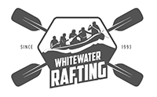

## Colors

**Primary-color:** 06AED5

**Secondary-color:** 4DA167

**Accent1-color:** 086788

**Accent2-color:** 19381F

**Accent3-color:** FAF37A

## Fonts

**Heading-font:** Segwick Ave; Bebas Neue

**Text-font:** Anuphan; Inter

## Color Palette

<https://coolors.co/06aed5-086788-4da167-19381f-faf37a>