REPORT-READY DRAFT
Section 4.5 and Chapter 5 Model Evaluation (Part 1)
NYC Yellow Taxi Zone-Level Hourly Demand Prediction
This document presents the completed model-building method and results for the baseline and enriched Random Forest and XGBoost experiments. All reported values, tables and figures were taken from the executed modelling notebooks. The discussion covers default performance, Bayesian optimisation, the untouched test period, individual taxi-zone performance and low-demand outer-borough zones.

4.5 Model Building
This phase turns the prepared taxi-zone data into a fair model test. Its purpose is to find out whether Random Forest and XGBoost can predict the number of yellow-taxi pickups in each zone and hour. The models are first tested with time and weather information. They are then tested with the added location-based information. Model tuning and final testing are kept separate so that the final results show performance on future hours that were not used to choose the model.

4.5.1 Prediction Task and Unit of Analysis
Each row represents one taxi zone during one hour. The value to predict, pickup_count, is the number of pickups recorded for that zone and hour. The prepared dataset contains 559,181 rows from 259 taxi zones and 2,159 complete hours in the first quarter of 2025. The model produces one predicted pickup count for every zone-hour in the test data.
The final test period covers 18 future days, or 432 consecutive hours. The first test hour is one hour after the training and validation period, while the last is 432 hours after it. The model does not use earlier pickup counts as input. Therefore, it does not feed one prediction into the next. It predicts each future zone-hour from the time, weather and location-based variables available for that hour.

4.5.2 Chronological Data Partitioning
The 2,159 unique hourly timestamps were sorted and divided chronologically into training, validation and testing periods. All 259 zones belonging to a timestamp were assigned to the same partition. This prevents records from one hour being scattered across different partitions and preserves the direction in which a real forecasting model would be applied: earlier observations are used to predict later observations.
Table 4.5.1 Chronological model-development partitions
Partition | Hours | Rows | Share | Period
Training | 1,295 | 335,405 | 59.98% | 1 Jan 2025 00:00 – 23 Feb 2025 22:00
Validation | 432 | 111,888 | 20.01% | 23 Feb 2025 23:00 – 13 Mar 2025 23:00
Testing | 432 | 111,888 | 20.01% | 14 Mar 2025 00:00 – 31 Mar 2025 23:00

The first 60% gives the models most of the rows needed for learning. The next 20% is used to compare different model settings during tuning. The last 20% is kept completely separate until the best setting has been selected. An 80/20 split was not used because the same 20% would then have to be used for both tuning and final reporting. Reusing it would make the reported result look better than performance on truly unseen data. The 60/20/20 split provides one period for learning, one for choosing settings and one for the final test.
LocationID was retained in every saved partition as evaluation metadata but excluded from the predictor matrix. All 259 LocationIDs occur in training, validation and testing, repeating 1,295, 432 and 432 times respectively. This design measures future-hour prediction for already observed taxi zones. It does not claim transfer to completely unseen zones.
Code 4.5.1 Splitting complete hourly blocks in chronological order
unique_hours = np.sort(baseline["pickup_hour"].unique())
train_end = int(len(unique_hours) * 0.60)
validation_end = int(len(unique_hours) * 0.80)

train_hours = unique_hours[:train_end]
validation_hours = unique_hours[train_end:validation_end]
test_hours = unique_hours[validation_end:]
The code first splits the list of unique hours and then uses those hour lists to select rows. It does not randomly split individual zone-hour records. The same hour boundaries are applied to the baseline and enriched datasets, making their later comparison fair.
Figure 4.5.1 summarises the complete model-building logic. It connects preparation, model selection and evaluation in the order in which evidence is produced.
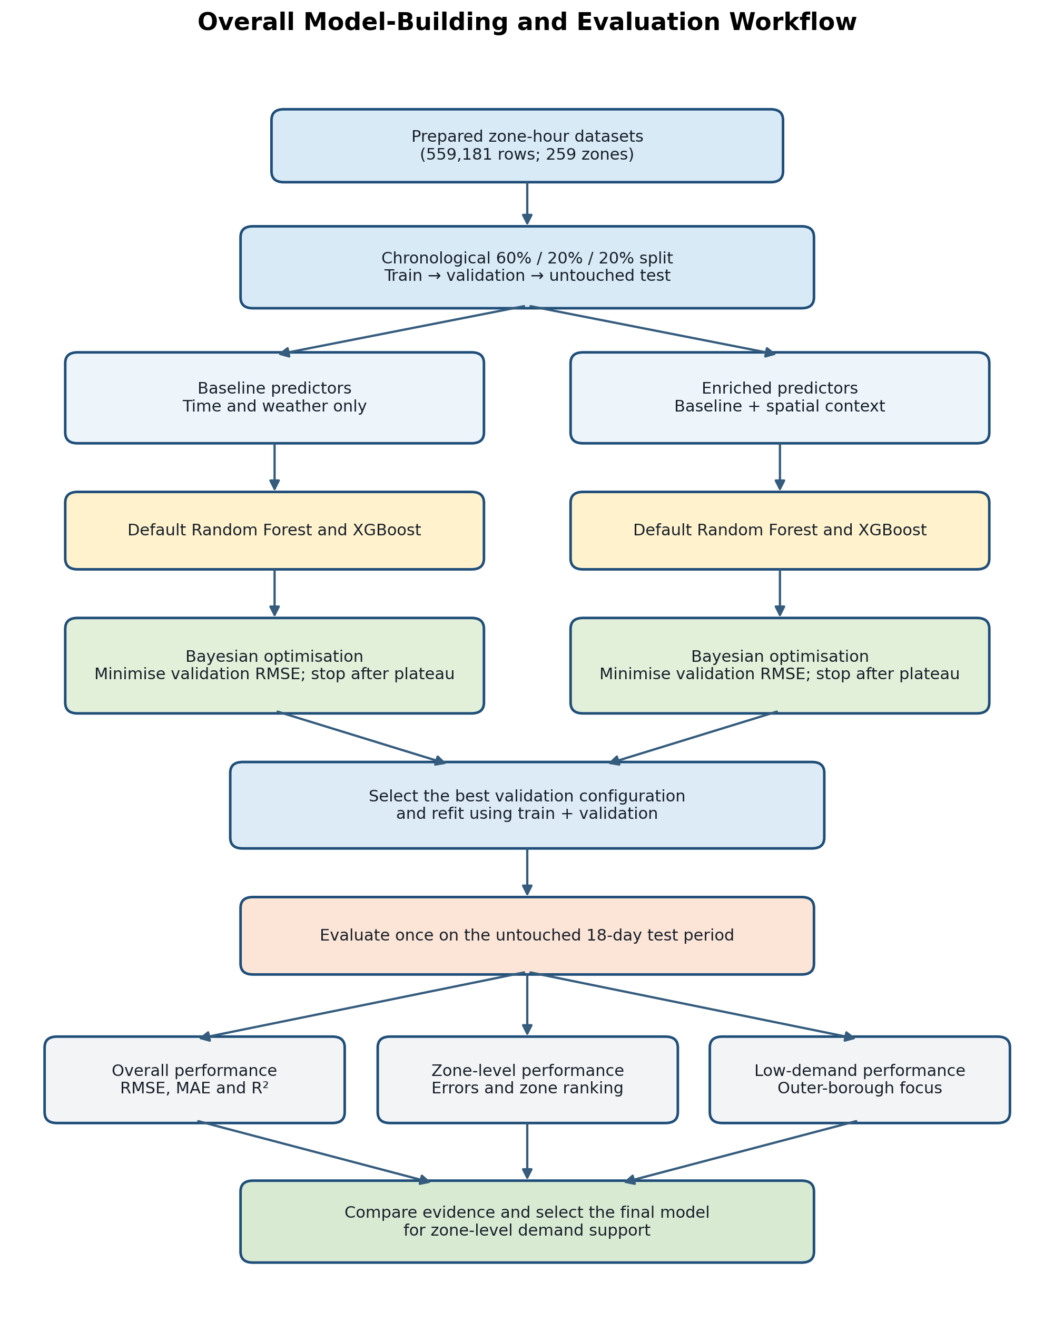
Figure 4.5.1 Overall model-building and evaluation workflow
The workflow has two parallel feature branches but one shared evaluation design. Default models establish an untreated reference. Bayesian optimisation then uses only training and validation information. After a configuration is selected, the model is refitted on the combined training and validation observations and evaluated once on the untouched test period. Overall, zone-level and low-demand evaluations are deliberately placed after testing so that model selection is not influenced by repeated inspection of test results.

4.5.3 Predictor Configurations and Data Preparation
Table 4.5.2 Variables used during model building
Role | Variables | Reason
Baseline predictors | hour; day_of_week; month; temperature_f; precipitation_in | Creates a controlled time-and-weather reference.
Enriched additions | subway_proximity_km; zero_vehicle_household_rate | Adds interpretable spatial and socioeconomic context.
Target | pickup_count | Number of pickups to predict for each zone-hour.
Evaluation metadata | pickup_hour; LocationID; borough; zone | Supports time checks and zone-level reporting; not fitted as predictors.

The same exclusions must be applied to training, validation and testing predictors. Removing LocationID only from the training matrix would create incompatible feature columns at prediction time and would not remove the identifier from the model consistently. Metadata is therefore stored beside the target for evaluation, while the predictor matrices contain only the declared features.
Code 4.5.2 Creating consistent baseline predictor matrices
BASELINE_FEATURES = [
"hour", "day_of_week", "month",
"temperature_f", "precipitation_in"
]
TARGET = "pickup_count"

X_train = training_data[BASELINE_FEATURES]
y_train = training_data[TARGET]
X_validation = validation_data[BASELINE_FEATURES]
X_test = testing_data[BASELINE_FEATURES]

4.5.4 Default Model Construction
Random Forest and XGBoost were selected because taxi demand may change in complex ways across different hours, days, weather conditions and zones. Random Forest builds many different decision trees and averages their predictions. This is usually more stable than relying on one tree. XGBoost builds trees one after another, with each new tree trying to correct the errors left by the earlier trees. Both models are first run with their default settings. These results provide a clear starting point for measuring whether tuning actually helps.
Code 4.5.3 Reproducible Random Forest and XGBoost construction
def build_model(algorithm, parameters=None):
parameters = parameters or {}
if algorithm == "Random Forest":
return RandomForestRegressor(
random_state=RANDOM_STATE, n_jobs=-1, **parameters
)
return XGBRegressor(
objective="reg:squarederror",
tree_method="hist",
random_state=RANDOM_STATE,
n_jobs=-1,
**parameters,
)
A fixed random seed makes repeated runs comparable. The XGBoost squared-error objective matches the continuous regression target, while the histogram tree method reduces computation on the large dataset. No test observations are supplied while these default models or tuning candidates are selected.

4.5.5 Bayesian Hyperparameter Optimisation
Bayesian optimisation was used to choose the model settings. It does not change, delete or resample the saved training, validation or test datasets. Instead, each trial changes the rules used by the model while it learns from the same training rows and the same predictor columns. The trial is then checked on the validation data, and its validation RMSE is recorded.
The first 10 trials used randomly chosen setting combinations. These trials gave the optimiser examples of settings that worked well and settings that worked poorly. After that, a Gaussian-process model studied the completed trials and Expected Improvement was used to choose the next combination that was most likely to reduce RMSE. This is more efficient than a large grid search, which would test every planned combination even when similar settings had already performed poorly.
Validation RMSE was minimised because it gives more weight to large pickup errors. At least 15 trials were required. After trial 15, the search stopped when eight further trials failed to improve the best validation RMSE by at least 0.1%, or when 30 trials had been completed. The best trial was always kept; the final trial was not automatically selected.
Table 4.5.3 How the Random Forest settings use the training data
Setting | Values tested | What it does while learning | Why these values were tested
n_estimators | 80–300 | Builds this many trees from the training rows and averages their pickup predictions. | Tests whether more trees make the result steadier without adding too much running time.
max_depth | 4–18 | Limits how many levels of questions each tree can ask about the predictor values. | Tests simple trees against deeper trees that can learn more detailed patterns.
min_samples_split | 2–30 | A tree node can split only when it contains at least this many training rows. | Stops the model from creating new rules from very small groups of zone-hours.
min_samples_leaf | 1–1,200 (log-scaled) | Each final leaf must contain at least this many training rows. Its prediction is based on those rows. | Tests detailed predictions against smoother predictions based on larger groups of rows.
max_features | 50%–100% | At each split, the tree considers only this share of the available predictor columns. | Tests whether using different feature subsets creates more useful and varied trees.

Table 4.5.4 How the XGBoost settings use the training data
Setting | Values tested | What it does while learning | Why these values were tested
n_estimators | 80–350 | Builds this many trees one after another. Each tree tries to correct earlier errors. | Tests whether more correction steps improve validation RMSE.
learning_rate | 0.01–0.20 (log-scaled) | Reduces or increases how much each new tree can change the current prediction. | Tests slow, careful learning against faster learning that may fit too strongly.
max_depth | 2–8 | Limits the number of levels in each new tree. | Tests simple patterns against more detailed interactions between the predictors.
min_child_weight | 1–500 (log-scaled) | A new branch is kept only when it contains enough combined training information. | Prevents branches based on weak evidence while still allowing useful smaller groups.
subsample | 60%–100% | Uses this share of the training rows to build each tree. | Tests whether changing the rows used by each tree reduces overfitting.
colsample_bytree | 60%–100% | Uses this share of predictor columns when building each tree. | Tests whether different feature subsets improve the boosted model.

Code 4.5.4 Plateau-based stopping while preserving the best trial
if validation_rmse < selected_rmse:
selected_rmse = validation_rmse
selected_parameters = candidate_parameters.copy()

if validation_rmse < meaningful_reference * (1 - 0.001):
meaningful_reference = validation_rmse
non_improving_trials = 0
elif trial_number >= 15:
non_improving_trials += 1

if trial_number >= 15 and non_improving_trials >= 8:
break
This rule does not force the search to stop at exactly 15 trials. Both algorithms receive the same minimum number of trials and the same stopping rule. The search continues while useful improvement is still being found, but it stops after the result has remained almost unchanged for several trials. The setting with the lowest validation RMSE is kept even when it appeared before the final trial.

4.5.6 Controlled Baseline and Enriched Experiments
Two predictor configurations were trained on the same chronological rows. The baseline experiment used hour, day of week, month, temperature and precipitation. The enriched experiment added subway proximity and the zero-vehicle household rate. Keeping the target, partitions, random seed, algorithms and evaluation procedure unchanged means that any baseline-to-enriched difference can be attributed to the added context rather than to a different test period or modelling rule.
Table 4.5.5 Predictor-matrix dimensions used by the two experiments
Dataset | Partition | Predictor shape
Baseline | Training | 335,405 × 5
Baseline | Validation | 111,888 × 5
Baseline | Testing | 111,888 × 5
Enriched | Training | 335,405 × 7
Enriched | Validation | 111,888 × 7
Enriched | Testing | 111,888 × 7
Code 4.5.5 Defining the enriched predictor configuration
ENRICHED_FEATURES = BASELINE_FEATURES + [
"subway_proximity_km",
"zero_vehicle_household_rate"
]

X_train_enriched = training_data[ENRICHED_FEATURES]
X_validation_enriched = validation_data[ENRICHED_FEATURES]
X_test_enriched = testing_data[ENRICHED_FEATURES]
LocationID remained evaluation metadata and was not included in either predictor matrix. The two enriched variables are constant within each zone and therefore provide stable contextual descriptions of known zones. This is appropriate for the project scope, which predicts future hours for the same 259 taxi zones. The results should not be interpreted as proof that the model can transfer unchanged to a completely unseen zone, because that would require a separate spatial hold-out experiment.

4.5.7 Final Refit and Prediction
After the best configuration was chosen from validation RMSE, the corresponding model was rebuilt and fitted to the combined training and validation observations. Combining these two periods makes all pre-test information available for final estimation. The test partition was then predicted once and used for the reported metrics and feature-importance analysis.
Code 4.5.5 Refit on train plus validation and predict the untouched test period
X_train_validation = pd.concat([X_train, X_validation])
y_train_validation = pd.concat([y_train, y_validation])

final_model = build_model(algorithm, best_parameters)
final_model.fit(X_train_validation, y_train_validation)
test_predictions = final_model.predict(X_test)

4.5.8 Saved Predictions and Evaluation Preparation
Each final model produced one prediction for every row in the untouched test partition. The prediction files retained the actual pickup count, predicted pickup count, pickup hour, LocationID, borough and zone. This design allowed the evaluation stage to calculate overall metrics and then group the same predictions by LocationID without retraining the models. It also prevents LocationID from influencing model fitting while preserving the identifier needed to evaluate individual zones.
Code 4.5.7 Creating evaluation-ready prediction records
prediction_records = testing_data[
["pickup_hour", "LocationID", "borough", "zone", "pickup_count"]
].copy()
prediction_records["predicted_pickups"] = test_predictions
Low-demand outer-borough zones were defined from the training period only. The first quartile of mean hourly training demand among Bronx, Brooklyn, Queens and Staten Island zones was 0.2093 pickups per zone-hour. Forty-nine zones at or below this threshold formed the low-demand group. Using training data for the threshold avoids looking at the validation or test outcomes before the final evaluation.
For each LocationID, RMSE, MAE and R² were calculated from its 432 test hours. R² was reported as undefined when the actual pickup count had zero variance, because no within-zone variation existed to explain. A z-score was calculated from zone RMSE values within each model configuration; zones at least two standard deviations above that model's mean RMSE were flagged as unusually high-error planning cases.

4.5.8.1 Zone-Level Diagnostic Separation of Peak and Normal Demand
The unusually high-error flag identifies a zone whose test RMSE is at least two standard deviations above the mean zone RMSE within the same model configuration. A second diagnostic was used to explain where the error occurred. For each LocationID, the actual pickup counts from the combined training and validation periods were used to calculate a zone-specific 90th-percentile demand threshold (P90). The threshold was therefore based only on observations available before the test period and was different for each taxi zone.
A test observation was classified as a peak-demand hour when its actual pickup_count was greater than or equal to that zone's historical P90 threshold. Test observations below the threshold were classified as normal-demand hours. The model did not receive the peak/normal label as a predictor; the classification was used only to divide the saved test predictions for error diagnosis.
For each flagged model-zone combination, RMSE was calculated separately for peak and normal test hours. Peak bias was calculated as the mean of predicted pickups minus actual pickups during the peak hours. A negative peak bias therefore indicates that the model generally underpredicted historically high-demand hours, while a positive value indicates overprediction. The share of total squared error produced by peak hours was also calculated to show whether a relatively small number of high-demand observations contributed disproportionately to the zone RMSE.
The 90th percentile was used as a diagnostic threshold because it identifies the upper part of each zone's historical demand distribution while retaining enough observations for comparison. A single citywide pickup threshold was not used because the normal demand scale differs substantially between taxi zones.
Diagnostic calculations used the same saved test predictions that produced the reported RMSE, MAE and R² values. They explain the remaining errors and do not alter the fitted models or the model-selection results.

4.5.9 Model-Building Summary
The procedure establishes identical chronological partitions, compares default models, tunes only on validation RMSE, refits on all pre-test data and evaluates the test period once. LocationID is retained only for later zone-level reporting. Applying this sequence to both predictor sets allows later differences to be attributed to feature content rather than data partitioning.
CHAPTER 5
RESULTS AND DISCUSSION

5.1 Introduction
This chapter evaluates whether the models provide useful hourly pickup estimates for New York City taxi zones. It first establishes the baseline performance, then measures the contribution of the enriched spatial and socioeconomic variables. The final comparison considers both citywide results and the performance of individual zones, including low-demand outer-borough locations.
The discussion does more than identify the model with the smallest error. Every result is linked to the project. One row represents one taxi zone during one hour, and the model predicts the number of pickups in that row. A useful model should keep its predicted pickup counts close to the real counts in both busy and quiet zones.

5.2 Model Evaluation and Discussion

5.2.1 Evaluation Measures in the Context of Taxi Demand
Three main measures were used. Each one answers a different question, so the three results are discussed together.
- Root Mean Squared Error (RMSE) shows the size of the prediction errors in pickups per zone-hour. Before averaging the errors, it squares them, so large mistakes receive more weight. For example, missing demand by 40 pickups affects RMSE much more than missing it by 4. A lower RMSE is better. In this project, it shows whether the model makes serious mistakes that could lead to too many or too few taxis being expected in a zone.
- Mean Absolute Error (MAE) shows the average number of pickups by which the prediction is wrong. It ignores whether the model predicted too high or too low and uses the size of the difference. A lower MAE is better. For example, an MAE of 28 means that a prediction differs from the real value by about 28 pickups per zone-hour on average.
- R-squared (R²) shows how much of the difference in pickup demand the model can explain when compared with simply using one average pickup value for every row. A higher value is better. An R² of 0.80 would mean that 80% of the differences in pickup counts are explained by the model. A value close to zero means that the model is only slightly better than using the same average value for all zone-hours.
Accuracy usually means the percentage of predictions that are exactly correct, or the percentage placed in the correct category. For this project, the target is a number of pickups rather than a category. If the actual value is 50, predictions of 49 and 10 would both be marked as simply 'incorrect', even though 49 is much closer. The pickup counts could be changed into groups such as low, medium and high demand, but the chosen group boundaries would be subjective and useful numerical detail would be lost. Accuracy was therefore not used because it does not show how far a pickup prediction is from the real value.
Mean Absolute Percentage Error (MAPE) first calculates each error as a percentage of the actual pickup count and then averages those percentages. For example, predicting 2 pickups when the actual value is 1 gives a 100% error, while predicting 101 when the actual value is 100 gives only a 1% error, even though both predictions are wrong by one pickup. When the actual pickup count is zero, the percentage cannot be calculated because it would require division by zero. This dataset contains many zero and very small counts in low-demand zones. MAPE would therefore become undefined for some rows and unfairly large for others. It was not used as a main measure because it could give a misleading view of the zones that are especially important to this study.

5.2.2 Default Baseline Validation Performance
The first comparison trained both models with their default settings and checked their predictions on the validation period. This gives a starting performance result before the Bayesian search tries other settings.
Table 5.1 Default baseline validation performance
Model | RMSE | MAE | R² | Fit time
Random Forest | 56.7443 | 28.1821 | 0.0302 | 36.8149 s
XGBoost | 56.7824 | 28.5934 | 0.0289 | 3.8517 s

Random Forest had a slightly lower validation RMSE and MAE, but its R² was only 0.0013 higher than the XGBoost result. Both R² values were close to zero. This does not mean that the models learned nothing. It means that time and weather alone explained only a small part of the large differences between taxi zones and hours. The almost equal RMSE values also show that changing the algorithm did not solve the lack of location information in the baseline data.

5.2.3 Bayesian Optimisation Behaviour
The convergence charts show the validation RMSE obtained by each candidate and the best value achieved up to that trial. Grey points belong to the initial random warm-up, blue points belong to the Bayesian-guided phase, and the horizontal reference marks the default validation RMSE. A falling best-so-far line indicates that the search has found a better configuration; a flat line indicates that later trials are not improving the selected result.
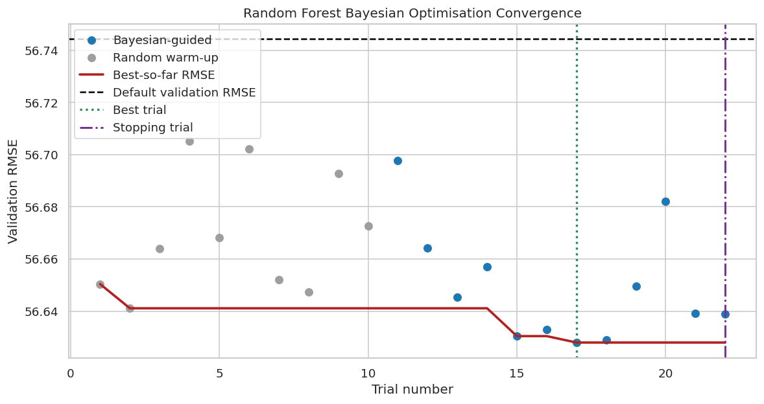
Figure 5.1 Random Forest Bayesian optimisation convergence on the baseline validation period
Random Forest reached its best validation RMSE of 56.628 at trial 17, during the Bayesian-guided phase. This was a 0.205% reduction from the default validation RMSE of 56.744. The following trials did not produce the required 0.1% meaningful improvement, so the search stopped at trial 22. The chart therefore supports the stopping decision: Bayesian guidance found a small improvement, but performance had largely plateaued.
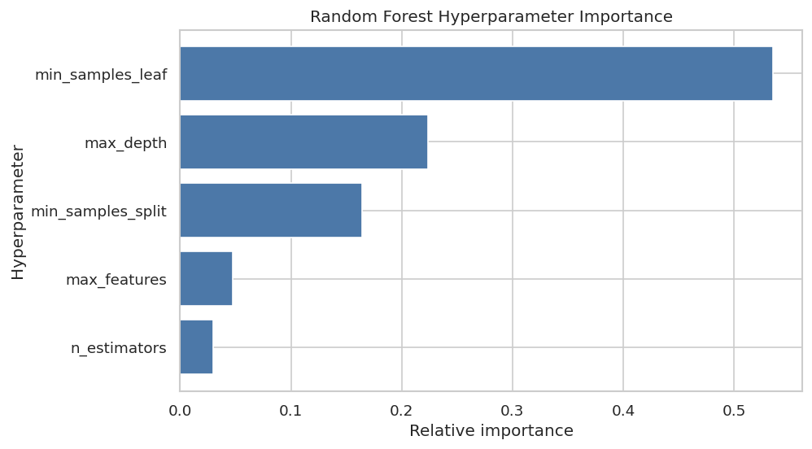
Figure 5.2 Exploratory Random Forest search-parameter importance
In the completed Random Forest trials, min_samples_leaf was most strongly linked with changes in validation RMSE. It was followed by max_depth and min_samples_split. In simple terms, changing how many rows were required in the final leaves and how complex the trees could become mattered more than simply adding more trees. These scores only summarise this search. They do not prove that the same settings will always be the most important on another dataset.
Table 5.2 Selected baseline Random Forest configuration
Item | Selected value
Best trial | 17
n_estimators | 171
max_depth | 9
min_samples_split | 5
min_samples_leaf | 955
max_features | 0.9220
Validation RMSE | 56.6280

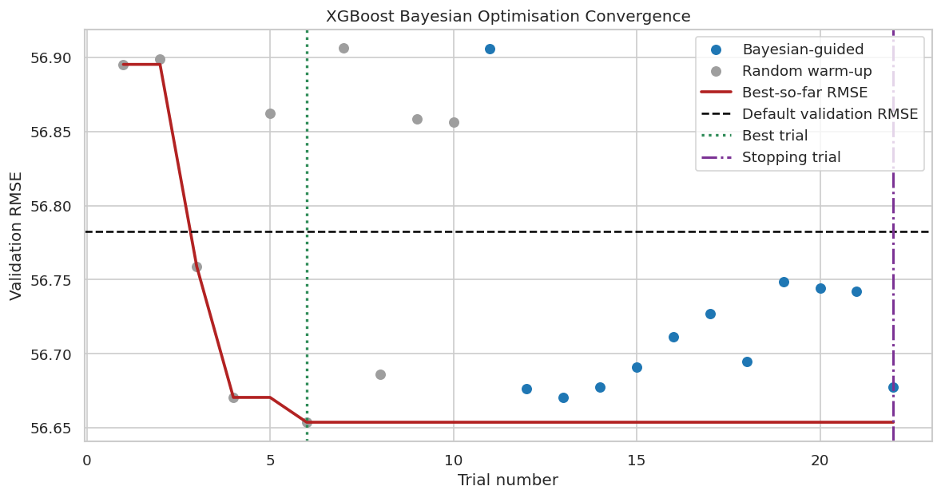
Figure 5.3 XGBoost Bayesian optimisation convergence on the baseline validation period
XGBoost achieved its best validation RMSE of 56.6655 at trial 19, during the Bayesian-guided phase. The later Bayesian-guided trials explored additional combinations but did not surpass that candidate, and the search stopped at trial 22. The 0.227% validation reduction was slightly larger than the Random Forest validation reduction, but the chart shows that it came from an early sampled configuration rather than continued improvement during the guided phase.
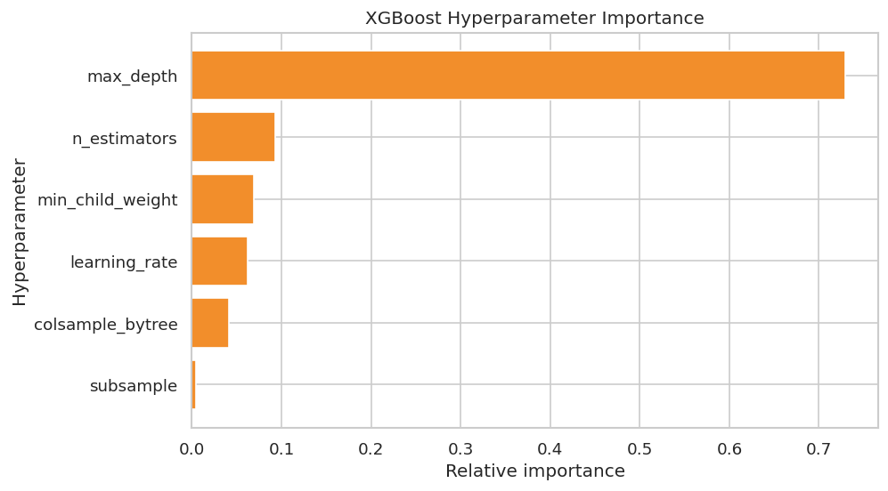
Figure 5.4 Exploratory XGBoost search-parameter importance
Maximum tree depth had the strongest link with validation RMSE in the completed XGBoost trials. This means that changing how detailed each tree could become affected the trial results more than the tested changes to row or feature sampling. Figure 5.4 explains what happened during this search only. It does not prove that maximum depth will always be the most important XGBoost setting.
Table 5.3 Selected baseline XGBoost configuration
Item | Selected value
Best trial | 19
n_estimators | 334
learning_rate | 0.0210
max_depth | 3
min_child_weight | 7.2539
subsample | 0.6038
colsample_bytree | 0.9268
Validation RMSE | 56.6655

5.2.4 Unseen Test Performance: Default versus Tuned
The selected configurations were refitted using the combined training and validation periods and then evaluated once on the untouched 432-hour test period. Table 5.4 provides the exact test results. The separate charts that follow keep RMSE, MAE and R² on their own scales because lower values are better for the two error measures, while higher values are better for R².
Table 5.4 Baseline performance on the untouched test period
Model | Setting | RMSE | MAE | R²
Random Forest | Default | 54.6348 | 28.2677 | 0.0345
Random Forest | Tuned | 54.6256 | 28.2422 | 0.0349
XGBoost | Default | 54.6276 | 28.3391 | 0.0348
XGBoost | Tuned | 54.6447 | 28.3933 | 0.0342

Figure 5.5 compares RMSE, the metric used during optimisation. The purpose is to test whether validation improvements transferred to future data rather than remaining specific to the validation period.
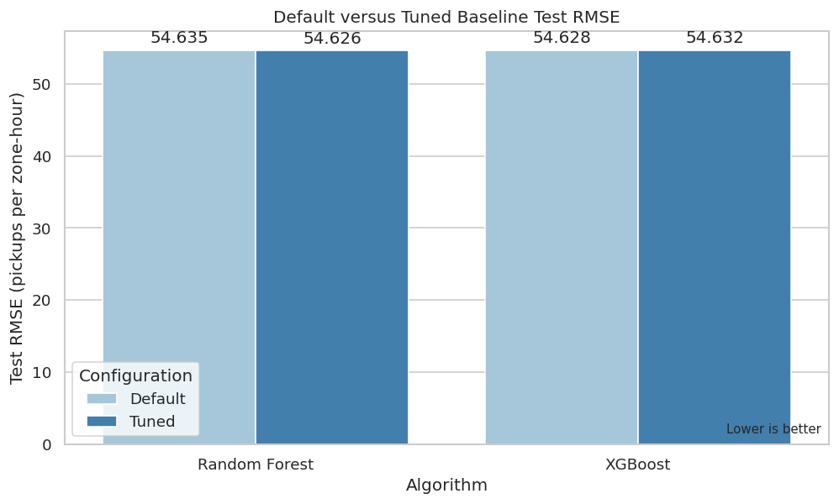
Figure 5.5 Baseline test RMSE before and after tuning
Tuned Random Forest reduced test RMSE by only 0.009 pickups per zone-hour, or 0.0167%. Tuned XGBoost increased RMSE by 0.0171 pickups per zone-hour, meaning that it became 0.0314% worse. These changes are too small to make a practical difference. The result also shows why the final test is needed: XGBoost improved on the validation data, but that improvement did not continue on the unseen test hours.
Figure 5.6 compares MAE so that the typical absolute prediction difference can be interpreted independently from the large-error weighting used by RMSE.
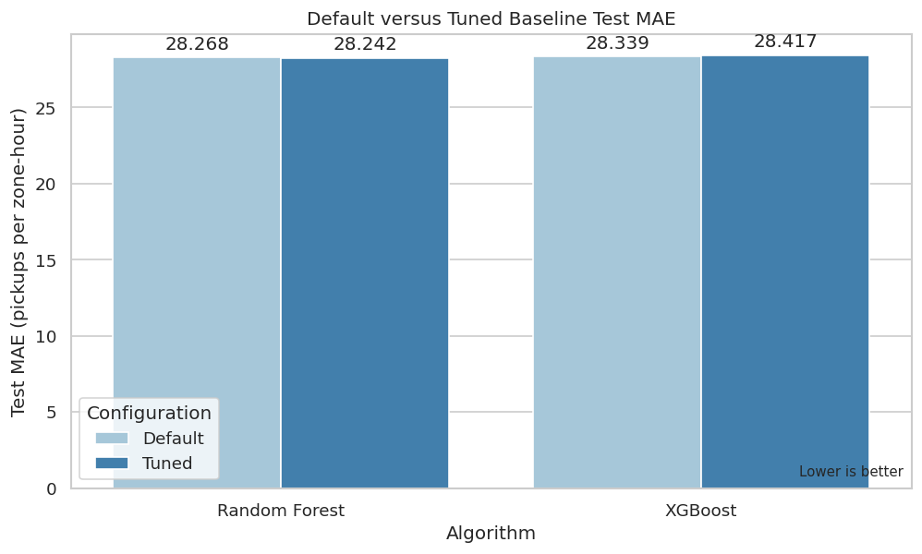
Figure 5.6 Baseline test MAE before and after tuning
Random Forest reduced MAE from 28.268 to 28.242 pickups per zone-hour, a 0.090% reduction. XGBoost increased MAE from 28.3391 to 28.3933, a 0.1914% deterioration. The small scale of these changes confirms that tuning model complexity cannot compensate for spatial information that is absent from the baseline inputs.
Figure 5.7 reports R² separately because it measures explained variation rather than error magnitude.
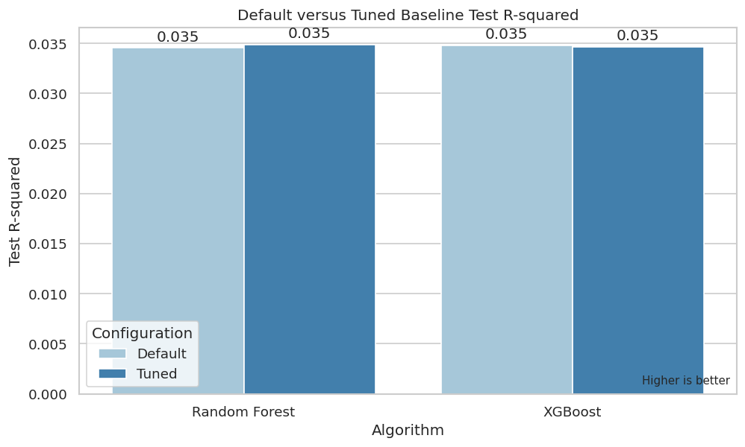
Figure 5.7 Baseline test R² before and after tuning
All four R² values were about 0.035. Tuning increased the Random Forest result by 0.00032 and reduced the XGBoost result by approximately 0.0006. This means that the baseline models explained only about 3.5% of the differences in pickup demand across all zone-hours. During the same hour, every zone has the same time and weather values. Without location information, the model cannot clearly separate a busy Manhattan zone from a quiet outer-borough zone. The low R² therefore gives a useful baseline finding; it does not mean that the algorithms were incorrectly run.

5.2.5 Permutation Feature Importance of the Tuned Baseline Models
Permutation importance checks how much the model needs each feature. One feature is mixed up at a time in the untouched test data while all other columns remain unchanged. The model predicts again, and the increase in RMSE is measured. A large increase means that the model relied strongly on that feature. The mixing process is repeated several times, and the error bars show how much the result changed between repetitions. All baseline features are displayed, including those with little or no effect.
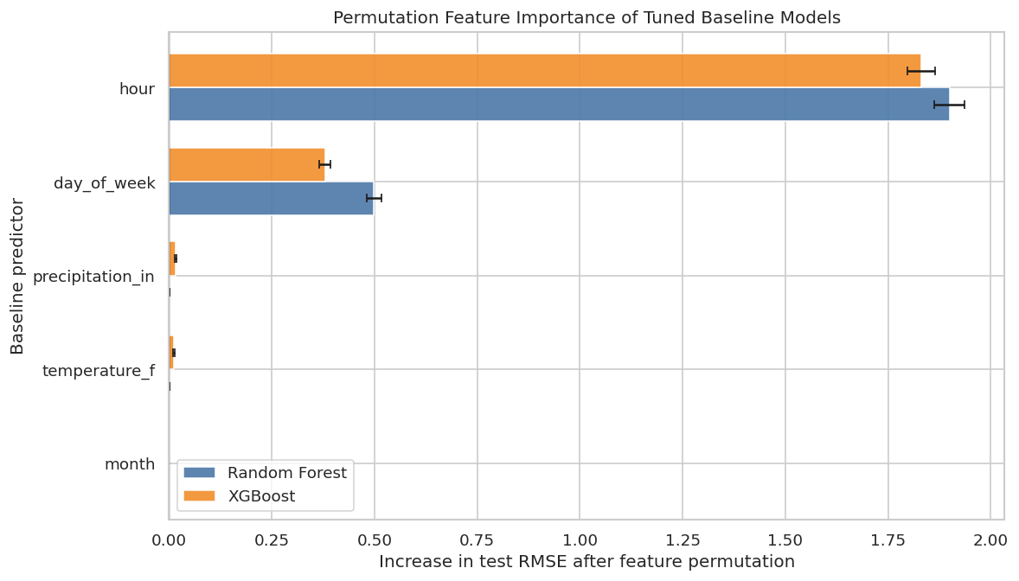
Figure 5.8 Permutation feature importance for all tuned baseline predictors
Hour was the dominant baseline predictor for both algorithms, increasing RMSE by approximately 1.90 for Random Forest and 1.83 for XGBoost when shuffled. Day of week was the second most useful variable, with increases of approximately 0.50 and 0.38. Temperature and precipitation produced very small changes, and month produced no measurable change in either model. This pattern indicates that the baseline models mainly learned the daily and weekly demand cycle. The short first-quarter observation period and the absence of spatial predictors limited the useful contribution of month and weather.

5.2.6 Baseline Evaluation Conclusion
The baseline test shows that both algorithms produced almost the same errors from the time-and-weather inputs. Tuning did not produce a useful improvement on the unseen test hours. Random Forest became only slightly better, while XGBoost became slightly worse. This suggests that the baseline mainly lacks useful location information; testing more setting combinations would not solve that missing-information problem.
Tuned Random Forest has the smallest baseline errors, but the difference is very small (RMSE 54.626; MAE 28.242; R² 0.03486). It will be used as the starting benchmark for checking whether the added location-based features lower test errors and improve predictions across taxi zones.

5.2.7 Default Enriched Validation Performance
The enriched models were first trained with default settings, using exactly the same training and validation periods as the baseline models. This stage tests the value of the two additional contextual predictors before any tuning is applied.
Table 5.5 Default enriched validation performance
Algorithm | Configuration | RMSE | MAE | R2 | Fit seconds
Random Forest | Default | 15.9697 | 4.9194 | 0.9232 | 71.2152
XGBoost | Default | 16.8063 | 6.8176 | 0.9149 | 23.9651
Default enriched Random Forest achieved RMSE 15.9697, MAE 4.9194 and R² 0.9232. Default enriched XGBoost achieved RMSE 16.8063, MAE 6.8176 and R² 0.9149. Both results are much stronger than the baseline validation R² values near 0.03, showing that the two zone-context variables contain information that the time-and-weather baseline does not provide. Random Forest was the stronger default enriched model on all three measures.

5.2.8 Bayesian Optimisation of the Enriched Models
The same Gaussian-process Bayesian optimisation procedure and search spaces were applied to the enriched Random Forest and XGBoost models. This maintains a controlled comparison: tuning was guided only by validation RMSE, the test period remained untouched, and the search stopped after the common plateau rule was reached.
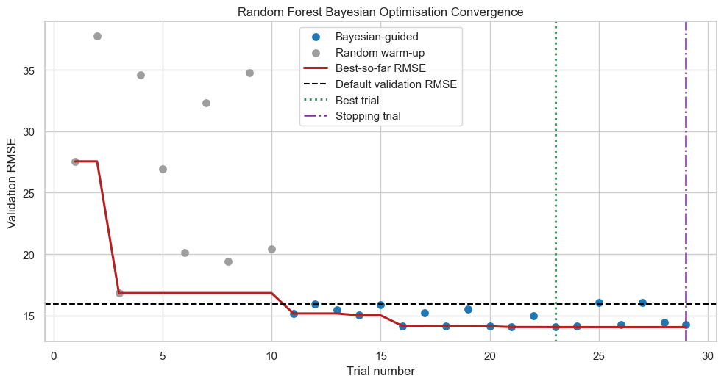
Figure 5.9 Enriched Random Forest Bayesian optimisation convergence
The enriched Random Forest search stopped at trial 29. Its best validation RMSE was 14.0640 at trial 23, an 11.9327% reduction from the default value of 15.9697. The later trials did not produce a meaningful further improvement, so the earlier best configuration was retained.
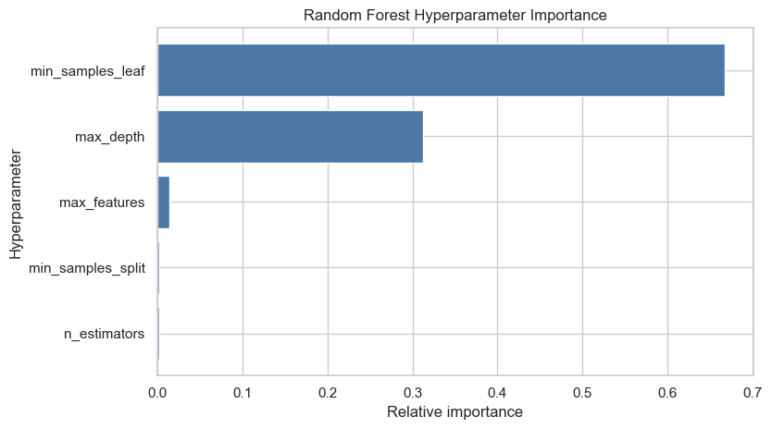
Figure 5.10 Enriched Random Forest search-parameter importance
For enriched Random Forest, min_samples_leaf had the largest exploratory importance (0.6670), followed by max_depth (0.3124). These parameters control how specific each leaf may become and therefore had the strongest relationship with validation RMSE during the completed search.
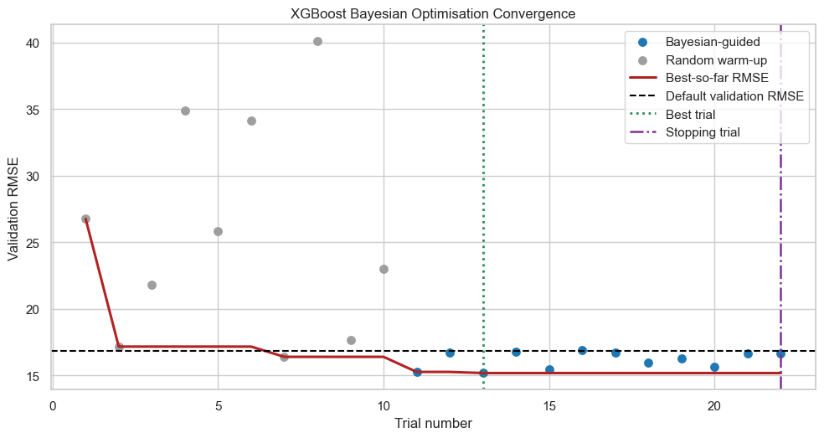
Figure 5.11 Enriched XGBoost Bayesian optimisation convergence
The enriched XGBoost search stopped at trial 22. Its best validation RMSE was 15.1656 at trial 13, a 9.7624% reduction from 16.8063. The best trial occurred before the stopping point, demonstrating why the procedure preserved the best configuration rather than using the final trial automatically.
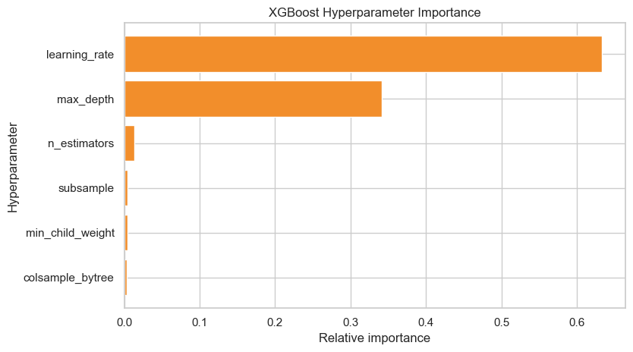
Figure 5.12 Enriched XGBoost search-parameter importance
Learning rate had the strongest relationship with XGBoost validation RMSE (0.6329), followed by max_depth (0.3419). The result is consistent with boosting behaviour: learning rate controls the size of each correction, while tree depth controls the complexity of the correction.
Table 5.6 Enriched validation improvement selected by Bayesian optimisation
Algorithm | Default validation RMSE | Best validation RMSE | Best trial | Stopping trial | Validation RMSE reduction (%)
Random Forest | 15.9697 | 14.0640 | 23 | 29 | 11.9327
XGBoost | 16.8063 | 15.1656 | 13 | 22 | 9.7624
Table 5.6 confirms that Bayesian optimisation found lower validation RMSE values for both enriched algorithms. Random Forest achieved the larger validation reduction (11.9327%), while XGBoost improved by 9.7624%. These are model-selection results rather than final performance claims because the settings were chosen using the validation period. Their usefulness must therefore be confirmed on the untouched test period.

5.2.9 Unseen Enriched Test Performance: Default versus Tuned
After validation selection, each chosen configuration was refitted on the combined training and validation rows and evaluated once on the untouched 432-hour test period. This test determines whether the validation gain transferred to later data.
Table 5.7 Enriched model performance on the untouched test period
Model | RMSE | MAE | R2 | Fit seconds
Random Forest (Default) | 11.5477 | 3.8465 | 0.9569 | 42.0671
Random Forest (Tuned) | 11.9725 | 3.9007 | 0.9536 | 112.5366
XGBoost (Default) | 13.3107 | 5.2677 | 0.9427 | 2.3367
XGBoost (Tuned) | 12.0126 | 4.4925 | 0.9533 | 11.3071
Table 5.7 shows that default enriched Random Forest produced the strongest aggregate test result: RMSE 11.5477, MAE 3.8465 and R² 0.9569. Tuning helped XGBoost substantially, reducing its RMSE from 13.3107 to 12.0126 and its MAE from 5.2677 to 4.4925. However, tuning did not improve Random Forest on the aggregate test set; its RMSE increased from 11.5477 to 11.9725. This indicates that the validation-optimal Random Forest settings did not transfer perfectly to the later test period.
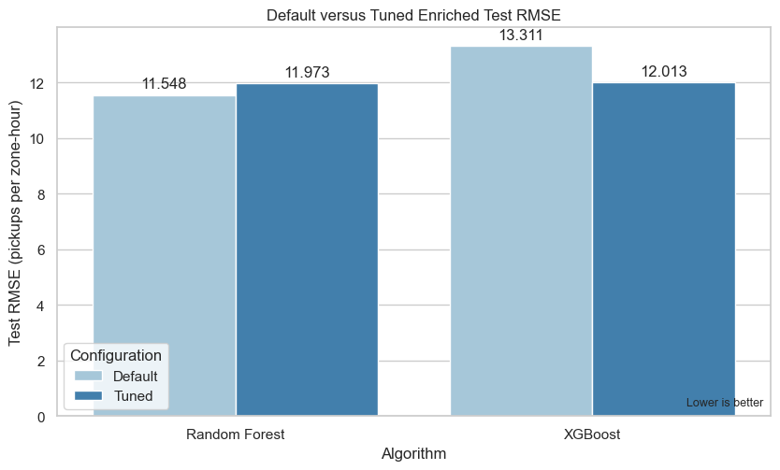
Figure 5.13 Enriched test RMSE before and after tuning
Figure 5.13 compares the size of larger prediction errors because RMSE gives extra weight to large misses. Default Random Forest has the shortest bar and is therefore the best aggregate model on this measure. The Random Forest bar becomes slightly taller after tuning, showing a 3.6788% deterioration. In contrast, the XGBoost tuned bar is clearly shorter than its default bar, showing a 9.7519% improvement. The chart therefore shows that Bayesian tuning benefited XGBoost but did not improve Random Forest's citywide test RMSE.
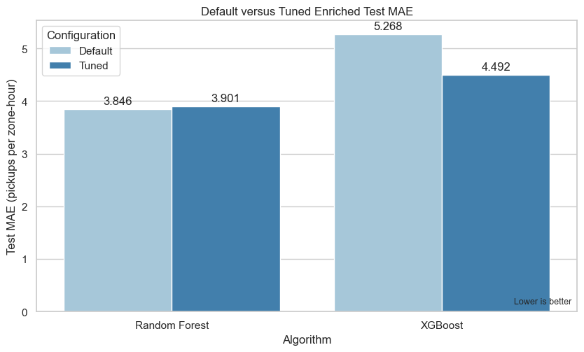
Figure 5.14 Enriched test MAE before and after tuning
Figure 5.14 shows the typical absolute difference between predicted and actual pickups. Default Random Forest again has the lowest value, meaning that its predictions were wrong by the fewest pickups on average across all test rows. Tuned Random Forest is slightly worse, whereas tuned XGBoost reduces MAE by 14.7159%. The result supports the RMSE pattern and confirms that XGBoost's tuning gain was not limited to a few extreme errors.
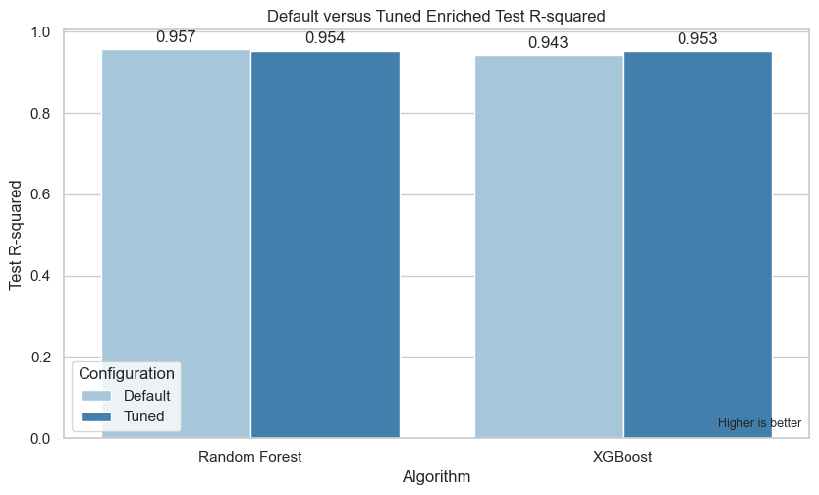
Figure 5.15 Enriched test R² before and after tuning
Figure 5.15 reports explained variation, where a taller bar is better. All enriched models explain more than 94% of the overall variation in test demand. Default Random Forest is highest at 0.9569. Tuning raises XGBoost from 0.9427 to 0.9533, bringing it close to Random Forest, but lowers Random Forest slightly to 0.9536. This confirms that default enriched Random Forest is the strongest model for overall test performance.
Tuning affected the two algorithms differently. Tuned XGBoost improved RMSE by 9.7519%, MAE by 14.7159% and R² by 0.0106 compared with default XGBoost. In contrast, tuned Random Forest produced a 3.6788% higher RMSE, a 1.4088% higher MAE and a 0.0032 lower R² than default Random Forest. Therefore, the best validation setting did not guarantee the best aggregate test result. Default enriched Random Forest remained the strongest citywide model, with RMSE 11.5477, MAE 3.8465 and R² 0.9569.

5.2.10 Permutation Feature Importance of the Enriched Models
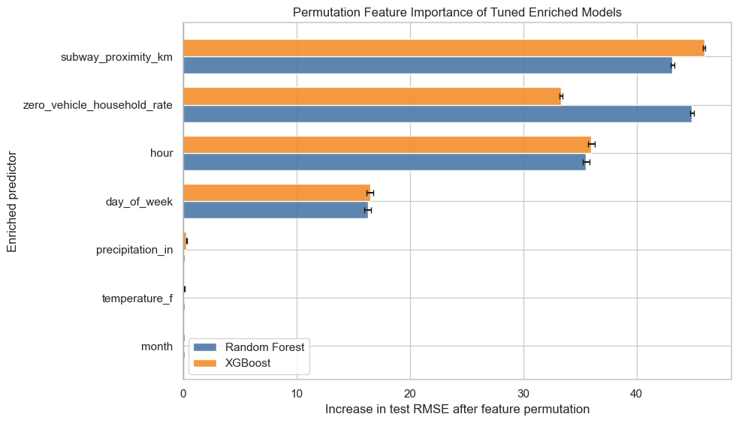
Figure 5.16 Permutation importance for all enriched predictors
Table 5.8 Enriched test permutation importance
Model | Feature | RMSE increase | Standard deviation
Random Forest | zero_vehicle_household_rate | 44.8898 | 0.1844
Random Forest | subway_proximity_km | 43.1528 | 0.1619
Random Forest | hour | 35.5436 | 0.2932
Random Forest | day_of_week | 16.2837 | 0.2779
Random Forest | temperature_f | 0.0283 | 0.0065
Random Forest | precipitation_in | 0.0278 | 0.0090
Random Forest | month | 0.0000 | 0.0000
XGBoost | subway_proximity_km | 45.9699 | 0.0990
XGBoost | hour | 36.0062 | 0.3097
XGBoost | zero_vehicle_household_rate | 33.3559 | 0.1437
XGBoost | day_of_week | 16.4910 | 0.3174
XGBoost | precipitation_in | 0.3064 | 0.0193
XGBoost | temperature_f | 0.1011 | 0.0266
XGBoost | month | 0.0000 | 0.0000
The two added contextual predictors dominated the enriched models. For Random Forest, shuffling the zero-vehicle household rate increased RMSE by 44.8898 and shuffling subway proximity increased it by 43.1528. For XGBoost, subway proximity produced the largest increase (45.9699), followed by hour (36.0062) and the zero-vehicle household rate (33.3559). This explains the large enriched performance gain, but it also requires careful interpretation: both contextual values are constant within each zone and can act as stable zone signatures. The finding supports prediction for future hours in the known zones; it does not establish generalisation to zones whose spatial profiles were never observed during training.
Figure 5.16 and Table 5.8 show the practical effect of each predictor by measuring how much test RMSE rises when that feature is randomly disrupted. Large increases mean that the model depends strongly on that information. The dominance of subway proximity and zero-vehicle household rate explains why enrichment made such a large difference, while hour and day of week remain important for the temporal pattern within each zone. Temperature, precipitation and month add comparatively little during this particular test period.

5.2.11 Overall Baseline and Enriched Test Comparison
Before comparison, baseline and enriched prediction files were aligned by pickup hour and LocationID. Each contained 111,888 rows, 259 taxi zones and the same 432 test hours from 14 to 31 March 2025. This confirms that the models were compared on identical observations.
Table 5.9 Overall performance of all eight model configurations
Dataset | Algorithm | Configuration | RMSE | MAE | R2
Baseline | Random Forest | Default | 54.6348 | 28.2677 | 0.0345
Baseline | Random Forest | Tuned | 54.6256 | 28.2422 | 0.0349
Baseline | XGBoost | Default | 54.6276 | 28.3391 | 0.0348
Baseline | XGBoost | Tuned | 54.6447 | 28.3933 | 0.0342
Enriched | Random Forest | Default | 11.5477 | 3.8465 | 0.9569
Enriched | Random Forest | Tuned | 11.9725 | 3.9007 | 0.9536
Enriched | XGBoost | Default | 13.3107 | 5.2677 | 0.9427
Enriched | XGBoost | Tuned | 12.0126 | 4.4925 | 0.9533
Table 5.9 provides the direct overall comparison. The four baseline models remain close to RMSE 54.6, MAE 28.2–28.4 and R² 0.034, so neither algorithm nor tuning could compensate for the limited baseline predictors. Every enriched model is substantially better. Among all eight configurations, default enriched Random Forest has the lowest RMSE and MAE and the highest R².
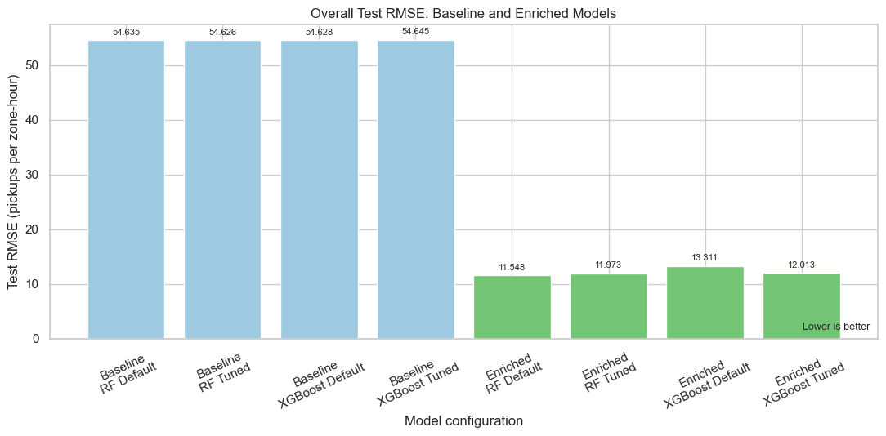
Figure 5.17 Overall test RMSE across baseline and enriched models
Figure 5.17 shows a large separation between the baseline and enriched bars. Baseline RMSE stays around 54.6 pickups per zone-hour, whereas enriched RMSE falls to approximately 11.5–13.3. Default enriched Random Forest is lowest at 11.5477. The scale of the reduction shows that adding zone context had a much larger effect than changing hyperparameters.
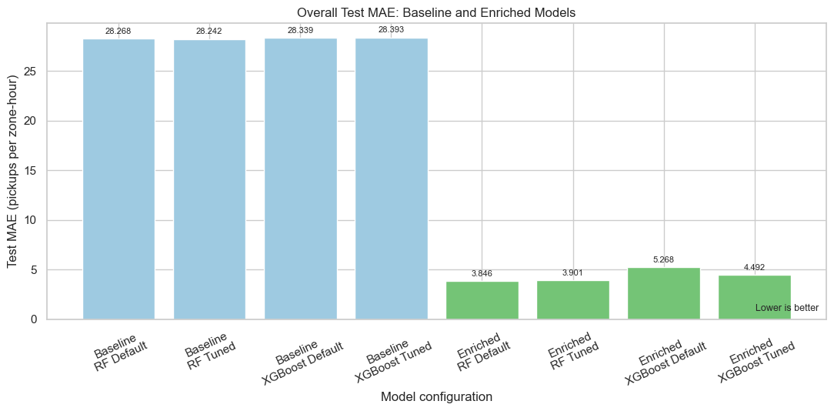
Figure 5.18 Overall test MAE across baseline and enriched models
Figure 5.18 shows the same conclusion for typical absolute error. Baseline MAE is above 28 pickups, while the enriched models reduce it to approximately 3.8–5.3 pickups. Default enriched Random Forest is again best at 3.8465. This means its typical citywide prediction error is the smallest among the tested models.
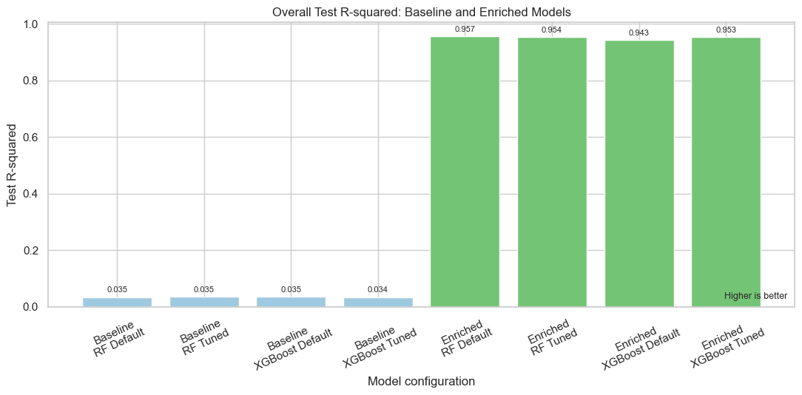
Figure 5.19 Overall test R² across baseline and enriched models
Figure 5.19 shows that the baseline models explain only about 3.4% of overall demand variation, while the enriched models explain approximately 94.3%–95.7%. Default enriched Random Forest has the highest R² of 0.9569. The chart confirms that the enriched variables allow the models to distinguish the different demand levels of known taxi zones rather than applying nearly the same prediction across locations.
Table 5.10 Improvement from each baseline model to its matching enriched model
Algorithm | Configuration | RMSE reduction (%) | MAE reduction (%) | R² change
Random Forest | Default | 78.8638 | 86.3927 | 0.9223
Random Forest | Tuned | 78.0826 | 86.1885 | 0.9188
XGBoost | Default | 75.6338 | 81.4119 | 0.9079
XGBoost | Tuned | 78.0168 | 84.1776 | 0.9191
Table 5.10 quantifies the gain visible in Figures 5.17–5.19. Depending on the matched configuration, enrichment reduces RMSE by 75.6338%–78.8638% and MAE by 81.4119%–86.3927%. The largest matched aggregate gain occurs for default Random Forest. The result demonstrates that predictor enrichment, rather than tuning alone, produced the main improvement in overall prediction quality.
Every enriched configuration substantially outperformed its matching baseline. RMSE fell by 75.6338% to 78.8638%, while MAE fell by 81.4119% to 86.3927%. The largest aggregate improvement was produced by default Random Forest. These changes are large enough to show that the model's useful predictive information came mainly from enrichment rather than from hyperparameter tuning.
Overall-performance conclusion. Default enriched Random Forest is the best model for aggregate citywide performance because it records the lowest overall RMSE (11.5477), the lowest MAE (3.8465) and the highest R² (0.9569). Tuned enriched XGBoost is competitive, but it does not exceed the default enriched Random Forest on any of the three overall measures.

5.2.12 Individual Taxi-Zone Performance
Overall metrics combine all 111,888 test rows and can be dominated by high-demand locations. To meet the first objective, the same predictions were grouped by LocationID and evaluated over each zone's 432 test hours. Median zone metrics describe the typical zone, while the number of negative R² zones shows how often a model performed worse than predicting that zone's test-period mean.
Table 5.11 Summary of individual-zone test performance
Dataset | Algorithm | Configuration | Zones | Median RMSE | Median MAE | Median R² | Negative R² zones | Undefined R² zones
Baseline | Random Forest | Default | 259 | 21.1689 | 18.3861 | -136.5213 | 242 | 6
Baseline | Random Forest | Tuned | 259 | 21.2021 | 18.3368 | -136.9854 | 242 | 6
Baseline | XGBoost | Default | 259 | 21.3293 | 18.5025 | -138.5460 | 242 | 6
Baseline | XGBoost | Tuned | 259 | 20.9118 | 18.5533 | -132.5475 | 243 | 6
Enriched | Random Forest | Default | 259 | 1.5402 | 1.1110 | 0.1829 | 76 | 6
Enriched | Random Forest | Tuned | 259 | 1.5239 | 1.0920 | 0.2294 | 28 | 6
Enriched | XGBoost | Default | 259 | 2.6911 | 1.8730 | -0.2048 | 159 | 6
Enriched | XGBoost | Tuned | 259 | 2.3575 | 1.5962 | -0.0716 | 141 | 6
Table 5.11 changes the evaluation unit from all rows together to the typical taxi zone. Baseline median zone RMSE remains around 21 pickups and more than 240 zones have negative R². Enrichment greatly reduces the median errors. Tuned enriched Random Forest has the lowest median zone RMSE (1.5239), the lowest median zone MAE (1.0920), the highest median zone R² (0.2294) and only 28 negative-R² zones. It is therefore the strongest model for consistent performance across individual locations.
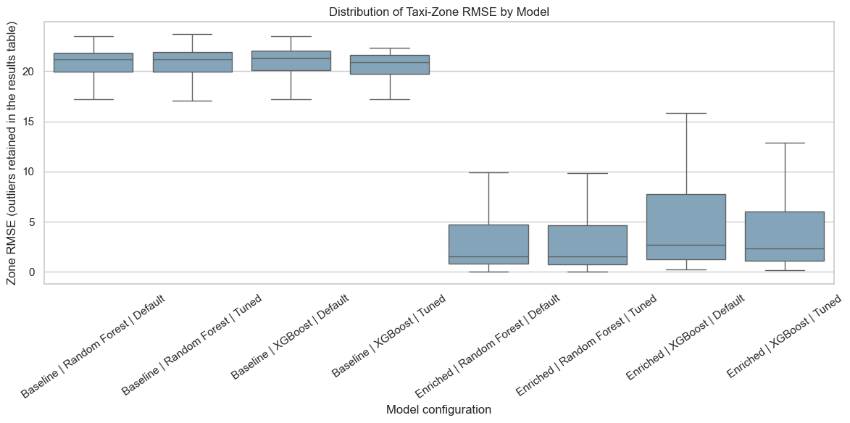
Figure 5.20 Distribution of taxi-zone RMSE by model configuration
Figure 5.20 displays how zone RMSE values are distributed rather than reporting only one citywide average. The baseline distributions are much higher, showing that weak baseline performance occurs across many zones. The enriched Random Forest boxes are lowest and most concentrated around small errors. Tuning slightly lowers the Random Forest median from 1.5402 to 1.5239, although its mean zone RMSE rises from 5.8107 to 5.9429. This means tuning improves the typical zone but does not reduce every large-error case in the upper tail.
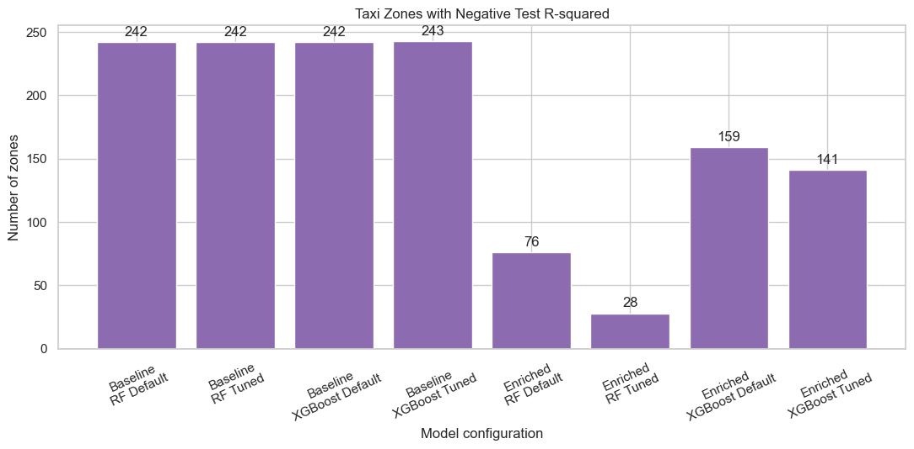
Figure 5.21 Number of taxi zones with negative R²
Figure 5.21 counts zones where the model performs worse than using that zone's average test demand. The tuned enriched Random Forest bar is lowest at 28 zones, compared with 76 for default enriched Random Forest, 159 for default enriched XGBoost and 141 for tuned enriched XGBoost. This is the clearest evidence that Random Forest tuning improves reliability across individual taxi zones even though it slightly worsens aggregate RMSE.
Table 5.12 Matched zone-level improvement after enrichment
Algorithm | Configuration | Zones | Improved zones | Median RMSE reduction | Median RMSE reduction (%) | Median R² change | Improved zones (%)
Random Forest | Default | 259 | 259 | 20.0329 | 92.5164 | 136.7117 | 100.0000
Random Forest | Tuned | 259 | 259 | 20.0718 | 92.5225 | 137.0601 | 100.0000
XGBoost | Default | 259 | 258 | 19.3403 | 86.7569 | 133.0017 | 99.6139
XGBoost | Tuned | 259 | 259 | 19.1236 | 88.4416 | 132.5142 | 100.0000
Table 5.12 shows that enrichment improved all 259 zones for both Random Forest configurations and tuned XGBoost. Default XGBoost improved 258 zones, leaving only one zone without improvement. Median RMSE reductions range from 86.7569% to 92.5225%, confirming that the improvement is widespread rather than being produced only by a few high-demand Manhattan zones.
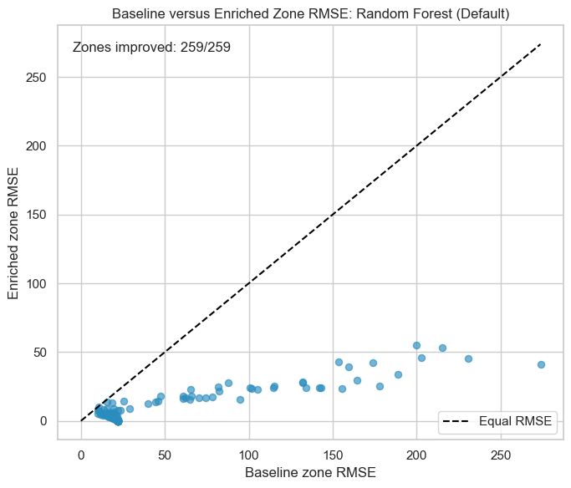
Figure 5.22 Baseline versus enriched zone RMSE for Random Forest default
Figure 5.22 interpretation. Every point represents one taxi zone. All 259 points fall below the equality line, meaning default enriched Random Forest has lower RMSE than its baseline counterpart in every zone. The median zone reduction is 20.0329 pickups, or 92.5164%.
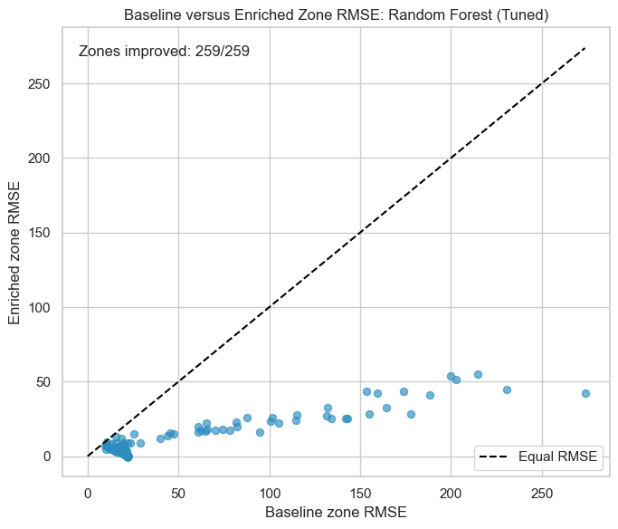
Figure 5.23 Baseline versus enriched zone RMSE for Random Forest tuned
Figure 5.23 interpretation. All 259 points again fall below the equality line. Tuned enriched Random Forest produces the largest median percentage reduction, 92.5225%, and the smallest median zone RMSE of all configurations. This supports it as the strongest individual-zone model.
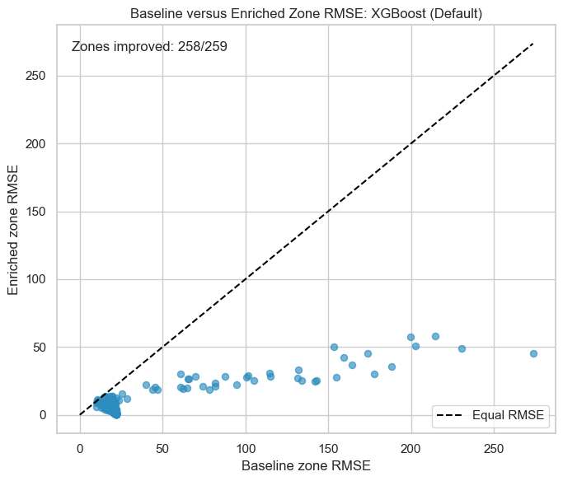
Figure 5.24 Baseline versus enriched zone RMSE for XGBoost default
Figure 5.24 interpretation. A total of 258 of 259 points fall below the equality line. Default enriched XGBoost therefore improves almost every zone, but one zone does not improve. Its median percentage reduction of 86.7569% is smaller than the Random Forest reductions.
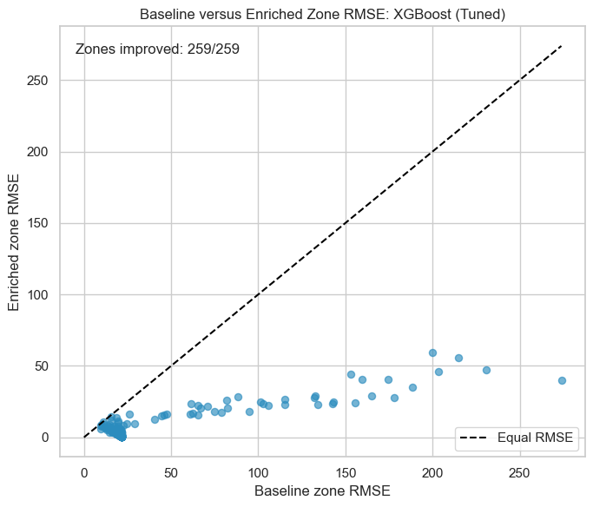
Figure 5.25 Baseline versus enriched zone RMSE for XGBoost tuned
Figure 5.25 interpretation. All 259 points fall below the equality line after XGBoost tuning, so the tuned enriched model removes the one non-improving zone seen under default XGBoost. Nevertheless, its median zone RMSE of 2.3575 and 141 negative-R² zones remain weaker than tuned enriched Random Forest.
Enrichment improved all 259 zones for both Random Forest configurations and tuned XGBoost; default XGBoost improved 258 of 259 zones. Tuned enriched Random Forest produced the best typical-zone results: median zone RMSE 1.5239, median zone MAE 1.0920 and median zone R² 0.2294. It also reduced the number of negative-R² zones to 28, compared with 76 for default enriched Random Forest and more than 140 for either enriched XGBoost model. This is why model selection cannot rely only on aggregate RMSE.
Individual-zone conclusion. Tuned enriched Random Forest performs best for individual taxi-zone prediction. It has the lowest median zone RMSE and MAE, the highest median zone R² and the fewest negative-R² zones. Default enriched Random Forest remains slightly better for overall citywide error, but the tuned model is more consistent across the 259 locations and therefore better matches the first project objective.

5.2.13 Low-Demand Outer-Borough Performance
The second objective focuses on zones where demand is low and prediction is operationally difficult. The training-only first-quartile rule identified 49 outer-borough zones. Each contributed 432 test observations, giving 21,168 low-demand zone-hour records. The threshold was not recalculated from the test period, so the group definition remained independent of final model performance.
Table 5.13 Pooled test performance for low-demand outer-borough zones
Dataset | Algorithm | Configuration | Zones | Observations | RMSE | MAE | R²
Baseline | Random Forest | Default | 49 | 21168 | 21.8040 | 19.1251 | -3673.6136
Baseline | Random Forest | Tuned | 49 | 21168 | 21.8315 | 19.0940 | -3682.9169
Baseline | XGBoost | Default | 49 | 21168 | 21.9651 | 19.2211 | -3728.1213
Baseline | XGBoost | Tuned | 49 | 21168 | 21.5524 | 19.3223 | -3589.3198
Enriched | Random Forest | Default | 49 | 21168 | 0.3632 | 0.1606 | -0.0198
Enriched | Random Forest | Tuned | 49 | 21168 | 0.3403 | 0.1567 | 0.1052
Enriched | XGBoost | Default | 49 | 21168 | 1.3334 | 0.7495 | -12.7428
Enriched | XGBoost | Tuned | 49 | 21168 | 1.1096 | 0.5279 | -8.5167
Table 5.13 combines all 21,168 test observations from the 49 low-demand zones. The baseline models produce RMSE above 21 pickups, which is extremely large compared with the small actual demand in these areas. Tuned enriched Random Forest is best, with RMSE 0.3403, MAE 0.1567 and a positive R² of 0.1052. It is the only configuration in this pooled comparison that clearly improves on the default enriched Random Forest across all three measures.

Table 5.14 Typical individual-zone performance within the low-demand group
Dataset | Algorithm | Configuration | Zones | Median RMSE | Median MAE | Median R² | Negative R² zones | Undefined R² zones
Baseline | Random Forest | Default | 49 | 21.8513 | 19.1820 | -5827.4901 | 43 | 6
Baseline | Random Forest | Tuned | 49 | 21.8781 | 19.1510 | -5841.9667 | 43 | 6
Baseline | XGBoost | Default | 49 | 22.0124 | 19.2764 | -5913.6282 | 43 | 6
Baseline | XGBoost | Tuned | 49 | 21.6014 | 19.3797 | -5693.6129 | 43 | 6
Enriched | Random Forest | Default | 49 | 0.2298 | 0.0994 | -0.1733 | 40 | 6
Enriched | Random Forest | Tuned | 49 | 0.2123 | 0.1019 | 0.0035 | 19 | 6
Enriched | XGBoost | Default | 49 | 0.8464 | 0.6504 | -10.7728 | 43 | 6
Enriched | XGBoost | Tuned | 49 | 0.6936 | 0.4497 | -6.8932 | 42 | 6
Table 5.14 confirms that the pooled result is also visible at the individual-zone level. Tuned enriched Random Forest has the lowest median RMSE (0.2123), a median R² close to zero but positive (0.0035), and reduces the negative-R² count from 40 to 19. Six zones have undefined R² because their actual demand does not vary during the test period; their RMSE and MAE remain valid for evaluation.
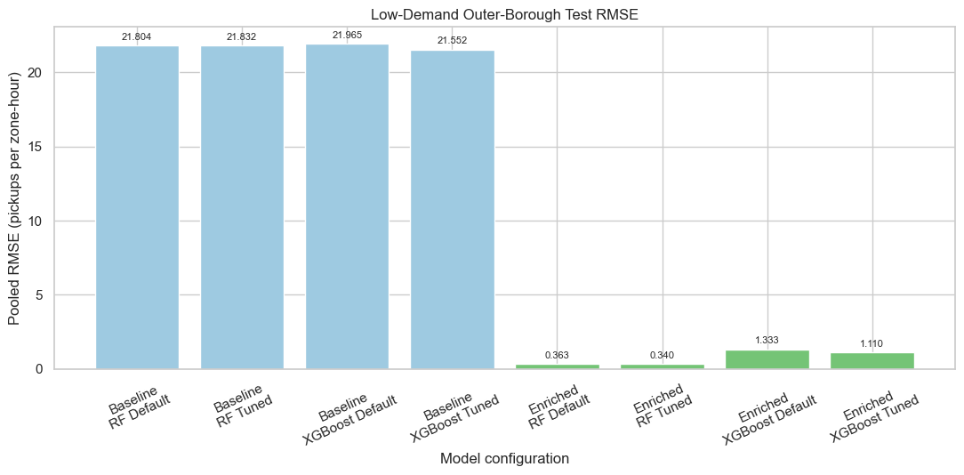
Figure 5.26 Pooled RMSE for low-demand outer-borough zones
Figure 5.26 makes the low-demand difference visible. All baseline bars are above 21, while the enriched bars are below 1.4. Tuned enriched Random Forest has the shortest bar at 0.3403, followed by default enriched Random Forest at 0.3632. Tuning also improves XGBoost from 1.3334 to 1.1096, but its errors remain more than three times those of tuned Random Forest.
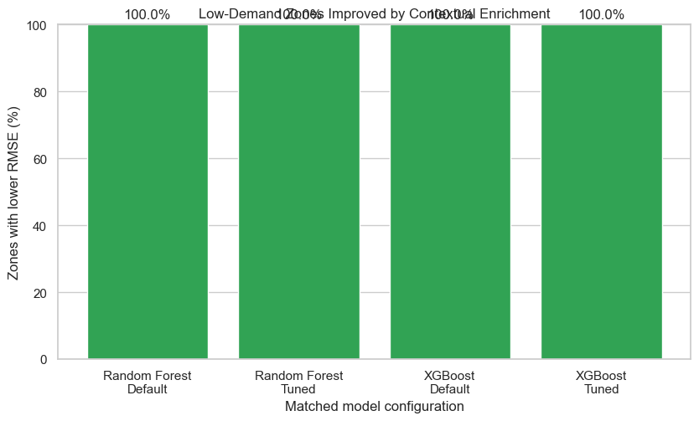
Figure 5.27 Percentage of low-demand zones improved by enrichment
Figure 5.27 shows 100% improvement for all four matched comparisons. This means every one of the 49 low-demand outer-borough zones has lower RMSE after enrichment, regardless of algorithm or tuning status. The result is important because it demonstrates broad improvement across the target group rather than an average gain caused by only a few zones.

5.2.13.1 Why R² Remains Difficult in Low-Demand Zones
The low-demand group has a different error pattern from the busy zones that produce the largest RMSE values. These 49 zones are dominated by zero-pickup hours. The median training zone records zero pickups in 97.99% of hours, while the median test zone records zero pickups in 96.30% of hours. The typical low-demand zone therefore has only 26 non-zero training hours out of 1,295 and 16 non-zero test hours out of 432. This means that the absolute target values are very small and the amount of within-zone variation is limited.
Table 5.15 summarises the target sparsity that remains after the low-demand zones are selected from the training period. The statistics are calculated from the actual pickup_count values rather than from model predictions.
Table 5.15 Target sparsity evidence for the low-demand outer-borough zones
Diagnostic | Observed result
Low-demand outer-borough zones | 49
Median training mean demand | 0.0201 pickups/hour
Median test mean demand | 0.0394 pickups/hour
Median training zero-demand share | 97.99%
Median test zero-demand share | 96.30%
Median non-zero training hours | 26 of 1,295
Median non-zero test hours | 16 of 432
Zones with at least 90% zero hours in training | 39 of 49
Zones with at least 90% zero hours in testing | 32 of 49
Negative-R² zones, tuned enriched RF | 19
Undefined-R² zones, tuned enriched RF | 6
Figure 5.28 shows the test zero-demand percentage for every one of the 49 zones. The chart is intentionally zone-level rather than an overall average so that the concentration of zero observations can be seen across the whole target group.
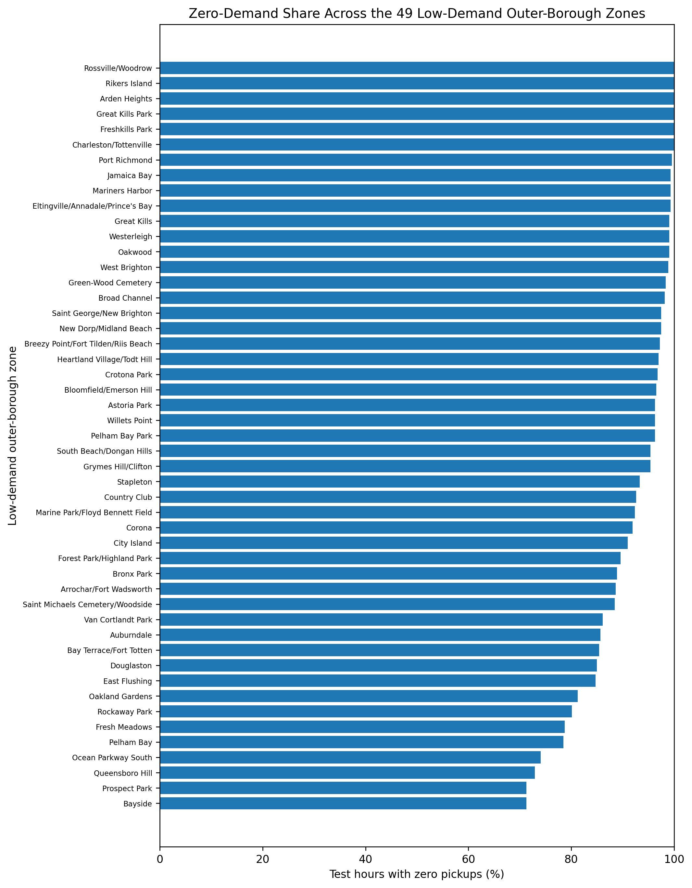
Figure 5.28 Zero-demand share across all 49 low-demand outer-borough zones
The zero-heavy target explains why R² must be interpreted carefully in this subgroup. After enrichment, the tuned Random Forest has a pooled RMSE of only 0.3403 and a pooled MAE of 0.1567 pickups per zone-hour, so the remaining absolute errors are small. However, R² compares prediction error with the amount of variation in the actual values. When almost every observed hour is zero, there is very little variation to explain. Small absolute misses can therefore produce negative R², and R² is undefined when the actual test series has zero variance. Six low-demand zones have this undefined case.
All 49 low-demand zones improved under every matched enriched configuration. The target-sparsity evidence shows that the remaining difficulty is not large absolute RMSE but limited variation in the pickup counts. Tuned enriched Random Forest is strongest for this objective: pooled RMSE is 0.3403, pooled MAE is 0.1567 and pooled R² is 0.1052, while the number of negative-R² zones falls to 19. The contextual variables therefore improve prediction even in zones where non-zero demand is rare.
Low-demand outer-borough conclusion. The enriched predictors substantially improve predictions throughout the 49 target zones, but the zero-heavy target means that R² remains a stricter and sometimes unstable measure at the individual-zone level. The tuned enriched Random Forest provides the best balance of low absolute error and zone-level reliability for the second objective.

5.2.14 High-Error Zones and Diagnostic Interpretation
A zone was flagged as unusually high-error when its RMSE z-score was at least +2 within the same model configuration. This standardises RMSE relative to each model's own zone-error distribution. The flag is therefore a diagnostic rather than a statement that a zone is predicted poorly in absolute terms. This distinction becomes important after enrichment because a zone can remain relatively high-error compared with other enriched zones even though its RMSE is much lower than under the baseline model.
Table 5.16 Number of unusually high-error zones across all model configurations
Dataset | Algorithm | Configuration | High-error zones
Baseline | Random Forest | Default | 17
Baseline | Random Forest | Tuned | 17
Baseline | XGBoost | Default | 17
Baseline | XGBoost | Tuned | 17
Enriched | Random Forest | Default | 13
Enriched | Random Forest | Tuned | 15
Enriched | XGBoost | Default | 14
Enriched | XGBoost | Tuned | 14
All four baseline configurations flag 17 zones. The baseline feature set contains time and weather variables but no zone-specific predictor, so the same hourly conditions cannot distinguish a very busy location from a quiet location. This produces systematic underprediction in the busiest zones and explains why the baseline high-error lists are dominated by high-demand Manhattan and airport zones. The enriched configurations reduce the high-error count to 13-15 zones, even though their overall and median zone errors are much lower.
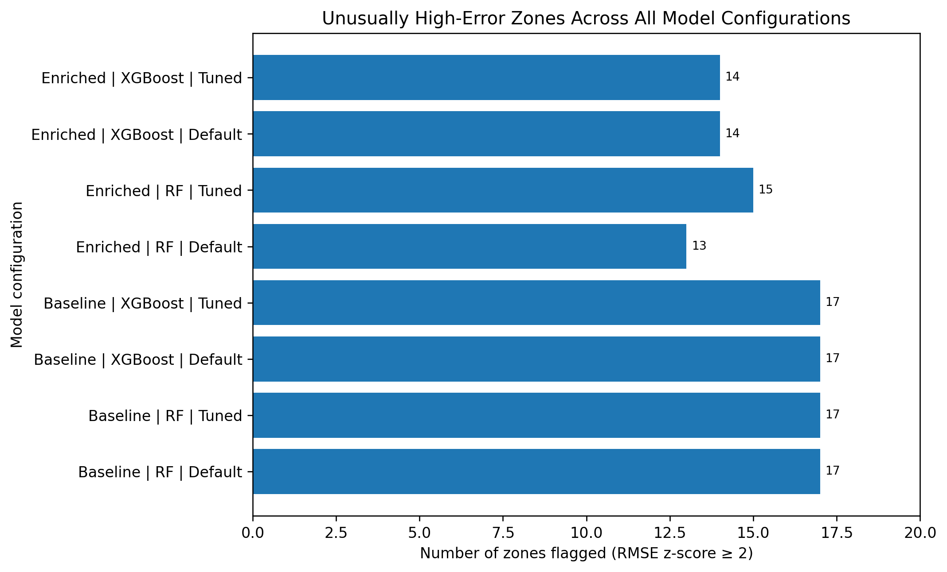
Figure 5.29 Unusually high-error zones across all model configurations
Figure 5.29 shows that the z-score flag does not disappear completely after enrichment. This is expected because the threshold is relative to each model's own error distribution. The enriched models make the whole distribution much smaller, but a smaller set of busy locations still sits unusually high relative to the other zones.

5.2.14.1 Peak-Demand Diagnosis of the Tuned Enriched Random Forest
The tuned enriched Random Forest is the final objective-aligned model, so its 15 unusually high-error zones were examined using the historical P90 procedure described in Section 4.5.8.1. Table 5.17 reports the exact error behaviour during normal and peak test hours. Table 5.18 then compares each of these zones with the matching tuned baseline Random Forest to show how much contextual enrichment reduced the error.
Table 5.17 Peak-demand diagnostics for all 15 tuned enriched Random Forest high-error zones
ID | Zone | Mean demand | RMSE | R² | Historical P90 | Peak hours | Normal RMSE | Peak RMSE | Peak bias | Peak error share
132 | JFK Airport | 200.2 | 55.15 | 0.796 | 315.4 | 95 | 37.06 | 94.66 | -76.38 | 64.8%
236 | Upper East Side North | 175.2 | 54.16 | 0.832 | 413.0 | 2 | 54.23 | 35.43 | 5.27 | 0.2%
79 | East Village | 139.1 | 51.70 | 0.905 | 262.4 | 58 | 26.46 | 124.08 | -57.39 | 77.3%
237 | Upper East Side South | 202.6 | 44.73 | 0.910 | 437.4 | 11 | 43.46 | 79.47 | -39.91 | 8.0%
186 | Penn Station/Madison Sq West | 168.7 | 43.74 | 0.798 | 273.0 | 53 | 28.63 | 98.65 | -83.76 | 62.4%
138 | LaGuardia Airport | 139.1 | 43.51 | 0.819 | 234.0 | 86 | 30.78 | 75.49 | -58.84 | 59.9%
161 | Midtown Center | 223.6 | 42.36 | 0.951 | 512.4 | 39 | 35.74 | 83.73 | -42.17 | 35.3%
142 | Lincoln Square East | 143.1 | 42.15 | 0.850 | 268.4 | 40 | 29.45 | 103.37 | -67.81 | 55.7%
230 | Times Sq/Theatre District | 167.7 | 41.03 | 0.891 | 333.8 | 44 | 31.29 | 88.87 | -63.23 | 47.8%
249 | West Village | 124.5 | 32.71 | 0.938 | 255.4 | 57 | 21.27 | 71.62 | -41.69 | 63.3%
48 | Clinton East | 127.8 | 32.33 | 0.846 | 216.0 | 51 | 21.74 | 72.94 | -56.17 | 60.1%
162 | Midtown East | 158.0 | 28.61 | 0.943 | 328.4 | 43 | 25.05 | 50.42 | -12.07 | 30.9%
234 | Union Sq | 140.9 | 28.28 | 0.929 | 285.0 | 43 | 23.36 | 55.68 | -41.18 | 38.6%
164 | Midtown South | 112.1 | 27.56 | 0.872 | 209.0 | 50 | 18.02 | 63.89 | -47.15 | 62.2%
239 | Upper West Side South | 127.5 | 27.02 | 0.896 | 223.0 | 39 | 21.30 | 59.31 | -41.19 | 43.5%
Fourteen of the 15 zones have higher RMSE during peak-demand hours than during normal hours, and 14 have negative peak bias. This means that the main residual pattern is underprediction when actual demand reaches the upper part of the zone's historical distribution. Upper East Side North is the clear exception: only two test hours exceed its historical P90, while the test-period mean demand is 14.72% below its pre-test mean. Its high RMSE is therefore associated mainly with broad normal-hour overprediction rather than peak underprediction.
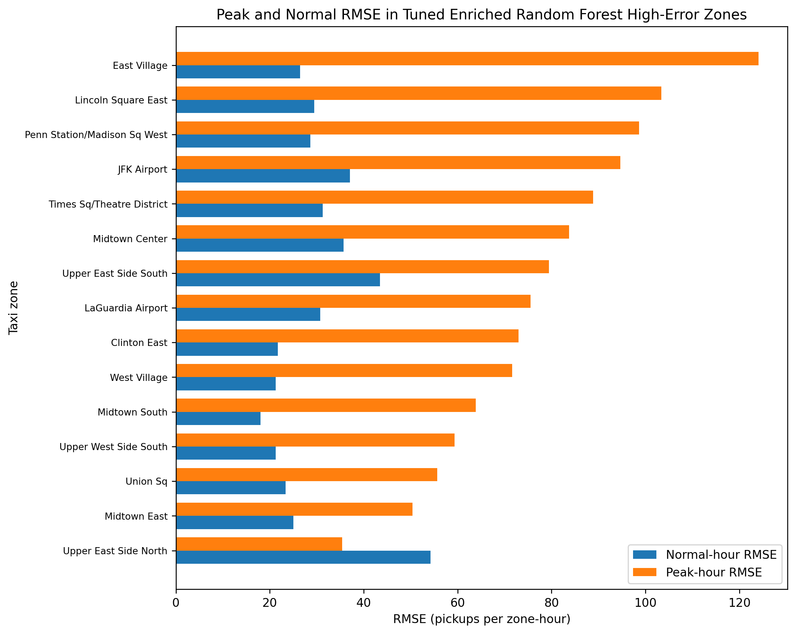
Figure 5.30 Peak-hour versus normal-hour RMSE in tuned enriched Random Forest high-error zones
Figure 5.30 makes the location of the remaining error visible. East Village, Penn Station/Madison Sq West, JFK Airport, Lincoln Square East and several other zones show much larger RMSE in the peak subset than in normal hours. Midtown Center still has an overall RMSE above 42 pickups per zone-hour, but its R² is 0.951, showing that a high absolute RMSE can coexist with strong explanatory performance when the zone operates at a very large demand scale.
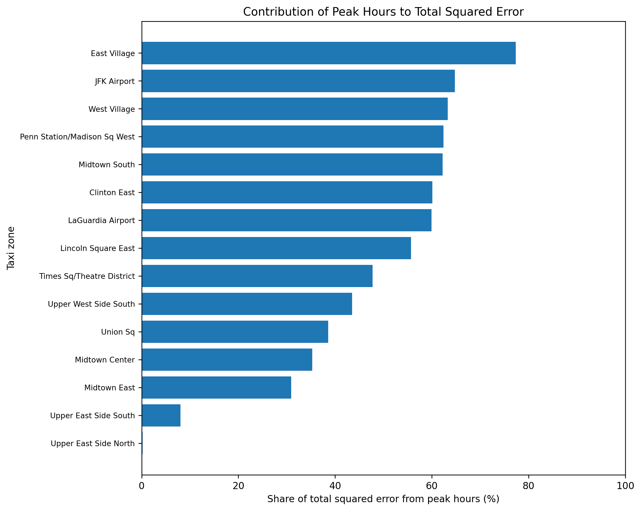
Figure 5.31 Share of total squared error produced by peak-demand hours
Figure 5.31 measures how much of each zone's total squared error is generated by the peak subset. For East Village, approximately 77.3% of the squared error comes from peak hours. The corresponding shares are about 64.8% for JFK Airport, 63.3% for West Village, 62.4% for Penn Station/Madison Sq West and 62.2% for Midtown South. These results show that a relatively small set of historically high-demand hours can account for a large part of the RMSE in several flagged zones.
Table 5.18 Enrichment effect and diagnostic interpretation for all 15 final high-error zones
ID | Zone | Test mean change | Baseline tuned RMSE | Enriched tuned RMSE | RMSE reduction | Evidence-based interpretation
132 | JFK Airport | 18.5% | 214.92 | 55.15 | 74.3% | Higher future demand level; peak-demand underprediction.
236 | Upper East Side North | -14.7% | 199.87 | 54.16 | 72.9% | Lower future demand level with broad normal-hour overprediction; only two test hours exceeded the historical P90.
79 | East Village | 17.3% | 202.71 | 51.70 | 74.5% | Higher future demand level; peak-demand underprediction.
237 | Upper East Side South | -7.5% | 230.75 | 44.73 | 80.6% | Peak-demand underprediction; high absolute demand scale despite strong r².
186 | Penn Station/Madison Sq West | 7.8% | 174.12 | 43.74 | 74.9% | Peak-demand underprediction.
138 | LaGuardia Airport | 16.4% | 153.43 | 43.51 | 71.6% | Higher future demand level; peak-demand underprediction.
161 | Midtown Center | 1.0% | 273.72 | 42.36 | 84.5% | Peak-demand underprediction; high absolute demand scale despite strong r².
142 | Lincoln Square East | -0.9% | 159.26 | 42.15 | 73.5% | Peak-demand underprediction.
230 | Times Sq/Theatre District | 6.0% | 188.47 | 41.03 | 78.2% | Peak-demand underprediction.
249 | West Village | 12.9% | 164.23 | 32.71 | 80.1% | Higher future demand level; peak-demand underprediction.
48 | Clinton East | 13.5% | 132.06 | 32.33 | 75.5% | Higher future demand level; peak-demand underprediction.
162 | Midtown East | 1.0% | 178.06 | 28.61 | 83.9% | Peak-demand underprediction; high absolute demand scale despite strong r².
234 | Union Sq | 6.1% | 155.21 | 28.28 | 81.8% | Peak-demand underprediction.
164 | Midtown South | 10.3% | 115.05 | 27.56 | 76.0% | Higher future demand level; peak-demand underprediction.
239 | Upper West Side South | 0.7% | 131.73 | 27.02 | 79.5% | Peak-demand underprediction.
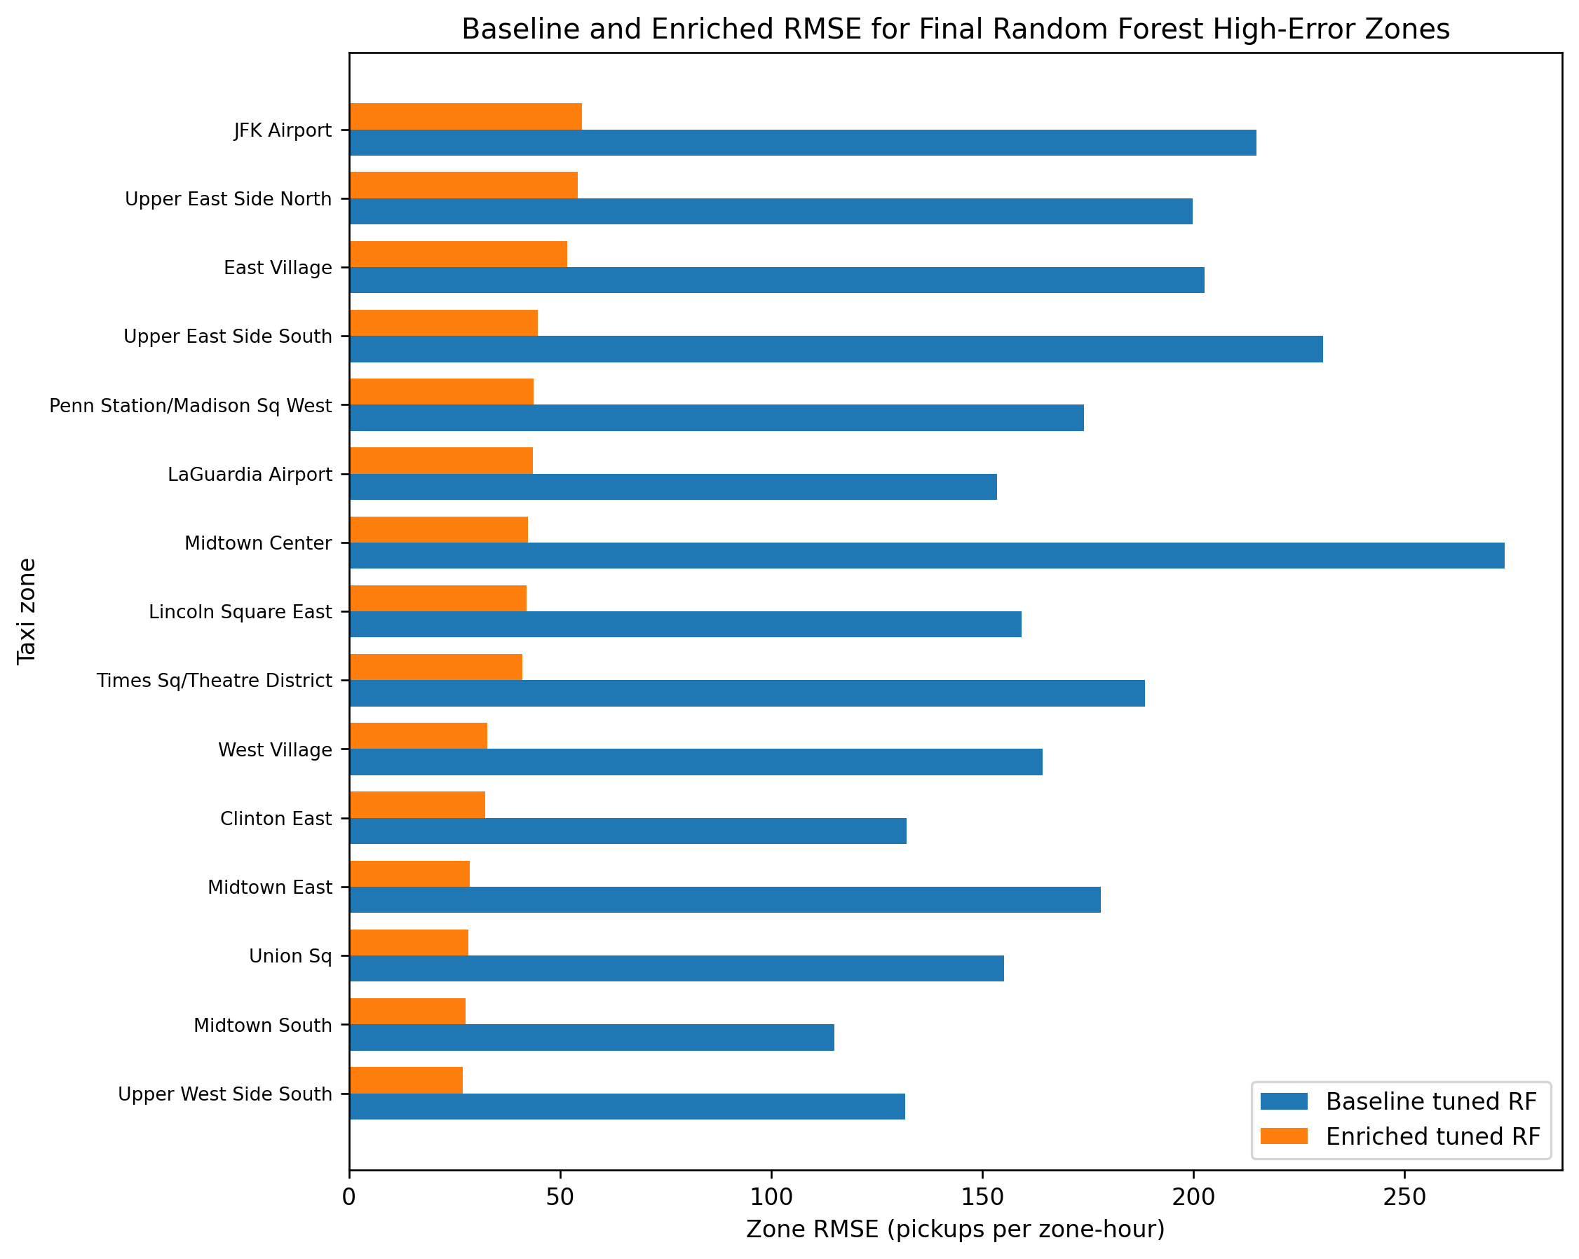
Figure 5.32 Baseline versus enriched RMSE for the final Random Forest high-error zones
Figure 5.32 confirms that remaining high-error status does not mean that enrichment failed. All 15 zones have substantially lower RMSE after adding subway proximity and zero-vehicle household rate. The reduction ranges from 71.6% at LaGuardia Airport to 84.5% at Midtown Center. The enriched variables therefore solve much of the zone-differentiation problem, while the remaining error is concentrated mainly in peak-demand conditions, future demand-level shifts, or the larger absolute scale of very busy zones.
The individual diagnoses in Table 5.18 also show that the cause is not identical in every zone. JFK Airport, East Village, LaGuardia Airport, West Village, Clinton East and Midtown South combine higher future mean demand with peak underprediction. Penn Station/Madison Sq West, Lincoln Square East, Times Sq/Theatre District, Union Sq and Upper West Side South are dominated mainly by peak-hour underprediction. Midtown Center and Midtown East retain relatively large absolute RMSE because of their high demand scale, but both still achieve strong R². Upper East Side North behaves differently because future demand falls and the model overpredicts normal hours. Upper East Side South shows mixed behaviour: normal hours are generally overpredicted while the relatively small number of peak hours is underpredicted.
High-error-zone conclusion. The baseline high-error problem is primarily a lack of zone differentiation, while the remaining errors in the tuned enriched Random Forest have a different cause. Contextual enrichment reduces RMSE dramatically in every final high-error zone, but it does not remove all residual difficulty during unusually busy hours or demand-level changes. These zones should therefore remain visible as diagnostic planning cases rather than being treated as evidence that the enriched model is unusable.

5.2.15 Final Model Selection and Objective Achievement
Table 5.19 Evidence used for final model selection
Model | Role in interpretation | Key evidence
Default enriched Random Forest | Best aggregate result | RMSE 11.5477; MAE 3.8465; R² 0.9569
Tuned enriched Random Forest | Best objective-aligned result | Median zone RMSE 1.5239; low-demand RMSE 0.3403; 28 negative-R² zones
Tuned enriched XGBoost | Competitive alternative | RMSE 12.0126; MAE 4.4925; R² 0.9533
Default enriched Random Forest is the strongest citywide benchmark because it has the lowest overall RMSE and MAE and the highest overall R². Tuned enriched Random Forest is selected as the final objective-aligned model because the project also requires consistent performance across individual zones and improved prediction in low-demand outer-borough zones. Although its aggregate RMSE is 3.6788% higher than the default Random Forest, it has the best median zone R², far fewer negative-R² zones and the strongest low-demand performance. Tuned XGBoost remains competitive overall, but it does not match the tuned Random Forest on the zone-level objectives.

