

**Smart Car Parking System**

**CSE360**

**Section: 02**

**Group: 06**

**Group Members:**

|  |  |
| --- | --- |
| **Name** | **ID** |
| Golam Rasul | 19301126 |
| Faiyaz Masrur | 18301213 |
| Krishno Saha | 19101271 |
| Md. Fahim Faisal | 19101161 |
| Abir Hasan Akash | 18301215 |

**Project Title: Smart Car Parking System**

**Introduction:**

In our country, we see people suffer sometimes due to the poor parking system in parking slots which are manually controlled by humans. Instead, if we use a smart car parking system we can save time and people will be able to park their cars in the slots by themselves easily. And also, A high car density on the road due to population growth results in inadequate parking spaces and traffic problems, according to a survey of metropolitan areas. Vehicle parking is a significant issue in many places because of the rise in urbanization . For many drivers, finding adequate parking spaces is a huge challenge, especially when they are visiting crowded public venues like malls, movie theaters, five-star hotels, etc. The parking spaces offered in multi-storey buildings, malls, multi-complex buildings, etc. typically work manually, meaning a person is designated to watch over vacant slots, which wastes time and fuel and is therefore inefficient. Drivers often squander time and fuel today when people are in a rush and there is such high inflation that fuel prices are.

**Project Details:**

**Components:**

The proposed project requires:

1. 2 pieces of Infrared Sensor (IR)
2. 1 piece of Servo Motor
3. 3 pieces of Ultrasonic Sonar Sensor
4. 1 piece of LED
5. 1 piece of Buzzer
6. 1 piece of LCD
7. 1 piece of Arduino Uno
8. Power Source
9. Jumper wires
10. Resistors

The proposed project will perform some smart actions depending on some specified components such as:

1. It can show the parking slot information (for example, if there's any empty slot or all slots are booked) via LCD on the basis of the information of the Sonar sensor.
2. It has an automatic door/gate opening and closing system with the help of servo and IR sensor.
3. It has an automatic lighting system (for example, at night or when it is cloudy weather, the parking area’s LED light will turn on and at day time it is turned off automatically) with the help of LDR sensor and LED.
4. It will notify the entry and exit of a car via beeping with the help of a buzzer.

Here when a new car come the IR sensor detect it send the data to Arduino and it open the Door via servo motor action and beep the buzzer once to indicate a new entry and when the car goes to one of the parking slots, the associated ultrasonic sonar sensor send data to the Arduino and via LCD it will shows the remaining empty slot. Now when a car goes out similar thing happens, data goes from the associated ultrasonic sensor to Arduino, and Arduino beeps the buzzer twice for notifying one exit and shows the remaining empty slot via LCD. Moreover, depending on the lighting situation in the parking area the LDR sends value to Arduino and the Arduino turns on or off the LED light automatically.

**The below figure shows the connection among the components and the overall setup:**

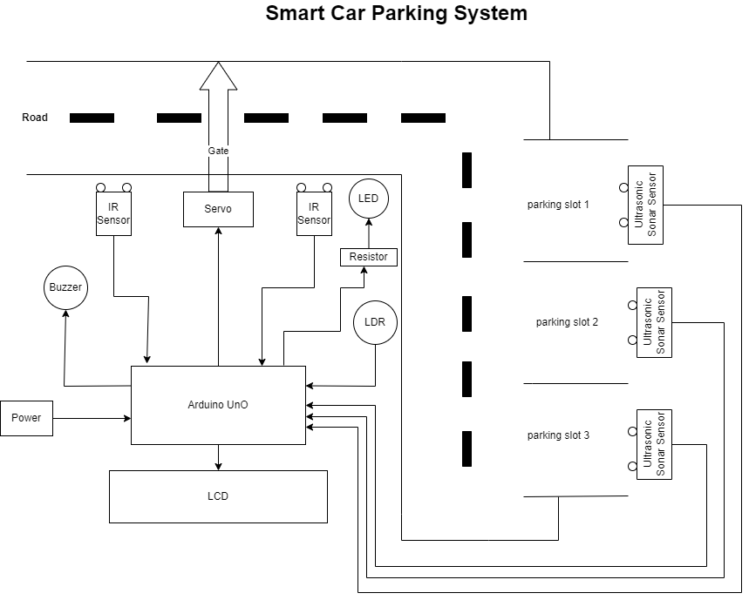

**Estimated Cost Analysis:**

|  |  |  |  |
| --- | --- | --- | --- |
| **Component** | **Unit Price** | **Quantity** | **Cost** |
| Infrared Sensor (IR) | 60/- | 2 | 120/- |
| Servo Motor | 149/- | 1 | 149/- |
| Ultrasonic Sonar Sensor | 110/- | 3 | 330/- |
| LED | 2/- | 1 | 2/- |
| Buzzer | 15/- | 1 | 15/- |
| LCD | 228/- | 1 | 228/- |
| Arduino Uno | 1100/- | 1 | 1100/- |
| Power Source | 1000/- | 1 | 1000/- |
| Jumper wires | 500/- | 1 | 500/- |
| Resistors | 2/- | 1 | 2/- |
| **Total Cost** |  |  | 3446/- |

**Work Distribution:**

* + - 1. Faiyaz Masrur – 18301213- Introduction & project details
      2. Krishno Saha- 19101271-project details & circuit design
      3. Golam Rasul-19301126-Circuit design & Cost analysis
      4. Md. Fahim Faisal-19101161-Circuit design &References
      5. Abir Hasan Akash-18301215-Conclusion &future Work

**Conclusion and Future work:**

This paper showcases a smart Car parking system using Arduino UNO, Servo motor, ultrasonic solar sensor and LCD. This system makes parking allocation easier since there is no registration required and directly guides people to the exact location of the empty slot. In case there is no empty slot remaining the entry gate does not open which saves lots of time. This system has an LCD where through LCD users can get to know the status of slots. In future we can develop a mobile application, which will help users to book the slot if available. The slot will be allotted in order of numbers and if any slot in between gets empty that empty slot will be allotted first to any user, and if any user does not park the car after booking the slot, after 2 minutes the booked slot will be updated as empty. This feature makes our model more efficient than others.

**References:**

<https://www.electroduino.com/smart-parking-system-project-using-arduino-and-ir-sensor/>

<https://robodocbd.com/components/resistors>

<https://www.researchgate.net/publication/369597207_Smart_Car_Parking_System_Using_Arduino_UNO_Mobile_Application>