**Text Summarization Report**

1. **TF-IDF Based Summarizer:**

Term Frequency: For every word in given sentence we have calculated term frequency

$$TF =\frac{Number of Repetition of W_{i} in sentence}{Number of words in sentence}$$

**Inverse Document Frequency:** For every word in complete text given IDF Score.

$$IDF=log(\frac{Total Number of Sentences}{Number of sentences containg word W_{i}})$$

**TF-IDF:** Assigning weight for each word based on TF and IDF score

$Weight(W_{i}) =TF*IDF$

**Sentence Weightage:**

$$Sentence Weight=\frac{Sum of weight of all words in sentence}{Number of words in Sentence}$$

**Sentence Extraction:**

sentence weight> average sentence weight * tuning factor

**2. Centroid Based Summarizer:**

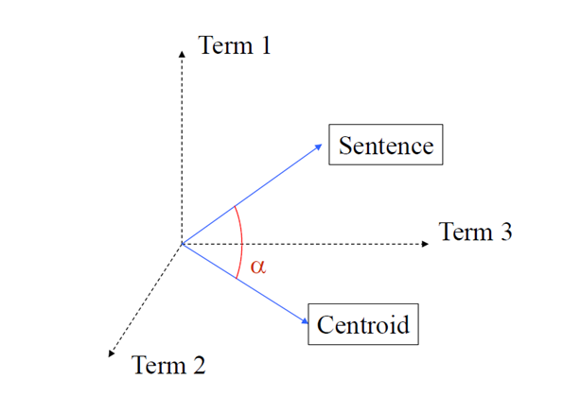

**Centroid Vector:** We have taken those words in a text which have higher tf-idf score

than the average tf-idf score.

**Sentence Vector:** All the words along with tf-idf score in a sentence act as vector

**Cosine Sentence Similarity:** Weight of sentence given based on the cosine similarity between the centroid vector and sentence vector

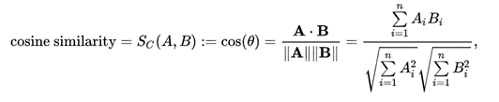

**Sentence Extraction:**

Cosine sentence similarity>avg cosine sentence similarity*tuning factor

**3. TF-IDF vs Centroid based summarizer**

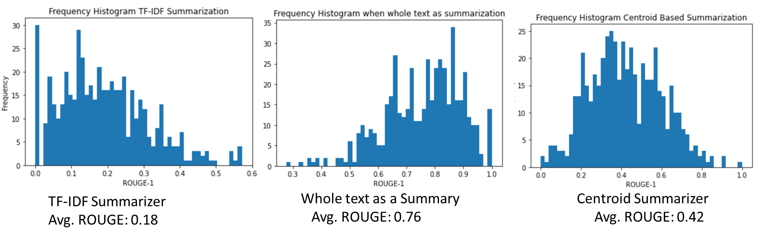

All the above results are based on 500 instances of data.

Given that the gold reference summary is abstractive in nature, in this scenario, by using extractive summarization, the maximum ROUGE-1 score attainable will always be less than the ROUGE-1 score of the whole text as summary.

We are getting an average ROUGE-1 score as 0.22 for TF-IDF summarizer and 0.42 as Centroid based summarizer. It is evident that centroid based summarizers are performing better for giving the central idea of text.