**Power BI Assignment 5**

1. Explain DAX.

Ans: DAX is a collection of functions, operators, and constants that can be used in a formula, or expression, to calculate and return one or more values. Stated more simply, DAX helps you create new information from data already in your model.

1. Explain datasets, reports, and dashboards and how they relate to each other?

Ans: A data set is an ordered collection of data. As we know, a collection of information obtained through observations, measurements, study, or analysis is referred to as data. It could include information such as facts, numbers, figures, names, or even basic descriptions of objects.

A report is a document that presents information in an organized format for a specific audience and purpose. Although summaries of reports may be delivered orally, complete reports are almost always in the form of written documents.

A dashboard is a way of displaying various types of visual data in one place. Usually, a dashboard is intended to convey different, but related information in an easy-to-digest form.

Dashboards are created from multiple datasets or reports. Dashboards always concentrate on building insights into the data by using graphs, attractive visuals, charts, etc. Reports are not concentrated on the visualization part of the data rather it looks to create summary pages.

1. How reports can be created in power BI, explain two ways with Navigation of each.

Ans: Create a report from an Excel file in the Power BI service

In the navigation pane in the Power BI service, you can select the Create button that opens a page where you can select your data source. It's also accessible from the New report button on Home.

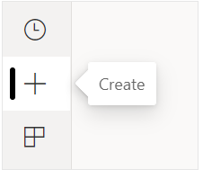

Currently, we only support creating a report based on an existing dataset, or pasting or manually entering data directly in a table. Over time you'll see other sources, such as uploading an Excel file.

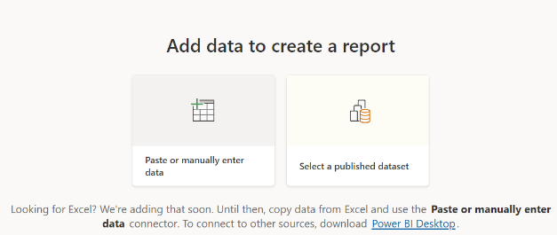

When you choose to paste or manually enter data, you get a grid that you can start to type into. You can also paste data by using Ctrl + V or the context menu.

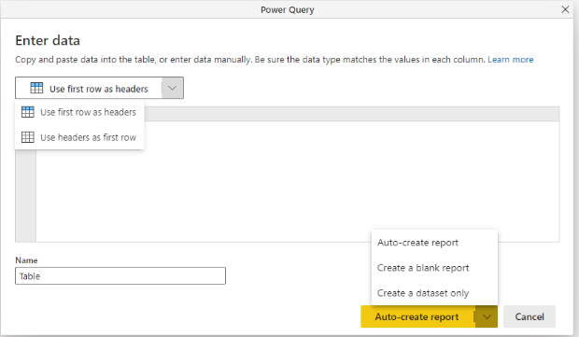

You can use the context menu to add and remove columns. If your pasted data includes a header row, select **Use first row as headers** to automatically promote the first row to the header row. Power BI automatically detects the data types, but you have the option to set them manually. Select the **Data type** button next to the column name.

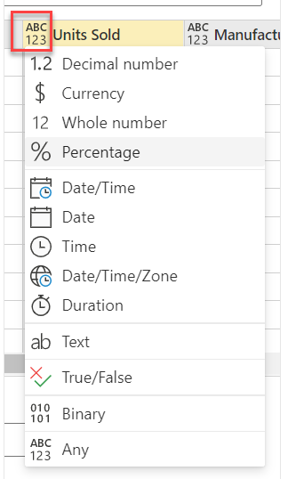

As you go through the creation process, Power BI creates a new dataset for you, and autogenerates a summarized view of your data. These autogenerated visuals propel you from raw data to insights faster than ever.

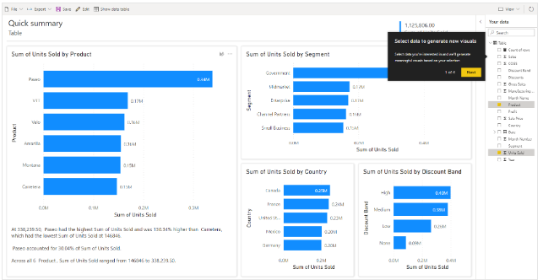

Step 2: Select a data source

You can connect to a variety of data sources. Read more about connecting to data sources.

From the welcome screen, select Get Data.

Or on the Home tab, select Get Data.

Select your data source -- in this example, Analysis Services.

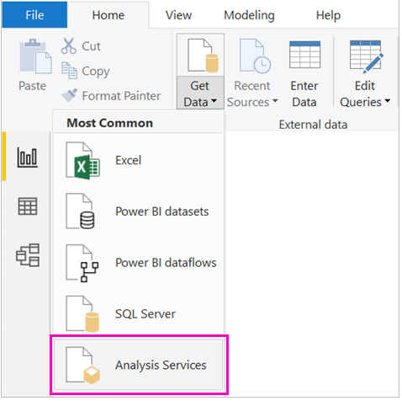

Fill in Server, and optionally, Database. Make sure Connect live is selected > OK.

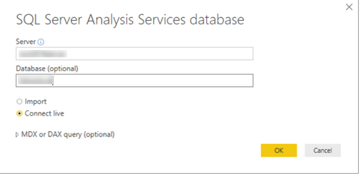

Choose the report server where you'll save your reports.

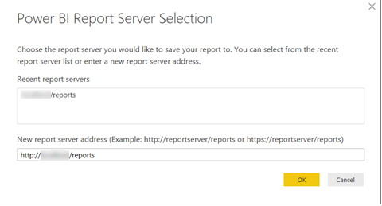

1. How to connect to data in PowerBI? How to use the content pack to connect to google analytics?Mention the steps.

Ans: To connect to data, from the Home ribbon select Get data. The Get Data window appears. You can choose from the many different data sources to which Power BI Desktop can connect. In this quickstart, use the Excel workbook that you downloaded in Prerequisites.

In Power BI Desktop, select Get data from the Home ribbon tab.

In the Get Data window, select Online Services from the categories in the left pane.

Select Google Analytics from the selections in the right pane.

At the bottom of the window, select Connect.

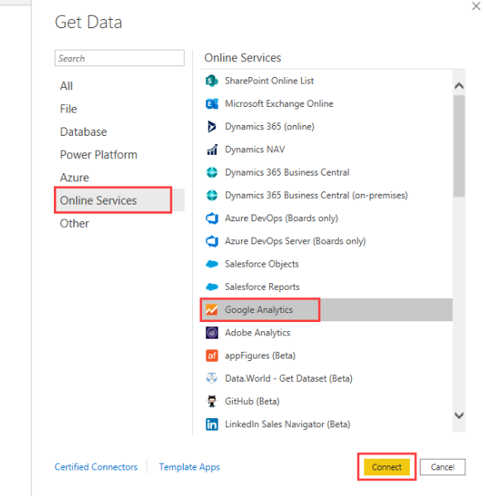

You're prompted with a dialog that explains that the connector is a Third-Party Service, and warns about how features and availability may change over time, and other clarifications.

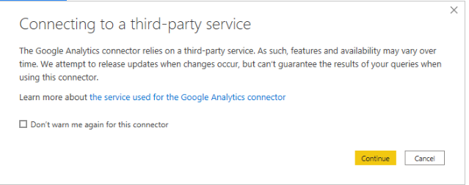

When you select **Continue**, you're prompted to sign in to Google Analytics.

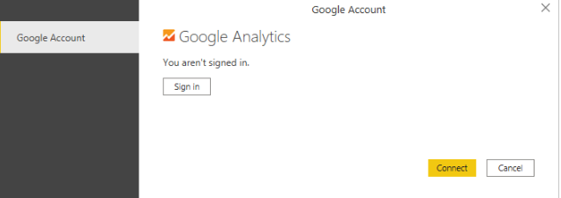

When you enter your credentials, you're prompted that Power BI would like to have offline access. This is how you use Power BI Desktop to access your Google Analytics data.

Once you accept, **Power BI Desktop** shows that you're currently signed in.

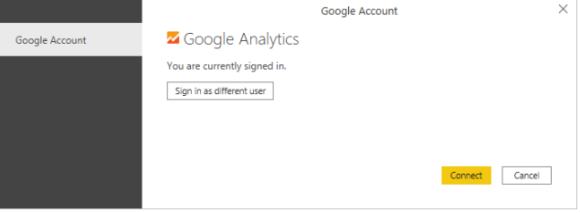

Select **Connect**, and your Google Analytics data is connected to **Power BI Desktop**, and loads the data.

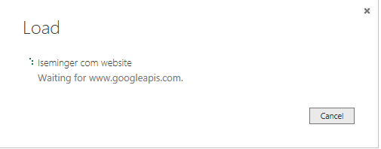

1. How to import Local files in Power BI? Mention the Steps.

Ans : If you want to import Analytics data manually through Power BI, follow these instructions.

In Power BI, click Get Data in the lower left screen.

Under Import or Connect to Data > Files, click Get.

Click Local File.

Choose which file to upload and click Open.

Click Upload under Upload your Excel file to Power BI.

The message “Your file has been uploaded” should appear.

1. In Power BI visualization, what are Reading View and Editing view?

Ans: The Power BI service has two different modes for interacting with reports: Reading view for report business users and Editing view for report owners and creators. You need a Power BI Pro or Premium Per User (PPU) license to share reports and to edit reports created by others.

Take a look at the list of articles under the Power BI reports header in the Table of Contents. It's a long list and many of the articles cover functionality only available if you have editing permissions for a report. To help you navigate the Table of Contents, Editing view is required for the following actions