# Hackerrank Plugin Sublime Text 2

This plugin can run and compile on hackerrank by sending the current editing code. Then it can show how many test cased passed and not passed.

This plugin is tested on Windows, but should work on linux and OSX as well.

## Note:

1. It currently works for C, C++, Java, Php files
2. Your code file name should be named as the **hackerrank problems’s slug**, such as for this problem <https://www.hackerrank.com/challenges/solve-me-first> , slug is solve-me-first. Now if you want to submit your c++ file then your file name should be solve-me-first.cpp

## Installation:

1. Download Sublime Text 2 from the website. Link: <http://www.sublimetext.com/2>
2. Install and open Sublime Text 2
3. Click the Preferences > Browse Packages… menu
4. Download the plugin from [here](https://drive.google.com/file/d/0B1tobqDtambaYklPMnpGMlJXZXc/view?usp=sharing), extract and copy HackerRank folder into the Packages/ directory
5. Restart Sublime Text

## Usage

* To confirm the installation of the plugin, press Ctrl + Shift + P, write Hackerrank, you will see a suggestion named “Hackerrank Code Run”

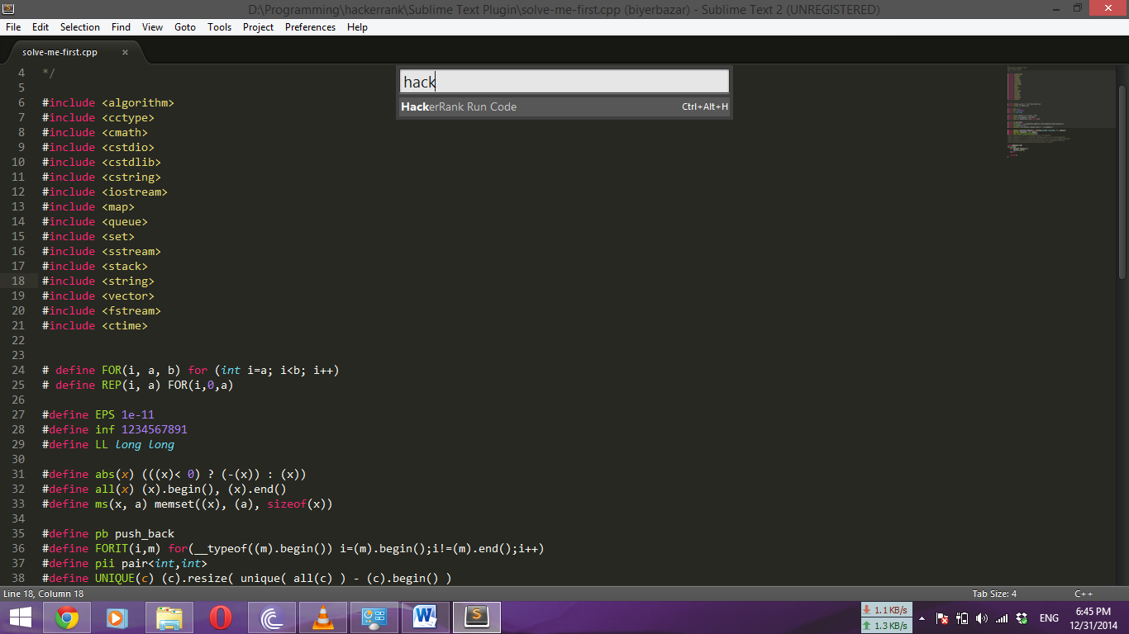

Figure: Hackerrank Plugin Confirm

* If you want to run the code on Hackerrank and test with the sample simply run press **Ctrl + Alt + H.** Console window will be opened and will show the screen like the below:

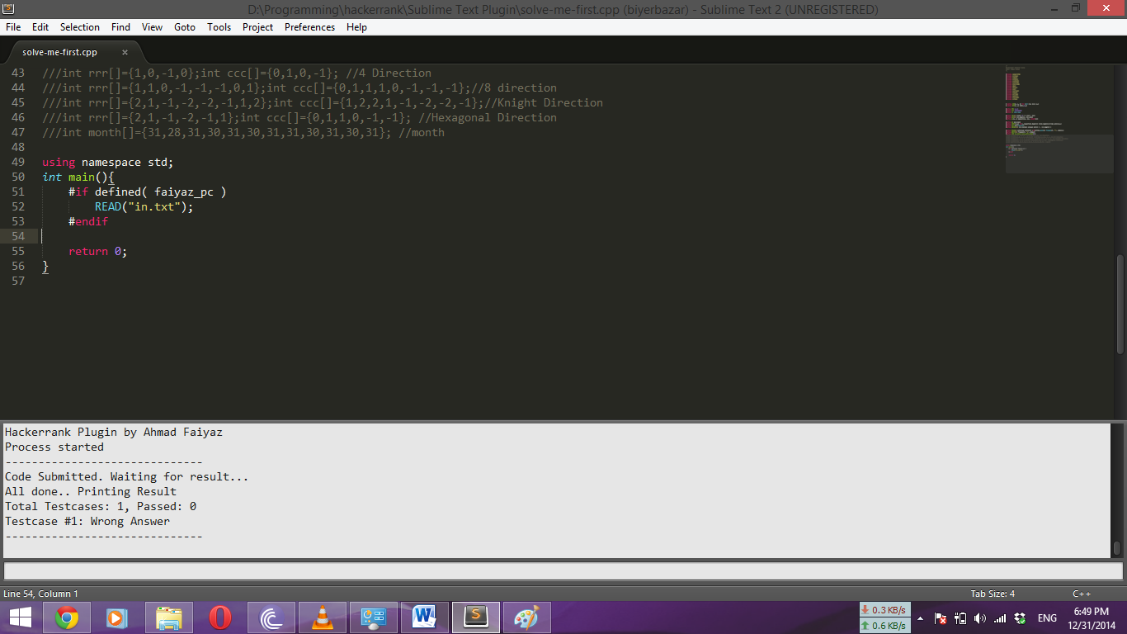

Figure: Console window showing result