

**Software Requirements** **Specification**

**For**

**Shaggy Food Ordering App**

**Prepared By –**

*Faiyaz Shaikh* 17CO45

*Rafil Deshmukh* 17CO23

*Huzefa Surme* 17CO53

|  |  |
| --- | --- |
| Instructor: | Prof Abdul Salam Shaikh |
| Course: | Software Engineering |
| Lab: | Software Engineering Lab |
| Date: | 13 January, 2020 |

**Contents**

**1** **INTRODUCTION**

1.1 DOCUMENT PURPOSE

1.2 PRODUCT SCOPE

1.3 INTENDED AUDIENCE AND DOCUMENT OVERVIEW

1.4 DEFINITIONS, ACRONYMS AND ABBREVIATIONS

1.5 REFERENCES AND ACKNOWLEDGMENTS

**2** **OVERALL DESCRIPTION**

2.1 PRODUCT PERSPECTIVE

2.2 PRODUCT FUNCTIONALITY

2.3 OPERATING ENVIRONMENT

2.4 DESIGN AND IMPLEMENTATION CONSTRAINTS

2.5 USER DOCUMENTATION

2.6 ASSUMPTIONS AND DEPENDENCIES

**3** **SPECIFIC REQUIREMENTS**

3.1 EXTERNAL INTERFACE REQUIREMENTS

3.2 FUNCTIONAL REQUIREMENTS

3.3 NON-FUNCTIONAL REQUIREMENTS

**4** **OTHER REQUIREMENTS**

4.1 PERFORMANCE REQUIREMENTS

4.2 SAFETY AND SECURITY REQUIREMENTS

4.3 LEGAL REQUIREMENTS

**5 CONCLUSIONS AND FUTURE WORK**

*SRS for Shaggy Food Ordering App*

***1.1 Document Purpose***

This document presents a detailed explanation of the objectives, features, user interface and application of Shaggy Food Ordering App in real life. It will also describe how the system will perform and under which it must operate. In this document it will also show user interface. Both the stakeholders and the developers of the system can be benefitted from this document.

***1.2 Product Scope***

This system will help to manage and run the restaurant business systematically. In this online food ordering system, we will provide an app that can be used by the customers to order food. Customers can also give feedback through this app. So that owner of the restaurant can evaluate the whole system. This will ultimately lead to hire less waiters and create an opportunity to appoint more chefs and better kitchen place to serve food faster. Customers can also make payment through cash, debit or credit cards using POS which will be integrated with the management software. Customers can see current discount facility of the restaurant. Customers can also see the calorie chart which will increase consciousness about their health. All the information about daily expenses and profit will be saved in the system. Also the required information’s about employees will be saved in the system which can be only accessed by the system admin.

***1.3 Intended Audience and Document Overview***

This document is intended for different types of readers such as restaurant owner, customers, system designer, system developer and tester. By reading this document a reader can learn about what the project is implemented for and how it will present it’s basic ideas. This document has a sequential overview of the whole project so if a reader reads the document from top to bottom, he will get a clear idea about the project.

*SRS for Shaggy Food Ordering App*

***1.4 Definitions, Acronyms and Abbreviations***

We will also use bold letter to emphasis main topics and for all the major functions of the system. Underline will represent hyperlink. Italic will represent acronyms and useful notes. We will use some acronyms through this document. Abbreviations and definition of some useful terms we will use are given below :

|  |  |  |  |  |  |  |
| --- | --- | --- | --- | --- | --- | --- |
| **Term** |  |  | **Definition** | | | |
|  |  |  |  |  |  | |
| System Admin |  | System admin is a person who is responsible for managing | | | |  |
|  |  |  |  | |  | |
|  |  | the whole system and who has full access to the system. | |  |  | |
|  |  |  |  | | | |
| System User |  | A person who is using or operating the system but with a | | |  | |
|  |  |  | | | | |
|  |  | limited privilege. |  | | | |
|  |  |  | | | | |
| Database |  | Collection of all the information monitored by this system. | | | | |
|  |  |  | | | | |
| Field |  | A cell within a form. | | | | |
|  |  |  | | | | |
| Software Requirements |  | A document that completely describes all of the functions | | | | |
| Specification *(SRS)* |  | of a proposed system and the constraints under which it | | | | |
|  |  | must operate. For example, this document. | | | | |
|  |  |  | | | | |
| Stakeholder |  | Any person who is involved in the development process of | | | | |
|  |  | the software. | | | | |
|  |  |  | | | | |
| Point of Sale *(POS)* |  | A point of sale system is either a stand-alone machine or a | | | | |
|  |  | network of input and output devices used by restaurant | | | | |
|  |  |  |  |  |  |  |

*SRS for Shaggy Food Ordering App*

***1.5 References***

[www.google.com](http://www.google.com/)-the world's information.

[www.wikipedia.com](http://www.wikipedia.com/)-free online encyclopedia.

[www.cnet.com](http://www.cnet.com/) -technology portal. [www.slideshare.net](http://www.slideshare.net/)-the world's largest professional content sharing community.

IEEE. *IEEE Std 830-1998 IEEE Recommended Practice for Software* *Requirements Specifications.* IEEE Computer Society, 1998.

*SRS for Shaggy Food Ordering App*

***2.1 Product Perspective***

The Shaggy Food Ordering System application is a web-based system. It can be accessed using IE 10.0 and above, Firefox 31 and above and Google Chrome.

The system processes transaction and stores the resulting data. Reports will be generated from these data which help the owner to make appropriate business decisions for the restaurant. For example, knowing the number of customers for a particular time interval, the manager can decide whether more waiters and chefs are required. Moreover, easily calculate daily expenditure and profit.

The whole system is designed for a general Computerized Digital Restaurant. So that any restaurant owner can get it and can start automated process to his restaurant.

**System Model**

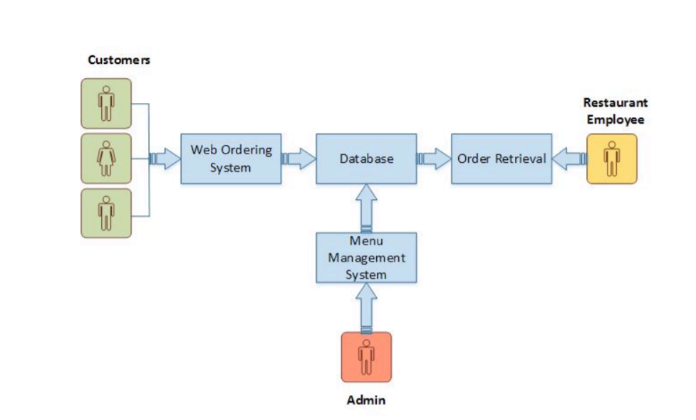

*Fig. System Model for Shaggy Food Ordering App*

The structure of the system can be divided into 3 main logical components:

• Web Ordering System- provides the functionality for customers to place their order and supply necessary details.

• Menu Management-allows the restaurant to control what can be ordered by the customers

• Order Retrieval System-This is a final logical component. Allows restaurant to keep track of all orders placed. This component takes care of order retrieving and displaying order information.

*SRS for Shaggy Food Ordering App*

***2.2 Product Functionality***

**Web Ordering System Module** This module provides the functionality for customers to place their order and supply necessary details. Users of the system, namely restaurant customers, must be provided the following functionality:

• Create an account.

• Manage their account.

• Log in to the system.

• Navigate the restaurant’s menu.

• Select an item from the menu.

• Add an item to their current order.

• Review their current order.

• Remove an item/remove all items from their current order.

• Provide payment details.

• Place an order.

• Receive confirmation in the form of an order number.

• View order placed.

Out of all the functions outlined above, Account Creation and Management only will be used every time a customer places an order. This will allow to simplify the overall user experience.

**Menu Management System Module** This module provides functionality for the power user-Administrator only. It will not be available to any other users of the system like Restaurant Employees or Customers. Using a graphical interface, it will allow an Admin to manage the menu that is displayed to users of the web ordering system:

• Add/update/delete food category to/from the menu.

• Add /update/delete food item to/from the menu.

• Update price for a given food item.

• Update additional information (description, photo, etc.) for a given food item. Before customers can actually use this system, functionality provided by this component will have to be configured first. Once the initial configuration is done, this will be the least likely used component as menu updates are mostly seasonal and do not occur frequently.

**Order Retrieval System Module** This is the most simplest module out of all 3 modules. It is designed to be used only by restaurant employees, and provides the following functions: • Retrieve new orders from the database. • Display the orders in an easily readable, graphical way.

***2.3 Operating Environment***

Hardware/Software Interface: This section lists the minimum hardware and software requirements needed to run the system efficiently.

**Hardware Interface:**

* Pentium Processor or higher
* 200 MB of free hard-drive space
* 1024 MB of RAM

*SRS for Shaggy Food Ordering App*

**Software Interface:**

* Operating System: Windows (Vista/7 or above), Unix, Mac OS
* Web Browser: IE 10 or above, Mozilla FF 31 and above or Google Chrome
* Database: SQlite
* Drivers: Python, Django Framework
* Integrated Development Environment: Python, Django, Apache Tomcat

***2.4 Design and Implementation Constraints***

There are some constraints which costs more for the system. If those constraints can overcome then this whole system will perform best. They are-

1. Mobile App and Windows App.
2. Information flow or data flow can be controled and more effective.
3. Faster server system such as LINUX server.
4. Regional language for States and Other language for other countries.
5. C# can be use for more security.
6. Hardware Limitations: The minimum hardware requirement for the system is 1024 MB of Ram and a 200MB hard-disc drive.
7. The application should be built using Django and JavaScript inscribed in HTML, and it should, initially, be accessible through the IDE and later published on a server

***2.5 User Documentation***

It will provide specific guidelines to a user for using the system. Further more a Video *(Slide Show)* will be provided which will represent the whole system function and how it works.

***2.6 Assumptions and Dependencies***

If this system has Mobile and Windows app then customers who use such kind of smartphone *(windows and android)* will be more benefited. If there are more Tablets for each tables the whole system performance will be better. For more secure system it is beneficial to use CC camera and TV.

*SRS for Shaggy Food Ordering App*

***3.1 External Interface Requirements***

There are many types of interfaces as such supported by this software system namely; User Interface, Software Interface and Hardware Interface.

**3.1.1 User Interfaces**

The user interface will be implemented using any android smartphone app browser. This interface will be user friendly. So that every kind of customer can place the food order easily. Customers can also give feedback through it easily with some demo comment or if they are keen to write their review by own they can do it.

**3.1.2 Hardware Interfaces**

There shall be logical address of the system in IPv6 format.

**3.1.3 Software Interfaces**

The system shall communicate with the Configurator to identify all the available components to configure the product.

The system shall communicate with the content manager to get the product specifications.

***3.2 Functional Requirement Specifications***

Activity Diagram:

This section lists the activity diagram and describes the flow of the activities in the system. A detailed description is then given after the figure which provides the overview of the activity of the Shaggy Food Ordering System application.

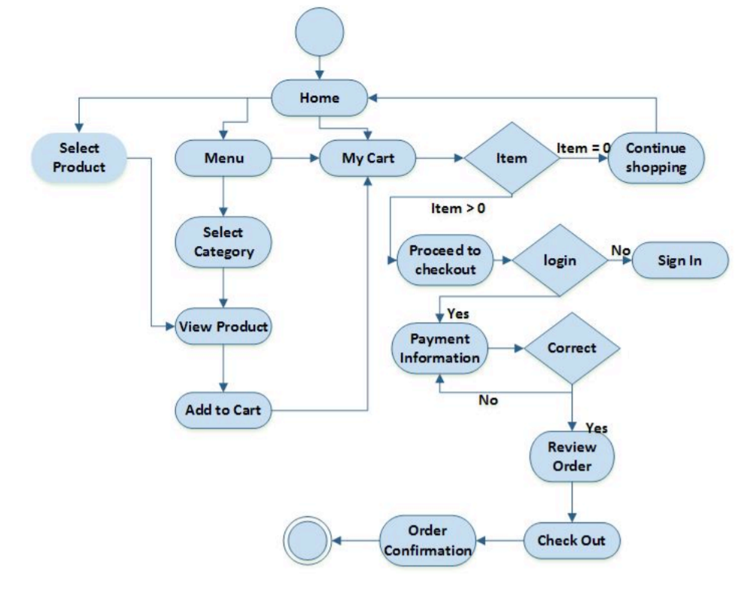

*Fig. Activity Diagram for Shaggy Food Ordering App*

*SRS for Shaggy Food Ordering App*

All users of the system, are provided with below menu options: Home, Menu, My Cart, UserAccount , AboutUs and Contact

**Web Ordering System Module** Customers of the Web Ordering system will interact with the application through an easy to use top navigation menu.

• “Home” menu option: allows the users to see all food items offered with nice images as well as select an item to place an order.

• “Menu”menu option: a ‘Drop-Down’ menu, allows users to see all food items per category. Item can then be added to the cart using a single button click.

• “My Cart (x)”menu option: - Allows users to see details of the items placed in cart. Details include Item #, Product Name, Product Image, Product Description, Quantity, Unit Price, Total per item and final Total of the order. It also allows ‘Update’ and ‘Delete’ an item using single button click. User can then use a ‘Proceed to checkout’ button to proceed further. - Once, Check Out button is selected, user will be prompted for the Sign In/Sign Up process if not logged in else user will be presented with a simple “Payment Information” form. User will be asked to provide all required details in displayed text boxes and make appropriate Dropdown selections. Then, all this information can be saved using a ‘Save’ button. - User will then be presented with a “Review Order” page, which will display Payment Information along with Order details to review. User can then use a ‘Check Out’ button to place an order. - Once order is placed, user will be presented with appropriate Order confirmation success/failure message.

• “MyAccount”: a “Drop Down” menu will display the user orders, Sign In and Sign Out options.

**Menu Management System Module** Similar to Web ordering system, this module presents Admin with below additional options under “MyAccount” Drop down menu:

• Add Category: Allows to add a food Category name in a simple form.

• Add Product: Allows to add Product Name, Description, Price and choose Category in a simple form along with Product Image.

• Modify Product: Allows updating or deleting product details.

**Order Retrieval System Module** The application will automatically fetch new orders from the database at regular intervals and display the order numbers.

• Under “MyAccount’ menu a customer will be able to see only his/her order whereas a Restaurant Employee or an Admin can see all users orders.

• To view the details of an order, the user must click on that order number, which will display all order details This structure can intuitively be expanded and collapsed to display only the desired information.

*SRS for Shaggy Food Ordering App*

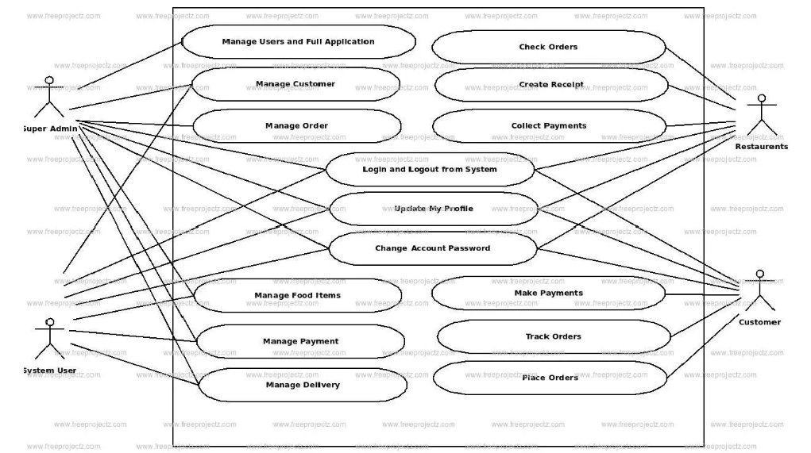

*Fig. Use case Diagram For Shaggy Food Ordering App*

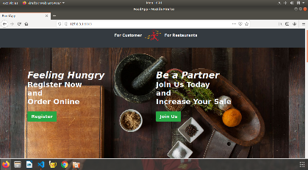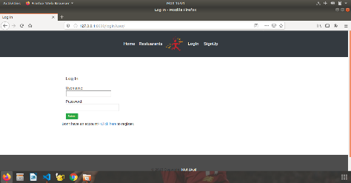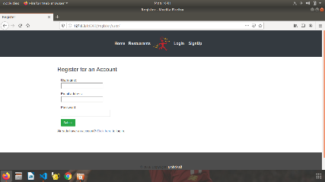

*Homepage Login page Registration Page*

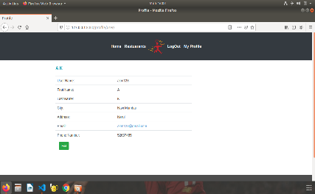 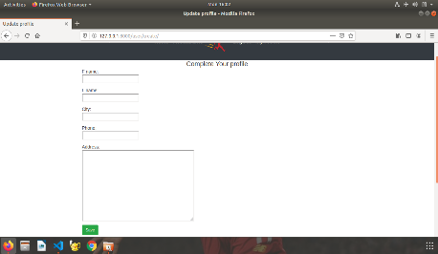 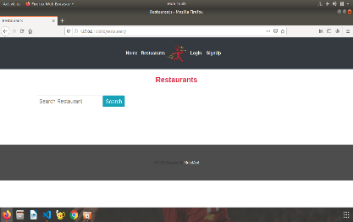

*Register Restaurant Add Restaurant Search Restaurant*

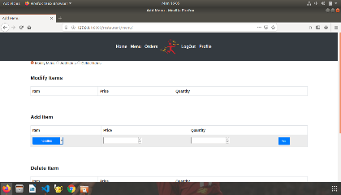 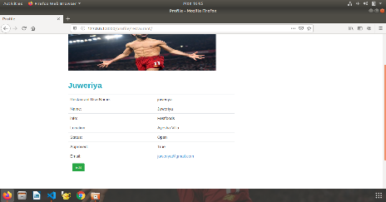

*Search Food Customer Order Booking*

*SRS for Shaggy Food Ordering App*

***3.3 Non-functional Requirements***

All of the application data is stored in a SQlite database, and therefore a SQlite Database must also be installed on the host computer. As with Apache2, this software is freely available and can be installed and run under most operating systems and django framework must be installed. The server hardware can be any computer capable of running both the web and database servers and handling the expected traffic. For a small scale restaurant that is not expecting to see much web traffic, an average personal computer may be appropriate. Once the site starts generating more hits, though, it will likely be necessary to upgrade to a dedicated host to ensure proper performance. The exact cutoffs will need to be determined through a more thorough stress testing of the system.

*SRS for Shaggy Food Ordering App*

***4.1 Performance Requirements***

* The product will be based on local server.
* The product will take initial load time.
* The performance will depend upon hardware components.
* Payment system will be fully secure through POS system.
* Different database for employee.

***4.2 Safety and Security Requirements***

* The source code developed for this system shall be maintained in configuration management tool.
* The whole system is secured. Only Admin can access all the data.
* This system will use HTTPS. Because of this protocol this is more secure.
* This system will use secured POS system.

***4.3 Legal Requirements***

**4.3.1 Licensing Requirements**

Not Applicable

**4.3.2 Legal, Copyright, and Other Notices**

All rights are reserved by our team.

**4.3.3 Applicable Standards**

It should be as per the industry standard.

*SRS for Shaggy Food Ordering App*

***5 Conclusions and Future Work***

**5.1 Conclusion:**

The main objective of the application is to help understands the basics of Django, Python, CSS, Bootstrap, SQlite Queries, JavaScript and HTML.

The following results have been achieved after completing the system and relate back to the system’s objective:

• Should allow Computer Science students to browse through the code and application: This can be achieved when students are able to run and install the application. When they run the application, they can browse through the implementation of different objects.

• Should allow users to browse through different product categories: This is achieved through an easy to use graphical interface menu options.

• Should allow users to save items to the cart and view detailed information about the order: The users can add any number of items to the cart from any of the available food categories by simply clicking the Add to Cart button for each item. Once item is added to the cart, user is presented with detailed order to review or continue shopping.

• Should allow the user to CheckOut the item(s): This is achieved using the “Proceed to checkout button” in the cart initially and then “CheckOut” button at last step after “review Order” step.. Button is disabled when there are no items in the cart.

• Should allow the user to process the payment: This is achieved when user selects “Processed to Checkout” button and fill up the Payment information details.

• Should allow the user to see Success message after placing an order: This is achieved when user successfully places an order. The user is given the order conformation number along with success message.

**5.2 Future Work:**

The following section describes the work that will be implemented with future releases of the software.

• Customize orders: Allow customers to customize food orders

• Enhance User Interface by adding more user interactive features. Provide Deals and promotional Offer details to home page. Provide Recipes of the Week/Day to Home Page

• Payment Options: Add different payment options such as PayPal, Cash, Gift Cards etc. Allow to save payment details for future use

• Allow to process an order as a Guest

• Delivery Options: Add delivery option

• Order Process Estimate: Provide customer a visual graphical order status ba

• Order Status: Show only Active orders to Restaurant Employees.

• Order Ready notification: Send an Order Ready notification to the customer

• Restaurant Locator: Allow to find and choose a nearby restaurant

• Integrate with In store touch screen devices like iP