**Research question**

1. What are the variables that affect hotel reservation cancellations?
2. How can we make hotel reservations cancellations better?
3. How will hotels be assisted in making pricing and promotional decisions?

**Analysis and findings**

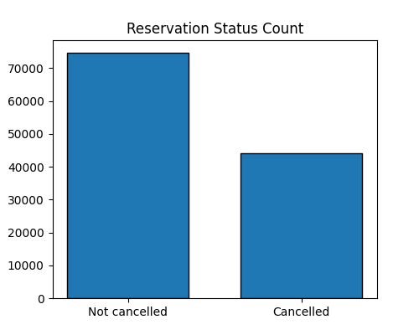

The accompanying bar graph shows the percentage of reservations that are cancelled and those that are not. It is obvious that there are still a significant number of reservations that have not been cancelled. There are still 37% of clients who cancelled their reservation, which has a significant impact on the hotel’s earnings.

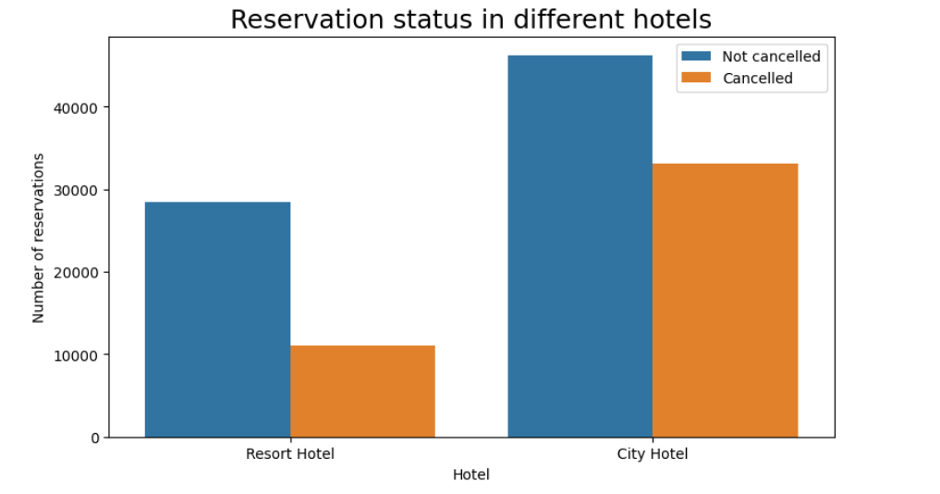

In comparison to Resort hotels, city hotels have more bookings. It’s possible that resort hotels are more expensive than those in cities.

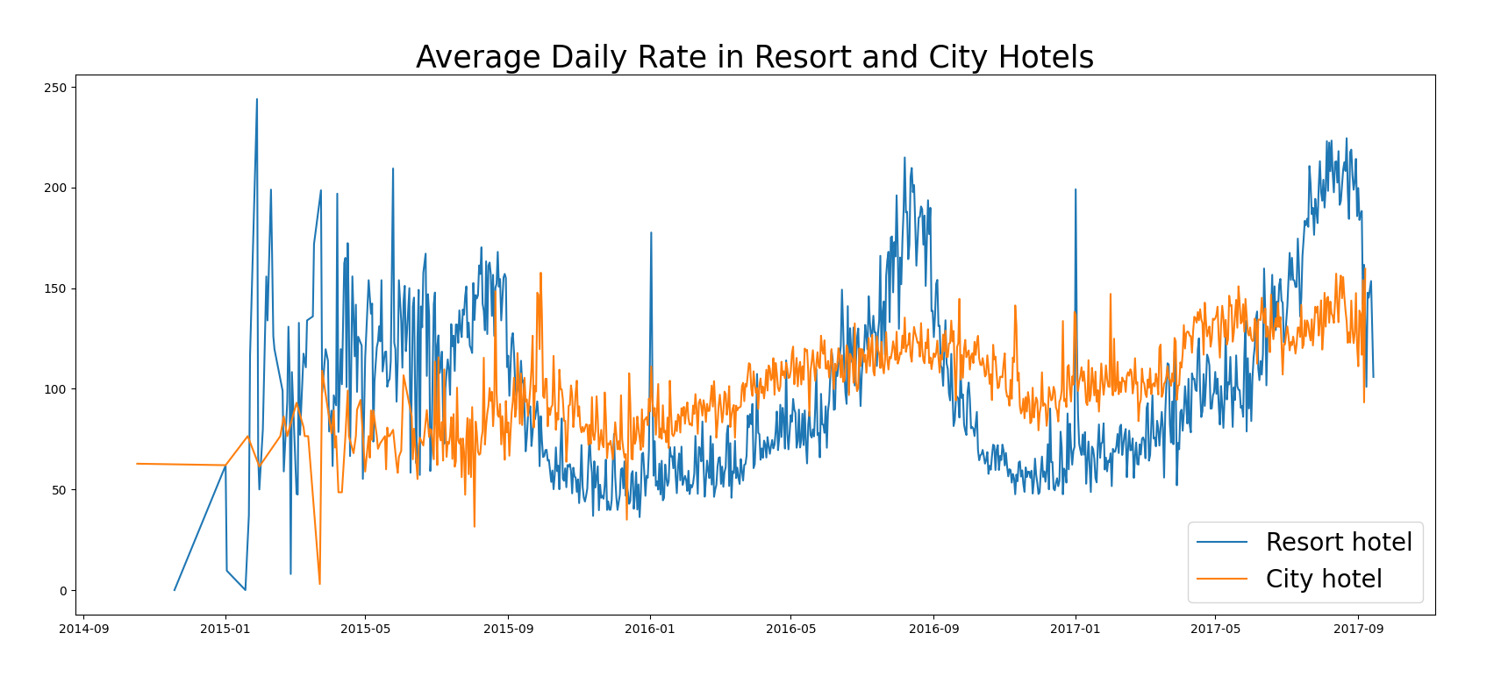

The line graph shows that, on certain days, the average daily rate for a city hotel is less than that of resort hotels. It goes without saying that on weekends and holidays may see a rise in resort hotel rates.

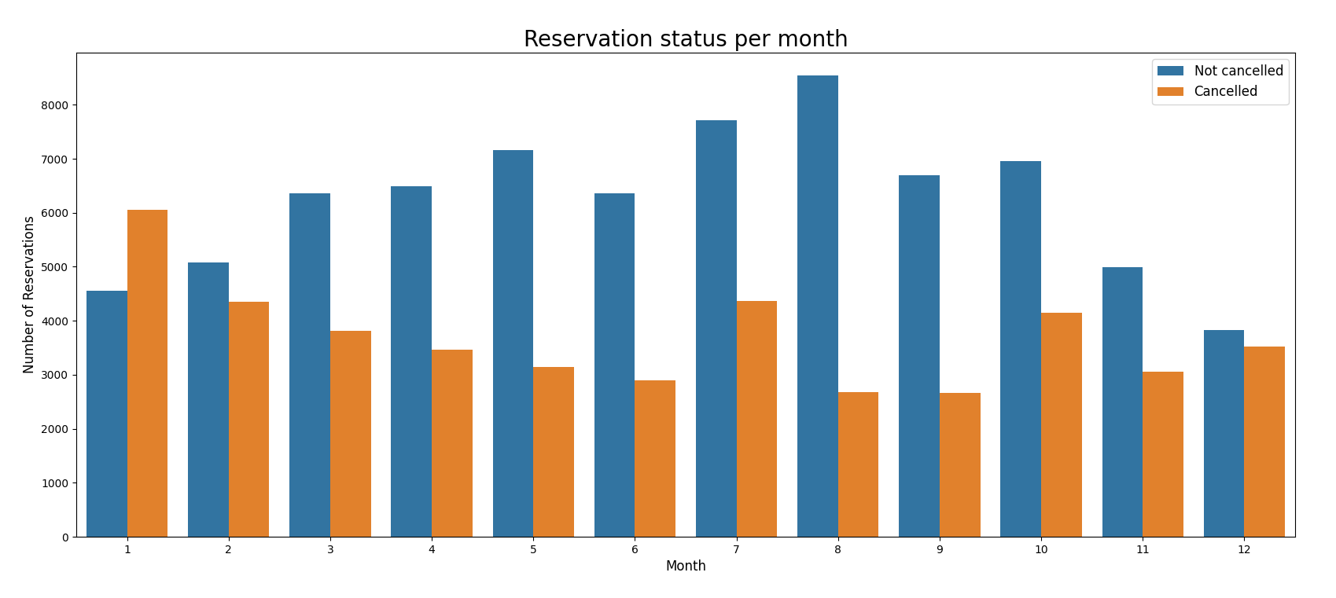

We have developed the grouped bar graph to analyze the months with the highest and lowest reservation levels according to reservation status. As can be seen, both the number of confirmed reservations are in January and the number of lowest reservations are in August.

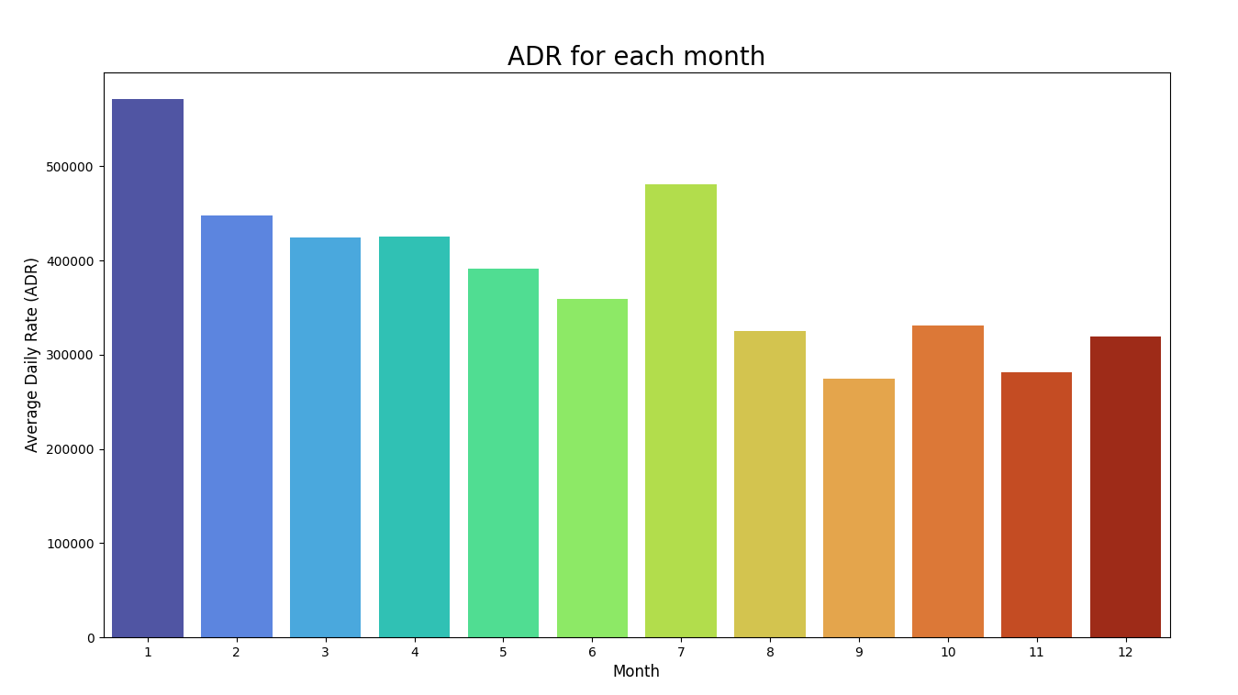

This bar graph shows that cancellations are most common when prices are greatest and least common when they are lowest. Therefore, the cost of accommodation is solely responsible for the cancellation.

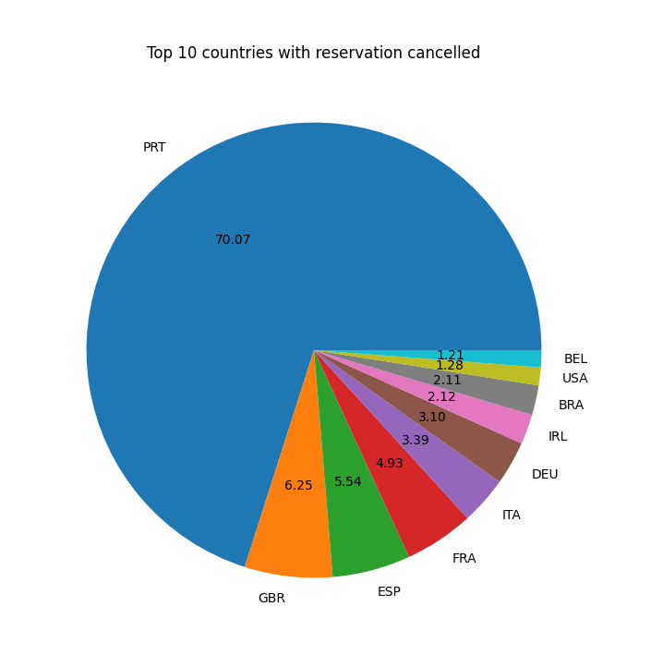Now, let’s see which country has the highest reservation cancelled. The top country is Portugal with the highest number of cancellations.

Let’s check the area from where guests are visiting the hotels and making reservations. Is it coming from Direct or Groups, Online or Offline travel agents? Around 46% of the clients come from online travel agencies, whereas 27% come from groups. Only 4% of clients book hotels directly by visiting them and making reservations.

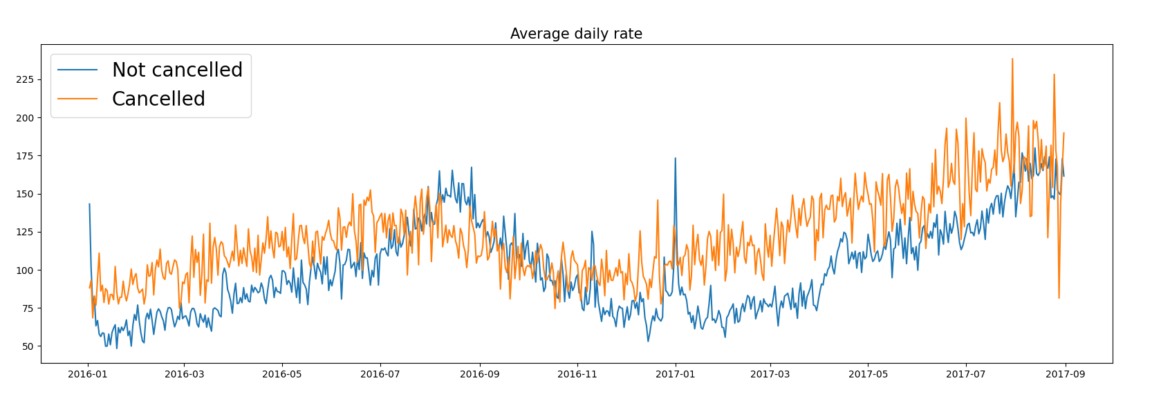

As seen in the graph reservations are cancelled when the average daily rate is higher than when it is not cancelled. It clearly proves all the above analysis, that the higher price leads to higher cancellation.

**Suggestions**

1. Cancellation rates rise as the price does. To prevent cancellations of reservations, hotels could work on their pricing strategies and try to lower the rates for specific hotels based on locations. They can also provide discounts to the customers.
2. As the ratio of the cancellation and not cancellation of the resort hotel is higher in the resort hotel than the city hotels. So, the hotels should provide a reasonable discount on the room prices on weekends or holidays.
3. In the month of January, hotels can start campaigns or marketing with a reasonable amount to increase their revenue as cancellation is the highest this month.
4. They can also increase the quality of their hotels and their services mainly in Portugal to reduce the cancellation rate.