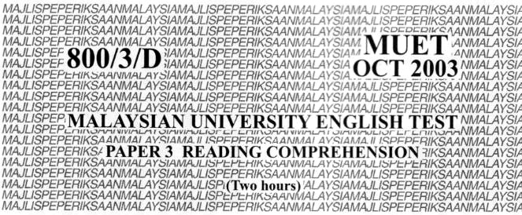

**MAJLIS PEPERIKSAAN MALAYSIA**

**(MALAYSIAN EXAMINATIONS COUNCIL)**

**Instructions to candidates:**

**DO NOT OPEN THIS QUESTIONS BOOKLET UNTIL YOU ARE TOLD TO DO SO.**

*There are fifty questions in this test. For each question, choose the most appropriate answer.*

*Indicate your answer in the separate answer sheet given.*

*Read the instructions on the answer sheet carefully.*

*Attempt* **all** *questions.*

**This question paper consists of 17 printed pages and 3 blank pages.**

**©** Majlis Peperiksaan Malaysia 2003

*Questions* **1** *to* **15** *based on the following passage.*

KUALA LUMPUR, Thurs. – A team of researchers has developed a stratified fish rearing technique, which could breed about one million fish within 0.4ha pond. Developed by Technology Park Malaysia (TPM), the technique is a novel and innovate **(1) _________** to overcome shortage faced by aquaculture **(2) _________**. The technique is similar to the concept **(3)** _________ building condominiums and flats to overcome land **(4) __________** in urban areas.

“Different fish have different **(5) _________** habits. For example, *tilapia* prefers to eat **(6) _________** the surface, others like *patin* and catfish **(7) _________** to feed at the middle and bottom **(8) ________** respectively,” said the TPM Director.

Based on **(9) _________** feeding habit, fish could be bred at **(10) ________** water levels. The ponds would be closely **(11)** _________ to ensure an adequate supply of oxygen **(12)** ________ also to prevent fish fry from being **(13)** ________ by other larger fish. At the moment, **(14) _________** of this technology still remain a well-guarded **(15) ­________** secret. The TPM Director said that a patent is pending.

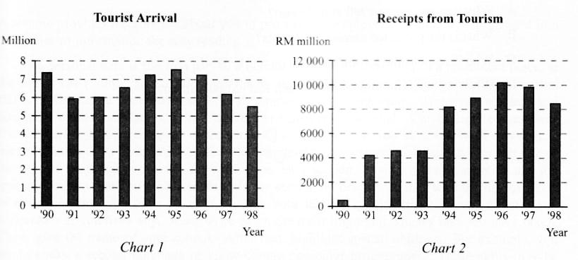*Questions* **16** *to* **19** *are based on the following charts.*

(Adapted from *The Edge,* January 31, 2000)

*Questions* **20** *to* **23** *are based on the following passage.*

A resume provides information about you to prospective employers. It should be organised into categories of information for easy reading.

The personal data is the first part of a resume. Put this information in a prominent place, at the top of the resume. It includes your name and mailing address. Your gender, age, marital status or Employee Provident Fund (EPF) number are not important. However, nowadays, a telephone contact number e-mail address is considered essential. Career aims comes next. Here, describe your career goals or the kind of job that you want. If you have any work experience, list the jobs that you have had as well as the length of time you have worked and your job title or the type of work that you did in the work experience section. You should also mention any job training courses that you have attended. In the section on education, start with the highest level of education that you have completed. List your tertiary qualification – your degrees and diplomas – if you have any. Also, write down the most important courses that you have taken. Then, give the name of your school. After that, highlight special abilities. For example, you might speak a second language or know certain computer programmes. These skills may be important in a particular job. Finally, give your reference. These are the people who will be able to give an accurate and supportive report of your character and capabilities. They may be your teachers, or even your current employer.

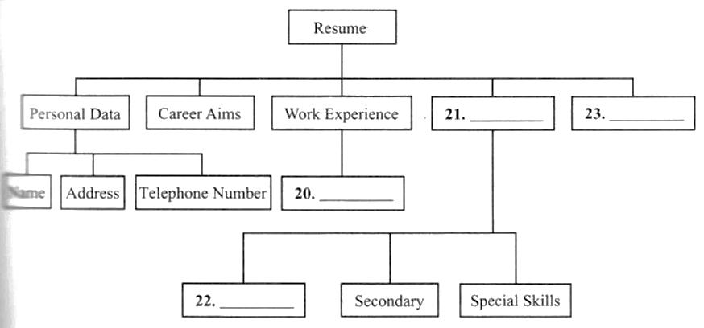

*Questions* **24** *to* **30** *are based on the following passage.*

Just 25 years ago, medical researchers boasted that victory against infectious disease was simply a matter of time. Polio had been tamed by the Salk/Sabin vaccines, and smallpox, diphtheria, and tetanus were virtually gone. Moreover, widespread antibiotic use had transformed the most terrifying diseases known to man – tuberculosis, syphilis, pneumonia, bacterial meningitis and bubonic plague - into manageable illness, if caught in time. Many who went to medical school were told not to bother going into infectious diseases and that it was better to concentrate on real problems like cancer and heart disease.

*That thinking* was destroyed by the rise era number of diseases particularly AIDS. The sight of tens of thousands of young people dying from a virus that no one had known about was a shocking experience. Faced with AIDS and an ever-increasing number of antibiotic-resistant bacteria, the medical profession has had to renew its battle against germs. The question is no longer: When will infectious diseases be wiped out? Rather, it is: Where will the next deadly new killer appear?

Scientists are watching the lethal Marburg and Ebola viruses in Africa and the Junin and Guanarito viruses in South America. Germs, which were once confined to certain regions, may now travel to all parts of the world. Two cases of malaria reported in 1991 in New York, for example, were transmitted by local mosquitoes. The mosquitoes were probably infected when they bit untreated malaria victims who had recently retired m the United States from Latin America or Asia.

These two incidents come on top of a long series of horror stories. In 1993, several deaths occurred in the U.S. Northwest from eating undercooked hamburgers tainted with a hazardous strain of *E. coli* bacteria. The rare Hantavirus, once unknown as a cause of disease in America, emerged from rodents to kill more than 50 people in the United States and Canada.

The possibility of contracting a life-threatening infectious disease is still very low - at least in the developed world. But the threats are real enough to spur medical researchers to learn more about how microbes cause disease and how to keep them at bay. It is tempting to think of the tiny pathogens that produce diseases as malevolent little beasts, out to destroy higher forms of life. *In fact, all they are u3'ink, to do* is *survive and reproduce, just as we are.* Human suffering and death are merely unfortunate by-products.

(Adapted from *Journal of Medical Science,* Vol. XII)

*Questions* **31** *to* **36** *are based on the following passage.*

I am someone who has always loved language. I spend a great deal of time thinking about the way it can evoke emotion, a visual image, a complex idea or a simple truth. *Language is the tool of my trade.* And I use them all – all the English’s I grew up with.

One day. I was giving a talk to a large group of people about my writing, my life and my book, *The Joy Luck Club.* The talk was going along well until I remembered one major difference that made the whole talk sound wrong. My mother was in the room and it was perhaps the first time she had heard me give a speech. I was saying things literary people tend to say, things like. “The intersection of memory upon imagination…” and “There is an aspect of my fiction that relates thus-and-thus”. It was a speech wrought with grammatical phrases, burdened; it seemed to me, with complex forms of standard English that I have learned in school, forms of English I did not use at home with my mother.

One day I was walking down the street with her and we were talking about the price of new and used furniture. I heard myself saying, "Not waste money that way." It was a different sort of English, “family talk”, the language I grew up with. You should know that my mother's command of spoken English belies how much she actually understands. She reads *Forbes* magazine, watches “Wall Street Week”, converses daily with her stockbroker – and grasps all kind of things I cannot begin to understand.

Yet some friends tell me they understand only 50 per cent of what my mother says. Some say they understand 80 to 90 per cent. Some say they understand none of it, as if she were speaking pure Chinese. But to me, my mother’s English is perfectly clear, perfectly natural.

Her language, as I hear it, is vivid, direct, and full of observation and imagery. That was the language that helped shape the way I saw things, expressed things, made sense of the world. I have described the kind of English my mother speaks as “broken” or “fractured”. But I wince when I say that.

It has always bothered me that I can think of no way to describe it other than “broken”, as if it were damaged and needed to be fixed, as if it lacked a certain wholeness and soundness. It limits people’s perception of the speaker. I know this because when I was growing up, I believed that my mother’s English reflected the quality of what she had to say. That is, because she expressed them imperfectly, I considered her thoughts imperfect. And I had plenty of evidence to support me: the fact that people in departmental stores, at banks, at restaurant did not take her seriously, did not give her good service, pretended not to understand her, or even acted as if they did not hear her.

My mother has long realised her limitations in English as well. And she wanted thing to be different for us. When I was growing up, *Readers’ Digest* was the only magazine that my parents subscribed to because it contained “Word Power”. That elevated *Readers’ Digest* from entertainment to education. With polysyllabic “Word Power” as our passport, our family had access to better opportunities. We – our parent’s children – could win approval and *rise like balloons above the masses.*

I think my mother’s English almost had an effect on my choice of career. The language spoken in the family, especially in immigrant families, which are more insular, plays a large role in shaping the language of the child. While my English skills were never judged as poor, compared to mathematics they could not be considered as my strong suit. In primary school, I did moderately well in English but those grades were not good enough to override the opinion that my true abilities were in mathematics and science. And I had teachers who tried to steer me away from writing and into mathematics and science. Fortunately, I happen to be rebellious in nature and enjoy dispelling *the assumptions* made about me. I became an English major my first year at university. I started writing non-fiction freelance the week after I was told by my boss that writing was my worst skill and that I should think about accounts management.

However, I later decided to envision a reader for my short stories, and I decided on my mother. So, because of this, I began to write using all the English’s I grew up with: the English I spoke to my mother, which may be termed “simple”, or “broken”; my translation of her Chinese and what I imagined to be her translation of her Chinese if she could speak in perfect English. Apart from what any critic had to say about my work I knew that I had succeeded where it counted when my other finished reading my book and gave me her verdict; “So easy to read”.

(Adapted from *Mother Tongue*, by Amy Tan)

*Questions* **37** *to* **43** *are based on the following passage*

Many wild creatures are constantly threatened with extinction. One such animal is the tiger. No more than 5000 to 7500 of the majestic carnivores remain on the entire planet – a 95 per cent decline in this century. Unless something drastic is done soon, tigers will be seen only in zoos or circuses.

Officials only recently realised the scale of the slaughter of tigers. An operation by the Indian government and TRAFFIC, an organisation that monitors the wildlife trade, uncovered a vast poaching network centre in New Delhi. One raid alone, in August 1993, yielded 617 pounds of tiger bone (equivalent to 20 tigers) and eight pelts. The operation also discovered more than a dozen families in dirty squatter houses, engaged in illicit wildlife trade. *There,* tigers are skinned, their prized parts dried and packaged, their bones cleaned and bleached. The skins, which can bring as much as £9500, travel west, often to the homes of wealthy Arabs, while the bones move east, across mountainous terrain to the Chinese border.

Indian conservationists watch dismay as this new round of poaching unravels the work of decades. Sanjay Debroy, a wildlife officer who directed a tiger reserve in Assam for more than 12 years has heard that 30 to 40 of the park’s estimated 90 tigers were killed in just four months. ‘I thought I had done something to restore the tiger.’ Debroy says, ‘but now I watch my life’s work go down the drain’.

The situation is even worse in eastern Russia’s taiga. The Amur tiger that in habits this 800-mile stretch of evergreen forest nearly disappeared during the 1930s, when Communist bigwigs would kill 10 cats in a single hunt. When state decided to protect the tigers, their population recovered from roughly 30 to as many as 400 by the late 1980s – but then tiger process surged just when fall of the Soviet Union led to economic chaos, leaving local wildlife departments broke and officials susceptible to bribes. The losses have been great. In the winter of 1992-93, some tigers were killed in the taiga. Unless the Russian government controls hunting, the Amur tiger could face extinction within two or three years.

The crises expose the shortcomings of old-line conversation efforts. Says Samuel LaBudde of the Endangered Species Project in San Francisco: The failure to address market demand – means that millions invested to save the tiger have amounted to little more than a subsidy for the Chinese traditional-medicine market.

But Western publicity campaigns, which helped reduce the demand for ivory, may have less effect on the demand for tiger bone in China, Korea, and Taiwan. And tiger-bone remedies are so *ingrained* in these cultures that their governments have been slow control to the trade. In fact, all three countries have long paid lip service to agreements protecting endangered species while continuing to do business as usual. In September 1993 the Convention on International Trade in Endangered Species of Wild Fauna and Flora (CITES) warned China and Taiwan to stop their illicit trade in tiger and rhino parts, and in April 1994 the US announced limited trade sanctions against Taiwan for its failure to do so. However, investigations by environmental groups suggest that potions made from endangered species are still readily available on the market.

Even if international pressure eliminated poaching, the tiger would still be in trouble. Its habitat and food supply is shrinking as the territory claimed by humans expands. Say Geoffrey Ward, co-author of *Tiger-Wallahs*: “Poaching is murder, but given the pressures of human population growth, crowding is slow strangulation”. Humans and tigers have coexisted for hundreds of thousands of years. Until now, the big cat has been highly adaptable and resilient. But the tiger has finally come face to face with man, who has proved to be more resourceful killer.

(Adapted from the article *Can Tigers Survive?* By Hal Linden)

*Questions* **44** *to* **50** *are based on the following passage.*

As adolescents progress through school and learn more about their strengths and weaknesses, they asked to decide what they want to do with their lives. According to a development theory of vocational choice unfolds through three stages: (1) the fantasy stage, (2) the tentative stage, and (3) the realistic stage. Children up to about age 10, who are in the *fantasy stage* of vocational development, base their choices primarily on wishes and whims, wanting to be basketball players, fire fighters, rock stars, or whatever else strikes them as glamorous and exciting. As Linda Gottfredson (1996) emphasizes, however, these youngsters are already beginning to narrow their ideas about future careers to those that are consistent with their emerging self-concepts – as human beings rather than bunnies or ninja turtles, as males or females, and so on. As early as kindergarten, for instance, almost all boys choose traditionally masculine occupations such as fire fighters for example, and most girls name traditionally female occupations such as nurse or teacher.

According to Ginzberg, it is during the second stage of vocational choice, the *tentative stage*, which adolescent aged 11 to 18 begin to weigh factors other than their wishes and to make preliminary decisions. After considering their interests (Would I enjoy counselling people?), they consider their capabilities (Am I skilled at relating to people, or am I too shy and insecure for this kind of work?). They also start thinking about their values (Is it really important to me to help people, or do I value power, money, or intellectual challenges more?). As they get older, adolescents base their vocational choices more on their values and capacities and loss on their fantasies and interests.

As adolescents leave this tentative stage, they also begin to take into account the realities of the job market and the requirements for different occupations. They might now consider the availability of job openings in a field such as psychological counselling, the years of education required, the work conditions, and so on. During this third stage of vocational choice, the *realistic stage* which spans the ages of about 18 to 22, the individual is likely to narrow things down to a specific choice based on interests, capacities, values, and available opportunities. Now a firm vocational identity is achieved and serious preparation for a chosen occupation begins.

The main developmental trend evident in Ginzberg's states is increasing realism about what one can be. As adolescents narrow down career choices in terms of both personal factors (their own interest, capacities, and values) and environmental factors (the opportunities available and tile realities of the job market), they seek the vocation that best suits them. According toinfluential vocational theorists, vocational choice is just this: an effort to find an optional fit between one's self-concept or personality and an occupation.

As they get older, adolescents from lower-income families often make compromises in their career plans. They lower their career aspirations and aim toward the jobs they think they can get rather than the jobs they may most want.

Similarly, the vocational choices of females have been and continue to be constrained by traditional gender norms. *Still,* young women are increasingly aspiring toward high-status jobs and many are seriously considering traditionally male-dominated jobs. Although many doubt their ability to attain such jobs, and they think they should aim instead toward feminine-stereotyped – and often lower status-occupations, a number of young women have broken through this invisible glass ceiling and succeeded in the world of men.

(Adapted from Carol K. Sigelman, *Life-Span Human Development*)