**Convex Optimizations – Homework 3**

**Q1.**

* 1. Implementation   
       
     Code updated
  2. Experiments  
     1. 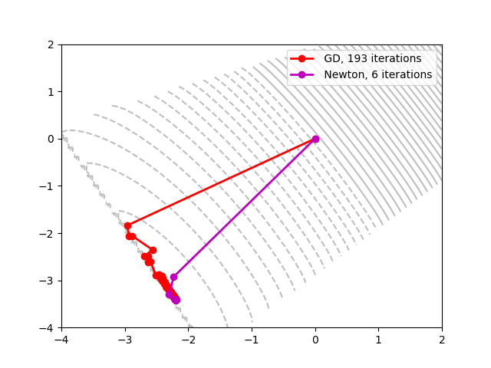  
          
          
          
          
          
          
          
          
          
          
          
          
          
          
          
          
          
          
          
          
          
        We observe that while Newton’s method converges really quickly, Gradient Descent takes a lot more iterations to converge to the same point. After a few initial iterations, GD keeps going in a ‘zig-zag’ fashion while very slowly moving towards the optimal point
     2. Over here we observe that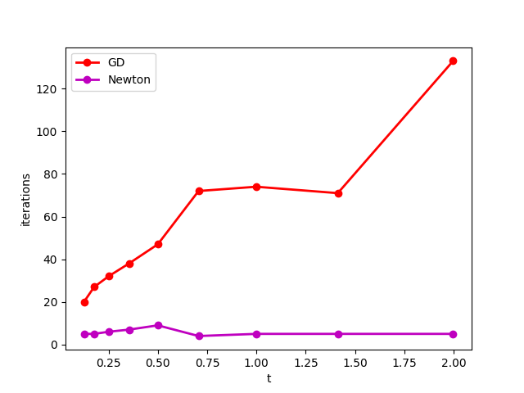 as the value of t increases, the number of iterations required by the Newton’s method is almost independent of t, while for gradient descent the number of iterations are directly proportional to the value of t

1. **Log Barrier Method**
   1. Implementation  
        
      Code updated
   2. 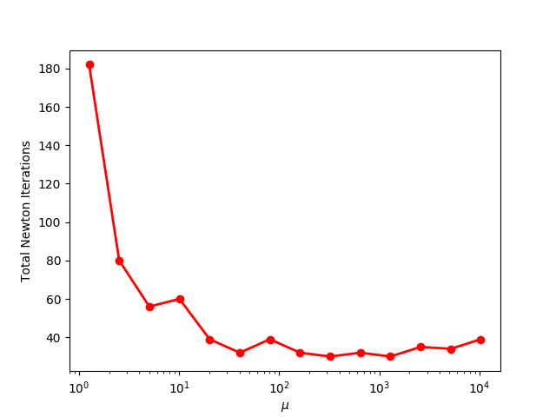Experiments  
        
        
        
        
        
        
        
        
        
        
        
        
        
        
        
        
        
        
        
        
        
        
        
        
        
        
        
        
        
        
        
        
        
      1. For small μ we expect a small number of Newton steps per outer iteration, but of course a large number of outer iterations since each outer iteration reduces the gap by only a small amount. On the other hand, if μ is large we have the opposite situation. After each outer iteration t increases a large amount, so the current iterate is probably not a very good approximation of the next iterate. Thus, we expect many more inner iterations.
      2. No, it doesn’t meet the expectations. As the value of $μ$ increases, we expect the total number of iterations to go high, but they don’t seem to.
      3. The minimum value found for the problem is approximately 30610