**Convex Optimizations – Homework 4**

**Q1. Mirror Descent**

* 1. Calculate the Fenchel conjugate of $Ψ(x)$  
       
     We know that $Ψ\left(x\right)=\frac{1}{2\left(p-1\right)} {\left\|x\right\|}_{p}^{2}$ where $1<p≤2$

Using Cauchy Shwarz inequality we get,

$$\begin{aligned}y^{T}x- \frac{1}{2\left(p-1\right)} {\left\|x\right\|}_{p}^{2}≤{\left\|y\right\|}_{*}{\left\|x\right\|}_{p}- \frac{1}{2\left(p-1\right)} {\left\|x\right\|}_{p}^{2} \#\left(1\right)\end{aligned}$$

Here, ${\left\|.\right\|}_{p}$ is the p-norm and ${\left\|.\right\|}_{*}$ is its dual norm.

Eqn (1) is true for all x, the right-hand side of the equation is quadratic in terms of ${\left\|x\right\|}_{p}$

To maximize the RHS of the inequality, we can take the derivative of the right part of the equation w.r.t ${\left\|x\right\|}_{p}$ and equate it to 0.

$$∴ {\left\|y\right\|}_{*}- \frac{2}{2\left(p-1\right)} {\left\|x\right\|}_{p}=0$$

$$\begin{aligned}∴{\left\|x\right\|}_{p}=\left(p-1\right){\left\|y\right\|}_{*}\#\left(2\right)\end{aligned}$$

By substituting the value of (2) in (1), we get,

$$y^{T}x- \frac{1}{2\left(p-1\right)} {\left\|x\right\|}_{p}^{2}≤{\left\|y\right\|}_{*} (\left(p-1\right){\left\|y\right\|}_{*})- \frac{1}{2\left(p-1\right)} {\left(\left(p-1\right){\left\|y\right\|}_{*}\right)}^{2}$$

$$\begin{aligned}∴ y^{T}x- \frac{1}{2\left(p-1\right)} {\left\|x\right\|}_{p}^{2}≤ \frac{\left(p-1\right)}{2} {\left\|y\right\|}_{*}^{2} \#\left(3\right)\end{aligned}$$

We know that dual norm follows the property,

$$\frac{1}{p}+\frac{1}{q}=1$$

where ${\left\|.\right\|}_{q}$ is the dual norm of ${\left\|.\right\|}_{p}$.

$$\begin{aligned}∴p=\frac{q}{q-1 } \#\left(4\right)\end{aligned}$$

Substituting $(4)$ in $(3)$,

$$\begin{aligned}y^{T}x- \frac{1}{2\left(p-1\right)} {\left\|x\right\|}_{p}^{2}≤ \frac{1}{2\left(q-1\right)} {\left\|y\right\|}_{q}^{2} \#\left(5\right)\end{aligned}$$

This shows that

$\begin{aligned}Ψ^{*}\left(y\right)≤ \frac{1}{2\left(q-1\right)} {\left\|y\right\|}_{q}^{2} \#\left(6\right)\end{aligned}$

To show the other inequality, let x be any vector with $y^{T}x={\left\|y\right\|}_{q}‖x‖$ scaled so that

${\left\|x\right\|}_{p}=\left(p-1\right){\left\|y\right\|}_{q}$. Then we have for this x,

$$\begin{aligned}y^{T}x- \frac{1}{2\left(p-1\right)} {\left\|x\right\|}_{p}^{2}= \frac{1}{2\left(q-1\right)} {\left\|y\right\|}_{q}^{2} \#\left(7\right)\end{aligned}$$

which shows that

$$\begin{aligned}Ψ^{*}\left(y\right)≥ \frac{1}{2\left(q-1\right)} {\left\|y\right\|}_{q}^{2} \#\left(8\right)\end{aligned}$$

From $\left(7\right) and (8)$ we can conclude that,

* 1. Calculate the gradient of $Ψ(x)$

We know that $Ψ\left(x\right)=\frac{1}{2\left(p-1\right)} {\left\|x\right\|}_{p}^{2}$ where $1<p≤2$

$$∴Ψ\left(x\right)=\frac{1}{2 (p-1)} {\left(\sum_{i=1}^{d}{{\left|x_{i}\right|}^{p}}\right)}^{\frac{2}{p}}$$

Differentiating $Ψ(x)$ w.r.t $x_{i}$,

$$\frac{δΨ}{δx_{i} }=\frac{1}{2 (p-1)}*\frac{2}{p}*{\left(\sum_{i=1}^{d}{{\left|x_{i}\right|}^{p}}\right)}^{\frac{2}{p}-1}*p*{\left|x_{i}\right|}^{p-1}*\frac{δ}{δx_{i}}|x_{i}|$$

$$=\frac{1}{p-1 }* {\left(\sum_{i=1}^{d}{{\left|x_{i}\right|}^{p}}\right)}^{\frac{2}{p}-1}* {\left|x_{i}\right|}^{p-1}*sign(x_{i})$$

$$= \frac{1}{p-1 }* {\left(\sum_{i=1}^{d}{{\left|x_{i}\right|}^{p}}\right)}^{\frac{2-p}{p}}* {\left|x_{i}\right|}^{p-1}*sign(x_{i})$$

$$∴ \frac{δΨ}{δx_{i} } =\frac{{\left|x_{i}\right|}^{p-1}}{p-1} {\left({\left\|x\right\|}_{p} \right)}^{2-p} sign\left(x_{i}\right) ∀i=1…d$$

Converting the above equation in vector form

$$\begin{aligned}∴∇Ψ=\frac{{\left\|x\right\|}_{p}^{2-p}}{p-1}*diag\left({\left|x\right|}^{p-1}\right)*sign\left(x\right) \#\left(10\right)\end{aligned}$$

Where $diag({\left|x\right|}^{p-1})$ is a matrix that has terms of ${\left|x\right|}^{p-1}$ as its diagonal elements and the rest of the terms are zero.

and is a vector of the form,

* 1. Calculate the gradient of $Ψ^{*}(x)$

From $(9)$ know that $Ψ^{*}\left(x\right)= \frac{1}{2\left(q-1\right)} {\left\|x\right\|}_{q}^{2}$

$$∴Ψ^{*}\left(x\right)=\frac{1}{2 (q-1)} {\left(\sum_{i=1}^{d}{{\left|x_{i}\right|}^{q}}\right)}^{\frac{2}{q}}$$

Differentiating $Ψ^{*}(x)$ w.r.t $x_{i}$,

$$\frac{δΨ^{*}}{δx_{i} }=\frac{1}{2 (q-1)}*\frac{2}{q}*{\left(\sum_{i=1}^{d}{{\left|x_{i}\right|}^{q}}\right)}^{\frac{2}{q}-1}*q*{\left|x_{i}\right|}^{q-1}*\frac{δ}{δx_{i}}|x_{i}|$$

$$=\frac{1}{q-1 }* {\left(\sum_{i=1}^{d}{{\left|x_{i}\right|}^{q}}\right)}^{\frac{2}{q}-1}* {\left|x_{i}\right|}^{q-1}*sign(x_{i})$$

$$= \frac{1}{q-1 }* {\left(\sum_{i=1}^{d}{{\left|x_{i}\right|}^{q}}\right)}^{\frac{2-q}{q}}* {\left|x_{i}\right|}^{q-1}*sign(x_{i})$$

$$∴ \frac{δΨ^{*} }{δx_{i} } =\frac{{\left|x_{i}\right|}^{q-1}}{q-1} {\left({\left\|x\right\|}_{q} \right)}^{2-q} sign\left(x_{i}\right) ∀i=1…d$$

Converting the above equation in vector form

$$\begin{aligned}∴∇Ψ^{*}=\frac{{\left\|x\right\|}_{q}^{2-q}}{q-1}*diag\left({\left|x\right|}^{q-1}\right)*sign\left(x\right) \#\left(11\right)\end{aligned}$$

Where $diag({\left|x\right|}^{q-1})$ is a matrix that has terms of ${\left|x\right|}^{q-1}$ as its diagonal elements and the rest of the terms are zero.

and is a vector of the form,

* 1. Write the update rule for mirror descent

The update rule for Mirror Descent can be written as,

$$X_{t+1}=∇Ψ^{*}\left(∇Ψ\left(X_{t}\right)-η_{t}g_{t}\right) …(given)$$

From $\left(10\right)$ we get,

$$∴X_{t+1}=∇Ψ^{*}\left(\frac{{\left\|X_{t}\right\|}_{p}^{2-p}}{p-1}*diag\left({\left|X_{t}\right|}^{p-1}\right)*sign\left(X_{t}\right)- η_{t}g_{t}\right)$$

From (11) we get,

$$∴X_{t+1}= \frac{1}{q-1 }{\left\|\frac{{\left\|X_{t}\right\|}_{p}^{2-p}}{p-1}*diag\left({\left|X_{t}\right|}^{p-1}\right)*sign\left(X_{t}\right)- η_{t}g_{t}\right\|}_{q}^{2-q}*diag\left({\left|\frac{{\left\|X_{t}\right\|}_{p}^{2-p}}{p-1}*diag\left({\left|X_{t}\right|}^{p-1}\right)*sign\left(X_{t}\right)- η_{t}g_{t}\right|}^{q-1}\right)*sign\left(\frac{{\left\|X_{t}\right\|}_{p}^{2-p}}{p-1}*diag\left({\left|X_{t}\right|}^{p-1}\right)*sign\left(X_{t}\right)- η_{t}g_{t}\right)$$

1. Programming Exercise

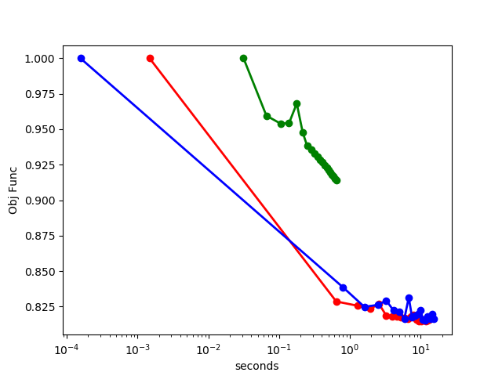Plot 1:

Plot 2:

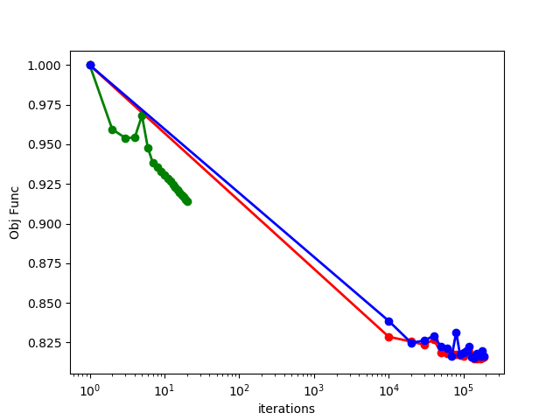

OUTPUT:

Solution found by stochastic subgradient descent

[[-3.82766340e-01], [-3.81199210e-02], [-1.33802728e-02], [-5.23892968e-01], [ 3.87125284e-04], [ 7.92598865e-01], [-1.63058725e-02], [ 9.88906872e-03], [ 9.18107436e-02], [ 1.54241552e-01], [ 3.11034142e-02], [ 2.14837698e-02], [-4.36862199e-02], [ 1.65145408e-01], [-2.44947948e-02], [ 2.29216069e-02], [-2.31771226e-02], [ 2.58326202e-01], [ 1.33468110e-02], [ 3.95091361e-03], [-3.98102673e-02], [-2.66643596e-01], [ 9.17257424e-01], [ 1.17738321e+00], [ 6.17161348e-01], [-1.51896124e+00], [ 2.42179921e+00], [-3.84489995e+00]]

Objective function 0.8148441242106866

Solution found by stochastic adagrad

[[-2.93993292e-01], [-8.47177834e-02], [-1.56053677e-03], [-4.88253260e-01], [ 2.84568649e-02], [ 7.90104525e-01], [ 6.62801863e-03], [-2.14067903e-03], [ 9.02412127e-02], [ 1.59807984e-01], [-3.86026941e-02], [-2.24010421e-02], [-3.81838505e-02], [ 2.20424331e-01], [ 4.63755831e-02], [-2.89309034e-02], [-5.72662586e-02], [ 2.29611015e-01], [-3.16711860e-02], [ 3.35261481e-03], [-3.68488598e-02], [-2.38980461e-01], [ 8.62666343e-01], [ 1.18104634e+00], [ 6.32419470e-01], [-1.52388920e+00], [ 2.91419386e+00], [-4.42720816e+00]]

Objective function 0.8176521573618533

Solution found by subgradient descent

[[-0.02582542], [-0.01474747], [-0.00618211], [-0.21100792], [ 0.00319675], [ 0.22824581], [-0.00754905], [ 0.00146226], [ 0.14210423], [ 0.12311359], [ 0.01842417], [-0.005359 ], [-0.05565465], [ 0.12481449], [ 0.00288305], [ 0.01901484], [ 0.00618816], [ 0.19496673], [-0.01605185], [ 0.0104227 ], [ 0.05892398], [ 0.05372047], [ 0.14753203], [ 0.20979349], [ 0.08846406], [-0.39405411], [-0.04870572], [-0.1612745 ]]

Objective function 0.9125785012725371