**Que 1 :- How are inline and block elements different from each other?**

**Ans 1:**

**Code:-** <!doctype html>

<html>

<head>

<title>Learning | to the new</title>

<style>

#inline_block{

width:960px;

margin: auto;

height: auto;

}

#inline_block{

font-family: calibri;

font-size:1.2em;

color:dimgrey;

}

#inline_block .in_block{

width: 150px;

height: 100px;

background-color: brown;

margin: 10px;

display: inline-block;

}

#block{

width:960px;

margin: auto;

height: auto;

}

#block{

font-family: calibri;

font-size:1.2em;

color:dimgrey;

}

#block .in_block{

width: 150px;

height: 100px;

background-color: brown;

margin: 10px;

}

</style>

</head>

<body>

<div id="inline_block">

<h1>Block are displayed Inline</h1>

<div class="in_block">

</div>

<!--in_block-->

<div class="in_block">

</div>

<!--in_block-->

<div class="in_block">

</div>

<!--in_block-->

<div class="in_block">

</div>

<!--in_block-->

</div>

<!--inline_block-->

<div id="block">

<h1>Boxes are displayed in Blocks</h1>

<div class="in_block">

</div>

<!--in_block-->

<div class="in_block">

</div>

<!--in_block-->

<div class="in_block">

</div>

<!--in_block-->

<div class="in_block">

</div>

<!--in_block-->

</div>

<!--inline_block-->

</body>

</html>

**Output:-**

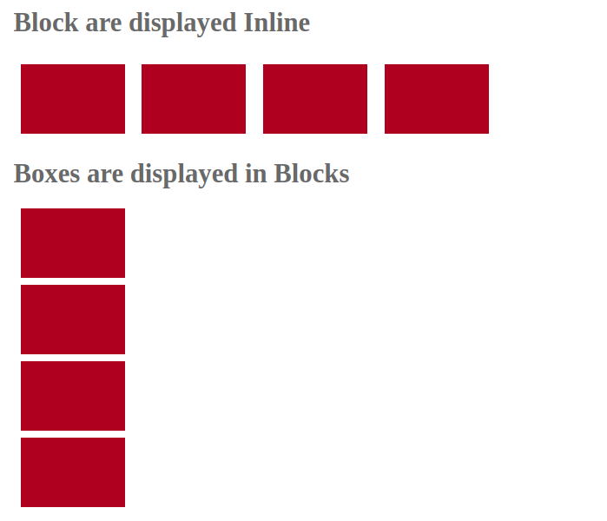

**Que 2:- Explain the difference between visibility:hidden and display:none?**

**Ans 2:- display:none** :- this property of css is used to not to display block.

**Visibility :hidden** :- this property of css is also used to hide the block

But the difference between these property is

**Display:none** :- space/area is not allocated to a block but it doesnot appear on page

**Visibility :hidden** :- space/area is allocated to block but it doesnot appear on page

**Que 3**:-**Explain the clear and float properties.**

**Ans 3**:- **float** :- float property is used to makes the block float

**Clear** :- clear property is used to remove the float

**Que 4:- Explain difference between absolute, relative,fixed and static.**

**Ans 4:- absolute :-** absolute property of css is used to define the position of block.

Absolute property is defined position according to its ancestor

**Relative** :- Relative property change its position from its normal position

**Fixed** :- fixed property is used to fix the position of block which doesnot change its position on scrolling of page.

**Static** :- Static property is by default position which is doesnot affect by top,bottom,left,right.

**Que 5:- Write the HTML code to create a table in which there are 4 columns( ID , Employee Name, Designation, Department) and at least 6 rows. Also do some styling to it.**

**Ans 5**:-**Code:-** <!doctype html>

<html>

<head>

<title>Table</title>

<style>

table{

width: 500px;

height: auto;

margin: auto;

font-family: Arial;

border: #000 thin solid;

}

table tr{

padding: 20px;

border: #000 thin solid;

}

table tr th{

text-transform:capitalize;

font-style: initial;

padding: 15px;

background-color:#000;

color: #fff;

}

table tr td{

padding: 10px;

}

</style>

</head>

<body bgcolor="pink">

<h1><center>Table design</center></h1>

<table border="0">

<thead>

<tr>

<th>Id</th>

<th>Employee Name</th>

<th>Designation</th>

<th>Department</th>

</tr>

<tr>

<td>3221</td>

<td>Harshdeep Singh</td>

<td>MEAN</td>

<td>Development</td>

</tr>

<tr>

<td>3222</td>

<td>Varnit Goyal</td>

<td>MEAN</td>

<td>Development</td>

</tr>

<tr>

<td>3223</td>

<td>Deepanshu Singh</td>

<td>DevOps</td>

<td>Development</td>

</tr>

<tr>

<td>3224</td>

<td>Sounak Gutpa</td>

<td>FEEN</td>

<td>Development</td>

</tr>

<tr>

<td>3225</td>

<td>Prabal Gutpa</td>

<td>FEEN</td>

<td>Development</td>

</tr>

<tr>

<td>3225</td>

<td>Swapnil yadav</td>

<td>FEEN</td>

<td>Development</td>

</tr>

</thead>

</table>

</body>

</html>

**Output:-** 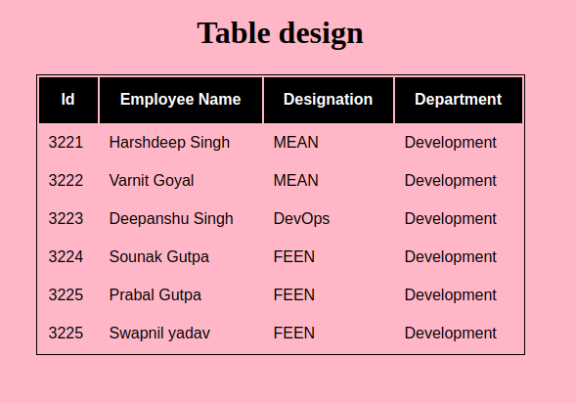

**Que 6:- Why do we use meta tags?**

**Ans 6:-** meta tag is used for adding keyword,descriptions,author name,copyright etc

Meta tag also help for browser to get the information about website.it is also used for Search Engine Optimazation.

<meta name=”author” content=”etc”>

<meta name=”description” content=”this is a demo content used for assignment”>

<meta name=”keywords” content=”learning,tothenew,assignement”>

**Que 7:- Explain box model.**

**Ans 7:-** HTML is block design which is divided into various box. So here we use box model to divide the content in the form of block.

Box model also used in css to divide content through

Content,margin,padding,border.

**Content**:- Content is used to display text,images etc.

**Margin** :- Margin is used to add margin between the content where content are divided without carrying space.

**Padding** :- padding is also used to divide content but the difference between margin and padding carry space but margin doesnot. It is also called inside margin

**Border** :- border is used to add border on the content.

**Que 8:-What are the different types of CSS Selectors?**

**Ans 8:-** CSS Selectors are generally pattern which is used to add css on Id’s, classes and html elements.

**Like:- .id ,#class ,p etc.**

**Que 9:-Define Doctype.**

**Ans 9:-** Doctype is used to define the version of html which we are used in code like html 4,html5.

**Like :- <!Doctype html>, <!Doctype html public “-//w3c//dtc html 4.01/en/strict.dtd”.**

**Que 10 :- HTML5 semantic tags.**

**Ans 10:- Semantic tags are those tag which are not used in html4 but to be as name in html5**

**Like :- <header>,<footer>,<span> etc**

**Que 11 :- create HTML for web-page.jpg (check resources, highest weightage for answers)**

**Ans 11:-**

**Code :-**

**webpage.html**

**<!DOCTYPE html>**

**<html>**

**<head>**

**<title>webpage|layout</title>**

**<link href="web.css" rel="stylesheet">**

**</head>**

**<body>**

**<div id="main">**

**<header>**

**<div id="container">**

**<h1>TO The New</h1>**

**<ul style="padding-left: 5px;">**

**<li>Text Link</li>**

**<li>Text Link</li>**

**<li>Text Link</li>**

**<li>Text Link</li>**

**<li>Text Link</li>**

**</ul>**

**</div>**

**<!--container-->**

**</header>**

**<div id="main_con">**

**<div id="black">**

**<p>960 x 360 px</p>**

**</div>**

**<!--black-->**

**<div id="l_grey">**

**<p>Lorem Ipsum is simply dummy text of the printing and typesetting industry.**

**Lorem Ipsum has been the industry's**

**standard dummy text**

**ever since the 1500s, when an unknown printer took a**

**galley of type and scrambled it to make a type specimen book.**

**</p>**

**</div>**

**<!--l_grey-->**

**<div id="bottom">**

**<h2>Latest from the gallery</h2>**

**<div class="b_block">**

**<section>**

**</section>**

**<p>Image Caption Here</p>**

**</div>**

**<!--block-->**

**<div class="b_block">**

**<section>**

**</section>**

**<p>Image Caption Here</p>**

**</div>**

**<!--block-->**

**<div class="b_block">**

**<section>**

**</section>**

**<p>Image Caption Here</p>**

**</div>**

**<!--block-->**

**<div class="b_block">**

**<section>**

**</section>**

**<p>Image Caption Here</p>**

**</div>**

**<!--block-->**

**</div>**

**<footer>**

**<section id="f_con">**

**<p>Copyright &copy; 2009-2017-All Rights Reserved-To the New</p>**

**<span> Web layout to the new</span>**

**</section>**

**</footer>**

**</div>**

**<!--main_con-->**

**</div>**

**<!--main-->**

**</body>**

**</html>**

**CSS:-**

**body{**

**background-color: #3b3b3b;**

**}**

**#main header{**

**width: 90%;**

**height: 140px;**

**background-color: #353535;**

**margin: auto;**

**margin-top: -17px;**

**}**

**#main header #container{**

**width:960px;**

**margin: auto;**

**}**

**#main header #container h1{**

**font-family: 'Times New Roman', Times, serif;**

**font-size:16px;**

**color: #fff;**

**padding: 25px 0px 10px 10px;**

**font-size: 25px;**

**}**

**#main header #container ul{**

**background-color: #000;**

**}**

**#main header #container ul li{**

**display: inline-block;**

**padding: 12px 10px 10px 13px;**

**color: #fff;**

**}**

**#main #main_con{**

**width: 90%;**

**margin: auto;**

**background-color: #fff;**

**position: relative;**

**top: -35px;**

**}**

**#main #main_con #black{**

**width: 960px;**

**height:360px;**

**background-color: #000;**

**margin: auto;**

**}**

**#main #main_con #black p{**

**color: #fff;**

**font-size: 35px;**

**text-align: center;**

**position: relative;**

**top: 180px;**

**}**

**#main #main_con #l_grey{**

**width: 960px;**

**margin:auto;**

**background-color: #ccc;**

**}**

**#main #main_con #l_grey p{**

**padding: 13px;**

**font-family: calibri;**

**font-size: 15px;**

**color:#333**

**}**

**#main #main_con #bottom{**

**width:960px;**

**margin:auto;**

**}**

**#main #main_con #bottom h2{**

**font-family: Arial, Helvetica, sans-serif;**

**font-size: 15px;**

**color: #333;**

**border-bottom:thin solid #666;**

**}**

**#main #main_con #bottom .b_block{**

**width: 215px;**

**height: 315px;**

**background-color: #ccc;**

**border: thin solid #ccc;**

**float: left;**

**margin: 8px;**

**}**

**#main #main_con #bottom .b_block section{**

**width: 100%;**

**height:290px;**

**background-color:#333;**

**}**

**#main #main_con #bottom .b_block p{**

**text-align: center;**

**font-family: arial;**

**font-size: 13px;**

**margin-top: 7px;**

**}**

**#main #main_con footer{**

**width: 100%;**

**height: 60px;**

**background-color: #000;**

**clear: both;**

**}**

**#main #main_con footer #f_con{**

**width: 960px;**

**height: auto;**

**margin: auto;**

**}**

**#main #main_con footer #f_con p{**

**float: left;**

**font-size: 13px;**

**padding: 10px;**

**color:#ccc;**

**}**

**#main #main_con footer #f_con span{**

**float: right;**

**margin-top: 25px;**

**font-size: 13px;**

**color: #ccc;**

**}**

**12. Create HTML for form.png (check resources, highest weightage for answers)**

**Ans 12:-**

**Code:-<!DOCTYPE html>**

**<html>**

**<head>**

**<title>form</title>**

**<Style>**

**#main{**

**width: 100%;**

**margin: auto;**

**height: auto;**

**}**

**#main #container{**

**width: 960px;**

**height: 70px;**

**margin: auto;**

**border-bottom:thin solid rgb(187, 186, 186);**

**}**

**#main #container h1{**

**font-family: arial,calibri,'Times New Roman', Times, serif;**

**font-size: 1.2em;**

**color: #00c69a;**

**float: left;**

**}**

**#main #container ul{**

**float: right;**

**}**

**#main #container ul li{**

**display: inline-block;**

**color: #00c69a;**

**}**

**#main #container ul li:first-child{**

**margin-right: 10px;**

**}**

**#main #form{**

**width: 500px;**

**height: auto;**

**border: thin solid #333;**

**border-radius: 2%;**

**margin: auto;**

**position: relative;**

**top: 50px;**

**overflow: hidden;**

**}**

**#main #form h1{**

**font-family:arial,'Times New Roman', Times, serif;**

**margin-top: 0px;**

**font-size: 22px;**

**padding: 20px 0px 20px 20px;**

**background-color:#bac1ca;**

**color: #fff;**

**}**

**#main #form table{**

**width: 90%;**

**margin: auto;**

**}**

**#main #form table tr td{**

**width: 100%;**

**font-family:arial;**

**font-size: 14px;**

**}**

**#main #form table tr td input[type="text"]{**

**width: 100%;**

**padding: 7px 0px 0px 0px;**

**border-radius: 10%;**

**border: thin solid #666;**

**}**

**#main #form table tr td textarea{**

**border-radius: 4%;**

**width: 100%;**

**height: 80px;**

**}**

**#main #form table tr td select{**

**border-radius: 6%;**

**width: 100%;**

**padding-top: 8px;**

**padding-bottom: 8px;**

**color: #fff;**

**background-color: #00c69a;**

**border: none;**

**text-transform: capitalize;**

**}**

**#main #form table tr td #vers{**

**width: 80px;**

**}**

**#main #form #send{**

**width: 100%;**

**height: 30px;**

**background-color: #eceef1;**

**padding:25px 0px 30px 0px;**

**position: relative;**

**margin-top: 10px;**

**}**

**#main #form #send input[type="submit"]{**

**background-color:#00c69a;**

**border-radius: 10%;**

**padding: 10px;**

**color: #fff;**

**border: none;**

**text-transform: capitalize;**

**font-size: 16px;**

**position: absolute;**

**right: 0px;**

**margin-right:30px;**

**}**

**#main #form table tr td input[type="file"]{**

**border-radius: 6%;**

**width: 100%;**

**padding-top: 5px;**

**padding-bottom: 5px;**

**color: #fff;**

**background-color: #00c69a;**

**border: none;**

**text-transform: capitalize;**

**}**

**#main #form table tr td input[type="button"]{**

**border-radius: 6%;**

**width: 100%;**

**padding-top: 5px;**

**padding-bottom: 5px;**

**color: #fff;**

**background-color: #00c69a;**

**border: none;**

**text-transform: capitalize;**

**}**

**</Style>**

**</head>**

**<body>**

**<div id="main">**

**<section id="container">**

**<h1>To the New</h1>**

**<ul>**

**<li>Home</li>**

**<li>Quick help</li>**

**</ul>**

**</section>**

**<div id="form">**

**<h1>Bug Report</h1>**

**<form name="demo">**

**<table>**

**<tr>**

**<td>Title*</td>**

**</tr>**

**<tr>**

**<td><input type="text" name="title"></td>**

**</tr>**

**<tr>**

**<td>Description*</td>**

**</tr>**

**<tr>**

**<td><textarea name="desc"></textarea></td>**

**</tr>**

**<tr>**

**<td>Operating system:</td>**

**</tr>**

**<tr>**

**<td>**

**<select id="format">**

**<option>window xp</option>**

**<option>linux</option>**

**</select>**

**</td>**

**</tr>**

**<tr>**

**<td>Product:*</td>**

**</tr>**

**<tr>**

**<td>**

**<select>**

**<option>Formoid</option>**

**<option>Android</option>**

**</select>**

**</td>**

**</tr>**

**<tr>**

**<td>Version.*</td>**

**</tr>**

**<tr>**

**<td><input type="text" id="vers"></td>**

**</tr>**

**<tr>**

**<td>License:</td>**

**</tr>**

**<tr>**

**<td><input type="radio" name="free">Free&nbsp;&nbsp;&nbsp;&nbsp;&nbsp;**

**&nbsp;&nbsp;&nbsp;&nbsp;&nbsp;&nbsp;&nbsp;&nbsp;**

**<input type="radio" name="free">Business</td>**

**</tr>**

**<tr>**

**<td>Severity</td>**

**</tr>**

**<tr>**

**<td><select>**

**<option>severity</option>**

**</select>**

**</td>**

**</tr>**

**<tr>**

**<td>Attachments</td>**

**</tr>**

**<tr>**

**<td><input type="file"></td>**

**</tr>**

**</table>**

**<section id="send">**

**<input type="submit" value="send">**

**</section>**

**</form>**

**</div>**

**</div>**

**</div>**

**</body>**

**</html>**

**Output :-**

