**Introduction to Version Control**

Que 1- Git Setup <https://confluence.atlassian.com/bitbucket/set-up-git-744723531.html>

Ans :- Git is working 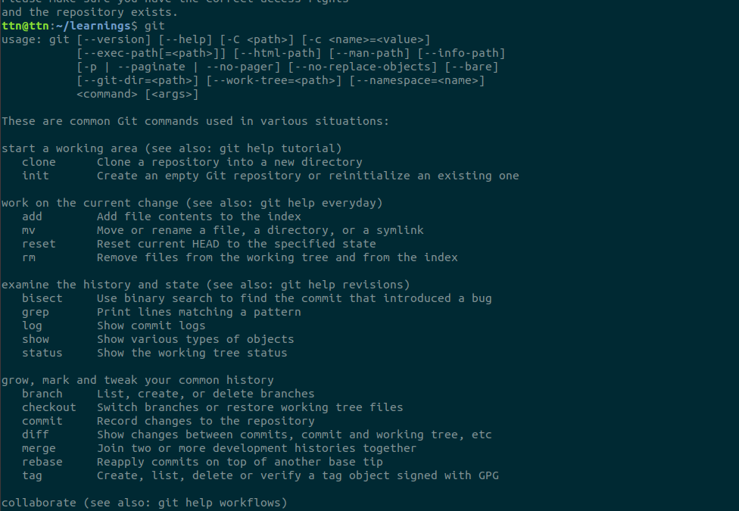

Que2 :- Initialize a Git Repository

Ans:-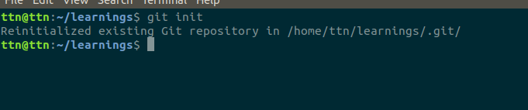

Que3 :- Add files to the repository

Ans 3:- 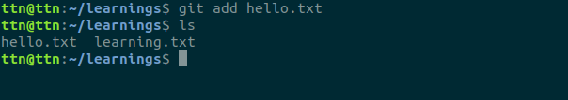

Que4 :- Unstage 1 file

Ans 4 :-

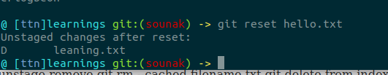

Que5 :- Commit the file

Ans 5:- 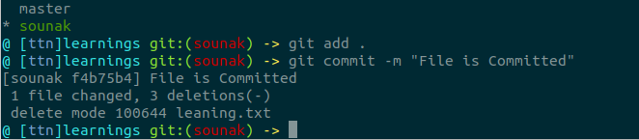

Que 6:- Add a remote

Ans 6:-

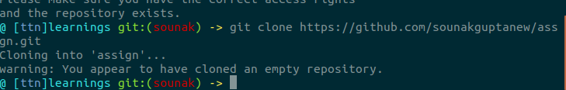

Que 7:- Undo changes to a particular file

Ans 7:- 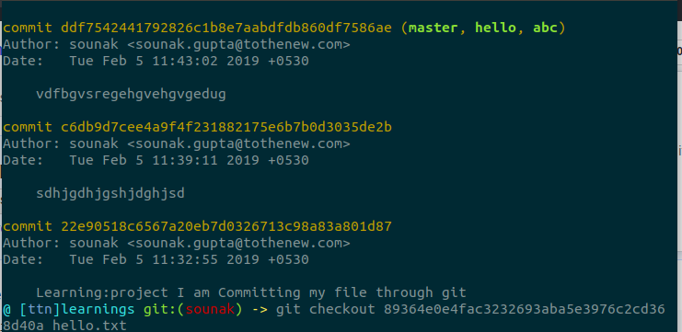

Que 8:- Push changes to Github

Ans 8:- 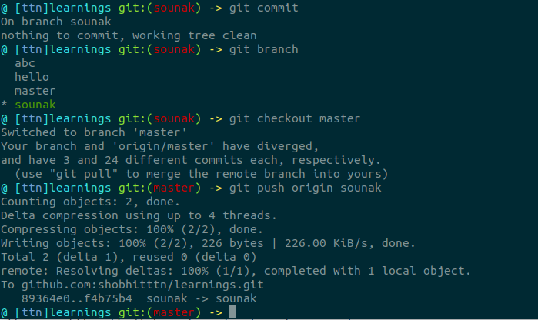

Que 9:- Clone the repository

Ans 9:-

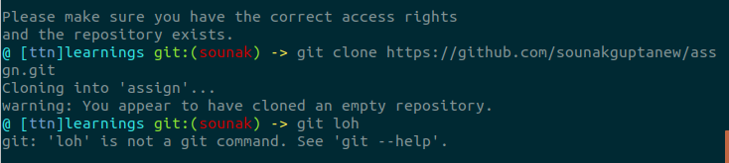

Que 10:- Add changes to one of the copies and pull the changes in the other.

Ans 10:- 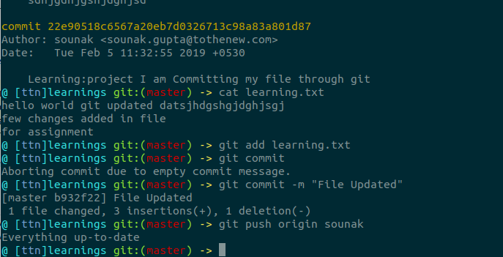

Que 11:- Check differences between a file and its staged version

Ans 11:-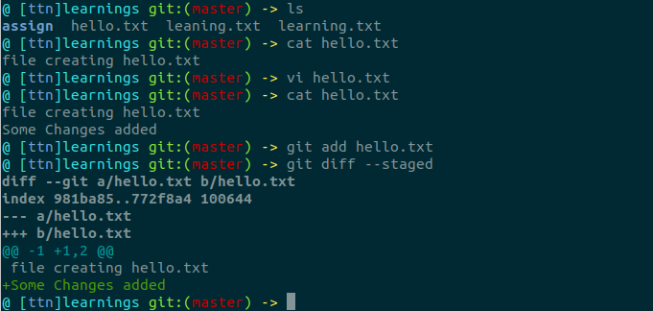

Que 12 :- Ignore a few files to be checked in

Ans 12:-

:- 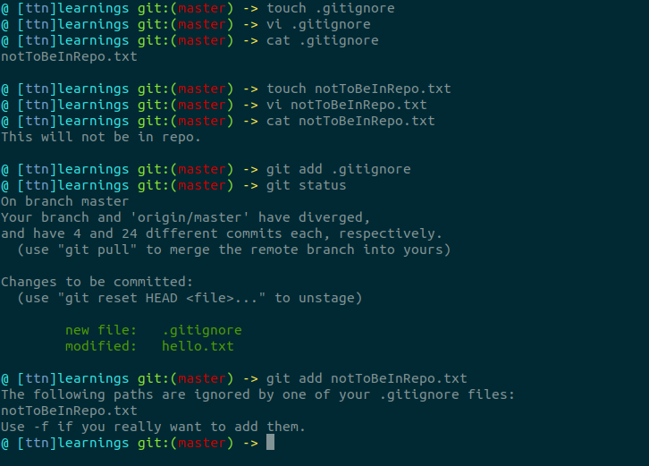

Que 13:- Create a new branch.

Ans 13:- 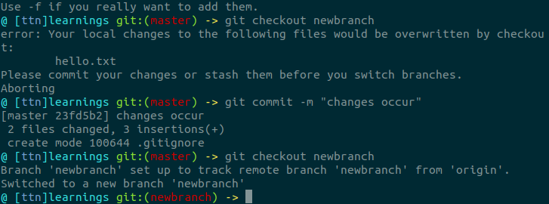

Que14 :- Diverge them with commits

Ans 14:-

Que 15:- Edit the same file at the same line on both branches and commit

Ans 15:-

Que 16:- Try merging and resolve merge conflicts

Ans:-

Que 17:- Stash the changes and pop them

Ans 17 :- 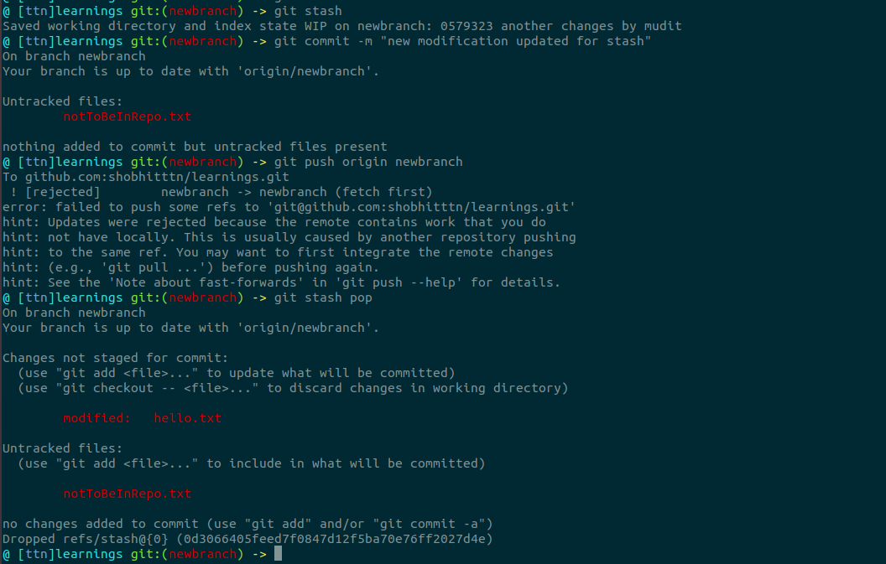

Que18:- Add the following code to your .bashrc file : color_prompt="yes"  
parse_git_branch() {  
git branch 2> /dev/null | sed -e '/^[^*]/d' -e 's/* \(.*\)/(\1)/'  
}  
if [ "$color_prompt" = yes ]; then  
PS1='\u@\h\[\033[00m\]:\[\033[01;34m\]\W\[\033[01;31m\] $(parse_git_branch)\[\033[00m\]\$ '  
else  
PS1='\u@\h:\W $(parse_git_branch)\$ '  
fi  
unset color_prompt force_color_prompt

Ans:- 