**Document**

The **Document interface** represents any web page loaded in the browser and serves as an entry point into the web page's content, which is the DOM tree. When an HTML document is loaded into a **web browser**, it becomes a document object. It is the root node of the HTML document. The document actually gets loaded inside the window object and has properties available to it like title, URL, cookie, etc. HTML documents, served with the **"text/HTML"** content type, also implement the HTMLDocument interface, whereas XML and SVG documents implement the XMLDocument interface.**window.document** or just **document**is the main object of the potentially visible (or better yet: rendered) document object model/DOM. Since window is the global object you can reference any properties of it with just the property name-so you do not have to write down window- it will be figured out by the runtime

**Window**

The JavaScript **window object** sits at the top of the JavaScript Object hierarchy and represents the browser window. The window object is supported by all browsers. All global **JavaScript objects**, functions, and variables automatically become members of the window object. The window is the first thing that gets loaded into the **browser**. This window object has the majority of the properties like length, inner width, inner height, name if it has been closed, its parents, and more.

The window object represents the current **browsing context**. It holds things like windows. location, window. history, window.screen, window. status, or the **window. document**. Each browser tab has its own top-level window object. Each of these windows gets its own separate global object. window. window always refers to a window, but a **window. parent** and window. top might refer to enclosing windows, giving access to other execution contexts. Moreover, the window property of a window object points to the window object itself. So the following statements all return the same window object.

**Window**is the main JavaScript object root, aka the **global object**in a browser, also can be treated as the root of the document object model. You can access it as **window.**

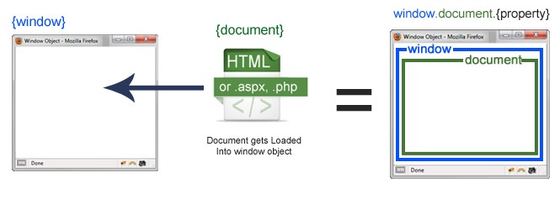

**SCREEN**

A screen is a small information object about physical **screen dimensions**. It can be used to display screen width, height, color depth, pixel depth, etc. It is not mandatory to write a **window prefix** with screen objects. It can be written without the window prefix. The **Window**object also has a **screen**object with properties describing the physical display:

* screen properties width and height are the full screens
* screen properties availWidth and availHeight omit the toolbar

**window. screen** or just **screen**is a small information object about physical screen dimensions.