**ASSIGNMENT 6.3**

**on**

**Documentation and Security**

**Submitted by:**

**Haseebullah Shaikh (2303.KHI.DEG.015)**

**Faiza Gulzar Ahmed (2303.KHI.DEG.001)**

**and**

**Aqsa Tauheed (2303.KHI.DEG.001)**

**Dated:** 25th May 2023

**Task:**

**1. Provide a template Sphinx command line command which auto documents your project. Explain what each flag and each element of your command do.**

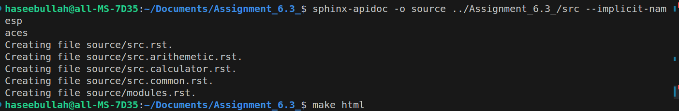

The above command uses sphinx-apidoc, that is a tool provided by sphinx to auto doc the python code files.

**Elements and flags commands:**

1. **Sphinx-apidoc :**  It is a tool which is provided by sphinx which auto docs your project code files,
2. -**o** source: It will store the generated sources and output files in directory named source, it will create by itself if it doesn’t exist.
3. Module path - ../Assignment_6.3/src : It is the path of project which is to be auto documented.
4. **Flag:** --implicit-namespaces **:** This flag allows sphini-apidoc to automatically access the directories within the specified module and generate the docs for the code files within the directories , like we have directories in our task calculator, arithmetic, and common.

**2. What flag should you add if you use implicit namespaces in your project?**

We should use –implicit-namespaces with above command because by default modules are only auto documented by sphinix, it allows sphinix-apidoc to auto document given project in the path by understanding path structure and documents files within the directories and their functions.

**HTML documentation Output**

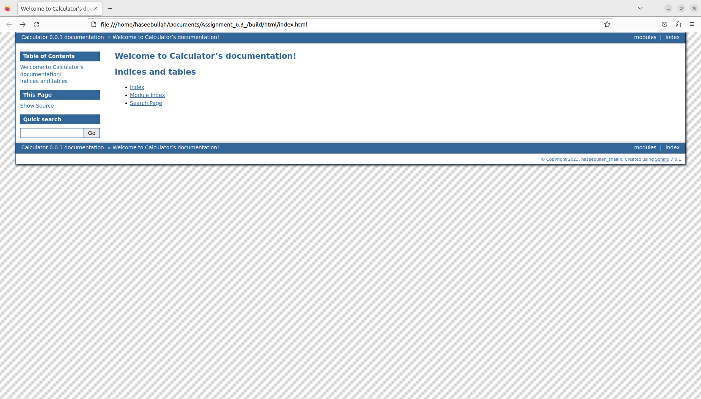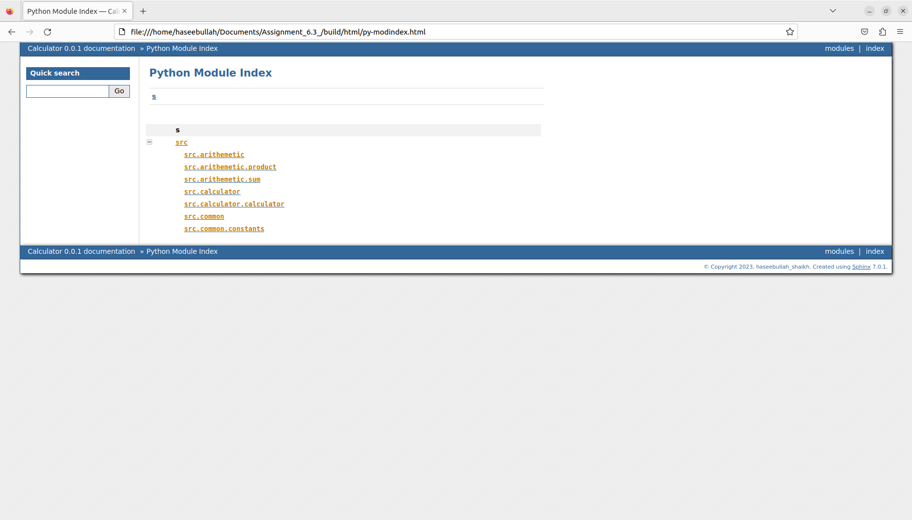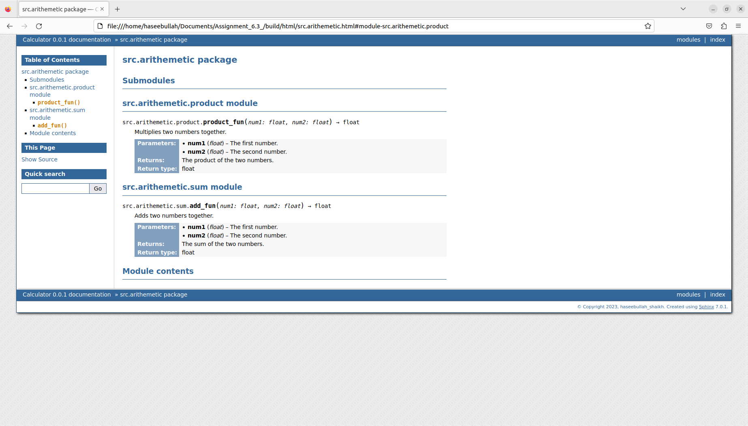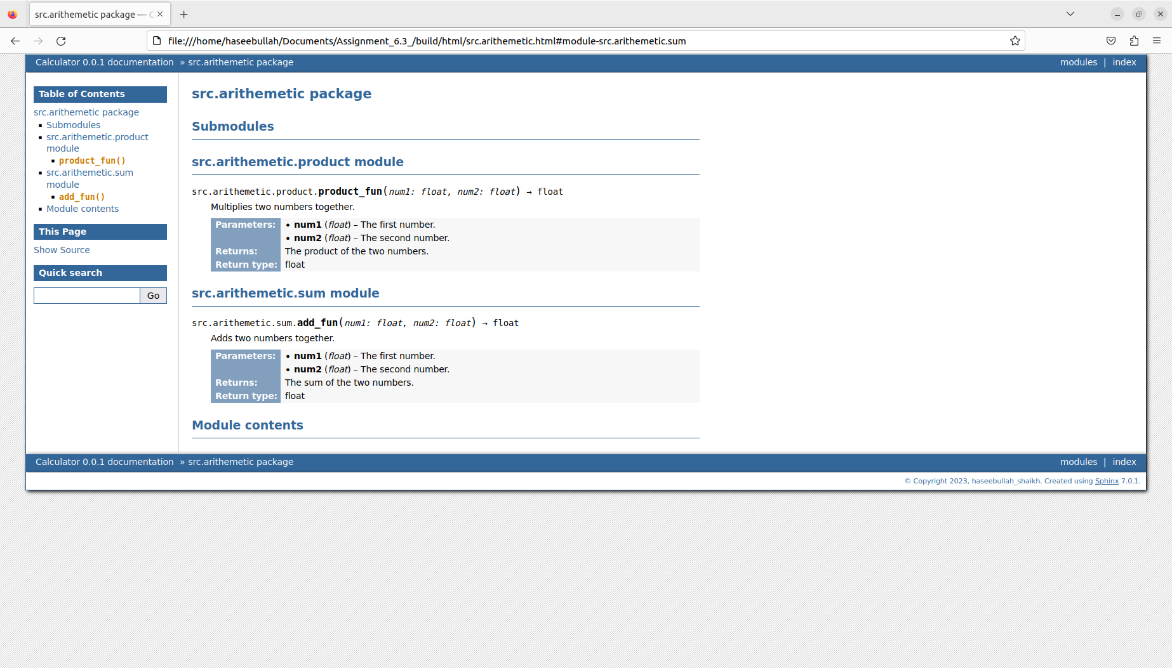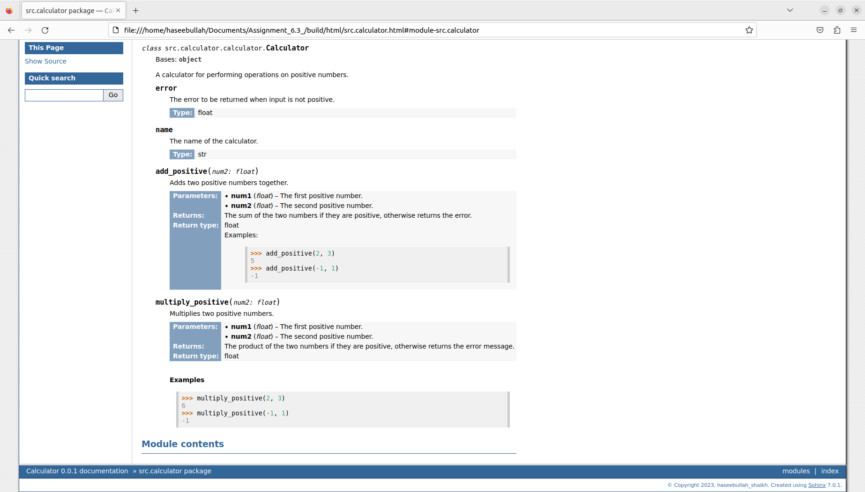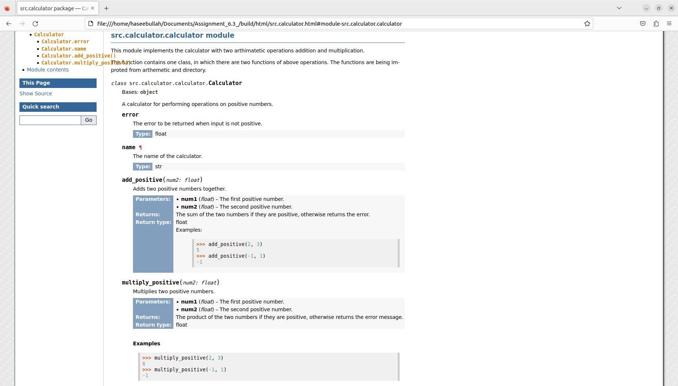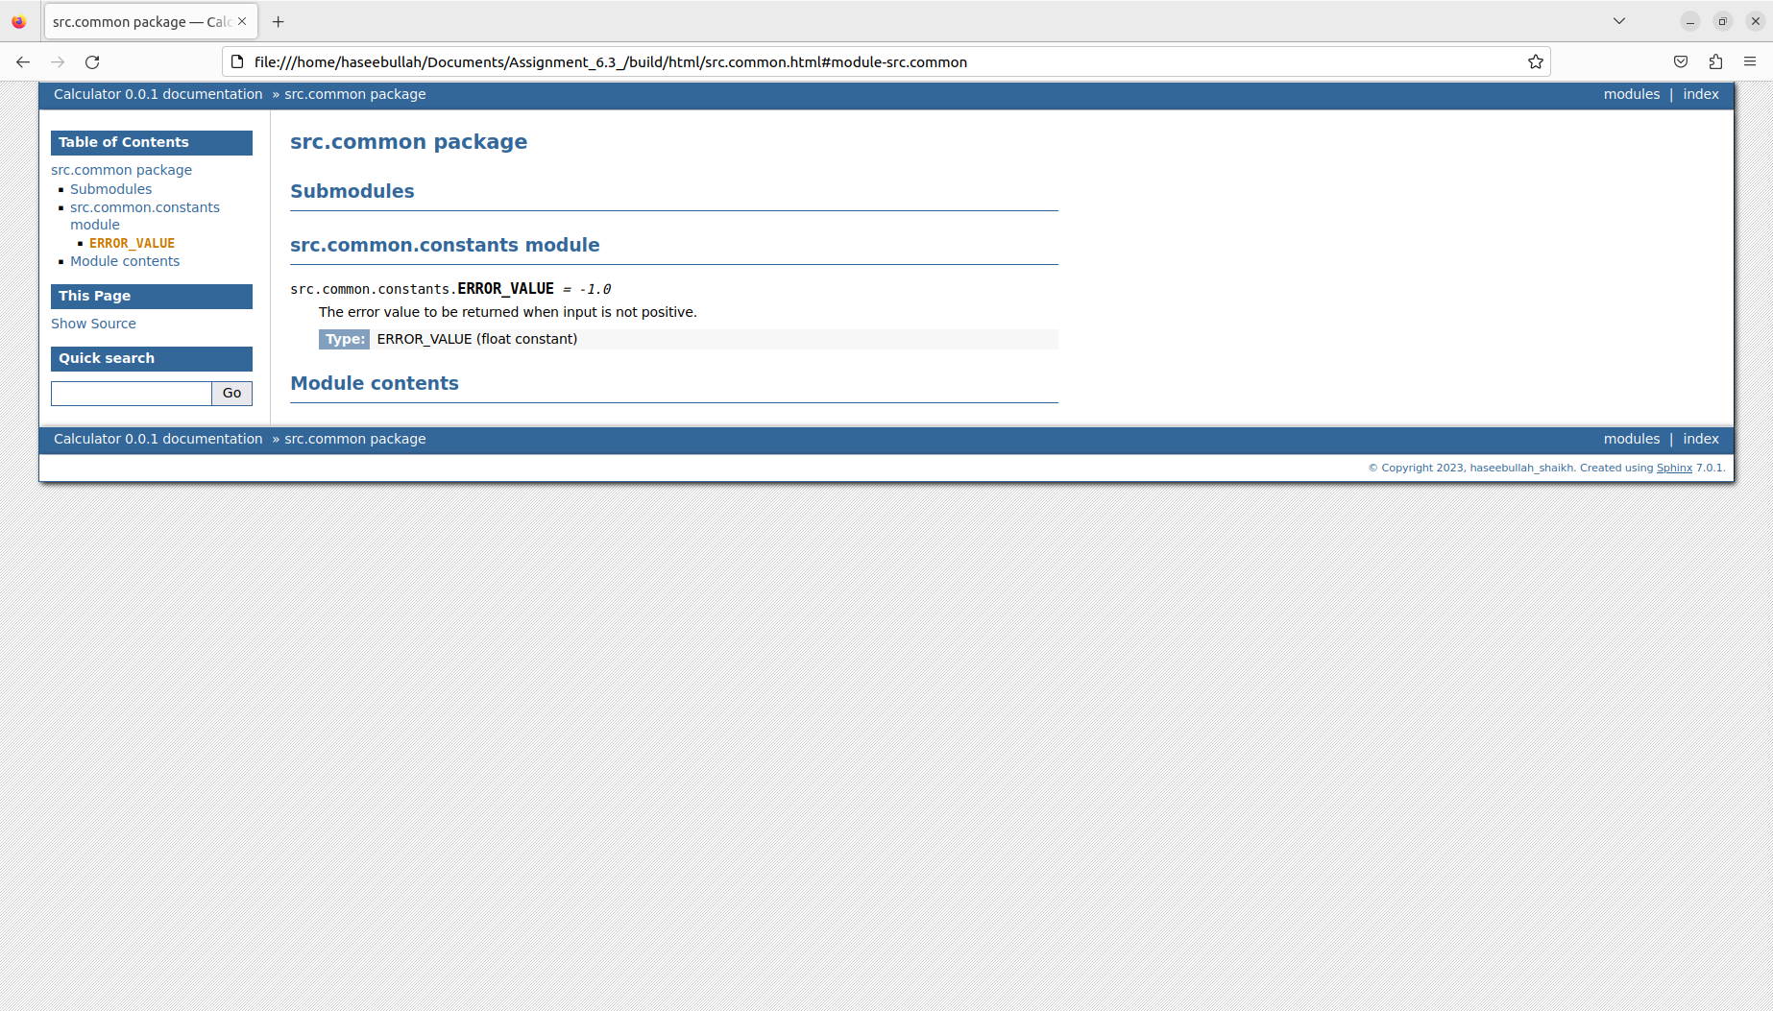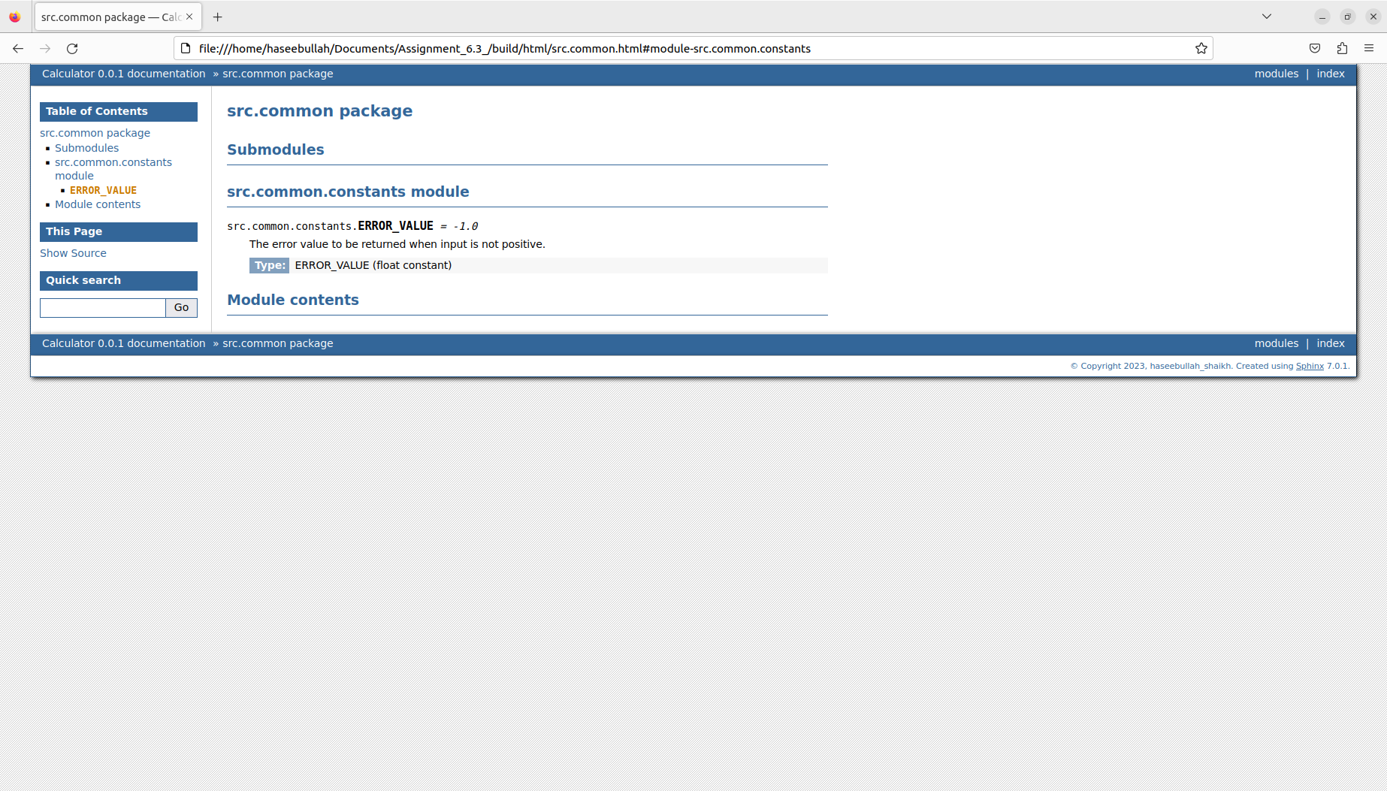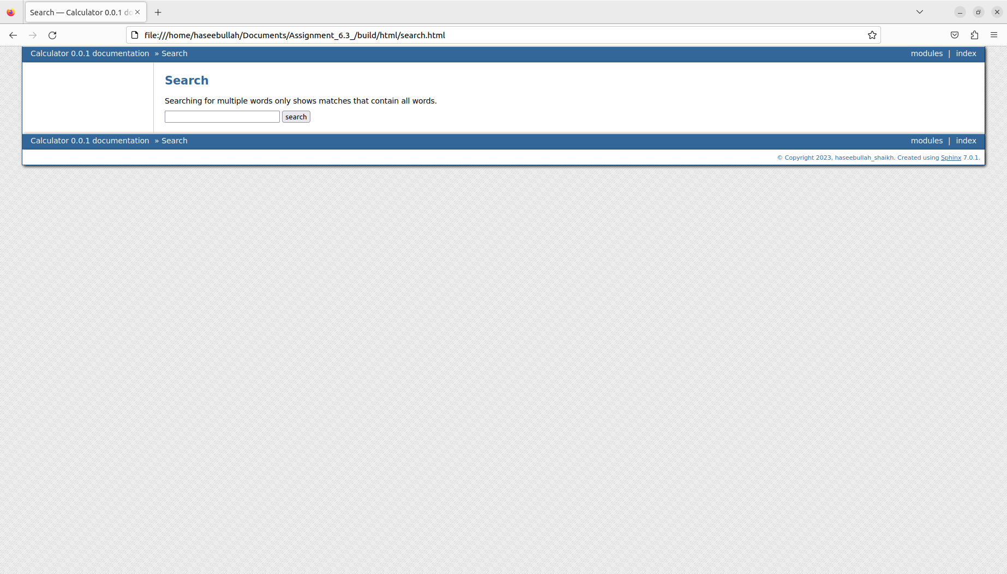

**The E**nd **😊**