Week 1 Task
Design and Document a Scalable Software Architecture
for a Hypothetical E-Commerce Platform

Student Name | Faiz Akhtar
Task | Week 1 – Scalable Software Architecture
Architecture | Microservices
Implementation Example | Python + FastAPI
Repository Target | GitHub

Prepared as a technical design and documentation submission

1. Overview of the Architecture
The proposed platform is a high-traffic e-commerce system designed using a microservices architecture. The system separates major business capabilities into independently deployable services. The initial scope covers user registration and authentication, product listing, cart operations, order management, and payment processing. The design also includes an API Gateway, asynchronous messaging, independent data ownership, observability, and security controls.
The main scalability principle is to scale services independently. For example, the Product Service can have more instances during a product-browsing spike without requiring the Payment Service to scale at the same rate.
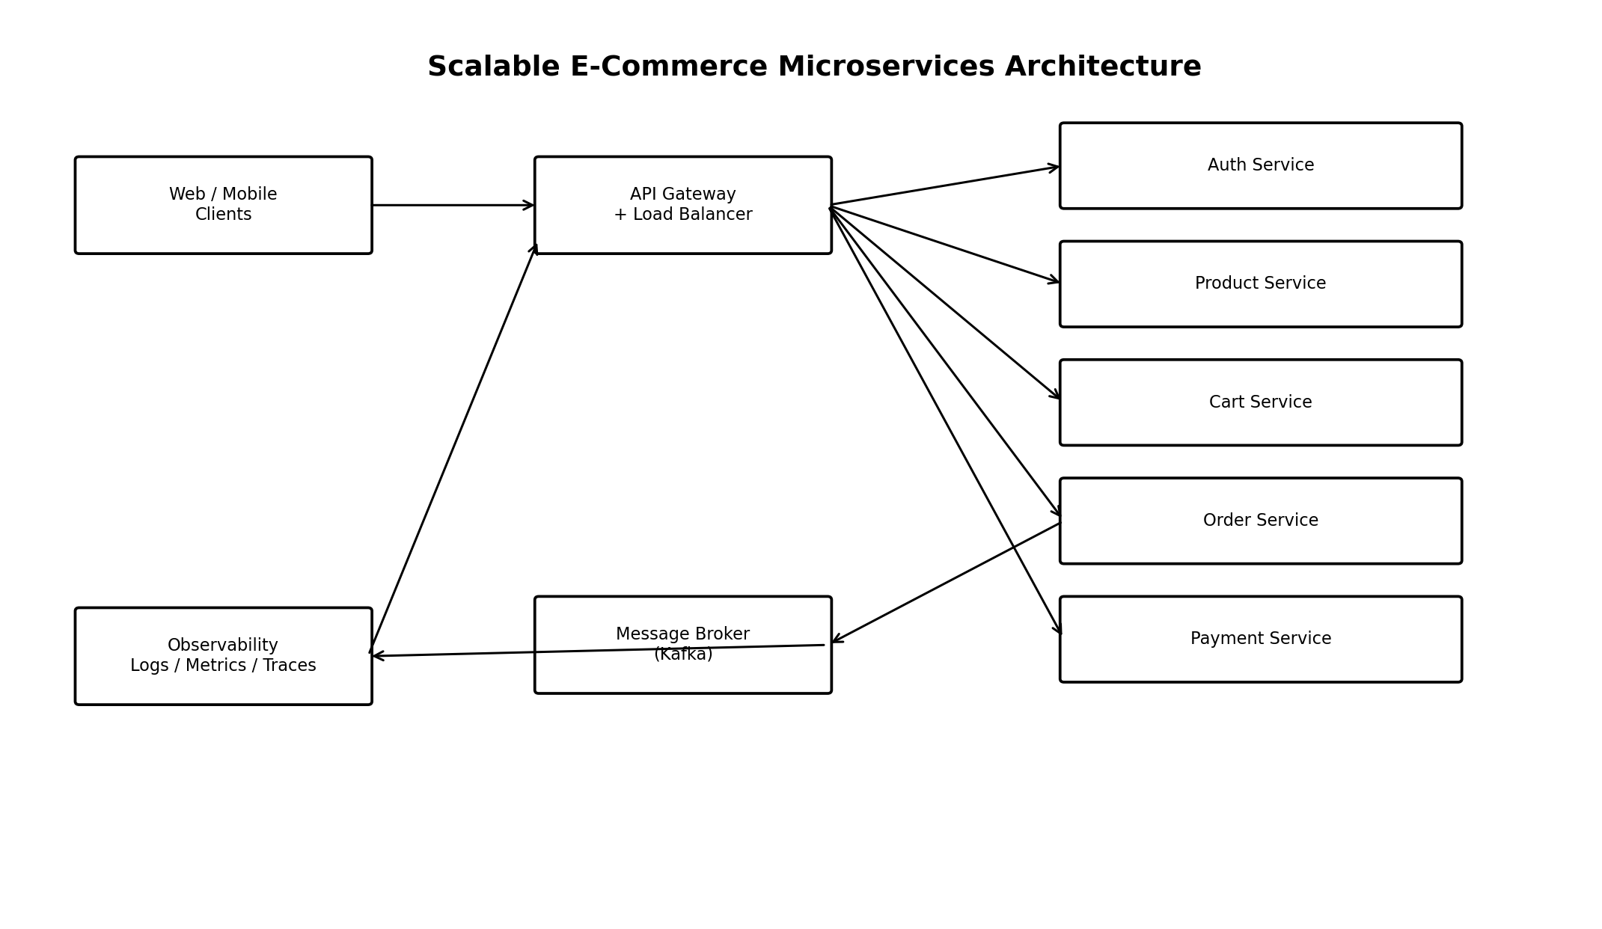
Figure 1. High-level microservices architecture.

1.1 Architecture Goals
- Handle high volumes of concurrent requests through horizontal scaling.
- Keep business capabilities isolated so that services can be developed and deployed independently.
- Avoid a single database becoming the direct dependency of every service.
- Support asynchronous processing for events such as order creation and payment updates.
- Provide secure authentication, authorization, encryption, validation, and auditability.
- Make failures observable through centralized logs, metrics, traces, and health checks.
- Allow future services such as inventory, shipping, notifications, reviews, and recommendations to be added without redesigning the entire platform.

1.2 Request Path
Clients communicate with the public API through the API Gateway. The gateway performs routing, TLS termination, authentication-related checks, rate limiting, and request correlation. Requests are then routed to the appropriate microservice. Services communicate synchronously over HTTP/REST for immediate responses and asynchronously through Kafka events when loose coupling is beneficial.

2. Detailed Description of Each Microservice
Component | Main Responsibilities | Scalability | Data
API Gateway | Single public entry point; routing, TLS, rate limiting, request IDs, authentication enforcement. | Stateless; horizontally scalable. | No business database.
Auth/User Service | Registration, login, password hashing, user profile, roles and token lifecycle. | Stateless API instances. | PostgreSQL – user data.
Product Service | Product catalog, categories, product details, search-oriented reads. | Scale read replicas/caches independently. | PostgreSQL; Redis cache.
Cart Service | Create/update cart, add/remove items, cart totals and expiration. | Stateless API + distributed cache/data store. | Redis for active carts.
Order Service | Create orders, order state, order history, checkout orchestration. | Horizontally scalable; event-driven. | PostgreSQL.
Payment Service | Payment intent, payment status, idempotency, gateway integration. | Stateless service with strict controls. | PostgreSQL for transaction state.
Message Broker | Reliable asynchronous events between services. | Kafka partitions and consumer groups. | Kafka topics; retention policy.
Observability | Metrics, logs, distributed traces, alerts and dashboards. | Collectors and monitoring nodes can scale. | Prometheus/Grafana/central log store.

2.1 API Gateway
The API Gateway is the controlled public boundary of the platform. It routes requests such as /users, /products, /cart, /orders, and /payments to internal services. It can also enforce rate limits and attach a correlation ID to each request. Keeping internal services private reduces their direct exposure to the internet.

2.2 Authentication and User Service
The service manages account registration, authentication, roles, and profile information. Passwords are never stored as plaintext. A strong password hashing algorithm such as Argon2id or bcrypt is used. Access tokens should be short-lived, and refresh-token handling should include rotation and revocation controls.

2.3 Product Service
The Product Service owns product information such as product ID, name, category, price, description, and availability metadata. Frequently requested product information can be cached with Redis. The service can be scaled horizontally because product browsing is primarily read-heavy.

2.4 Cart Service
The Cart Service handles active shopping carts. Redis is suitable for fast, short-lived cart data, with an expiration policy. For durable recovery requirements, important cart state can also be persisted to a relational database or reconstructed from events.

2.5 Order Service
The Order Service creates and tracks orders. A typical lifecycle is PENDING → PAYMENT_PENDING → CONFIRMED or FAILED/CANCELLED. Order creation should be idempotent so that a client retry does not create duplicate orders.

2.6 Payment Service
The Payment Service isolates payment-related operations from the rest of the platform. It creates payment requests, calls an external payment provider, records payment status, and publishes payment success/failure events. Card details should not be stored by the application unless there is a specific compliant architecture for doing so; tokenized payment-provider data is preferred.

3. Data Flow Diagrams
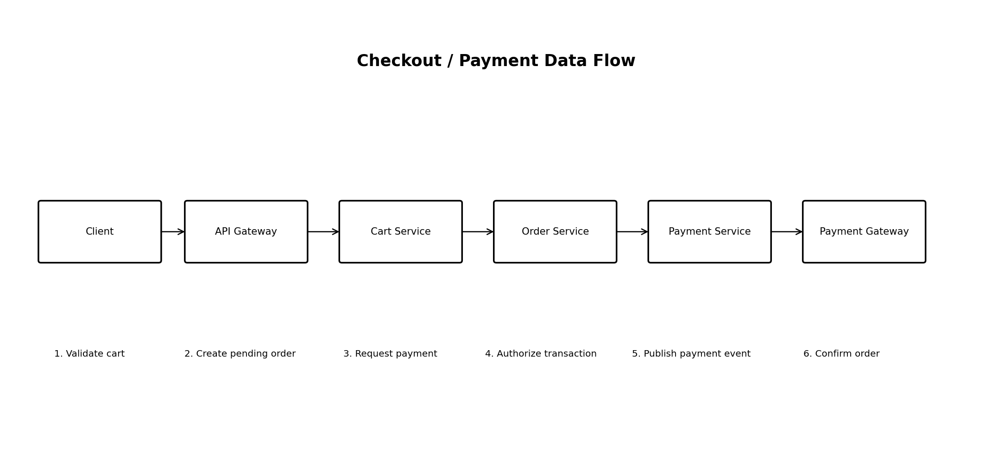
Figure 2. Checkout and payment data flow.

3.1 User Registration Flow
- Client sends registration data to the API Gateway over HTTPS.
- Gateway validates basic request structure and routes the request to the Auth/User Service.
- Auth/User Service validates email uniqueness and password policy.
- Password is hashed and the user record is stored in the User database.
- The service returns a successful registration response.
- An optional UserRegistered event can be published for notifications or analytics.

3.2 Product Listing Flow
- Client requests a product list through the API Gateway.
- Product Service checks Redis for a cached result.
- If present, the cached response is returned.
- If absent, Product Service queries its database, builds the response, and updates the cache.
- The response is returned to the client.

3.3 Checkout and Payment Flow
- Client submits checkout request with the cart and an idempotency key.
- Order Service validates the cart and creates a pending order.
- Order Service requests a payment operation from Payment Service.
- Payment Service sends the payment request to the external payment provider.
- The provider returns authorization or failure information.
- Payment Service records the result and publishes PaymentSucceeded or PaymentFailed.
- Order Service consumes the event and changes the order status.
- A notification service could consume the same event in a future version.

3.4 Asynchronous Event Flow
Order Service
|
| OrderCreated
v
Kafka ---> Inventory Service
| | ---> Notification Service
|
---> Analytics Service
Payment Service
|
| PaymentSucceeded / PaymentFailed
v
Kafka ---> Order Service
---> Notification Service

4. Justification of Technologies and Tools
Technology / Tool | Reason for Selection
Python | Fast development, large ecosystem, readable code, strong support for APIs, testing, data processing and automation.
FastAPI | Modern Python API framework with type hints, validation, automatic OpenAPI documentation and good asynchronous support.
PostgreSQL | Reliable relational database suitable for users, products, orders and payment state where transactions and constraints matter.
Redis | Low-latency in-memory store useful for carts, caching, rate-limit counters and short-lived data.
Apache Kafka | Durable event streaming and asynchronous communication using topics, partitions and consumer groups.
Docker | Packages each service consistently and simplifies local development and deployment.
Kubernetes | Provides container orchestration, service discovery, rolling deployments, self-healing and horizontal scaling.
Nginx / Cloud Load Balancer | Distributes incoming traffic and can provide TLS termination and edge-level controls.
Prometheus + Grafana | Metrics collection and dashboards for latency, throughput, error rates and resource utilization.
OpenTelemetry | Standardized collection of distributed traces, metrics and telemetry context.
Git + GitHub | Version control, collaboration, pull requests, issue tracking and CI/CD integration.

4.1 Scalability Strategy
- Horizontal scaling: run multiple instances of stateless API services behind a load balancer.
- Caching: cache hot product reads and other safe-to-cache responses in Redis.
- Database scaling: use indexes, connection pooling, read replicas where appropriate, and partitioning when justified by measured workload.
- Asynchronous processing: move non-critical work to Kafka consumers so user-facing requests are not blocked.
- Autoscaling: Kubernetes Horizontal Pod Autoscaler can adjust service replicas using CPU, memory, or application metrics.
- Resilience: configure timeouts, retries with backoff, circuit breakers where appropriate, and idempotency for operations that may be retried.

5. Security Measures
Control | Implementation
Transport Security | Use HTTPS/TLS for client and service traffic. Protect internal communication as required by the deployment environment.
Authentication | Use secure authentication tokens, short-lived access tokens, refresh-token rotation, and account/session controls.
Authorization | Apply role-based or permission-based authorization at service boundaries; do not rely only on UI restrictions.
Password Security | Hash passwords using a modern password-hashing algorithm such as Argon2id or bcrypt with appropriate parameters.
Input Validation | Validate types, lengths, ranges, formats, and allowed values before processing requests.
Secrets | Store API keys, database credentials, and payment-provider secrets in a secrets manager rather than source code.
Payment Security | Use tokenization and a compliant payment provider. Minimize the application’s exposure to sensitive payment data.
Rate Limiting | Limit abusive traffic at the gateway and/or service level, particularly login and payment endpoints.
Database Security | Use least-privilege database accounts, encrypted connections where required, backups, and controlled network access.
Logging & Audit | Record security-relevant events without logging passwords, tokens, or sensitive payment information.
Dependency Security | Pin and regularly update dependencies, scan for known vulnerabilities, and review third-party packages.
Container Security | Use minimal images, non-root containers where practical, vulnerability scanning, and restricted runtime permissions.

6. Python Implementation Example
A small Python/FastAPI example is included to demonstrate how one microservice could be implemented. The example is intentionally limited to the Product Service API and is suitable as a starting point for a GitHub repository. Production deployment would add authentication, a real database, migrations, structured logging, tests, configuration management, rate limiting, and observability.
from fastapi import FastAPI, HTTPException
from pydantic import BaseModel
app = FastAPI(title="Product Service")
class Product(BaseModel):
id: int
name: str
price: float
products = [
Product(id=1, name="Laptop", price=65000),
Product(id=2, name="Headphones", price=2500),
]
@app.get("/health")
def health():
return {"status": "ok"}
@app.get("/products")
def list_products():
return products
@app.get("/products/{product_id}")
def get_product(product_id: int):
for product in products:
if product.id == product_id:
return product
raise HTTPException(status_code=404, detail="Product not found")

6.1 Running the Python Service
python -m venv venv
# Windows PowerShell
venv\Scripts\Activate.ps1
pip install fastapi uvicorn
uvicorn main:app --reload
The service can then be tested locally through the generated API documentation and HTTP requests. For the full project, each microservice can have its own Python package, Dockerfile, tests, configuration, and deployment manifest.

7. GitHub Repository and Python Project Structure
The architecture can be maintained as a GitHub repository so that the source code, documentation, tests, and deployment files are version controlled. A monorepo is used for this academic example because it keeps all services and architecture documentation in one repository.
ecommerce-microservices/
│
├── services/
│ ├── auth_service/
│ │ ├── main.py
│ │ ├── requirements.txt
│ │ └── tests/
│ ├── product_service/
│ │ ├── main.py
│ │ ├── requirements.txt
│ │ └── tests/
│ ├── cart_service/
│ ├── order_service/
│ └── payment_service/
│
├── infrastructure/
│ ├── docker/
│ └── kubernetes/
│
├── docs/
│ ├── architecture.md
│ └── diagrams/
│
├── .gitignore
├── README.md
└── docker-compose.yml

7.1 Basic Git Workflow
git init
git add .
git commit -m "Initial e-commerce microservices architecture"
git branch -M main
git remote add origin <YOUR_GITHUB_REPOSITORY_URL>
git push -u origin main
The repository URL should be replaced with the student's own GitHub repository. For future changes, the usual workflow is to create a branch, make changes, run tests, commit, push, and open a pull request.

8. Reliability, Testing, and Failure Handling
- Unit tests validate business logic inside each service.
- Integration tests validate service-to-database and service-to-broker interactions.
- API tests validate request validation, status codes, authentication, and response schemas.
- Contract tests help detect breaking changes between services.
- Load tests measure throughput, latency, and behavior under increasing traffic.
- Health endpoints distinguish liveness from readiness so unhealthy instances can be removed from service.
- Timeouts prevent one slow dependency from consuming all application resources.
- Retries should be limited and use backoff; payment operations additionally require idempotency to avoid duplicate charges.
- Kafka consumer groups allow event-processing workloads to be distributed across multiple instances.

9. Design Trade-offs and Challenges
Microservices improve independent scaling and deployment but introduce distributed-system complexity. The architecture therefore accepts additional operational overhead in exchange for service isolation.
Decision | Benefit | Trade-off
Microservices vs. Monolith | More independent scaling and deployment | More networking, monitoring and operational complexity
PostgreSQL vs. NoSQL everywhere | Strong transactions and relational integrity for core business data | Schema changes and scaling require deliberate database design
Kafka vs. synchronous calls only | Loose coupling and asynchronous processing | Eventual consistency and operational complexity
Redis caching | Lower read latency and database load | Cache invalidation and stale-data risks
Kubernetes | Automated orchestration and scaling | Higher learning and operational cost than a simple server deployment

10. Conclusion
This design provides a scalable microservices architecture for a hypothetical high-traffic e-commerce platform. The platform separates authentication, product catalog, cart, order, and payment responsibilities into independently deployable services. An API Gateway controls external access, Kafka supports asynchronous communication, PostgreSQL provides transactional storage, Redis supports low-latency caching, and container orchestration provides a path toward horizontal scaling.
Security is treated as a cross-cutting requirement through HTTPS, authentication, authorization, input validation, secret management, least privilege, rate limiting, secure password hashing, payment tokenization, and audit-aware logging. The Python/FastAPI example demonstrates the implementation style, while the GitHub structure provides a practical foundation for version-controlled development.

11. Submission Checklist
- Architecture overview included.
- Detailed description of each microservice included.
- Architecture and checkout data-flow diagrams included.
- Technology and tool choices justified.
- Security measures documented.
- Scalability and reliability strategies documented.
- Python/FastAPI implementation example included.
- GitHub repository structure and basic Git commands included.
- Trade-offs and design challenges documented.
- Conclusion and submission checklist included.

