WEEK 2 TASK
Exploratory Data Analysis and Visualization
Breast Cancer Wisconsin (Diagnostic) Dataset
Item | Details
Prepared by | Mohammad Faizullah Akhtar
Dataset | Breast Cancer Wisconsin (Diagnostic), UCI Machine Learning Repository
Tools | Python, Pandas, NumPy, Matplotlib, Seaborn, SciPy, scikit-learn
Source code | eda_breast_cancer.py (included with this report)

1. Introduction and Objective
Exploratory Data Analysis (EDA) is the first and most important step of any data-driven project. Before building a model or drawing conclusions, an analyst must understand what the data contains, how clean it is, how its variables are distributed, and how they relate to one another. This report documents a complete EDA performed on a public medical dataset using Pandas, Matplotlib and Seaborn.
The objectives of this task are to:
- choose a suitable public dataset and summarise its basic statistics;
- create multiple visualizations that reveal patterns, correlations and anomalies;
- interpret each visualization and explain why the patterns may exist;
- document every data transformation or aggregation that was performed.

2. Dataset Selection
The Breast Cancer Wisconsin (Diagnostic) dataset was selected. It was created by Dr. William H. Wolberg, W. Nick Street and Olvi L. Mangasarian at the University of Wisconsin and is publicly available through the UCI Machine Learning Repository. It is also bundled with scikit-learn, so the accompanying code runs offline with no manual download.
Why this dataset is suitable:
- Rich numeric structure: 30 continuous features give plenty of scope for distributions, correlations and dimensionality reduction.
- A meaningful target: each tumour is labelled Benign or Malignant, so every pattern can be compared across two real-world groups.
- Realistic data issues: skewed distributions, outliers and strong multicollinearity make the EDA genuinely informative.
- Clean and reproducible: no missing values, and widely used as a benchmark, so results can be cross-checked.
Each of the 569 rows is one patient. The features were computed from a digitised image of a fine needle aspirate (FNA) of a breast mass and describe the characteristics of the cell nuclei. Ten base measurements are recorded in three forms: the mean, the standard error, and the worst (largest) value, giving 30 features in total.
Table 1: The ten base nuclear measurements
Measurement | Meaning
radius | Mean distance from the centre to points on the nucleus boundary
texture | Standard deviation of grey-scale values
perimeter / area | Size of the nucleus
smoothness | Local variation in radius lengths
compactness | Perimeter squared divided by area, minus 1
concavity | Severity of concave portions of the contour
concave points | Number of concave portions of the contour
symmetry | Symmetry of the nucleus shape
fractal dimension | Coastline approximation minus 1 (boundary roughness)

3. Tools and Environment
The analysis was carried out in Python using the libraries below. All code is contained in a single, modular script (eda_breast_cancer.py) in which each analysis step is a separate function.
import matplotlib.pyplot as plt
import numpy as np
import pandas as pd
import seaborn as sns
from scipy import stats
from sklearn.datasets import load_breast_cancer
from sklearn.decomposition import PCA
from sklearn.preprocessing import StandardScaler

4. Initial Data Inspection

4.1 Loading the data
The dataset was loaded as a Pandas DataFrame. scikit-learn encodes the target as 0 = malignant and 1 = benign, so a readable diagnosis column was created for use in all plots and group summaries.
def load_data() -> pd.DataFrame:
raw = load_breast_cancer(as_frame=True)
df = raw.frame.copy()
df["diagnosis"] = df["target"].map({0: "Malignant", 1: "Benign"})
return df.drop(columns="target")

4.2 Structure and data quality
print(df.shape) # (569, 31)
print(df.isna().sum().sum()) # 0 missing values
print(df.duplicated().sum()) # 0 duplicate rows
print(df["diagnosis"].value_counts())

Table 2: Data quality summary
Check | Result
Rows x columns | 569 x 31 (30 numeric features + diagnosis label)
Data types | 30 float64 columns, 1 categorical column
Missing values | 0
Duplicate rows | 0
Benign / Malignant | 357 (62.74%) / 212 (37.26%)

The dataset is complete and needs no imputation or de-duplication. The only data-quality concerns found later are skewness, outliers and multicollinearity.

4.3 Descriptive statistics
desc = df[features].describe().T
desc["skew"] = df[features].skew()
desc["kurtosis"] = df[features].kurt()

Table 3: Descriptive statistics of the ten 'mean' features
Feature | Mean | Std | Min | Median | Max | Skew
mean radius | 14.127 | 3.524 | 6.981 | 13.370 | 28.110 | 0.94
mean texture | 19.290 | 4.301 | 9.710 | 18.840 | 39.280 | 0.65
mean perimeter | 91.969 | 24.299 | 43.790 | 86.240 | 188.500 | 0.99
mean area | 654.889 | 351.914 | 143.500 | 551.100 | 2501.000 | 1.65
mean smoothness | 0.096 | 0.014 | 0.053 | 0.096 | 0.163 | 0.46
mean compactness | 0.104 | 0.053 | 0.019 | 0.093 | 0.345 | 1.19
mean concavity | 0.089 | 0.080 | 0.000 | 0.061 | 0.427 | 1.40
mean concave points | 0.049 | 0.039 | 0.000 | 0.034 | 0.201 | 1.17
mean symmetry | 0.181 | 0.027 | 0.106 | 0.179 | 0.304 | 0.73
mean fractal dimension | 0.063 | 0.007 | 0.050 | 0.061 | 0.097 | 1.30

Three observations stand out. First, the features sit on very different scales: mean area ranges from 143.5 to 2501 while mean smoothness lies between 0.053 and 0.163, so any distance-based method would require standardisation. Second, every feature has positive skewness, and in each case the mean exceeds the median. Mean area is the most skewed (skew 1.65, kurtosis 3.65), which indicates a long right tail of unusually large tumours. Third, mean concavity and mean concave points have a minimum of 0, meaning some nuclei have perfectly convex boundaries.

5. Data Transformations and Aggregations
The following transformations and aggregations were applied. Each is explained so that the reader knows precisely what was done to the raw data.
- Label mapping: the numeric target (0/1) was converted to Malignant/Benign text labels for readable legends. The underlying values were not changed.
- Group aggregation (groupby): mean and standard deviation of key features were computed separately for each diagnosis group (Table 4).
- Binary encoding for correlation: malignant was coded as 1 and benign as 0 to measure each feature's correlation with the diagnosis (Figure 5).
- Standardisation (z-score): features were rescaled to mean 0 and standard deviation 1 using StandardScaler. This was applied before the violin plot and before PCA so that large-valued features such as area do not dominate.
- Reshaping (melt): the wide table was converted to long format so Seaborn could draw all features in a single violin plot.
- IQR outlier flagging: observations beyond 1.5 x IQR from the quartiles were counted but not removed (see Section 6.9).
- Dimensionality reduction (PCA): 30 standardised features were projected onto principal components for visualization (Figure 10).
df.groupby("diagnosis")[KEY_FEATURES].agg(["mean", "std"])

z = pd.DataFrame(StandardScaler().fit_transform(df[cols]), columns=cols)
z["diagnosis"] = df["diagnosis"].values
long = z.melt(id_vars="diagnosis", var_name="feature", value_name="z-score")

Table 4: Group means of key features by diagnosis
Feature | Benign mean | Malignant mean | Difference
mean radius | 12.147 | 17.463 | 44%
mean texture | 17.915 | 21.605 | 21%
mean area | 462.790 | 978.376 | 111%
mean concavity | 0.046 | 0.161 | 249%

Malignant tumours are on average 44% larger in radius and more than twice as large in area. Their mean concavity is about 3.5 times that of benign tumours. Texture differs the least (21%), so it is expected to be a weaker separator.

6. Visualization and Interpretation

6.1 Class distribution
sns.countplot(data=df, x="diagnosis", order=HUE_ORDER,
hue="diagnosis", palette=PALETTE, legend=False, ax=ax)

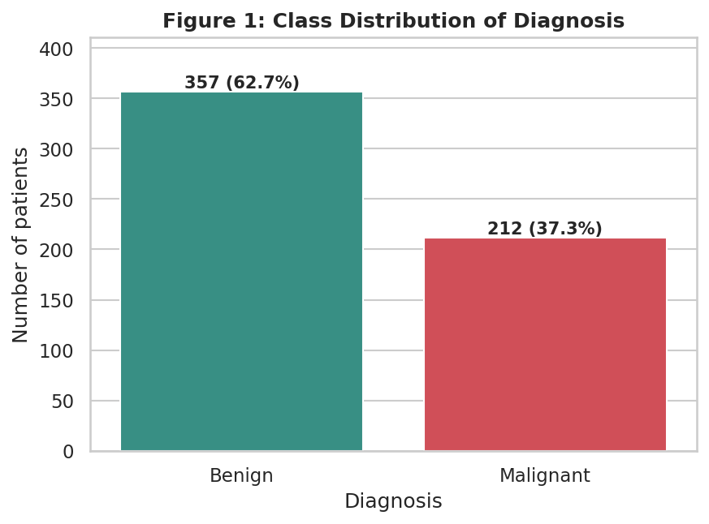
Figure 1: Count of benign and malignant cases
Interpretation: The data contains 357 benign (62.7%) and 212 malignant (37.3%) cases, a ratio of about 1.7 to 1. The imbalance is mild, but it matters for later modelling: a model that always predicts 'benign' would already score 62.7% accuracy, so accuracy alone would be a misleading metric. Precision, recall and the F1 score should be used instead. In medical screening, missing a malignant case (a false negative) is far more costly than a false alarm.

6.2 Distributions of key features
for ax, feat in zip(axes.ravel(), KEY_FEATURES):
sns.histplot(data=df, x=feat, hue="diagnosis", hue_order=HUE_ORDER,
palette=PALETTE, kde=True, bins=30, alpha=0.55, ax=ax)

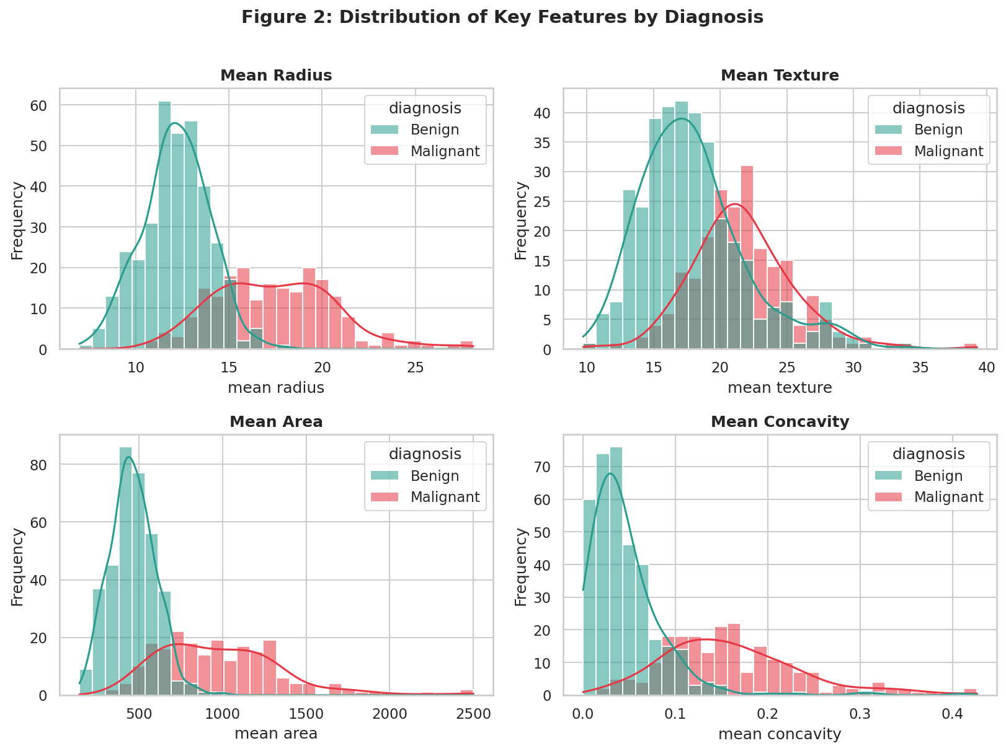
Figure 2: Histograms with KDE curves for four key features, split by diagnosis
Interpretation: In mean radius, mean area and mean concavity the malignant distribution (red) is clearly shifted to the right of the benign one (green). Benign tumours cluster tightly: their area is mostly below 600 while malignant areas are spread widely up to 2501. Several distributions are right-skewed with long tails, particularly mean area and mean concavity. This reflects biology: benign nuclei are regular and similar in size, whereas malignant cells grow and divide abnormally, producing greater variation. Mean texture overlaps heavily between the groups, so it is a weak stand-alone discriminator. The skewness also suggests that a log transform would help any model that assumes normality.

6.3 Box plots by diagnosis
sns.boxplot(data=df, x="diagnosis", y=feat, order=HUE_ORDER,
hue="diagnosis", palette=PALETTE, legend=False, width=0.55)

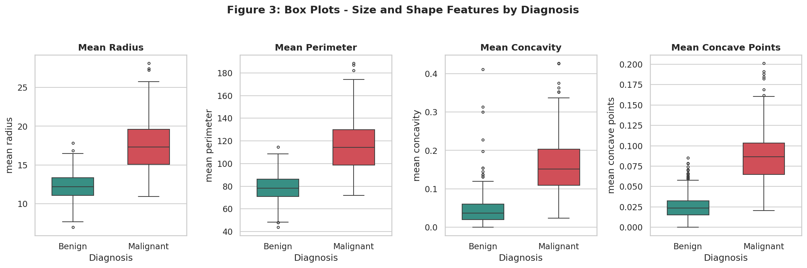
Figure 3: Box plots of size and shape features for benign and malignant tumours
Interpretation: The median of every plotted feature is much higher for malignant tumours, and for all four plotted features the benign upper quartile lies below the malignant lower quartile, so the interquartile ranges do not overlap at all. The malignant boxes are also taller, confirming greater variability (for example, the standard deviation of mean radius is 3.20 for malignant versus 1.78 for benign). Dots above the whiskers mark statistical outliers. Benign tumours show a few unusually large values, which are potential borderline cases that could be misclassified by a simple threshold.

6.4 Correlation heatmap
corr = df[mean_cols].corr()
mask = np.triu(np.ones_like(corr, dtype=bool))
sns.heatmap(corr, mask=mask, annot=True, fmt=".2f", cmap="coolwarm",
center=0, vmin=-1, vmax=1, linewidths=0.5)

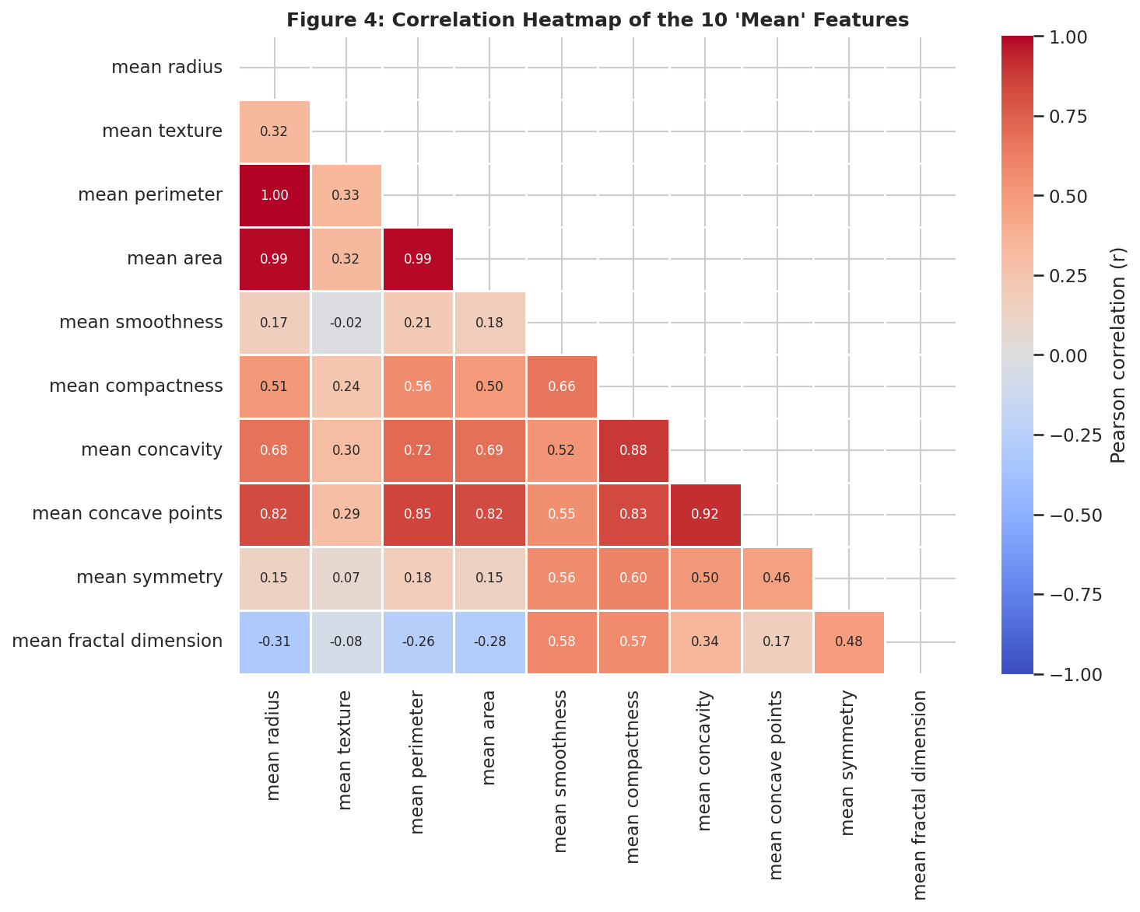
Figure 4: Pearson correlation matrix of the ten 'mean' features (lower triangle)
Interpretation: Radius, perimeter and area are almost perfectly correlated (radius vs perimeter r = 0.998, radius vs area r = 0.987). This is expected: all three measure nucleus size and are linked geometrically, since perimeter is proportional to radius and area to radius squared. A second tight group is formed by concavity, concave points and compactness (concavity vs concave points r = 0.921). In contrast, texture is only weakly related to radius (r = 0.324) and fractal dimension is negatively related to radius (r = -0.312), so these two features carry independent information. In effect, the ten measurements reduce to about three or four distinct concepts: size, shape irregularity, texture and smoothness.
Table 5: Strongest feature pairs across all 30 features (|r| >= 0.95)
Feature 1 | Feature 2 | Pearson r
mean radius | mean perimeter | 0.998
worst radius | worst perimeter | 0.994
mean radius | mean area | 0.987
mean perimeter | mean area | 0.987
worst radius | worst area | 0.984
worst perimeter | worst area | 0.978

In total, 15 feature pairs have |r| of at least 0.95. This severe multicollinearity would inflate coefficient variance in linear or logistic regression, so redundant size features should be dropped or combined (for example by PCA or regularisation) before modelling.

6.5 Correlation of each feature with the diagnosis
y = (df["diagnosis"] == "Malignant").astype(int)
corr = df[features].corrwith(y).sort_values()
ax.barh(corr.index, corr.values, color=colors)

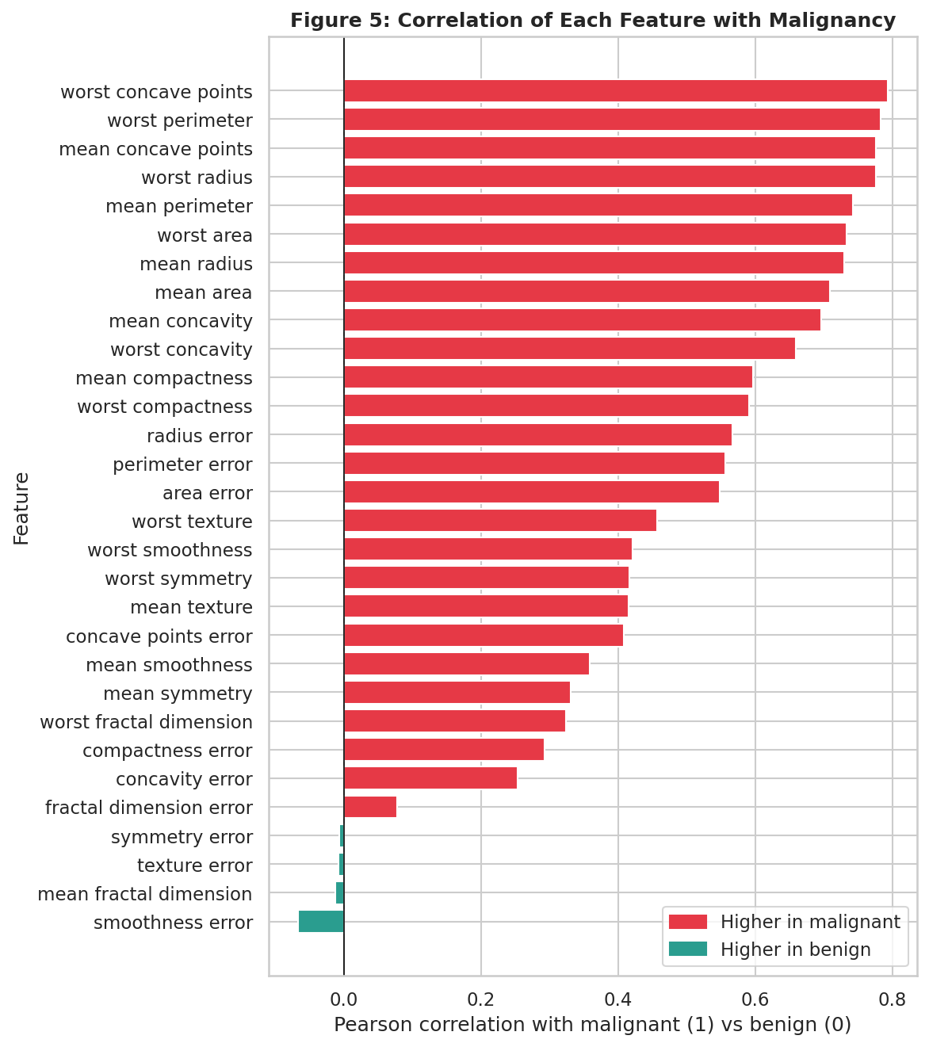
Figure 5: Correlation of each of the 30 features with malignancy (1) versus benign (0)
Interpretation: Because the diagnosis is binary, this is a point-biserial correlation. The strongest positive relationships are with worst concave points (r = 0.794), worst perimeter (0.783), mean concave points (0.777) and worst radius (0.777). The 'worst' features consistently rank higher than the 'mean' features, which makes clinical sense: the most abnormal cells in a sample are more telling than the average cell. Features such as mean fractal dimension (r = -0.013), texture error (-0.008) and symmetry error (-0.007) have virtually no linear relationship with the diagnosis. No feature is negatively associated with malignancy in any meaningful way.

6.6 Pair plot
sns.pairplot(df, vars=PAIR_FEATURES, hue="diagnosis", hue_order=HUE_ORDER,
palette=PALETTE, diag_kind="kde", corner=True,
plot_kws={"alpha": 0.6, "s": 22})

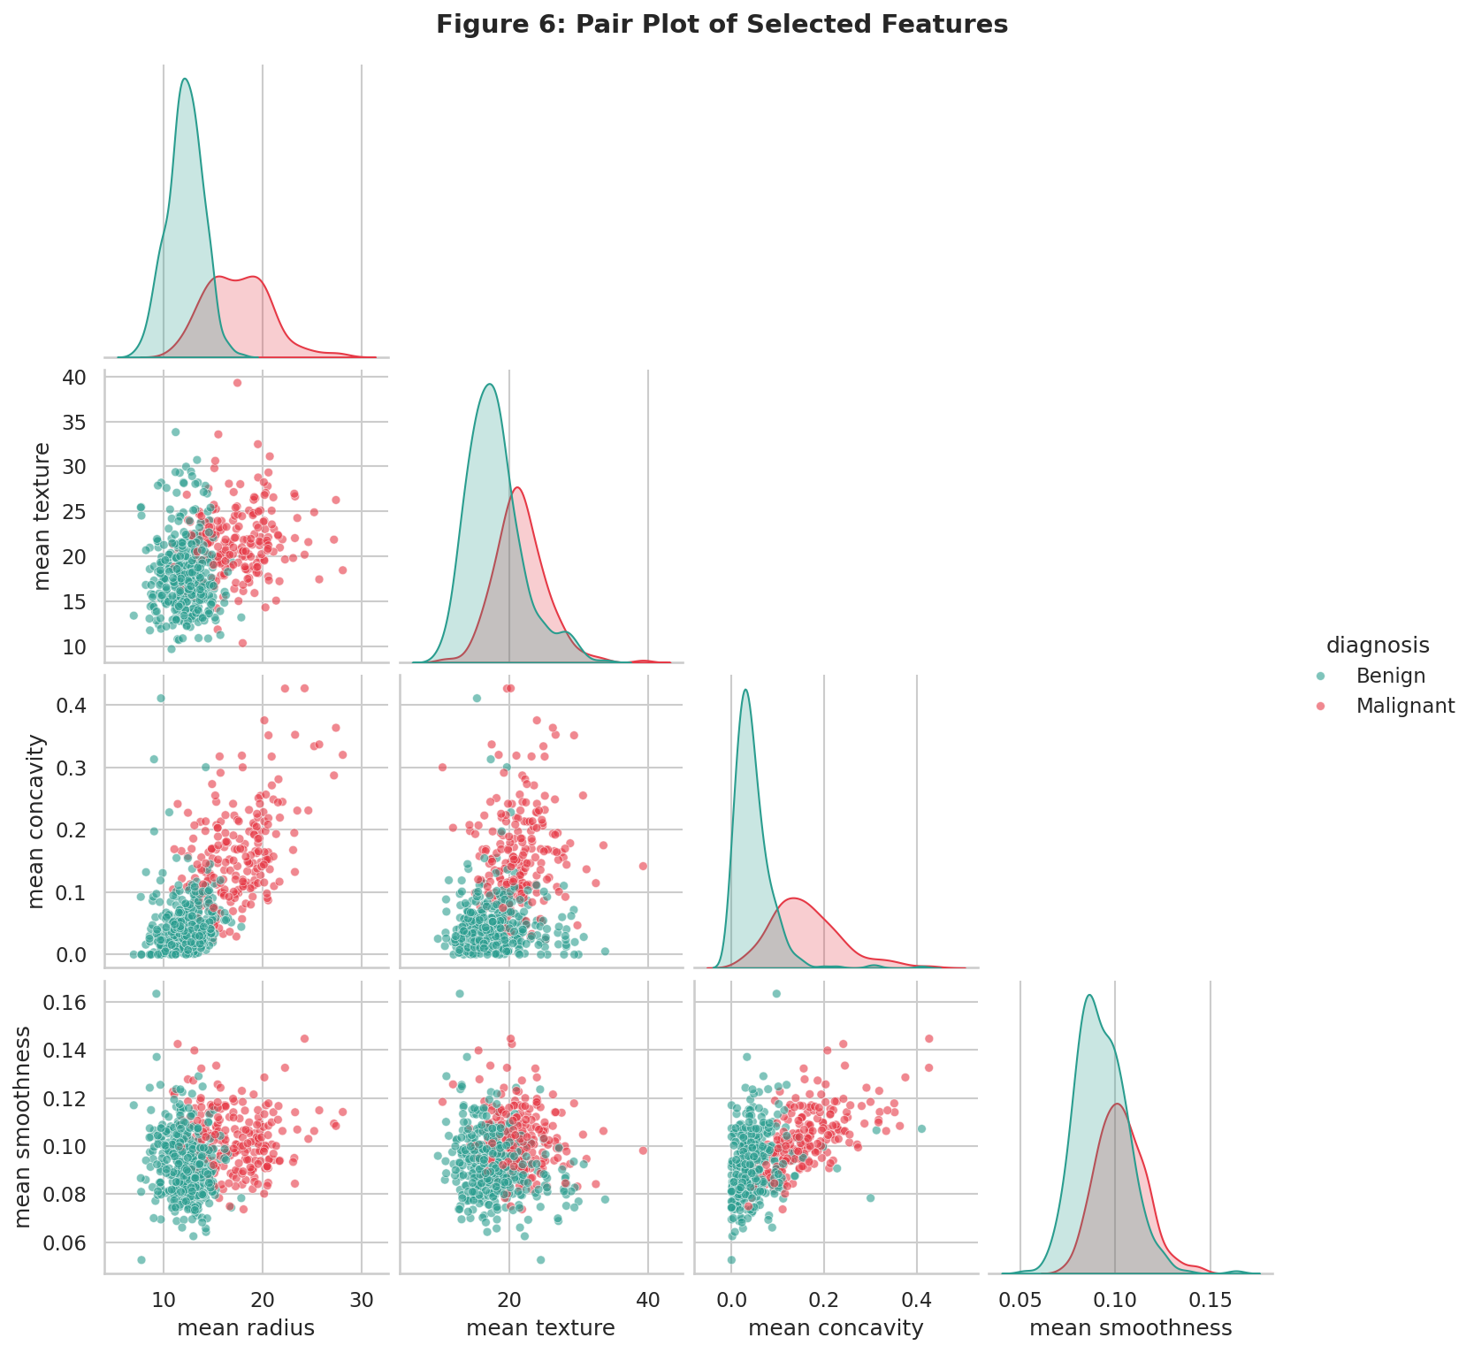
Figure 6: Pair plot of mean radius, mean texture, mean concavity and mean smoothness
Interpretation: The pair plot shows how well two features together separate the classes. The combination of mean radius and mean concavity gives the clearest split: benign cases gather in the lower-left corner and malignant cases in the upper right, with only a narrow overlap band. Combinations involving texture or smoothness show far more mixing. The diagonal density curves confirm the earlier finding that radius and concavity separate the groups well, while smoothness and texture mainly shift the distributions slightly. The lesson is that no single feature is sufficient, but a pair of complementary features (size plus shape) is very powerful.

6.7 Scatter plots with regression lines
sns.scatterplot(data=df, x=x, y=y, hue="diagnosis", hue_order=HUE_ORDER,
palette=PALETTE, alpha=0.7, s=35, ax=ax)
sns.regplot(data=df, x=x, y=y, scatter=False, color="black",
line_kws={"linestyle": "--"}, ax=ax)

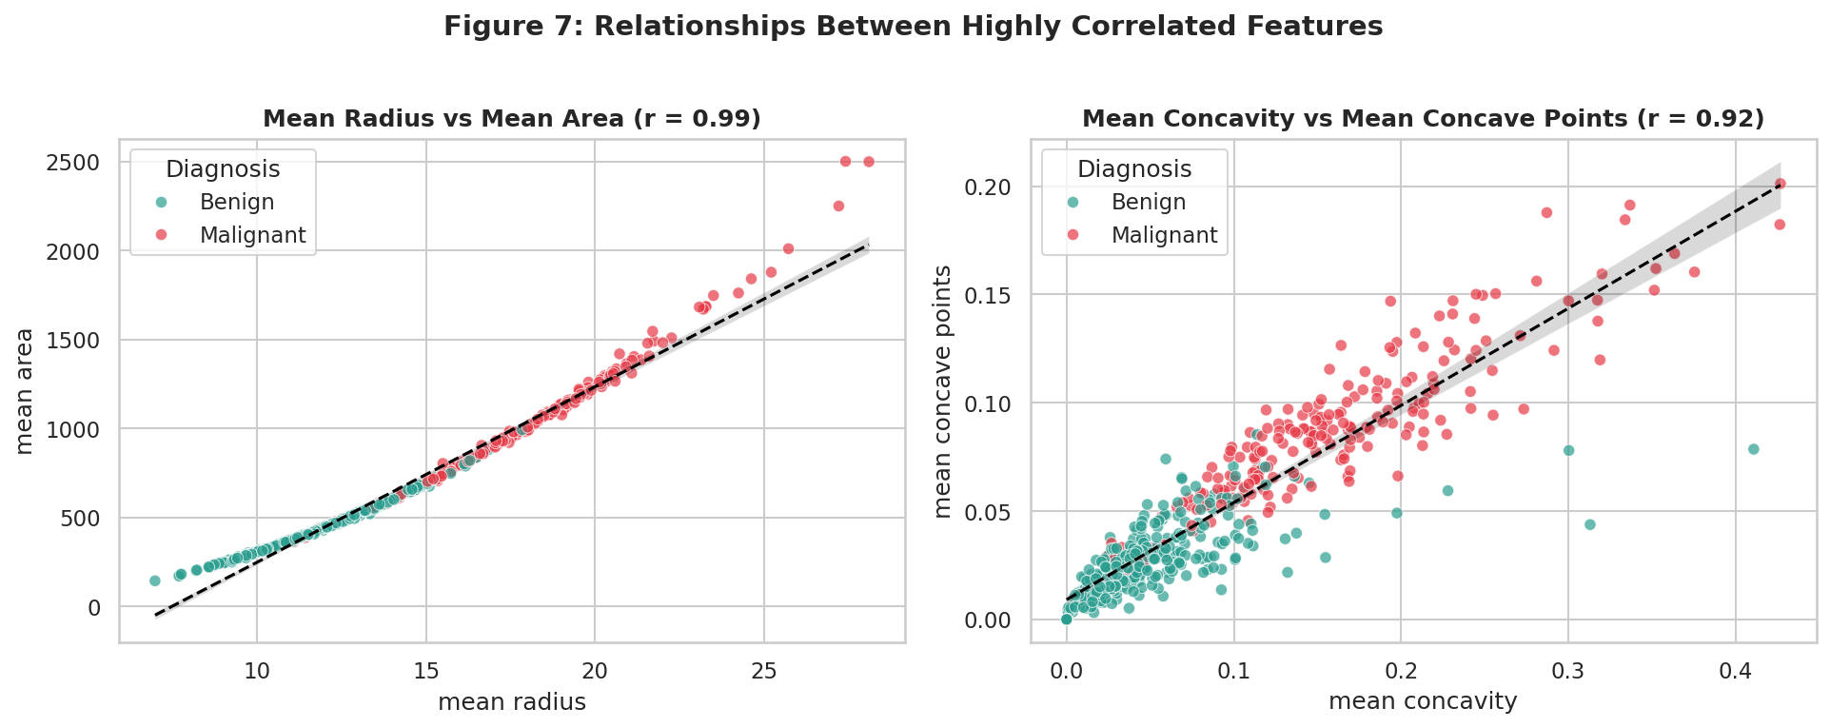
Figure 7: Mean radius vs mean area (left) and mean concavity vs mean concave points (right)
Interpretation: Radius versus area is nearly a perfect curve (r = 0.99): because area grows with the square of radius, the fitted straight line slightly underestimates the largest tumours, a hint that the relationship is non-linear. Of the 173 tumours with a mean radius above 15, 161 (93%) are malignant, and the largest tumours lie far from the main cloud. In the right panel, concavity and concave points rise together (r = 0.92) and the malignant points occupy the high end of both axes, whereas benign points stay in the lower left. The two shape features therefore reinforce each other rather than adding new information.

6.8 Standardised violin plots
cols = [c for c in features if c.startswith("worst ")]
z = pd.DataFrame(StandardScaler().fit_transform(df[cols]), columns=cols)
sns.violinplot(data=long, x="feature", y="z-score", hue="diagnosis",
split=True, inner="quart", density_norm="width")

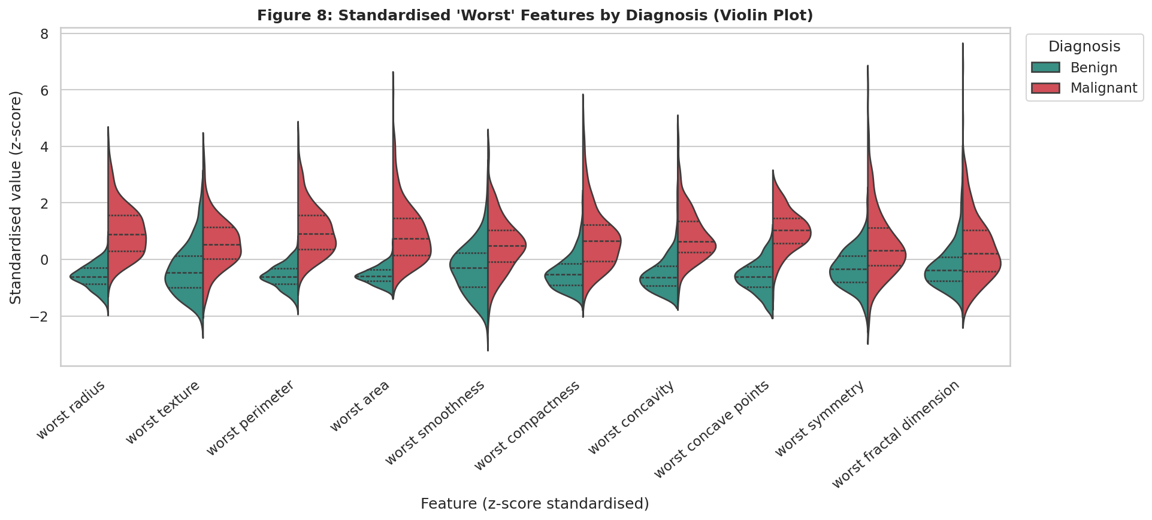
Figure 8: Standardised 'worst' features for benign (left half) and malignant (right half) tumours
Interpretation: After standardisation all ten features share one scale, so the separation between groups can be compared directly. The malignant half is shifted upward for every feature. The shift is largest and the overlap smallest for worst concave points, worst perimeter, worst radius and worst area, while worst symmetry and worst fractal dimension overlap heavily. The long upward tails of the malignant violins (z-scores above 4 to 6) are extreme observations that would strongly affect models sensitive to outliers.

6.9 Outlier analysis
Outliers were detected with Tukey's rule: a value is flagged if it is below Q1 - 1.5 x IQR or above Q3 + 1.5 x IQR.
q1, q3 = df[col].quantile([0.25, 0.75])
iqr = q3 - q1
lo, hi = q1 - 1.5 * iqr, q3 + 1.5 * iqr
n_outliers = ((df[col] < lo) | (df[col] > hi)).sum()

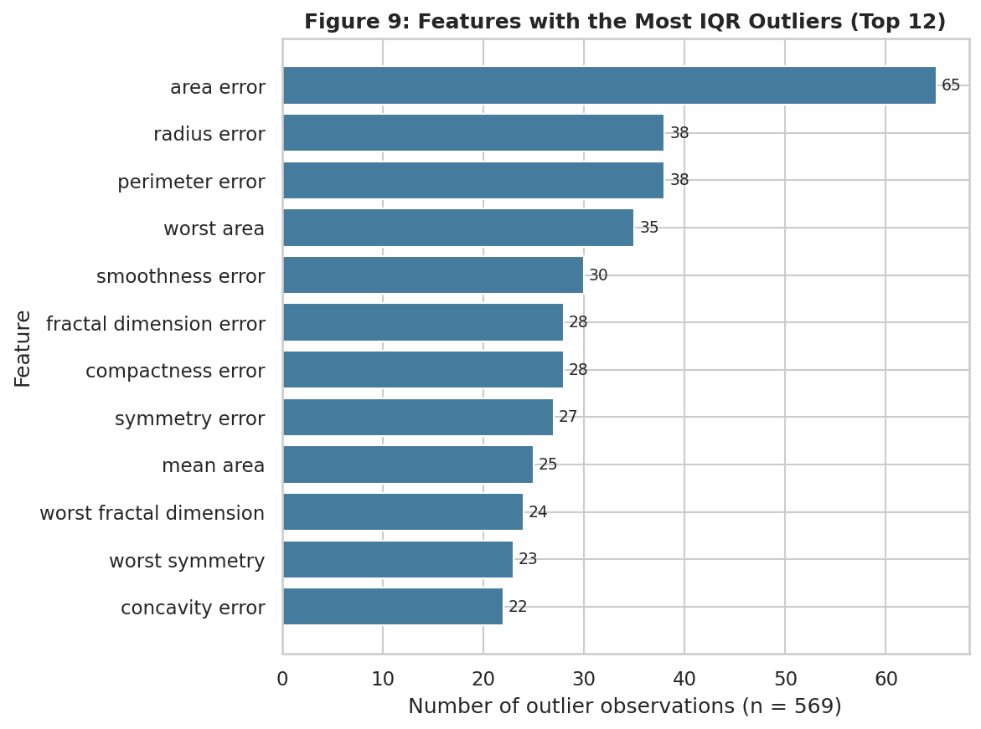
Figure 9: The twelve features with the most IQR outliers
Table 6: Features with the most outliers
Feature | Outliers | Share of 569 rows
area error | 65 | 11.42%
radius error | 38 | 6.68%
perimeter error | 38 | 6.68%
worst area | 35 | 6.15%
smoothness error | 30 | 5.27%
fractal dimension error | 28 | 4.92%

Interpretation: The 'error' (standard error) features have the most outliers, led by area error with 65 outliers (11.4%), followed by radius error and perimeter error with 38 each (6.7%). This is natural: a standard error measures variability within one sample, and a few samples with very irregular cells produce extreme values. These points were not removed. They are not data-entry errors; they are valid measurements of unusually large or irregular tumours, many of them malignant, and removing them would discard exactly the cases that matter most. If a model sensitive to outliers is used later, a transform (log) or a robust scaler is a better remedy than deletion.

6.10 Principal Component Analysis
X = StandardScaler().fit_transform(df[feature_columns(df)])
pca = PCA().fit(X)
scores = pca.transform(X)
cum = np.cumsum(pca.explained_variance_ratio_)

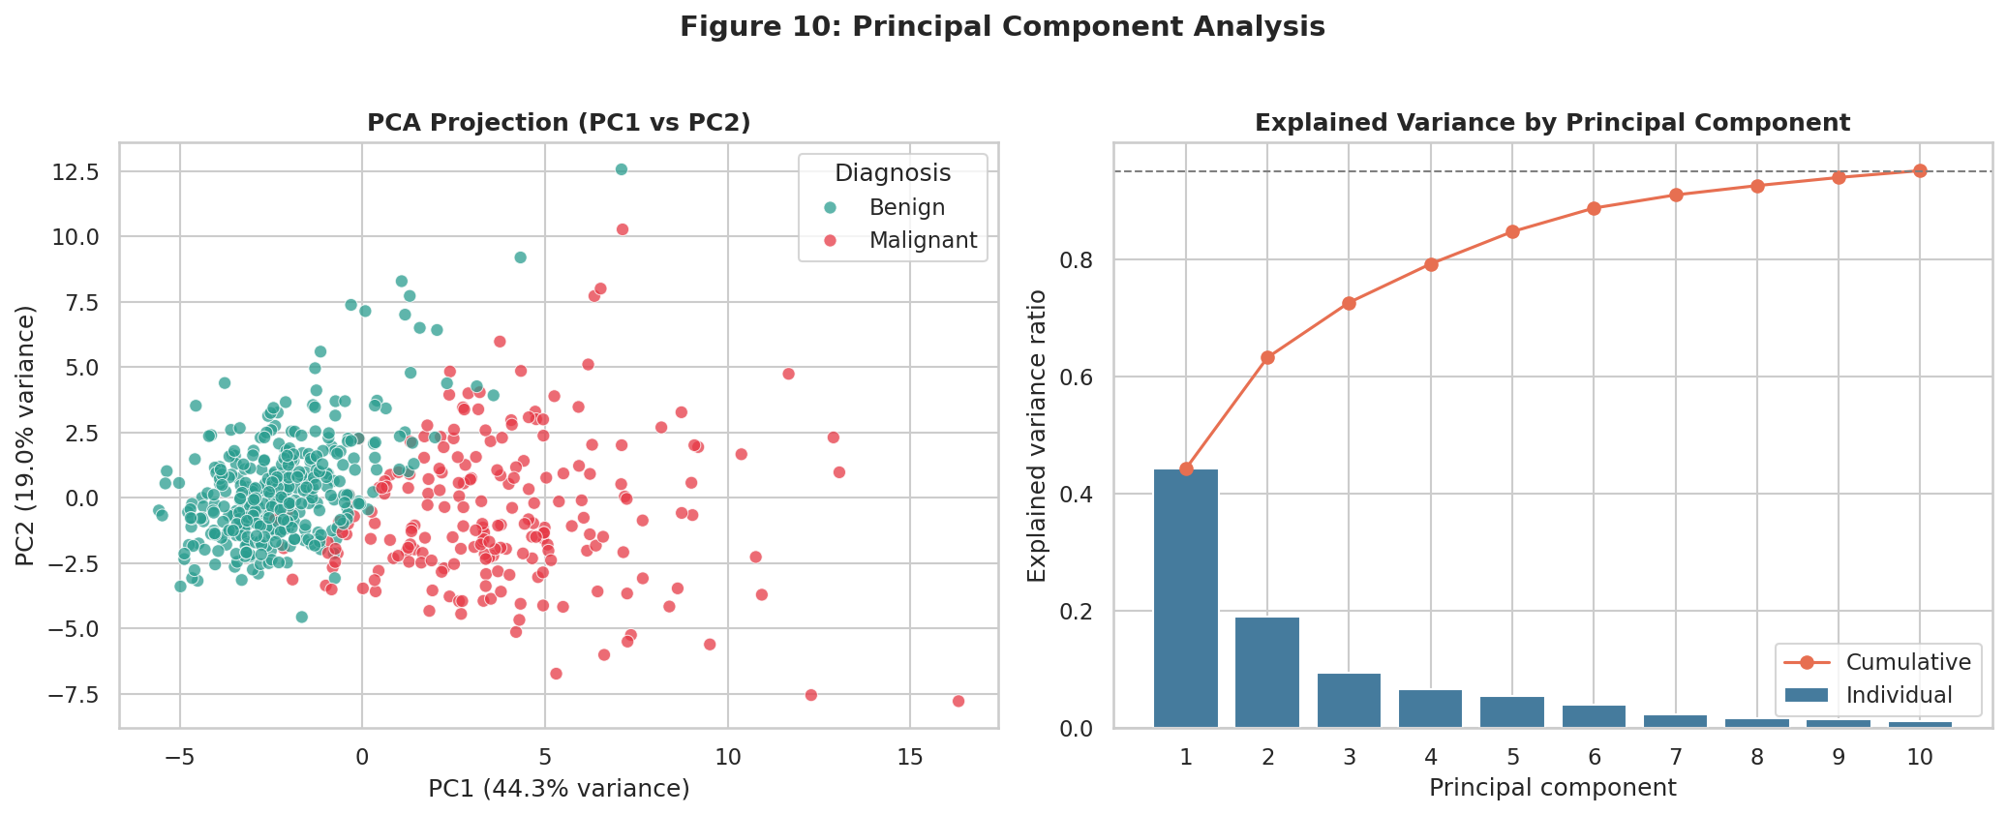
Figure 10: PCA projection of the standardised data (left) and explained variance (right)
Interpretation: The first principal component alone captures 44.3% of the total variance and the first two capture 63.2%. Ten components are enough to retain 95% of the information, so the 30 original features are highly redundant, which agrees with the correlation analysis. In the two-dimensional projection the benign and malignant groups separate almost completely along PC1, with only a small overlap region near the centre. This is strong evidence that the classes are structurally different in feature space, and that a simple classifier should perform well. PC1 is dominated by size and shape-irregularity features, which is why those features were found to be the most discriminating.

7. Statistical Validation
To confirm that the visual differences are not due to chance, a Mann-Whitney U test (a non-parametric test, chosen because most features are skewed) was run on every feature, comparing malignant and benign groups. Cohen's d was computed as an effect size.
u, p = stats.mannwhitneyu(malignant[col], benign[col], alternative="two-sided")
pooled = np.sqrt(((n_m - 1) * malignant[col].var() + (n_b - 1) * benign[col].var())
/ (n_m + n_b - 2))
d = (malignant[col].mean() - benign[col].mean()) / pooled

Table 7: Eight features with the largest effect sizes
Feature | Benign mean | Malignant mean | Cohen's d | p-value
worst concave points | 0.074 | 0.182 | 2.69 | < 0.001
worst perimeter | 87.006 | 141.370 | 2.60 | < 0.001
mean concave points | 0.026 | 0.088 | 2.55 | < 0.001
worst radius | 13.380 | 21.135 | 2.54 | < 0.001
mean perimeter | 78.075 | 115.365 | 2.29 | < 0.001
worst area | 558.899 | 1422.286 | 2.23 | < 0.001
mean radius | 12.147 | 17.463 | 2.21 | < 0.001
mean area | 462.790 | 978.376 | 2.08 | < 0.001

27 of the 30 features differ significantly between the groups at the 0.05 level. The only exceptions are smoothness error (p = 0.214), mean fractal dimension (p = 0.537) and texture error (p = 0.644). The top features have Cohen's d above 2.0, which is considered a very large effect (a value of 0.8 is already regarded as large). These results agree with the visual findings: size and concavity-related features are the most informative, while fractal dimension and texture-error features carry little information about the diagnosis.

8. Summary of Key Findings
- Data quality: 569 records, 30 numeric features, no missing values and no duplicates.
- Class balance: 62.7% benign and 37.3% malignant. The mild imbalance means accuracy alone is a poor metric.
- Size and shape matter most: malignant tumours have, on average, a 44% larger radius, 111% larger area and 249% higher concavity.
- Best predictors: worst concave points, worst perimeter, mean concave points and worst radius (r of about 0.78 to 0.79 with the diagnosis, Cohen's d above 2.5).
- Multicollinearity: 15 feature pairs have |r| of at least 0.95; radius, perimeter and area are essentially the same information.
- Skewness and outliers: most features are right-skewed. Standard-error features contain the most outliers, which are genuine and were retained.
- Separability: PCA shows that the two classes separate almost completely along the first principal component (44.3% of variance).
- Weak features: mean fractal dimension, texture error and smoothness error show no significant difference between groups.

9. Recommendations and Limitations

9.1 Recommendations for modelling
- Standardise features, or use tree-based models that do not need scaling.
- Remove or combine redundant size features (radius, perimeter, area) or use regularisation or PCA.
- Use stratified train/test splitting and evaluate with precision, recall, F1 and ROC-AUC rather than accuracy.
- Keep the outliers; apply a log transform or robust scaler if the model is sensitive to them.

9.2 Limitations
- The dataset has only 569 patients from a single institution, so conclusions may not generalise to other populations or imaging equipment.
- Correlation and statistical significance do not prove causation; the analysis describes associations only.
- Pearson correlation measures linear association and may understate non-linear relationships such as radius versus area.
- This is an educational analysis and must not be used for real medical diagnosis.

10. Conclusion
This EDA shows that the Breast Cancer Wisconsin dataset is clean, well structured and highly informative. Using Pandas for inspection and aggregation, and Matplotlib and Seaborn for ten annotated visualizations, it was established that malignant tumours are larger, more irregular and more variable than benign ones, that many features are redundant, and that the two classes are almost linearly separable in a low-dimensional projection. Statistical testing confirmed these visual impressions. The findings give a clear and defensible basis for any later predictive modelling.

Appendix: How to Reproduce the Analysis
pip install pandas numpy matplotlib seaborn scipy scikit-learn
python eda_breast_cancer.py # outputs to ./eda_output
python eda_breast_cancer.py --out results # custom folder
python eda_breast_cancer.py --show # also display plots

The script writes ten PNG figures to <output>/figures and eight summary CSV tables to <output>/tables, and prints all statistics to the console.

References
- Wolberg, W. H., Street, W. N., and Mangasarian, O. L. (1995). Breast Cancer Wisconsin (Diagnostic) Data Set. UCI Machine Learning Repository.
- Street, W. N., Wolberg, W. H., and Mangasarian, O. L. (1993). Nuclear feature extraction for breast tumor diagnosis. IS&T/SPIE International Symposium on Electronic Imaging.
- McKinney, W. (2010). Data structures for statistical computing in Python. Proceedings of the 9th Python in Science Conference.
- Hunter, J. D. (2007). Matplotlib: A 2D graphics environment. Computing in Science and Engineering, 9(3).
- Waskom, M. L. (2021). seaborn: statistical data visualization. Journal of Open Source Software, 6(60), 3021.

