WEEK 3 TASK
Unsupervised Learning and Clustering Analysis
Segmenting Wines by Chemical Composition with K-Means, Hierarchical, GMM and DBSCAN
Item | Details
Prepared by | Mohammad Faizullah Akhtar
Dataset | Wine Recognition dataset, UCI Machine Learning Repository (178 wines, 13 features)
Algorithms | K-Means (final model), Hierarchical (Ward, complete, average), Gaussian Mixture, DBSCAN
Tools | Python, Pandas, NumPy, Scikit-learn, SciPy, Matplotlib, Seaborn
Source code | wine_clustering.py (included with this report)

1. Introduction and Objective
Unsupervised learning looks for structure in data that has no target label. Clustering, its most common task, groups observations so that members of the same group are similar to each other and different from members of other groups. It is widely used for customer segmentation, product grouping, anomaly detection and scientific discovery.
The objectives of this task are to:
- select a public dataset that is suitable for clustering and preprocess it correctly;
- apply several clustering algorithms, justify the parameter choices (especially the number of clusters) and compare the results;
- visualize the clusters with appropriate plots;
- describe the characteristics of every cluster and discuss business and research implications;
- test how reliable the clusters are, rather than simply accepting them.
A distinctive feature of this study is that the dataset also contains a true label (the grape cultivar). That label is hidden from every algorithm and used only at the end as an independent check. This shows whether the unsupervised clusters correspond to something real, which is rarely possible in practice.

2. Dataset Selection
The Wine Recognition dataset was selected. It comes from the UCI Machine Learning Repository (Forina et al.) and contains the results of a chemical analysis of 178 wines grown in the same region of Italy but derived from three different grape cultivars. Each wine is described by 13 continuous chemical measurements. The dataset is bundled with scikit-learn, so the code runs offline without any download.
Why this dataset suits clustering:
- All features are numeric and continuous: distance-based algorithms such as K-Means and hierarchical clustering work directly, with no categorical encoding.
- Genuine group structure: wines from different cultivars have different chemistry, so there is real structure to discover.
- Features on very different scales: proline is measured in hundreds while hue is near 1, so it demonstrates why preprocessing matters.
- Verifiable result: the hidden cultivar label allows an honest external validation.
- Clean and small: no missing values, so the report can focus on clustering rather than data repair.
Table 1: The 13 chemical features
Feature | Description
alcohol | Alcohol content (% by volume)
malic_acid | Malic acid concentration (a source of tartness)
ash | Ash content after evaporation
alcalinity_of_ash | Alkalinity of the ash
magnesium | Magnesium content
total_phenols | Total phenolic compounds (linked to colour, bitterness and astringency)
flavanoids | Flavanoid phenols (a major phenolic sub-group)
nonflavanoid_phenols | Non-flavanoid phenolic compounds
proanthocyanins | Proanthocyanins (tannin-type compounds)
color_intensity | Colour intensity of the wine
hue | Hue (colour tone)
od280/od315_of_diluted_wines | Optical-density ratio of diluted wine (relates to protein and phenol content)
proline | Proline, an amino acid

3. Tools and Environment
All code is in one modular script, wine_clustering.py, in which every step is a separate function. The main imports are shown below.
import numpy as np
import pandas as pd
import matplotlib.pyplot as plt
import seaborn as sns
from scipy.cluster.hierarchy import dendrogram, linkage
from sklearn.cluster import KMeans, AgglomerativeClustering, DBSCAN
from sklearn.mixture import GaussianMixture
from sklearn.decomposition import PCA
from sklearn.manifold import TSNE
from sklearn.preprocessing import StandardScaler
from sklearn.metrics import silhouette_score, davies_bouldin_score, calinski_harabasz_score
from sklearn.metrics import adjusted_rand_score, normalized_mutual_info_score

4. Data Inspection and Preprocessing

4.1 Loading the data
The 13 features are loaded as a DataFrame. The cultivar label is stored separately in y so that it can never leak into the clustering.
def load_data():
raw = load_wine(as_frame=True)
X = raw.data.copy() # 13 features used for clustering
y = raw.target.map({0: "Cultivar 1", 1: "Cultivar 2", 2: "Cultivar 3"})
return X, y # y is used ONLY for final validation

4.2 Data quality
Table 2: Data quality summary
Check | Result
Size | 178 rows x 13 numeric features
Missing values | 0
Duplicate rows | 0
Largest feature range | proline: 1402 (278 to 1680)
Smallest feature range | nonflavanoid_phenols: 0.53 (0.13 to 0.66)
Most skewed features | magnesium (1.10), malic_acid (1.04); all others below 1
Rows with at least one IQR outlier | 17 of 178 (9.6%)

The data is complete, so no imputation was needed. Skewness is mild (no feature exceeds 1.10), so no log transformation was applied.

4.3 Why feature scaling is essential
K-Means, hierarchical clustering and DBSCAN all rely on Euclidean distance. Proline ranges over 1402 units while nonflavanoid phenols range over only 0.53, a ratio of roughly 2,600 to 1. Without scaling, proline alone would dominate every distance calculation and the other twelve features would be effectively ignored. All features were therefore standardised to z-scores (mean 0, standard deviation 1).
scaler = StandardScaler()
Xs = scaler.fit_transform(X) # every feature now has mean 0 and std 1

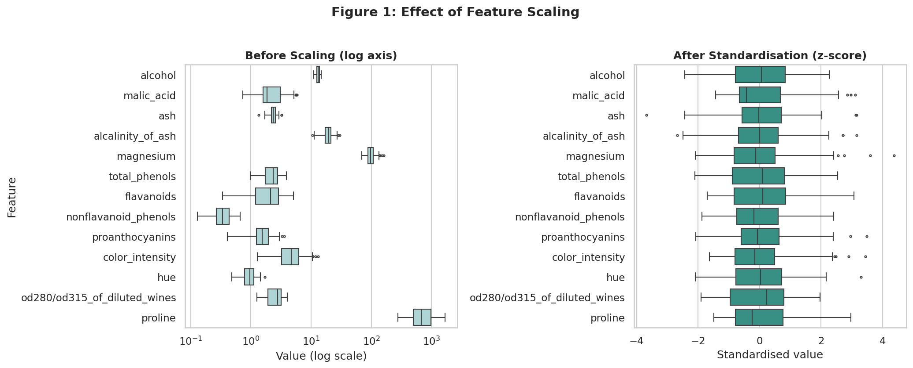
Figure 1: Feature distributions before (left, log axis) and after (right) standardisation
Interpretation: Before scaling, the boxes sit at wildly different positions and widths (proline in the hundreds, hue near 1), which is why a logarithmic axis was needed to show them together. After standardisation all features are centred on zero with comparable spread, so each contributes fairly to the distance calculation.

4.4 Outliers
Seventeen wines (9.6%) have at least one value outside the 1.5 x IQR fences, mostly in magnesium, alkalinity of ash and colour intensity (4 each). They were kept. They are real measurements, not errors, and removing them would shrink an already small dataset of 178 wines. K-Means is somewhat sensitive to outliers, so their effect is checked later through the bootstrap stability test (Section 8).

4.5 Feature correlations
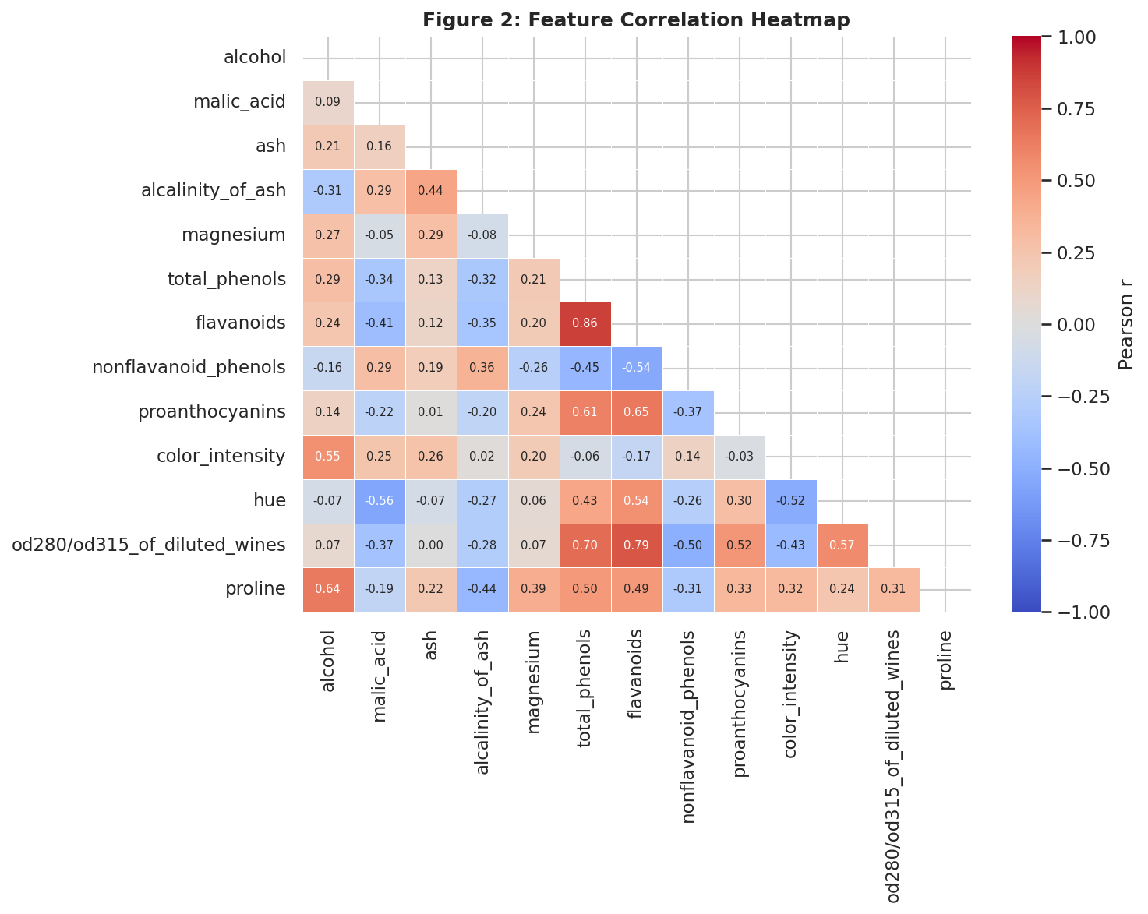
Figure 2: Pearson correlation matrix of the 13 features
Interpretation: Several features move together. Flavanoids are strongly related to total phenols (r = 0.86) and to the OD280/OD315 ratio (r = 0.79), and negatively to non-flavanoid phenols (r = -0.54). Alcohol is related to proline (r = 0.64), and colour intensity is negatively related to hue (r = -0.52). These relationships hint that the wines differ along a few underlying dimensions (phenolic richness, colour and strength) rather than 13 independent ones. A side effect is that the correlated phenolic features carry extra weight in the distance calculation, which is discussed under limitations.

5. Methodology and Rationale
Rather than relying on a single algorithm, four families of clustering methods were applied. Each makes different assumptions about what a cluster is, so agreement between them is stronger evidence than any single result.
Table 3: Algorithms used and the reasoning for each
Algorithm | How it works | Why it was included
K-Means | Assigns each point to the nearest of k centroids and repeats until the centroids stop moving, minimising within-cluster variance. | Fast, simple and the standard baseline. Suits compact, roughly spherical clusters. Used as the final model.
Hierarchical (Ward, complete, average) | Starts with every wine as its own cluster and repeatedly merges the closest pair, producing a tree (dendrogram). | Needs no pre-set k; the dendrogram shows structure at every level. Three linkage rules are compared.
Gaussian Mixture (GMM) | Models the data as overlapping Gaussian distributions and gives each wine a probability of belonging to each. | Allows elliptical clusters and soft assignment. Its BIC score gives a second opinion on k.
DBSCAN | Groups dense regions and labels isolated points as noise; no k is needed. | A density-based contrast that tests whether the data has clear density gaps.

5.1 Evaluation metrics
Because there are no labels during clustering, quality is judged with internal validity indices. Each looks at compactness and separation differently, so several are used together.
Table 4: Metrics used
Metric | Meaning | Better when
Inertia (elbow) | Sum of squared distances to the cluster centroid | Lower (look for the bend)
Silhouette score | How much closer a wine is to its own cluster than to the nearest other cluster (-1 to +1) | Higher
Calinski-Harabasz | Ratio of between-cluster to within-cluster variance | Higher
Davies-Bouldin | Average similarity of each cluster to its most similar neighbour | Lower
BIC (GMM only) | Model fit penalised for complexity | Lower
ARI and NMI | Agreement with the hidden cultivar labels (external check only) | Higher (1 = perfect)

6. Choosing the Number of Clusters
The number of clusters is the most important parameter in K-Means. Instead of guessing, K-Means was run for every k from 2 to 10 with 20 random restarts each (n_init = 20, to avoid poor local minima) and scored with four criteria.
for k in range(2, 11):
km = KMeans(n_clusters=k, n_init=20, random_state=42).fit(Xs)
gmm = GaussianMixture(n_components=k, n_init=5, random_state=42).fit(Xs)
rows.append({"k": k, "inertia": km.inertia_,
"silhouette": silhouette_score(Xs, km.labels_),
"davies_bouldin": davies_bouldin_score(Xs, km.labels_),
"calinski_harabasz": calinski_harabasz_score(Xs, km.labels_),
"gmm_bic": gmm.bic(Xs)})

Table 5: Cluster-validity metrics for each k
k | Inertia | Silhouette | Davies-Bouldin | Calinski-Harabasz | GMM BIC
2 | 1658.8 | 0.259 | 1.526 | 69.5 | 5608
3 | 1277.9 | 0.285 | 1.389 | 70.9 | 5806
4 | 1175.4 | 0.259 | 1.817 | 56.2 | 5807
5 | 1107.0 | 0.232 | 1.681 | 47.2 | 6026
6 | 1046.0 | 0.237 | 1.554 | 41.7 | 6353
7 | 981.6 | 0.204 | 1.661 | 38.7 | 6710
8 | 935.2 | 0.157 | 1.741 | 35.8 | 6408
9 | 889.9 | 0.150 | 1.708 | 33.8 | 6449
10 | 845.9 | 0.144 | 1.707 | 32.4 | 6645

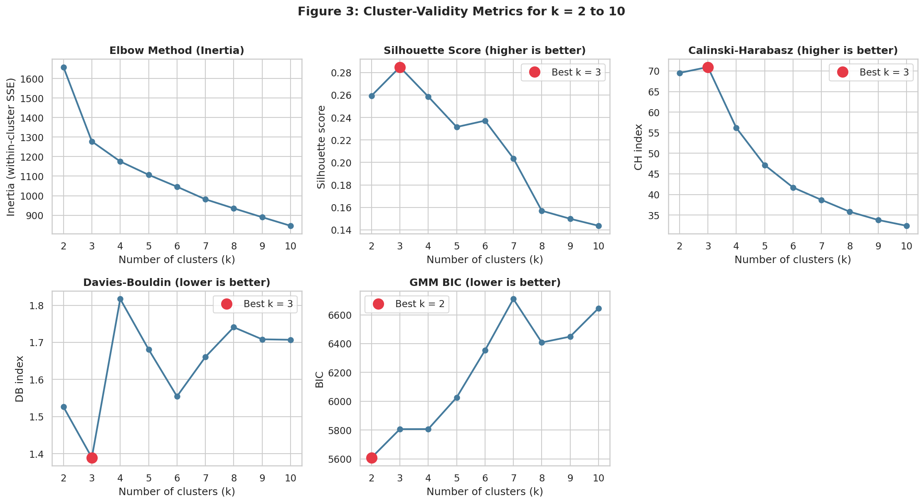
Figure 3: Elbow, silhouette, Calinski-Harabasz, Davies-Bouldin and GMM BIC for k = 2 to 10
Interpretation: Three of the four K-Means criteria (silhouette, Calinski-Harabasz and Davies-Bouldin) all peak at k = 3. The elbow curve is gentle rather than sharp, but the largest single drop in inertia occurs from k = 2 to k = 3 (a 23% reduction), whereas going from 3 to 4 reduces it by only 8%. The exception is the GMM BIC, which prefers k = 2 (5608 against 5806 for k = 3). A gap of about 200 BIC points is not trivial, so this disagreement is acknowledged rather than ignored. A likely reason is that BIC penalises the large number of covariance parameters a full Gaussian model needs with 13 features and only 178 wines, so it favours a simpler model. Given the agreement of the other criteria, the dendrogram (Section 6.1) and the external check in Section 11, k = 3 was chosen. The peak silhouette is only 0.285, which indicates moderate rather than sharply separated clusters, a point examined in Section 8.

6.1 Hierarchical view: the dendrogram
Z = linkage(Xs, method="ward")
dendrogram(Z, truncate_mode="lastp", p=30, color_threshold=cut_height)

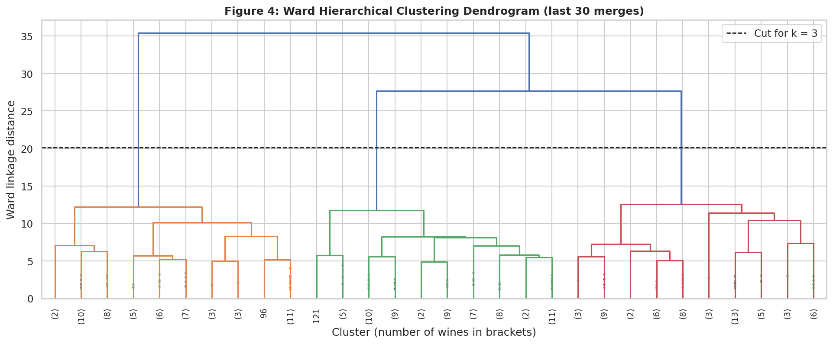
Figure 4: Ward dendrogram (last 30 merges); the dashed line marks the cut that yields three clusters
Interpretation: The dendrogram gives independent support for three groups. The last two merges happen at very large linkage distances (about 27.7 and 35.4), far above the heights at which the individual branches form (mostly below 13). Cutting anywhere across that long gap leaves exactly three branches, shown in orange, green and red. Hierarchical clustering therefore agrees with the K-Means metrics without being told the number of clusters.

7. Comparing the Clustering Algorithms
Every algorithm was run on the same standardised data. For the four methods that require a cluster count, k = 3 was used. DBSCAN does not need k; its neighbourhood radius (eps = 2.2, min_samples = 5) was chosen from the k-distance plot (Figure 5), where the curve starts to rise steeply.
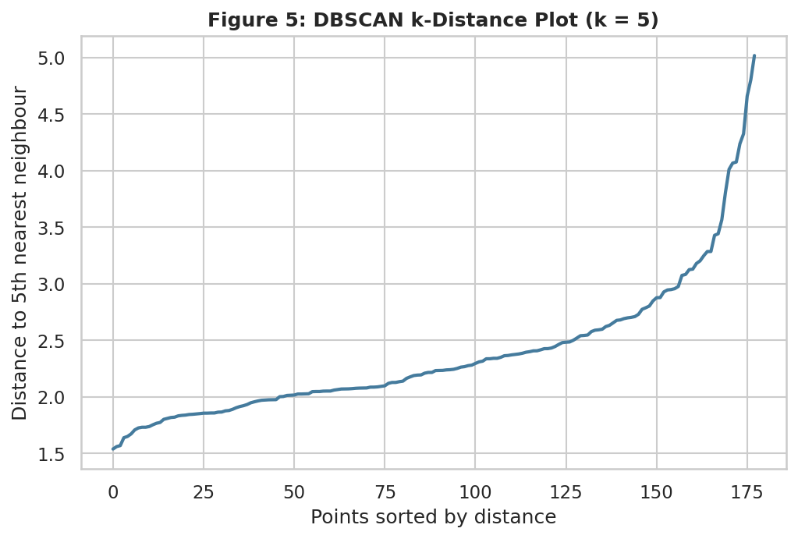
Figure 5: k-distance plot used to choose the DBSCAN radius
Table 6: Algorithm comparison (internal metrics, then agreement with the hidden cultivars)
Algorithm | Clusters | Noise | Silhouette | Davies-Bouldin | ARI
K-Means | 3 | 0 | 0.285 | 1.389 | 0.897
Hierarchical (Ward) | 3 | 0 | 0.277 | 1.419 | 0.790
Hierarchical (Complete) | 3 | 0 | 0.204 | 1.896 | 0.577
Hierarchical (Average) | 3 | 0 | 0.158 | 1.030 | -0.005
Gaussian Mixture | 3 | 0 | 0.284 | 1.394 | 0.880
DBSCAN (eps = 2.2) | 2 | 55 | 0.348 | 1.124 | 0.329

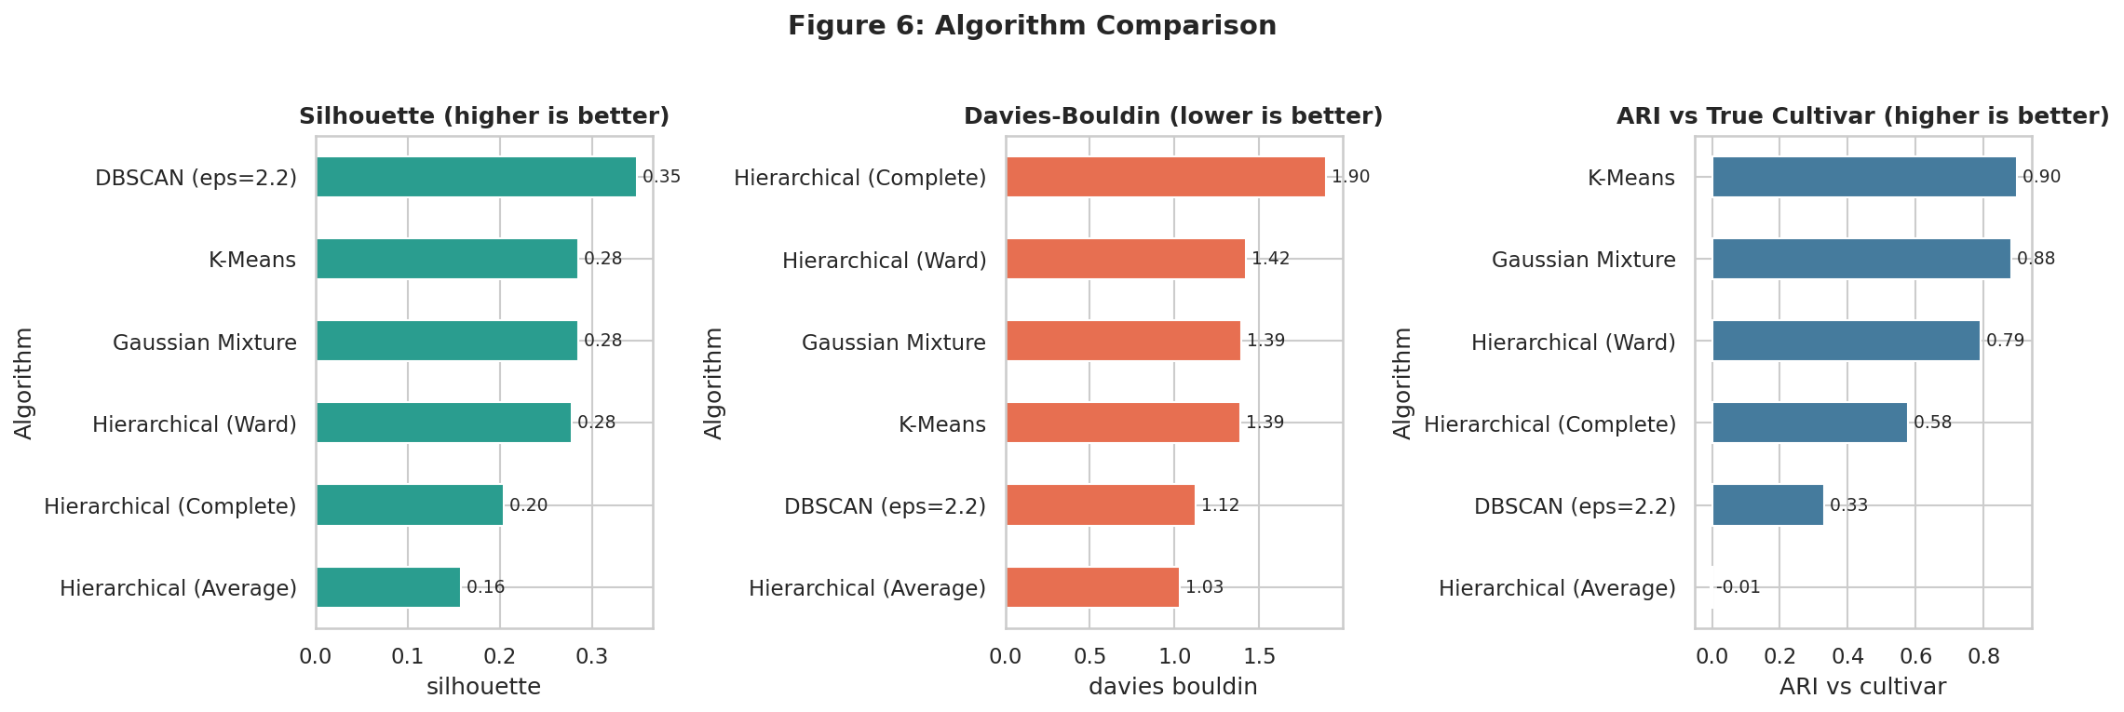
Figure 6: Silhouette, Davies-Bouldin and ARI for each algorithm
Interpretation: K-Means, Gaussian Mixture and Ward hierarchical clustering give very similar internal scores, and K-Means is the best on both silhouette and agreement with the true cultivars (ARI 0.897). Two results need careful reading. First, average linkage has the best Davies-Bouldin score (1.03) but is a degenerate solution: it puts 174 of the 178 wines in one cluster and leaves one and three wines in the others, a known 'chaining' effect. Its ARI of -0.005 confirms it is no better than random grouping. Second, DBSCAN reports the highest silhouette (0.348), but only because 55 wines (31%) were labelled as noise and excluded from the score, and it found just two clusters. Its low ARI (0.329) shows it is not a good segmentation of the full dataset. This is a useful reminder that a single metric can be misleading, and that the best internal score is not always the best clustering.
K-Means was therefore selected as the final model: it performs at or near the top on every sensible criterion, it assigns every wine to a group, and its centroids are easy to interpret as cluster profiles.

8. Final Model and Reliability

8.1 K-Means with k = 3
km = KMeans(n_clusters=3, n_init=50, random_state=42).fit(Xs)
labels = km.labels_

The final model uses 50 random initialisations and keeps the best (lowest inertia). It produces three clusters of 65, 51 and 62 wines (inertia 1277.9, silhouette 0.285). The sizes are reasonably balanced, so no cluster is trivially small.

8.2 Silhouette analysis
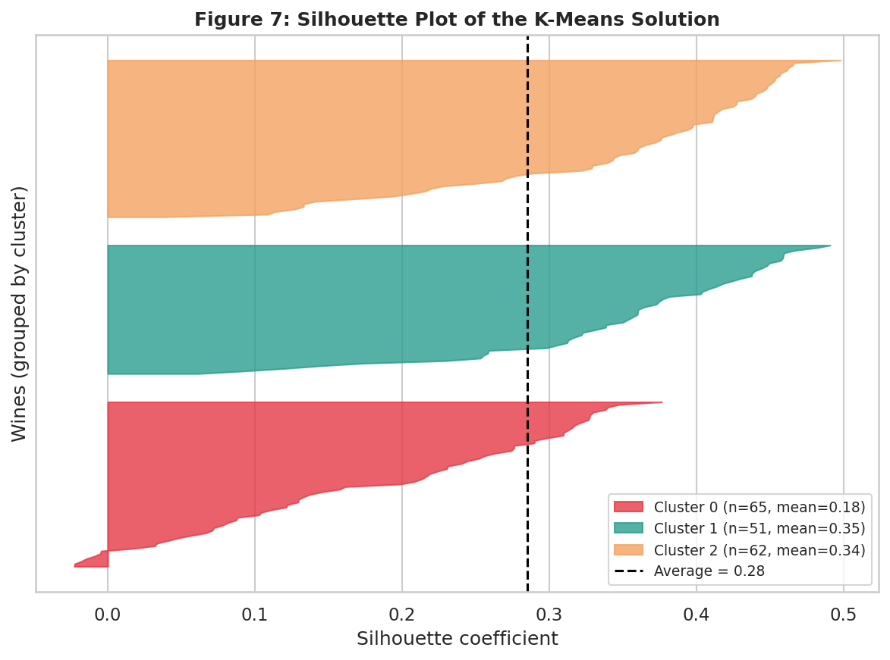
Figure 7: Silhouette coefficient of every wine, grouped by cluster
Interpretation: Clusters 1 and 2 are well formed (mean silhouette 0.35 and 0.34) with almost every wine above zero. Cluster 0 is weaker (mean 0.18) and contains the only wines with negative silhouettes (7 wines in total), meaning they lie closer to a neighbouring cluster than to their own. This is visible in the projections below: cluster 0 sits between the other two, so it borders both of them.

8.3 Stability under resampling
A clustering that changes whenever a few wines are removed cannot be trusted. To test this, 200 random subsets containing 80% of the wines were re-clustered, and each result was compared with the full-data solution using the Adjusted Rand Index (ARI, where 1 means identical grouping).
for _ in range(200):
idx = rng.choice(len(Xs), size=int(0.8 * len(Xs)), replace=False)
sub = KMeans(n_clusters=3, n_init=10).fit(Xs[idx])
scores.append(adjusted_rand_score(km.labels_[idx], sub.labels_))

Table 7: Bootstrap stability of the K-Means solution
Statistic | ARI
Mean over 200 subsamples | 0.980
5th percentile | 0.934
Minimum | 0.854

The mean ARI of 0.98 shows the three-cluster structure is highly stable. Even the worst of the 200 subsamples reproduces the full solution with an ARI of 0.85. The 17 outlying wines therefore do not distort the result.

9. Visualizing the Clusters
Thirteen dimensions cannot be plotted directly, so two complementary projections were used. PCA is a linear method that preserves global distances and is easy to interpret. t-SNE is non-linear and emphasises local neighbourhoods.
pca = PCA().fit(Xs)
P = pca.transform(Xs)
centers = pca.transform(km.cluster_centers_)
tsne = TSNE(n_components=2, perplexity=30, init="pca",
learning_rate="auto", random_state=42).fit_transform(Xs)

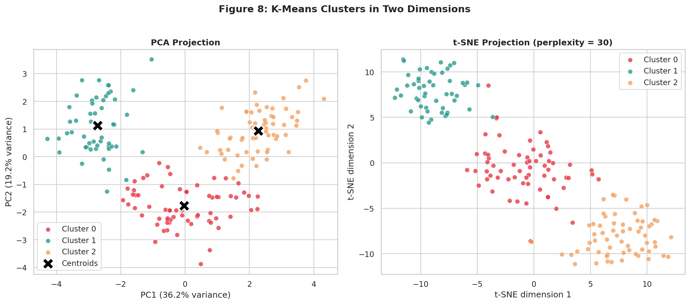
Figure 8: K-Means clusters shown by PCA (left, with centroids) and t-SNE (right)
Interpretation: In both projections the three clusters form distinct regions. In the PCA view the first two components explain 36.2% and 19.2% of the variance (55.4% together), and the centroids lie far apart. Cluster 1 (green) is isolated at the left, cluster 2 (orange) at the upper right, and cluster 0 (red) at the bottom centre between them, which matches the silhouette finding that cluster 0 is the 'bridge' group. The t-SNE view, which does not preserve global distances, shows the same three groups with a small amount of overlap at the boundaries. Because both an unrelated linear and a non-linear method show the same structure, the clusters are not an artefact of one visualization technique.
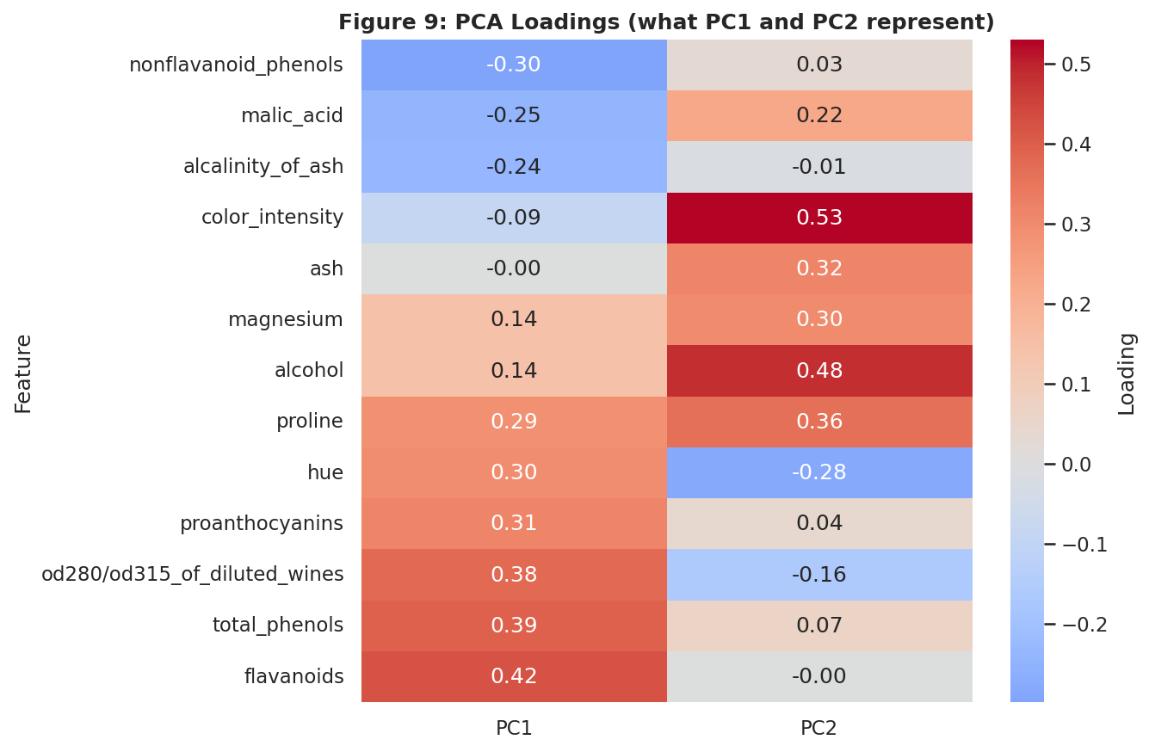
Figure 9: PCA loadings for the first two principal components
Interpretation: The loadings explain what the axes mean. PC1 is driven by flavanoids (0.42), total phenols (0.40) and OD280/OD315 (0.38), and opposed by non-flavanoid phenols (-0.30), so it is essentially a phenolic richness axis. PC2 is driven by colour intensity (0.53), alcohol (0.48) and proline (0.36), so it is an intensity and strength axis. The clusters therefore separate mainly by how phenol-rich the wine is (left to right) and how strong or deeply coloured it is (top to bottom).

10. Cluster Characteristics

10.1 Which features define the clusters?
A one-way ANOVA was run on every feature across the three clusters, with eta-squared (the share of a feature's variance explained by cluster membership) as the effect size. Features were then ranked by eta-squared.
Table 8: Eight features that best separate the clusters
Feature | F statistic | Eta-squared | p-value
flavanoids | 271.6 | 0.756 | < 0.001
od280/od315_of_diluted_wines | 221.5 | 0.717 | < 0.001
proline | 200.3 | 0.696 | < 0.001
alcohol | 113.2 | 0.564 | < 0.001
color_intensity | 111.9 | 0.561 | < 0.001
total_phenols | 106.9 | 0.550 | < 0.001
hue | 104.7 | 0.545 | < 0.001
malic_acid | 38.7 | 0.306 | < 0.001

All 13 features differ significantly between clusters, but flavanoids, OD280/OD315 and proline are the strongest, each explaining roughly 70% or more of its own variance. Ash and magnesium separate the clusters least (eta-squared 0.15 and 0.21). A caution: because the clusters were built from these same features, the p-values are descriptive of the separation rather than formal hypothesis tests, and should not be read as independent proof.

10.2 Cluster profile heatmap
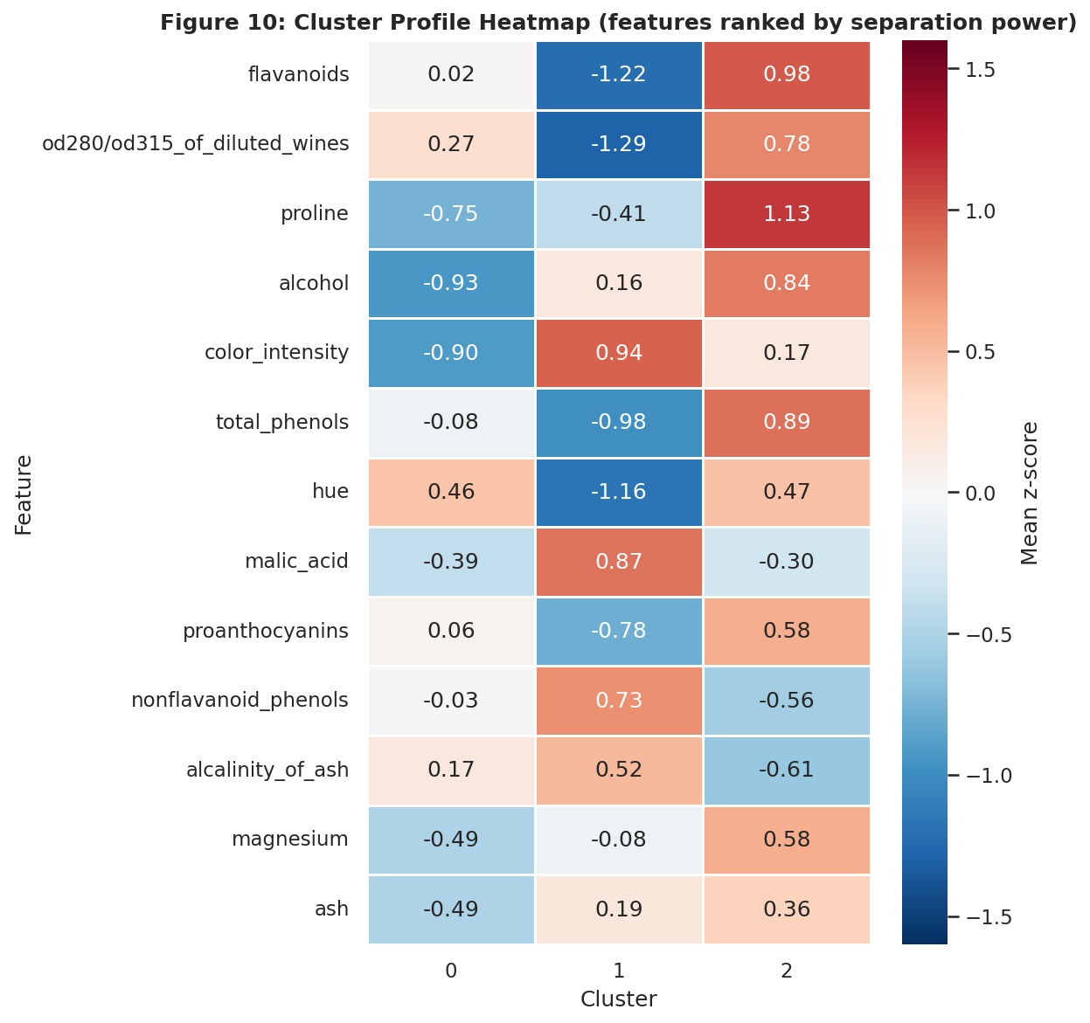
Figure 10: Mean standardised value of each feature in each cluster (features ranked by separation power)
Interpretation: Red cells mean the cluster is above the overall average for that feature; blue means below. Each cluster has a clear chemical signature. Cluster 2 is red on flavanoids, proline, total phenols and alcohol. Cluster 1 is blue on flavanoids, OD280/OD315 and hue, but red on colour intensity and malic acid. Cluster 0 is blue on alcohol, colour intensity and proline, and close to average on flavanoids, total phenols and OD280/OD315.
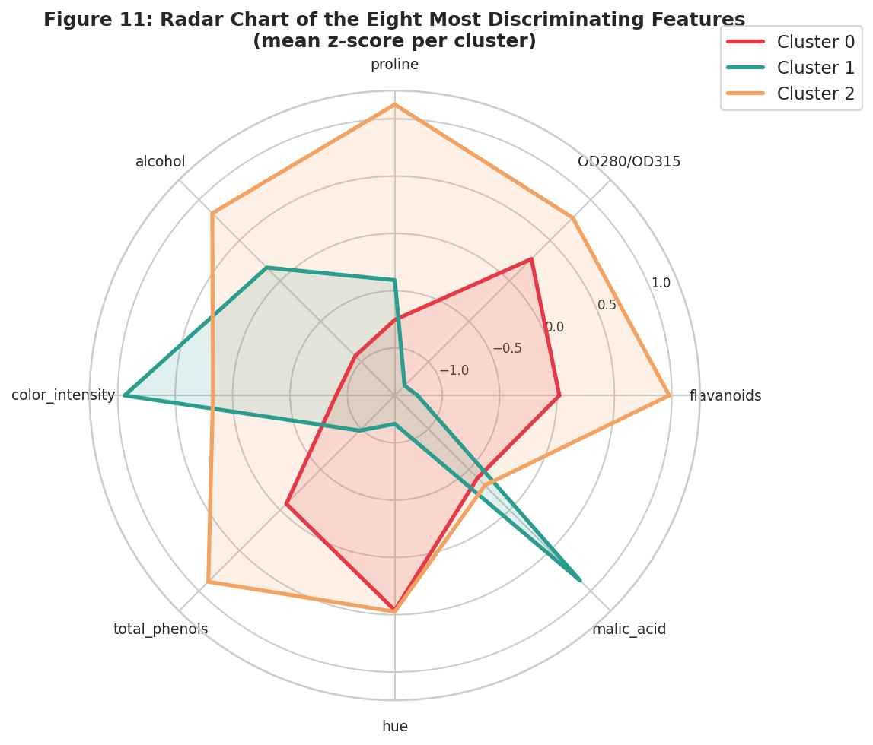
Figure 11: Radar chart of the eight most discriminating features (mean z-score per cluster)
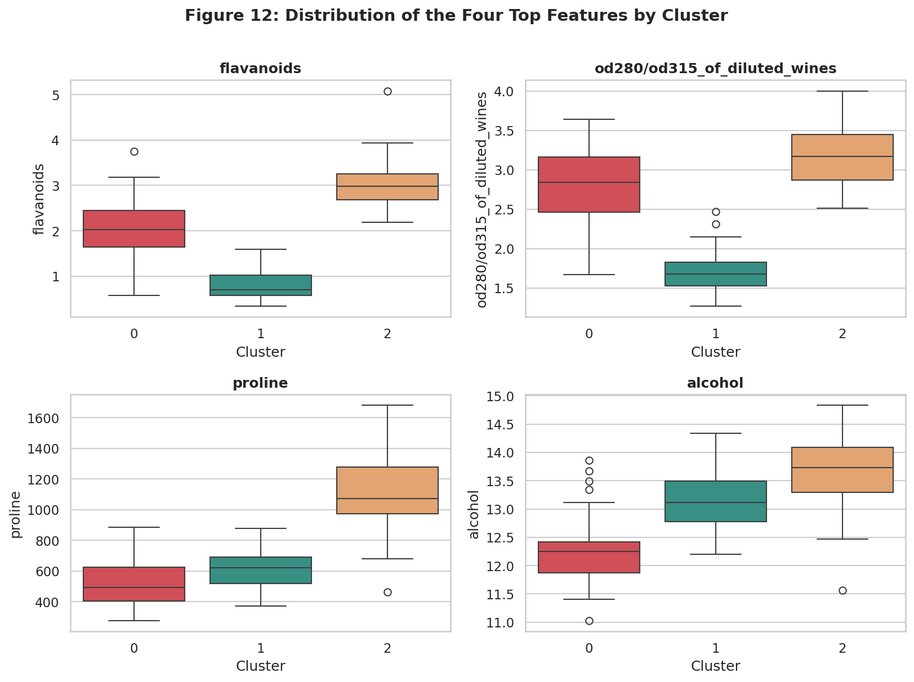
Figure 12: Distribution of the four strongest features within each cluster
Interpretation: The radar chart shows the three clusters as three clearly different shapes. The box plots show that for flavanoids the three clusters barely overlap at all (cluster 1 lowest, cluster 0 in the middle, cluster 2 highest), and that for OD280/OD315 cluster 1 sits well below the other two. However, no single feature separates all three clusters: for proline, clusters 0 and 1 are almost indistinguishable and only cluster 2 stands out, while for OD280/OD315 clusters 0 and 2 overlap. Each feature separates a different pair of clusters, which is why the clusters only emerge when all features are used together.

10.3 Raw feature means (original units)
Table 9: Mean value of the key features in each cluster
Feature | Cluster 0 (n=65) | Cluster 1 (n=51) | Cluster 2 (n=62)
alcohol (%) | 12.25 | 13.13 | 13.68
malic_acid | 1.90 | 3.31 | 2.00
total_phenols | 2.25 | 1.68 | 2.85
flavanoids | 2.05 | 0.82 | 3.00
color_intensity | 2.97 | 7.24 | 5.45
hue | 1.06 | 0.69 | 1.06
od280/od315 | 2.80 | 1.70 | 3.16
proline | 510 | 619 | 1100
alcalinity_of_ash | 20.1 | 21.2 | 17.5

10.4 Cluster descriptions
The names below are descriptive labels chosen for this report, based on the chemical profile. The sensory descriptions are reasonable inferences from the chemistry (for example, high phenols are generally linked to body and astringency) and were not tested by tasting.
Table 10: Summary of the three clusters
Cluster | Label | Defining chemistry | Size
2 | Rich and phenol-rich | Highest proline (1100), alcohol (13.7%), flavanoids (3.0) and total phenols (2.85); lowest alkalinity of ash (17.5) | 62 (34.8%)
1 | Deep-coloured and tart | Highest colour intensity (7.2) and malic acid (3.3); lowest flavanoids (0.82), OD280/OD315 (1.70) and hue (0.69) | 51 (28.7%)
0 | Light and mild | Lowest alcohol (12.3%) and colour intensity (3.0); low proline (510); mid-range phenols; high hue (1.06) | 65 (36.5%)

11. External Validation Against the True Cultivars
Only now is the hidden cultivar label used. A cross-tabulation compares each K-Means cluster with the real grape cultivar.
ct = pd.crosstab(pd.Series(labels, name="Cluster"), y.rename("Cultivar"))
purity = ct.max(axis=1).sum() / ct.values.sum()
ari = adjusted_rand_score(y, labels)

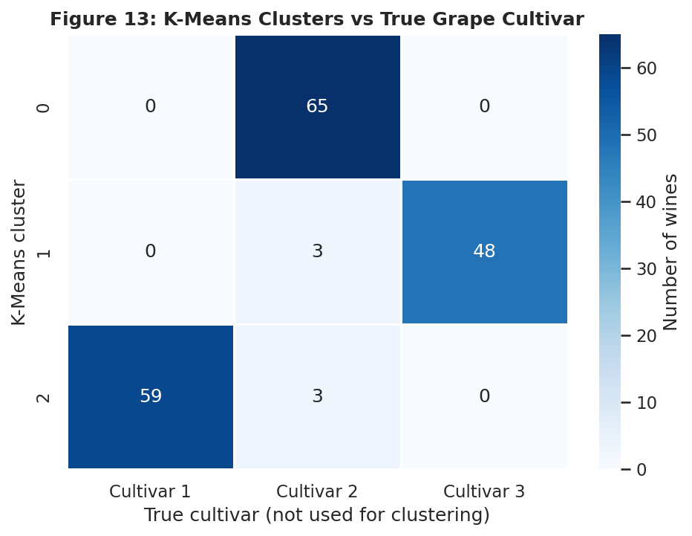
Figure 13: K-Means clusters compared with the true grape cultivars
Table 11: Validation scores
Measure | Value
Purity | 0.966 (172 of 178 wines in the matching cluster)
Adjusted Rand Index | 0.897
Normalised Mutual Information | 0.876

Interpretation: Each cluster corresponds almost exactly to one cultivar: cluster 2 holds 59 of the 59 Cultivar 1 wines, cluster 0 holds 65 of the 71 Cultivar 2 wines, and cluster 1 holds 48 of the 48 Cultivar 3 wines. Only 6 wines (3.4%) are placed in a different cluster, and all six are Cultivar 2 wines (three assigned to cluster 1 and three to cluster 2). These are consistent with the weak silhouette of cluster 0 and its position between the others. The result shows that unsupervised clustering on chemistry alone, with no labels, rediscovered the grape varieties. It also validates the choice of k = 3 independently of the internal metrics.

12. Business and Research Implications

12.1 Business implications
- Product portfolio segmentation: a producer can treat the three clusters as three product lines (a rich premium style, a deep-coloured and tart style, and a light and mild style) and manage production, inventory and branding for each.
- Targeted pricing and marketing: the phenol-rich, high-proline cluster is a candidate for premium positioning, while the light and mild cluster may suit casual or entry-level customers. Whether buyers actually respond this way would need to be tested with sales data.
- Blending and quality control: cluster centroids give a measurable target chemistry for each style. A new batch that falls far from its intended centroid can be flagged for review, and blending between clusters can be planned using the measured distances.
- Authenticity and traceability: since the clusters mirror the grape cultivars, a similar model could help flag mislabelled or suspicious batches by checking whether a wine's chemistry fits the cluster of its claimed variety.
- A reusable method: the same pipeline (scale, choose k with several criteria, compare algorithms, test stability, profile, validate) transfers directly to customer segmentation, product grouping or market analysis.

12.2 Research implications
- Chemometric classification of wines can be done from a small panel of measurements. Flavanoids, OD280/OD315 and proline alone explain most of the separation, so a cheaper reduced test panel is worth investigating.
- The intermediate position of cluster 0 suggests a gradient between styles rather than hard boundaries, which motivates soft-clustering methods such as GMM for borderline wines.
- Comparing several algorithms and validity indices, as done here, is a safeguard against over-trusting any single metric, as the average-linkage and DBSCAN results showed.

13. Limitations
- The dataset is small (178 wines) and comes from one region and one period, so the clusters may not generalise to wines from elsewhere.
- Internal separation is moderate (silhouette 0.285). The clusters are real and stable but overlap at the edges, especially cluster 0.
- Correlated features (for example flavanoids, total phenols and OD280/OD315) give the phenolic dimension extra weight in distance calculations. Applying PCA before clustering or removing redundant features could be explored.
- K-Means assumes compact, roughly spherical clusters of similar size and is sensitive to outliers. Stability testing suggests this was not a problem here, but it would matter for other data.
- The cluster names and sensory descriptions are interpretations of the chemistry, not tasting results.
- The comparison with true cultivars is possible only because labels happen to exist. In a real project the internal metrics, stability tests and expert judgement would be the only evidence.

14. Conclusion
This study applied four families of clustering algorithms to the Wine dataset after standardising the features. Silhouette, Calinski-Harabasz and Davies-Bouldin all indicated three clusters, the dendrogram showed a clear three-way split, and K-Means with k = 3 gave the best balance of internal quality and interpretability. The solution is highly stable (mean ARI 0.98 over 200 subsamples) and is explained by three groups with distinct chemical signatures: a rich and phenol-rich group, a deep-coloured and tart group and a light and mild group. When the hidden cultivar labels were revealed, 96.6% of wines were in the matching cluster, showing that the unsupervised method recovered real structure.
The comparison also produced two practical lessons: the best-looking number on one metric (DBSCAN's silhouette, average linkage's Davies-Bouldin) can describe a useless clustering, and a good analysis therefore combines several metrics, a stability test and visual checks before trusting the result.

Appendix: How to Reproduce the Analysis
pip install pandas numpy matplotlib seaborn scipy scikit-learn
python wine_clustering.py # outputs to ./clustering_output
python wine_clustering.py --out results # custom output folder
python wine_clustering.py --k 4 # force a different number of clusters
python wine_clustering.py --show # also display plots

The script writes 13 PNG figures to <output>/figures, summary CSV tables to <output>/tables, and a copy of the dataset with the assigned cluster of every wine (wine_with_clusters.csv). A fixed random seed (42) makes all results reproducible.

References
- Forina, M., Leardi, R., Armanino, C., and Lanteri, S. (1988). PARVUS: An Extendable Package of Programs for Data Exploration, Classification and Correlation. Elsevier, Amsterdam. (Wine Recognition Data, UCI Machine Learning Repository.)
- Rousseeuw, P. J. (1987). Silhouettes: a graphical aid to the interpretation and validation of cluster analysis. Journal of Computational and Applied Mathematics, 20, 53-65.
- Calinski, T., and Harabasz, J. (1974). A dendrite method for cluster analysis. Communications in Statistics, 3(1), 1-27.
- Davies, D. L., and Bouldin, D. W. (1979). A cluster separation measure. IEEE Transactions on Pattern Analysis and Machine Intelligence, 1(2), 224-227.
- Ester, M., Kriegel, H.-P., Sander, J., and Xu, X. (1996). A density-based algorithm for discovering clusters in large spatial databases with noise. Proceedings of KDD-96.
- van der Maaten, L., and Hinton, G. (2008). Visualizing data using t-SNE. Journal of Machine Learning Research, 9, 2579-2605.
- Hubert, L., and Arabie, P. (1985). Comparing partitions. Journal of Classification, 2(1), 193-218.
- Pedregosa, F. et al. (2011). Scikit-learn: Machine learning in Python. Journal of Machine Learning Research, 12, 2825-2830.

