WEEK 1 TASK
Introduction to Code Navigation and Documentation
Sample Python Codebase Analysis
Prepared by: Mohammad Faizullah Akhtar
GitHub-ready Python implementation included

1. Introduction
Code navigation is the process of entering an unfamiliar codebase, locating important components, understanding how those components interact, and documenting the program flow. This report demonstrates that process using a small Python application.
The sample application represents a simple product catalog and shopping-cart flow. It contains a data class, functions, a loop, conditional logic, returned values, and a main entry point. The code is intentionally small so each component can be traced from start to finish.

2. Objective
- Understand the structure of a small Python codebase.
- Identify classes, functions, variables, conditions, loops, and the entry point.
- Trace how product data moves through the program.
- Create diagrams that explain interactions between code components.
- Document technical findings in language understandable to non-programmers.
- Provide a GitHub-ready Python file that can be executed and studied.

3. Codebase Overview
The project contains one main Python file, code_navigation_sample.py. It is organized into a Product data model, product operations, checkout operations, and the main program flow.
Component | Type | Purpose
Product | dataclass | Stores product ID, name, and price.
create_products | function | Builds the sample product catalog.
display_products | function | Prints the catalog.
find_product | function | Searches for a product by ID.
calculate_total | function | Adds prices in the cart.
checkout | function | Checks the cart and reports the total.
main | function | Coordinates the complete program flow.

4. Analysis of Key Components

4.1 Product data class
Product is a dataclass with product_id, name, and price. It groups related product information into one structured object.

4.2 create_products()
Creates three Product objects and returns them in a list. This is the source of the sample catalog.

4.3 display_products()
Receives the product list and uses a for loop to print each product.

4.4 find_product()
Receives a product list and ID, loops through the list, compares IDs, and returns the matching object or None.

4.5 calculate_total()
Receives the cart and adds the price of every product in it.

4.6 checkout()
Checks whether the cart is empty. If not, it calls calculate_total(), displays the total, and returns it.

4.7 main() and entry point
Coordinates the application: creates data, displays products, selects an item, adds it to the cart, and performs checkout. The final if statement runs main() when the file is executed directly.

5. Code Navigation Method
- Start at the entry point: locate if __name__ == '__main__' and main().
- Read main() to understand the overall story of the program.
- For every function called by main(), inspect its input, processing, and output.
- Locate the data model and identify what information each object stores.
- Trace important variables such as products, selected_product, and cart.
- Check conditions and loops because they control execution paths.
- Follow returned values to the next component that uses them.
- Summarize the flow with diagrams and plain-language notes.

6. Diagrams and Data Flow
The diagrams below show the structure of the codebase and the order in which the main program moves through its components.
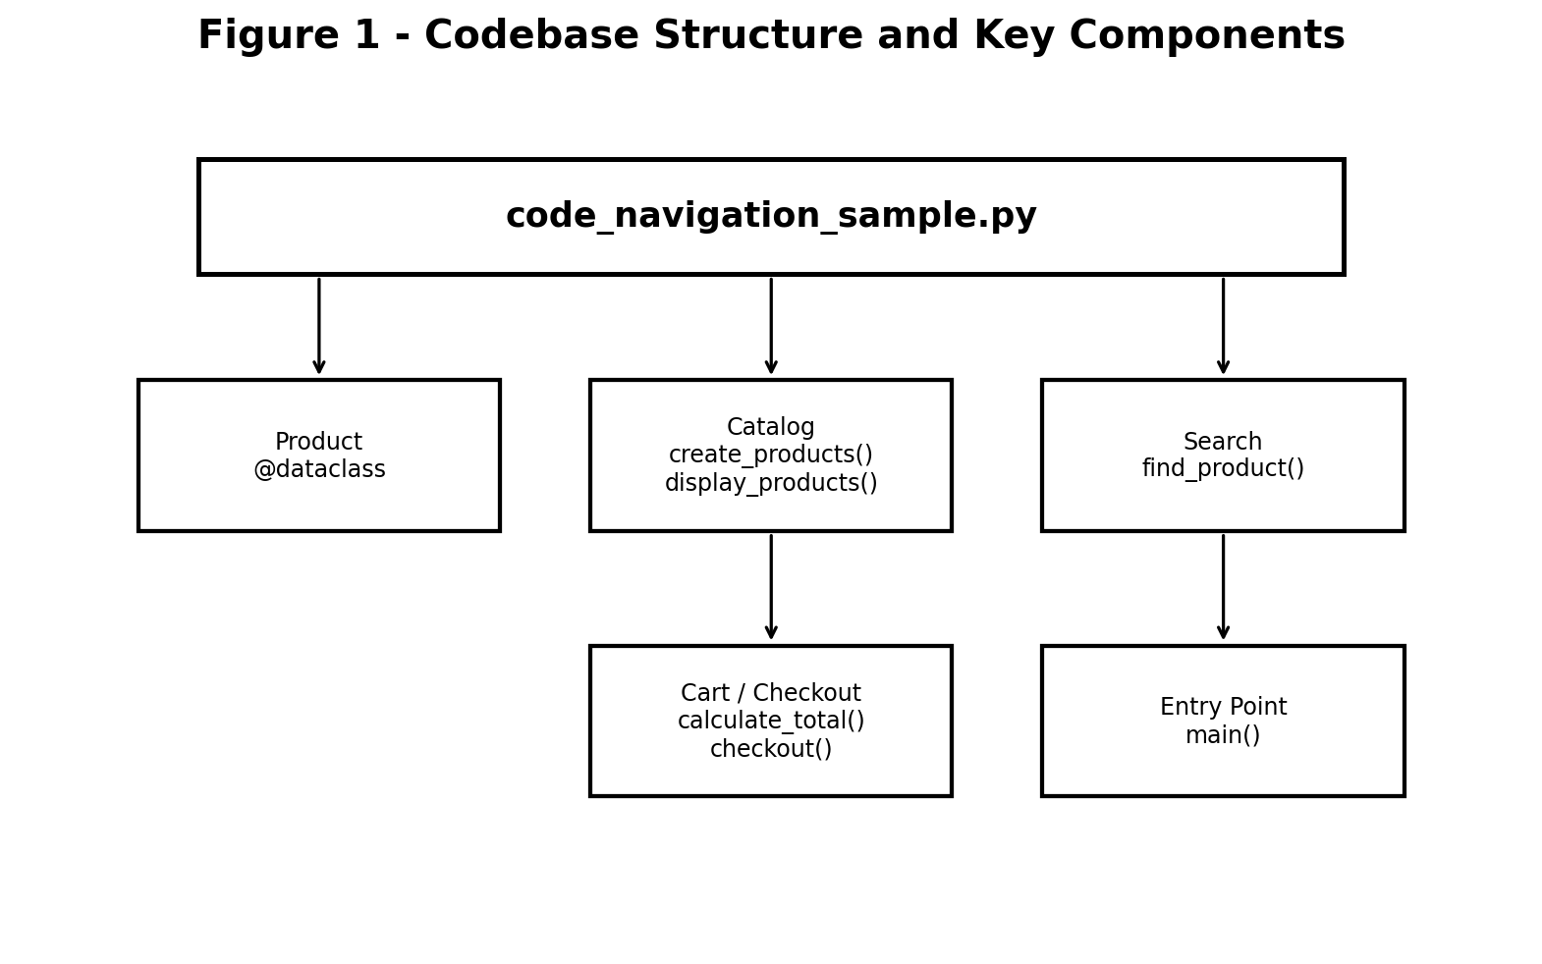
Figure 1: Codebase structure and key components.
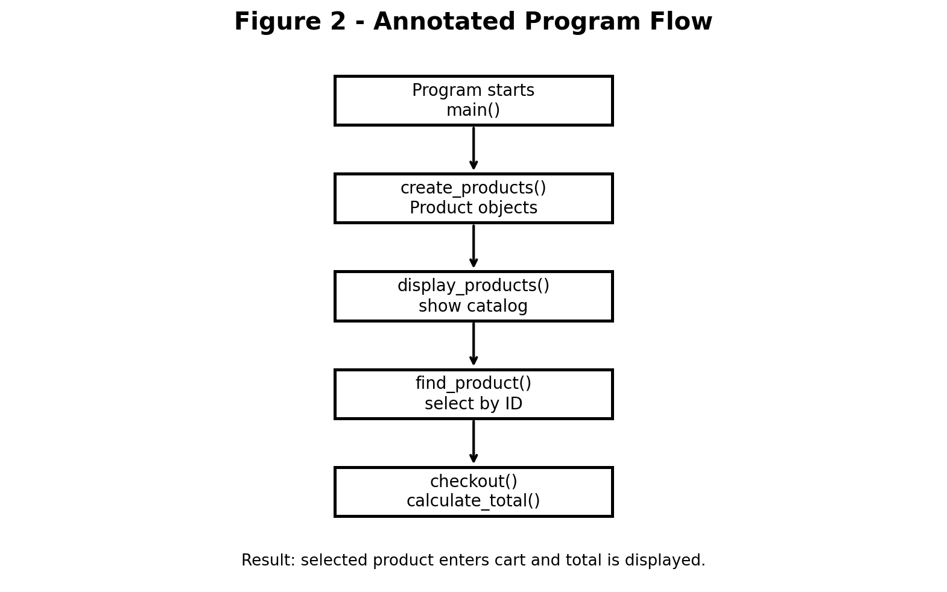
Figure 2: Main execution and data flow.

7. Step-by-Step Data Flow
Start: Python executes the file and enters main().
Create data: create_products() creates three Product objects and returns a list.
Display data: display_products() receives the list and prints the catalog.
Select data: find_product() searches for product ID 2 and returns the matching object.
Update state: The selected Product is appended to the cart list.
Validate: checkout() checks whether the cart contains an item.
Calculate: calculate_total() adds the prices in the cart.
Output: checkout() prints the total and returns the amount.

8. Example Execution
When the program is run, the output is approximately:
Available Products
-----------------------------------
1. Keyboard - Rs.1200.00
2. Mouse - Rs.650.00
3. Headphones - Rs.1800.00
Added to cart: Mouse
Checkout successful. Total: Rs.650.00

9. Insights and Recommendations
- The main function is a useful starting point because it reveals the sequence of operations.
- Small single-purpose functions make code easier to navigate and explain.
- A dataclass makes the data model explicit.
- Returning values makes functions easier to reuse and test.
- Learn Python modules and packages so larger programs can be split into logical files.
- Practice Git and GitHub commands such as clone, branch, commit, pull, and push.
- Learn pytest and write tests for find_product(), calculate_total(), and checkout().
- Study exception handling, type hints, APIs, databases, and software architecture as next steps.

10. GitHub and Reproducibility
The supplied Python file is GitHub-ready. A README file is also included with run instructions and a suggested navigation order.
git init
git add .
git commit -m "Add Week 1 code navigation sample"
git branch -M main
git remote add origin YOUR_GITHUB_REPOSITORY_URL
git push -u origin main

11. Conclusion
This Week 1 exercise demonstrates a practical method for navigating an unfamiliar codebase. The reader begins at the entry point, follows function calls, identifies data structures, traces variables, and documents the resulting flow. The sample project provides a compact foundation for learning how to understand larger multi-file software projects.

12. Submission Checklist
☐ Introduction included.
☐ Codebase structure and key components identified.
☐ Functions and data model explained.
☐ Annotated diagrams included.
☐ Data flow documented step by step.
☐ Insights and recommendations included.
☐ GitHub-ready Python source provided.
☐ README provided for execution and navigation.

Appendix A - Attached PNG Diagrams
The two PNG diagrams used in this report are embedded below so that the DOCX contains the visual files directly.

A.1 Codebase Structure Diagram
Attached PNG: codebase_structure_diagram.png

A.2 Annotated Program Flowchart
Attached PNG: code_navigation_flowchart.png

