CRITICAL REVIEW REPORT
Evaluating Simplified Coding Methodologies for Non-Programmers
Week 5 Task | Programming Fundamentals
Prepared as an evidence-informed comparative review. The scoring chart is an analytical rubric created for this report; it is not a claim that a controlled experiment was conducted.

Executive Summary
This report reviews two practical routes for introducing programming to non-programmers: (1) visual, block-based programming using Scratch, and (2) a scaffolded transition to text-based programming using Python, supported by plain-language explanations, worked examples and small projects. It also considers unplugged activities as a useful supporting technique. Scratch reduces early syntax demands and enables learners to see program structure visually. Guided Python develops familiarity with the notation and tools used in many real-world programming tasks, but requires more careful sequencing and feedback. The review recommends a blended pathway: begin with everyday algorithms and visual blocks, then gradually reveal equivalent Python statements and support learners through short, meaningful projects.

1. Introduction and Scope
Programming literacy is more than memorising commands. A beginner needs to describe a problem, divide it into steps, recognise patterns, use sequence/selection/repetition, test a solution and explain why it works. Non-programmers may also face unfamiliar vocabulary, fear of making mistakes, limited device access or language barriers. An effective teaching approach should therefore make concepts understandable while preserving a path toward independent problem solving.
This review compares two approaches that can be used with adult beginners as well as younger learners, while noting that Scratch was designed especially for young people. The focus is instructional clarity, accessibility, learning efficiency, debugging and transfer to text-based programming. The review uses publicly available platform and curriculum information, alongside a published comparative study. It is a desk-based critical review, not a new learner trial.

2. Method and Evaluation Framework
Sources were selected for direct relevance to beginner coding instruction: official Scratch Foundation and Code.org learning resources, an educational resource from UC Agriculture and Natural Resources, and a peer-reviewed 2025 study comparing novice learners' comprehension in Scratch and Python. Each approach was assessed against five criteria. Scores use a 1–5 qualitative rubric (1 = relatively weak; 5 = relatively strong) informed by the source review and instructional analysis. They are indicative judgements, not measured outcome data.
Criterion | What is assessed | Why it matters
Clarity | How easily a beginner can understand and follow instructions. | Reduces confusion and cognitive overload.
Accessibility | Ease of entry, language/device considerations and inclusion. | Determines who can participate.
Fast start | How quickly learners can create a working first result. | Early success can support motivation.
Transfer | How well learning prepares students for general text-based coding. | Avoids a learning dead end.
Debugging insight | Whether learners can inspect, explain and correct errors. | Builds independence and resilience.

3. Approach A: Visual Block-Based Programming (Scratch)
Scratch lets learners assemble graphical instruction blocks rather than typing every command. The blocks represent actions and control structures; compatible shapes help prevent many syntax and punctuation errors. Learners can create animations, stories and games, which makes abstract ideas such as events, loops and conditionals visible in an immediate result.
Strengths: a low entry barrier; visible program structure; rapid experimentation; creative project choice; and opportunities for peer sharing. The Scratch Foundation describes learning through imagining, creating, playing, sharing and reflecting, and encourages projects that learners find meaningful. UC ANR similarly explains that block coding removes the need to manage syntax at the earliest stage and can help learners develop concepts before moving to traditional text code.
Limitations: block interfaces can hide punctuation, indentation and typing errors that learners later meet in text languages. Large block scripts can become visually crowded, and learners may become dependent on the interface if teachers do not explicitly connect blocks to underlying concepts. Scratch is a programming environment, not a substitute for teaching how to read and write text-based code when that is the learner's goal.

4. Approach B: Scaffolded Text-Based Programming (Python)
This approach introduces real code from the beginning, but reduces complexity through carefully sequenced instruction. An instructor first explains a concept in ordinary language, demonstrates a short working example, traces it line by line, then asks learners to change one feature and predict the result. Beginners can progress from print statements and variables to input, conditions, loops, functions and small command-line projects.
Strengths: learners encounter authentic syntax and develop skills that transfer directly to broader programming work. Code can be copied, modified, tested and versioned; errors provide opportunities to learn careful reading and debugging. Python's relatively readable syntax can make it a suitable first text language when lessons are paced appropriately.
Limitations: spelling, punctuation, indentation and error messages can distract from the underlying concept. A learner may understand a loop in principle yet struggle to type it correctly. Without scaffolding, lengthy examples and unfamiliar setup steps can create unnecessary barriers. The instructor should therefore avoid introducing several new concepts at once.

5. Supporting Technique: Unplugged Learning
Unplugged activities teach computational thinking without requiring a computer. For example, learners can write precise directions for a partner to navigate a grid, sort paper cards using a rule, or act out a loop. Code.org's CS Fundamentals materials combine online activities with unplugged lessons and describe the use of physical activities to model computing concepts. This is not a complete replacement for coding practice: learners still need to apply ideas in a programming environment. It is especially useful before or alongside either main approach.

6. Comparative Analysis
The two approaches solve different beginner problems. Scratch is particularly effective when the immediate goal is to understand program logic and gain confidence. Scaffolded Python is stronger when the goal includes reading and writing textual programs. Neither should be treated as universally superior; learner age, purpose, prior experience, device access and available teaching support affect the best choice.
Dimension | Scratch blocks | Guided Python | Critical judgement
Syntax burden | Low; commands are assembled as blocks. | Higher; exact spelling and indentation matter. | Scratch is easier at entry; Python builds text fluency.
Concept visibility | Control flow and events are visually represented. | Learner reads statements and program flow. | Blocks can clarify structure; tracing Python develops code-reading.
First project | Often quick visual result such as animation/game. | A small text interaction or calculator. | Both can motivate when project scope is small.
Error experience | Some invalid combinations are prevented; logic bugs remain. | Syntax and logic errors are both visible. | Python offers richer exposure to textual debugging.
Transfer | Requires explicit bridge to text syntax. | Direct practice in a general-purpose language. | Python wins for direct transfer; Scratch can prepare concepts.
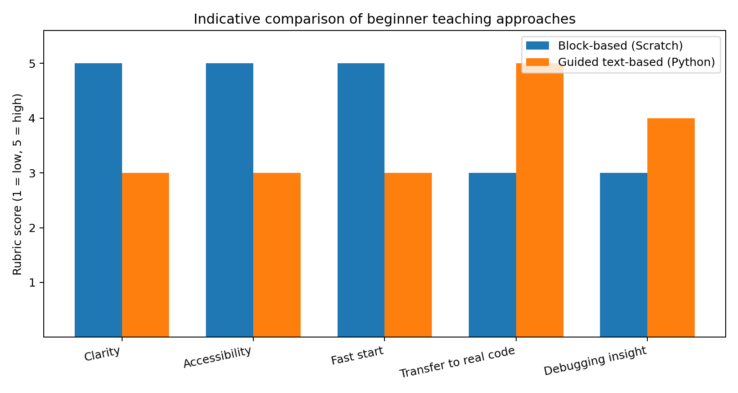
Figure 1. Indicative rubric scores (1–5). Scores are the report author's structured assessment, not experimental measurements.

7. Evidence and Critical Interpretation
The Scratch Foundation presents Scratch as a creative environment for building projects and developing computational thinking through iterative making and reflection. Its guidance supports the value of meaningful projects and peer learning, although platform guidance is not itself proof that every learner will achieve the same outcomes. Code.org's CS Fundamentals curriculum provides a complementary model: self-paced online practice is combined with unplugged activities, and concepts are revisited over time. This supports a blended and scaffolded design rather than a single-tool solution.
A 2025 study in Computers & Education examined 70 novice college students completing Scratch and Python tasks. Its abstract reports stronger comprehension performance and lower indicators of mental effort for the Scratch group in the tested tasks. This is useful comparative evidence, but the sample and task context are limited; it should not be generalised to every age, course, language or long-term learning outcome. Better short-term comprehension does not automatically mean better transfer to professional text-based programming.
Overall, the evidence supports using blocks to reduce initial barriers while preserving explicit instruction in algorithms, debugging and later text-based expression. The strongest instructional decision is therefore a planned progression, not an either/or choice.

8. Recommendations for Improved Coding Literacy
- Use a concept-first sequence. Start with everyday algorithms and vocabulary, then teach sequence, events, selection, repetition, variables and functions in that order where appropriate.
- Adopt a blocks-to-text bridge. Show one concept in Scratch and its Python equivalent side by side. For example, connect a repeat block with a Python for-loop and discuss what each part means.
- Teach through small, meaningful projects. Use familiar tasks such as a quiz, simple calculator, story animation or shopping total. Keep each project focused on one or two new concepts.
- Use worked examples and gradual release. Demonstrate; trace together; complete a partly written example; then ask learners to solve a similar task independently.
- Make debugging routine and safe. Ask learners to predict, run, observe, locate the mismatch and revise. Treat errors as information rather than failure.
- Improve accessibility. Offer plain-language glossaries, captions, readable contrast, keyboard alternatives, translated explanations where possible and low-bandwidth/offline options.
- Check learning with explanation, not only completion. Ask learners to explain what a loop does, predict an output, modify a condition and describe a bug they fixed.
- Provide teacher support and feedback. Use peer discussion, short feedback cycles and clear rubrics. Avoid leaving novices alone with long tutorials.

9. Suggested 30–35 Hour Evaluation Plan
Activity | Hours | Output
Define scope and criteria | 3 | Set learner profile, goals and review questions.
Collect and screen sources | 6 | Review platform documentation, curricula and research.
Analyse both approaches | 8 | Compare clarity, access, effort, debugging and transfer.
Create visuals and rubric | 4 | Score criteria transparently and build comparison tables/chart.
Draft report and recommendations | 9 | Write findings, limitations and practical recommendations.
Quality review and finalise | 4 | Check citations, consistency, visual readability and document formatting.
Total planned effort: 34 hours. This is a suggested work plan, not a record of time already spent.

10. Conclusion
Block-based Scratch instruction offers a welcoming route into programming logic, while scaffolded Python instruction develops the ability to read and write real code. Unplugged activities can make abstract ideas concrete before learners move to a screen. For non-programmers, the most balanced model is a gradual pathway: explain the idea in everyday language, model it physically or visually, practise it in blocks, then connect it to short Python examples. Repeated projects, accessible materials and supportive debugging can improve confidence while building durable coding literacy.

References
- Scratch Foundation. (n.d.). Getting Started. https://www.scratchfoundation.org/learn/learning-library/getting-started
- Scratch Foundation. (n.d.). Scratch's Creative Learning Philosophy. https://scratchfoundation.org/learn/learning-library/scratch-creative-learning-philosophy
- Code.org. (n.d.). How should my child get started without a teacher? https://support.code.org/hc/en-us/articles/14961738901645-How-should-my-child-get-started-without-a-teacher
- Code.org. (n.d.). CS Fundamentals Curriculum Guide. https://code.org/files/CSF_CoursesA-F_Curriculum_Guide.pdf
- UC Agriculture and Natural Resources. (n.d.). Introducing block-based coding (Scratch). https://ucanr.edu/site/uc-science-connect/3-introducing-block-based-coding-scratch
- Tsai, M.-J., Chien, F. P., Sun, W.-T., & Jha, N. K. (2025). How block-based programming supports novice learners’ coding comprehension: Evidence from eye-tracking lag-sequential analysis. Computers & Education, 239, 105430. https://doi.org/10.1016/j.compedu.2025.105430

Appendix A: Interpretation of the Rubric
Scores: Scratch = clarity 5, accessibility 5, fast start 5, transfer 3, debugging insight 3. Guided Python = clarity 3, accessibility 3, fast start 3, transfer 5, debugging insight 4. A score is a comparative judgement for this report's defined beginner context. The values are intentionally transparent and should be revisited if the target learners or instructional setting changes.

