WEEK 6 – FINAL CAPSTONE

Code Literacy for
Non-Programmers
A hypothetical interactive learning project integrating planning, implementation, debugging, evaluation, and educational reflection

Document detail | Description
Project name | CodeSteps – Beginner Code Literacy Learning Tool
Project type | Hypothetical educational application and guided learning resource
Intended audience | Non-programmers, students, educators, and first-time learners
Submission | Comprehensive capstone report with companion Python learning tool
Evidence note | Project outcomes and sample learning scores are illustrative, not real user research.

This capstone demonstrates how programming concepts can be taught through plain language, practical examples, feedback, and gradual practice.

Document Guide
This report is organised as a complete project narrative. It moves from the educational problem and project plan to design, implementation, debugging, evaluation, reflection, and recommendations.
Section | Contents
1. Executive summary | Project purpose, solution, and main conclusions
2. Project overview | Learners, problem statement, objectives, scope, and success criteria
3. Methodology and planning | Learning design, requirements, work plan, and project approach
4. Solution design | Components, architecture, pseudocode, and learning flow
5. Implementation and execution | Feature descriptions, sample Python concepts, and delivery practices
6. Testing and debugging | Test strategy, defects, troubleshooting examples, and quality assurance
7. Evaluation | KPIs, illustrative results, feedback, and limitations
8. Internship reflection | Progress, challenges, lessons, and skills developed
9. Educational application | How the approach can be used in real classrooms and training
10. Future roadmap | Prioritised improvements and recommendations
Appendices | Glossary, sample lesson plan, references, and Python tool guide

1. Executive Summary
This capstone presents CodeSteps, a hypothetical beginner-friendly code literacy learning tool designed for people who have little or no programming experience. The project responds to a common learning barrier: programming can appear intimidating when instruction begins with unfamiliar syntax, dense terminology, and large examples before learners understand the underlying ideas. CodeSteps introduces core concepts through plain-language explanations, relatable examples, short activities, immediate feedback, and small Python demonstrations.
The report consolidates the major areas explored during the virtual internship: planning, requirements, architecture, implementation, version control, integration, code review, testing, debugging, quality assurance, project evaluation, and future improvement. It describes a modular solution with learning lessons, guided examples, quizzes, a progress record, and a teacher-oriented review view. A companion Python program provides a small command-line version of the learning experience, including concept explanations, multiple-choice questions, and a simple progress summary.
The capstone's central conclusion is that code literacy is not the same as training every learner to become a professional programmer. It is the ability to understand what code does, reason about instructions and data, recognise patterns, interpret simple examples, and communicate effectively about digital systems. A learner-centred approach can build confidence by connecting abstract ideas to familiar situations and by treating errors as useful feedback.
All project details, sample evaluation results, and learner progress figures in this report are hypothetical and are provided to demonstrate a responsible evaluation method. They should not be interpreted as results from a real deployment or user study.

2. Project Overview

2.1 Problem statement
Many non-programmers use digital tools every day but may not understand how software instructions, conditions, data, and repetition work. Traditional introductory material can be difficult to approach when it assumes prior technical knowledge. Learners may memorise syntax without understanding the problem being solved, or become discouraged when an error message appears. Educators also need compact activities that can be adapted to different ages, subjects, and levels of confidence.

2.2 Proposed solution
CodeSteps is a hypothetical learning application that teaches foundational computational thinking and introductory Python through short, structured modules. Each lesson follows a repeatable pattern: explain a concept in plain language, connect it to a familiar analogy, show a small example, invite the learner to predict the result, and provide feedback. The learning tool avoids unnecessary technical complexity and introduces terminology only after the idea has been explained.

2.3 Target users and user needs
User group | Need | Design response
First-time learners | A welcoming introduction without assumed coding knowledge. | Plain-language lessons, glossary, short examples, and low-pressure practice.
School or college students | Concrete examples that connect logic to everyday situations. | Activities using schedules, shopping totals, classroom tasks, and simple decisions.
Educators | A structured sequence that can be taught and assessed. | Lesson objectives, quiz questions, progress indicators, and discussion prompts.
Adult learners | Flexible self-paced practice relevant to digital literacy. | Short modules, clear feedback, and repeatable exercises.

2.4 Project objectives
- Explain core concepts such as algorithms, variables, input/output, conditions, loops, and debugging in accessible language.
- Provide short practical examples that connect programming ideas to everyday tasks.
- Encourage active learning through prediction, experimentation, quizzes, and reflection.
- Help learners interpret simple code and explain its purpose without requiring advanced syntax knowledge.
- Give educators a reusable structure for introducing code literacy in classroom or workshop settings.

2.5 Scope and exclusions
Included in the hypothetical first version | Out of scope for the first version
Five introductory learning modules; plain-language glossary; guided Python examples; short quizzes; local progress summary; educator discussion prompts. | Full learning-management system; user accounts and cloud storage; live collaborative coding; automated grading of arbitrary code; commercial analytics; mobile app distribution.

2.6 Success criteria
- A learner can describe the purpose of an algorithm, variable, condition, and loop in their own words.
- A learner can follow a short code example and predict its output.
- A learner can identify a simple error and describe a reasonable debugging step.
- An educator can use the modules as a short introductory learning sequence.
- The application provides clear feedback and does not treat incorrect answers as personal failure.

3. Methodology and Project Planning

3.1 Learner-centred development approach
The project uses an iterative, learner-centred approach. Instead of building every feature before reviewing the learning experience, the work is divided into small increments. Each increment produces a lesson or tool capability that can be reviewed for clarity, correctness, and usefulness. The approach combines basic software project practices with instructional design: define the learner outcome, create a small learning activity, test it with representative scenarios, review feedback, and improve.

3.2 Requirements gathering
Requirement type | Example requirement | Acceptance condition
Functional | The learner can open a lesson about variables. | The lesson explains a variable, includes an example, and presents a practice question.
Functional | The learner can answer a multiple-choice question. | The tool checks the selected answer and displays explanatory feedback.
Functional | The learner can view a progress summary. | The summary shows completed activities and correct answers in the current local session.
Usability | The content should be understandable to a beginner. | Technical terms are explained and examples use familiar contexts.
Accessibility | The learning content should be navigable and readable. | Use clear headings, keyboard-friendly controls in a future GUI, readable contrast, and descriptive labels.
Reliability | The tool should handle invalid input gracefully. | Unexpected menu selections do not crash the program.
Privacy | Learner progress should be handled responsibly. | The prototype stores no personal data and keeps progress local to the running session.

3.3 Work breakdown and indicative schedule
Stage | Activities | Indicative effort
Discovery and planning | Define learners, learning objectives, scope, requirements, risks, and acceptance criteria. | 4 hours
Learning and solution design | Create module sequence, component structure, pseudocode, examples, and interface outline. | 5 hours
Implementation | Build lesson content, quiz flow, input validation, scoring, and progress summary. | 9 hours
Testing and debugging | Run functional tests, test invalid input, inspect explanations, and fix defects. | 6 hours
Evaluation and refinement | Review sample outcomes, assess limitations, prioritise improvements. | 4 hours
Documentation and reflection | Prepare report, visuals, lessons learned, and educational recommendations. | 5 hours
Total | Indicative capstone effort; actual time may vary. | 33 hours

3.4 Project management practices
- Maintain a prioritised task list and define a clear owner for each item.
- Use small, traceable changes and version control to preserve development history.
- Review code and learning content for correctness, readability, and beginner suitability.
- Track defects with steps to reproduce, expected behaviour, actual behaviour, severity, and status.
- Use a definition of done that includes working behaviour, tests, understandable content, and updated documentation.

4. Solution Design

4.1 Learning modules
Module | Concept | Everyday analogy / activity | Learner outcome
1. Algorithms | A sequence of steps to complete a task. | Write instructions for making a sandwich or organising a school bag. | Explain why order and clarity matter.
2. Variables and data | Named places to store information. | A labelled container holding a name, age, or shopping total. | Identify a value and how it can change.
3. Input and output | Information entering and leaving a program. | A form asks a question and displays a response. | Trace a simple interaction.
4. Conditions | Choosing an action based on a rule. | If it rains, take an umbrella; otherwise, do not. | Predict which branch runs.
5. Loops and debugging | Repeating steps and finding mistakes. | Repeat a checklist; inspect a step that was skipped. | Explain repetition and a basic debugging process.

4.2 Component structure
The conceptual application is divided into small components with clear responsibilities. The lesson library stores explanations and examples. The activity engine presents questions and checks answers. The progress tracker records completion and scores for the current session. The feedback component explains why an answer is correct or incorrect. The educator guide supplies discussion prompts and optional extension tasks.
Component | Responsibility | Example input/output
Lesson library | Provide ordered lesson content. | Input: selected topic; output: explanation and example.
Activity engine | Present a question and collect a response. | Input: answer choice; output: correct/incorrect result.
Feedback module | Explain the reasoning behind an answer. | Input: question and response; output: supportive explanation.
Progress tracker | Count attempts, correct responses, and completed modules. | Input: activity result; output: session summary.
Educator guide | Suggest classroom prompts and extension activities. | Input: module; output: discussion question and practice task.

4.3 Project development flow
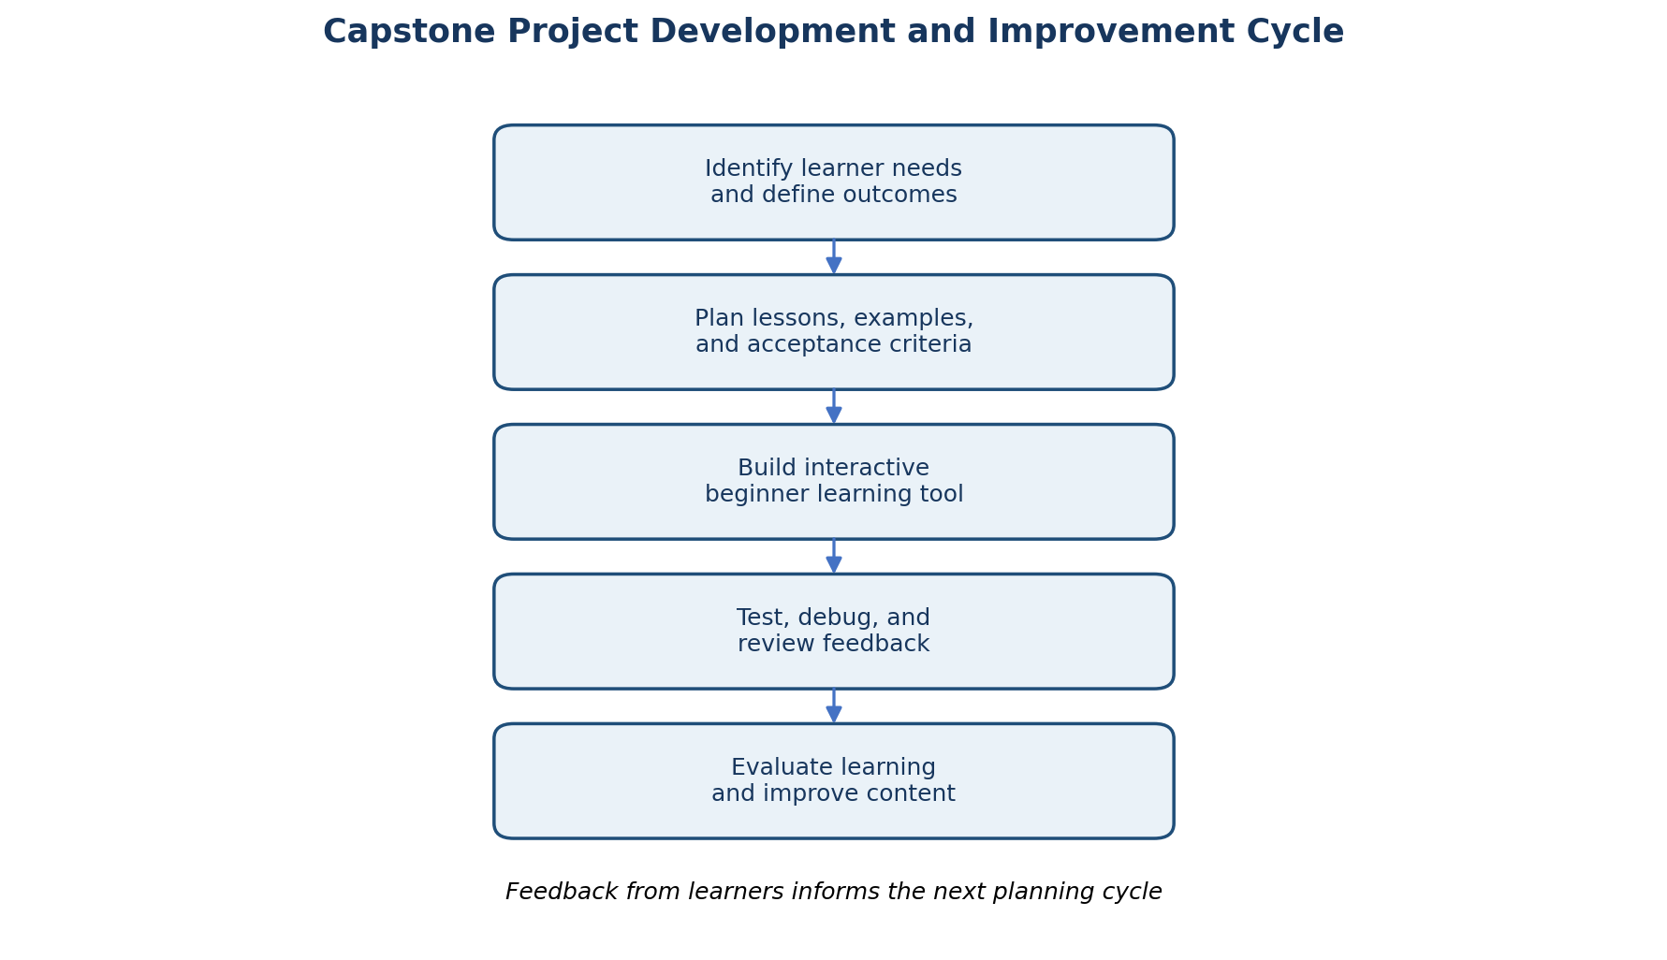

4.4 Pseudocode for the learning activity
START
display welcome message
set score = 0
set question_number = 0
FOR each question in the selected lesson
display question and answer choices
ask learner for an answer
IF answer is valid
IF answer matches correct answer
increase score
display positive explanation
ELSE
display correct answer and explain why
END IF
increase question_number
ELSE
explain how to enter a valid choice
repeat the same question
END IF
END FOR
calculate percentage score
display progress summary
invite learner to revisit any difficult concept
END

4.5 Example concept explanation
A variable can be explained as a labelled box. The label is the variable name, and the item inside is its value. In Python, the statement points = 10 creates a variable named points and stores the number 10. If the learner later writes points = 12, the value changes. This analogy helps introduce naming and changing data before discussing data types in depth.

5. Implementation and Execution

5.1 Implementation strategy
Implementation begins with the smallest complete learning journey: show a concept, ask a question, check the answer, explain the result, and show a summary. Once this journey works, further lessons can be added using the same structure. Reusing a consistent activity pattern keeps the application predictable and reduces duplicated logic.

5.2 Core Python example
# A small example: a condition makes a decision
score = 7
if score >= 5:
print("You passed the practice activity.")
else:
print("Try the activity again.")
# A loop repeats an action
for attempt in range(3):
print("Practice makes progress!")
The first example compares a value with a threshold and chooses one of two messages. The second repeats a message three times. These examples are intentionally short so that learners can focus on the meaning of a condition and a loop.

5.3 Execution sequence
- Start the program and show a short welcome message explaining the learning goal.
- Let the learner choose a topic or follow the suggested lesson order.
- Present the explanation and a relatable example before showing code.
- Ask a prediction or multiple-choice question to encourage active thinking.
- Validate the response, give supportive feedback, and record the result.
- Display a summary and recommend a concept to revisit.

5.4 Version control and code review
A real implementation should use a version-control repository with a clear README, meaningful commits, and a branch or pull-request workflow. Changes should be small enough for a reviewer to understand. Reviewers should check that the code matches the requirement, input is validated, feedback is accurate, names are meaningful, repeated logic is avoided, and tests cover both expected and invalid inputs. Learning content should also receive review for clarity, inclusion, and factual correctness.

5.5 Companion Python program
The companion file week6_code_literacy_learning_tool.py is a working command-line prototype. It offers a welcome screen, short explanations of foundational concepts, a multiple-choice quiz, immediate feedback, and a session score. It uses only Python's standard library and stores no personal information. It is intentionally lightweight so that a beginner can read and modify it.

6. Testing, Debugging, and Quality Assurance

6.1 Testing strategy
Test level | What is checked | Example test
Unit testing | Small functions behave as expected. | The answer-checking function accepts the correct option and rejects a wrong one.
Integration testing | Components work together. | A quiz answer updates the progress summary correctly.
System testing | The complete learning flow works from start to finish. | Launch, select lesson, answer questions, and view final score.
Usability testing | Instructions and feedback are understandable. | A beginner can complete a module without unexplained jargon.
Accessibility review | Content and interaction are perceivable and usable. | Check headings, keyboard operation, labels, and colour contrast in a graphical version.
Regression testing | A fix does not break previously working behaviour. | Repeat the quiz after changing input validation.

6.2 Sample test cases
ID | Scenario | Expected result | Priority
TC-01 | Launch the tool. | Welcome menu appears without an exception. | High
TC-02 | Choose a valid lesson option. | The selected concept explanation is displayed. | High
TC-03 | Enter the correct quiz answer. | Positive feedback appears and score increases. | High
TC-04 | Enter an incorrect quiz answer. | Helpful correction appears; program continues. | High
TC-05 | Enter an invalid menu value. | The tool explains valid choices and remains usable. | Medium
TC-06 | Complete all quiz questions. | Final score and completion message are displayed. | High
TC-07 | Interrupt or restart the session. | The application exits or restarts cleanly without corrupting data. | Medium

6.3 Debugging methodology
- Reproduce the problem consistently and record the exact input and observed output.
- Compare actual behaviour with the requirement and expected result.
- Reduce the example to the smallest case that still demonstrates the issue.
- Inspect relevant variables, conditions, loop boundaries, and function calls.
- Identify the root cause rather than changing code only to hide the symptom.
- Apply one focused correction and add or update a test for the defect.
- Run the relevant tests and a regression check, then document the resolution.

6.4 Example debugging experiences
Hypothetical defect | Root cause | Correction | Prevention
Quiz accepts an invalid option. | Input was compared without checking the allowed choices. | Validate the input against the available option set before scoring. | Add invalid-input tests and reuse a validation helper.
Score is one point too high. | Score was incremented before answer correctness was checked. | Move score update inside the correct-answer branch. | Add tests for correct and incorrect responses.
Loop displays one extra practice message. | Loop range boundary was misunderstood. | Use the intended repeat count and test zero, one, and multiple repetitions. | Explain inclusive/exclusive boundaries with a trace table.

6.5 Quality assurance principles
- Correctness: examples and explanations must agree with actual program behaviour.
- Clarity: code and instructions should be readable and use beginner-friendly language.
- Reliability: invalid input should not cause unexpected termination.
- Maintainability: content and quiz logic should be separated where practical.
- Accessibility: a future graphical interface should support keyboard use, readable contrast, and assistive technologies.
- Privacy: collect only information needed for learning and explain how it is used.

7. Evaluation and Learning Outcomes

7.1 Evaluation framework
Evaluation should consider both software quality and educational value. Software indicators assess whether the tool works reliably; learning indicators assess whether learners understand and can apply the concepts. In a real pilot, evidence should be collected with informed consent, clear instructions, and appropriate protection of learner information.
KPI | How it is measured | Illustrative target | Illustrative result
Lesson completion | Completed modules ÷ modules started × 100. | ≥ 80% | 85%
Quiz improvement | Final assessment score minus baseline score. | ≥ 20 percentage points | +44 points
Correct answer rate | Correct answers ÷ attempted questions × 100. | ≥ 75% | 78%
Task independence | Learners completing the activity without facilitator intervention. | ≥ 70% | 72%
Content clarity | Average learner rating on a 1–5 scale. | ≥ 4.0 | 4.1
Critical defects | Unresolved critical defects at release decision. | 0 | 0 in the hypothetical example
Test pass rate | Passed test cases ÷ executed test cases × 100. | ≥ 95% | 96%

7.2 Illustrative learning progress
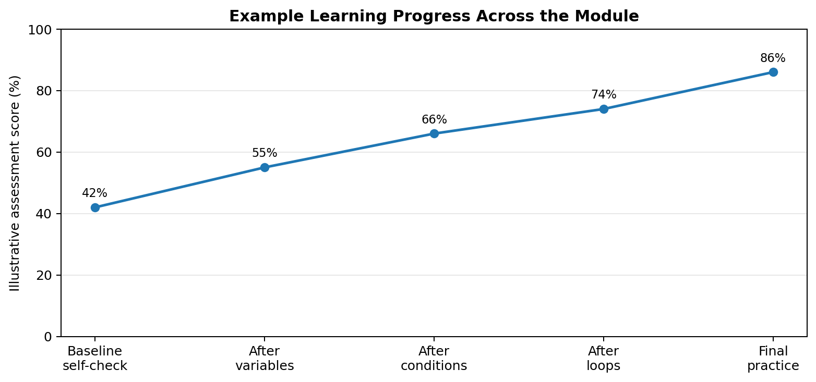
The chart is a hypothetical example showing a gradual increase in assessment performance as learners complete additional concept modules. The values are illustrative only. A real evaluation would need a defined assessment instrument, participant group, sample size, consistent scoring rules, and analysis of factors that may influence results.

7.3 Evaluation insights
- Short lessons can make unfamiliar concepts easier to approach, but the tool should not assume that a quiz score alone proves deep understanding.
- Prediction questions and explanations can reveal misconceptions more clearly than memorisation questions.
- Learners benefit from being allowed to retry and inspect examples without penalty.
- An educator should be able to adapt the pace and provide alternative examples for different levels of prior knowledge.
- Accessibility, language level, device access, and confidence may affect participation and should be considered in any real pilot.

7.4 Limitations
The proposed tool is a small prototype and does not include a graphical interface, accounts, persistent learner profiles, teacher dashboards, or automated execution of arbitrary learner code. The report's KPI results are illustrative and cannot establish real educational effectiveness. A future pilot should test the content with a diverse group of learners, compare baseline and follow-up understanding, gather qualitative feedback, and review accessibility with appropriate users.

8. Internship Progress and Personal Reflection

8.1 Progress across the internship
The internship learning journey can be understood as a progression from understanding individual programming concepts to considering the complete software lifecycle. Early work focused on planning, requirements, and breaking a problem into manageable tasks. Later work introduced architecture, implementation, version control, integration, code review, and testing. The final stages brought these practices together through evaluation, retrospection, risk analysis, and a roadmap for continuous improvement.
Learning area | Progress demonstrated in this capstone | Why it matters
Planning | Translate a broad educational need into scope, requirements, and success criteria. | Prevents unclear expectations and uncontrolled feature growth.
Programming concepts | Explain variables, conditions, loops, input/output, and algorithms using examples. | Builds a bridge between everyday reasoning and code.
Implementation | Structure a small program into understandable steps and reusable functions. | Improves readability and makes changes easier.
Debugging | Reproduce, isolate, fix, and retest a defect. | Turns errors into a systematic problem-solving process.
Testing and QA | Define test cases and consider multiple test levels. | Builds confidence that software behaves as expected.
Evaluation | Use KPIs, feedback, and limitations to judge outcomes. | Encourages evidence-based improvement.

8.2 Challenges encountered
- Explaining technical ideas without relying on technical vocabulary requires careful examples and repeated editing.
- Choosing a realistic project scope is difficult because an educational application could expand into accounts, analytics, collaboration, and many other features.
- Designing feedback that is encouraging while still correcting misconceptions requires attention to tone and accuracy.
- Debugging can be frustrating when the visible error is not the root cause; a repeatable investigation process helps.
- Evaluating learning is more complex than counting completed lessons because confidence, understanding, and transfer of knowledge are different outcomes.

8.3 Lessons learned
The most important lesson is to begin with the learner's problem rather than the technology. A technically correct application can still fail as an educational tool if its explanations are confusing or its activities do not match the learner's needs. Another lesson is that small, testable increments make both software and content easier to improve. Finally, project completion should include honest evaluation: unknown results should be labelled as unknown, and recommendations should be linked to evidence or clearly stated assumptions.

8.4 Applying the learning in future work
In future projects, these skills can be applied by defining requirements before coding, sketching the flow of a solution, writing pseudocode for complex logic, implementing small components, reviewing changes, and testing expected and unexpected inputs. In an educational setting, the same discipline can help teachers introduce computational thinking through everyday examples and guide learners to explain their reasoning rather than simply copy code.

9. Application in Real Educational Scenarios

9.1 Classroom use
A teacher could use the algorithm module in a lesson about sequencing by asking learners to write instructions for arranging a classroom activity. The variable module could connect to a simple budget or points total. Conditions could be introduced through everyday rules, while loops could be explored through repeated routines. Students can first describe the logic in ordinary language, then compare it with a short code example.

9.2 Suggested 45-minute lesson
Time | Activity | Evidence of learning
5 minutes | Introduce a familiar problem, such as deciding what to pack based on the weather. | Learners identify a decision and possible outcomes.
8 minutes | Explain conditions using a plain-language rule and a simple flow diagram. | Learners describe the meaning of IF and ELSE.
10 minutes | Walk through a short Python example and predict its output. | Learners trace which branch executes.
12 minutes | Pairs modify the condition and test different values. | Learners connect input values to program behaviour.
7 minutes | Discuss an intentional error and model a debugging process. | Learners state a reproducible debugging step.
3 minutes | Exit question: explain one concept in your own words. | Teacher identifies topics for review.

9.3 Inclusive teaching recommendations
- Offer examples from different everyday contexts so that learners can connect concepts to their own experience.
- Allow learners to explain an answer verbally, in writing, with a diagram, or through a short code example.
- Use readable fonts, clear contrast, descriptive headings, captions for media, and keyboard-accessible activities.
- Provide optional hints and additional practice without publicly ranking learners.
- Separate assessment of concept understanding from typing speed or prior access to computers.
- Make clear that mistakes are expected during learning and are useful evidence for the next teaching step.

10. Future Roadmap and Recommendations
Phase | Planned enhancement | Reason / expected value | Completion evidence
1. Prototype refinement | Improve wording, add more examples, expand invalid-input handling, and strengthen automated tests. | Improve accuracy and stability before adding complexity. | Reviewed lesson content; tests pass; known issues documented.
2. Educator pilot | Run a small, voluntary classroom or workshop pilot; collect anonymous feedback where appropriate. | Check whether instructions and activities work for actual learners. | Pilot plan, consent approach, feedback summary, and revised content.
3. Accessible interface | Develop a graphical interface with keyboard support, readable contrast, and responsive layout. | Make the learning experience easier to use across devices and abilities. | Accessibility review and successful task completion with keyboard navigation.
4. Learning analytics | Add privacy-conscious progress reporting and topic-level learning summaries. | Help learners and educators identify topics that need reinforcement. | Defined data minimisation policy and validated progress reports.
5. Expanded curriculum | Add functions, lists, simple data structures, and responsible AI/data literacy topics. | Extend learning after the foundational concepts are understood. | New modules reviewed, tested, and linked to measurable learning objectives.

10.1 Final recommendations
- Keep the first version small and focused on a complete beginner learning journey.
- Validate explanations with non-programmers before assuming that the wording is clear.
- Use short examples and ask learners to predict outcomes before revealing answers.
- Treat debugging as a normal part of the curriculum and demonstrate a calm, repeatable method.
- Measure both technical quality and learning outcomes; do not rely on one metric.
- Protect learner privacy and include accessibility in the design from the beginning.
- Use pilot feedback to prioritise improvements rather than adding features solely because they are technically interesting.

11. Conclusion
CodeSteps demonstrates how software development practices can be combined with accessible teaching to support code literacy for non-programmers. The project begins with a learner need, defines measurable objectives, plans a manageable solution, and uses modular design to organise lessons, activities, feedback, and progress tracking. Its execution illustrates how pseudocode, Python examples, version control, testing, and debugging can support a reliable learning experience.
The evaluation section shows that success must be considered from more than one perspective. The software should work correctly and consistently, but learners must also understand the concepts, feel supported when making mistakes, and be able to apply what they learn to new situations. The hypothetical results in this report provide a framework for evaluation rather than a claim of proven impact.
The internship has reinforced that programming is a structured way to solve problems and communicate instructions. By translating technical ideas into familiar situations, using small examples, and encouraging learners to reason about outcomes, educators can make code literacy more approachable. The final recommendation is to develop and test the learning experience with real learners, improve it through evidence, and keep the focus on understanding rather than memorising syntax.

Appendix A – Glossary
Term | Plain-language meaning
Algorithm | A clear sequence of steps for completing a task or solving a problem.
Variable | A named place where a program stores a value.
Input | Information supplied to a program.
Output | Information or a result produced by a program.
Condition | A rule that determines which action should happen.
Loop | A structure that repeats instructions.
Function | A named, reusable group of instructions.
Bug | An error or unexpected behaviour in a program.
Debugging | The process of finding, understanding, and correcting a problem.
Pseudocode | A plain-language outline of program logic, written without strict programming syntax.

Appendix B – Sample Learner Reflection Prompts
- What is one programming idea that you can now explain in your own words?
- Which example helped you understand the concept, and why?
- What did you do when your answer or code did not work as expected?
- How could you use an algorithm or condition in a task outside programming?
- What would make the learning activity clearer or more accessible?

Appendix C – Public References and Further Reading
- Python Software Foundation. Python Tutorial. https://docs.python.org/3/tutorial/
- BBC Bitesize. Introduction to computational thinking. https://www.bbc.co.uk/bitesize
- Computer Science Unplugged. Activities and resources for teaching computer science concepts. https://www.csunplugged.org/
- W3C. Web Content Accessibility Guidelines (WCAG) 2.2. https://www.w3.org/TR/WCAG22/
- OWASP Foundation. OWASP Top 10. https://owasp.org/www-project-top-ten/
- Google. Site Reliability Engineering: Monitoring Distributed Systems. https://sre.google/sre-book/monitoring-distributed-systems/
These resources provide general background for Python, computational thinking, accessibility, and software quality. The CodeSteps project, its example learners, and its evaluation figures are hypothetical.

Appendix D – Running the Companion Python Tool
Save week6_code_literacy_learning_tool.py and run it using Python 3.8 or later. No third-party packages are required.
python week6_code_literacy_learning_tool.py
python week6_code_literacy_learning_tool.py --help
The program presents a menu of beginner topics, offers a short quiz, gives immediate feedback, and displays the learner's score. It is a command-line teaching prototype rather than a complete graphical application.

