DSA06 - Data Handling and Visualization
List of Experiments – Sets 16 to 20
R Code → Output Visualization → Python Equivalent Code

SET 16: Customer Demographics Analysis
SET 16: Customer Demographics Analysis
Dataset: CustomerID, Age, Gender, Income (3 sample customers)
1. Create a bar chart to show the distribution of customer ages.
2. Create a pie chart to show the percentage of customers by gender.
3. Generate a table displaying the demographic information (Age, Gender, Income) of customers.
4. Develop an interactive Tableau dashboard combining the bar chart, pie chart, and table.
R Code
demo_df <- data.frame(
CustomerID = 1:3,
Age = c(28, 35, 42),
Gender = c("Female", "Male", "Female"),
Income = c(50000, 60000, 75000)
)

# 1. Bar chart of customer age distribution
ggplot(demo_df, aes(x = factor(CustomerID), y = Age, fill = factor(CustomerID))) +
geom_bar(stat = "identity") +
labs(title = "Customer Age Distribution", x = "Customer ID", y = "Age") +
theme_minimal() + theme(legend.position = "none")

# 2. Pie chart of customers by gender
gender_counts <- as.data.frame(table(demo_df$Gender))
colnames(gender_counts) <- c("Gender", "Count")
ggplot(gender_counts, aes(x = "", y = Count, fill = Gender)) +
geom_bar(stat = "identity", width = 1) + coord_polar("y") +
labs(title = "Customer Gender Distribution") +
geom_text(aes(label = Count), position = position_stack(vjust = 0.5)) +
theme_void()

# 3. Table of demographic information
print(demo_df)

# 4. NOTE: "Tableau dashboard combining bar chart, pie chart, and table" ->
# Sheet1 = CustomerID vs Age (bar), Sheet2 = Gender count (pie),
# Sheet3 = raw table -> combine on one Dashboard.
Output Visualization
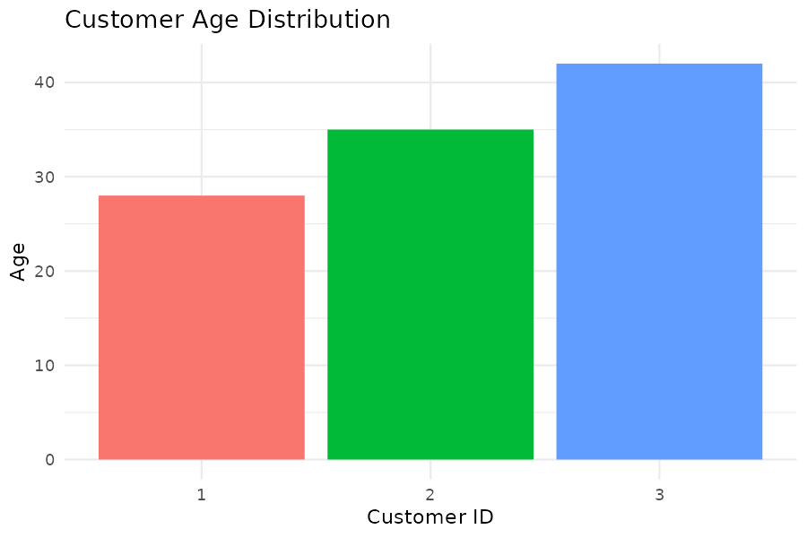
Fig 16.1 – Customer Age Distribution (Bar Chart)
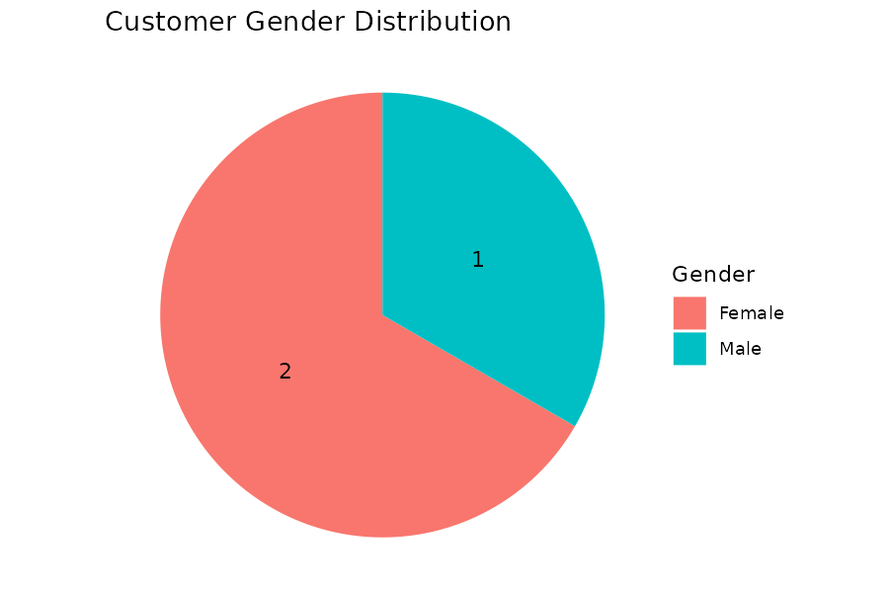
Fig 16.2 – Customer Gender Distribution (Pie Chart)
Note: Task 4 (Tableau dashboard) is built in Tableau Desktop, not in R/Python.
Python Code (Equivalent)
import pandas as pd
import matplotlib.pyplot as plt
import seaborn as sns

demo_df = pd.DataFrame({
"CustomerID": [1, 2, 3],
"Age": [28, 35, 42],
"Gender": ["Female", "Male", "Female"],
"Income": [50000, 60000, 75000]
})

# 1. Bar chart - customer age distribution
sns.barplot(data=demo_df, x="CustomerID", y="Age",
hue="CustomerID", palette="viridis", legend=False)
plt.title("Customer Age Distribution")
plt.xlabel("Customer ID"); plt.ylabel("Age")
plt.show()

# 2. Pie chart - customers by gender
gender_counts = demo_df["Gender"].value_counts()
plt.pie(gender_counts, labels=gender_counts.index, autopct="%1.0f%%", startangle=90)
plt.title("Customer Gender Distribution")
plt.show()

# 3. Table of demographic information
print(demo_df)

# 4. Tableau dashboard step done in Tableau, not Python.

SET 17: Employee Performance Evaluation
SET 17: Employee Performance Evaluation
Dataset: EmployeeID, Department, YearsOfService, PerformanceScore (5 sample employees)
1. Create a line chart to visualize the trend in employee performance.
2. Generate a bar chart showing the distribution of employees across departments.
3. Create a scatter plot to visualize the relationship between years of service and performance score.
4. Develop an interactive Tableau dashboard combining the line chart and bar chart.
R Code
emp_df <- data.frame(
EmployeeID = 1:5,
Department = c("Sales", "HR", "Marketing", "Sales", "HR"),
YearsOfService = c(5, 3, 7, 4, 2),
PerformanceScore = c(85, 92, 78, 90, 76)
)

# 1. Line chart of performance trend
ggplot(emp_df, aes(x = EmployeeID, y = PerformanceScore)) +
geom_line(color = "purple") + geom_point(size = 2) +
labs(title = "Employee Performance Trend", x = "Employee (order)",
y = "Performance Score") +
theme_minimal() + scale_x_continuous(breaks = emp_df$EmployeeID)

# 2. Bar chart: employee distribution across departments
dept_counts <- as.data.frame(table(emp_df$Department))
colnames(dept_counts) <- c("Department", "Count")
ggplot(dept_counts, aes(x = Department, y = Count, fill = Department)) +
geom_bar(stat = "identity") +
labs(title = "Employees by Department", x = "Department", y = "Count") +
theme_minimal() + theme(legend.position = "none")

# 3. Scatter plot: years of service vs performance score
ggplot(emp_df, aes(x = YearsOfService, y = PerformanceScore)) +
geom_point(size = 3, color = "darkgreen") +
geom_smooth(method = "lm", se = FALSE) +
labs(title = "Years of Service vs Performance Score",
x = "Years of Service", y = "Performance Score") +
theme_minimal()
cor(emp_df$YearsOfService, emp_df$PerformanceScore)

# 4. NOTE: Tableau -> Sheet1 = EmployeeID vs PerformanceScore (line),
# Sheet2 = Department count (bar) -> combine on one Dashboard.
Output Visualization
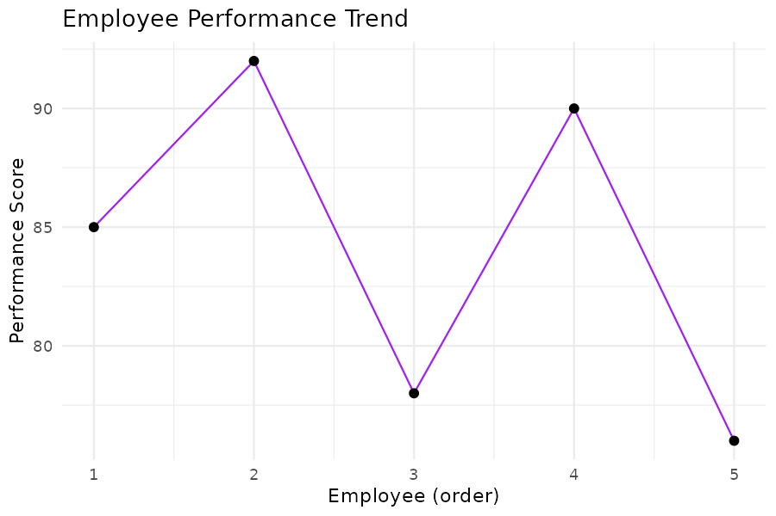
Fig 17.1 – Employee Performance Trend (Line Chart)
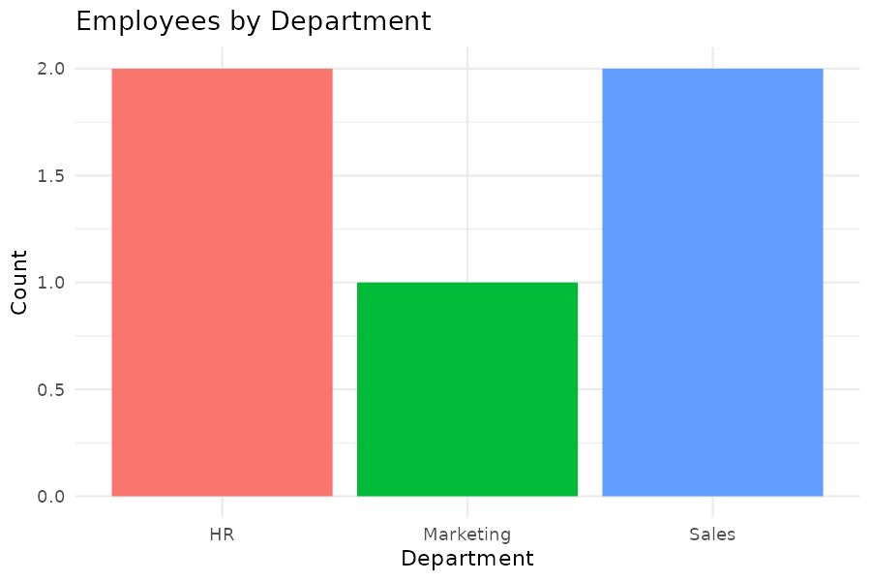
Fig 17.2 – Employees by Department (Bar Chart)
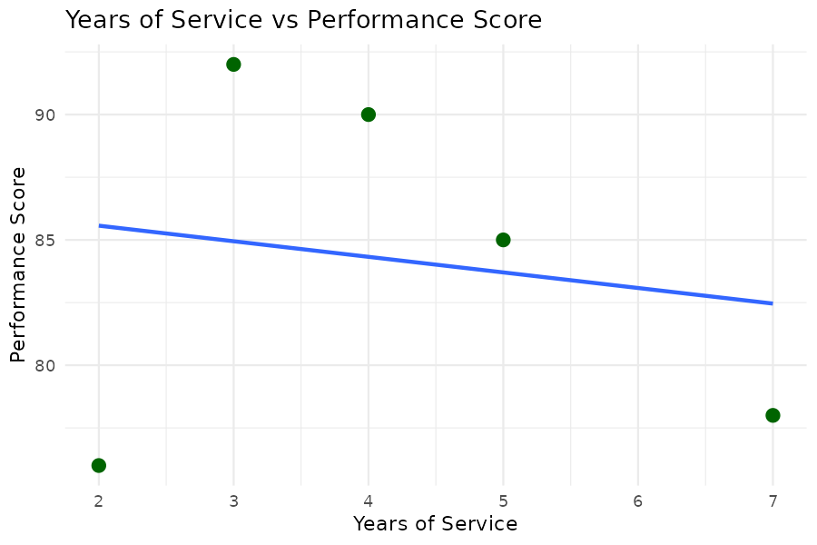
Fig 17.3 – Years of Service vs Performance Score (r = -0.17)
Note: Task 4 (Tableau dashboard) is built in Tableau Desktop, not in R/Python.
Python Code (Equivalent)
import pandas as pd
import matplotlib.pyplot as plt
import seaborn as sns

emp_df = pd.DataFrame({
"EmployeeID": [1, 2, 3, 4, 5],
"Department": ["Sales", "HR", "Marketing", "Sales", "HR"],
"YearsOfService": [5, 3, 7, 4, 2],
"PerformanceScore": [85, 92, 78, 90, 76]
})

# 1. Line chart - performance trend
plt.plot(emp_df["EmployeeID"], emp_df["PerformanceScore"], marker="o", color="purple")
plt.title("Employee Performance Trend")
plt.xlabel("Employee (order)"); plt.ylabel("Performance Score")
plt.xticks(emp_df["EmployeeID"])
plt.show()

# 2. Bar chart - employees per department
dept_counts = emp_df["Department"].value_counts().reset_index()
dept_counts.columns = ["Department", "Count"]
sns.barplot(data=dept_counts, x="Department", y="Count",
hue="Department", palette="Set2", legend=False)
plt.title("Employees by Department")
plt.show()

# 3. Scatter plot with regression line
sns.regplot(data=emp_df, x="YearsOfService", y="PerformanceScore",
color="darkgreen", ci=None)
plt.title("Years of Service vs Performance Score")
plt.show()
print(emp_df["YearsOfService"].corr(emp_df["PerformanceScore"]))

# 4. Tableau dashboard step done in Tableau, not Python.

SET 18: Product Inventory Management
SET 18: Product Inventory Management
Dataset: ProductID, ProductName, Quantity, Price (5 sample products; Category assumed for grouping)
1. Create a bar chart to visualize the quantity of each product available.
2. Generate a stacked bar chart to show the quantity of products by category.
3. Create a scatter plot to visualize the relationship between product price and quantity available.
4. Develop an interactive Tableau dashboard combining the bar chart and stacked bar chart.
R Code
inv_df <- data.frame(
ProductID = 1:5,
ProductName = c("Product A", "Product B", "Product C", "Product D", "Product E"),
Quantity = c(250, 175, 300, 200, 220),
Price = c(20, 15, 18, 22, 19)
)
inv_df$Category <- c("Electronics", "Electronics", "Home", "Home", "Office") # ASSUMED

# 1. Bar chart of quantity available per product
ggplot(inv_df, aes(x = ProductName, y = Quantity, fill = ProductName)) +
geom_bar(stat = "identity") +
labs(title = "Product Inventory Quantities", x = "Product", y = "Quantity Available") +
theme_minimal() + theme(legend.position = "none")

# 2. Stacked bar chart: quantity by product category
ggplot(inv_df, aes(x = Category, y = Quantity, fill = ProductName)) +
geom_bar(stat = "identity", position = "stack") +
labs(title = "Quantity by Product Category", x = "Category", y = "Quantity") +
theme_minimal()

# 3. Scatter plot: price vs quantity available
ggplot(inv_df, aes(x = Price, y = Quantity)) +
geom_point(size = 3, color = "brown") +
geom_smooth(method = "lm", se = FALSE) +
labs(title = "Product Price vs Quantity Available", x = "Price ($)", y = "Quantity") +
theme_minimal()
cor(inv_df$Price, inv_df$Quantity)

# 4. NOTE: Tableau -> Sheet1 = ProductName vs Quantity (bar), Sheet2 =
# Category vs Quantity coloured by ProductName (stacked bar) -> Dashboard.
Output Visualization
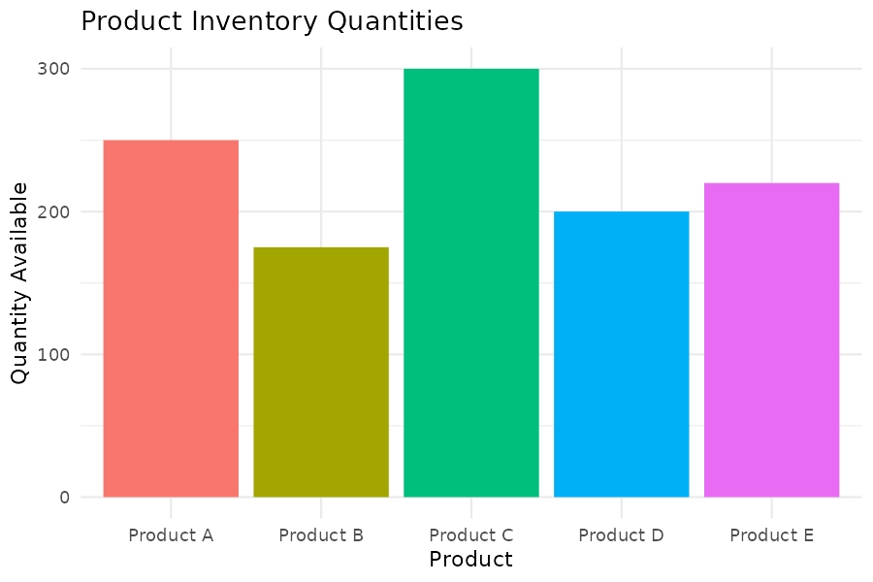
Fig 18.1 – Product Inventory Quantities (Bar Chart)
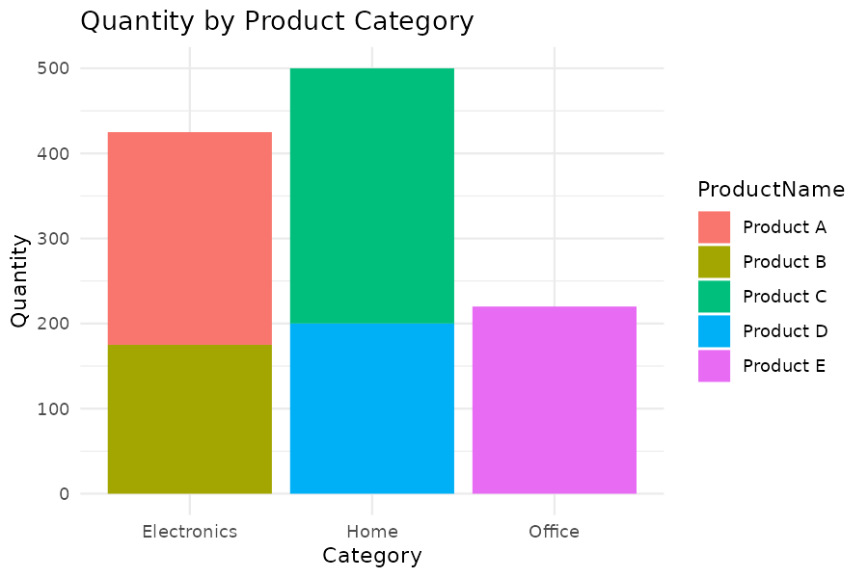
Fig 18.2 – Quantity by Product Category (Stacked Bar Chart)
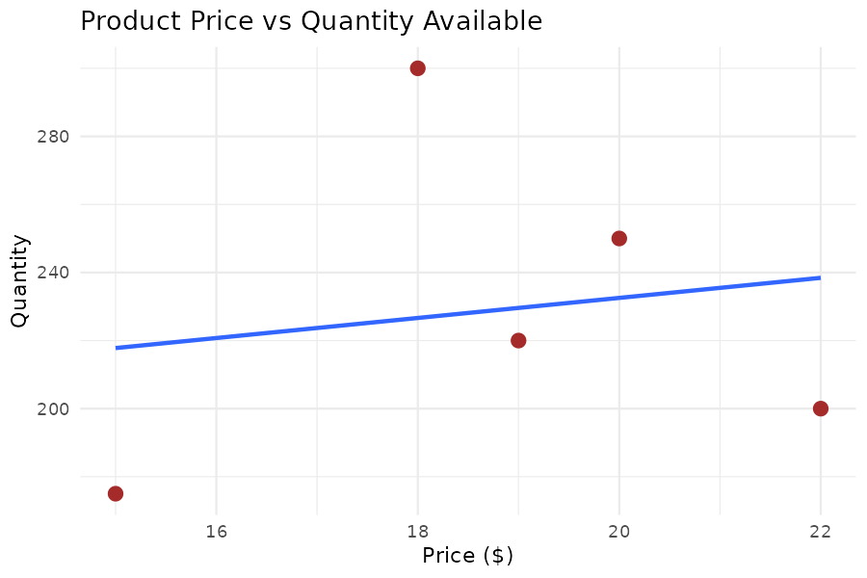
Fig 18.3 – Product Price vs Quantity Available (r = 0.16)
Note: Task 4 (Tableau dashboard) is built in Tableau Desktop, not in R/Python.
Python Code (Equivalent)
import pandas as pd
import matplotlib.pyplot as plt
import seaborn as sns

inv_df = pd.DataFrame({
"ProductID": [1, 2, 3, 4, 5],
"ProductName": ["Product A", "Product B", "Product C", "Product D", "Product E"],
"Quantity": [250, 175, 300, 200, 220],
"Price": [20, 15, 18, 22, 19],
"Category": ["Electronics", "Electronics", "Home", "Home", "Office"] # ASSUMED
})

# 1. Bar chart - quantity per product
sns.barplot(data=inv_df, x="ProductName", y="Quantity",
hue="ProductName", palette="mako", legend=False)
plt.title("Product Inventory Quantities")
plt.show()

# 2. Stacked bar chart - quantity by category
pivot = inv_df.pivot_table(index="Category", columns="ProductName",
values="Quantity", aggfunc="sum", fill_value=0)
pivot.plot(kind="bar", stacked=True, colormap="tab10")
plt.title("Quantity by Product Category")
plt.show()

# 3. Scatter plot with regression line
sns.regplot(data=inv_df, x="Price", y="Quantity", color="brown", ci=None)
plt.title("Product Price vs Quantity Available")
plt.show()
print(inv_df["Price"].corr(inv_df["Quantity"]))

# 4. Tableau dashboard step done in Tableau, not Python.

SET 19: Survey Responses Analysis
SET 19: Survey Responses Analysis
Dataset: SurveyID, Question1, Question2, Question3 (3 sample respondents, categorical answers A-D)
1. Create a grouped bar chart to show the distribution of answers for Question 1.
2. Generate a stacked bar chart to visualize the overall distribution of responses across all questions.
3. Create a table displaying the survey response data.
4. Develop an interactive Tableau dashboard combining the grouped bar chart, stacked bar chart, and table.
R Code
survey_df <- data.frame(
SurveyID = 1:3,
Question1 = c("A", "B", "C"),
Question2 = c("B", "A", "A"),
Question3 = c("C", "D", "B")
)

# 1. Grouped bar chart: distribution of answers for Question 1
q1_counts <- as.data.frame(table(survey_df$Question1))
colnames(q1_counts) <- c("Answer", "Count")
ggplot(q1_counts, aes(x = Answer, y = Count, fill = Answer)) +
geom_bar(stat = "identity", position = "dodge") +
labs(title = "Distribution of Answers - Question 1", x = "Answer", y = "Count") +
theme_minimal()

# 2. Stacked bar chart: overall distribution across all 3 questions
survey_long <- melt(survey_df, id.vars = "SurveyID",
variable.name = "Question", value.name = "Answer")
survey_summary <- survey_long %>% count(Question, Answer)
ggplot(survey_summary, aes(x = Question, y = n, fill = Answer)) +
geom_bar(stat = "identity", position = "stack") +
labs(title = "Overall Response Distribution (All Questions)", x = "Question", y = "Count") +
theme_minimal()

# 3. Table of survey response data
print(survey_df)

# 4. NOTE: Tableau -> build the 3 sheets above and combine on a Dashboard
# with a Question filter.
Output Visualization
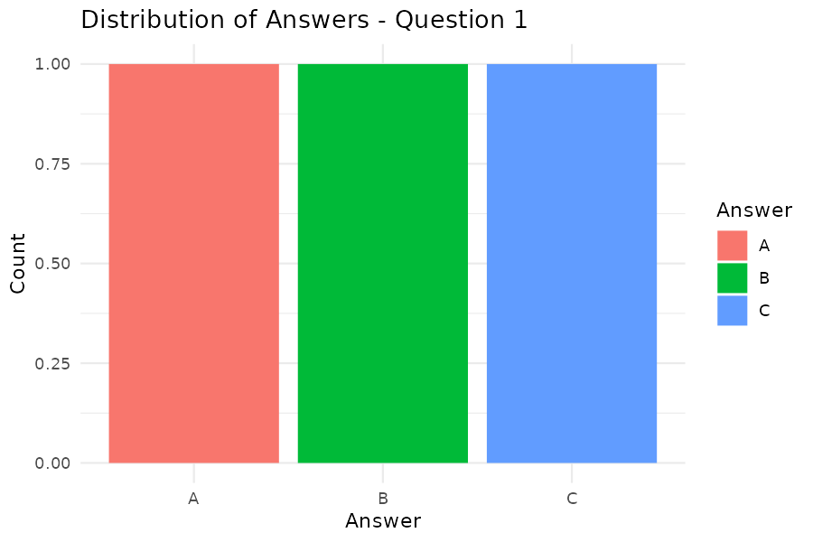
Fig 19.1 – Distribution of Answers, Question 1 (Grouped Bar Chart)
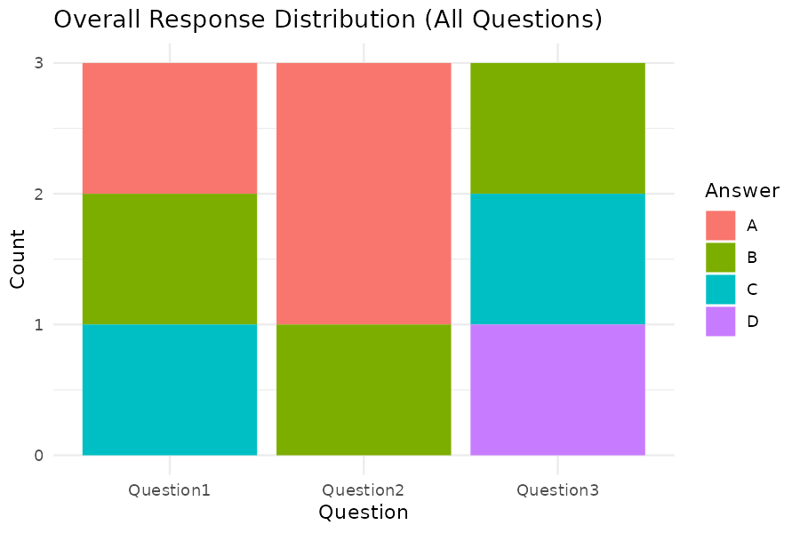
Fig 19.2 – Overall Response Distribution (Stacked Bar Chart)
Note: Task 4 (Tableau dashboard) is built in Tableau Desktop, not in R/Python.
Python Code (Equivalent)
import pandas as pd
import matplotlib.pyplot as plt
import seaborn as sns

survey_df = pd.DataFrame({
"SurveyID": [1, 2, 3],
"Question1": ["A", "B", "C"],
"Question2": ["B", "A", "A"],
"Question3": ["C", "D", "B"]
})

# 1. Grouped bar chart - distribution of answers for Question 1
q1_counts = survey_df["Question1"].value_counts().reset_index()
q1_counts.columns = ["Answer", "Count"]
sns.barplot(data=q1_counts, x="Answer", y="Count",
hue="Answer", palette="pastel", legend=False)
plt.title("Distribution of Answers - Question 1")
plt.show()

# 2. Stacked bar chart - overall distribution across all 3 questions
survey_long = survey_df.melt(id_vars="SurveyID", var_name="Question", value_name="Answer")
survey_summary = survey_long.groupby(["Question", "Answer"]).size().unstack(fill_value=0)
survey_summary.plot(kind="bar", stacked=True, colormap="tab20")
plt.title("Overall Response Distribution (All Questions)")
plt.show()

# 3. Table of survey response data
print(survey_df)

# 4. Tableau dashboard step done in Tableau, not Python.

SET 20: Stock Analysis
SET 20: Stock Analysis
Dataset: Date, StockA, StockB, StockC (3-day closing prices for three stocks)
1. Create a line chart to visualize the stock prices of three different stocks over time.
2. Generate a bar chart showing the daily percentage change of Stock A.
3. Create a table displaying the stock price data.
4. Develop an interactive Tableau dashboard combining the line chart and bar chart.
R Code
stock_df <- data.frame(
Date = as.Date(c("2023-01-01", "2023-01-02", "2023-01-03")),
StockA = c(100, 105, 110),
StockB = c(150, 152, 148),
StockC = c(120, 118, 122)
)

# 1. Line chart of 3 stock prices over time
stock_long <- melt(stock_df, id.vars = "Date", variable.name = "Stock", value.name = "Price")
ggplot(stock_long, aes(x = Date, y = Price, color = Stock)) +
geom_line(size = 1) + geom_point() +
labs(title = "Stock Prices Over Time", x = "Date", y = "Price ($)") +
theme_minimal()

# 2. Bar chart: daily percentage change in Stock A
stock_df$StockA_PctChange <- c(NA, diff(stock_df$StockA) / head(stock_df$StockA, -1) * 100)
ggplot(stock_df[-1, ], aes(x = as.character(Date), y = StockA_PctChange,
fill = StockA_PctChange > 0)) +
geom_bar(stat = "identity") +
labs(title = "Daily % Change in Stock A", x = "Date", y = "% Change") +
theme_minimal() + theme(legend.position = "none")

# 3. Table of stock price data
print(stock_df[, c("Date", "StockA", "StockB", "StockC")])

# 4. NOTE: Tableau -> Sheet1 = Date vs Price by Stock (line), Sheet2 = daily
# % change in Stock A (bar) -> combine on a Dashboard.
Output Visualization
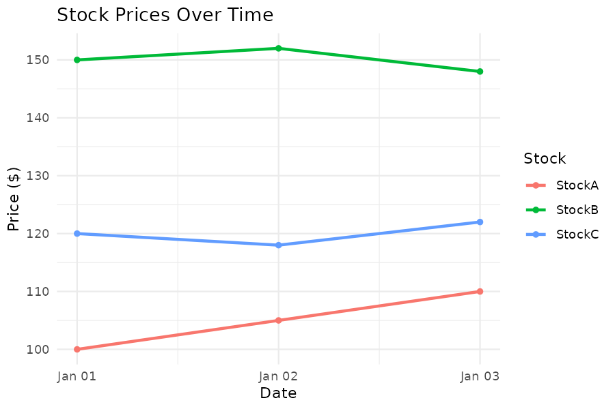
Fig 20.1 – Stock Prices Over Time (Line Chart)
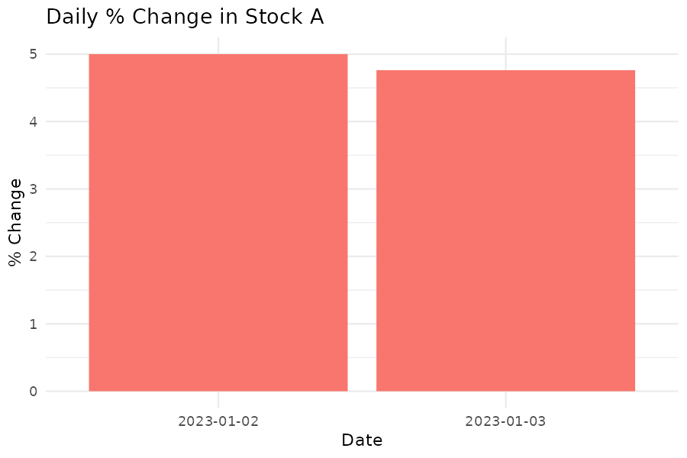
Fig 20.2 – Daily % Change in Stock A (Bar Chart)
Note: Task 4 (Tableau dashboard) is built in Tableau Desktop, not in R/Python.
Python Code (Equivalent)
import pandas as pd
import matplotlib.pyplot as plt
import seaborn as sns

stock_df = pd.DataFrame({
"Date": pd.to_datetime(["2023-01-01", "2023-01-02", "2023-01-03"]),
"StockA": [100, 105, 110],
"StockB": [150, 152, 148],
"StockC": [120, 118, 122]
})

# 1. Line chart of 3 stock prices over time
stock_long = stock_df.melt(id_vars="Date", var_name="Stock", value_name="Price")
sns.lineplot(data=stock_long, x="Date", y="Price", hue="Stock", marker="o")
plt.title("Stock Prices Over Time")
plt.show()

# 2. Bar chart - daily percentage change in Stock A
stock_df["StockA_PctChange"] = stock_df["StockA"].pct_change() * 100
plot_df = stock_df.dropna(subset=["StockA_PctChange"])
colors = ["green" if v > 0 else "red" for v in plot_df["StockA_PctChange"]]
plt.bar(plot_df["Date"].dt.strftime("%Y-%m-%d"), plot_df["StockA_PctChange"], color=colors)
plt.title("Daily % Change in Stock A")
plt.show()

# 3. Table of stock price data
print(stock_df[["Date", "StockA", "StockB", "StockC"]])

# 4. Tableau dashboard step done in Tableau, not Python.

