TAJUK

NAMA 1

NAMA 2

NAMA 3

SEMESTER 2

SESI 2019/2020

JABATAN TEKNOLOGI MAKLUMAT

UNIVERSITI TUN HUSSEIN ONN MALAYSIA

TAJUK

NAMA 1

NAMA 2

NAMA 3

Laporan projek dikemukakan bagi

memenuhi keperluan untuk penganugerahan

Diploma Teknologi Maklumat

Jabatan Teknologi Maklumat,

Pusat Pengajian Diploma

Universiti Tun Hussein Onn Malaysia

JUN, 2020

PENGAKUAN PENGARANG

Dengan ini saya akui bahawa laporan ini adalah hasil kerja saya sendiri dan dibuat berdasarkan peraturan yang termaktub di bawah Projek Tahun Akhir Jabatan Teknologi Maklumat, Pusat Pengajian Diploma, UTHM. Ia adalah asli berpandukan daripada kajian yang telah dilakukan oleh saya. Projek ini masih belum dihasilkan olehmana-manapihakatauinstitutuntukmana-manadiplomaataukelayakan.

Saya dengan ini berjanji sekiranya projek yang dilaksanakan oleh saya melanggar mana-mana syarat yang tertera di atas, segala hasil kerja saya akan digagalkan dan didapati sebagai tidak melengkapkan diploma dan bersetuju untuk dikenakan sebarangtindakansepertiyangditetapkandidalamperaturanProjekTahunAkhir.

Nama Penulis : NAMA 1

Tandatangan :

Nama Penulis : NAMA 2

Tandatangan :

Nama Penulis : NAMA 3

Tandatangan :

Kursus : PROJEK TAHUN AKHIR DIPLOMA

Jabatan : JABATAN TEKNOLOGI MAKLUMAT

Fakulti : PUSAT PENGAJIAN DIPLOMA

Tajuk Projek : TAJUK

Tarikh :

PENGAKUAN PENYELIA

Saya dengan ini memperakui bahawa telah membaca laporan ini dan segala yang terkandung di dalam adalah benar. Projek ini adalah memadai dengan skop dan kualiti serta telah memenuhi segala syarat dan undang-undang di bawah peraturan Projek Tahun Akhir Jabatan Teknologi Maklumat, Pusat Pengajian Diploma, UTHM bagi tujuan penganugerahan Diploma Teknologi Maklumat.

Nama Penyelia : NAMA PENYELIA (cth. DR ZURAIDA IBRAHIM)

Tandatangan :

Tarikh :

PENGHARGAAN

Tulis penghargaan anda disini (tidak melebihi satu mukasurat).

ABSTRAK

Abstrak Bahasa Malaysia (tidak lebih daripada 200 patah perkataan).

ABSTRACT

Abstract in English (not more than 200 words).

ISI KANDUNGAN

PENGAKUAN ii

PENGHARGAAN v

ABSTRAK vi

ABSTRACT vii

ISI KANDUNGAN viii

SENARAI JADUAL xi

SENARAI RAJAH xii

SENARAI ALGORITHM xiii

SENARAI SIMBOL DAN AKRONIM xiv

SENARAI LAMPIRAN xv

SENARAI PENERBITAN xvi

PENGANUGERAHAN xvii

BAB 1 PENGENALAN 1

1.1 Pengenalan 1

1.2 Latar Belakang Projek 1

1.3 Penyataan Masalah 1

1.4 Objektif 1

1.5 Kepentingan Projek 1

1.6 Skop Kajian 2

1.7 Kekangan Projek 2

1.8 Tajuk 2

1.9 Kesimpulan 2

BAB 2 KAJIAN LITERASI 3

2.1 Pengenalan 3

2.2 Tajuk 3

2.2.1 Tajuk 3

2.2.2 Tajuk 4

2.2.3 Tajuk 4

2.3 Tajuk 4

2.3.1 Tajuk 4

2.4 Tajuk 4

2.5 Tajuk 5

2.5.1 Tajuk 5

2.5.2 Tajuk 5

2.5.3 Tajuk 5

2.5.4 Tajuk 5

2.5.5 Tajuk 5

2.6 Tajuk 6

2.7 Kesimpulan 6

BAB 3 METODOLOGI KAJIAN 7

3.1 Pengenalan 7

3.2 Tajuk 7

3.3 Tajuk 7

3.4 Tajuk 8

3.5 Tajuk 8

3.5.1 Tajuk 8

3.5.2 Tajuk 8

3.5.3 Tajuk 8

3.5.4 Tajuk 8

3.5.5 Tajuk 8

3.5.6 Tajuk 9

3.6 Tajuk 9

3.7 Tajuk 9

3.8 Tajuk 9

3.9 Tajuk 9

3.10 Tajuk 10

3.11 Kesimpulan 10

BAB 4 HASIL KAJIAN DAN IMPLEMENTASI 11

4.1 Pengenalan 11

4.2 Tajuk 11

4.2.1 Tajuk 12

4.2.2 Tajuk 12

4.2.3 Tajuk 12

4.2.4 Tajuk 12

4.2.5 Tajuk 12

4.2.6 Tajuk 12

4.2.7 Tajuk 13

4.2.8 Kesimpulan 13

BAB 5 KESIMPULAN DAN CADANGAN 14

5.1 Pengenalan 14

5.2 Tajuk 14

5.3 Tajuk 14

5.4 Kesimpulan 14

RUJUKAN 15

LAMPIRAN 16

SENARAI JADUAL

3.1 Summary 1

3.2 Network 1

4.1 Summary 1

4.2 Summary 1

4.3 Summary 1

4.4 Summary 1

4.5 Summary 1

4.6 Summary 1

4.7 Summary 1

SENARAI RAJAH

2.1 The 1

2.2 The 1

2.3 The 1

2.4 The 1

2.5 The 1

2.6 The 1

2.7 The 1

3.1 Step 1

3.2 Out 1

3.3 Number 1

4.1 Performance 1

4.2 Performance 1

SENARAI ALGORITHM

3.1 Algorithm 1

3.2 algorithm 1

SENARAI SIMBOL DAN AKRONIM

 - Bias for the  unit.

 - Learning rate

 - Momentum coefficient

 - Net input activation function for the  unit.

KPM - Kementerian Pelajaran Malaysia

SENARAI LAMPIRAN

**LAMPIRAN TAJUK MUKASURAT**

A Table A.1: Gantt Chart of Research Activities 1

B Table B.1: Algorithms’ Performance for 1

B Table B.2: Algorithms’ Performance for 1

B Table B.3: Algorithms’ Performance for 2

B Table B.4: Algorithms’ Performance for 2

SENARAI PENERBITAN

|  |  |
| --- | --- |
| Journals: | |
| (i) |  |
| (ii) |  |
| (iii) |  |
|  |  |
| Proceedings: | |
| (i) |  |
| (ii) |  |
| (iii) |  |
|  |  |
|  |  |
|  |  |
|  |  |
|  |  |
|  |  |

PENGANUGERAHAN

|  |  |
| --- | --- |
| (i) | **Gangsa di dalam Malaysia International….** |

# BAB 1

PENGENALAN

## Pengenalan

1st paragraph.

2nd paragraph.

## Latar Belakang Projek

1st paragraph.

## Penyataan Masalah

1st paragraph.

2nd paragraph.

## Objektif

1st paragraph.

1. 1st Objective.
2. 2nd Objective
3. 3rd Objective.

## Kepentingan Projek

1st paragraph.

## Skop Kajian

1st paragraph.

## Kekangan Projek

1st paragraph.

## Tajuk

1st paragraph.

## Kesimpulan

1st paragraph.

# BAB 2

KAJIAN LITERASI

## Pengenalan

1st paragraph.

2nd paragraph.

## Tajuk

1st paragraph.

2nd paragraph.

### Tajuk

1st paragraph.

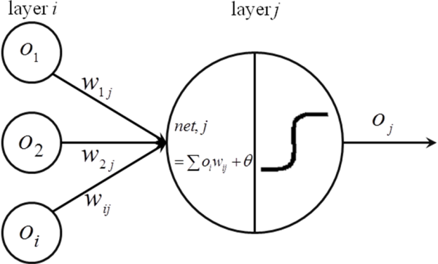

Rajah 2.1: The simple node

### Tajuk

1st paragraph

2nd paragraph.

### Tajuk

1st paragraph

## Tajuk

1st paragraph

2nd paragraph. Fjkasfjdkdasjdfkasjdfhakfdhkahfdsjkahdfkjahfhaskh hasjkdfhaksfhkh hsdfahskahfkahfdhaskjfh hakjfhkahfjhaf khj fjkahfjkahjkf. Hsaufhkashdf jhskjafhkdjshf

3rd paragraph.

### Tajuk

1st paragraph

1. 1st point

Explanation.

1. 2nd point

Explanation.

## Tajuk

1st paragraph

2nd paragraph.

3rd paragpraph.

## Tajuk

1st paragraph

2nd paragraph.

### Tajuk

1st paragraph

2nd paragraph.

### Tajuk

1st paragraph

2nd paragraph.

### Tajuk

1st paragraph

2nd paragraph.

### Tajuk

1st paragraph

2nd paragraph.

### Tajuk

1st paragraph

2nd paragraph.

## Tajuk

1st paragraph

 (2.14)

where,

 (2.15)

where,

 : output of the unit.

 : weight of the link from unit ** to unit .

 : net output for the  unit.

 : bias for the  unit.

 : gain of the activation function.

2nd paragraph

3rd paragraph

## Kesimpulan

1st paragraph

# BAB 3

METODOLOGI KAJIAN

## Pengenalan

1st paragraph

For a given epoch,

For each input vector,

Step 1. Calculate the weight and bias values using the previously converged gain value.

Step 2. Use the weight and bias values calculated in Step (1) to calculate the new gain value.

Repeat Steps (1) and (2) for each example on an epoch-by-epoch basis until the error on the entire training data set reduces to a predefined value.

Rajah 3.1: BPGD-AG Algorithm

## Tajuk

1st paragraph

## Tajuk

1st paragraph

2nd paragraph

## Tajuk

1st paragraph

2nd paragraph

## Tajuk

1st paragraph

2nd paragraph.

### Tajuk

1st paragraph

### Tajuk

1st paragraph

### Tajuk

1st paragraph

### Tajuk

1st paragraph

### Tajuk

1st paragraph

### Tajuk

1st paragraph

## Tajuk

1st paragraph

## Tajuk

1st paragraph

Jadual 3.1: Summary of dataset attributes for classification problems

|  |  |  |  |
| --- | --- | --- | --- |
|  |  |  |  |
|  |  |  |  |
|  |  |  |  |
|  |  |  |  |
|  |  |  |  |
|  |  |  |  |
|  |  |  |  |

## Tajuk

1st paragraph

## Tajuk

Jadual 3.2:

|  |  |  |  |  |
| --- | --- | --- | --- | --- |
|  |  |  |  |  |
|  |  |  |  |  |
|  |  |  |  |  |
|  |  |  |  |  |
|  |  |  |  |  |
|  |  |  |  |  |
|  |  |  |  |  |

3rd paragraph

4th paragraph

## Tajuk

1st paragraph

1. 1st point
2. 2nd point

2nd paragraph

## Kesimpulan

1st paragraph.

# BAB 4

HASIL KAJIAN DAN IMPLEMENTASI

## Pengenalan

1st paragraph

## Tajuk

1st paragraph

2nd paragraph. Hkashdsjahdakh hdkajhskhdfak ajhfkjhadf. Haksjfkasf. Ajfkasjkflj.

1. 1st point
2. 2nd point

3rd paragraph

4th paragraph Hkashdsjahdakh hdkajhskhdfak ajhfkjhadf. Haksjfkasf. Ajfkasjkflj.

1. 1st point
2. 2nd point
3. 3rd point
4. 4th point

5th paragraph Hkashdsjahdakh hdkajhskhdfak ajhfkjhadf. Haksjfkasf. Ajfkasjkflj.

1. 1st point
2. 2nd point
3. 3rd point

### Tajuk

1st paragraph

2nd paragraph

3rd paragraph

### Tajuk

1st paragraph

2nd paragraph

3rd paragraph

### Tajuk

1st paragraph

2nd paragraph

3rd paragraph

## Tajuk

1st paragraph

2nd paragraph

## Tajuk

1st paragraph

2nd paragraph

## Tajuk

1st paragraph

2nd paragraph

## Tajuk

1st paragraph

## Kesimpulan

1st paragraph

# BAB 5

KESIMPULAN DAN CADANGAN

## Pengenalan

1st paragraph

2nd paragraph

3rd paragraph

## Tajuk

1st paragraph

1. 1st point.
2. 2nd point

## Tajuk

1st paragraph

## Kesimpulan

1st paragraph

1. 1st point
2. 2nd oint.

RUJUKAN

Ackley, D. H., Hinton, G. E., & Sejnowski, T. J. (1986). A learning algorithm for boltzmann machines. *Cognitive Science, 9 (1)*, pp. 147-169.

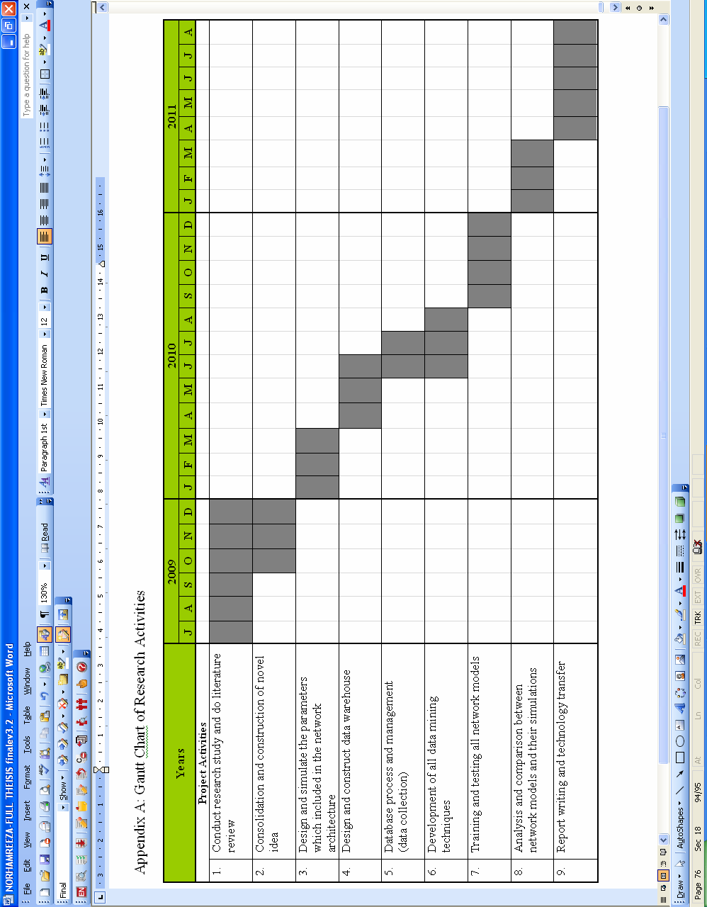

Jadual A.1: Gantt Chart of Research Activities

APPENDIX

Hidden Nodes : 5

Target Error : 0.001

Problem : Classification Problem

Maximum Epoch : 10000

Jadual B.1: Algorithms’ Performance

|  |  |  |  |  |  |  |  |  |  |
| --- | --- | --- | --- | --- | --- | --- | --- | --- | --- |
|  |  | | |  | | |  | | |
|  |  | | |  | | |  | | |
|  |  | | |  | | |  | | |
|  |  |  |  |  |  |  |  |  |  |
|  |  |  |  |  |  |  |  |  |  |
|  |  |  |  |  |  |  |  |  |  |
|  |  |  |  |  |  |  |  |  |  |
|  |  |  |  |  |  |  |  |  |  |
|  |  |  |  |  |  |  |  |  |  |
|  |  |  |  |  |  |  |  |  |  |
|  |  |  |  |  |  |  |  |  |  |
|  |  |  |  |  |  |  |  |  |  |
|  |  |  |  |  |  |  |  |  |  |
|  |  |  |  |  |  |  |  |  |  |
|  |  |  |  |  |  |  |  |  |  |
|  |  |  |  |  |  |  |  |  |  |
|  |  |  |  |  |  |  |  |  |  |
|  |  |  |  |  |  |  |  |  |  |
|  |  |  |  |  |  |  |  |  |  |
|  |  |  |  |  |  |  |  |  |  |
|  |  |  |  |  |  |  |  |  |  |
|  |  |  |  |  |  |  |  |  |  |
|  |  |  |  |  |  |  |  |  |  |
|  |  |  |  |  |  |  |  |  |  |
|  |  |  |  |  |  |  |  |  |  |
|  |  |  |  |  |  |  |  |  |  |
|  |  |  |  |  |  |  |  |  |  |
|  |  |  |  |  |  |  |  |  |  |
|  |  |  |  |  |  |  |  |  |  |
|  |  |  |  |  |  |  |  |  |  |
|  |  |  |  |  |  |  |  |  |  |
|  |  |  |  |  |  |  |  |  |  |
|  |  |  |  |  |  |  |  |  |  |
|  |  |  |  |  |  |  |  |  |  |
|  |  |  |  |  |  |  |  |  |  |
|  |  |  |  |  |  |  |  |  |  |
|  |  |  |  |  |  |  |  |  |  |
|  |  |  |  |  |  |  |  |  |  |
|  |  |  |  |  |  |  |  |  |  |
|  |  |  |  |  |  |  |  |  |  |
|  |  |  |  |  |  |  |  |  |  |
|  |  |  |  |  |  |  |  |  |  |
|  |  |  |  |  |  |  |  |  |  |
|  |  |  |  |  |  |  |  |  |  |
|  |  |  |  |  |  |  |  |  |  |
|  |  |  |  |  |  |  |  |  |  |
|  |  |  |  |  |  |  |  |  |  |
|  |  |  |  |  |  |  |  |  |  |
|  |  |  |  |  |  |  |  |  |  |
|  |  |  |  |  |  |  |  |  |  |
|  |  |  |  |  |  |  |  |  |  |
|  |  |  |  |  |  |  |  |  |  |
|  |  |  |  |  |  |  |  |  |  |
|  |  |  |  |  |  |  |  |  |  |
|  |  |  |  |  |  |  |  |  |  |
|  |  |  |  |  |  |  |  |  |  |
|  |  |  |  |  |  |  |  |  |  |
|  |  |  |  |  |  |  |  |  |  |
|  |  |  |  |  |  |  |  |  |  |
|  |  |  |  |  |  |  |  |  |  |

Hidden Nodes : 5………

Target Error : ………

Problem : ………..

Maximum Epoch : …………

……………………………….…………….