**1. DB and connection**

-DB structure.

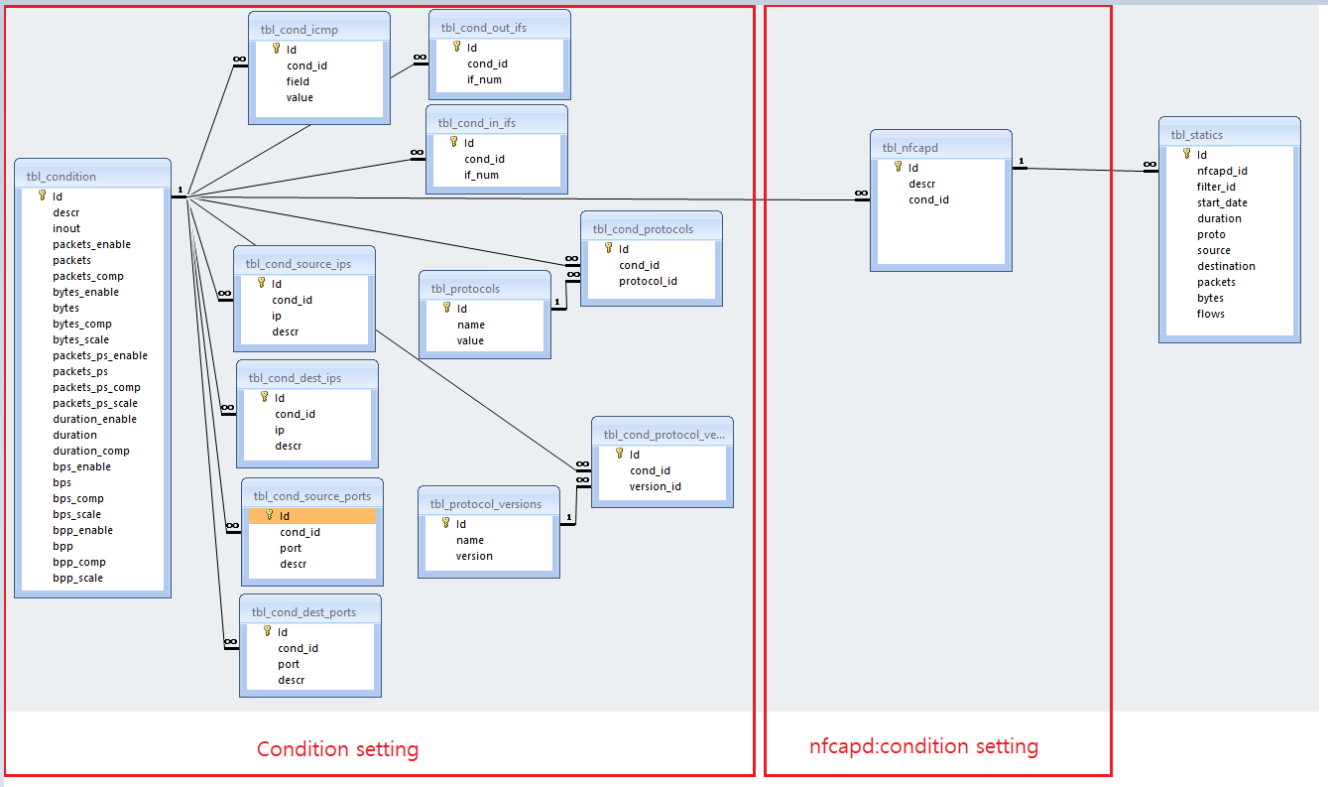

-DB connection in web

Web site source is in 121.165.242.78:8181/nfdump folder.

The db connection info is in /nfdump/application/config/database.php

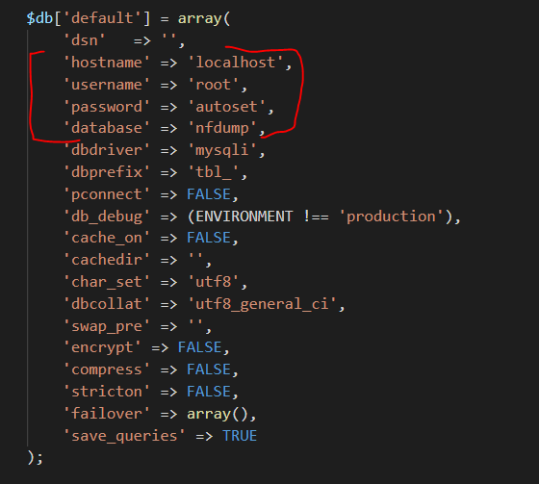

-DB connection in nfcapd source code

/nfdump-master/bin/webservice.c #line 38



**2. Condition and Filtering management.**

**1) filtering condition structure and parsing from server.**

**-**Filter condition structure. /bin/filter_condition.h

typedef struct _filter_condition{….}

-Filter condition reply from server

server back-end api reply filter condition as json format.

/nfdump/application/controllers/api.php #line 39

“getFilterCondition”

-Filter condition parsing on the client(nfcapd)

/nfdump-master /bin/backendapi.c #line 9

int getFilterCondition(int nfcapd_id, filter_condition* cond)

-Filtering

/nfdump-master /bin/filter.c #line 290

int filterRecord(filter_condition* cond, common_record_t* rd, master_record_t*

mrd);

This function call sub filter functions for filter condition elements.

**3. Sources**

-Web source is in /nfdump/ on the server.

-DB is on the server.

-client(nfcapd) source sent already and checked on the several systems.

All source will be attached again.

**% Compile nfdump-master source code.**

./autogen.sh

./configure

Copy original source /bin/MakeFile into working dir/bin/

./make

**4. Source list.**

-DB file source/www/nfdump.sql

-Web source source /www/nfdump.zip

-nfdump source source/nfdump-master.tar