AI CAREER MENTOR: CROSS-DISCIPLINARY CAREER GUIDANCE
Comprehensive Technical Overview & Executive Summary

1. Executive Summary
The AI Career Mentor project is a transformative full-stack application designed to modernize the career counseling industry. By integrating advanced Generative AI architectures (LLMs) with a high-performance cloud backend and a native Android frontend, the system provides individuals with an automated, data-driven path to professional growth. Unlike traditional platforms that focus on job postings, this system focuses on 'Skill Development'—identifying semantic gaps in a user's resume and architecting a customized, multi-week learning curriculum (Roadmap) to bridge those gaps.

1.2 Technology Stack
Layer | Technology Used | Key Feature
Frontend | Kotlin / Android XML | MVVM Pattern, Retrofit, Coroutines
Backend | Python 3.10 / FastAPI | Async processing, Pydantic validation
Intelligence | DeepSeek-V3 / Gemini 1.5 Pro | Zero-shot prompting, JSON-structured output
Database | PostgreSQL / SQLAlchemy | High performance, Relational Integrity
Deployment | Koyeb (PaaS) / Gunicorn | 24/7 Availability, Automated SSL

2. System Requirements & Specifications

2.1 Requirements Portfolio
Category | Requirement | Minimum Specification
Software | Operating System | Android 10.0 (API 29) +
Hardware | Processor | Octa-core 2.0 GHz or higher
Backend | Cloud Server | 512MB RAM, 1 vCPU (Serverless ready)
Network | Bandwidth | Stable 4G/5G connection for AI streaming

2.2 Functional Core
• Unified Authentication: Secure OAuth-style JWT session management.
• Resume Intelligence: Multi-page PDF text extraction and semantic normalization.
• Gap Analysis: AI-driven comparison between extraction skills and target career goal.
• Roadmap Engine: Dynamic 16-week curriculum generation with task persistence.
• Interactive Counsel: Persistent chat-based mentorship with context-aware advice.

2.3 Project Feasibility
The project is highly feasible economically as it leverages Tier-1 AI APIs (OpenRouter) that cost fractions of a cent per request. Operationally, the system uses a serverless-ready architecture, minimizing maintenance overhead and allowing for rapid deployment.

3. Workflow & Visual Architecture
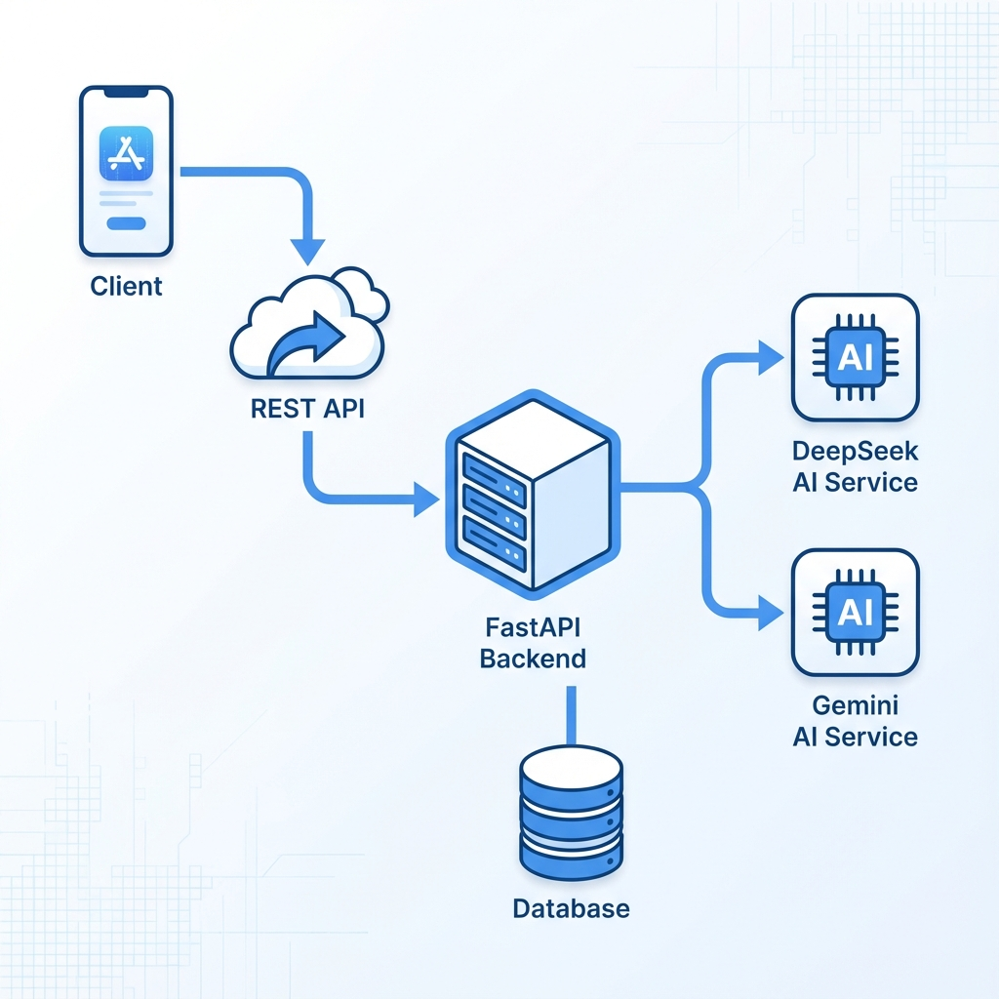
Figure 3.1: Sequential Operation Flow

3.2 Security Implementation
To protect user privacy, the AI Career Mentor implements top-tier security measures:
• Password Cryptography: Salted Bcrypt hashing for all user credentials.
• Transport Security: Mandatory HTTPS for all mobile-to-cloud communication.
• Stateless Auth: Access tokens with 24-hour expiration to prevent session hijacking.
• Pydantic Shield: Rigorous input validation on every API endpoint to prevent SQL injection.

3.3 Implementation Logic
The system follows the 'Separation of Concerns' principle. The Android client focuses on reactive UI updates using the Model-View-ViewModel (MVVM) pattern, while the Backend centralizes AI reasoning. This ensures that the mobile app remains lightweight and performant while the complex processing is handled by high-end cloud servers.

4. Scalability & Visionary Roadmap

4.1 Competitive Advantage
Traditional platforms are 'Static & Passive' (Job boards). AI Career Mentor is 'Dynamic & Active'. While other systems tell you *who* is hiring, this system tells you *how* to be the best candidate for those roles. The primary advantage is the integration of a 'Bridging Curriculum'—turning analysis into immediate action.

4.2 Horizontal & Vertical Scalability
The system is architected for the future:
• Global Scale: Regional API nodes can be deployed to reduce latency for international users.
• Data Scaling: The PostgreSQL database can be clustered to handle millions of professional profiles.
• Multi-Modal AI: Readiness to integrate Voice and Video AI for mock interview training.

4.3 Future Enhancements
Next iterations will focus on real-time connection to global job APIs (LinkedIn, Indeed) and the introduction of 'Interactive Mock Interviews' powered by real-time speech AI. A peer-learning module is also planned for users following identical roadmaps.

5. Conclusion
The AI Career Mentor project successfully demonstrates the fusion of modern app development and Artificial Intelligence. It provides an end-to-end framework for professional development in the AI era. Prepared and implemented by Faizan Haider - University CS Submission 2026.

