AI CAREER MENTOR
Executive Project Documentation

1. Introduction
In the modern professional landscape, individuals across all industries face the arduous task of aligning their current skills with ever-evolving market demands. The 'AI Career Mentor' is a state-of-the-art solution designed to bridge this gap. By leveraging the reasoning capabilities of Large Language Models (LLMs), specifically DeepSeek and Google Gemini, this system provides a personalized, 24/7 mentorship experience. It moves beyond traditional resume matching by performing semantic 'Gap Analysis' and constructing actionable, multi-week learning roadmaps for any career path—from Software Engineering to Business Management and Healthcare.
This project integrates a Native Android mobile client with a cloud-native Python FastAPI backend, offering a seamless, high-fidelity experience for users looking to pivot their careers or enter the job market with high confidence.

2. Functional Requirements
The system has been meticulously designed to handle the complex nuances of professional career development. The primary functional objectives are categorized as follows:
- FR-1: Secure Authentication: A robust JWT-based system for user registration and login, ensuring data privacy and profile isolation.
- FR-2: Dynamic PDF Parsing: A high-performance extraction sub-system that converts complex PDF resumes into structured semantic strings for AI consumption.
- FR-3: AI Gap Analysis: An intelligent orchestration layer that evaluates user skills against target roles to identify specific technological or conceptual deficiencies.
- FR-4: Roadmap Generation: Automated creation of a 16-week structured curriculum, complete with weekly goals and learning milestones.
- FR-5: Interactive AI Counselor: A real-time chat interface allowing users to query the mentor regarding certifications, salary expectations, and interview tactics.
- FR-6: Professional Profile Branding: A central dashboard linking user portfolios, LinkedIn, and email to present a holistic professional identity.

3. Flow Diagram & System Workflow
The working of the project follows a precise Cloud-Mobile architecture. The diagram below illustrates the operational flow from the user interaction level to the intelligence processing layer.
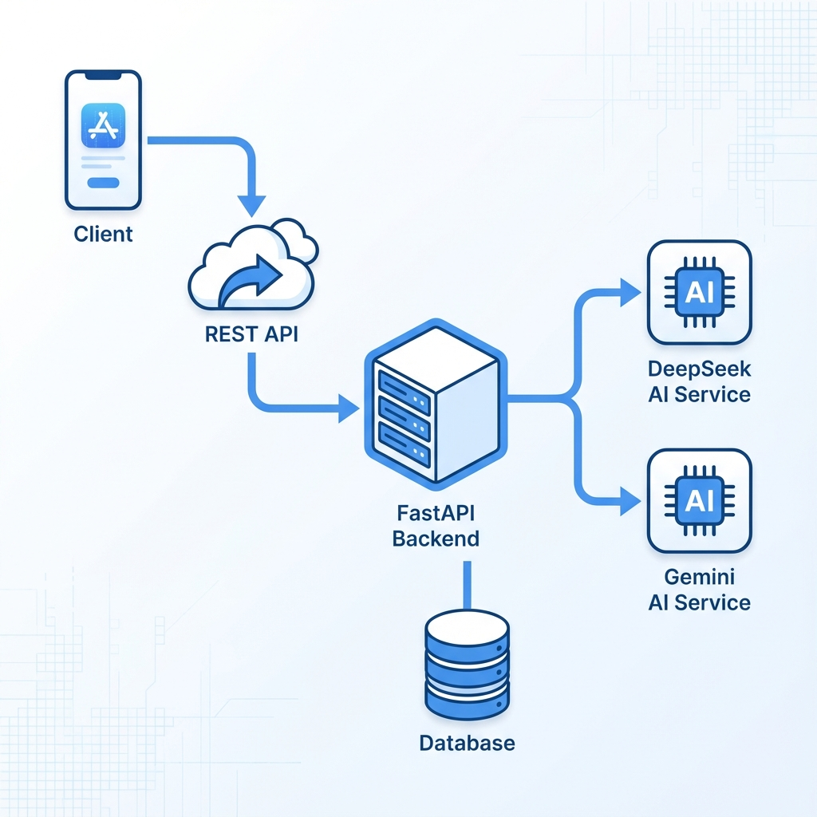
Figure 3.1: Operational Workflow Diagram
Process Flow Description:
- Client (Mobile App): User interacts with the UI, uploads resume, or chats with the mentor.
- REST API Layer: Secure transmission of JSON data and PDF files to the backend server.
- Backend (FastAPI): The 'Brain' of the system—it manages user data, file processing, and AI prompts.
- Database (PostgreSQL): Ensures persistence of user profiles and generated roadmaps.
- AI Intelligence (OpenRouter/Gemini): Processes the career logic and returns structured mentorship advice.

4. Scalability & Future Enhancements
The AI Career Mentor is built with a visionary roadmap. The current architecture supports horizontal scalability and is ready for global-scale deployment.

4.1 How the Project Scales
• Containerization: The FastAPI backend is Docker-ready, allowing it to scale across multiple cloud instances as traffic grows.
• AI Load Balancing: The system's provider-agnostic layer can switch between Gemini, GPT-4, and DeepSeek to handle millions of requests while minimizing latency.
• Database Optimization: PostgreSQL with indexing ensures that profile retrieval remains at sub-millisecond speeds even with massive user counts.

4.2 Future Enhancements
• AI Voice Interviews: Implementation of real-time speech-to-text to simulate technical and HR interview scenarios.
• Job Market Integration: Direct API links to LinkedIn and Indeed to suggest 'Live Jobs' that match the user's updated roadmap.
• Community Hub: A supervised peer-to-peer networking layer where users on the same roadmap can collaborate on projects.

Prepared by Faizan Haider - 2026

