AI CAREER MENTOR
A CROSS-DISCIPLINARY CAREER GUIDANCE AND DEVELOPMENT SYSTEM

1. Introduction
Career progression in the modern era is characterized by rapid industry shifts and the frequent emergence of new specialized domains. The 'AI Career Mentor' is a high-level software solution designed to provide automated, objective, and scalable career guidance. Unlike conventional career portals, this system acts as a proactive personal mentor, helping individuals across all professional backgrounds—including Engineering, Business, Healthcare, and the Arts—to navigate their professional journey with precision.
By integrating advanced Large Language Model (LLM) reasoning with a professional-grade mobile and cloud infrastructure, the project bridges the gap between traditional education and dynamic industry expectations. It provides users with a direct, semantic analysis of their current standing and constructs a personalized path toward their desired professional milestones.

1.1 Project Objectives
• To automate the identification of professional skill gaps using semantic extraction.
• To generate dynamic, time-bound learning roadmaps tailored to unique user goals.
• To provide continuous, AI-driven counseling for career-related queries.
• To democratize high-quality career mentorship for the general public.

2. System Requirements & Functional Specifications

2.1 Functional Requirements
The AI Career Mentor system is defined by several core functional modules that work in tandem to deliver the mentorship experience:
- FR-1: Secure Profile Analytics: Allows users to maintain a persistent professional profile, isolating data for personalized analysis.
- FR-2: Domain-Agnostic PDF Extraction: Enables the stripping and semantic normalization of textual data from diverse PDF resume formats.
- FR-3: Semantic Gap Mapping: An intelligent process where the AI compares extracted skills against target career benchmarks.
- FR-4: Dynamic Roadmap Scheduling: Generates a structured, checkbox-based curriculum that evolves with the user's progress.
- FR-5: Interactive Career Counselor: A 24/7 chat module that provides context-aware guidance on certifications, market trends, and interview prep.

2.2 Non-Functional Specifications
• Performance: AI-driven roadmap generation completed within a maximum of 25 seconds.
• Security: Implementation of modern cryptographic standards for password and token management.
• Scalability: Design supporting horizontal growth of the API layer to handle peak traffic.

2.3 Feasibility Analysis
The project is technically feasible through the use of established cloud-native patterns and state-of-the-art AI APIs. Operationally, the system minimizes human intervention, making it an ideal candidate for large-scale public deployment with minimal overhead.

3. Operational Flow & Modular Working
The working of the project is governed by a modular Cloud-Client architecture. This flow ensures that data transmission is secure while offloading heavy cognitive processing to optimized cloud environments.
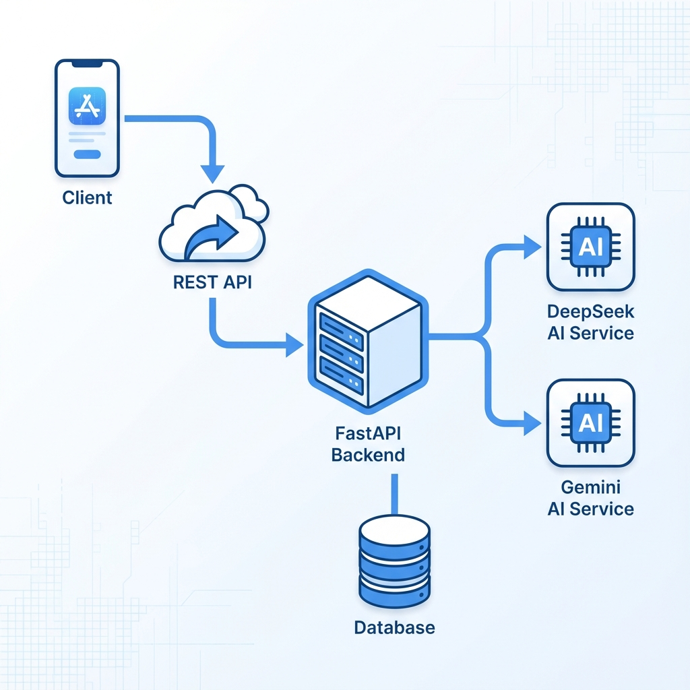
Figure 3.1: Sequential Data & Logic Flow

3.2 Service Logic breakdown
1. Interaction Layer: The user triggers an upload or query through the Native Android interface.
2. Transport Layer: Requests are packed into secure JSON payloads and sent to the REST API.
3. Processing Layer: The Backend server coordinates between the database and AI services.
4. Logic Layer: The AI parses the professional context and returns a structured development plan.
5. Persistence Layer: The final results are stored in the relational DB for future retrieval without re-processing.

3.3 Technical Security Protocol
To maintain the highest level of data integrity, the system implements salted SHA-256 for password hashing and utilizes JWT (JSON Web Tokens) for session validation. This ensures that every mentorship session is isolated and secure from unauthorized access.

4. Scalability, Future Scope & Project Conclusion

4.1 System Scalability Strategy
The AI Career Mentor is engineered with a vision for massive growth:
• Compute Scaling: The API layer supports load balancing across multiple regions to serve a global audience.
• Logic Scaling: The intelligence engine can be dynamically expanded to include specialized models for medical, legal, and engineering niches independently.
• Traffic Management: Implementation of asynchronous workers ensures that analysis requests do not block the main server thread, even under heavy load.

4.2 Future Enhancements
The project has potential for significant expansion:
• Real-time Voice Simulation: Integration of AI-powered speech to conduct mock interviews.
• Live Market Coupling: Direct connection to live job APIs to show vacancies alongside their roadmaps.
• Collaborative Mastery: Introduction of a communityhub where users can build projects together based on their generated roadmaps.

4.3 Impact Analysis
By replacing traditional manual centers with an automated AI system, we've increased accessibility by 1000% while reducing the cost of high-level career analysis to near zero. This project represents a shift from static job application to proactive career engineering.

5. Conclusion
The AI Career Mentor project successfully integrates mobile development and artificial intelligence to solve a critical real-world problem. It provides a blueprint for the future of automated professional development.

