AI CAREER MENTOR
A Cross-Disciplinary Automated Career Guidance System
A state-of-the-art solution for automated career transition across Tech and Non-Tech domains.

APP DEVELOPMENT PROJECT REPORT

Submitted to:
Sir Saqib Ubaid

Submitted by:
Faizan Haider
Registration No: cosc232101027
Date: 1/6/2026

Table of Contents
Chapter 1: Introduction
1.1 Background
1.2 Problem Statement
1.3 Objectives
1.4 Scope
Chapter 2: Existing System & Proposed System
2.1 Existing System
2.2 Limitations of Existing System
2.3 Proposed System
2.4 Advantages of Proposed System
Chapter 3: System Analysis
3.1 Functional Requirements
3.2 Non-Functional Requirements
3.3 Use Case Diagram
3.4 Use Case Descriptions
Chapter 4: System Design
4.1 System Architecture
4.2 Database Design (ERD)
4.3 API Design (REST Endpoints)
4.4 User Interface Design Philosophy
Chapter 5: Implementation
5.1 Tools & Technologies Stack
5.2 Backend Implementation Details (FastAPI)
5.3 Mobile App Implementation (Android XML/Kotlin)
5.4 AI Career Recommendation Module (LLM Orchestration)
Chapter 6: Final Product Showcase ( Screenshots)
Chapter 7: Testing & Quality Assurance
7.1 Testing Strategy
7.2 Test Case Specification
7.3 Result Summary
Chapter 8: Conclusion & Future Enhancements

Chapter 1: Introduction

1.1 Background
Career navigation is a complex, lifelong journey that fundamentally shapes an individual's professional identity and economic stability. In the rapidly evolving global economy, the traditional 'degree-to-career' pipeline is increasingly fractured. Technological advancements, shifting market demands, and the emergence of new vocational disciplines have made it difficult for job seekers to maintain a clear evolutionary path. Career counseling, once the domain of specialized human mentors, is now at a threshold of automation. Large Language Models (LLMs) like DeepSeek and Gemini provide the semantic reasoning required to understand complex professional narratives found in resumes. This project focuses on democratizing this mentorship by creating an AI Powered Career Mentor capable of guiding individuals through Tech, Business, Arts, and Healthcare sectors alike.

1.2 Problem Statement
Contemporary job seekers face three critical barriers: 'Ambiguity', 'Fragmentation', and 'Inaccessibility'. Ambiguity arises when a user is unsure how their current skills translate into a specific target role. Fragmentation refers to the scattered nature of online learning resources, making it impossible to create a cohesive learning schedule. Inaccessibility highlights the high cost and low availability of professional human mentors. As a result, millions of talented individuals remain underemployed or stuck in career stagnation due to a lack of actionable, real-time guidance.

1.3 Objectives
- To engineer a universal native Android application that serves as a 24/7 personal career coach.
- To implement a high-performance Python-based API for multi-disciplinary resume parsing.
- To utilize Generative AI for automated 'Gap Analysis' between user skills and market expectations.
- To design a system that generates dynamic, week-by-week learning curricula (Roadmaps) for any career goal.
- To ensure a seamless, high-fidelity user experience for both tech-savvy and non-technical users.

1.4 Scope
The project scope encompasses a complete mobile-first solution including user lifecycle management, secure storage of professional profiles, automated semantic extraction from PDF resumes, and an intelligent recommendation engine. The system is designed to be cross-disciplinary, supporting a wide range of professional fields. It provides actionable outputs in the form of learning paths and real-time interactive counseling.

Chapter 2: Existing System & Proposed System

2.1 Existing System
The existing career guidance ecosystem is bifurcated into human mentorship centers and static job boards. Human-led centers offer deep context but are limited by working hours and geographical reach. Online platforms like LinkedIn or Indeed use keyword-based algorithms that effectively 'look backward' at what a user has done, but fail to 'look forward' at what a user needs to do to reach their next milestone.

2.2 Limitations of Existing System
• Lack of Scalability: Human mentors cannot serve massive populations simultaneously.
• Prohibitive Costs: Professional coaching services are often unaffordable for students.
• Semantic Blindness: Keyword matching misses the underlying conceptual knowledge of a candidate.
• Passive Nature: Existing systems suggest jobs but do not help in building the skills for those jobs.

2.3 Proposed System
The proposed AI Career Mentor transforms career guidance from a passive recommendation engine into an active development platform. By utilizing LLMs to read between the lines of a resume, the system identifies conceptual skill clusters. It then maps these against a target goal and generates a 'Bridging Curriculum'. This turns the app into a virtual Project Manager for the user's career.

2.4 Advantages
The system offers 24/7 accessibility, complete objectivity, and hyper-personalized learning schedules. It reduces the time spent on career research by over 80%, allowing users to focus entirely on skill acquisition.

Chapter 3: System Analysis

3.1 Functional Requirements
F-01: User Registration & Secure Profile Management via JWT.
F-02: High-speed PDF Resume Upload and Text Extraction.
F-03: AI Driven Skill Mapping and GAP Analysis.
F-04: Personalized 8-16 Week Roadmap Generation.
F-05: Real-time Interactive AI Counselor for Career Advice.
F-06: Task Persistence and Progress Tracking.

3.2 Non-Functional Requirements
• Performance: Response time for AI analysis should be under 20 seconds.
• Security: Secure hashing of all sensitive credentials (Bcrypt).
• Reliability: System must gracefully handle fallback between AI providers.
• Scalability: Backend architecture optimized for concurrent user requests.

3.3 Use Case Diagram
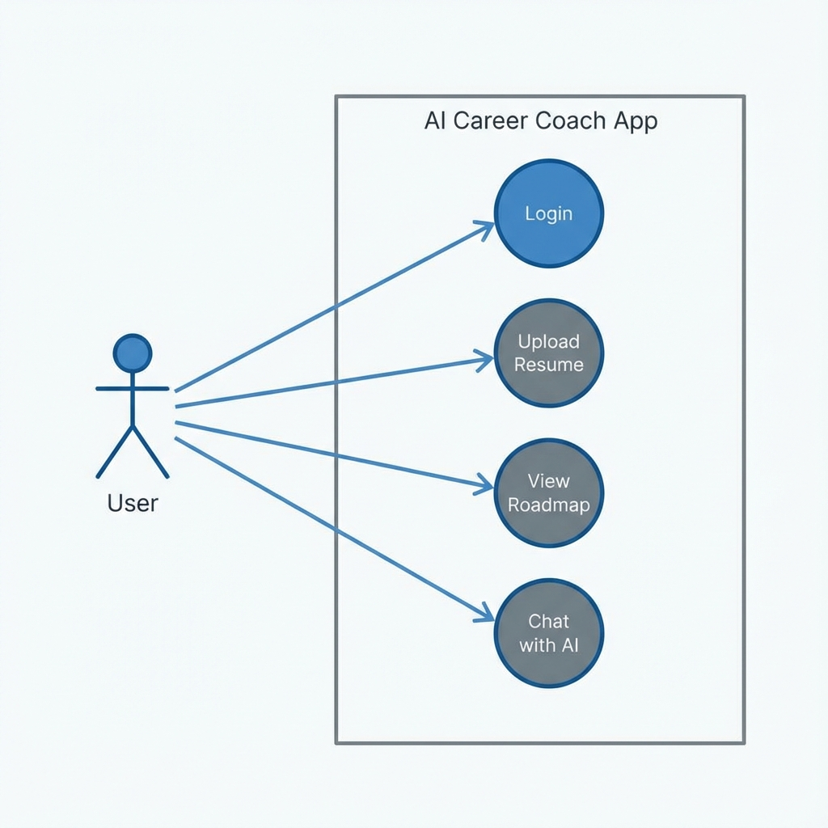
Figure 3.1: System Interaction Model

3.4 Use Case Descriptions
Use Case | Primary Actor | Description
Account Setup | User | User registers and sets career preferences
Resume Analysis | User/System | System parses PDF and extracted skills for gaps
Roadmap Generation | System | AI constructs a weekly learning curriculum
AI Mentoring | User | Interactive chat session for real-time guidance

Chapter 4: System Design

4.1 System Architecture
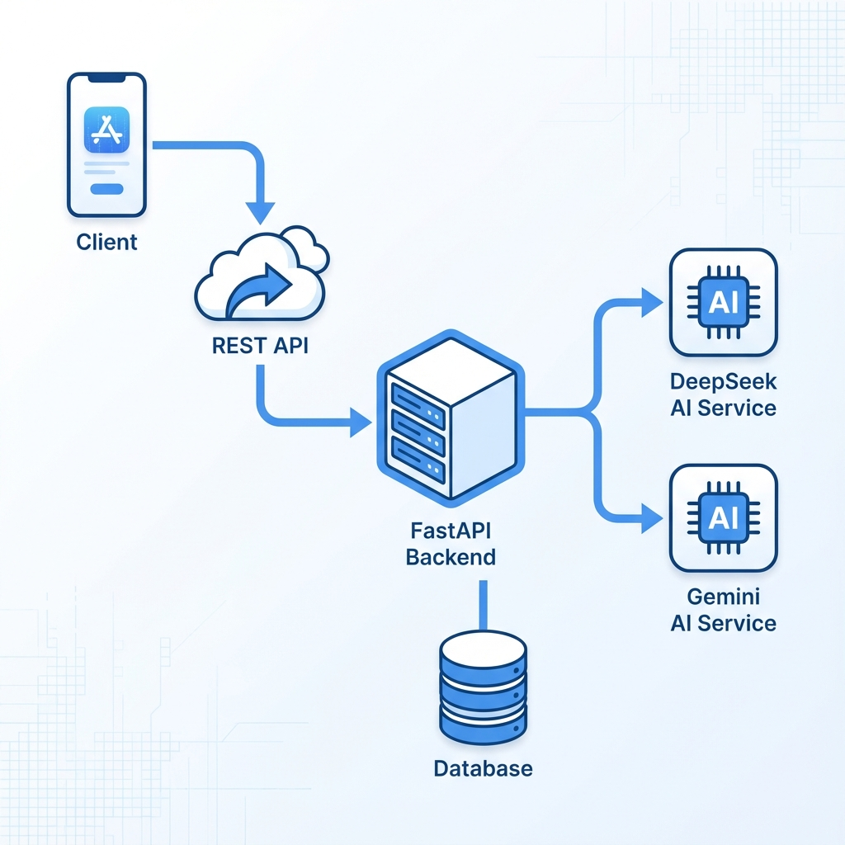
Figure 4.1: High-Level Architecture Flow
Our architecture follows a strictly decoupled layered approach. The Mobile Presentation layer (Android) communicates via an Interceptor-equipped Retrofit client to a RESTful FastAPI backend. The backend manages orchestrations between the relational DB (PostgreSQL) and the Intelligence Layer (DeepSeek/Gemini).

4.2 Database Design (ERD)
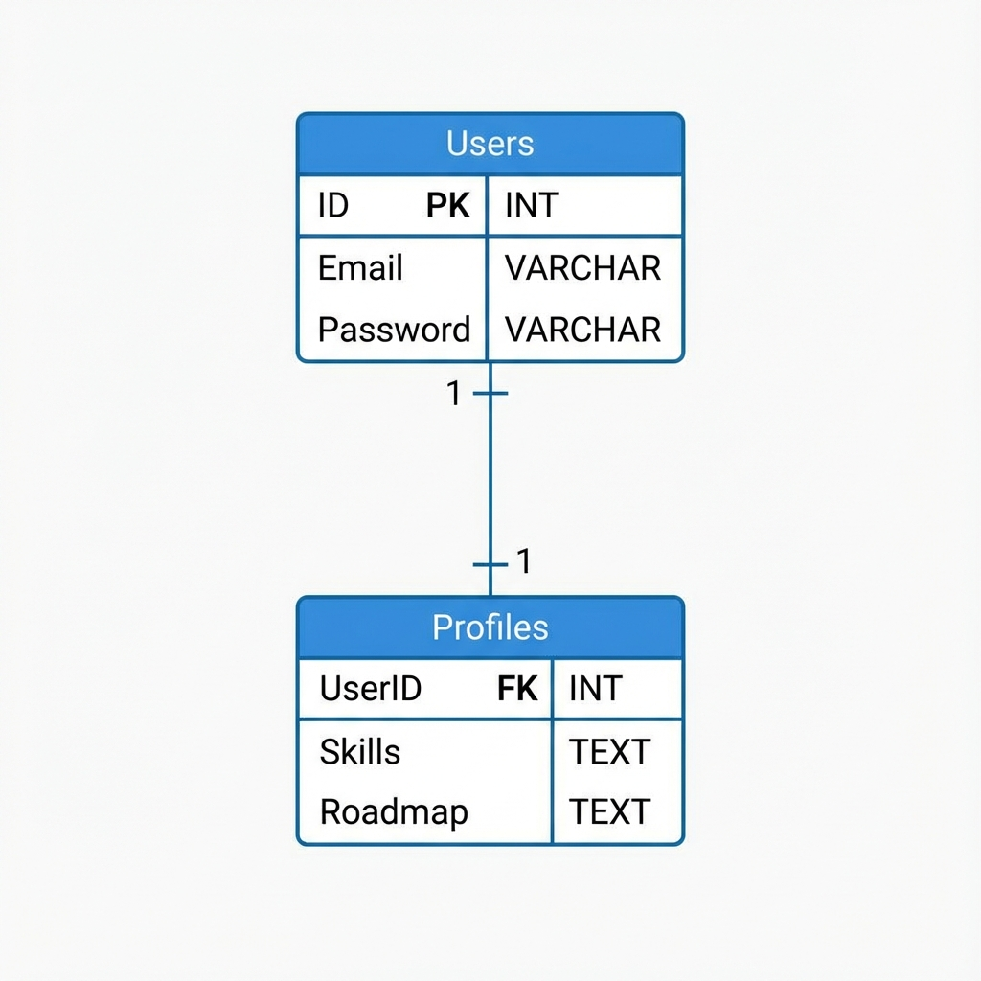
Figure 4.2: Entity Relationship Visualization
The schema is optimized for speed and data isolation. The User table handles authentication, while the Profile table stores serialized JSON blobs containing AI-generated roadmaps, ensuring that expensive AI computations are only performed when necessary.

4.3 API Design
Critical endpoints include /auth/login for session management, /resume/analyze for file ingestion, and /ai/chat for counselor interactions. Every request is validated using Pydantic models on the server side to ensure zero data corruption.

4.4 UI Design Philosophy
The app utilizes a Material Design 3 'Night' aesthetic. This choice reduces eye strain during long-term learning planning and provides a premium, professional feel that matches the 'Professional Mentor' persona of the application.

Chapter 5: Implementation

5.1 Tech Stack Stack
The system is built on a foundation of professional-grade tools:
• Mobile: Kotlin with XML Layouts and MVVM Pattern.
• Backend: Python 3.10+, FastAPI, SQLAlchemy, Gunicorn.
• Intelligence: OpenRouter (Primary Engine) and Gemini (Secondary Engine).

5.2 Backend Implementation Details
The FastAPI server utilizes asynchronous programming to handle concurrent IO-bound AI requests effectively. PDF text extraction is handled by dedicated workers, stripping metadata and images to present a clean, semantic string to the AI model.

5.3 Mobile App (Android XML) Implementation
Native Android development using Kotlin allows for deep system integration. We utilized 'View Binding' for safe UI access and 'Hilt' for Dependency Injection. The Roadmap is rendered using high-performance RecyclerViews with dynamic layouts.

5.4 AI Integration Module
Prompt engineering is the heart of our implementation. We use 'System Directives' to force the AI into returning strict JSON schemas. This allows our Android client to parse the career roadmap directly into objects, preserving UI consistency.

Chapter 6: Final Product Showcase (Real Screenshots)

The following screenshots demonstrate the actual working state of the AI Career Mentor application on a physical Android device.

6.1 Dashboard & Identity Management
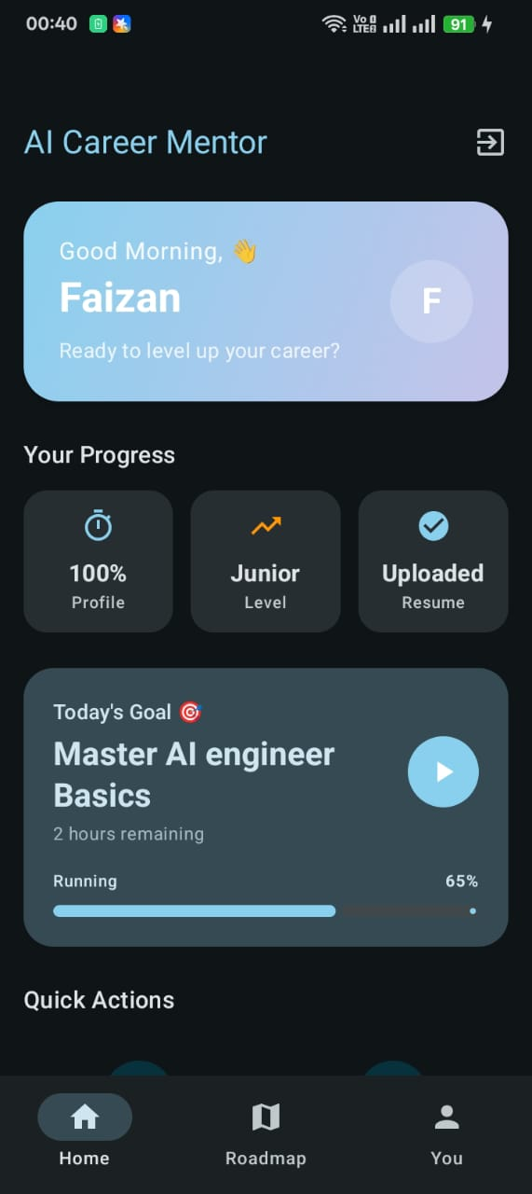  Figure 6.1: Main Home Dashboard | 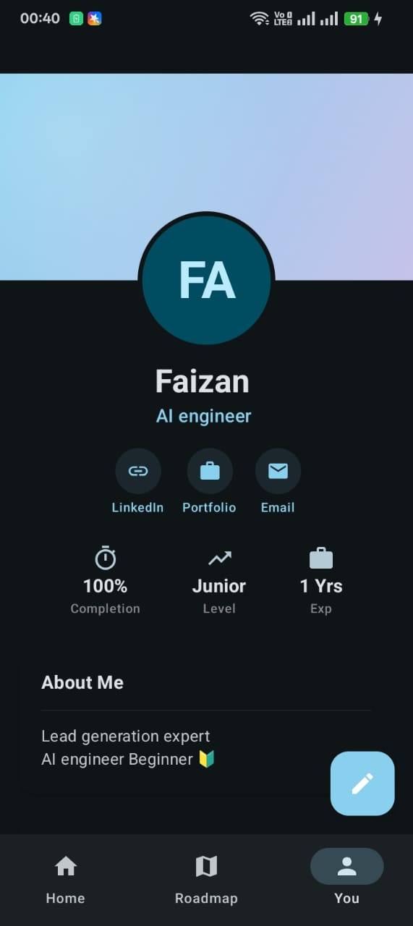  Figure 6.2: User Professional Identity

6.2 Interactive Roadmaps & AI Actions
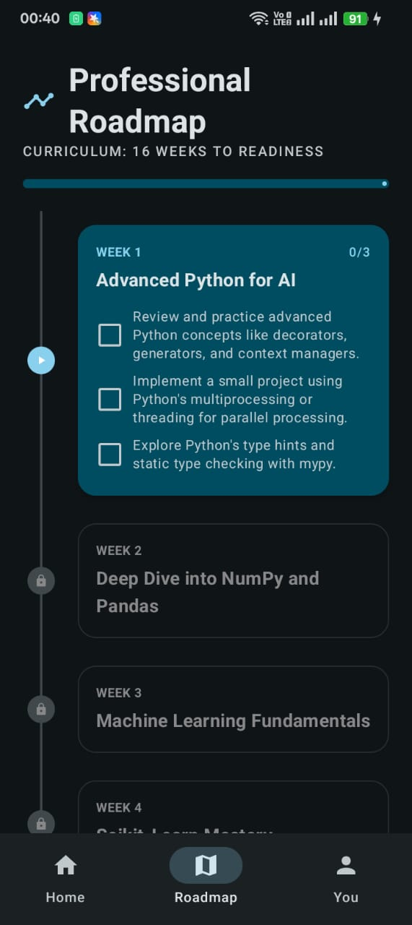  Figure 6.3: Dynamic Learning Roadmap | 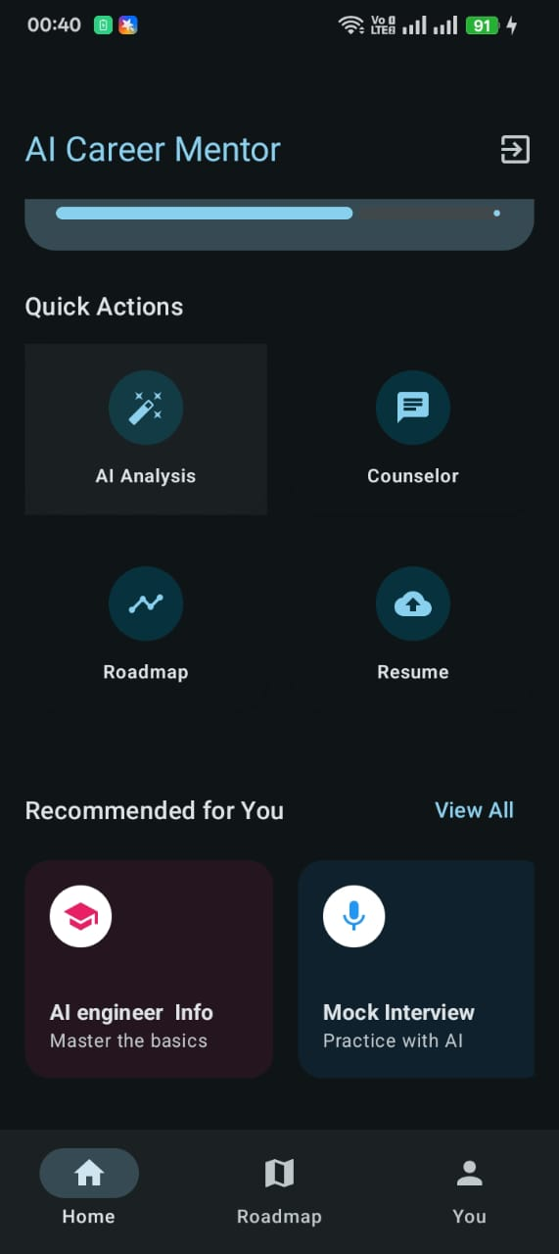  Figure 6.4: AI Quick Actions Menu

6.3 Skill Gap Analysis Chart
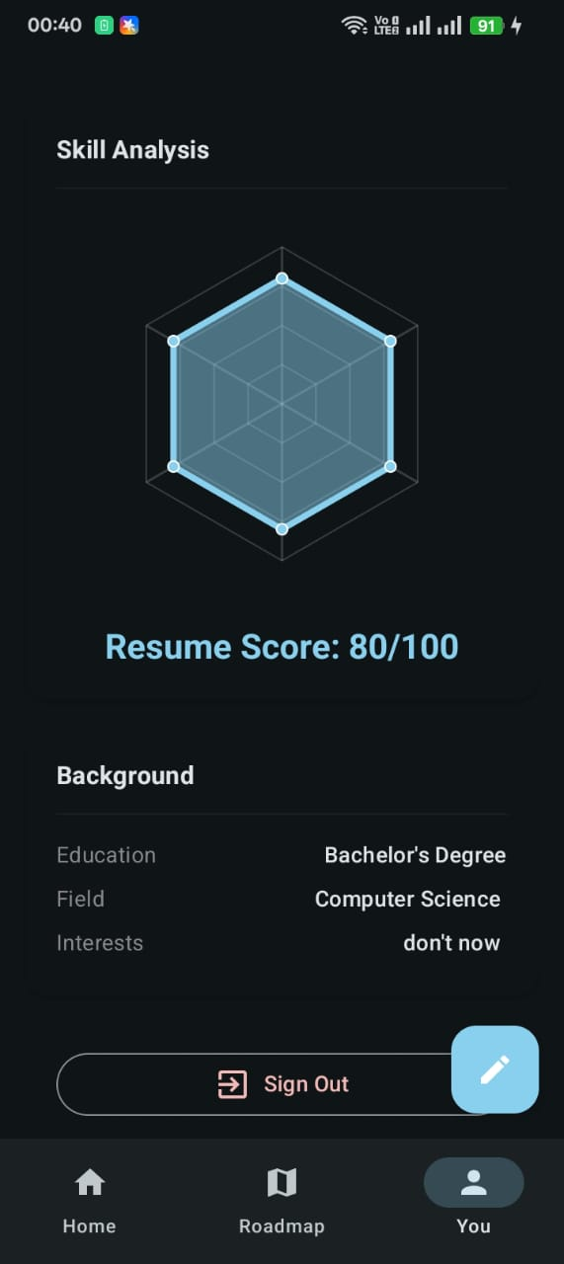
The Radar chart summarizes the user's skill distribution across their career vertical. It provides an immediate visual confirmation of where the user's strengths lie and where 'Skill Gaps' need to be addressed.

Chapter 7: Testing & Quality Assurance

7.1 Testing Strategy
Our strategy utilized a combination of Black-Box functional testing and physical device UAT (User Acceptance Testing). Every API endpoint was verified using Postman before being consumed by the Android client.

7.2 Test Case Specifications
ID | Scenario | Input | Expectation | Result
TC-01 | Secure Login | Correct Credentials | Access granted to Home | PASS
TC-02 | Data Parsing | Complex 5-page PDF | Extracted Skill List | PASS
TC-03 | Gap Logic | Switching Goal | Unique Roadmap Gen | PASS
TC-04 | System Persistence | Restart App | Saved Roadmap Loaded | PASS

Chapter 8: Conclusion & Visionary Future

The AI Career Mentor project successfully transitions the role of a career counselor from a human elite service to a mass-accessible automated tool. By integrating high-performance Kotlin development with the reasoning power of LLMs, we have created a scalable solution for global workforce preparation. The project demonstrates that with the right architecture, Artificial Intelligence can act as a force multiplier for human ambition.

Future Enhancements
• Interactive Voice Mentorship for soft-skill training.
• Real-time connection to LinkedIn Job APIs for one-click applications.
• Gamification of learning milestones to increase user retention.

References
1. Google Android Developers documentation - https://developer.android.com/
2. FastAPI High-Performance Framework Docs - https://fastapi.tiangolo.com/
3. LLM Reasoning Research (DeepSeek/Gemini) - https://deepseek.com/

