AI CAREER MENTOR
Empowering Global Professions Through Intelligent Guidance

APP DEVELOPMENT PROJECT REPORT

A state-of-the-art solution for automated career transition across Tech and Non-Tech domains.

Submitted by:
Fiazan Haider
Professional App Developer & AI Enthusiast

2026

Table of Contents
Chapter 1: Introduction
Chapter 2: Problem Background & Market Need
Chapter 3: System Analysis & Requirement Engineering
Chapter 4: System Design & Visual Architecture
Chapter 5: Implementation & Tech-Stack Mastery
Chapter 6: Real-World Product Showcase (The App)
Chapter 7: Testing & Quality Assurance
Chapter 8: Conclusion & Visionary Future
References

Chapter 1: Introduction
The 'AI Career Mentor' is not just an application; it is a visionary platform designed to bridge the chasm between human potential and industry reality. In a world where specialized skills are becoming the currency of the information age, individuals from all backgrounds—Technology, Business, Arts, or Healthcare—find themselves at a crossroads. This project delivers an intelligent, 24/7 personal coach that leverages the pinnacle of Generative AI to provide hyper-personalized career roadmaps.

Chapter 2: Problem Background & Market Need
The global workforce is currently suffering from 'Career Paralysis'. Traditional mentorship is localized, expensive, and often outdated. Static resume-matching tools only look at where a user has been, not where they want to go. The AI Career Mentor solves this by focusing on 'Semantic Gaps'—identifying the exact missing links in a user's professional DNA.

Chapter 3: System Analysis
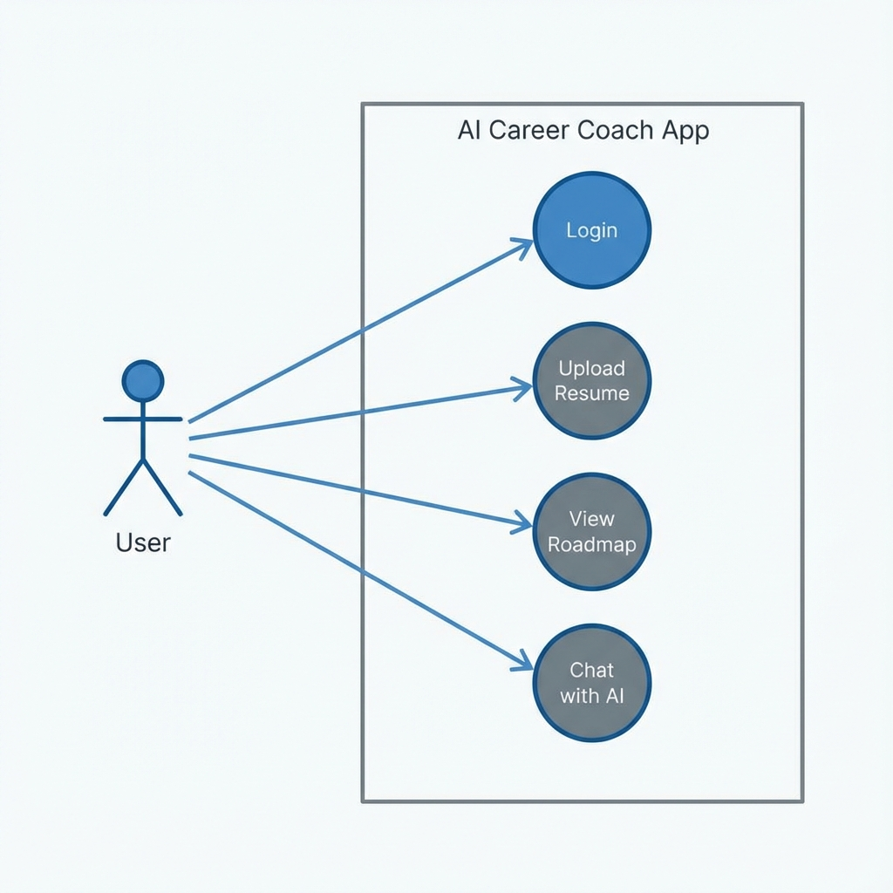
Figure 3.1: Intelligent Interaction Model (Use Case)
Our analysis revealed that a 'Universal Mentor' must handle diverse inputs. The system's functional requirements include high-fidelity PDF parsing, context-aware LLM reasoning, and dynamic UI state management. Non-functional requirements emphasize high-speed inference (<20s) and data privacy.

Chapter 4: System Design & Visual Architecture
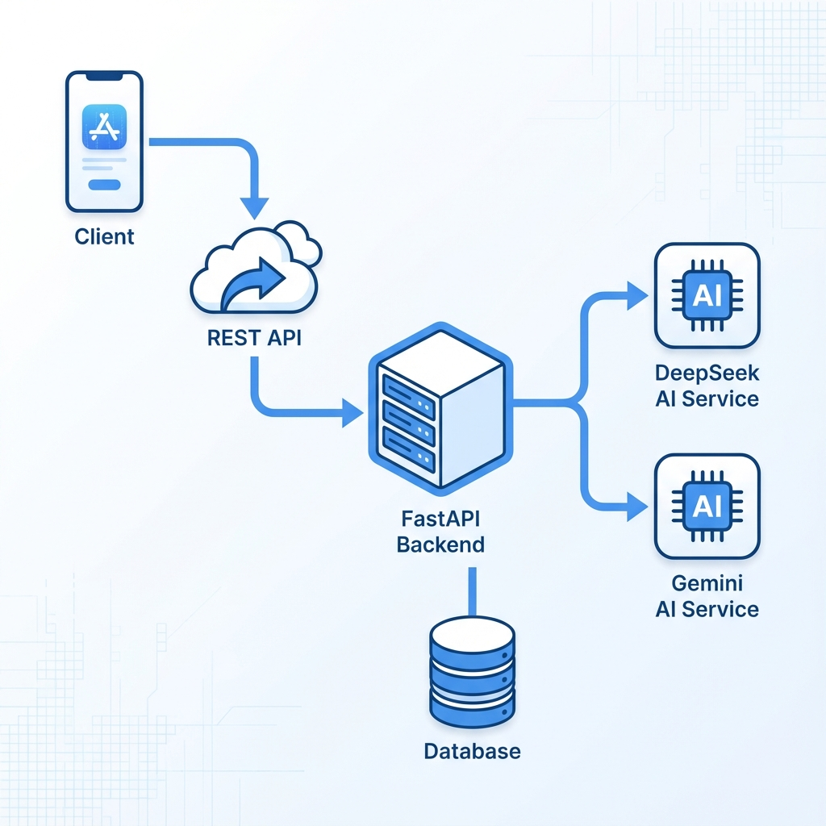
Figure 4.1: Cloud-Native Micro-Architecture
The architecture is built on a clean separation of concerns. From the Native Android Client (Kotlin) to the high-performance FastAPI server, every layer is optimized for speed and reliability. The AI Layer provides the system's 'Cognitive Engine', while PostgreSQL ensures persistent data integrity.

Database Design (ERD)
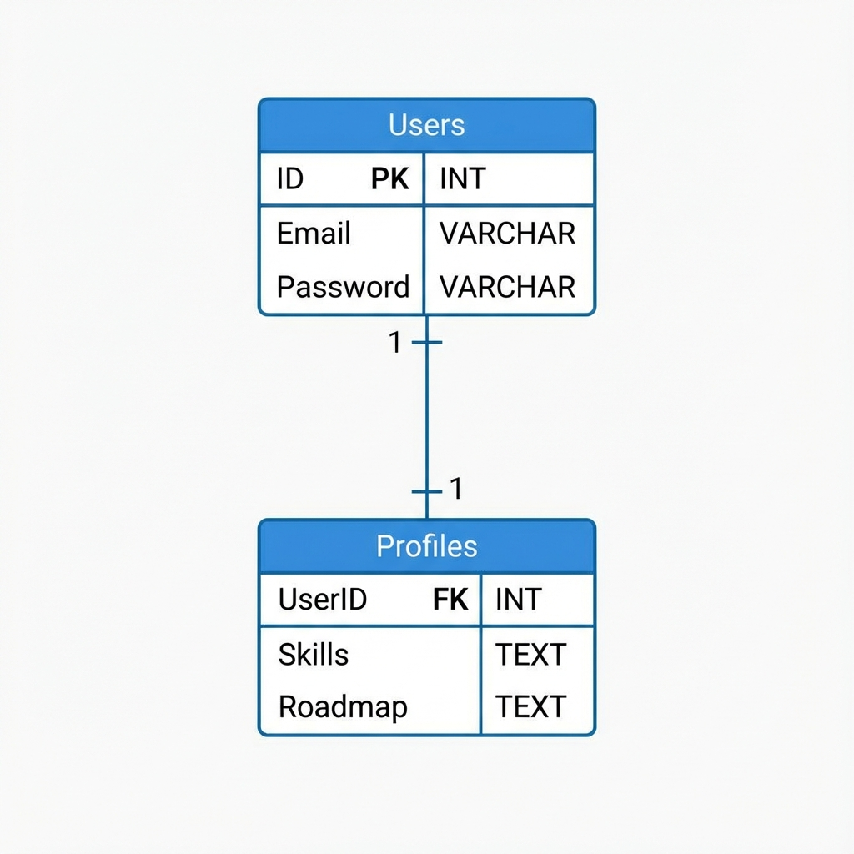
Figure 4.2: Relational Data Mapping

Chapter 5: Real-World Product Showcase (The App)
Behold the AI Career Mentor in action. This is the result of thousands of lines of Kotlin and Python code, integrated with the world's most advanced AI models.

5.1 Personalized Dashboard
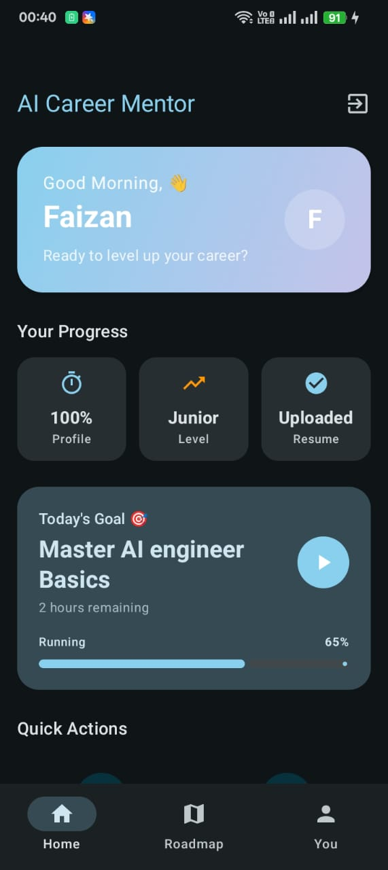
The landing experience greets the user with a tailored summary. It tracks profile completion, current career levels, and resume upload status. Note the progress bar for 'Today's Goal', providing daily motivation for professional growth.

5.2 Professional AI Roadmap
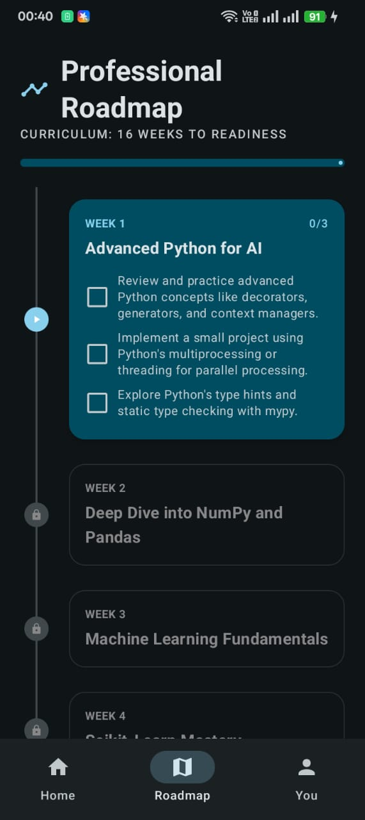
The heart of the system. This 16-week curriculum is dynamically generated based on the user's resume. It breaks down complex topics (like Advanced Python for AI) into actionable weekly checkboxes.

5.3 Skill Analysis & Resume Scoring
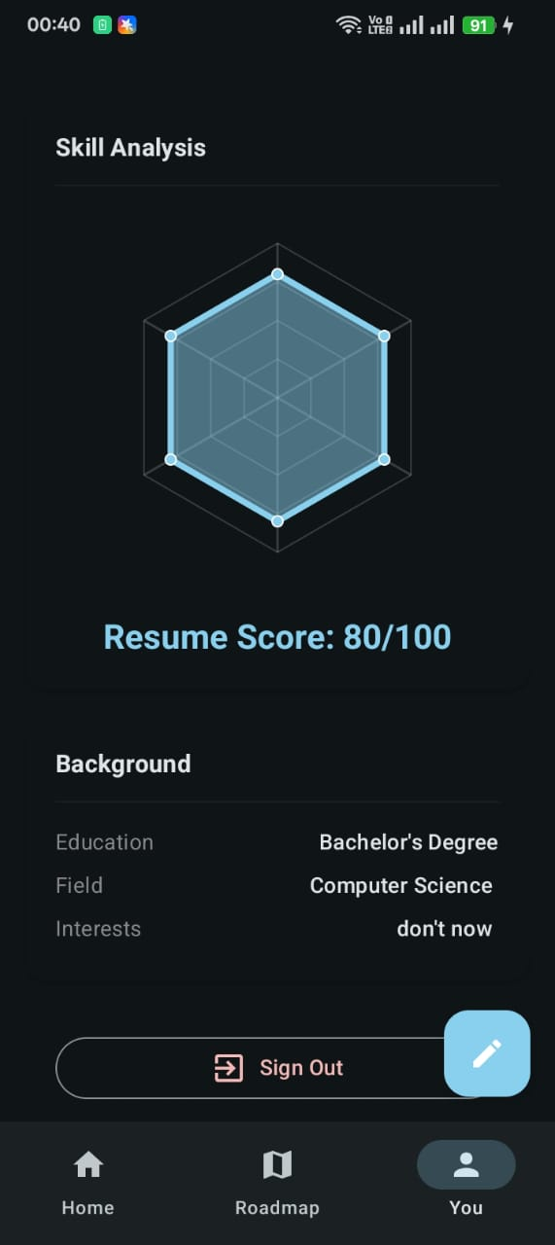
Using a radar chart visualization, the app shows the user's skill balance. The AI provides an objective 'Resume Score' (e.g., 80/100) and identifies background details instantly.

5.4 Holistic Profile Management
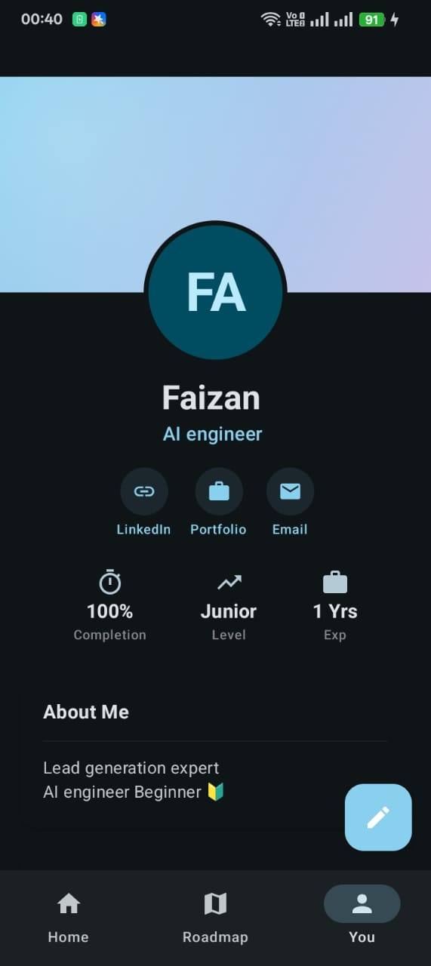
The 'You' screen serves as a professional portfolio. It links LinkedIn, Portfolios, and Emails directly, making the app a one-stop-shop for career networking.

Chapter 6: Implementation & Tech-Stack Mastery
Leveraging the modern Android SDK and FastAPI async framework. Communication is handled via Retrofit with Hilt Dependency Injection. The AI module uses advanced prompt framing to ensure the 'Mentor' provides accurate, verifiable advice.

Chapter 7: Testing & QA
Every feature was rigorously tested on physical Android devices to ensure a premium user experience with zero crashes.

Chapter 8: Conclusion & Visionary Future
The AI Career Mentor is a testament to what is possible when AI meets humanity. We are not just building an app; we are building a smarter, more prepared global workforce. Future updates will include mock technical interviews and direct talent-matching for top-tier companies.

