Mummy Game Integration with LCMS

Integration Specification

Contents

[Overview 2](#_Toc329614898)

[Interface Builder 3](#_Toc329614899)

[Configuration XML 5](#_Toc329614900)

[Preview Mode 6](#_Toc329614901)

[Splash Screen 6](#_Toc329614902)

[Play Area – Question with Options 6](#_Toc329614903)

[Play Area – Feedback 7](#_Toc329614904)

[Review and Analyze Module 7](#_Toc329614905)

[Final Screen 8](#_Toc329614906)

# Overview

In this assessment template, the author selects mummy game to set data with the help of interface builder. Assessment game template gets data from the assessment bank item and displays that data dynamically in the preview mode. Template manages the score on the LMS as per the policy.

Assessment template has one XML Configuration file.

1. **Interface Builder Generator** – LCMS loads xml and generate interface according to it.
2. **Data holder** - template gets data from xml.

lcms_logo copy.jpg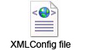

# Interface Builder

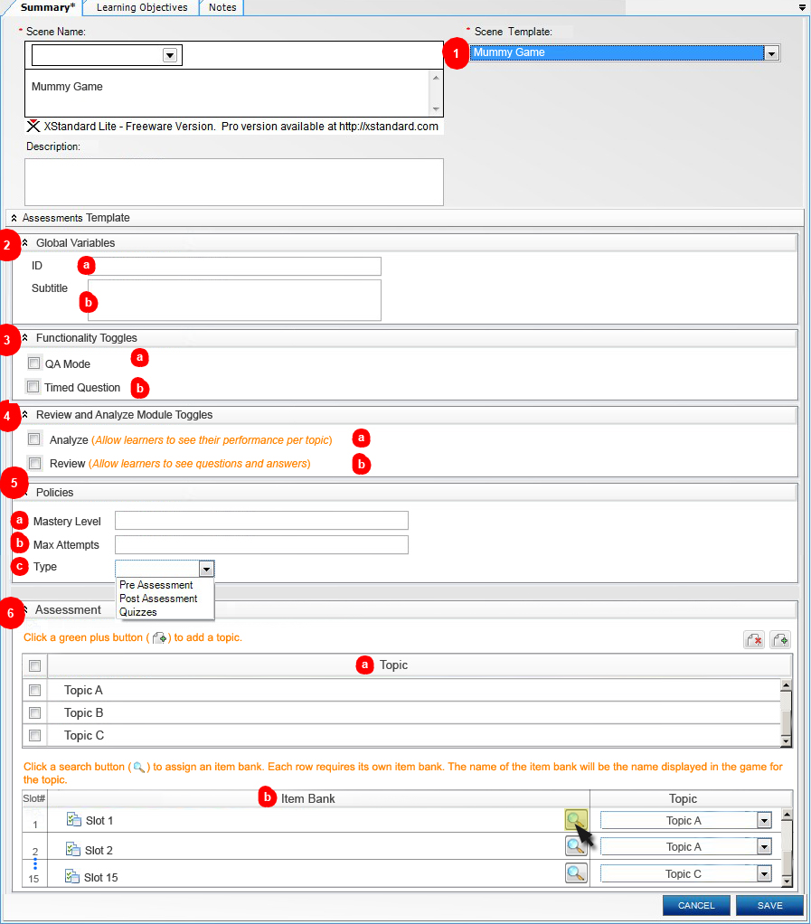

1. **Mummy Game** Assessment template.
2. Global Variables
   1. **Game ID** input text field.
   2. **Game Subtitle** text area.
3. Functionality Toggles
   1. **QA Mode Toggle** checkbox.
   2. **Timed Question Toggle** checkbox.
4. Review and Analyze Module Toggles
   1. **Analyze Toggle** checkbox.
   2. **Review Toggle** checkbox.
5. Policies
   1. **Mastery Level** input text field.
   2. **Max Attempts** input text field.
   3. **Type** drop down
6. Assessment
   1. **Topic**  
      Add/Remove functionality with this table.  
      Each row have 2 cells, first cell has checkbox and second has input text field.  
      Validation required – At least one topic.
   2. **Item Bank**

* Fixed 15 slots and each slot able to attach one **Assessment item Bank.**Validation required - Each slot has item bank and set topic.
* **Assessment item Bank** should have **Assessment item.**Validation required - Each bank has at least one item required.
* **Assessment item** has multiple choices – Single select with four option choices and simple feedback.
* Topic column has a list which was filled from the above **“Topic”** table.

# Configuration XML

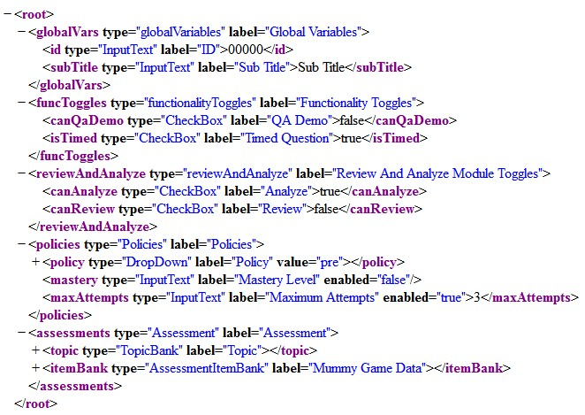

# Preview Mode

Splash Screen

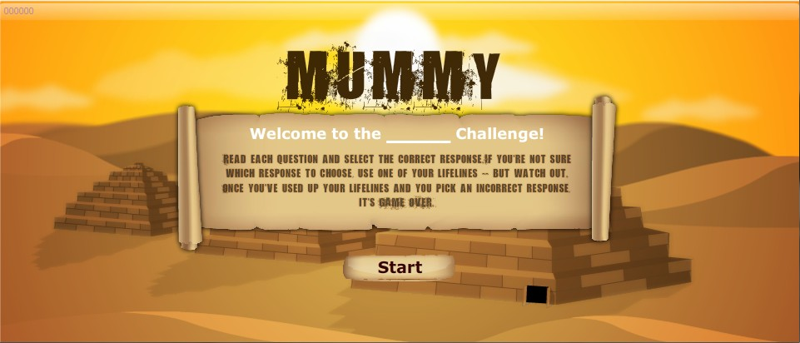

Play Area – Question with Options

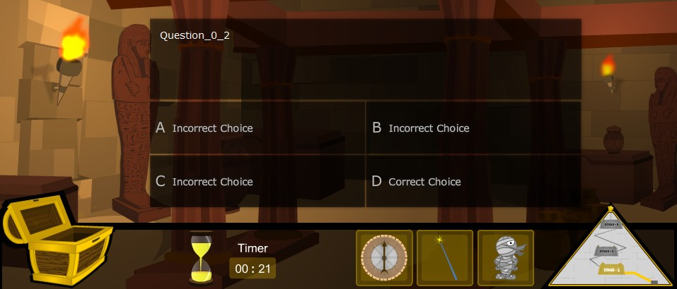

Play Area – Feedback

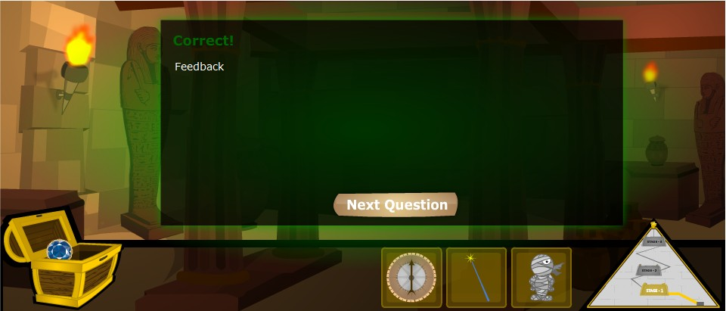

Review and Analyze Module

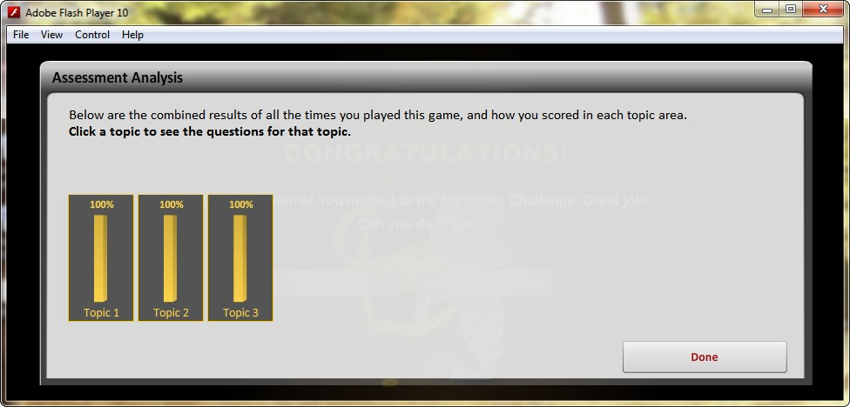

Final Screen

