# Name:

# Faizan Hamayun Khan

# SEC:

# C

# PROJECT:

# IIP

# ROLL NO:

# L1F14BSCS0496

# Abstract:

Problem of rice quality is very common. People don’t have any means to identify good quality rice. Rice quality control system solves this problem by measuring length, width, average colour, maximum colour and minimum colour of every grain of rice separately. On the basis of this data one can differentiate between low quality and good quality. Results have been performed on more than 500 images. System stores all the results in excel sheet so that the results can be used in future for monitoring purpose. Results are performed on different quality of rice in an image acquisition box .Results shows proper details of rice grain separately in the form of images and excel sheet.

# Introduction:

The problem of detecting quality rice is very common these days. We most of time buy low quality rice at a very high price. The reason of why this problem occurs is that we don’t have any system or tool to identify the quality of rice. We don’t know how to find best quality rice or differentiate best quality rice from low quality rice. Rice quality control system is designed to solve this problem. Rice quality control system finds the length, width, average colour, maximum colour and minimum colour of every grain of rice separately and it stores all the information on the excel sheet for the monitoring purpose. Rice quality control system gets images from different folders and produces folders of rice grain images.

# Methodology:

Different types of methods are used to get accurate information about rice.

## Acquisition :

To perform these experiments an image acquisition box is used. Shoe box is taken as image acquisition box. Black cloth is placed inside the box. Here black cloth with no or minor reflection is used. Then we placed the cloth on the base of the box, So that we can get a good picture of rice. For experiment purpose a coin of 5 rupees and cap of Coca-Cola bottle are placed on the cloth which is placed on the base of the box. A hole is made on the top of the box. Hole was large enough for the lens and flash of camera. Hole is placed at the middle of top portion so that camera can capture every portion of the box. After placing hole on the top of the box. Box is placed in no light, so that box will not get any reflection of light. If box will get any extra reflection it can produce more noise and it will effect the pictures of rice grain.

After placing box in no light condition, Rice grains are placed inside the box rice grains are placed at the bottom of the hole of the so that camera can get good angle of the grains. To perform the results 10 different types of rice are used. 10 different samples of rice have been taken and results are performed on that rice. These samples include basmati, super kernel, shaheen new , saila ,supri etc.

After taking the samples coin, bottle cap and rice grains are places at the bottom of the hole. From that hole 5 pictures have been taken for each sample of the rice. These samples are placed at different angle for every picture so that we cannot get same type of images every time.

After getting all the images, system performs processing on these pictures.

## Processing:

All the processing is done in python. First system performed thresholding on the images so that noise can be extracted from the image and system can get clear picture of rice. Thresholding has been done by the custom made function in which an image and threshold value is passed and that function performs thresholding on that image and returns a threshold image. After getting a threshold image a built in function of skimage is used. System used skimage.measure.label to find the number of objects in the image. skimage.measure.label function finds the label of images and returns a label image and number of objects in the image.

After getting label image a built in function of skimage is used. System used skimage.measure.reigionprops to find area and other important properties of the rice which are used to find the length,width, etc of rice. ReigionProps function puts a bounding box on every object of the image. With the help of this bounding box rice can differentiated from the coin and cap of the bottle.

After getting area from the reigionprop function a condition is used to get objects that lie in the specific range of area. This condition is used to get only the rice grain from the image. After getting the rice grain from the image we save these rice grain in a separate folder for monitoring purpose. The condition on area is applied on the basis of size of object as rice is smaller than bottle cap and coin that why it has small area.

After saving all the images of rice grain system will rotate rice grain so that it can come to 90 degree the reason for rotating the rice grain is that the bounding box can only be applied on vertical or horizontal so that if rice is tilted the system cannot find exact length and width of the rice.

After rotation we again apply reigion prop so to get exact area of the rice. After getting the area the system finds the 1 mm per pixel for finding the length and width of rice after getting length and width of rice system finds the mean, max and average intensity of rice. The system gets the mean,max and min intensity by using the original image with the label image.

After getting all the information about the rice including its length and width system writes all the information in the excel file . System writes image name and with that name it places length,width , min ,max and mean intensity in the file. System made sperate file for every quality of rice.

System made separate folder of crop images of rice, crop images of rotated rice and separate excel file for every quality of rice.

# Results:

Here are some results that have have been performed on different samples of rice

## Basmati(original):

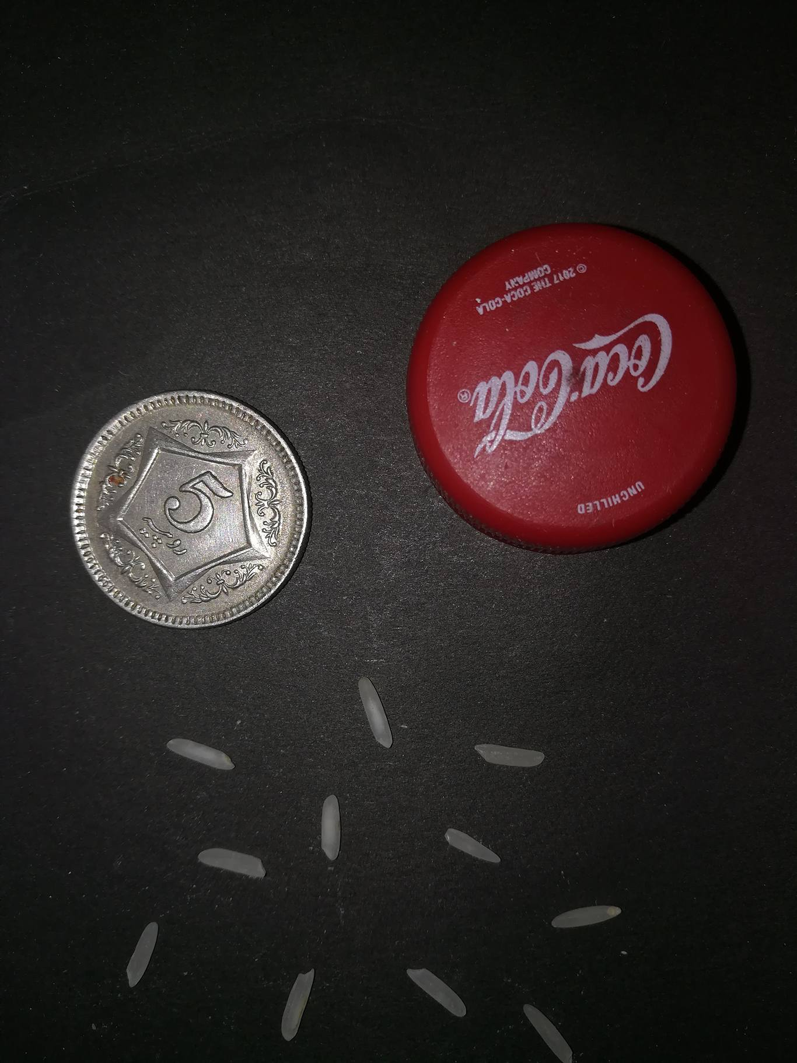

## Basmati(crop rice image):



## Basmati (rotated rice image):

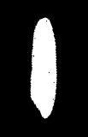

# C9(ORIGINAL):

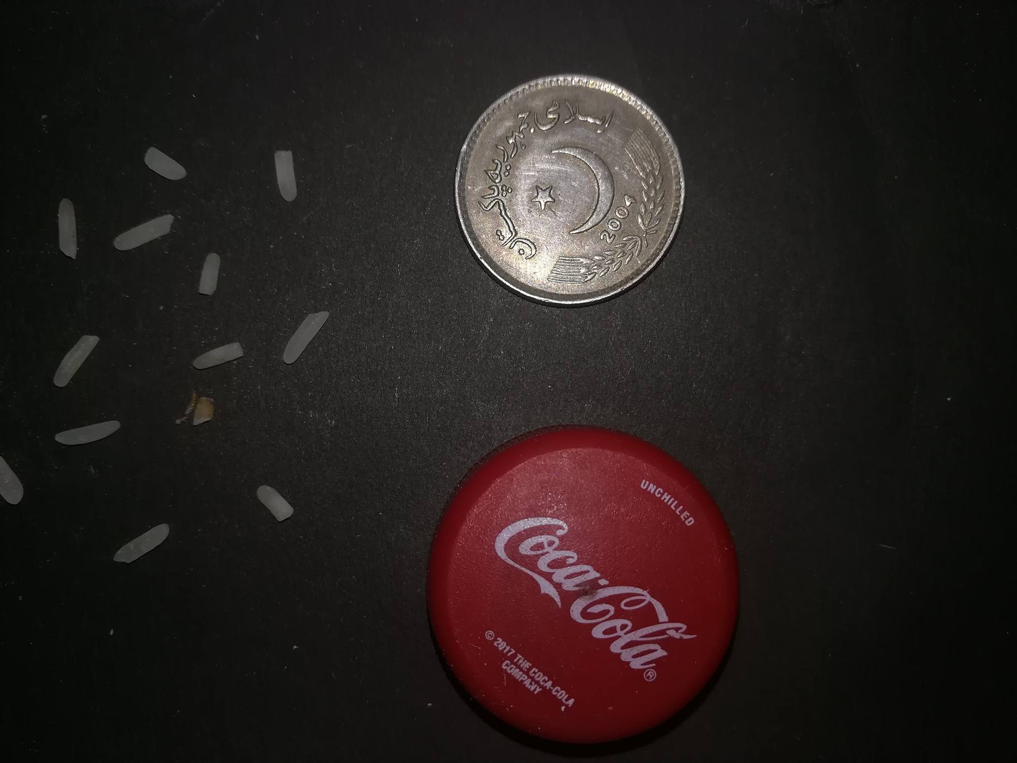

## C9(CROP IMAGE):



# C9(rotated image):

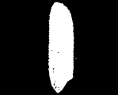

# References:

http://scikit-image.org/docs/dev/api/skimage.measure.html#skimage.measure.regionprops