PENETRATION TESTING REPORT
FOOTPRINTING, RECONNAISSANCE & NETWORK SCANNING PHASES
W2-PM-FINAL | CYBERSECURITY | NETWORKWALKS
Pentester Name  (Cybersecurity Professional) | Faizan Manazir
Program/Batch | B083-Networkwalks
Date | 26 September 2026
Modules completed | W2-PM1 (Multiple Kali Tools)  W2-PM2 (GHDB)  W2-PM3 (Maltego)  W2-PM4 (theHarvester)  W2-PM5 (Zenmap Scanning)
Client/Target | 1. networkwalks.com — assigned educational reconnaissance target  2. My own local LAN Network
Permission secured from client? | Yes — activities were performed within the assigned educational scope and on my own local network.
Phases covered | Phase 1: Reconnaissance & Footprinting  Phase 2: Scanning & Network Discovery  Phase 3-5: Reconnaissance exercises and supporting information gathering

1. Liability Disclaimer
I have performed these activities only within the assigned educational cybersecurity scope and on systems and devices that I own or was authorized to assess. All materials are for education and research purposes only. Do not use anything from this report to break the law. The instructor, the authors and Networkwalks are not responsible for misuse of this knowledge. Every action taken outside an authorized scope is the responsibility of the person performing it. Unauthorized access can be a criminal offence even when no damage is caused.

2. Introduction
This report covers the Week 2 practical activities completed as part of the Cybersecurity & Ethical Hacking program at Networkwalks. The work includes footprinting the networkwalks.com domain using multiple Kali Linux tools (W2-PM1), Google Hacking Database reconnaissance (W2-PM2), Maltego relationship analysis (W2-PM3), passive reconnaissance with theHarvester (W2-PM4), and network discovery with Zenmap (W2-PM5).
All practical activities were performed in Kali Linux. The reconnaissance exercises focused on publicly available information and the network-scanning activity was performed against my own local LAN. Every section below records the command or method used, the result observed, and a short explanation of why the observation matters from a cybersecurity perspective. Evidence screenshots are intentionally omitted from this report and can be inserted at the marked locations.

3. Tools Used
The table below lists each tool used in this report and its purpose.

Tool | Purpose
Kali Linux | Operating system used for reconnaissance, passive information gathering and network scanning.
WHOIS | Find publicly available domain registration details, dates and name servers.
WhatWeb | Fingerprint publicly observable web technologies, CMS and plugins.
nslookup | Resolve the domain name to its IP address using DNS.
curl -I | Read HTTP response headers from the website.
wafw00f | Detect whether a Web Application Firewall is publicly identifiable.
dnsrecon | Enumerate DNS records such as NS, MX, SPF, TXT and service-related records.
Google / GHDB | Perform search-engine reconnaissance using specialized search operators.
Maltego | Create a visual graph of entities and relationships and run reconnaissance transforms.
theHarvester | Collect publicly available emails, hosts, IPs and related information from supported sources.
Zenmap / Nmap | Discover live hosts on the authorized local subnet and visualize network topology.

4. Activities Performed

4.1 Footprinting & Reconnaissance
I performed reconnaissance against the networkwalks.com domain using six Kali Linux tools: WHOIS, WhatWeb, Nslookup, Curl, Wafw00f and DNSRecon. Each tool was used to collect a different category of publicly observable information.
First, I used WHOIS to obtain publicly available domain registration information and identify the domain's name servers. The results provided information about the domain registration and hosting infrastructure.
I then used WhatWeb to identify technologies used by the website. The results identified WordPress 7.0.4 and WP Download Manager 3.3.58, along with other information exposed by the website.
Using Nslookup, I resolved the domain name to its IP address. The recorded result identified 192.232.216.135.
I used Curl with the -I option to inspect the HTTP response headers. This provided additional information about the web application and exposed the WordPress REST API endpoint /wp-json/.
Next, I used Wafw00f to determine whether a Web Application Firewall was protecting the website. The recorded result identified ModSecurity (SpiderLabs).
Finally, I used DNSRecon to enumerate DNS records. The results provided information relating to name servers, mail servers, SPF/TXT records, service records and DNS software information.

4.2 Google Hacking Database (GHDB)
The GHDB activity introduced search-engine reconnaissance using specialized Google operators. The practical work focused on identifying publicly indexed security-camera related results and directory listings containing mathematics PDF material. The captured search results were documented in the accompanying worksheet.
For the security-camera search, ten result entries were recorded from the captured Google results. The entries included results from Alliance for Coastal Technologies, 100.42.92, Course Hero, Exploit-DB, Accio Work, Blogger and xvideosbr.to. The report records the search-result sources without reproducing direct camera-access URLs or credentials.

# | Source | Recorded Search Result
1 | Alliance for Coastal Technologies | Live view - AXIS 215 PTZ Network Camera
2 | 100.42.92 | Live View - AXIS 211 Network Camera version 4.11
3 | Course Hero | Cameras-Long.txt — ViewerFrame / Live View - AXIS
4 | Exploit-DB | tilt title: Live View / - AXIS
5 | Exploit-DB | intitle: MJPG Live Demo / intext: Select preset position
6 | Accio Work | Live View Axis: Find Top PTZ Cameras & Streaming Devices
7 | Blogger.com | Inurl Live View Axis Night Club Anyone Want To Hack Into ...
8 | Exploit-DB | intitle: Live View / - AXIS — Various Online Devices GHDB
9 | xvideosbr.to | Site query involving inurl:view.shtml / intitle: Live View / - AXIS
10 | Exploit-DB | tilt intitle: Live View / - AXIS | inurl:view/view.shtml

The mathematics directory-listing exercise produced the following ten documented entries.
# | Source | Directory Listing | URL
1 | University of New Mexico | Index of ~/megrad/Math | http://www.unm.edu/~megrad/Math/
2 | Ochicken.net | Index of /library/Mathematics/ | https://ochicken.net/library/Mathematics/
3 | University of Liverpool | Index of /maths | http://pcwww.liv.ac.uk/maths/
4 | The Netlib | Index of /math/docpdf | https://www.netlib.org/math/docpdf/
5 | ИПТ РАН | Index of /ebooks/books/open | http://www.iisp.ac.ru/ebooks/books/open/
6 | University of Galway | Index of ~/rquinlan/linearalgebra | https://maths.nuigalway.ie/~rquinlan/linearalgebra/
7 | Case Western Reserve University | Index of /artsci/math/singer/publish | https://case.edu/artsci/math/singer/publish/
8 | Dartmouth Mathematics | Index of ~/carlp/PDF | https://www.math.dartmouth.edu/~carlp/PDF/
9 | Jsoftware | Index of /books/pdf | https://www.jsoftware.com/books/pdf/
10 | Carnegie Mellon University | Index of /users/math/wow/osummerinst | https://www.cmu.edu/users/math/wow/osummerinst/

[Evidence: PM2 — GHDB search-result screenshots and completed worksheet — insert screenshot here]

4.3 Maltego
Maltego was used to create a Domain entity for networkwalks.com and run the transform [Utilities] To Emails @domain [Search Engine]. The transform completed successfully on one entity. The captured output showed that 10 unified credits were consumed, leaving 190 credits. The graph remained centered on the networkwalks.com domain entity and no additional linked email entity was displayed in the captured graph.
Item | Recorded Result
Domain entity | networkwalks.com
Transform | [Utilities] to emails @domain [Search Engine]
Entities processed | 1
Execution status | Completed
Credits consumed | 10 unified credits
Credits remaining | 190
Visible graph result | Domain node remained visible; no additional linked entity displayed in the captured graph.

4.4 Footprinting with theHarvester
The theHarvester exercise used microsoft.com as the module-specified passive reconnaissance target. Task 1 was performed with Baidu and a result limit of 1000. Task 2 was performed using all supported sources with a result limit of 50. The outputs were preserved separately as raw text because the all-source result was too large to reproduce completely in the report.
Task | Command | Observed Result
Task 1 | theHarvester -d microsoft.com -l 1000 -b baidu | 0 IPs found; 0 emails found; 0 people found; 2 hosts found: cla.opensource.microsoft.com and support.microsoft.com.
Task 2 | theHarvester -d microsoft.com -l 50 -b all | All-source passive reconnaissance output was captured separately as raw output. The complete terminal output is intentionally not reproduced here because it was large.

4.5 Network Scanning with Zenmap
For the final activity, I used Zenmap to perform network discovery on my own local network. The practical required me to identify my local IP address and subnet, discover live hosts, identify their IP and MAC addresses, and generate a network topology.
I first used the Kali Linux ip command to identify the active interface and local IPv4 address. The eth0 interface was assigned 10.0.0.3/24, which corresponds to the local subnet 10.0.0.0/24.
I then entered the subnet into Zenmap and selected Ping Scan. Zenmap used the command nmap -sn 10.0.0.0/24 and scanned 256 IP addresses. Three live hosts were identified.
IP Address | MAC Address | Status
10.0.0.1 | 52:54:00:12:35:00 | Up
10.0.0.2 | 08:00:27:53:38:90 | Up
10.0.0.3 | 08:00:27:5A:87:BC | Up — Kali host

The MAC address for 10.0.0.3 was also confirmed directly from the eth0 interface using ip link show eth0. After completing the scan, I opened the Topology section in Zenmap and generated the network topology.

5. Risk Analysis / Impact
Based on the information collected during the reconnaissance, GHDB, passive harvesting and local network scanning activities, I identified the following potential risks. These are observations from information gathering and host discovery, not confirmed vulnerabilities.
# | Risk / Finding | Evidence / Observation | Potential Impact | Risk Level
1 | Web technology information exposed | WhatWeb identified WordPress and WP Download Manager | Attackers may use exposed technology/version information to identify software requiring further security review | ● Medium
2 | Server IP address identifiable | Nslookup resolved the domain to 192.232.216.135 | Provides information about the network location of the web service | ● Low
3 | HTTP technical information exposed | Curl returned HTTP response headers and exposed /wp-json/ | May assist technology fingerprinting and further enumeration | ● Low
4 | WAF technology identifiable | Wafw00f identified ModSecurity (SpiderLabs) | Reveals information about the web application's security architecture | ● Low
5 | DNS infrastructure information exposed | DNSRecon identified DNS, mail and service-related records | DNS information can help build a broader infrastructure profile | ● Medium
6 | Publicly indexed information discoverable | GHDB searches returned indexed camera-related and directory-listing results | Search-engine indexing can expose information that assists reconnaissance and profiling | ● Medium
7 | Public-source host information collected | theHarvester identified two microsoft.com hostnames during the Baidu task | Public host information can support external reconnaissance and infrastructure mapping | ● Low
8 | Multiple live hosts visible on local network | Zenmap identified three live hosts in the 10.0.0.0/24 network | Unknown or unauthorized devices may potentially be present on a network | ● Medium

Risk level key: ● Critical ● Medium ● Low
The risks above are observations from the reconnaissance and scanning exercises, not confirmed vulnerabilities. The practical exercises primarily involved information gathering, public-source enumeration and host discovery. No exploitation or vulnerability validation was performed as part of these activities.
Therefore, the presence of information such as a software version, IP address, DNS record, indexed search result or hostname does not by itself mean that the system is vulnerable. Further authorized security testing would be required to confirm any actual vulnerability.

6. Recommendations
Based on the observations from these activities, I recommend the following security improvements:
1. Review publicly exposed technology information
Organizations should regularly review what information about their web technologies, CMS and plugins is publicly visible.
2. Keep software updated
CMS platforms, plugins and other web technologies should be regularly updated and reviewed against current security advisories.
3. Review HTTP headers
HTTP response headers should be reviewed to determine whether unnecessary technical information is being exposed.
4. Review DNS records regularly
DNS records should be checked periodically to ensure that only required information and services are publicly exposed.
5. Properly configure and monitor the WAF
Keep the WAF enabled and appropriately tuned, and review its configuration and logs regularly.
6. Review search-engine indexing
Organizations should periodically check search-engine results for information that should not be publicly indexed.
7. Review public directories and files
Publicly accessible directory listings and files should be reviewed and restricted where they are not intended for public access.
8. Review external information exposure
Use passive reconnaissance periodically to understand what infrastructure information can be collected by an external observer.
9. Perform regular internal network discovery
Organizations should periodically scan their own networks to identify active devices.
10. Investigate unknown devices
Any unexpected device discovered during network scanning should be investigated and verified.
11. Maintain network documentation
Network topology and device information should be documented and updated regularly.
12. Perform security testing with authorization
Reconnaissance and scanning should only be performed against systems and networks where appropriate authorization has been provided.

7. Conclusion
During Week 2 of my Cybersecurity & Ethical Hacking internship, I completed practical activities covering footprinting, reconnaissance, search-engine intelligence gathering, passive harvesting and network scanning.
In the footprinting activity, I used six Kali Linux tools to collect information about the networkwalks.com domain. I learned how WHOIS can provide domain information, WhatWeb can identify web technologies, Nslookup can resolve domain names, Curl can inspect HTTP headers, Wafw00f can identify a WAF, and DNSRecon can provide additional DNS information.
The GHDB activity demonstrated how search-engine operators can be used to locate publicly indexed information. I documented ten security-camera-related search results and ten mathematics directory listings. The exercise showed how search engines can unintentionally expose information that contributes to an attacker's reconnaissance.
In the Maltego activity, I created a domain entity for networkwalks.com and executed a search-engine email-domain transform. The transform completed successfully, although no additional linked entity was displayed in the captured graph.
The theHarvester exercise demonstrated passive reconnaissance using different public-source configurations. The Baidu task returned two hostnames and no IP, email or people results, while the all-source task generated a larger output that was preserved separately as raw evidence.
Finally, I used Zenmap to identify my local network configuration and discover active hosts. The local Kali interface was 10.0.0.3/24, the scanned subnet was 10.0.0.0/24, and three live hosts were identified. I also collected IP and MAC address information and created a network topology.
The exercises showed me that information gathering is an important part of cybersecurity. Even before attempting to exploit a system, a security professional can learn a significant amount about an environment by carefully analyzing publicly available information and network responses.
I also learned that technical findings should be documented clearly. A good cybersecurity report should explain what was performed, what was discovered, what the observation means, what risk it may create, and what can be done to reduce that risk.
Finally, I learned that reconnaissance and scanning must always be performed within an authorized scope. These activities were completed as part of the assigned educational cybersecurity lab and on my own local network.

8. Evidences Collected
1. PM1 — WHOIS output
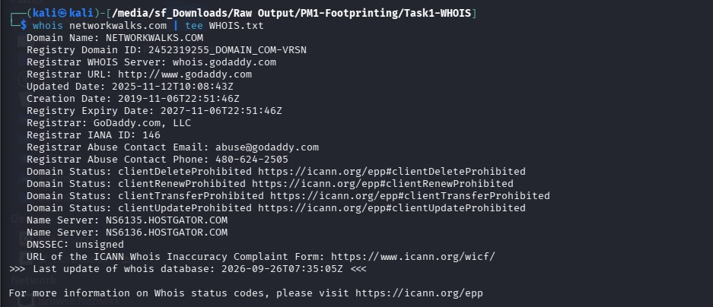
2. PM1 — WhatWeb output
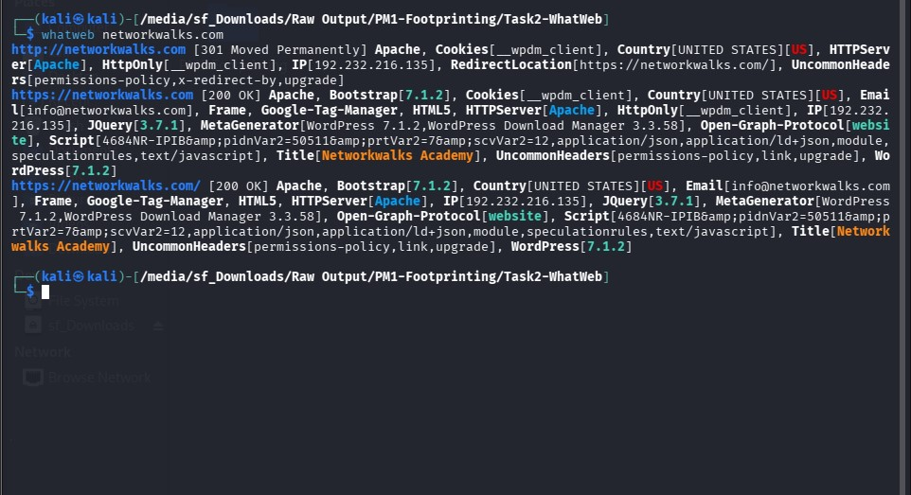3. PM1 — Nslookup output
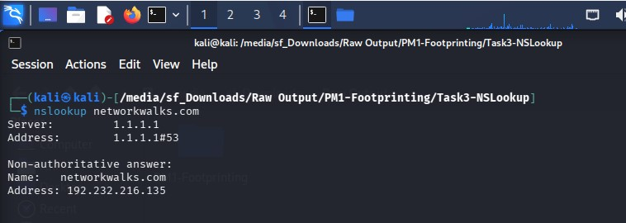4. PM1 — Curl HTTP headers
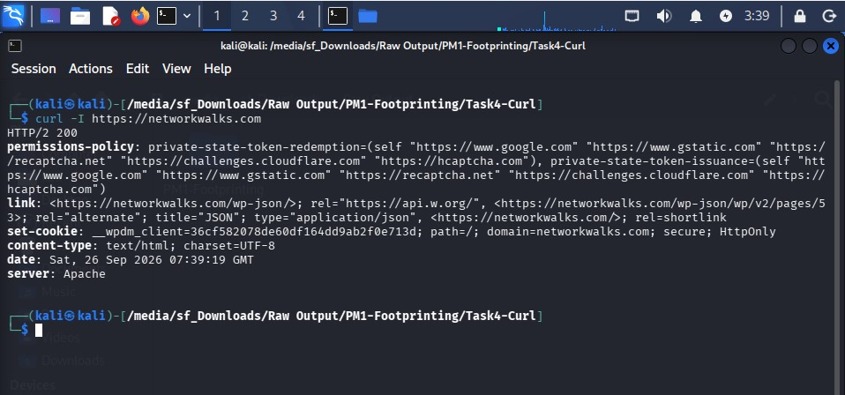
5. PM1 — Wafw00f output
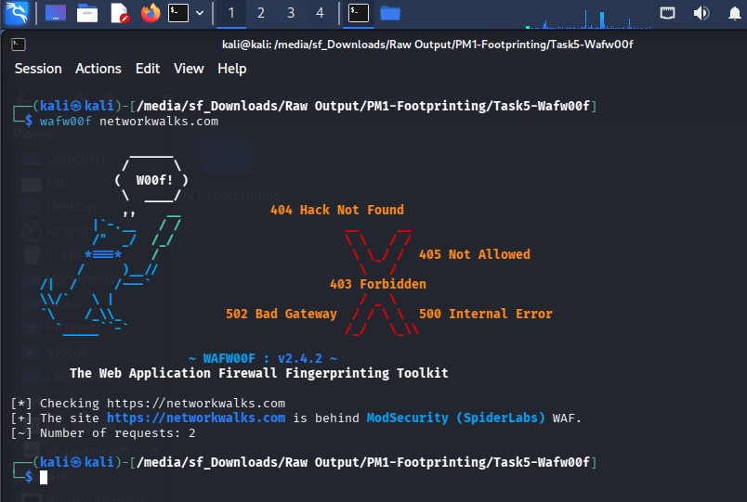6. PM1 — DNSRecon output
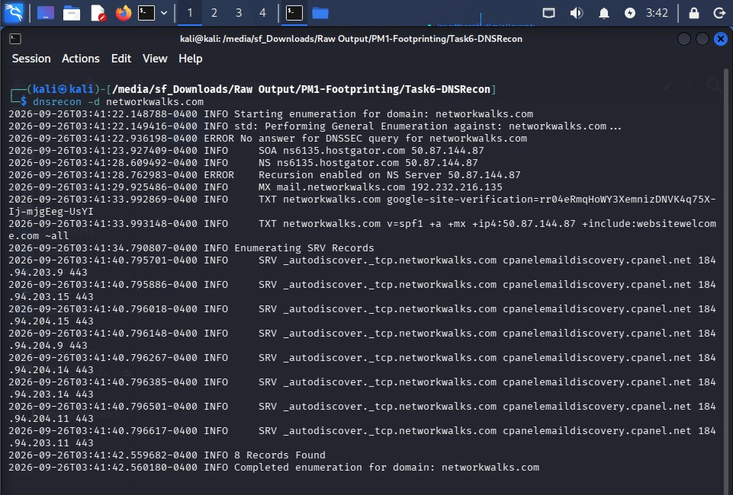

7. PM3 — Maltego domain graph
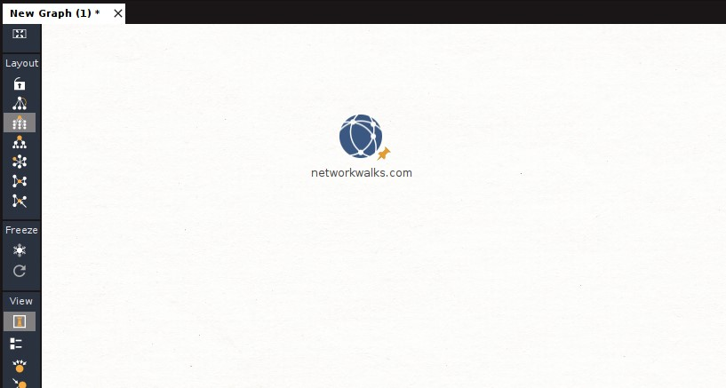
8. PM3 — Maltego transform output
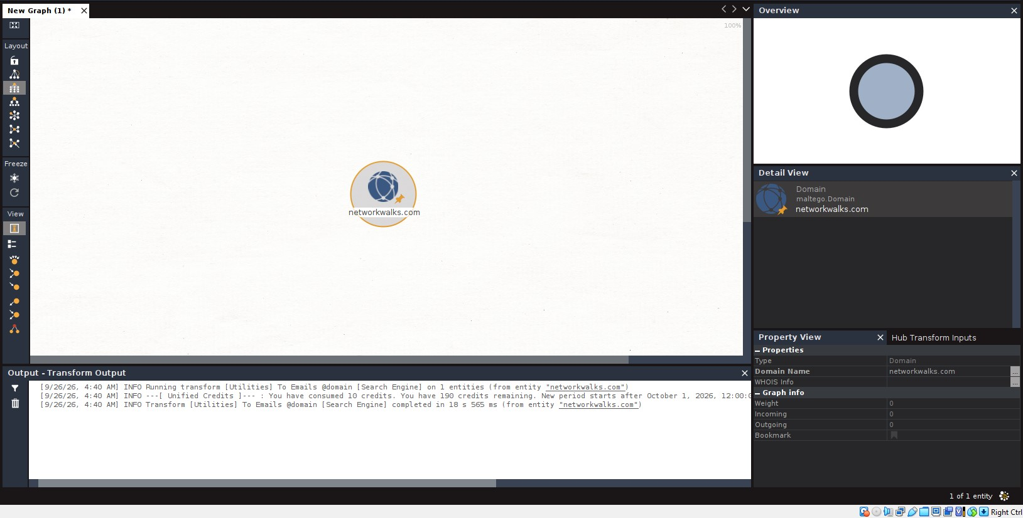9. PM4 — theHarvester Baidu output
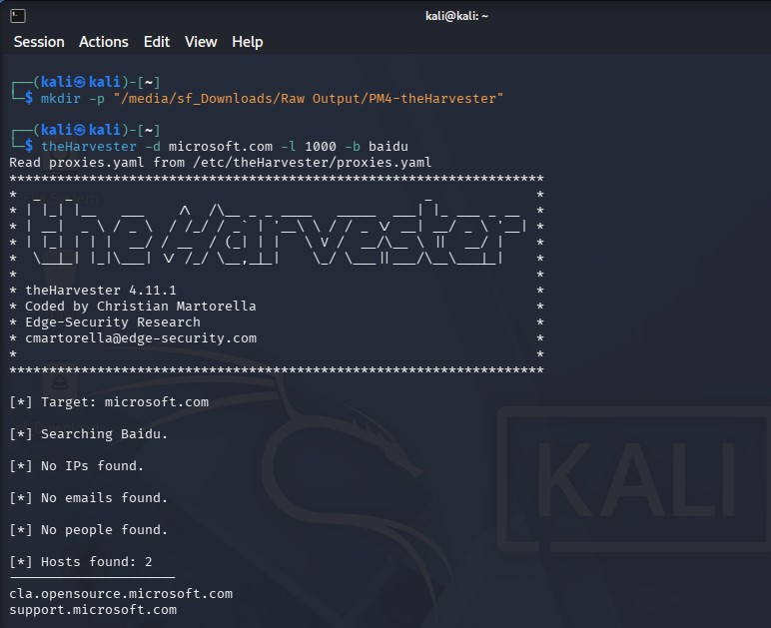10. PM4 — theHarvester all-source raw output
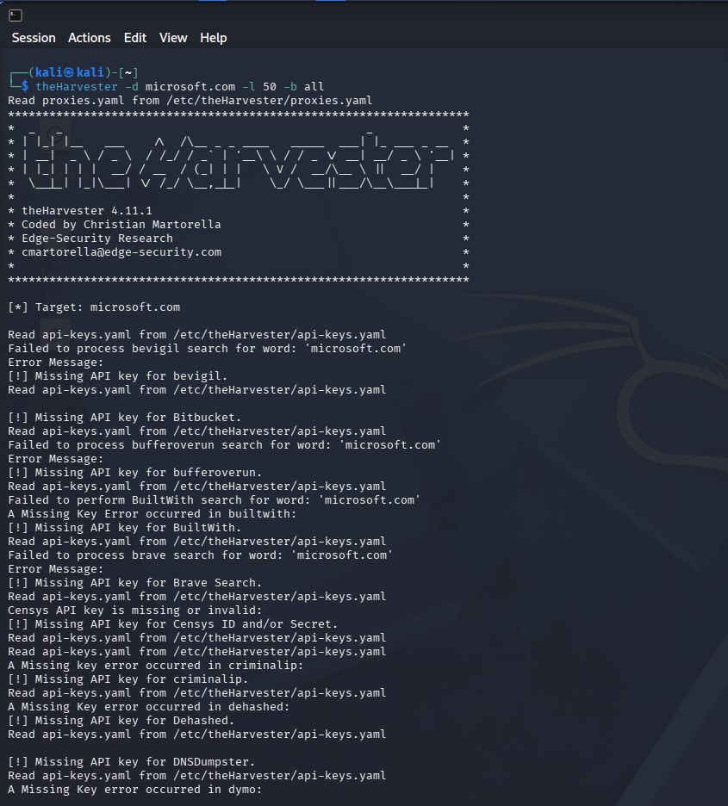

11. PM5 — Zenmap Ping Scan output
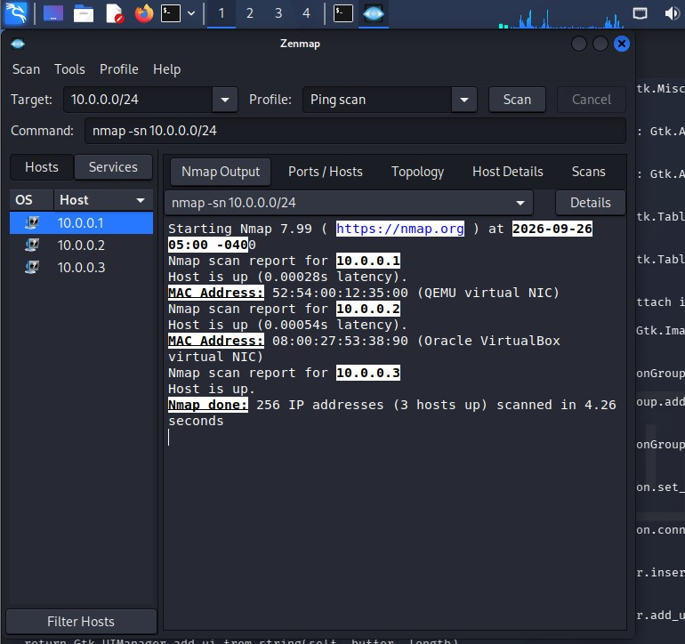
12. PM5 — Zenmap topology
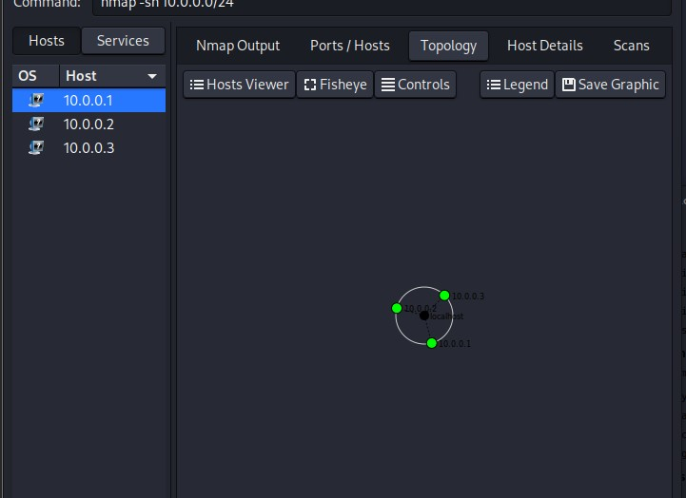

👤 Author
Faizan Manazir
Cybersecurity Professional B083
LinkedIn: https://www.linkedin.com/in/faizan-manazir-38046527a/

📌 Project Information
Program Name: Cybersecurity program at Networkwalks | Week: 02 | Repository: GitHub

