

**Visvesvaraya Technological University**

**BELAGAVI, KARNATAKA**

**Report on Mini Project**

**“STUDENT PROJECT MANAGEMENT”**

**for the course**

**DBMS LABORATORY WITH MINI PROJECT (18CSL58)**

**Submitted by**

1. **J SAHANA- 4JN18IS032**
2. **CHITRA S P -4JN19IS402**

**Under the guidance of**

**SATYANARAYAN K.B Asst.Prof.**

**Designation,**

**Dept. of IS&E,**

**JNNCE, Shivamogga**

Department of Information Science & Engineering

J N NCollege of Engineering

Shivamogga - 577 204

2020-21

**National Education Society ®**





**J N N COLLEGE OF ENGINEERING**

**SHIVAMOGGA-577204.**

**DEPARTMENT OF INFORMATION SCIENCE & ENGINEERING**

**CERTIFICATE**

This is to certify that Project entitled

**“STUDENT PROJECT MANAGEMENT”**

**Submitted by**

1. **J SAHANA- 4JN18IS032**
2. **CHITRA S P -4JN19IS402**

**for the course DBMS LABORATORY WITH MINI PROJECT (18CSL58),**students of 5th semester B.E. ISE, in partial fulfillment of the requirement for the award of degree of Bachelor of Engineering in Information Science and Engineering of Visvesvaraya Technological University, Belagavi during the year 2020-21.

**Signature of Guide Signature of HOD**

**Satyanarayan K.B Asst.Prof Dr. R Sanjeev KunteM.Tech, Ph.D**

**Designation, Professor & Head,**

**Dept. of IS&E, Dept. of IS&E,**

**JNNCE, Shivamogga JNNCE, Shivamogga**

**Name Signature**

**Examiner 1:**

**Examiner 2:**

**ACKNOWLEDGEMENT**

The satisfaction and euphoria that accompany the successful completion of any task would be incomplete without the mention of the people who made it possible, whose constant guidance and encouragement crowned the efforts with success.

It gives us great pleasure in placing on record a deep sense of gratitude to our guide **Satyanarayan K.B Asst.Prof**, Designation, Dept. of IS&E, for his guidance, initiative and encouragement that led us through the project work.

We would like to thank **Dr. R Sanjeev Kunte,** Ph.D, Professor and Head, Dept. of IS&E, and **Dr. Shashidhar K Kudari,** the Principal, JNNCE, Shivamogga for their support and encouragement.

Finally, we also would like to thank the whole teaching and non-teaching staff of Information Science and Engineering Dept., our respective parents, friends and well-wishers.

**J.SAHANA (4JN18IS032)**

**CHITRA S.P (4JN19IS402)**

**ABSTRACT**

Students form a main part of any institution that concerns with.But the institutions find it difficult to keep details of so many students projects just in one stretch.Student Project Management provides a simple interface for maintenance of student project information and and guid information and marks alotment from respctive guids the one who handels the projects.By useing our application the detailed information of the students projects can be saved and handeled eassely.

**TABLE OF CONTENTS**

|  |  |  |
| --- | --- | --- |
| **CHAPTER NO.** | **TITLE** | **PAGE NO.** |
|  | **ACKNOWLEDGEMENT** | **i** |
|  | **ABSTRACT** | **ii** |
|  | **CONTENTS** | **iii** |
|  |  |  |
|  |  |  |
| **Chapter 1** | **INTRODUCTION** | **01** |
|  | 1.1 Explanation |  |
|  |  |  |
| **Chapter 2** | **SYSTEM REQUIREMENTS SPECIFICATIONS** |  |
|  | 2.1 Functional Requirement |  |
|  | 2.2 Non-functional Requirement |  |
|  | 2.3 Hardware & Software Requirements |  |
|  |  |  |
| **Chapter 3** | **SYSTEM DESIGN** |  |
|  | ER Diagram |  |
|  | Architecture Diagram/Block diagram Etc |  |
| **Chapter 4** | **IMPLEMENTATION** |  |
|  | Tools and Technologies used |  |
|  |  |  |
|  |  |  |
| **Chapter 5** | **RESULT AND DISCUSSION** |  |
|  | Few (Important snapshots with explanation) |  |
|  |  |  |
|  | **CONCLUSION AND FUTURE WORK** |  |

|  |  |  |
| --- | --- | --- |
|  |  |  |
|  |  |  |
|  |  |  |

**Chapter 1**

# INTRODUCTION

Storing data and information has always been done through the traditional way i.e., by storing it physically. It may be by using paper to store documents or using up a whole room to store other physical materials. Day by day the size of the information and data to be stored is increasing thus the need for physical storage facility. If storage is one problem, retrieval and manipulation of the data is another problem. The time being invested in the same can be used for other productive work.

Thus our team is proposing a software system which eliminates the need for storing the information and data physically and which makes it easier to manipulate and retrieve the same. The name we have given to this software system is “**STUDENT’S PROJECT MANAGEMENT SYSTEM”.** Our system

makes use of the Database Management System to store all the data digitally which saves nearly 90% of the physical storage and also decreases the access time of the information/data.

Every semester hundreds of projects and mini projects are submitted by students of various specialization, all these project details were stored in an optical disk and hard copy of the reports were being submitted. By the implementation of our software we aim at storing all the above mentioned data in a computer with the help of the proposed system.

We store specific information related to the project, the students who submit them and their guides in tables specifically designed using MySQL. And to manipulate the stored information i.e., storing, retrieval and updating we make use of Html , Css and Php frameworks in the frontend. We believe this will help in saving up the store facilities, saving time and other resources.

**Chapter 2**

# SYSTEM ANALYSIS

**2.1 EXISTING SYSTEM EXPLANATION**

System analysis is a detailed study of the various operations performed by system and their relationships within and outside of the system. Here the key question is - What all problems exist in the present system? What must be done to solve the problem? Analysis begins when a user or manager begins a study of the program using existing system.

During analysis, data collected on various files, decision points and transactions handled by the present system. The commonly used tools in the system are Data Flow-Diagrams, interviews, etc.

training experience and common sense are required for collection of relevant information needed to develop the system.

The success of the system depends largely on how clearly the problem is defined, thoroughly investigated and properly carried out through the choice of the solution. A good analysis model should provide not only the mechanism of the problem understanding but also the framework of the solution.

The proposed system should be analyzed thoroughly in accordance with the needs. System analysis can be categorized into four parts.

1. System Planning and Investigation.
2. Information Gathering.
3. Applying analysis tools for structured analysis
4. Feasibility study

**2.2 PROPOSED SYSTEM EXPLANATION**

Currently there are many management software similar to what we have proposed but as we all know each management software is designed specifically based on the client needs. Considering the software all the collages use there is no specific software which is entirely designed to handle the requirements mentioned previously.

These are some of the utilities or features we provide in our application:

1. Complete digitization of the data.
2. The Admin can login using secure credentials
3. The lecturers can enter the data and view them
4. The students however cannot add or modify the data but can view all the projects entered in the database.
5. The Admin can make any kind of changes based on then requirements.

**2.3 FUNCTIONAL REQUIRMENT :**

* + - EASSYphp
    - Xamp
    - VSCODE

**2.4 NON FUNCTIONAL REQUIRMENT :**

SOFTWARE:

* + - Latest Windows
    - Web Browser

HARDWARE:

* + - Dual Core CPU at 2.7GHz
    - Min. 4 GB RAM
    - Min. 500GB Hard drive space.

**Chapter 3**

# SYSTEM DESIGN AND ARCHITECTURE

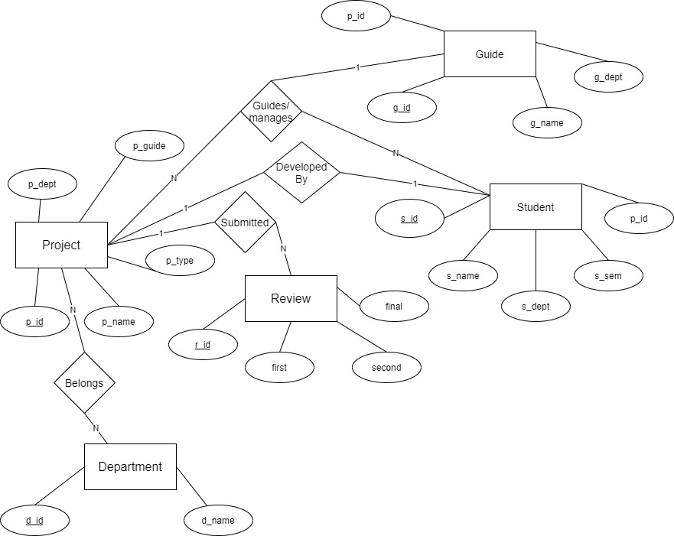

**Fig:3.1 ER Diagram**

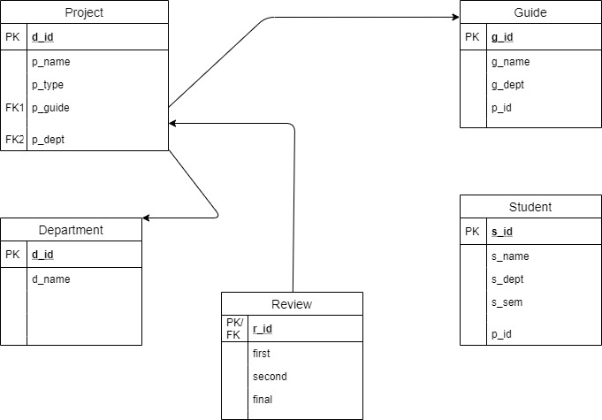

**Fig:3.2 Schema Daigram**

**Chapter 4**

TOOLS AND TECHNOLOGIES USED

**ABOUT MySQL and MySQL Workbench:**

MySQL is an open-source Relational Database Management System (RDBMS). MySQL is free and open-source software under the terms of the GNU General PublicLicence, and is also available under a variety of proprietary licenses. MySQL was owned and sponsored by the Swedish company MySQL AB, which was bought by Sun Microsystems (now Oracle Corporation).

MySQL Workbench is a visual database design tool that integrates SQL development, administration, database design, creation and maintenance into a single integrated development environment for the MySQL database system. DBDesigner 4 from fabFORCE.net, and replaces the previous package of software,.

**Chapter 5**

RESULTS

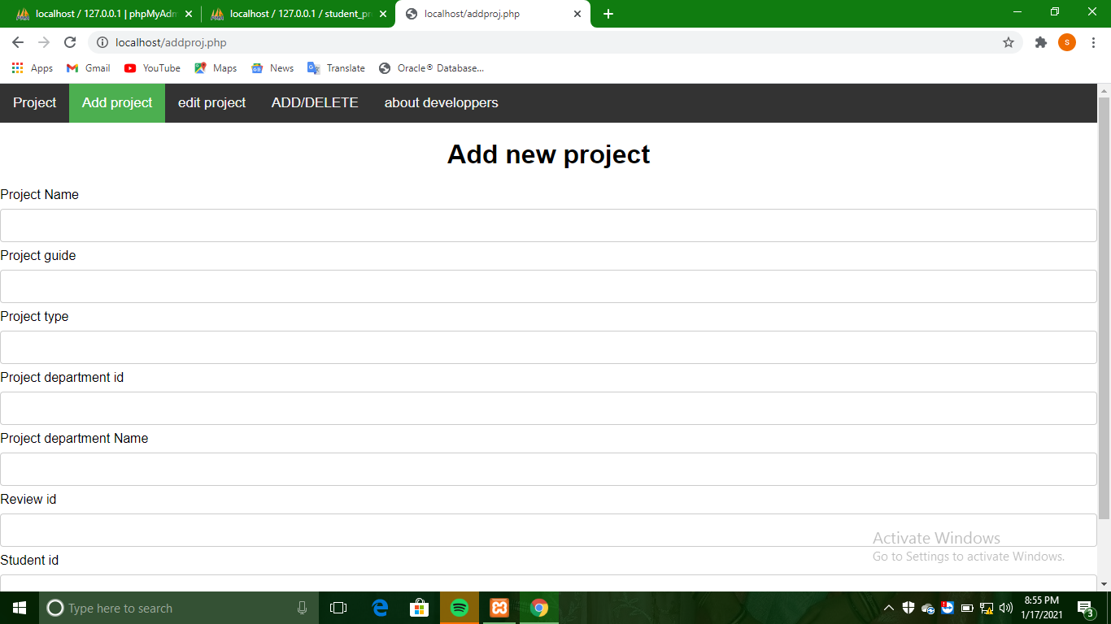

**Fig:5.1**

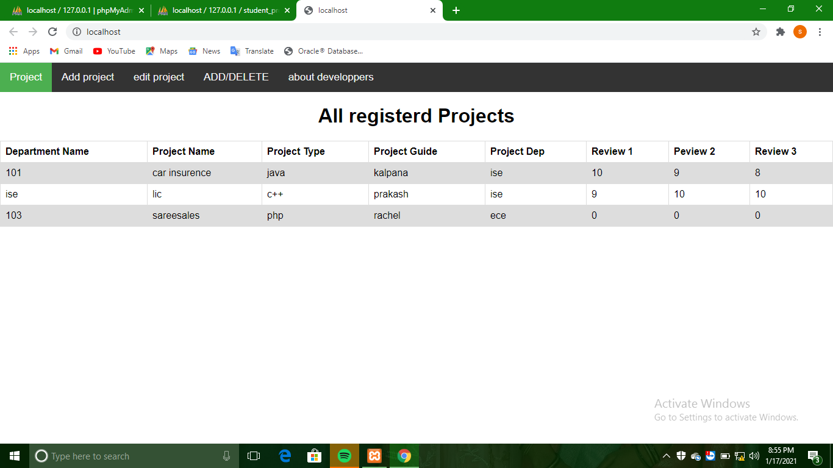

**Fig:5.2**

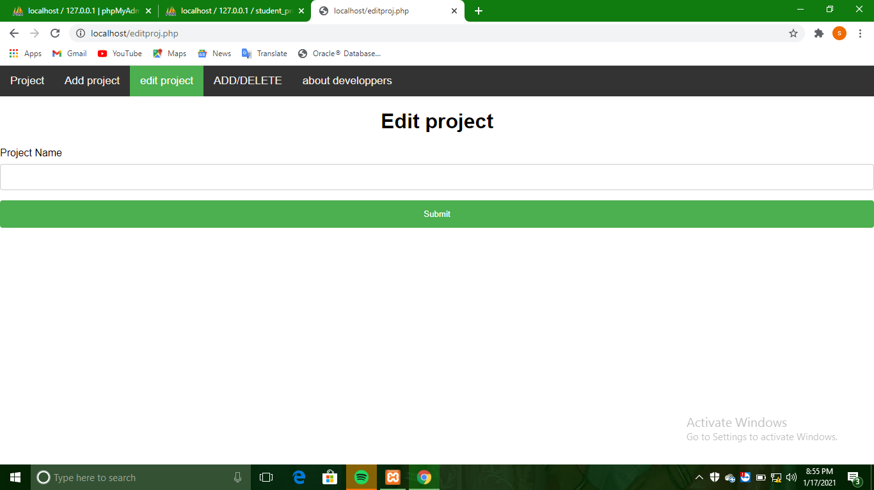

**Fig:5.3**

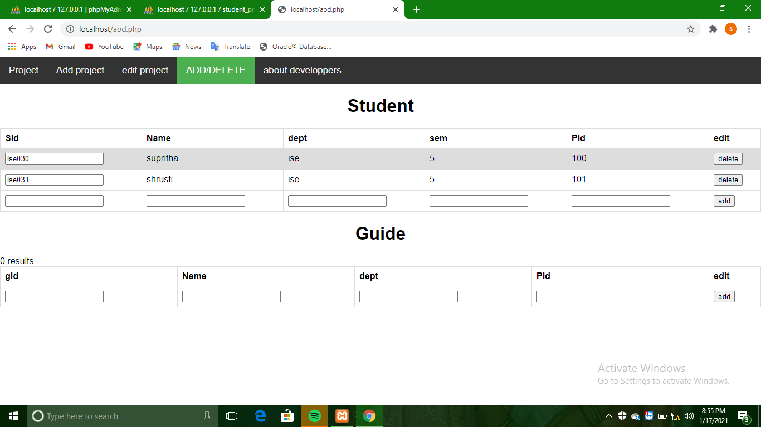

**Fig:5.4**

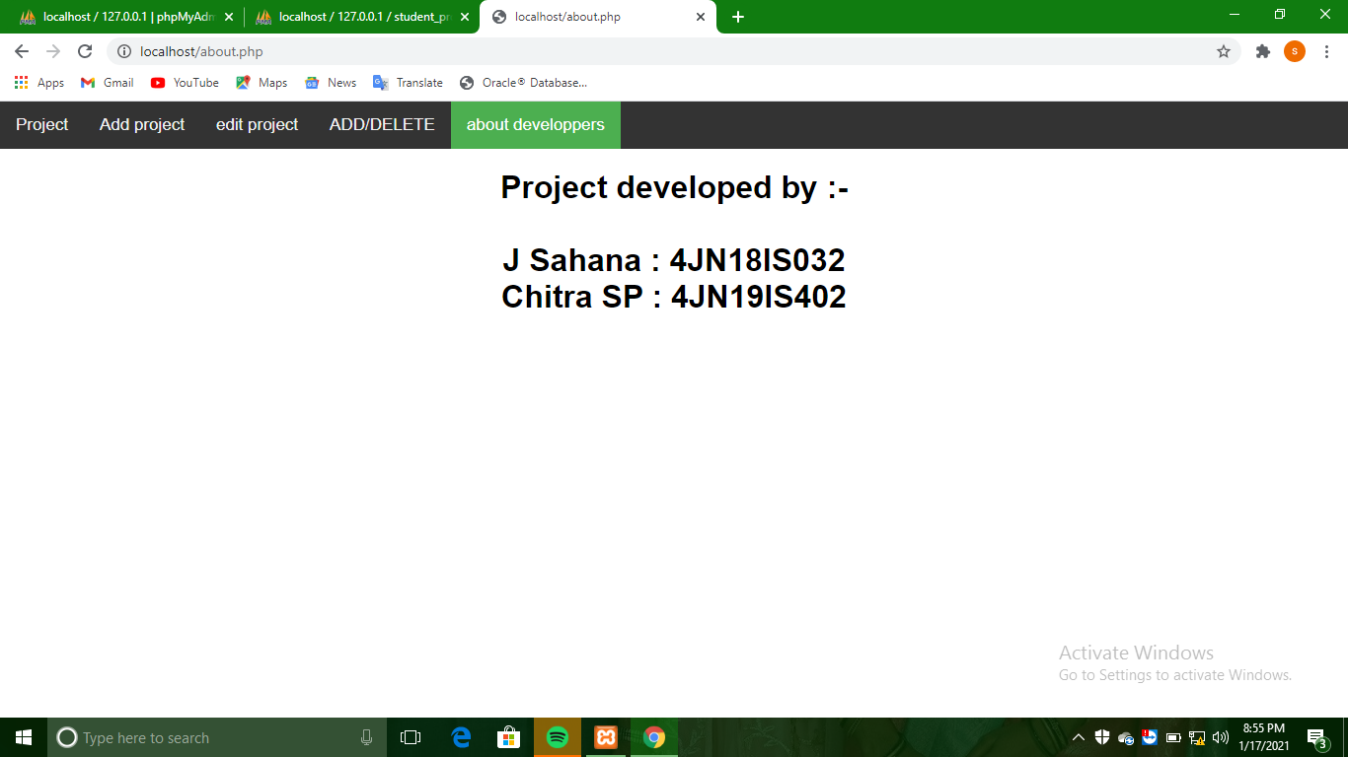

**Fig:5.5**

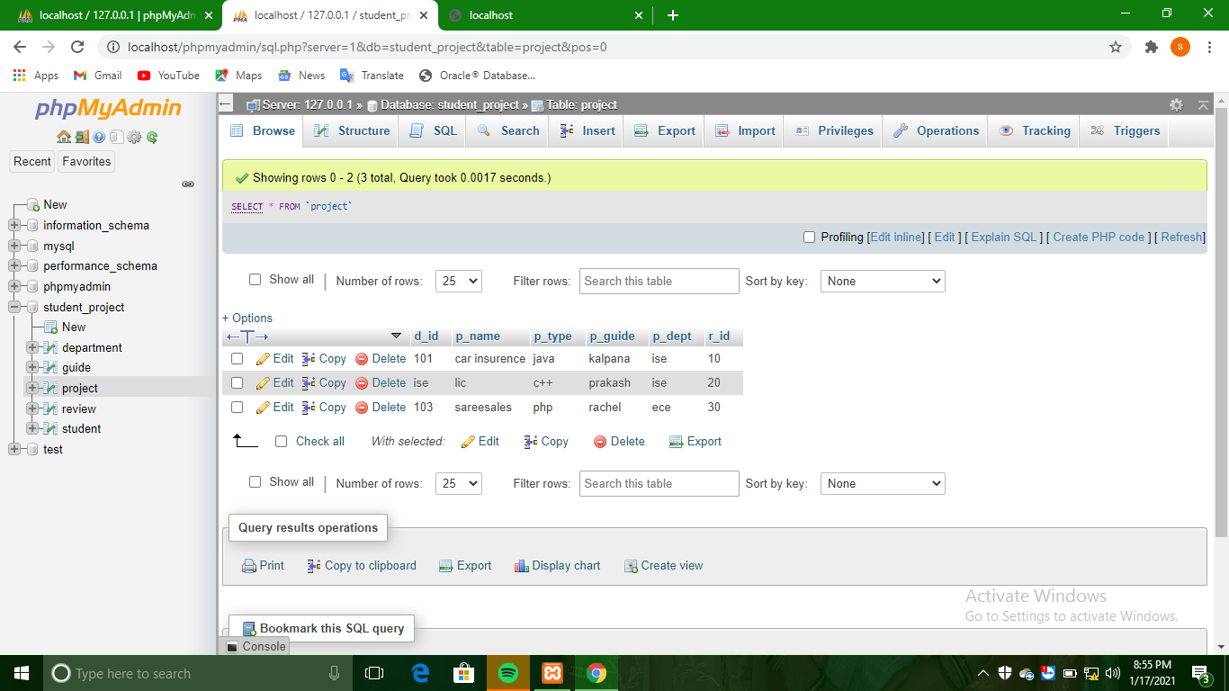

**Fig:5.6**

**Chapter 5**

CONCLUTION

This project is helpful to perform paperless work and manage all data. And also provides easy , accurate , unambiguous and faster data access. Deployment of our application will certainly help the collage to reduce unnecessary wastage of time in personally going for each project information.

**REFERENCES**

1. Ramez Elmasri and Shamkant B. Navathe, “Database system Models, Languages,Design and Application Programming” , Pearson, 7ThEdition, 2017,.
2. Raghu Ramakrishnan, and Gehrke, “Database management system” ,McGraw Hill, 3rd Edition,2014,
3. HerbertSchildt:JAVA the complete reference, 7th/9th Edition, TataMcGrawHill, 2007.
4. Jim Keogh:J2EE-TheCompleteReference, McGraw Hill, 2007.

**THANKING YOU**

J SAHANA 4JN19IS032

CHITRA SP 4JN19IS402