 A

Project report on

2048 GAME

As a partial fulfilment of BCA Semester-VI

Batch (2024-2025)

Under taken at

Matrushree L. J. Gandhi(bakorvala) BCA Collage, Modasa

Submitted by

|  |  |  |
| --- | --- | --- |
| Name | Roll No. | Exam No. |
| Faizan Shekh | 108(DIV-B) |  |
| Mo.Ayan Belim | 5 (DIV-A) |  |

|  |  |
| --- | --- |
| Internal Guide | External Guide |
| Mrs. Hemali Patel | Dr. Jaydip Trivedi |



Submitted to

Matrushree L. J. Gandhi(bakorvala) BCA Collage, Modasa

Affiliated by

Hemchandracharya North Gujarat University

PATAN- 384265

 Managed By: The M. L. Gandhi Higher Education Society, Modasa

Matrushree L. J. Gandhi (Bakorvala) BCA College

&

Dr. N. J. Shah PGDCA College, Modasa

Affiliated with Hemchadracharya North Gujarat Univrsity, Patan

Date:

**Certificate**

This is to certify that Ms.

Shekh Faizan I.

Is a student of Sem-VI bachelor of computer Application (BCA) during academic year 2024-2025 in

Matrushree L. J. Gandhi (Bakorvala) BCA College, Modasa

She developed project on

2048 Game

Using Html , Css and JavaScript at Matrushree L. J. Gandhi (Bakorvala) BCA College

The duration of the project is 30 days.

Project the system is verified by us and found suitable for implementation at the firm/Institute.

During project work, He was sincere and regular.

|  |  |
| --- | --- |
| Project Cordinator | Principal |
|  |  |
| Patel Hemali S. | Dr. Jaydip Trivedi |

Coleege Campus, Dhansura Road, Modasa Dist:Aravalli Pin: 383315

Ph.No: (02774)249039, Telefax: (02774)249039

Website: <http://www.ljgbcamod.ac.in>

Email: [principal@ljgbcamod.ac.in](mailto:principal@ljgbcamod.ac.in)

 Managed By: The M. L. Gandhi Higher Education Society, Modasa

Matrushree L. J. Gandhi (Bakorvala) BCA College

&

Dr. N. J. Shah PGDCA College, Modasa

Affiliated with Hemchadracharya North Gujarat Univrsity, Patan

Date:

**Certificate**

This is to certify that Ms.

Belim Mo.Ayan.

Is a student of Sem-VI bachelor of computer Application (BCA) during academic year 2024-2025 in

Matrushree L. J. Gandhi (Bakorvala) BCA College, Modasa

She developed project on

2048 Game

Using Html , Css and JavaScript at Matrushree L. J. Gandhi (Bakorvala) BCA College

The durationof the project is 30 days.

Project the system is verified by us and found suitable for implementation at the firm/Institute.

During project work, He was sincere and regular.

|  |  |
| --- | --- |
| Project Cordinator | Principal |
|  |  |
| Patel Hemali S. | Dr. Jaydip Trivedi |

Coleege Campus, Dhansura Road, Modasa Dist:Aravalli Pin: 383315

Ph.No: (02774)249039, Telefax: (02774)249039

Website: <http://www.ljgbcamod.ac.in>

Email: [principal@ljgbcamod.ac.in](mailto:principal@ljgbcamod.ac.in)

**INDEX**

|  |  |  |
| --- | --- | --- |
| NO | PARTICULAR | PAGE NO |
|  |  |  |
| 1 | INTRODUCTION | 01 |
| 2 | PROJECT PROFILE | 02 |
| 3 | EXISTING SYSTEM | 03 |
| 4 | NEED FOR NEW SYSTEM | 04 |
| 5 | HARDWARE REQUIREMENT | 05 |
| 6 | SOFTWARE REQUIREMENT | 05 |
| 7 | PROJECT DESCRIPTION | 06 |
| 8 | SYSTEM FLOWCHART | 09 |
| 9 | ROADMAP OF TASKS | 10 |
| 10 | SCREENSHOTS | 12 |
| 11 | FUTURE INHANCEMENT | 15 |
| 12 | BIBLIOGRAPHY | 16 |

INTRODUCTION

* 2048 is a captivating and deceptively simple puzzle game.
* Played on a 4x4 grid, the objective is straightforward yet challenging: slide numbered tiles to combine matching pairs, doubling their values until you reach the elusive **2048 tile**.
* Each move shifts all tiles in your chosen direction—up, down, left, or right—and spawns a new tile (either a 2 or 4) on the grid.
* When two tiles of the same number collide, they merge into one, incrementing their value.
* the rules are easy to grasp, mastering the game requires strategic thinking, spatial awareness, and the ability to anticipate chain reactions.
* Renowned for its addictive "just one more try" appeal, 2048 thrives on its simplicity.

|  |  |
| --- | --- |
| Project title | 2048 Game |
| Goal of System | Entertainment Purpose |
| Type of Application | Web-based application |
| Front end & back end | HTML, CSS, and JavaScript |
| Tool used | VS code(IDEs) |
| Internal guide | Hemali Patel |
| External guide | Dr. Jaydip Trivedi |
| Group No. |  |
| Developed by | Faizan Shekh &  Mo.Ayan Belim |
| Submitted to | Matrushree L. J. Gandhi BCA College, Modasa |

PROJECT PROFILE

EXISTING SYSTEM

* **Limited Grid Size**: The standard **4×4 grid** restricts extended gameplay.
* **No Undo Option**: Many versions do not allow undoing moves, making mistakes irreversible.
* **Not Engaging for All Players**: Casual players may find it too easy, while others find it too hard to reach 2048.
* **Unwinnable Situations**: Some games reach an unwinnable state early due to bad tile placement.
* **Lack of Variety**: The game follow repetitive pattern, which can become monotonous.

NEED FOR NEW SYSTEM

* **New Grid Sizes**: Options for **5×5, 6×6, or customizable grids** to extend gameplay.
* **Advanced Difficulty Levels**: Introduce **easy, medium, and hard** modes for different skill levels.
* **Undo & Save Feature**: Allow players to undo a few moves and save progress.
* **Theme Option** : You can change the theme Light or Dark.
* **Animations & Sound Effects**: Make the game more visually appealing and interactive.

HARDWARE REQUIREMENT

✅ **Processor**: Any modern CPU (Intel Core i3 or equivalent)  
✅ **RAM**: 2GB or more  
✅ **Storage**: Minimal (~50MB for installation)  
✅ **Display**: Standard resolution (1024×768 or higher)  
✅ **Input Devices**: Keyboard, Mouse (or Touchscreen for mobile)

SOFTWARE REQUREMENT

✅ **Operating System**: Windows, macOS, Linux (Any OS with a browser)  
✅ **Browser**: Chrome, Firefox, Edge, Safari (supports JavaScript)  
✅ **Languages Used**: HTML, CSS, JavaScript.

PROJECT DISCRIPTION

This project aims to **redefine** the 2048 game by making it more engaging, competitive, and visually appealing while keeping its core logic intact. The new version will offer **customization, strategic depth, and improved accessibility**, making it enjoyable for all users.

* To create this game you can have knowledge about Html ,Css and JavaScript to create this game.
* I’m use code editor ( **VS code(IDEs)** ) for write the game code.
* I’m use vercel v0 ,Qwel 2.5 and Chatgpt for help.

OVERVIEW

**Gameplay Mechanics**

* The game starts with **two tiles** (either "2" or "4") placed randomly on the **4×4 grid**.
* Players **click (Up, Down, Left, Right)** to move all tiles in that direction.
* When two tiles with the **same number** collide, they **merge** into one with their sum.
* After every move, a **new tile (2 or 4) appears** at a random empty position.
* The goal is to **create the 2048 tile**.
* The game **ends when no more valid moves** are possible.

**Variations & Enhancements**

* **We can add grid size (3x3,5x5, 6x6 and 8x8) in for extendend gameplay.**
* We can allow players to undo a few moves and save progress.
* We can introduce **easy, medium, and hard** modes for different skill levels.
* **We add soud on merging , adding tiles or Game Over and Wining celebration.**

**PROJECT STAGES**

### **Stage 1: Project Setup**

**Stage 2: Create HTML Structure**

**Stage 3: CSS Layout and Styling**

**Stage 4: JavaScript for Game Logic**

**Stage 5: Game Mechanics (Moving Tiles, Merging)**

**Stage 6: Handling User Input**

**Stage 7: Game Over & Restart**

**Stage 8: Score and UI Enhancements**

**Stage 9: Final Testing and Debugging**

**Stage 10: Deployment**

**SYSTEM FLOWCHART**

IsArrowUp?

IsArrowDown?

IsArrowKey?

IsArrowRight?

IsArrowLeft?

moveLeft()

End

Show

“Game Over”

Show

“ You Win ”

moveRight()

moveDown()

moveUp()

Ppress any key

**no**

Yes

GameOver()

WinScreen()

addRandomTile()

**no no**

**no yes yes**

**yes**

**no**

**yes**

**no**

**yes**

ROADMAP OF TASKS

### **🚀 Phase 1: Project Setup**

✅ Set up project structure (folders & files: index.html, style.css, script.js)  
✅ Link HTML, CSS, and JavaScript files in index.html

### **🎨 Phase 2: UI Design & Layout**

✅ Design the game container and 4x4 grid using CSS  
✅ Create grid cells (16 div elements representing tiles)  
✅ Style tiles with different colors based on their values  
✅ Add a game title, score display, and restart button

### **🧠 Phase 3: Game Grid & Rendering**

✅ Initialize a **2D array (4x4 grid)** to store tile values  
✅ Write a function to **render** the grid in the HTML  
✅ Add a function to **generate a random tile (2 or 4)** at the start  
✅ Display numbers in the corresponding grid cells

### **🎮 Phase 4: Implement Game Mechanics**

✅ Capture **user input (arrow keys)** for movement  
✅ Implement **tile movement** logic for each direction (left, right, up, down)  
✅ Implement **tile merging** logic when two tiles of the same number collide  
✅ Generate a **new random tile** after each move  
✅ Update the **score** when tiles merge

### **🛠 Phase 5: Advanced Game Features**

✅ Implement **game over detection** (no available moves)  
✅ Display a **Game Over** message when the game ends  
✅ Implement a **restart button** to reset the game  
✅ Store and display **best score** using localStorage

### **⚡️ Phase 6: UI & UX Enhancements**

✅ Add smooth **tile animations** (using CSS transitions or JavaScript)  
✅ Improve number **font styling** for readability

### **🚢 Phase 7: Testing & Deployment**

✅ Test the game on different browsers and devices  
✅ Optimize performance (avoid unnecessary re-renders)  
✅ Fix any remaining **bugs** or glitches  
✅ Deploy the game on **GitHub Pages, Netlify, or Vercel**

## **🔮 Bonus Features**

* 🔹 Add **sound effects** for moves and merges
* 🔹 Implement **dark mode**
* 🔹 Create **different board sizes** (e.g., 5x5 grid)
* 🔹 Add an **AI bot** to play automatically

**SCREENSHOT**

* SCREENSHOT : 1

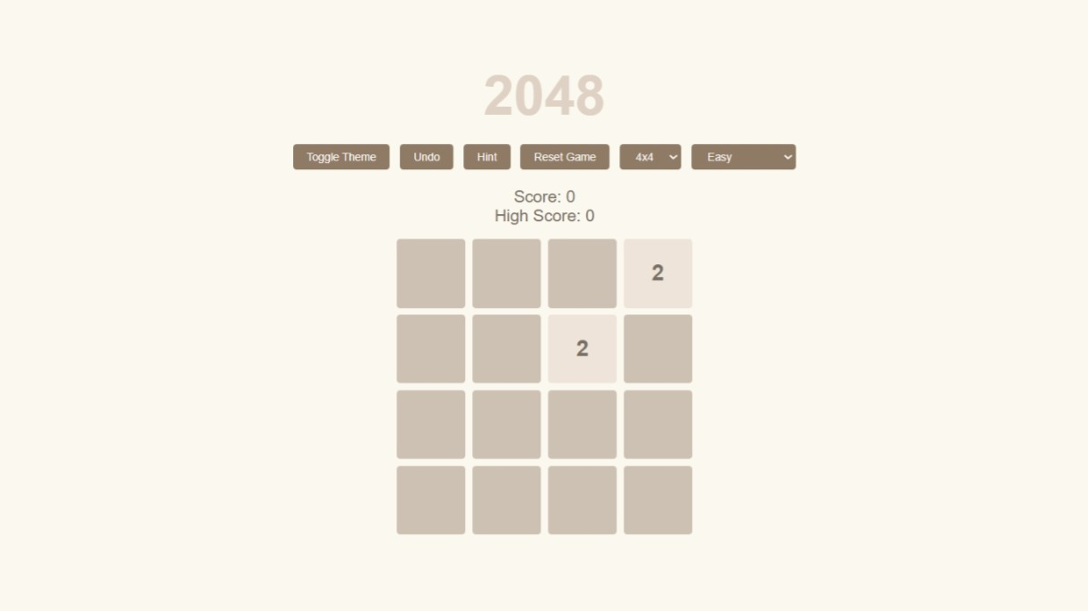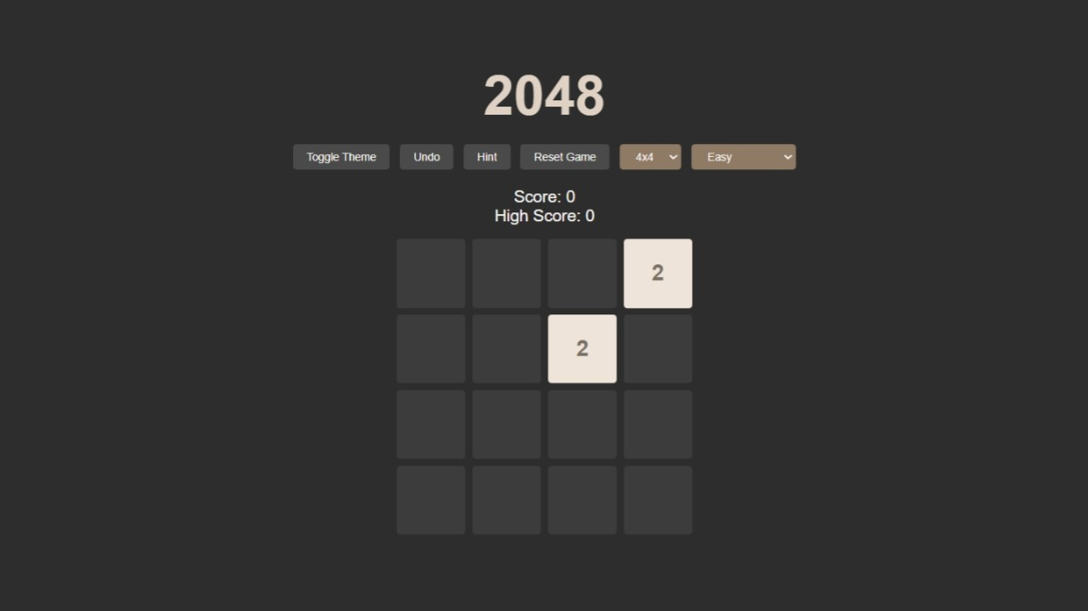 This screenshot show dark and Light Theme Function in Game

* SCREENSHOT : 2

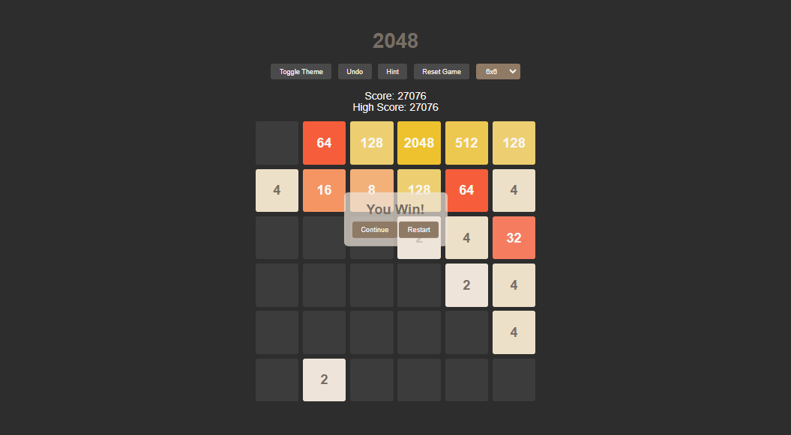

This ScreenShot shows the **“Win Moment”** Of player after Reach the **2048 Tiles.**

* SCREENSHOT : 3

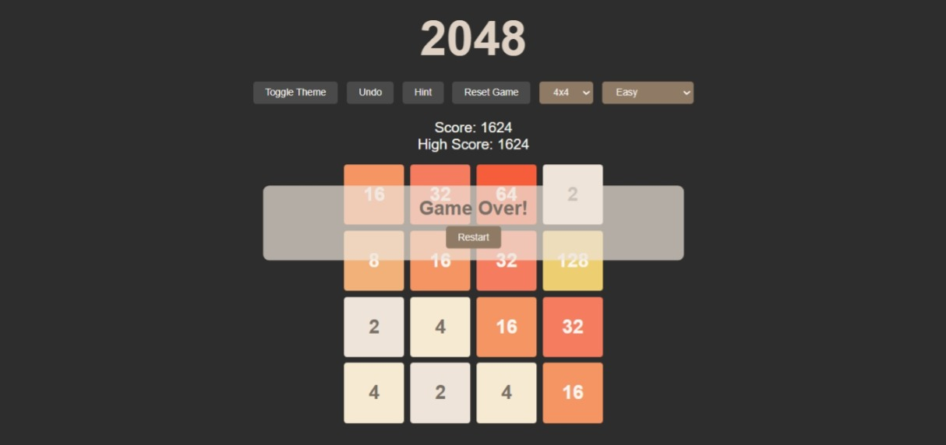

This ScreenShot shows the **“ Game Over ”** Moment of Player When they don’t have Any Moves.

**FUTURE ENHANCEMENT**

### **1. Enhanced Gameplay & User Experience**.

* **Multiplayer Mode**: Introduce **real-time** or **turn-based multiplayer** for competition.
* **Power-Ups & Boosters**: Adding special moves like **tile shuffle, double merge, or remove a tile** for strategic depth.

### **2. Improved AI & Strategic Depth**

* **Smart AI Opponents**: Implement AI that competes against the player.
* **Challenges & Missions**: Instead of just reaching 2048, introduce tasks like **"Merge only even numbers"** or **"Reach 4096"**.

### **3. Accessibility & Platform Expansion**

* **Cross-Platform Play**: Sync progress between **web, mobile, and desktop**.
* **Offline Mode**: Allow players to enjoy the game **without an internet connection**.
* **Leaderboard & Social Features**: Add **global leaderboards, achievements, and social sharing**.

### **4. Addressing the Endgame Problem**

* **Beyond 2048 Mode**: Introduce new goals after reaching 2048, such as **8192 Mode** or **Infinity Mode**.
* **Alternative Game Modes**:
  + **Time Attack** – Complete the game within a time limit.
  + **Limited Moves** – Win with a fixed number of moves.

**BIBLIOGRAPHY**

* A **bibliography** is a list of sources (books, articles, websites, research papers, etc.)
* During the development of our Project, we have taken the reference websites, Which is:

[www.google.com](http://www.google.com)

[www.openai.com](http://www.openai.com)

* The Original website Link : <https://play2048.co/>
* My Project GitHub Repository : <https://github.com/faizan09-hub/Project_2048Game>
* GitHub : <https://github.com/faizan09-hub>

THANK YOU