**T.Y.V.Sc. Computer Science**

**Semester VI**

**A.Y. 2023 – 2024**

**Project Proposal**

**ON**

Municipal Grievance Tracker

**( MuniTrack )**

**Faizan Alam Sajjad**

**Roll No: 24**

**Project proposal**

**By Faizan Alam TYCS-24**

**Title**

Municipal Grievance Tracker (MuniTrack)

**Introduction**

In our ever-evolving world, effective communication between residents and the government is pivotal for addressing the challenges faced by our communities.

In a society, where collective action plays a crucial role, MuniTrack serves as the bridge between the public and government agencies, providing a seamless channel for citizens to voice their concerns, report issues, and actively participate in the betterment of their neighborhoods.

This platform is more than just a complaint system, it's a dynamic hub that fosters collaboration, transparency, and swift resolution of civic issues.

Whether you've spotted unattended garbage in your locality, witnessed instances of harassment, or identified any other matter that demands attention,MuniTrack empowers you to make a meaningful impact.

**Objectives**

Upon Completion of this project, the main objectives are as follows:

* Developing skills in Web Application Development using Next.js
* Gain proficiency in building a user-friendly UI for smooth Data input and Flow.
* Implement a Backend System that is capable to manage large information and a smooth flow to filter data according to the need.
* Contribute the Web Application for making the Environment Clean and Green.

**Scope**

The Citizen Complaint Management System will offer the following features:

1. Promote Transparency: Increase transparency in local governance by making information about reported issues, their status, and resolutions easily accessible to the public.
2. Enable Quick Issue Resolution: Facilitate the swift resolution of citizen-reported issues by providing a platform that allows government agencies to respond promptly and take appropriate actions.
3. Bringing the Citizen and Government together for Solving the Issue.
4. User-Friendly Web Interface for Smooth User Experience
5. Showing The issue along with others details for effectively handling the user Problem
6. Taking Information of the issue and trying to Solve it in minimal time.
7. Handling Different User like Admin and Normal User.
8. Trying to make the Earth a Better Place to LIve.

**Methodology**

The Development process will follow the Agile methodology, allowing the iterative and incremental process. The Stages includes:

1. Requirement Gathering
2. Planning and Design
3. Implementation and Testing
4. Evaluation and Feedback

These Four steps will be taken repeatedly for all the major functionalities of the project

The Project will focus on the following major functionalities:

1. Authentication of user using different Login functionality like Username & Password, Google and Github Login.
2. User Flow throughout the website for Smooth experience and reducing the routing time of website.
3. Scalable backend for handling large data and traffic.
4. Integration of Next.js for Web Application Development.
5. Fetching the Data Efficiently for keeping the User with up-to-date Information or the Issues.

**Tools and Technologies**

The Citizen Complaint Management System will be developed using the following tools and technique:

* JavaScript Programming Language
* Next.js (A JavaScript Framework Build upon React.js)
* HTML,Tailwind Css for Frontend
* Firebase, and Next.js Response for Backend
* MongoDb , Firestore and firebase Storage for Database
* Various React Hooks like useState,useEffect, useContent for managing different Dynamic state.
* Vercel for Hosting the WebApp

**Timeline**

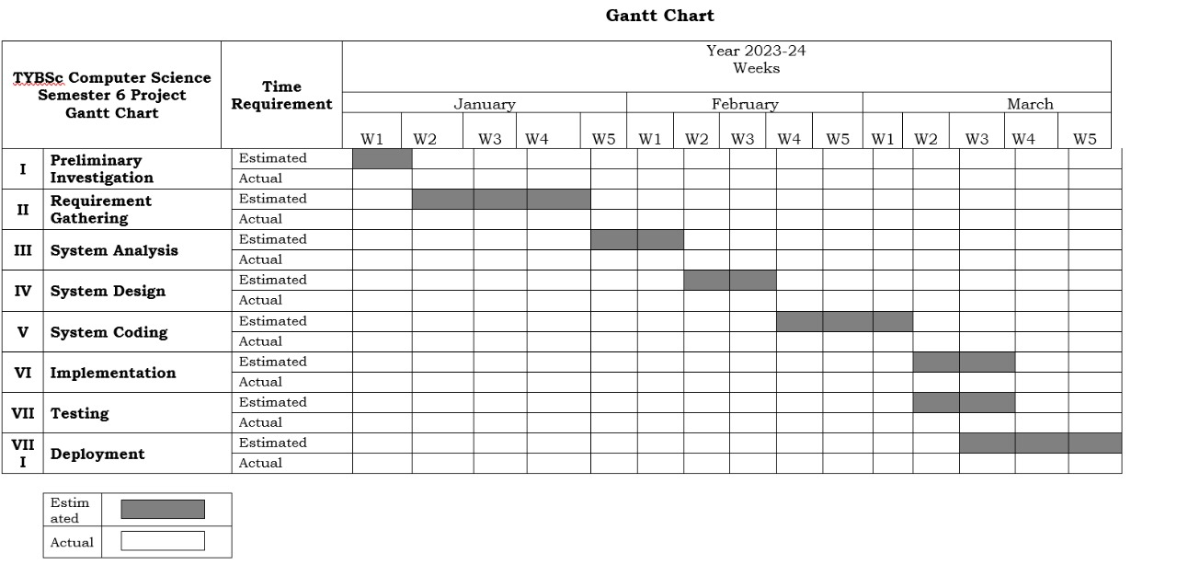

**Resources**

* Frontend: JavaScript, Next.js(Client Side),HTML and CSS.
* Backend: Next.js(Server Side), Firebase.
* Database: MongoDb, FireStore and Firebase Storage.
* System Requirement: Compatible with Standard web Browsers.
* Compartible: Supported on Mobile and Desktop.

**Expected Outcome**

1. The project promotes accountability among government agencies and ensures that actions taken are visible to the public.
2. Actionable data collected through the platform can help government agencies allocate resources more efficiently, targeting areas with the greatest need.
3. By actively involving citizens in community improvement, the project can contribute to an overall enhancement of the quality of life for residents.
4. Providing a platform for citizens to voice concerns and stay informed about local issues empowers them to take an active role in shaping their community's future.
5. The project can encourage government agencies to become more responsive and proactive in addressing the needs of the community, building trust between the government and its citizens.
6. Making the process of issue reporting and resolution transparent

**References**

# Research paper on Impact of Online Communities on Civic Engagement: An Inclusivity Assessment Using the Civic Engagement Test

1. Article on [Mediating Citizen Complaints Against Police Officers: Community Viewpoints From Trinidad and Tobago](https://www.researchgate.net/publication/376969665_Mediating_Citizen_Complaints_Against_Police_Officers_Community_Viewpoints_From_Trinidad_and_Tobago?_sg=OUqA39CDFPnxuozGLdNIOV8nCBJJU3X2yn1oGvFmktOEjkaBJfYjCDzrt38zdsKvPdxGPBusZDv6wwA&_tp=eyJjb250ZXh0Ijp7ImZpcnN0UGFnZSI6Il9kaXJlY3QiLCJwYWdlIjoiX2RpcmVjdCJ9fQ)
2. Article on Evaluating Citizen Satisfaction and Prioritizing Their Needs Based on Citizens’ Complaint Data
3. Article on The Management of Citizen Participation in Taiwan: A Case Study of Taipei City Government's Citizen Complaints System