Pixel & Flow — Creative Studio Website
Project 2 | Responsive Web Layout | DecodeLabs Industrial Training | Batch 2026

📌 Project Overview
Pixel & Flow is a fully responsive creative studio website built as Project 2 of the DecodeLabs Industrial Training Program (Batch 2026). The goal of this project is to demonstrate mastery of responsive web design using pure HTML and CSS — ensuring the website looks great on every screen size, from mobile phones to large desktop monitors.
🎯 Project Goal
Build a responsive webpage that works across different screen sizes using CSS media queries, responsive navigation, and proper spacing and alignment.
🗂️ Project Structure
project-2/
│
├── index.html # Main HTML file (all code in one file)
├──style.css
└── README.md # Project documentation
✅ Implementation Checklist
Feature | Status
Viewport Meta Tag (width=device-width) | ✅ Done
Mobile-First Base CSS | ✅ Done
CSS Flexbox for components | ✅ Done
Responsive Navigation | ✅ Done
Hamburger Menu (mobile) | ✅ Done
Media Query — Tablet (768px) | ✅ Done
Media Query — Desktop (1024px) | ✅ Done
Proper Spacing and Alignment | ✅ Done
Marquee / Scrolling Banner | ✅ Done
Accessible Touch Targets (44px+) | ✅ Done

📱 Responsive Breakpoints
Screen | Breakpoint | Layout
Mobile | Default (0px+) | Single column, hamburger menu
Tablet | max-width: 768px | 2 columns, stacked footer
Desktop | min-width: 1024px | 3 columns, full navbar

🧠 Key Concepts Used
1. Viewport Meta Tag
<meta name="viewport" content="width=device-width, initial-scale=1.0">
This is the "Key to the Kingdom" — without it, mobile browsers use a fake 980px viewport.
2. Mobile-First CSS
All base styles are written for mobile. Larger screens are handled with @media queries on top.
3. Flexbox Layout
Used for navbar, hero buttons, service cards, work grid, testimonials, and footer.
.services-grid {
display: flex;
flex-wrap: wrap;
gap: 20px;
}
4. CSS Media Queries
/* Tablet and below */
@media (max-width: 768px) {
.service-card { width: 100%; }
.nav-pages { display: none; }
.burger-btn { display: flex; }
}

/* Desktop */
@media (min-width: 1024px) {
.service-card { width: 30%; }
}
5. Hamburger Navigation (JavaScript)
Mobile navigation using a toggle button that shows/hides the mobile menu drawer.
🗂️ Sections in the Website
- Navbar — Fixed top navigation with logo, links, and hamburger for mobile
- Mobile Menu — Full-width dropdown that appears on burger click
- Hero — Full-screen landing section with title, description, CTA buttons, and stats
- Marquee — Scrolling skills banner using CSS animation
- Services — 6 service cards in a responsive flex grid
- Work — 4 project showcase cards in a responsive grid
- Process — 5-step numbered process list
- Testimonials — 3 client review cards
- CTA — Call to action section with dark background
- Footer — Multi-column footer with links and social icons
🛠️ Technologies Used
Technology | Purpose
HTML5 | Page structure and semantic markup
CSS3 | Styling, layout, animations
Flexbox | Responsive grid layouts
CSS Media Queries | Breakpoints for different screens
CSS Animations | Marquee scrolling effect
JavaScript (Vanilla) | Hamburger menu toggle
Google Fonts | Open Sans + Poppins typography

🚀 How to Run
- Download or clone this project
- Open index.html in any web browser
- No installations or dependencies required
- Resize the browser window to test responsiveness

🖥️ Screenshots / Preview
Device Description
Mobile (360px) Single column layout, hamburger menu visible
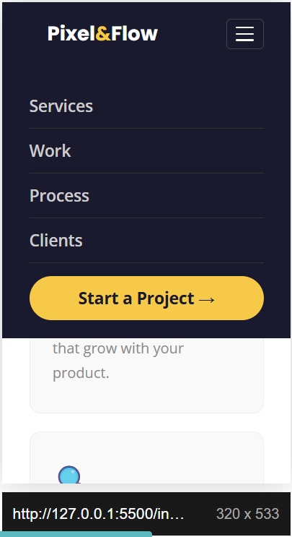

Tablet (768px) 2-column cards, nav still hidden
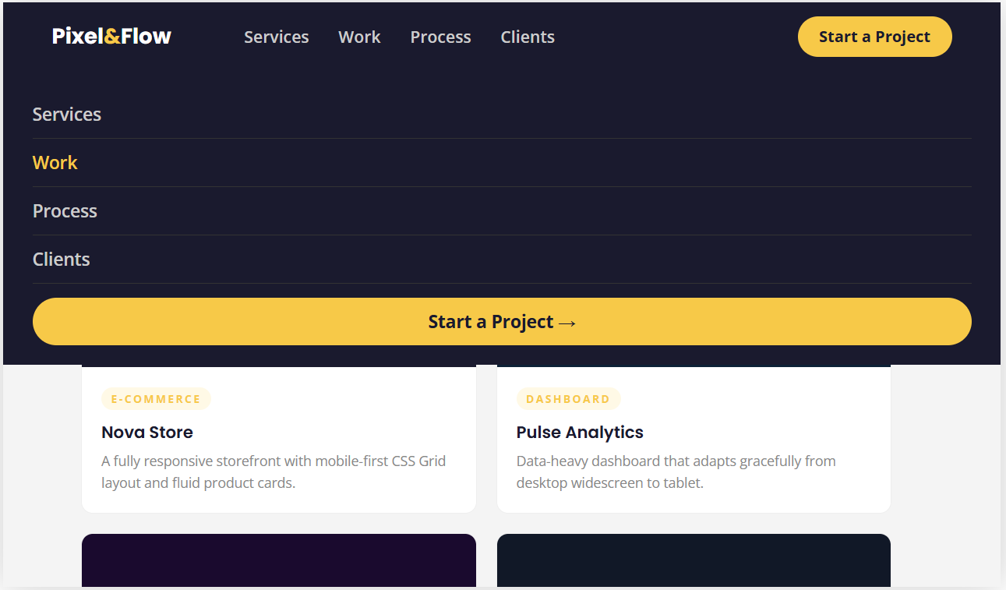

Desktop (1200px) Full 3-column layout, complete navbar
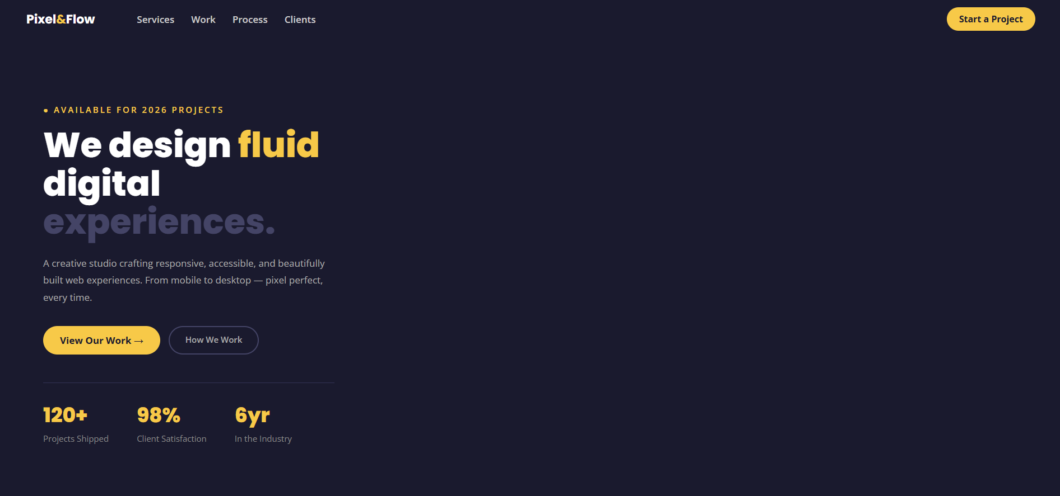

👨‍💻 Author
Muhammad Faizan Abdul Salam Frontend Developer Intern — DecodeLabs Batch 2026 | University of Lahore
🏢 Organization
DecodeLabs 📧 decodelabs.tech@gmail.com 🌐 www.decodelabs.tech 📍 Greater Lucknow, India
📄 License
This project was built as part of the DecodeLabs Industrial Training Program. For educational and training purposes only.

