Project Documentation
DecodeLabs — Frontend Development
Project 3 — Interactive Web Elements | Batch 2026

📷 SCREENSHOT: Full webpage — browser view of completed Project 3

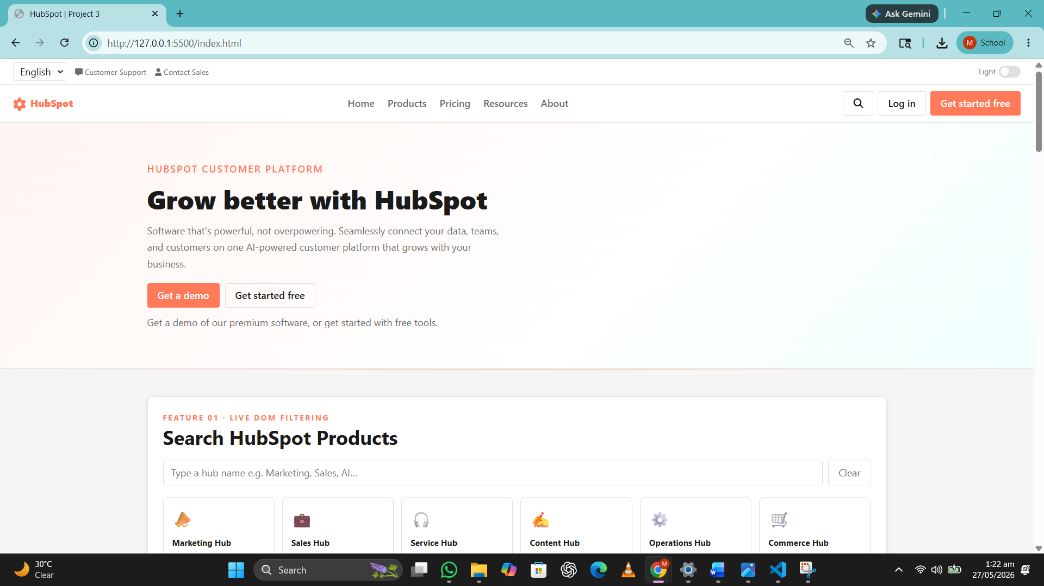

1 | Project Brief

Project Name | Interactive Web Elements
Project Type | Frontend Development (HTML + CSS + JavaScript)
Program | DecodeLabs Industrial Training
Batch | 2026
Theme | HubSpot Customer Platform Clone
Objective | Add interactivity to a webpage using JavaScript and DOM manipulation
Goal | Understand and apply event listeners, state management, and dynamic content updates

2 | Learning Objectives

By completing this project, the following skills were practiced:

- JavaScript basics — variables, functions, conditionals
- DOM selection — getElementById, querySelector, querySelectorAll
- Event listeners — click, input, change events
- State management — using let variables to track UI state
- DOM mutation — textContent, innerHTML, style.display
- classList — toggle, add, remove for visual state changes
- Dynamic element creation — createElement, appendChild
- Dark mode toggle using CSS custom properties
- Form validation and dynamic success message
- Header bug fix — script placement in HTML

3 | File Structure

project-3/
├── index.html → Main file (HTML + CSS + JS in one file)
├── assets/
│ ├── css/style.css → External stylesheet
├── login.html
├── register.html
├── screenshots
├── README.md
├── Project_Documentation.docx

4 | HTML Overview

Structure Used
- Two-part navbar — top utility bar and main sticky navbar
- Semantic layout — nav, main, section, footer
- Proper heading hierarchy (H1 → H2 → H3)
- Image tags with alt attributes and onerror fallback
- Navigation using anchor links and button elements
- Bootstrap 4 grid system for responsive layout

Header Bug Fixed
Original code had a <script> tag inside <head> calling getElementById before the HTML body loaded — returning null. Fix: all JavaScript moved to the bottom of <body> so every element exists before JS runs. The broken second navbar with placeholder <h1>head</h1> was also replaced with the real HubSpot logo.

📷 SCREENSHOT: Navbar — HubSpot logo, nav links, Login and Get Started buttons

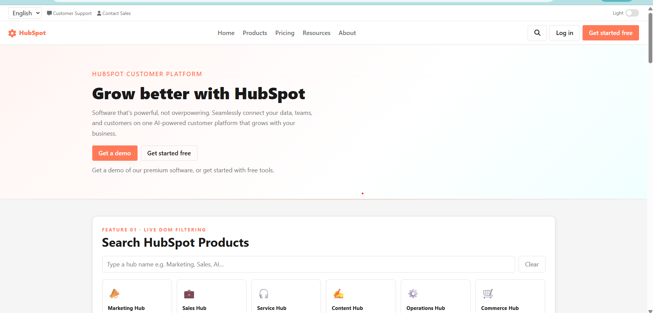

5 | CSS Overview

Features Used
- CSS custom properties (:root variables) for full theme control
- Dark mode via body.is-dark class overriding all CSS variables
- Bootstrap 4 for responsive grid and utility classes
- Smooth transitions on background, color, border
- Hover effects on cards, buttons, nav links
- CSS max-height transition for accordion animation
- Toggle pill animation using transform: translateX

Dark Mode System
JavaScript adds/removes the .is-dark class on <body>. CSS variables defined under body.is-dark override the :root values — no inline styles needed. Every element updates automatically.

📷 SCREENSHOT: CSS result — light mode view of a section


📷 SCREENSHOT: CSS result — same section in dark mode
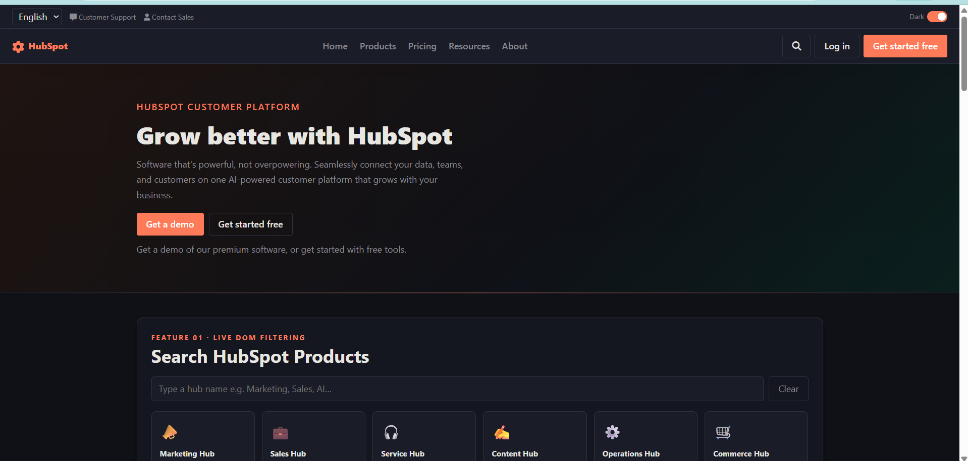

6 | JavaScript Features

Each feature follows the Input → Process → Output (IPO) loop.

Feature 1 — Live Hub Search Filter
Input | User types in the search box
Process | hubsData array filtered using Array.filter() on every keystroke
Output | Only matching hub cards rendered in the grid
Concepts | addEventListener('input'), filter(), createElement, appendChild

📷 SCREENSHOT: Search — typing 'Sales' shows only Sales Hub card
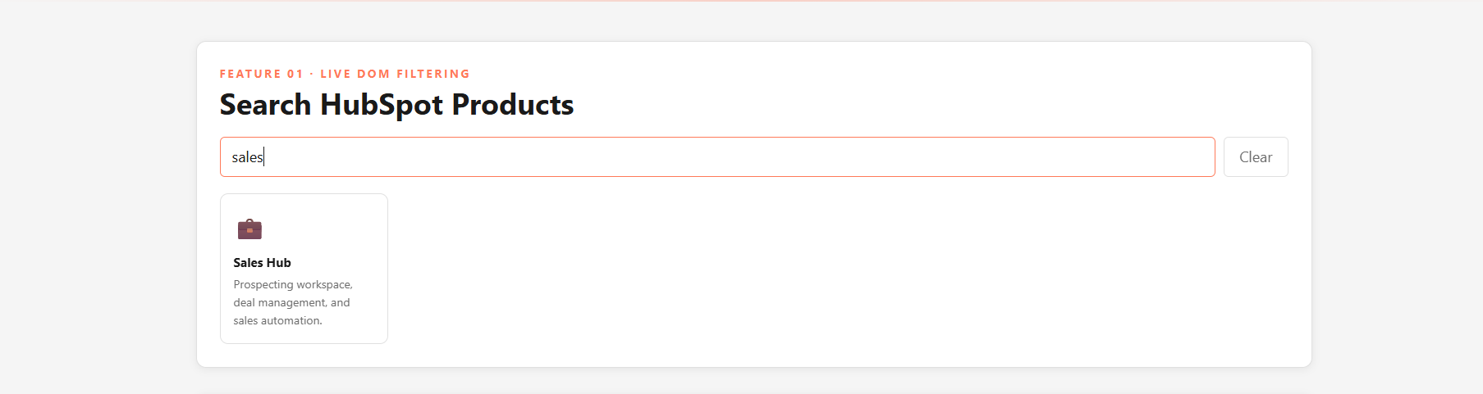

Feature 2 — Get a Demo Form
Input | User fills all fields and clicks Get a demo
Process | JS validates every field — shows error if any empty
Output | Form hides; personalised success message with name and email appears
Concepts | Input validation, style.display, classList.add, textContent

📷 SCREENSHOT: Form — empty state with all fields
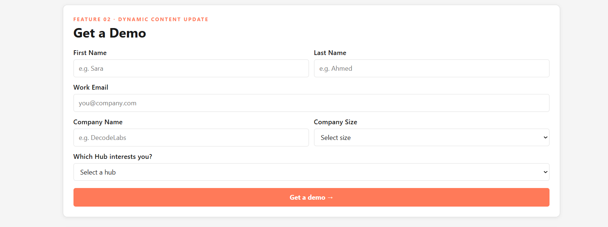

📷 SCREENSHOT: Form — success state after valid submission
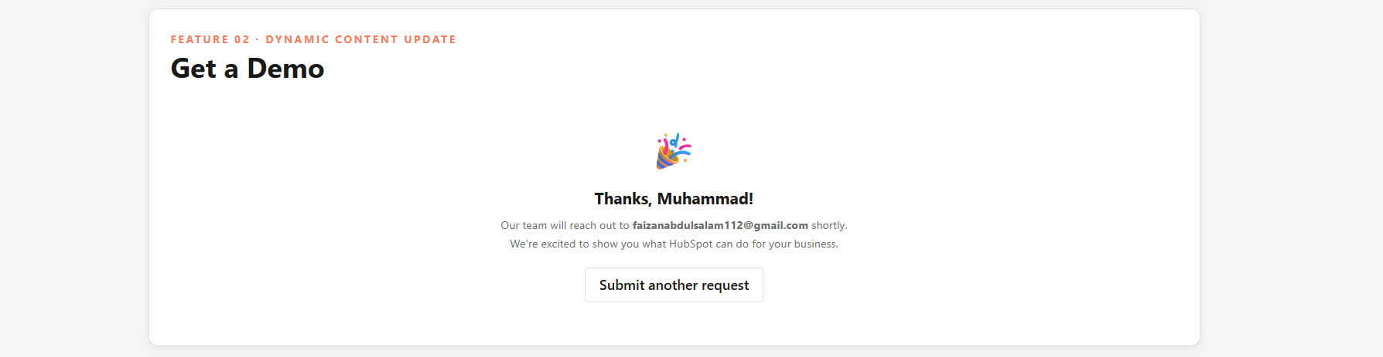

Feature 3 — Pricing Toggle
Input | User clicks the Monthly / Annual toggle pill
Process | isAnnual state variable flips; prices object looked up
Output | All plan prices update instantly; active label highlighted
Concepts | State variable (let isAnnual), innerHTML, classList.toggle
Prices | Starter $20/$15 | Professional $890/$668 | Enterprise $3,600/$2,700

📷 SCREENSHOT: Pricing — Monthly view (four plan cards)
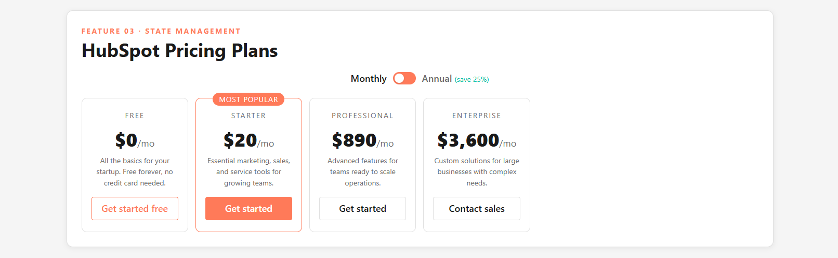

📷 SCREENSHOT: Pricing — Annual view (discounted prices shown)
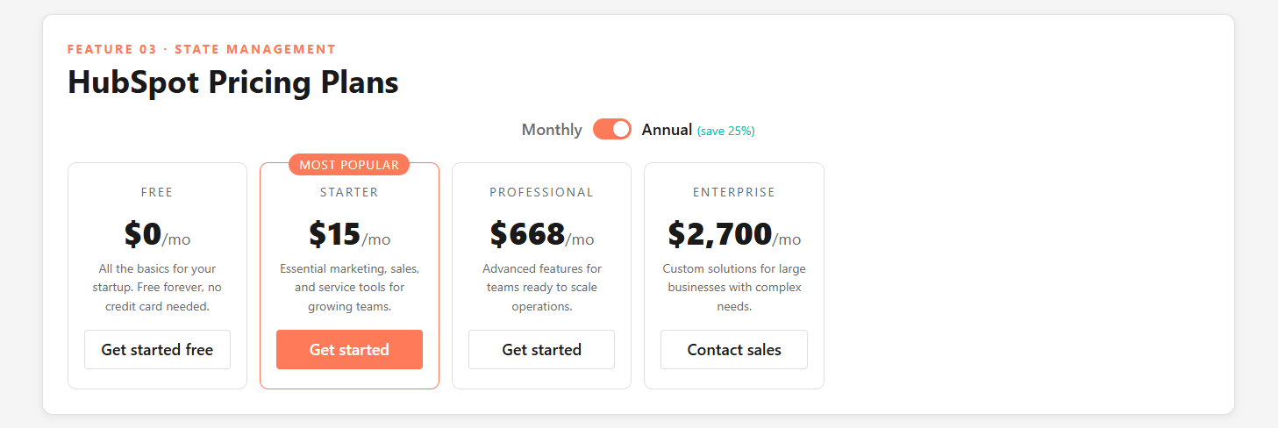

Feature 4 — Blog Post Save / Bookmark
Input | User clicks Save on a blog post row
Process | isSaved variable flips; totalSaved counter updates
Output | Button turns teal with checkmark; border changes; counter updates
Concepts | addEventListener, classList.toggle, textContent, live counter
Blog Posts | 4 posts — Erica Santiago, Amy Porterfield, Sonia Thompson, Ross Simmonds

📷 SCREENSHOT: Blog list — one or more posts saved (teal border and checkmark visible)
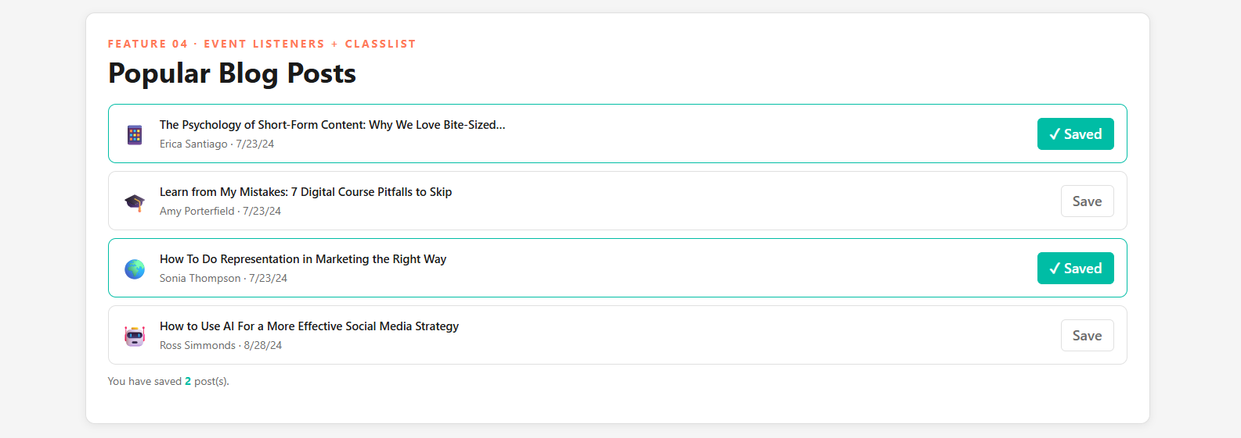

Feature 5 — FAQ Accordion
Input | User clicks a question header
Process | All panels closed first; clicked panel opened if it was closed
Output | Answer slides open; + icon rotates to x; border turns orange
Concepts | querySelectorAll, forEach, classList.add/remove, CSS max-height transition
Topics | What is HubSpot | Hubs | Free plan | Integrations | Getting started

📷 SCREENSHOT: Accordion — one question expanded (answer visible, icon rotated)
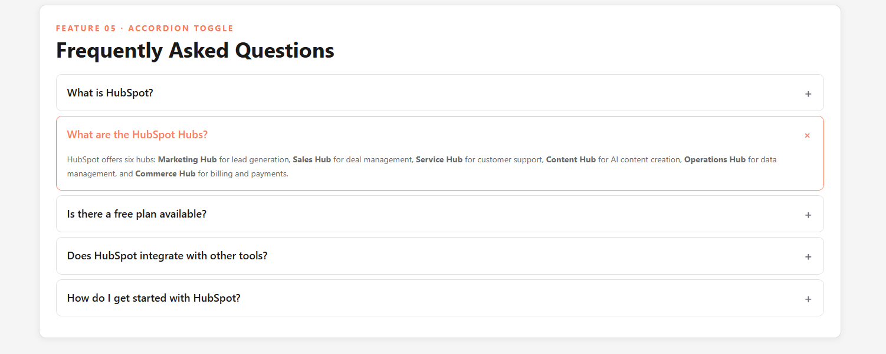

7 | Design Highlights

Color Theme | HubSpot orange (#FF7A59) as accent; teal (#00BDA5) for saved/active states
Typography | 48px headings, 18px body, 14px meta/labels — clear visual hierarchy
Container | Widened to 1400px (96% width) — removes excessive side whitespace
Spacing | Consistent padding and gap system throughout all sections
Transitions | 0.4s background/color transitions make dark mode feel smooth
Card Hover | Cards lift on hover with translateY(-3px) and increased box-shadow

📷 SCREENSHOT: Design — hero section showing color theme and typography scale
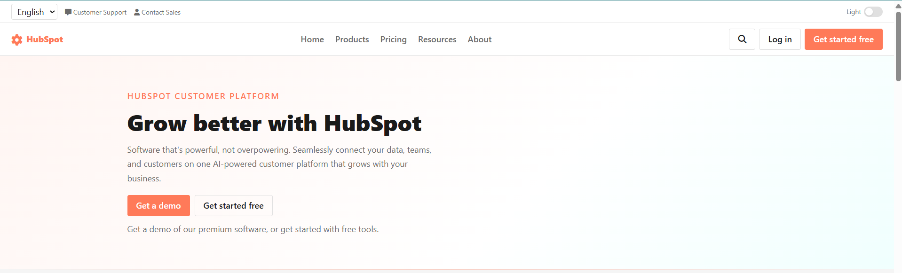

8 | Accessibility

- Alt text added for all images with onerror fallback
- Semantic HTML — nav, main, section, footer used throughout
- Proper heading hierarchy (H1 → H2 → H3)
- Good color contrast between text and backgrounds in both light and dark mode
- Keyboard-accessible buttons and inputs
- aria-label on hamburger button

9 | Project Output

🔗 GitHub Repository https://github.com/faizanab1122/decodelabs-project-3
🌐 Live Website (GitHub Pages) https://faizanab1122.github.io/decodelabs-project-3/

10 | Key Learnings

- How JavaScript makes HTML pages interactive through the IPO loop
- DOM manipulation — selecting, reading, and updating elements
- State management using variables to drive UI changes
- Event-driven programming — attaching listeners to user actions
- The difference between classList.toggle, .add, and .remove
- Why script placement in HTML matters and how to fix null errors
- CSS custom properties as a powerful theming system
- Clean code — js- prefixes for hooks, is- prefixes for state classes

DecodeLabs · Frontend Development · Project 3 · Batch 2026

